AI FAQ Assistant
AI-Augmented Backend Development Project
AI-powered FAQ Management & Content Automation REST API
Project Name | AI FAQ Assistant
Team ID | 6ab4aef20fc666a751b4634f
Date | 26 September 2026
Project Version | 1.0.0
Technology Stack | Node.js, Express.js, MongoDB (Mongoose), JWT, bcrypt, Google Gemini API

Project Description

In a Single Paragraph
AI FAQ Assistant is an AI-Augmented backend web application built on the MERN-adjacent stack (MongoDB, Express.js, Node.js) integrated with Google's Gemini large language model to automate FAQ authoring and answering. Registered users can create, update, delete and search a shared FAQ knowledge base, while the system's AI layer generates direct answers to free-text questions and produces complete, structured question/answer pairs from just a topic name. By combining a secure, JWT-protected REST API with on-demand generative AI, the platform removes the manual effort of writing and maintaining FAQ content while giving end users and client applications instant, searchable self-service answers.

Scenario

Background
Ananya is a support-operations lead at a growing SaaS company. Her team maintains a public help-center FAQ, but every entry is written and updated by hand, and the same handful of questions keep resurfacing from support tickets in slightly different wording.

Problem
- Writing and rephrasing near-identical FAQ answers by hand is slow and does not scale with a growing product.
- There is no fast, self-service way for end users or partner applications to get an answer without emailing support or waiting for a live agent.
- FAQ content quietly goes stale because updating it competes with the rest of the team's workload.
- Existing tools are either fully manual (docs/spreadsheets) or a rule-based chatbot that still needs its keyword rules maintained by hand.

AI Solution
Traditional CRUD-only backends solve storage and retrieval but do nothing about the authoring bottleneck itself — a human still has to think up and phrase every answer. AI FAQ Assistant closes that gap by placing a generative AI layer directly inside the authoring workflow: Google Gemini is called through a dedicated service layer to (1) answer any free-text question directly, and (2) turn a bare topic into a complete, structured {question, answer} pair using Gemini's structured JSON output feature, so the result is predictable and can be saved straight into the FAQ collection through the same endpoint used for manual entries.

Impact
The content team benefits directly: a topic that once took Ananya fifteen minutes to draft now produces a usable first draft in seconds, leaving only review and category selection. End users and any client application built on the API benefit from an always-available, public, keyword-searchable FAQ set that does not require a login to consume, cutting the number of questions that turn into support tickets in the first place.

System Requirements
To ensure smooth development, deployment and usage of the AI FAQ Assistant backend, the following prerequisites apply.

1. Software Requirements
Requirement | Details
Operating System | Windows 10/11, macOS, or Linux (cross-platform)
Node.js | v18 or above — JavaScript runtime for the server
npm | v9 or above — dependency/package manager
Express.js | ^4.19 — REST API routing framework
MongoDB | Local instance or MongoDB Atlas — primary NoSQL data store (Users, FAQs)
Mongoose | ^8.3 — ODM for schema definition and validation
Google Gemini API | @google/genai SDK — gemini-2.0-flash (direct answers), gemini-2.5-flash (structured FAQ generation)
Postman | API testing — a pre-built collection with automatic JWT capture ships with the project
Visual Studio Code | Development environment
Git & GitHub | Version control

2. Hardware Requirements
Component | Minimum
Processor | Intel Core i5 (8th Gen+) / AMD Ryzen 5+
RAM | 8 GB (16 GB recommended)
Storage | 1 GB free space
Internet Connection | Required for Gemini API communication

Project Architecture

Technical Architecture

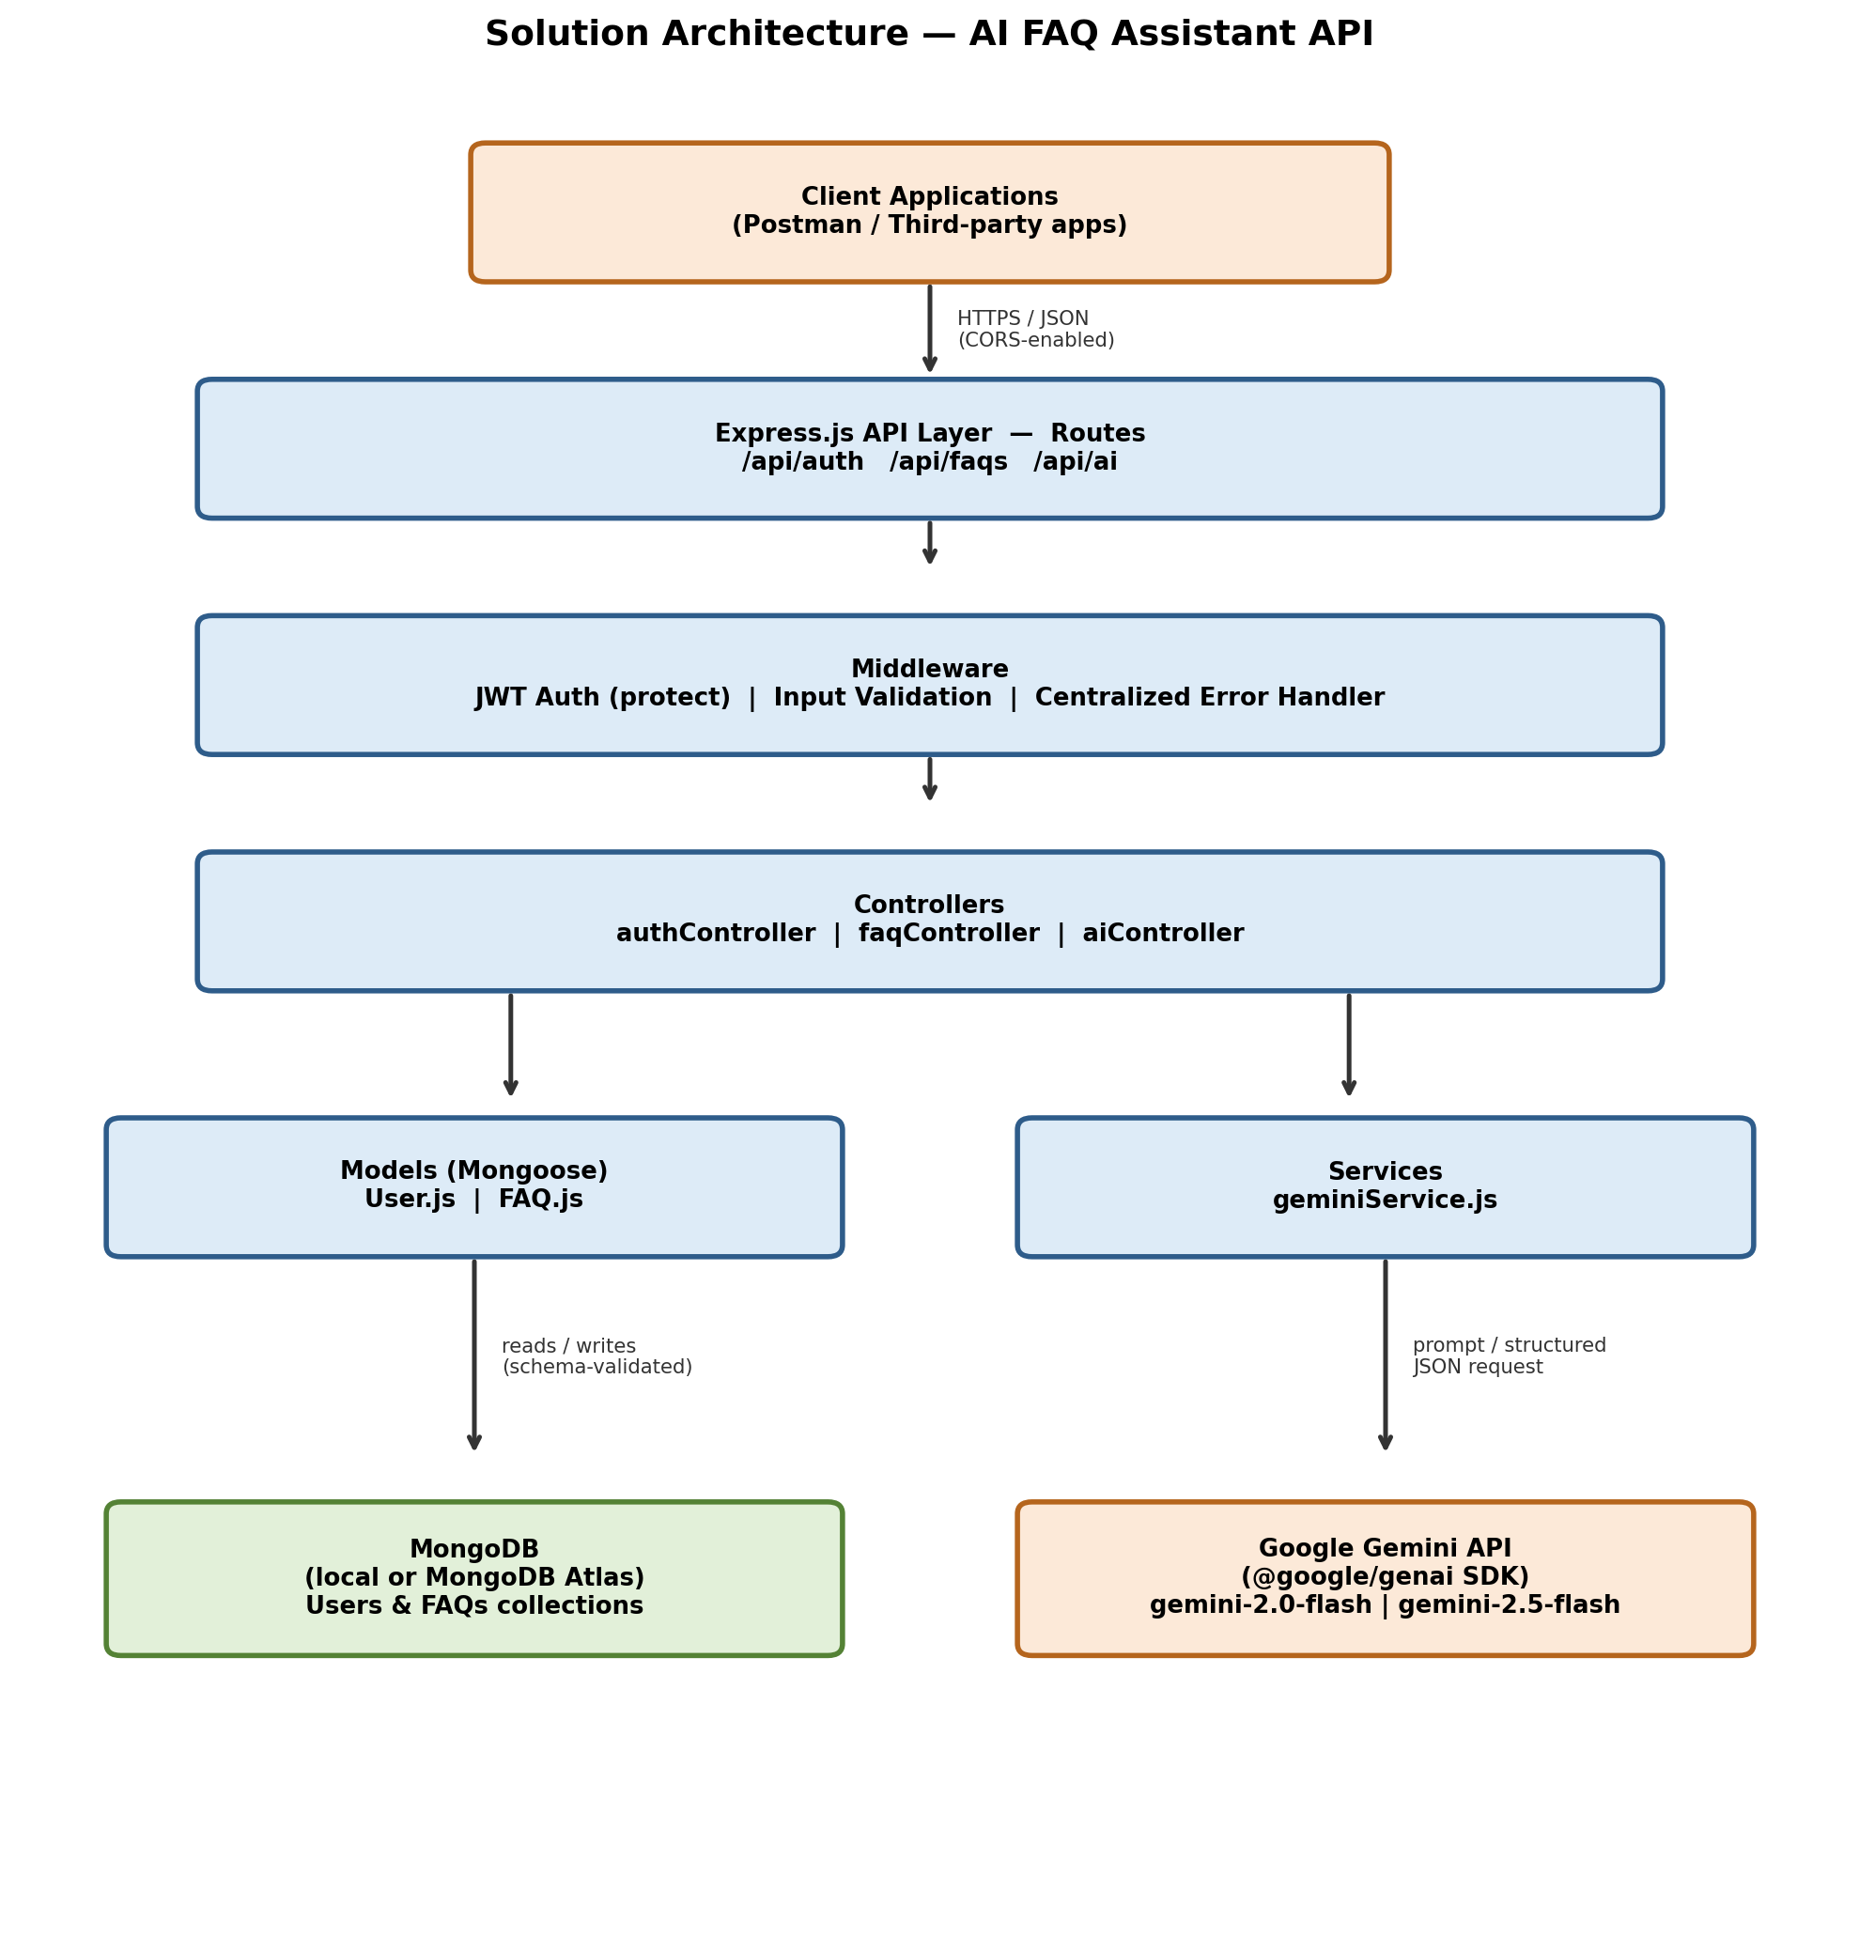
Figure 1: Solution Architecture — AI FAQ Assistant

Layer | Composition
Backend Layer | Node.js, Express.js, layered MVC (routes → controllers → services/models), REST APIs returning JSON only
Security Layer | JWT authentication (protect middleware), bcrypt password hashing (10 salt rounds), input-validation middleware, centralized error handler, CORS
Database Layer | MongoDB accessed via Mongoose; two collections — Users and FAQs — no Atlas Search / Vector Search index is configured in this version
AI Layer | Google Gemini API via @google/genai, isolated in geminiService.js; gemini-2.0-flash for direct answers, gemini-2.5-flash with a structured JSON schema for FAQ generation; no RAG pipeline or embeddings — Gemini is called directly per request

Components Definition
Interface: Postman (pre-built collection with auto JWT capture) and any third-party client application consuming the JSON API
Express Server Gateway (app.js / server.js): Binds the network port, applies CORS, parses JSON bodies, mounts /api/auth, /api/faqs and /api/ai routers, and forwards unhandled errors to the centralized handler
Authentication Middleware (protect): Extracts and verifies the Bearer <token> header, decodes the JWT, and attaches the authenticated user to the request; rejects missing/invalid/expired tokens with 401
Validation Middleware: Checks request bodies (required fields, email format, password length ≥ 6, valid FAQ category, non-empty AI input) before any controller logic runs
Controllers (auth/faq/ai): Hold request/response flow only; call the appropriate model or service and map the outcome to an HTTP status and JSON payload
Models (Mongoose: User.js, FAQ.js): Define schema, validation rules and the createdBy relationship; the only layer that talks to MongoDB
Service Layer (geminiService.js): Isolates all Gemini SDK calls, model selection and prompt/schema construction behind two plain functions the controller calls

ER Diagram
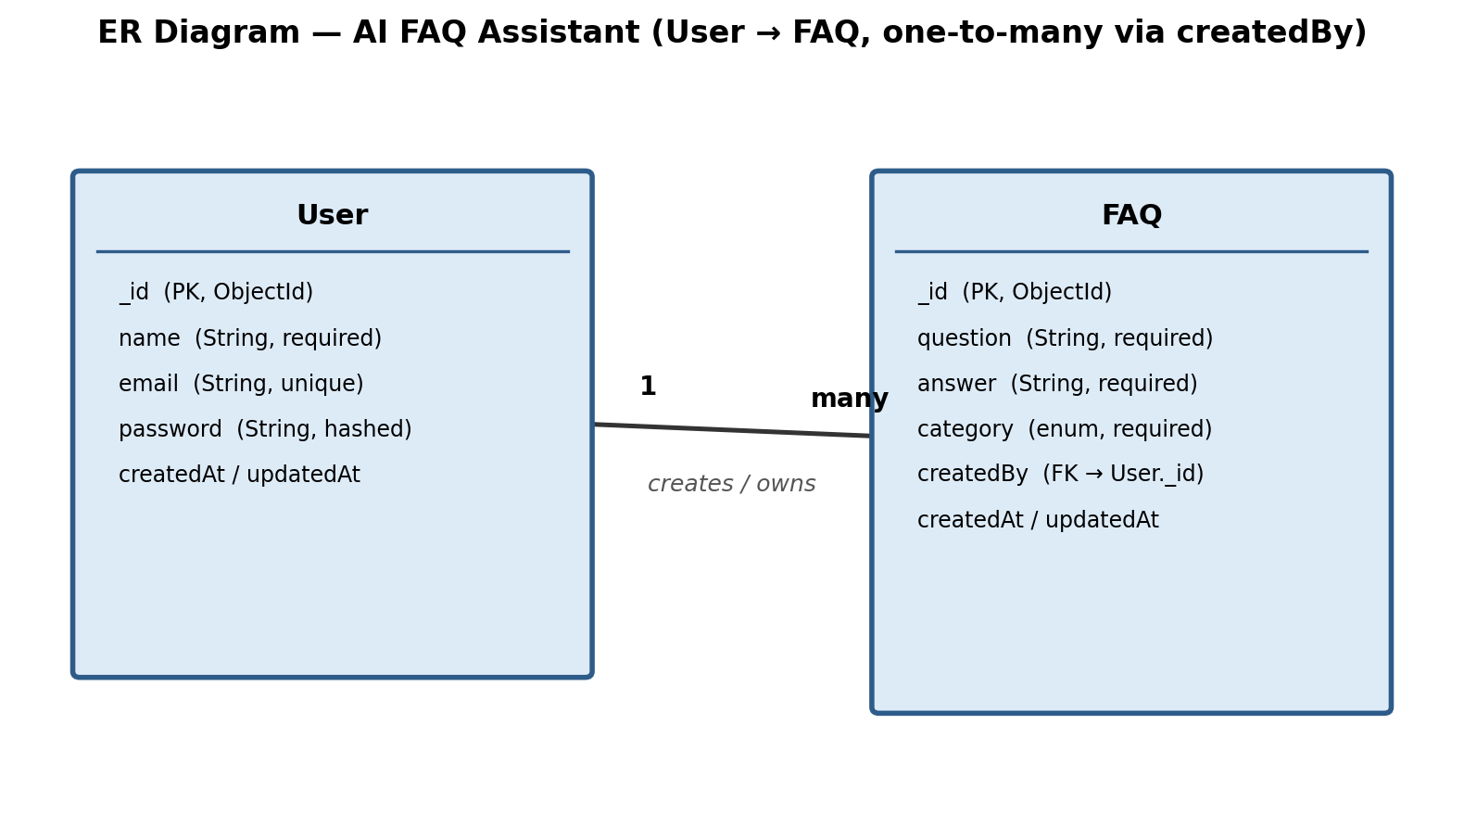

Figure 2: Entity-Relationship Diagram — AI FAQ Assistant

Collections

Users
- _id (ObjectId, PK)
- name (String, required)
- email (String, required, unique)
- password (String, bcrypt-hashed, required)
- createdAt / updatedAt

FAQs
- _id (ObjectId, PK)
- question (String, required)
- answer (String, required)
- category (String enum: Technology | Education | Health | Banking | General, default General)
- createdBy (ObjectId, FK → Users._id, required)
- createdAt / updatedAt

ER Diagram Explanation
The database consists of exactly two persisted collections. A registered user (Users) can create many FAQ documents (FAQs) — a one-to-many relationship enforced through the createdBy foreign key — and only that creator may update or delete a given FAQ (a 403 is returned for anyone else). AI-generated content is not stored as a separate collection: a generated {question, answer} pair is returned directly in the API response and only becomes persistent data if the client subsequently calls the same Create FAQ endpoint used for manually authored entries.

Key Features
Feature | Description
JWT Authentication & Authorization | Stateless, token-based sessions protect private routes (profile, FAQ writes, AI endpoints)
Password Encryption | User passwords are bcrypt-hashed (10 salt rounds) before storage
FAQ CRUD with Ownership | Create/Read/Update/Delete FAQs; update and delete are restricted to the original creator
Category Management | FAQs are organized under a fixed, validated category set for easier navigation
Keyword Search | Public, case-insensitive regex search across question, answer and category fields
AI Answer Generation | Gemini (gemini-2.0-flash) returns a direct, concise answer to any free-text question
AI FAQ Generation | Gemini (gemini-2.5-flash) returns a structured {question, answer} pair from a topic via JSON-schema output
Centralized Error Handling | Uniform JSON error responses for validation, cast and duplicate-key errors — no leaked stack traces
Schema Validation | Mongoose enforces required fields, email format and category enum before persistence
RESTful, Modular Architecture | Layered Express routes/controllers/services/models; no frontend — JSON over HTTP only

Roles and Responsibilities
Note: the current implementation does not include a formal role field or admin-level permissions on the User model — access is governed purely by authentication (logged in or not) and ownership (creator or not). The functional roles below describe how the system actually behaves today; a dedicated Admin role is listed as a suggested future enhancement.

Registered User (Content Creator)
- Register and log in to receive a JWT
- Create new FAQ entries with a question, answer and category
- Update or delete FAQs they personally created (403 on any other FAQ)
- View their own profile
- Request an AI-generated answer or AI-generated FAQ pair, and save the result

Guest / Public User
- Browse all FAQs (newest first, with creator populated) — no login required
- Retrieve a single FAQ by ID
- Keyword-search the FAQ set
- Cannot create, edit, delete FAQs, or call the AI endpoints

Suggested Future Role: Admin
- Manage/moderate all users' FAQs regardless of creator
- Monitor AI usage and costs
- Manage the fixed category list
- Would require adding a role field to the User schema and an authorize(role) middleware alongside the existing protect middleware

User Flow
- User Registration (POST /api/auth/register) — name, email, password; duplicate emails rejected; password bcrypt-hashed
- User Login (POST /api/auth/login) — returns a JWT on valid credentials
- JWT Authentication — the protect middleware verifies the Bearer token on every subsequent protected request
- Profile Access (GET /api/auth/profile) — returns the logged-in user's details, password excluded
- FAQ Creation (POST /api/faqs) — question, answer, category; stores the creator's user ID
- FAQ Update / Delete (PUT / DELETE /api/faqs/:id) — creator-only, 403 otherwise
- Public FAQ Listing & Retrieval (GET /api/faqs, GET /api/faqs/:id) — no login required
- FAQ Search (GET /api/faqs/search?q=) — case-insensitive regex match, no login required
- AI Answer Request (POST /api/ai/answer) — free-text question → direct Gemini answer
- AI FAQ Generation (POST /api/ai/generate-faq) — topic → structured {question, answer} pair
- Save Generated Pair — the client resubmits the generated pair to POST /api/faqs to persist it
- Centralized Error Handling — any failure at any step returns a consistent JSON error response

MVC Pattern
The backend follows the Model-View-Controller architecture, fully decoupling data, business logic and routing.

Model Layer (Data Blueprint)
Implemented with Mongoose. Defines the User schema (name, email, password with a pre-save bcrypt hook) and the FAQ schema (question, answer, category enum, createdBy reference), enforcing validation rules before any document is persisted.

Controller Layer (Execution Logic)
authController, faqController and aiController receive validated requests, delegate to the models or to geminiService, and shape the HTTP response — they contain no direct database queries or AI SDK calls of their own.

View Layer (Routes)
As a headless backend, there is no template/UI view layer. Its role is played by the Express routers, which map each URL under /api/auth, /api/faqs and /api/ai to its controller handler:
Route Group | Endpoints
Authentication Routes | POST /register, POST /login, GET /profile
FAQ Routes | POST /, GET /, GET /:id, PUT /:id, DELETE /:id, GET /search
AI Routes | POST /answer, POST /generate-faq

Advantages of MVC (as realized in this project)
- Separation of concerns — a Gemini model-name change during testing was a one-file fix in geminiService.js with zero controller/route changes
- Better maintainability — validation and error handling are centralized rather than duplicated per route
- Easy scalability — new endpoints can be added without disturbing existing ones
- Testability — each layer can be reasoned about and tested independently

Project Setup and Configuration

Project Structure
ai-faq-assistant/
src/
app.js
server.js
config/db.js
controllers/ (authController.js, faqController.js, aiController.js)
middleware/ (authMiddleware.js, errorMiddleware.js, validationMiddleware.js)
models/ (User.js, FAQ.js)
routes/ (authRoutes.js, faqRoutes.js, aiRoutes.js)
services/ (geminiService.js)
utils/helpers.js
test_api.js
AI_FAQ_Assistant_API.postman_collection.json
.env
package.json

Install Backend Packages
npm init -y
npm install express mongoose cors dotenv bcrypt jsonwebtoken @google/genai

Backend Development
Implemented modules:
- Authentication APIs — register, login, profile (authController.js, authRoutes.js)
- JWT Implementation — token issuance on register/login; verification via the protect middleware (authMiddleware.js)
- AI Service Integration — geminiService.js wraps the @google/genai SDK for both AI endpoints
- FAQ CRUD APIs — create, list, get-by-id, update, delete, search (faqController.js, faqRoutes.js)
- Centralized Validation & Error Handling — validationMiddleware.js and errorMiddleware.js

AI API Consumed: Google Gemini (@google/genai)
Aspect | Detail
Purpose | generateAnswer() returns a direct answer to a free-text question; generateFAQ() returns a structured {question, answer} pair from a topic
Models used | gemini-2.0-flash (direct answers) · gemini-2.5-flash (structured JSON-schema output for FAQ generation)
Request structure | A single contents prompt string; the FAQ-generation call additionally passes a responseSchema (OBJECT with required question/answer STRING fields) and responseMimeType: application/json
Response structure | generateAnswer returns response.text (trimmed); generateFAQ parses response.text as JSON into {question, answer}
Cost considerations | Billed per Gemini API call/token by Google; no local GPU or training cost since no model is hosted or fine-tuned
Security practices | GEMINI_API_KEY is read from environment variables only, never hard-coded; the AI endpoints sit behind the same JWT protect middleware as other private routes; the service throws a clear configuration error if the key is missing rather than silently failing

Database Development
- MongoDB Collections: Users, FAQs (see ER Diagram section)
- Relationship: FAQs.createdBy references Users._id (one user → many FAQs)
- Indexes: default _id index only in this version; category and question/answer are queried via Mongoose regex, not a MongoDB Atlas Search or Vector Search index
- Sample FAQ document: { question: "How do I reset my password?", answer: "...", category: "Technology", createdBy: ObjectId(...), createdAt, updatedAt }
Recommended: capture Postman/MongoDB Compass screenshots here showing a sample User document (hashed password) and a sample FAQ document, plus the collection list, before final submission.

Project Execution

Step 1: Install dependencies
cd server
npm install

Step 2: Configure Environment Variables (.env)
PORT=5000
MONGO_URI=mongodb://localhost:27017/ai_faq_assistant
JWT_SECRET=your_secret_key
GEMINI_API_KEY=your_google_gemini_api_key_here

Step 3: Run the Backend
npm run dev
# Backend URL: http://localhost:5000

API Testing Specification
Verified end-to-end using the project's pre-built Postman collection (auto JWT capture on register/login):

1. Register
Route: POST /api/auth/register · Access: Public
{
"name": "Ananya Rao",
"email": "ananya@example.com",
"password": "securePass123"
}

2. Login
Route: POST /api/auth/login · Access: Public
{
"email": "ananya@example.com",
"password": "securePass123"
}

3. Create FAQ
Route: POST /api/faqs · Access: Private (Bearer <JWT Token>)
{
"question": "How do I reset my password?",
"answer": "Go to Settings > Security > Reset Password.",
"category": "Technology"
}

4. Search FAQs
Route: GET /api/faqs/search?q=password · Access: Public

5. AI Answer Generation
Route: POST /api/ai/answer · Access: Private (Bearer <JWT Token>)
{
"question": "What is the difference between JWT and session-based auth?"
}

6. AI FAQ Generation
Route: POST /api/ai/generate-faq · Access: Private (Bearer <JWT Token>)
{
"topic": "MongoDB index performance tuning"
}

Mandatory Functionalities Coverage
An honest mapping of the program's mandatory checklist against what is actually implemented in this codebase, so gaps are visible before submission rather than assumed away:
Mandatory Item | Status | Notes
MVC Architecture | Implemented | routes → controllers → services/models, cleanly separated
JWT Authentication | Implemented | protect middleware; stateless Bearer tokens
AI API Integration | Implemented | Google Gemini via @google/genai (2 endpoints)
Prompt Engineering | Implemented | Structured JSON-schema prompting for FAQ generation; direct instruction prompting for answers
Semantic Search | Not Implemented | Current search is keyword/regex-based, not embedding-based semantic search
MongoDB Atlas Search | Not Implemented | No Atlas Search index configured; regex query on local/Atlas MongoDB instead
MongoDB Atlas Vector Search | Not Implemented | No vector embeddings are generated or stored
Role-Based Access Control | Partially Implemented | Ownership-based authorization exists (creator-only update/delete); no admin/user role field or role-based middleware yet

If Semantic/Vector Search and full RBAC are required for grading, the fastest path is: (1) add a role field (default "user") to the User schema plus an authorize(role) middleware for RBAC, and (2) generate embeddings for each FAQ with Gemini's embedding model and query them via MongoDB Atlas Vector Search instead of (or alongside) the existing regex search.

Output Screenshots with Explanation
Add screenshots here (Postman requests/responses, MongoDB Compass collections, terminal output) for:
- API Testing — register, login, create/search FAQ requests in Postman
- LLM Integration — a successful POST /api/ai/answer and POST /api/ai/generate-faq response
- Database — MongoDB Compass view of the Users and FAQs collections

Demo Video Link
AI FAQ ASSISTANT - Google Drive

Source Code Drive / GitHub Link
REPO LINK

