Pivot chart

Go to settings 🡪 data models -> choose the data model and choose Pivot

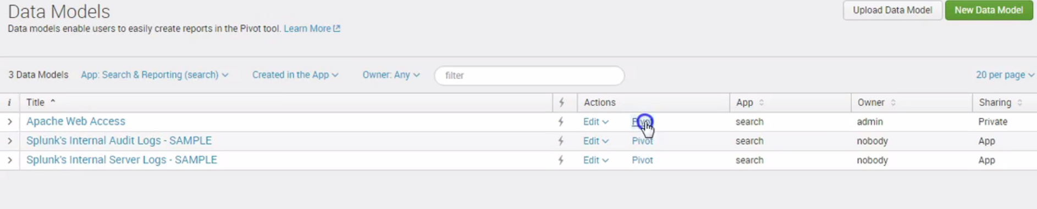

Click success under the data models

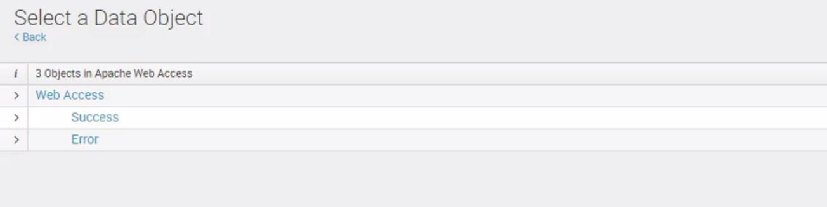

Click Split rows 🡪 clientip

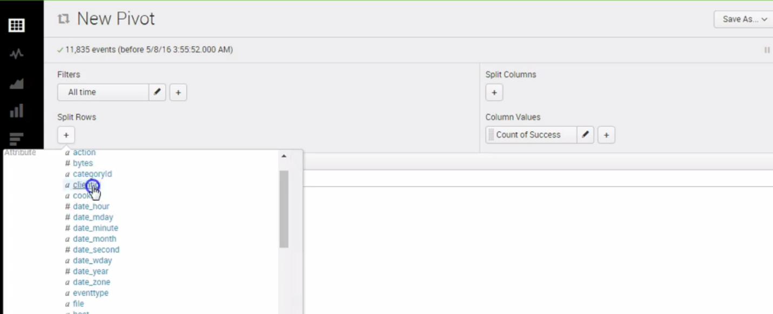

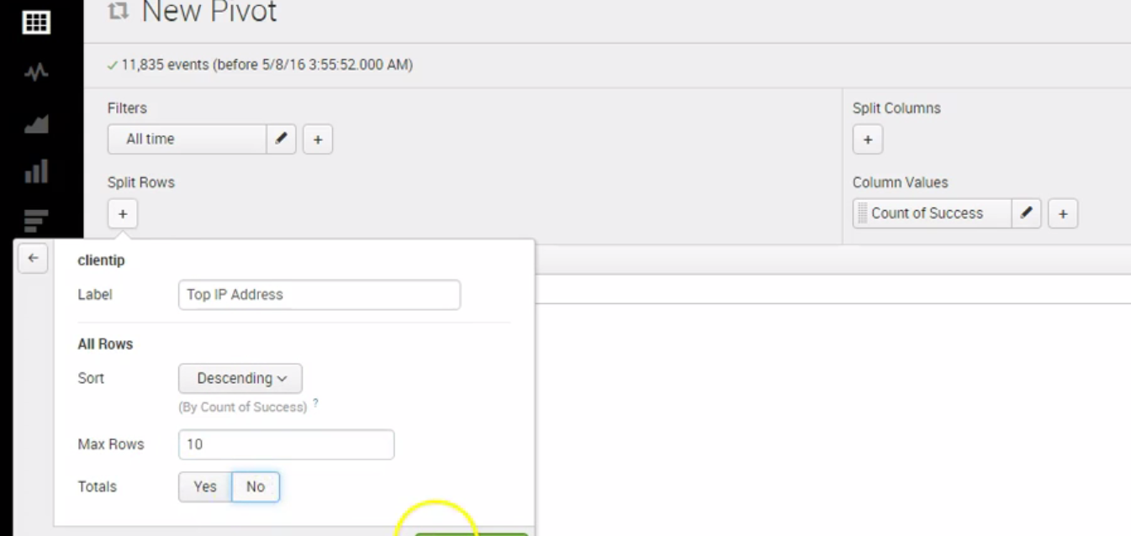

See the list of ips

From the left pane select any of the charts

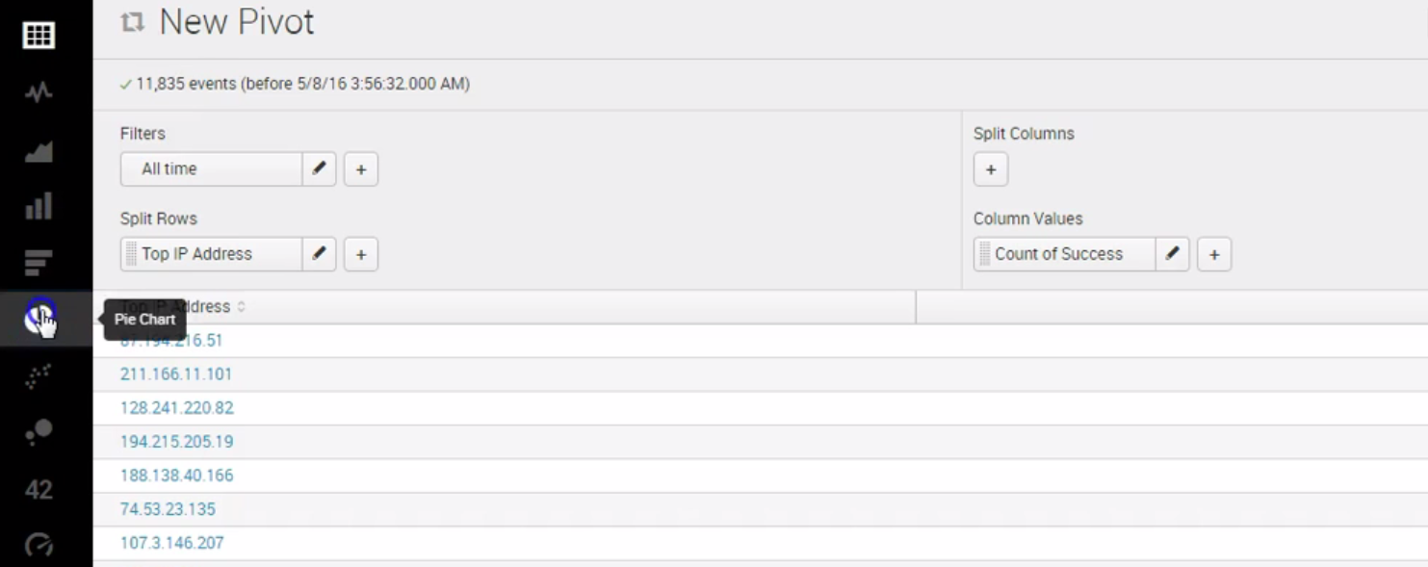

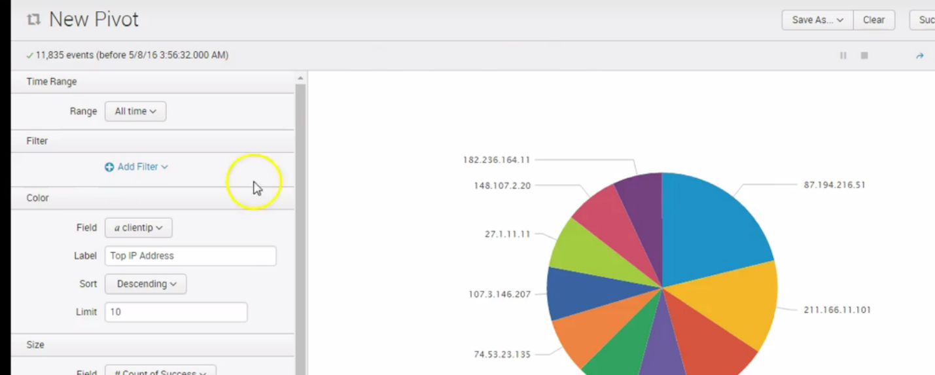

Click save as dashboard panel

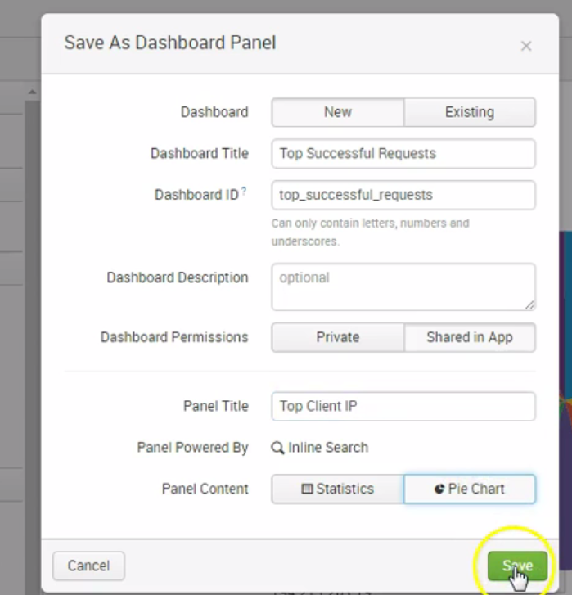

Click view dashboard

