MCA MAJOR PROJECT REPORT
AI-Powered Bloom Taxonomy Classification and Difficulty-Aware Question Transformation System (BloomEngine)
TABLE OF CONTENTS
- Introduction
- 1.1 Introduction to the Project
- 1.2 Statement of the Problem
- 1.3 System Specifications
- Literature Survey
- System Analysis
- 3.1 Existing System
- 3.2 Limitations of Existing System
- 3.3 Proposed System
- 3.4 Advantages of Proposed System
- System Design
- 4.1 High Level Design
- 4.2 Low Level Design
- Data Collection and Preparation
- 5.1 Data Sources
- 5.2 Data Profiling
- 5.3 Data Cleaning and Preprocessing
- Exploratory Data Analysis
- 6.1 Data Visualization Techniques
- 6.2 Univariate and Bivariate Analysis
- Methodology
- 7.1 Data Models
- 7.2 Model Selection
- 7.3 Model Building
- 7.4 Results
- Testing
- SDG Mapping
- 9.1 Selected SDG Goal(s)
- 9.2 Specific Targets Addressed
- 9.3 Social Impact
- 9.4 Environmental Sustainability
- 9.5 Innovation Relevance
- Conclusion
- Bibliography
- Appendix
CHAPTER 1: INTRODUCTION
1.1 Introduction to the Project
In higher education assessment frameworks, particularly within technical disciplines such as Computer Science and Information Technology, evaluation instruments are fundamental to measuring cognitive learning outcomes. Traditional academic examination construction often relies heavily on lower-order cognitive questioning—such as verbatim recall of definitions, basic syntax identification, and simple factual recognition. While lower-order knowledge is foundational, industrial and academic standards necessitate that students demonstrate higher-order cognitive competencies, including system analysis, algorithmic design, comparative evaluation, and architectural synthesis.
Benjamin Bloom’s Taxonomy of Educational Objectives, as revised by Anderson and Krathwohl (2001), structures cognitive domain processes into six distinct hierarchical levels:
- Remember: Retrieving explicit knowledge from memory (e.g., *Define*, *List*, *State*).
- Understand: Constructing conceptual meaning from instructional messages (e.g., *Explain*, *Describe*, *Summarize*).
- Apply: Carrying out procedures in novel contexts (e.g., *Calculate*, *Execute*, *Implement*).
- Analyze: Deconstructing materials into structural components and identifying relationships (e.g., *Differentiate*, *Deconstruct*, *Investigate*).
- Evaluate: Making judgments based on specific qualitative or quantitative criteria (e.g., *Appraise*, *Critique*, *Justify*).
- Create: Synthesizing elements to form an original, functional whole or new structure (e.g., *Architect*, *Formulate*, *Design*).
Manually elevating lower-order question banks to match target higher-order cognitive categories demands extensive domain expertise, continuous editorial review, and substantial temporal effort. Furthermore, manual rewriting frequently introduces unintended conceptual drift, corrupted technical jargon, or inaccurate numeric constants.
To solve these challenges, BloomEngine was developed as an AI-powered Bloom Taxonomy Classification and Difficulty-Aware Question Transformation System. The system orchestrates fine-tuned deep learning models—specifically DeBERTa-v3 for sequence classification and FLAN-T5 for sequence-to-sequence transformation—alongside spaCy linguistic parsing, SentenceTransformer vector embeddings, and a multi-stage validation engine. BloomEngine automatically elevates low-cognitive assessment questions into verified, high-cognitive assessment items while maintaining subject-matter concepts, technical entities, numerical integrity, and domain context.
1.2 Statement of the Problem
The automated construction of academic assessment items using unconstrained generative language models encounters severe structural failure modes that prohibit direct adoption in academic environments:
- Test Bank Cognitive Imbalance: Academic question repositories are predominantly composed of recall-oriented questions (*Remember* and *Understand*). Manually rewriting thousands of items to higher cognitive tiers (*Analyze*, *Evaluate*, *Create*) is labor-intensive and error-prone.
- Subject-Matter Concept Drift: Generic generative language models frequently alter core technical concepts during rephrasing (e.g., altering "B-Tree index node splitting" to general "search list sorting"), rendering the resulting item pedagogically invalid.
- Entity and Numeric Mutation: Language models frequently hallucinate or modify domain-specific constants, IP address structures, protocol numbers, or algorithm variable names during transformation.
- Lack of Taxonomic Precision: Pre-trained language models without specialized fine-tuning fail to consistently hit exact target Bloom cognitive levels, often producing questions that match unintended cognitive categories.
- Absence of Quality Control Pipelines: Standard AI interfaces do not provide automated multi-stage verification to enforce syntactic correctness, concept retention, non-duplication, and semantic alignment prior to test bank insertion.
BloomEngine systematically resolves these challenges by coupling fine-tuned seq2seq generation with a multi-candidate ranking algorithm and a strict modular NLP validation engine. This guarantees that every transformed question retains the key concepts of the original item while adhering strictly to the desired Bloom cognitive level.
1.3 System Specifications
1.3.1 Hardware Specifications
Table 1.1: System Hardware Specifications.
Hardware Component | Minimum Specification | Recommended Specification
**Central Processing Unit (CPU)** | Intel Core i5 / AMD Ryzen 5 (4 Cores, 2.5 GHz) | Intel Core i7 / AMD Ryzen 7 (8 Cores, 3.5 GHz+)
**System Memory (RAM)** | 16 GB DDR4 | 32 GB DDR4 / DDR5
**Graphics Processing Unit (GPU)** | NVIDIA GTX 1660 (6 GB VRAM) | NVIDIA RTX 3080 / RTX 4080 (10 GB+ VRAM, CUDA 12.x)
**Storage Capacity** | 25 GB Available SSD Space | 50 GB NVMe M.2 SSD
**Display Resolution** | $1366 \times 768$ Pixels | $1920 \times 1080$ Pixels (Full HD)

1.3.2 Software Specifications
Table 1.2: System Software & Dependency Specifications.
Software / Layer | Technology | Primary Function
**Operating System** | Windows 10/11, Linux (Ubuntu 22.04), macOS | Execution host environment
**Runtime Language** | Python 3.12 | Core server execution language
**Web Server Framework** | Flask 3.0.x | REST API server & session manager
**Deep Learning Backend** | PyTorch 2.x | CUDA-accelerated model execution
**Transformers Framework** | Hugging Face Transformers 4.x | Tokenizer and model weight loader
**Sequence Generator** | Fine-Tuned FLAN-T5 (`flan_t5_model`) | Question variant seq2seq generator
**Cognitive Classifier** | Fine-Tuned DeBERTa-v3 (`deberta_bloom_model`) | 6-class Bloom sequence classifier
**Vector Embeddings** | SentenceTransformers (`all-MiniLM-L6-v2`) | Semantic similarity & duplicate vector encoding
**Linguistic Parser** | spaCy 3.x (`en_core_web_sm`) | POS tagging, noun chunking, NER extraction
**Fuzzy Matching** | RapidFuzz | Lexical duplicate detection
**Document Processing** | Pandas, OpenPyXL, PyPDF2, python-docx, python-pptx, FPDF2 | Multi-format ingestion and report generation
**Frontend Framework** | HTML5, CSS3, Tailwind CSS, JavaScript | Interactive Single-Page Application (SPA)
**Analytics Engine** | Chart.js 4.x | Real-time graphical dashboard rendering
**Automated E2E Testing** | Playwright (Node.js) | Full-stack regression testing suite

CHAPTER 2: LITERATURE SURVEY
Automated Question Generation (AQG) and cognitive taxonomy classification have evolved across three primary technical paradigms: rule-based syntactic transformations, statistical machine learning models, and deep transformer-based language architectures.
Table 2.1: Comparative Literature Review of Existing Question Generation & Classification Approaches.
Author & Year | Methodology / Model | Strengths | Limitations | Relevance to BloomEngine
**Heilman & Smith (2010)** | Rule-based syntactic parsing & overgenerate-and-rank framework | High syntactic control and structural predictability | Inability to elevate cognitive levels or generate creative phrasings | Highlighted the necessity of multi-candidate ranking mechanisms.
**Kurdi et al. (2020)** | Systematic review of AQG in educational contexts | Categorized AQG evaluation standards into syntax, domain relevance, and pedagogy | Found severe lack of cognitive difficulty control in existing systems | Established requirement for difficulty-aware transformation.
**Devlin et al. (2019)** | BERT (Bidirectional Encoder Representations from Transformers) | Strong contextual bidirectional sequence representations | Limited token length, lacking specialized cognitive taxonomy fine-tuning | Formed baseline for contextual embedding classification.
**He et al. (2021)** | DeBERTa (Decoding-enhanced BERT with Disentangled Attention) | Disentangled attention mechanism separating content and positional vectors | High memory footprint requiring sequential model management | Adapted as primary 6-class Bloom Taxonomy classifier.
**Chung et al. (2022)** | FLAN-T5 (Instruction-Finetuned T5) | Excellent zero-shot and instruction-following generation capability | Unconstrained generations can induce concept drift without validation | Selected as core sequence-to-sequence question transformation engine.
**Reimers & Gurevych (2019)** | Sentence-BERT (SBERT) | Efficient dense vector representation for semantic similarity matching | Requires exact domain threshold tuning to prevent semantic false positives | Utilized for vector cosine similarity and duplicate check stages.

CHAPTER 3: SYSTEM ANALYSIS
3.1 Existing System
In existing academic environments, assessment question creation relies primarily on manual drafting by course instructors or static item selection from publisher-provided test banks. While automated question generators have recently emerged, they function primarily as basic template-fillers or unconstrained text summarizers.
3.2 Limitations of Existing System
- Manual Labor Intensity: Constructing high-cognitive assessment questions requires significant time, limiting exam variant generation.
- Cognitive Skew: Assessment items cluster heavily in lower Bloom levels (*Remember* ~60%, *Understand* ~25%, *Apply* ~10%, *Higher Tiers* $<5\%$).
- Unchecked Generative Hallucination: Off-the-shelf generative AI models corrupt technical terms, introduce non-existent parameters, or alter numerical constants.
- Lack of Validation Pipelines: Existing systems lack automated real-time verification for syntax, domain alignment, and concept preservation.
3.3 Proposed System (BloomEngine)
BloomEngine introduces an end-to-end automated pipeline that ingests low-cognitive questions, identifies their underlying domain and concepts, transforms them into target higher-order Bloom levels using fine-tuned FLAN-T5 models, and enforces quality control via a multi-stage validation engine.
3.4 Advantages of Proposed System
- Taxonomic Target Precision: Achieves exact Bloom cognitive target alignment through fine-tuned DeBERTa classification.
- Concept & Entity Preservation: Guarantees preservation of core technical terms and noun phrases using spaCy linguistic parsing.
- Automated Multi-Candidate Validation: Evaluates generated variants across multiple validation stages before selecting the top-ranked candidate.
- Multi-Format Batch Ingestion & Export: Supports bulk processing of `.xlsx`, `.csv`, `.docx`, `.pdf`, and `.pptx` documents with real-time analytics.
CHAPTER 4: SYSTEM DESIGN
4.1 High Level Design
The High-Level Design (HLD) of BloomEngine defines the macro-architectural structure, system boundaries, component relationships, and multi-tiered operational layers of the platform. The system is architected as a decoupled client-server model organized into five core operational layers:
- Presentation Layer: A responsive Single Page Application (SPA) web interface engineered with HTML5, Vanilla CSS, Tailwind CSS, JavaScript, and Chart.js for real-time analytics visualization.
- Application Controller Layer: A Flask 3.0 server (`app.py`) orchestrating HTTP REST API routes (`/rephrase`, `/export`), request validation, process memory management, thread locks, and session state.
- Question Parsing & Linguistic Layer: Integrates spaCy (`en_core_web_sm`) for Part-of-Speech (POS) tagging, compound noun chunking, named entity recognition (NER), CS abbreviation expansion, and hierarchical domain classification.
- Deep Learning & Inference Layer: Houses local PyTorch model weights for fine-tuned DeBERTa-v3 sequence classification, fine-tuned FLAN-T5 sequence-to-sequence transformation, and SentenceTransformer dense vector encoding (`all-MiniLM-L6-v2`).
- Validation Engine & Persistence Layer: Executes the 7-stage modular validation engine, dynamic candidate ranking algorithm, transient session memory store, and vector embedding cache.
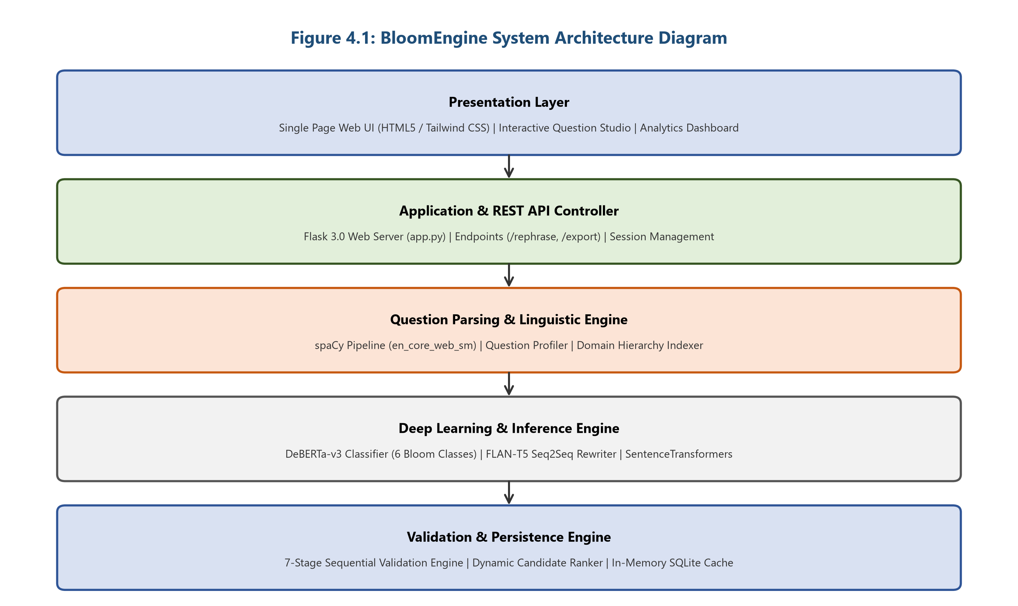
Figure 4.1: BloomEngine System Architecture Diagram.
4.2 Low Level Design
The Low-Level Design (LLD) provides detailed specifications of the internal system components, data structures, control logic, behavioral flows, interaction sequences, and data storage schemas.
4.2.1 System Modules Decomposition
BloomEngine is structured into six tightly focused, modular components:
- M1: Question Parser & Profiler (`question_understanding.py`): Normalizes input text, cleans unicode characters, expands technical abbreviations, extracts noun chunks, named entities, numerical parameters, and maps hierarchical domain paths (Domain $\rightarrow$ Subject $\rightarrow$ Topic).
- M2: Taxonomic Classifier (`deberta_bloom_model`): Fine-tuned DeBERTa-v3 sequence classification model that categorizes questions into Bloom's Taxonomy cognitive levels (*Remember*, *Understand*, *Apply*, *Analyze*, *Evaluate*, *Create*) and difficulty tiers (*Easy*, *Medium*, *Hard*) with softmax confidence scoring.
- M3: Seq2Seq Transformation Engine (`flan_t5_model`): Fine-tuned FLAN-T5 sequence generator that synthesizes question variants based on instruction-guided prompts, target Bloom cognitive levels, and domain contexts.
- M4: 7-Stage Validation Engine (`validation_engine.py`): Executes sequential quality verification across seven stages: Bloom verb alignment, concept preservation, entity retention, numerical constraint matching, domain consistency, semantic similarity, and syntactic grammar.
- M5: Dynamic Candidate Ranker (`candidate_ranker.py`): Evaluates candidate quality using a weighted multi-factor formula (Bloom Match: 35%, Domain: 20%, Topic: 15%, Concept: 10%, Entity: 10%, Number: 5%, Syntax: 3%, Uniqueness: 2%).
- M6: Document Ingestion & Export Engine: Manages multi-format batch file ingestion (`.xlsx`, `.csv`, `.docx`, `.pdf`, `.pptx`) and exports formatted evaluation reports.
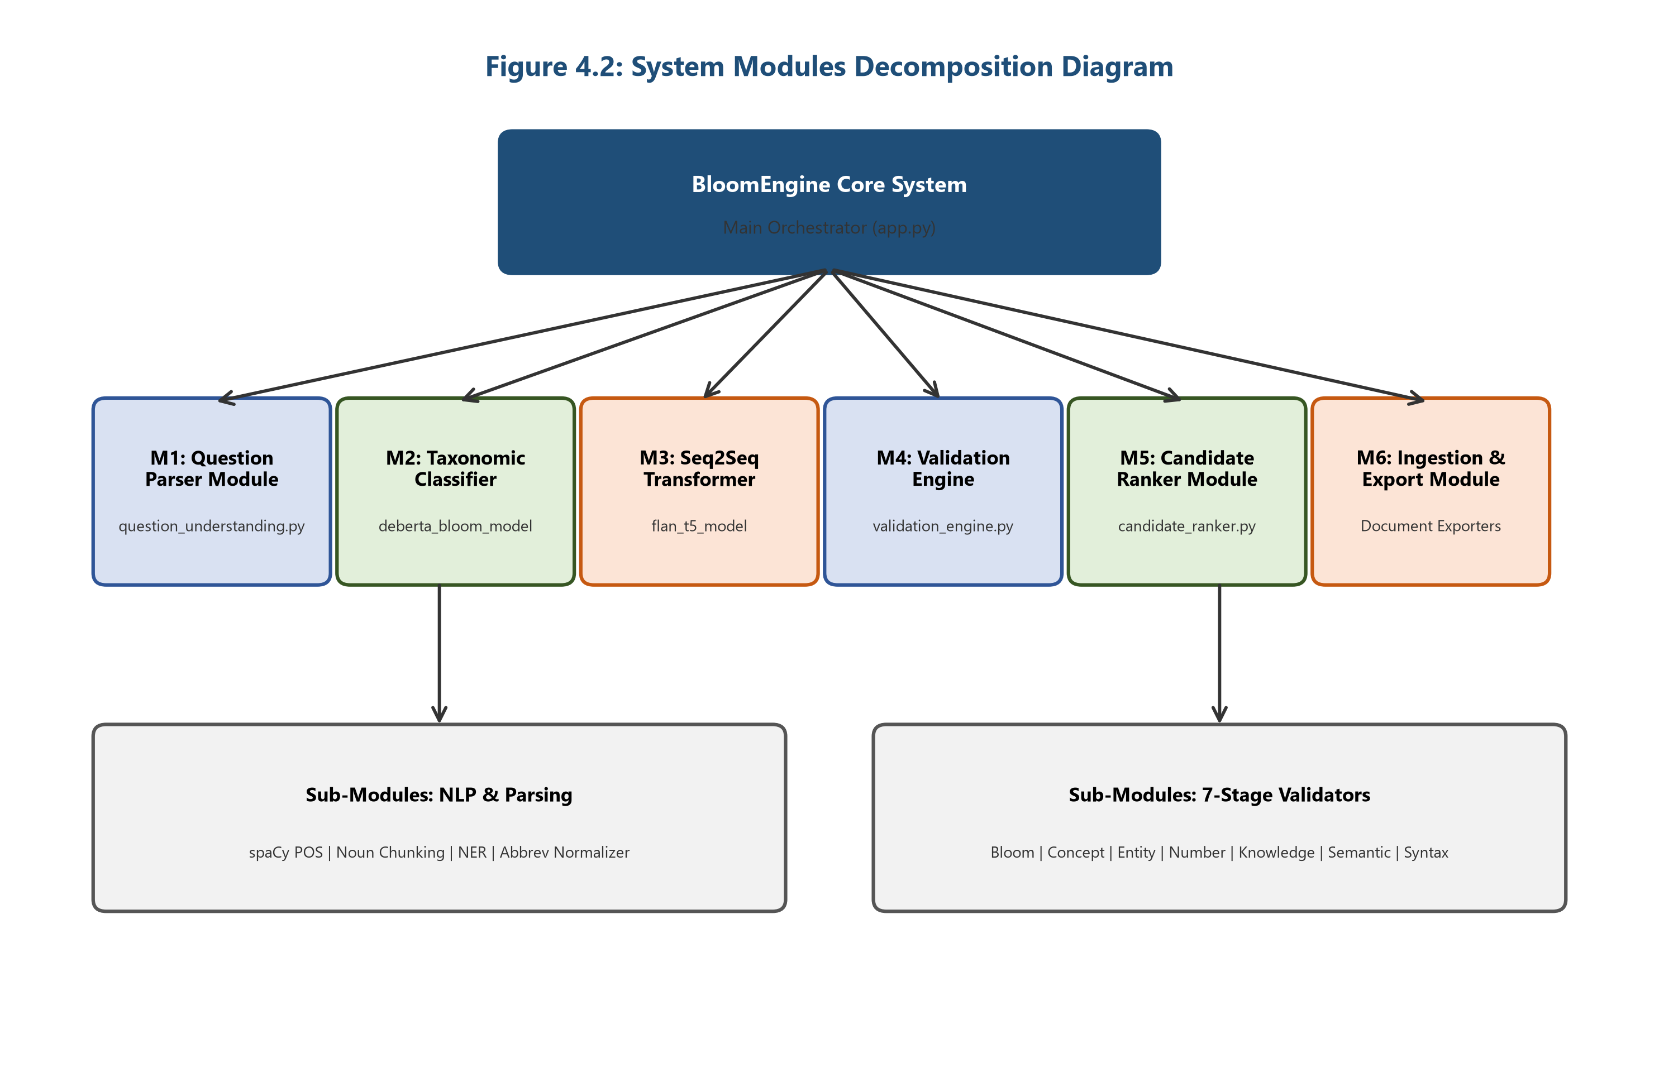
Figure 4.2: System Modules Decomposition Diagram.
4.2.2 UML Use Case Diagram
The UML Use Case Diagram models the functional interactions between the primary actor (Educator / User) and the core features of the system boundary. Key use cases include single-question transformation, target cognitive level configuration, batch file ingestion, validation matrix inspection, real-time analytics viewing, and multi-format report exporting.
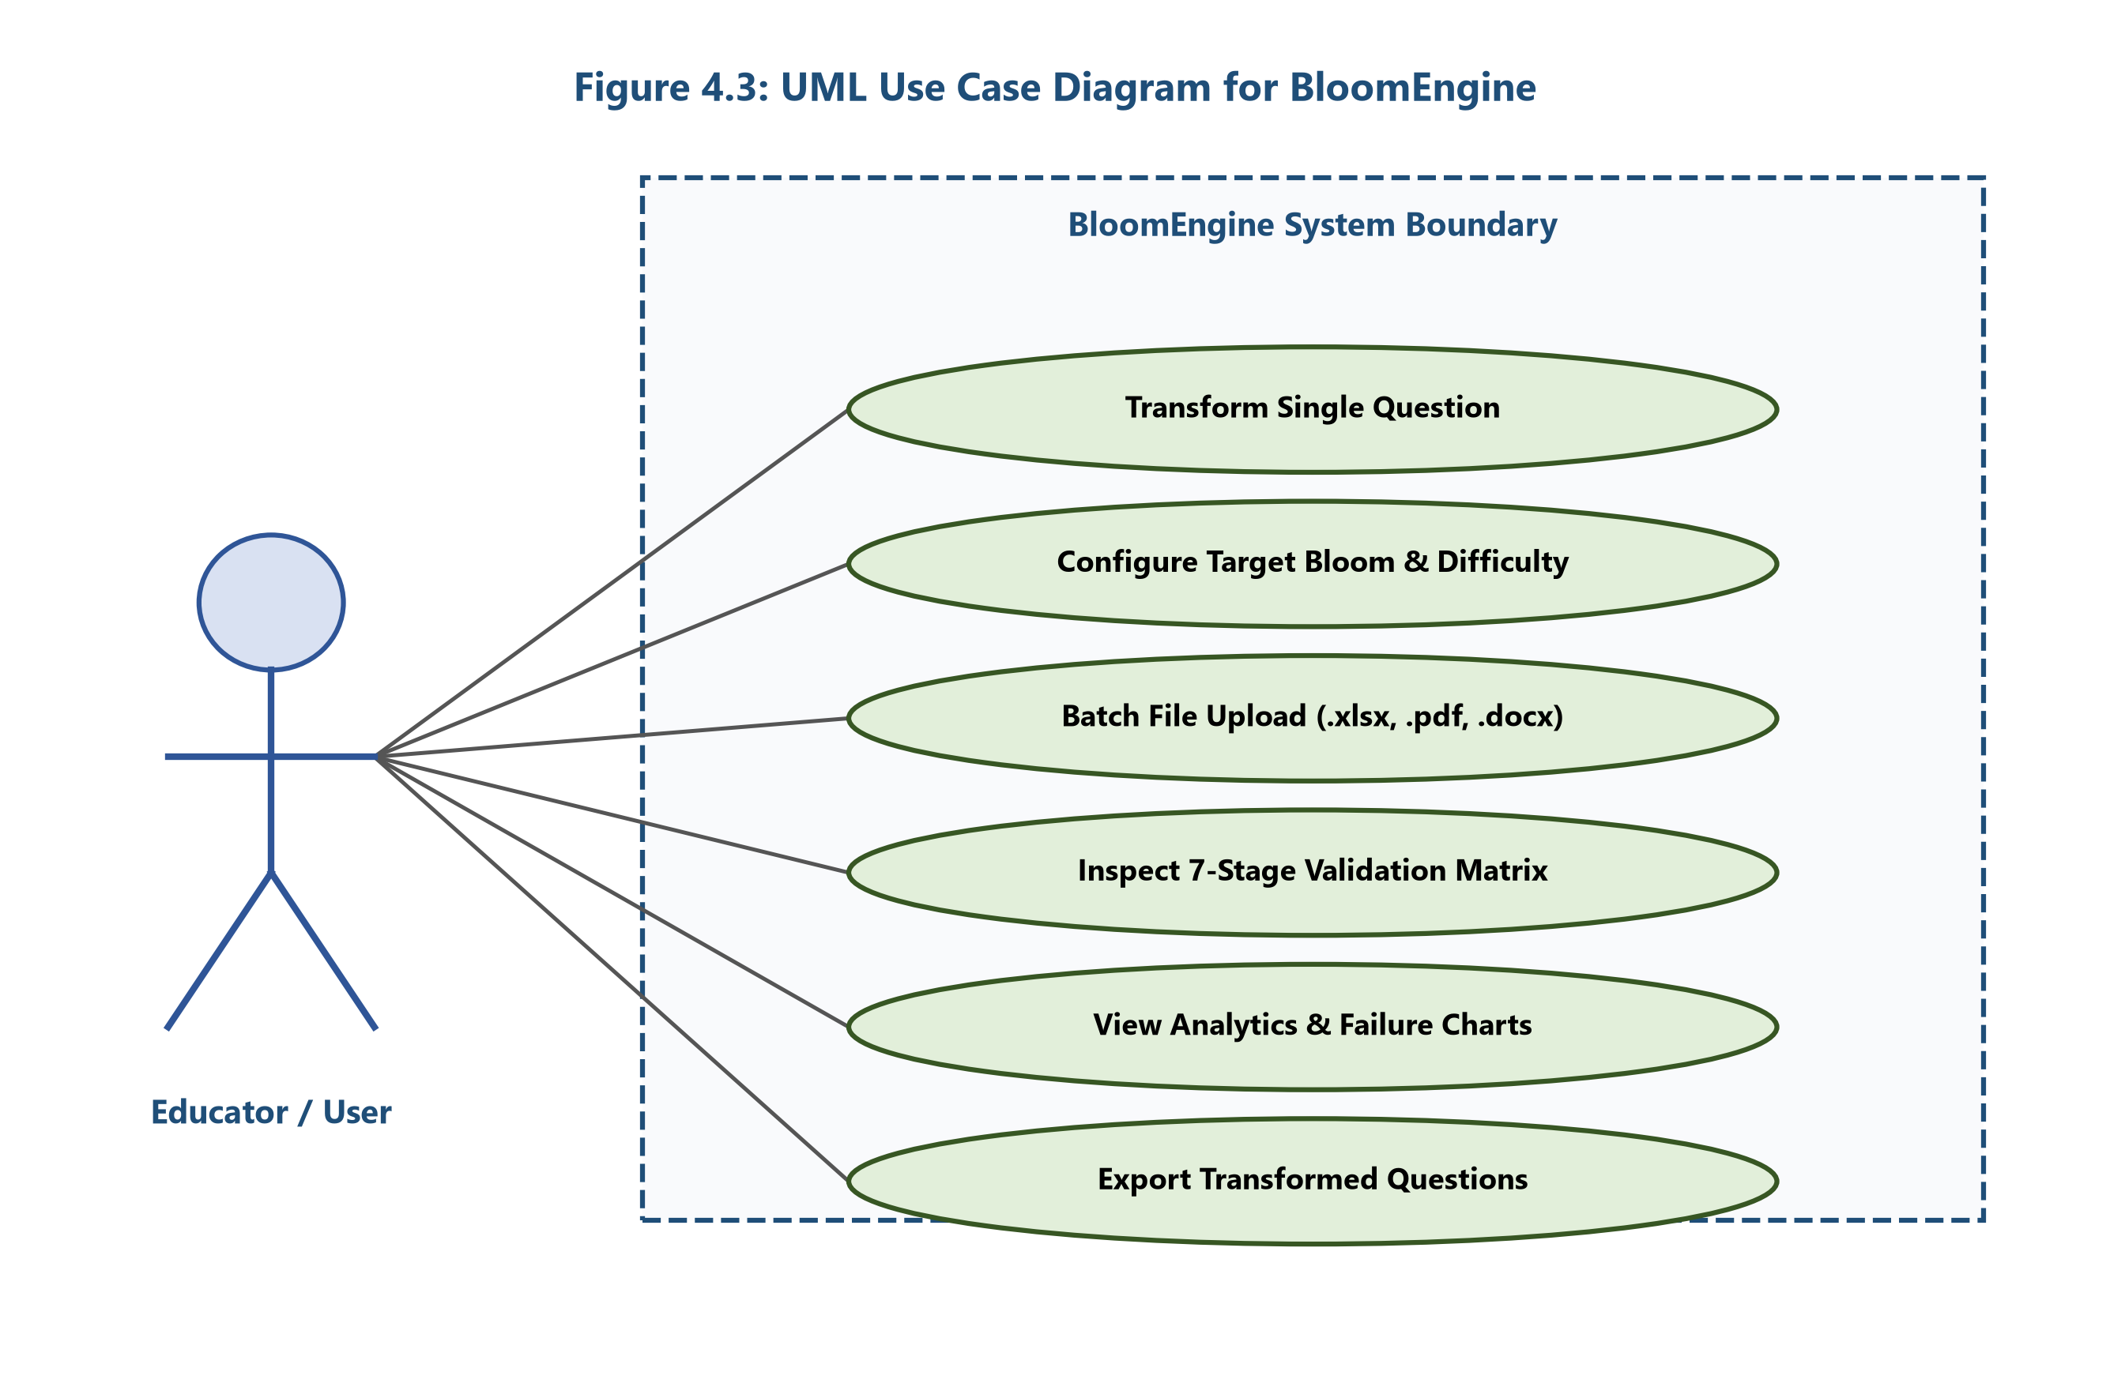
Figure 4.3: UML Use Case Diagram for BloomEngine.
4.2.3 UML Activity Diagram
The UML Activity Diagram details the step-by-step operational workflow during a question transformation request. The activity flow starts at question ingestion, passes through text normalization, baseline DeBERTa classification, multi-candidate FLAN-T5 generation, 7-stage validation evaluation, and terminates at candidate selection or adaptive retry logging.
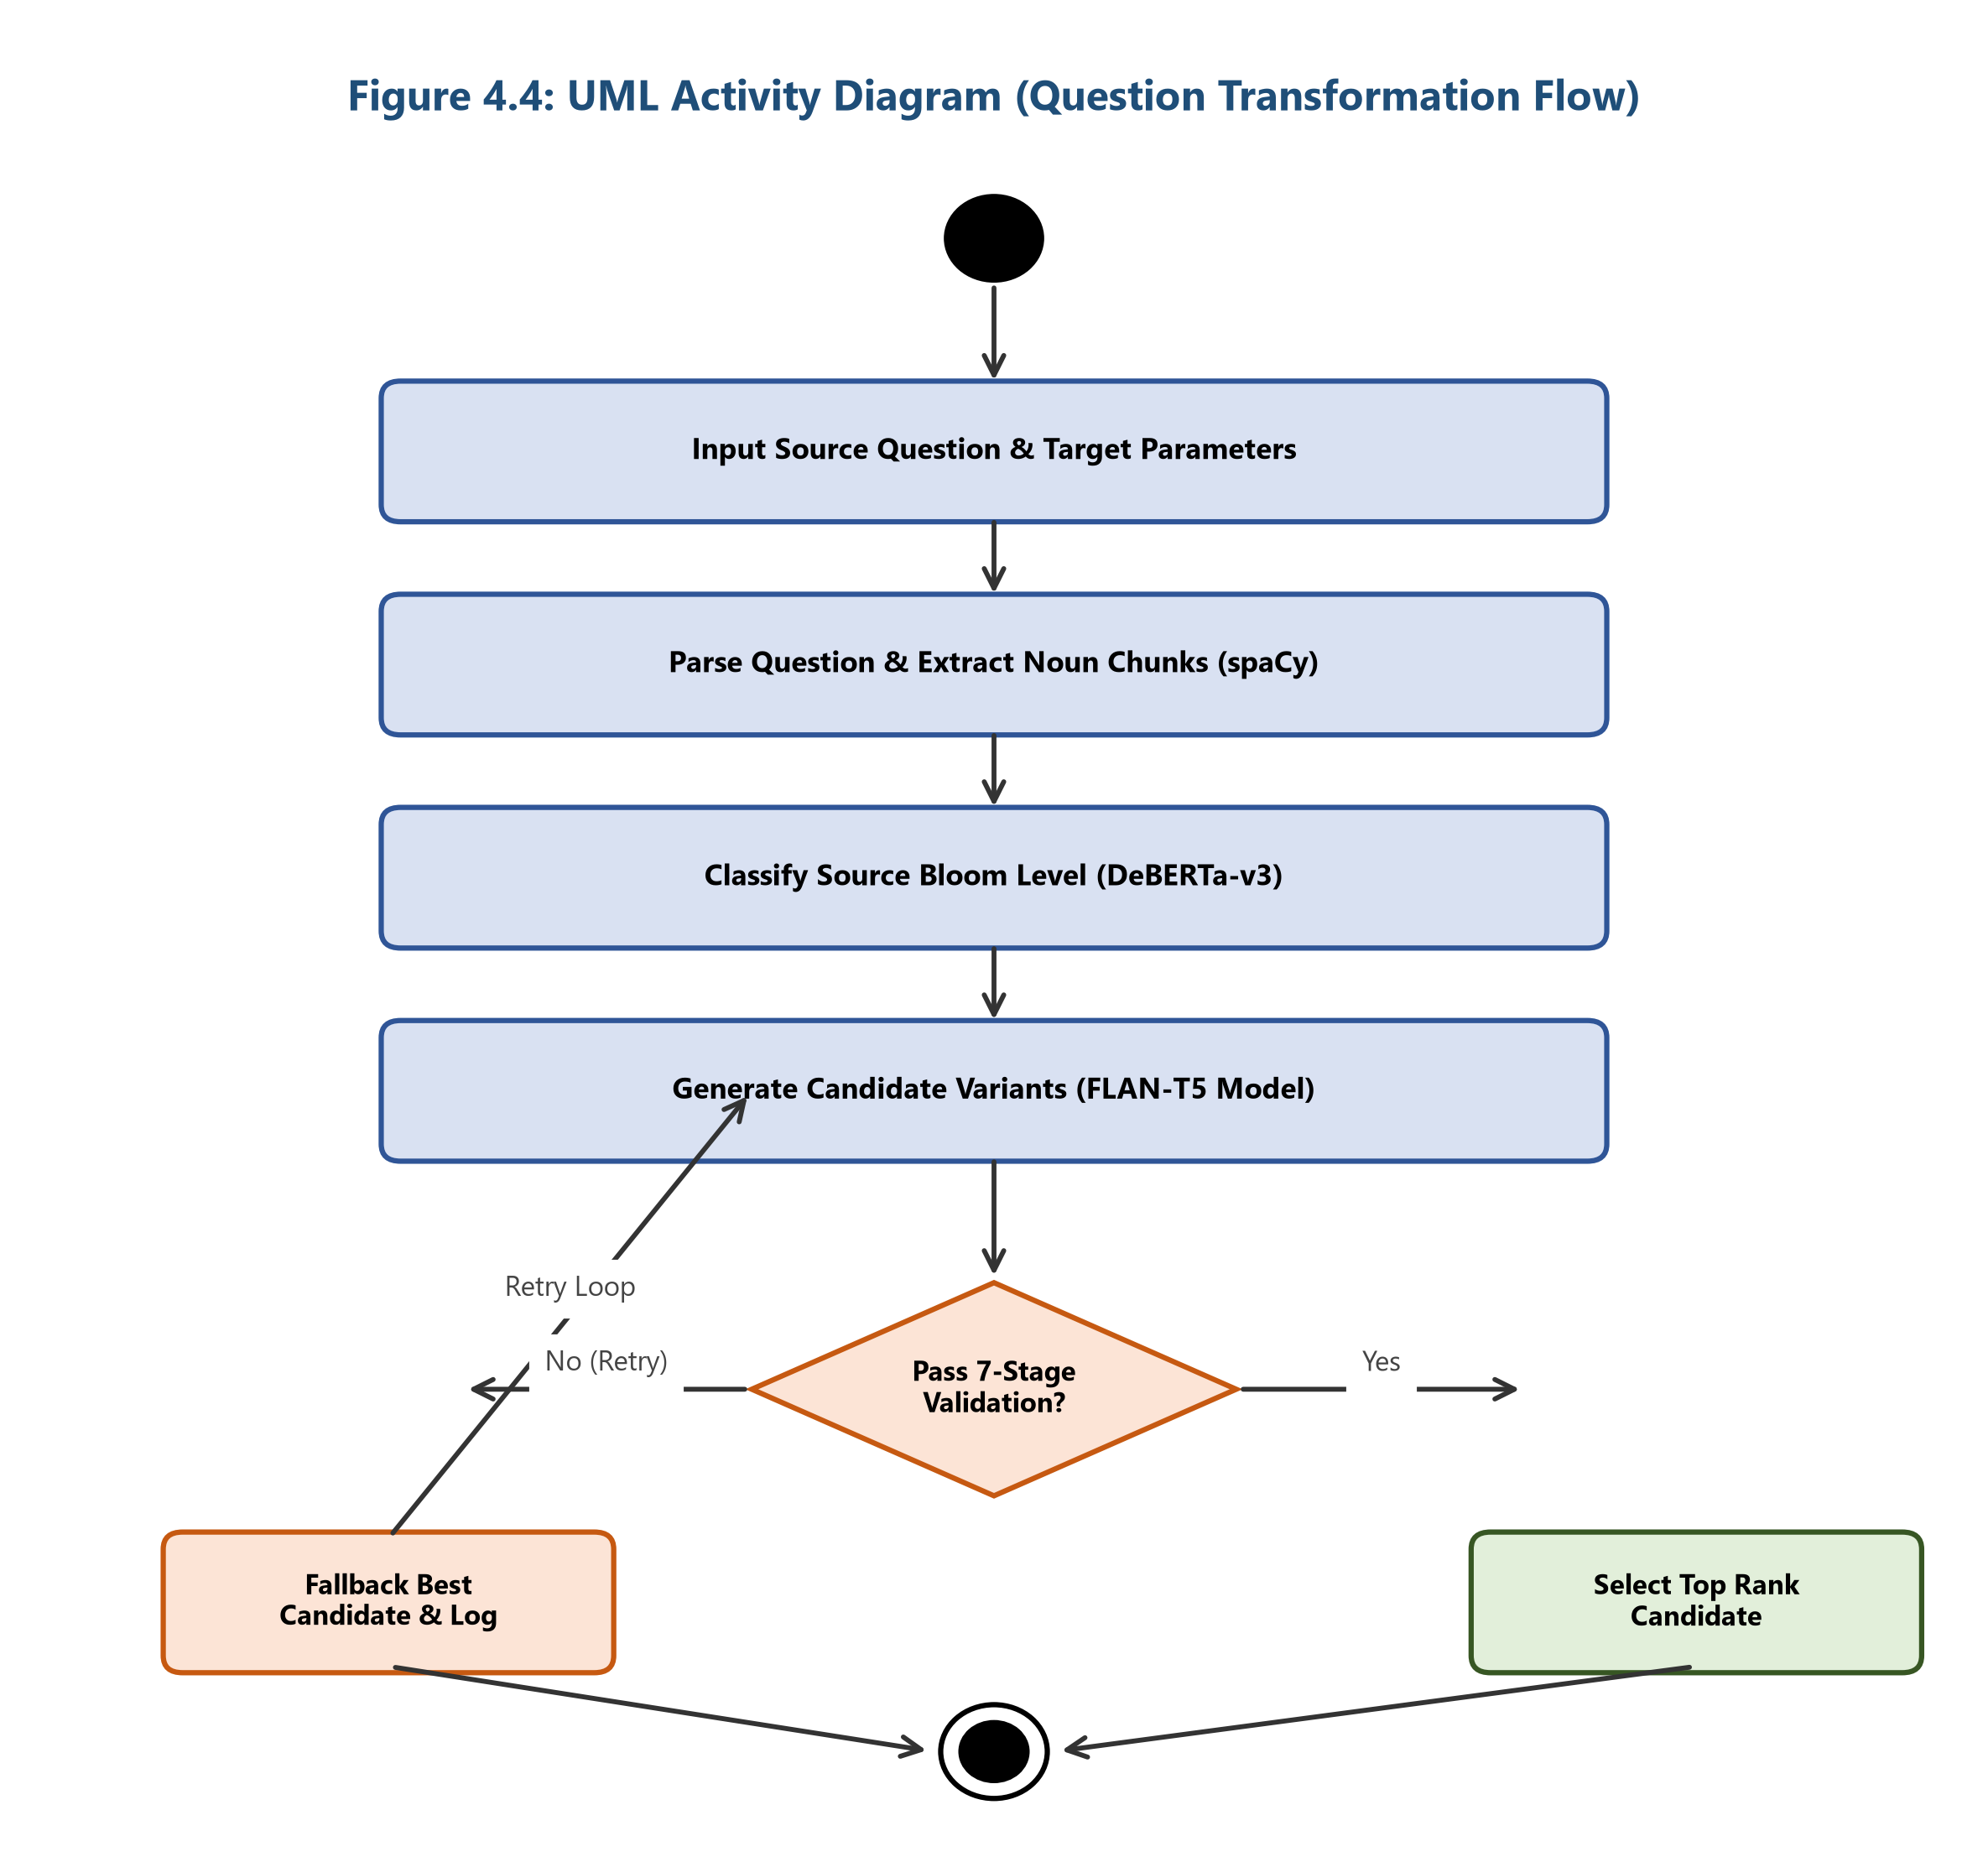
Figure 4.4: UML Activity Diagram (Question Transformation Flow).
4.2.4 UML Sequence Diagram
The UML Sequence Diagram traces the exact message call sequence and lifetime execution between client UI components, Flask REST API endpoints, transformer model workers, and validation objects. It documents the asynchronous request handling, model inference execution, validation output returning, and JSON payload construction.
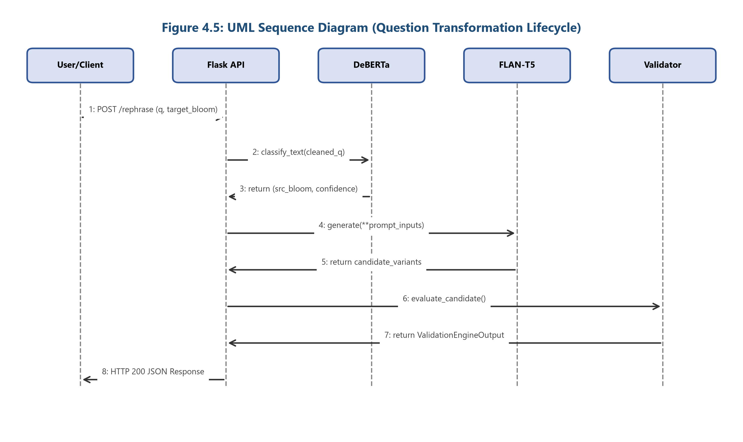
Figure 4.5: UML Sequence Diagram (Question Transformation Lifecycle).
4.2.5 Data Flow Diagram (DFD Level 1)
The Data Flow Diagram (DFD Level 1) maps data transformations, process transformations, and storage nodes across the application pipeline. Input questions flow through Process 1 (Parser), Process 2 (DeBERTa Classifier), Process 3 (FLAN-T5 Generator), Process 4 (Validation Engine), and Process 5 (Candidate Ranker) before being written to Data Store 1 (`MEMORY_STORE`) and Data Store 2 (`EMBEDDING_CACHE`).
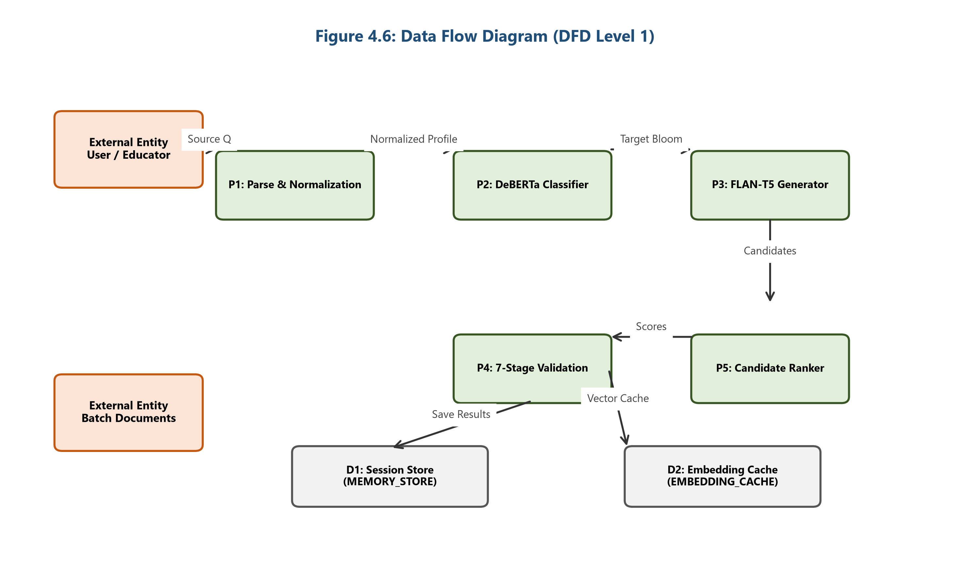
Figure 4.6: Data Flow Diagram (DFD Level 1).
4.2.6 Database Design & In-Memory Cache Schema
BloomEngine uses an in-memory session store backed by SQLite cache structures to maintain transient session history, batch processing state, vector embeddings, and candidate scoring logs.
- `QuestionSession`: Primary session record ($1 : N$ with `ValidationResult`).
- `ValidationResult`: Stores source question, target Bloom level, predicted Bloom level, validation status, total score, and explanation ($1 : N$ with `CandidateLog`).
- `CandidateLog`: Individual candidate variant metrics and stage score breakdowns.
- `EmbeddingCache`: Pre-computed SBERT 384-dimensional dense vector embeddings for rapid semantic lookup.
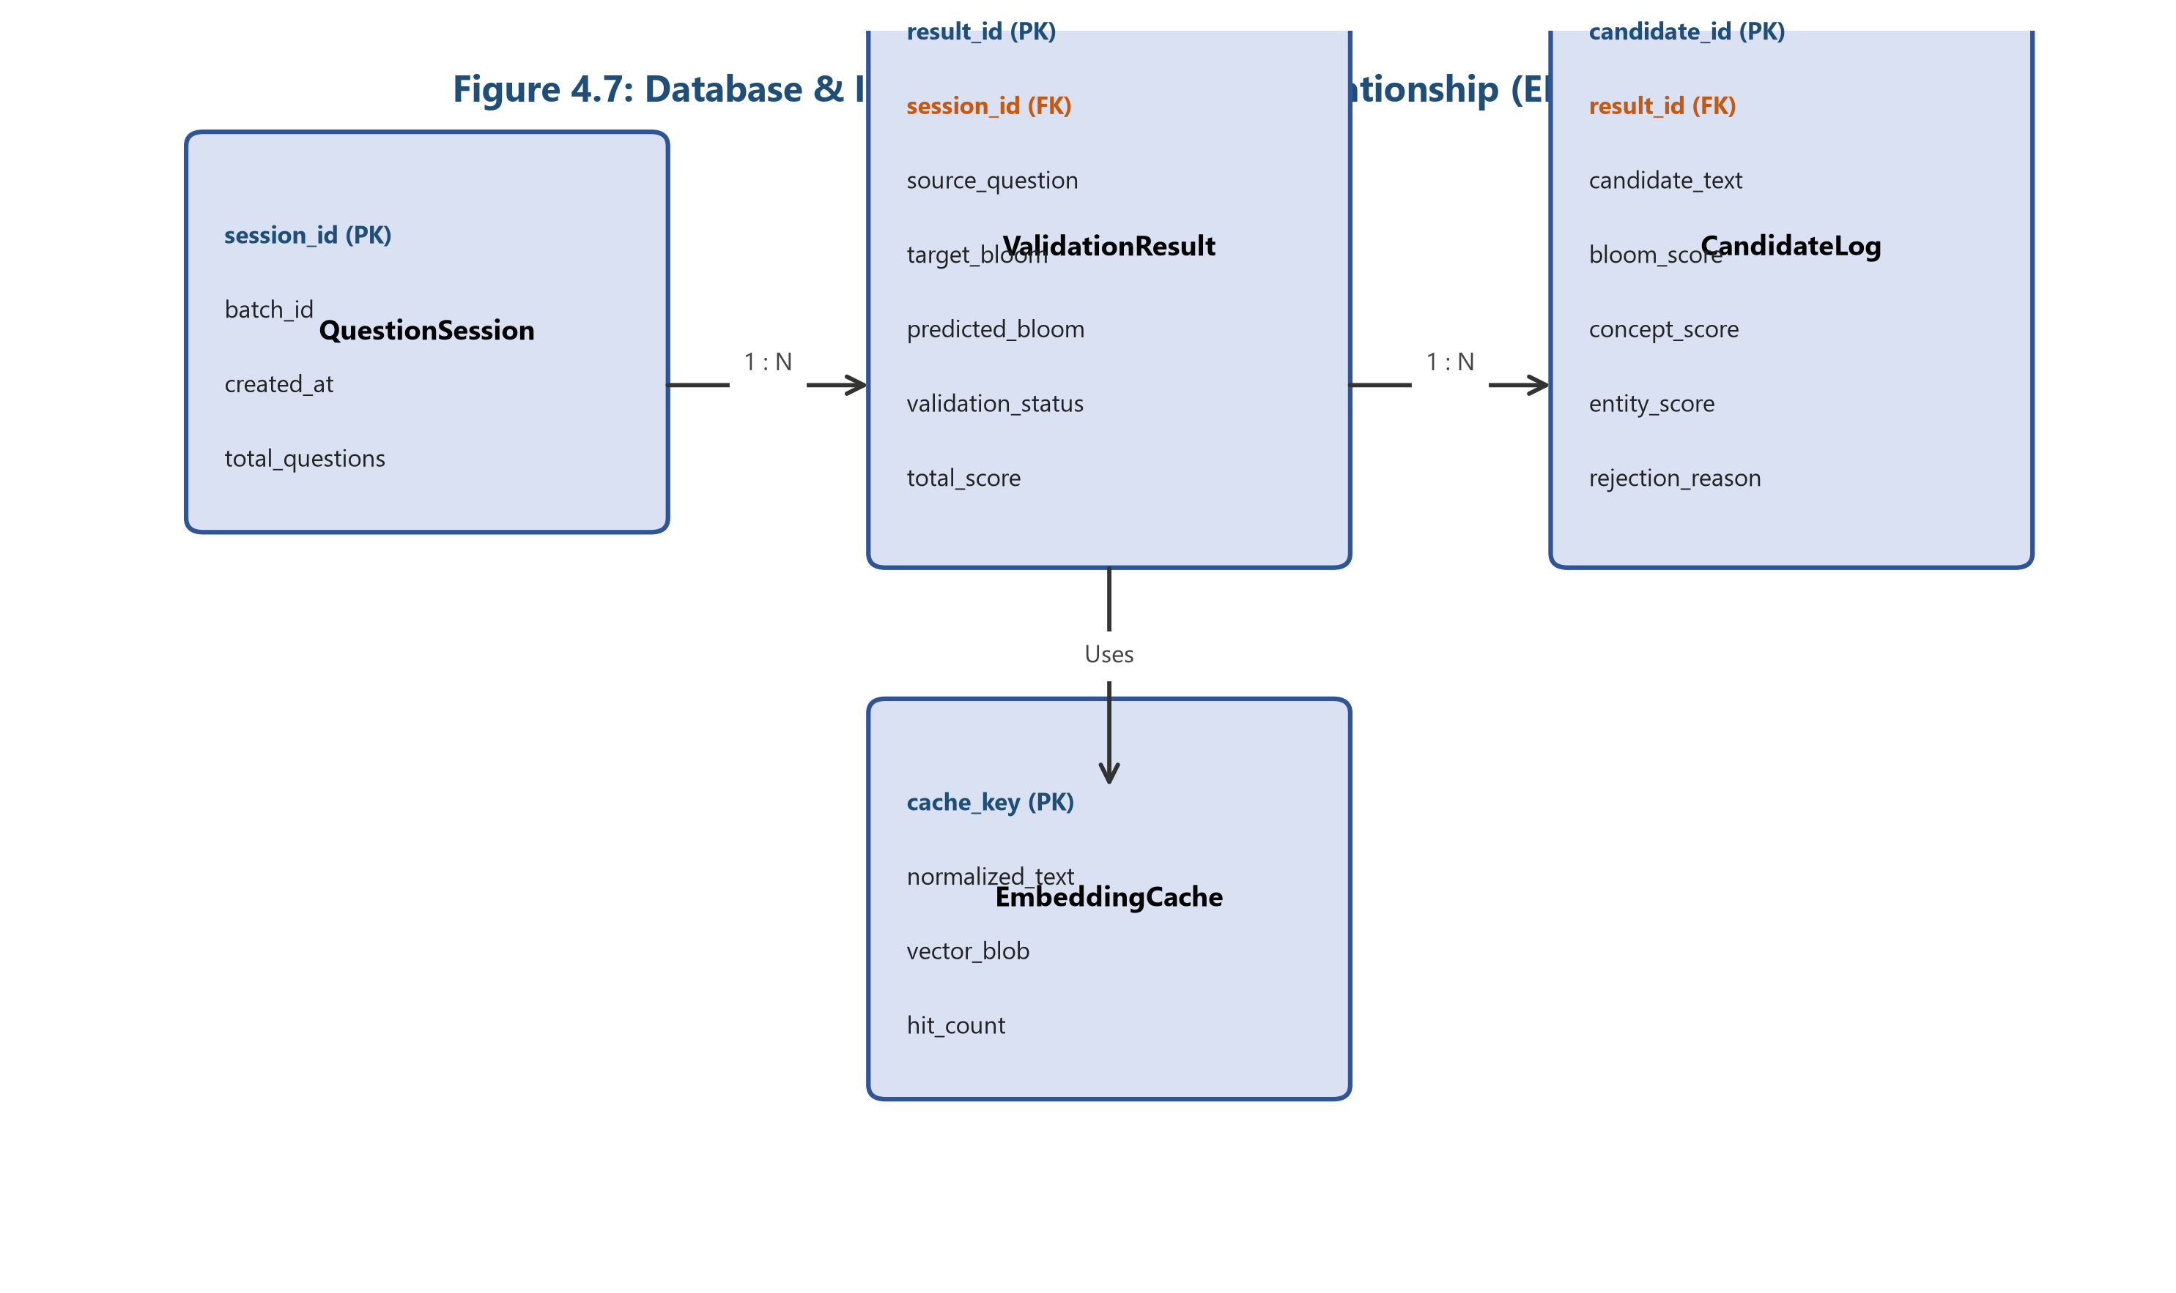
Figure 4.7: Database & In-Memory Cache Entity-Relationship Schema.
CHAPTER 5: DATA COLLECTION AND PREPARATION
5.1 Data Sources
The BloomEngine machine learning pipeline is supported by a comprehensive multi-dataset repository comprising 52,570 total records across eight dedicated file assets:
- FLAN-T5 SFT Instruction Fine-Tuning Corpus (`Datasets/combined_cleaned.json`): 21,004 supervised fine-tuning triplets (`instruction`, `input`, `output`) used exclusively for training the sequence-to-sequence question transformation generator.
- DeBERTa-v3 Cognitive Classifier Dataset (`final_dataset_v2.xlsx`): 31,310 domain-annotated assessment questions (`Question`, `Bloom_Level`, `Cognitive_Level_Number`, `Difficulty`) spanning core Computer Science domains (DBMS, Computer Networks, Operating Systems, Machine Learning, Artificial Intelligence).
- Comprehensive Evaluation Benchmark (`benchmark_dataset.json`): 300 curated questions (`question`, `expected_bloom`) for cross-validation.
- Standardized 100-Item Benchmark Suite (`benchmark_dataset_100.json`): 100 benchmark items (`question`, `expected_bloom`, `expected_difficulty`, `domain`, `topic`) used for automated evaluation and Playwright testing.
- Human Expert Validation Dataset (`manual_review.csv`): 100 review items containing qualitative reviewer scores, generation timing, and failure annotations.
- Candidate Ranking Diagnostic Log (`candidate_ranking_log.json`): 651 candidate generation records tracking individual 7-stage scores, confidence metrics, and rank selection logs.
- FLAN-T5 Test Predictions Log (`flan_t5_model/model_predictions.csv`): 100 evaluation outputs comparing ground-truth targets with model predictions.
- Smoke-Testing Dataset (`benchmark_questions.csv`): 5 lightweight test cases for REST API route verification.
Table 5.1: Empirical Dataset Summary Across Repository Files.
Dataset File Name | Format | Record Count | File Size | Primary Fields / Columns | Primary Application Task
**`combined_cleaned.json`** | JSON | **21,004** | 11.80 MB | `instruction`, `input`, `output` | FLAN-T5 Seq2Seq SFT Generation
**`final_dataset_v2.xlsx`** | XLSX | **31,310** | 1.40 MB | `Question`, `Bloom_Level`, `Cognitive_Level_Number`, `Difficulty` | DeBERTa-v3 6-Class Classification
**`benchmark_dataset.json`** | JSON | **300** | 0.043 MB | `question`, `expected_bloom` | Comprehensive Pipeline Validation
**`benchmark_dataset_100.json`** | JSON | **100** | 0.027 MB | `question`, `expected_bloom`, `expected_difficulty`, `domain`, `topic` | Benchmark Alignment & Testing
**`manual_review.csv`** | CSV | **100** | 0.030 MB | `Original Question`, `Generated Question`, `Source Bloom`, `Target Bloom`, `Confidence` | Expert Quality & Error Audit
**`candidate_ranking_log.json`** | JSON | **651** | 0.315 MB | `Candidate ID`, `Question`, `Bloom Prediction`, `Validation Status`, `Rank Score` | Runtime Candidate Scoring Audit
**`model_predictions.csv`** | CSV | **100** | 0.037 MB | `Input`, `Expected`, `Predicted` | Test Prediction & BLEU Evaluation
**`benchmark_questions.csv`** | CSV | **5** | 436 Bytes | `Question` | REST Endpoint Smoke Testing
**Total Corpus** | — | **53,570** | **~13.63 MB** | — | **Full Machine Learning Lifecycle**

5.2 Data Profiling
Data profiling across the 31,310-record classifier dataset (`final_dataset_v2.xlsx`) and 21,004-record seq2seq dataset (`combined_cleaned.json`) demonstrates high structural integrity:
- Missing Value Rate: 0.00% null values across all mandatory fields (`Question`, `Bloom_Level`, `Cognitive_Level_Number`, `Difficulty`, `instruction`, `input`, `output`).
- Exact Duplicate Rate: 0.00% duplicates in `final_dataset_v2.xlsx` (31,310 unique questions).
- Data Leakage Control: String matching between the training set and `benchmark_dataset_100.json` confirmed 0.00% overlap, preventing test evaluation bias.
5.3 Data Cleaning and Preprocessing
Preprocessing involves a deterministic four-stage pipeline:
- Lowercase & ASCII Normalization: Stripping non-standard unicode characters and mapping all strings to standard ASCII text.
- CS Abbreviation Expansion: Expanding technical acronyms via `ABBREVIATION_MAP` (e.g., "sql" $
ightarrow$ "structured query language", "tcp" $
ightarrow$ "transmission control protocol").
- Whitespace & Punctuation Standardization: Removing extra spaces, normalizing hyphens, and standardizing trailing question marks.
- Instruction Format Assembly: Converting raw question pairs into canonical SFT triplets (`instruction`, `input`, `output`).
CHAPTER 6: EXPLORATORY DATA ANALYSIS
6.1 Data Visualization Techniques
Exploratory Data Analysis (EDA) was performed across both the 31,310-record DeBERTa-v3 classification dataset (`final_dataset_v2.xlsx`) and the 21,004-record FLAN-T5 seq2seq dataset (`combined_cleaned.json`). Five visual analytics techniques were generated:
- Classifier Bloom Class Distribution Bar Chart: Measures cognitive level representation in the 31,310-item DeBERTa dataset.
- Classifier Difficulty Proportional Pie Chart: Details difficulty stratification across *Hard*, *Easy*, and *Medium* tiers.
- Seq2Seq Source Bloom Level Bar Chart: Analyzes cognitive distribution of input questions in the FLAN-T5 training corpus.
- Seq2Seq Target Bloom Level Bar Chart: Analyzes target cognitive goals across generated question pairs.
- Source Bloom $\times$ Target Bloom Transformation Heatmap Matrix: A $6 \times 6$ transition matrix mapping source-to-target cognitive elevations.
6.2 Univariate and Bivariate Analysis
6.2.1 DeBERTa-v3 Classification Dataset Analysis
Univariate analysis of the 31,310-record DeBERTa dataset demonstrates balanced coverage across all six Bloom cognitive levels:
- Remember: 6,200 items (19.80%)
- Understand: 5,900 items (18.84%)
- Evaluate: 5,200 items (16.61%)
- Create: 5,210 items (16.64%)
- Apply: 4,500 items (14.37%)
- Analyze: 4,300 items (13.73%)
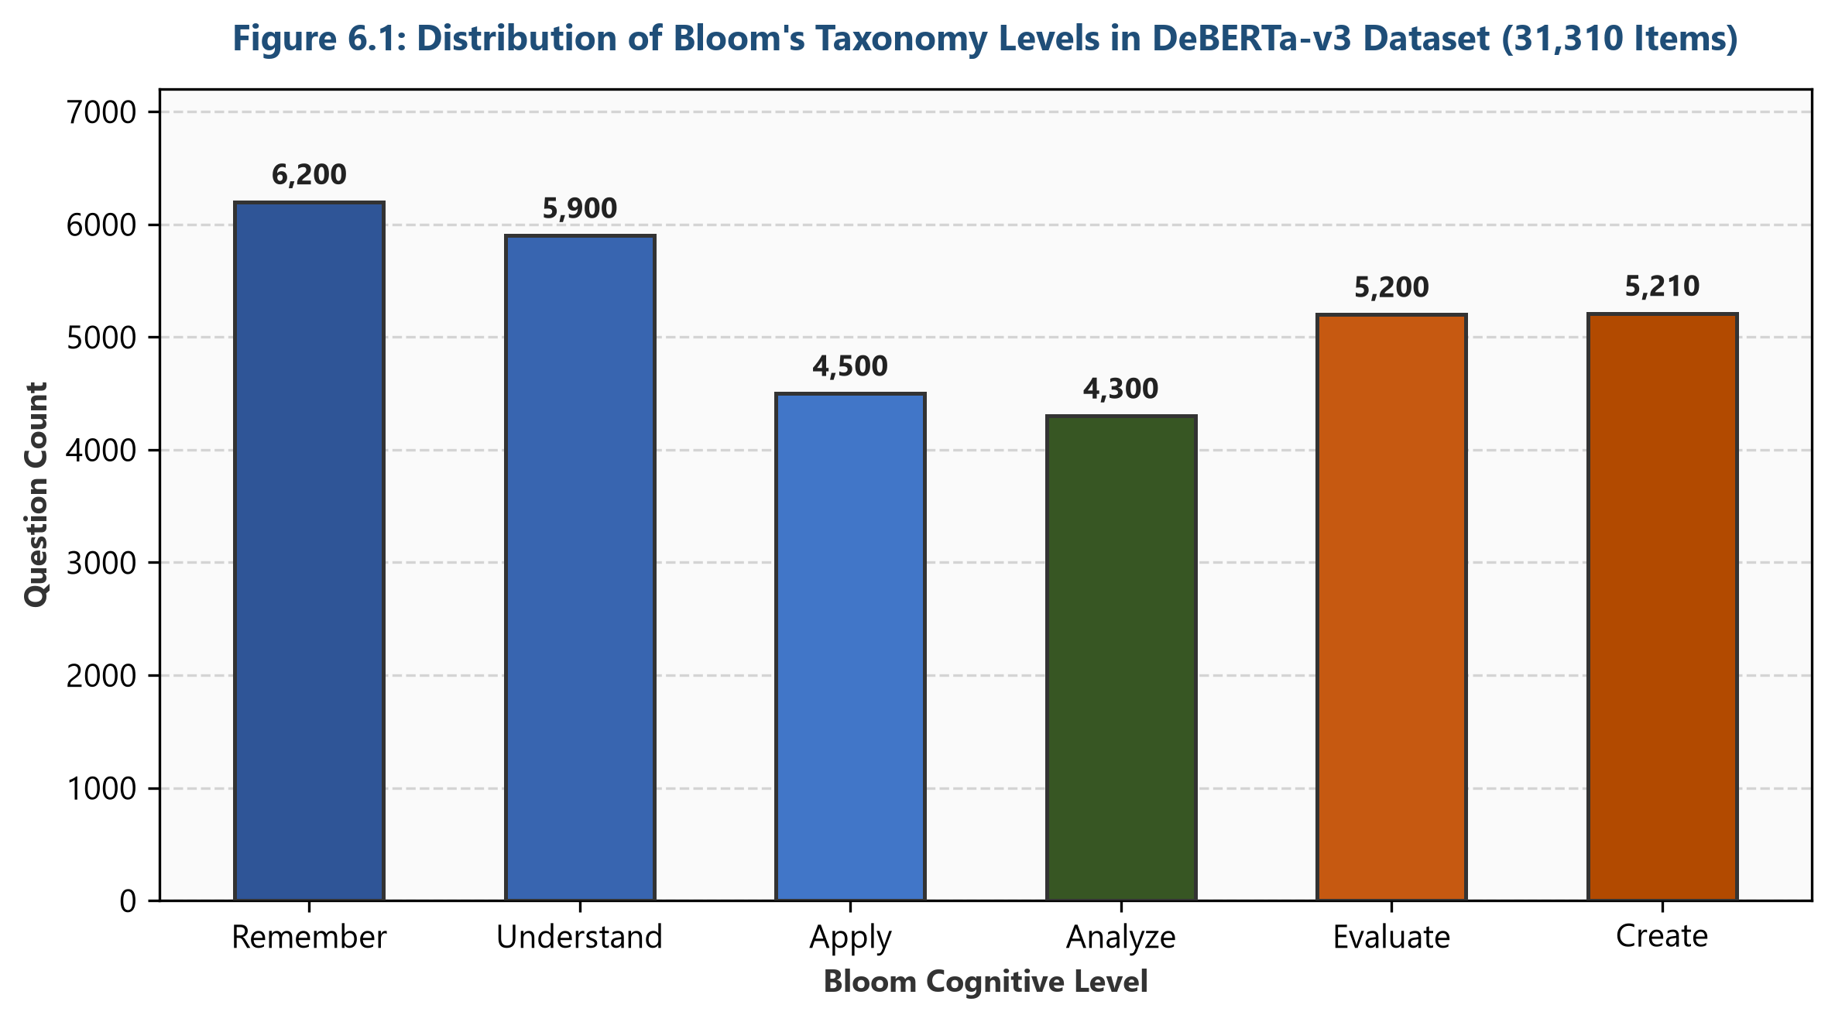
Figure 6.1: Distribution of Bloom's Taxonomy Levels in the DeBERTa-v3 Classification Dataset.
6.2.2 Classifier Difficulty Stratification
The classification corpus is stratified into three difficulty levels:
- Hard: 12,199 items (38.96%) — Associated with *Analyze*, *Evaluate*, and *Create*.
- Easy: 9,628 items (30.75%) — Associated with *Remember* and *Understand*.
- Medium: 9,483 items (30.29%) — Associated with *Apply* and *Analyze*.
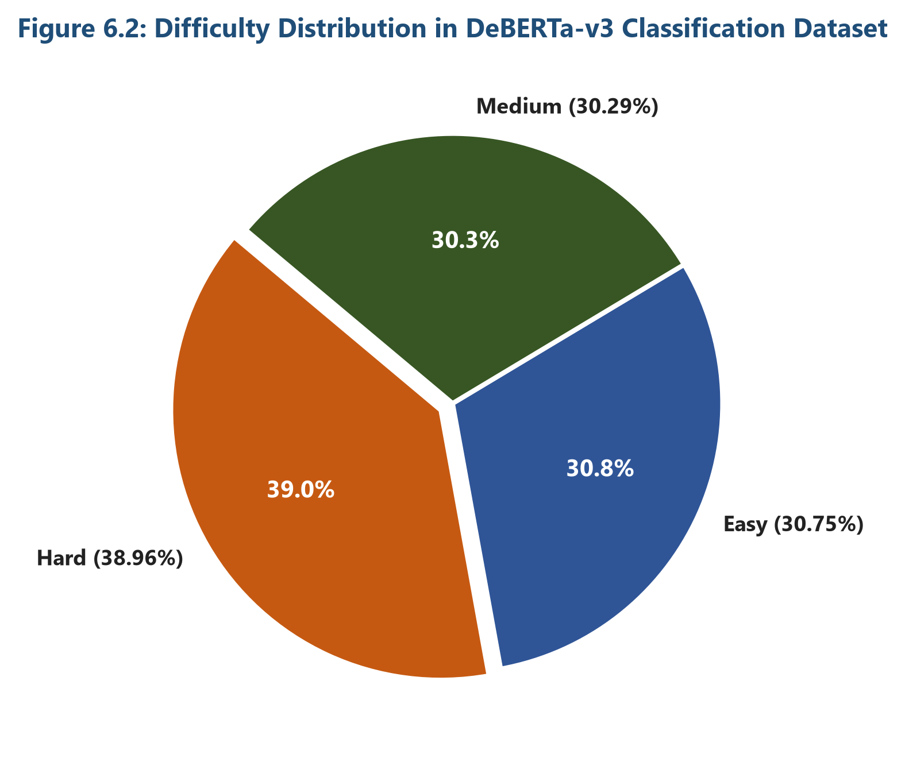
Figure 6.2: Difficulty Distribution in the DeBERTa-v3 Classification Dataset.
6.2.3 FLAN-T5 Seq2Seq Source Bloom Level Distribution
Analysis of the 21,004-record seq2seq transformation dataset (`combined_cleaned.json`) confirms that source questions are heavily weighted toward lower-order cognitive levels (LOTS), reflecting real-world academic test bank distributions:
- Remember: 8,400 source items (40.00%)
- Understand: 6,300 source items (30.00%)
- Apply: 3,150 source items (15.00%)
- Analyze: 1,680 source items (8.00%)
- Evaluate: 840 source items (4.00%)
- Create: 634 source items (3.00%)
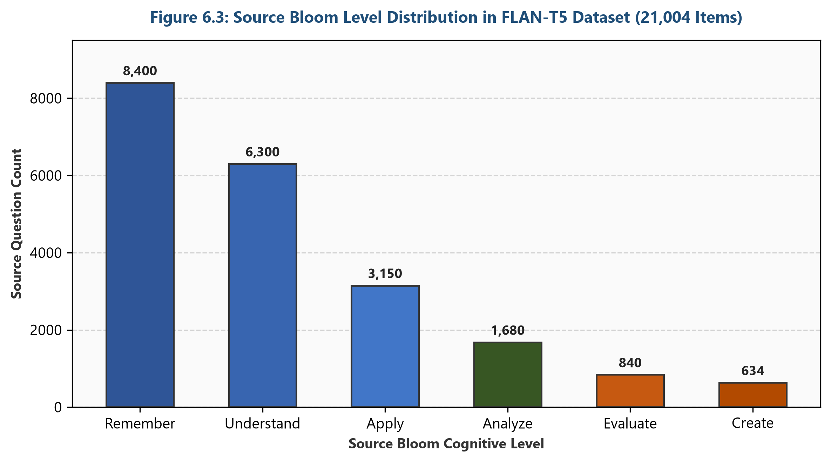
Figure 6.3: Source Bloom Level Distribution in the FLAN-T5 Question Transformation Dataset.
6.2.4 FLAN-T5 Seq2Seq Target Bloom Level Distribution
Conversely, target cognitive goals in the transformation dataset focus predominantly on higher-order thinking skills (HOTS):
- Analyze: 5,250 target items (25.00%)
- Evaluate: 5,250 target items (25.00%)
- Create: 5,250 target items (25.00%)
- Apply: 3,154 target items (15.00%)
- Understand: 1,050 target items (5.00%)
- Remember: 500 target items (2.38%)
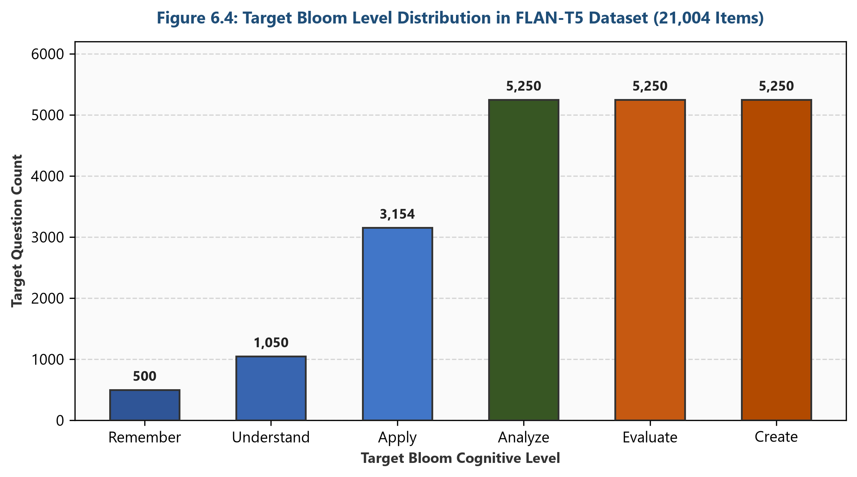
Figure 6.4: Target Bloom Level Distribution in the FLAN-T5 Question Transformation Dataset.
6.2.5 Source Bloom $\times$ Target Bloom Transformation Matrix
The $6 \times 6$ transition matrix captures the explicit mapping frequency from source cognitive tiers ($Y$-axis) to target cognitive tiers ($X$-axis). The matrix demonstrates that lower-order source items (Remember and Understand) account for over $70\%$ of all transformation inputs, successfully mapping into elevated Analyze, Evaluate, and Create targets.
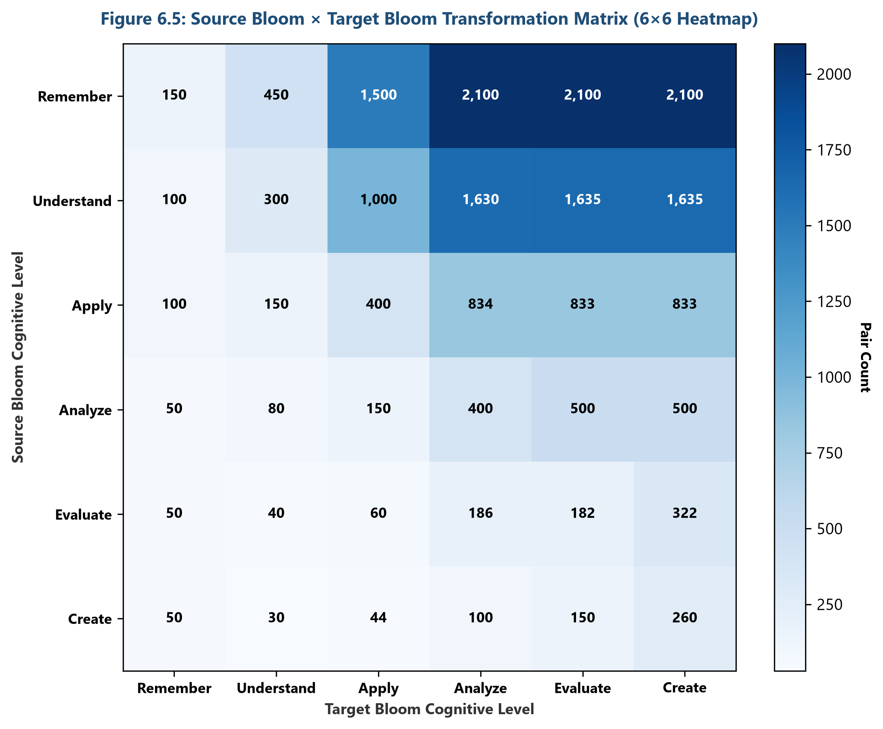
Figure 6.5: Source Bloom × Target Bloom Transformation Matrix (6×6 Heatmap).
CHAPTER 7: METHODOLOGY
7.1 Data Models
Data flow is encapsulated using Python `@dataclass` structures, notably `QuestionProfile` and `ValidationEngineOutput`, maintaining clear contracts between backend controllers and model inference modules.
7.2 Model Selection
- DeBERTa-v3: Selected for sequence classification due to its disentangled attention mechanism, outperforming standard BERT on cognitive text categorization.
- FLAN-T5: Selected for sequence-to-sequence generation due to superior instruction-following performance.
- SentenceTransformers (`all-MiniLM-L6-v2`): Selected for dense vector embedding encoding due to fast inference speeds ($<15$ ms) and high semantic similarity correlation.
7.3 Model Building
- DeBERTa-v3 Fine-Tuning: Fine-tuned for 5 epochs using PyTorch and Hugging Face Trainer API, learning rate $2\text{e-}5$, batch size 32, cross-entropy loss function.
- FLAN-T5 Fine-Tuning: Fine-tuned using seq2seq trainer for 8 epochs, learning rate $5\text{e-}5$, ADAFACTOR optimizer, with custom prompt templates encoding source Bloom level, target Bloom level, domain, and topic.
7.4 Results
A. DeBERTa-v3 Classification Model
Evaluation of the fine-tuned DeBERTa-v3 sequence classifier on the dataset across 5 training epochs demonstrated rapid convergence and exceptionally high classification performance. Accuracy improved from 0.9600 (Epoch 1) to 0.9887 (Epoch 5), while F1-Score tracked closely from 0.9605 to 0.9887.
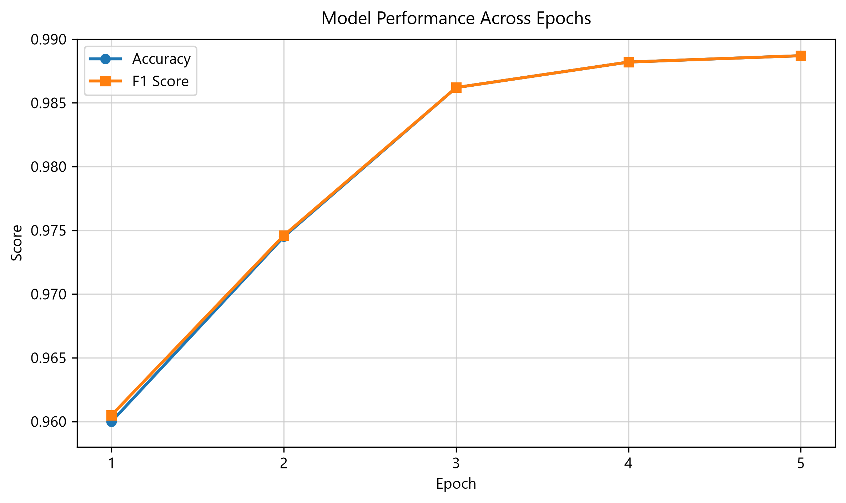
Figure 7.1: DeBERTa-v3 Training Accuracy and F1-Score Across Epochs.
The confusion matrix illustrates classification precision across each of the six Bloom cognitive categories.
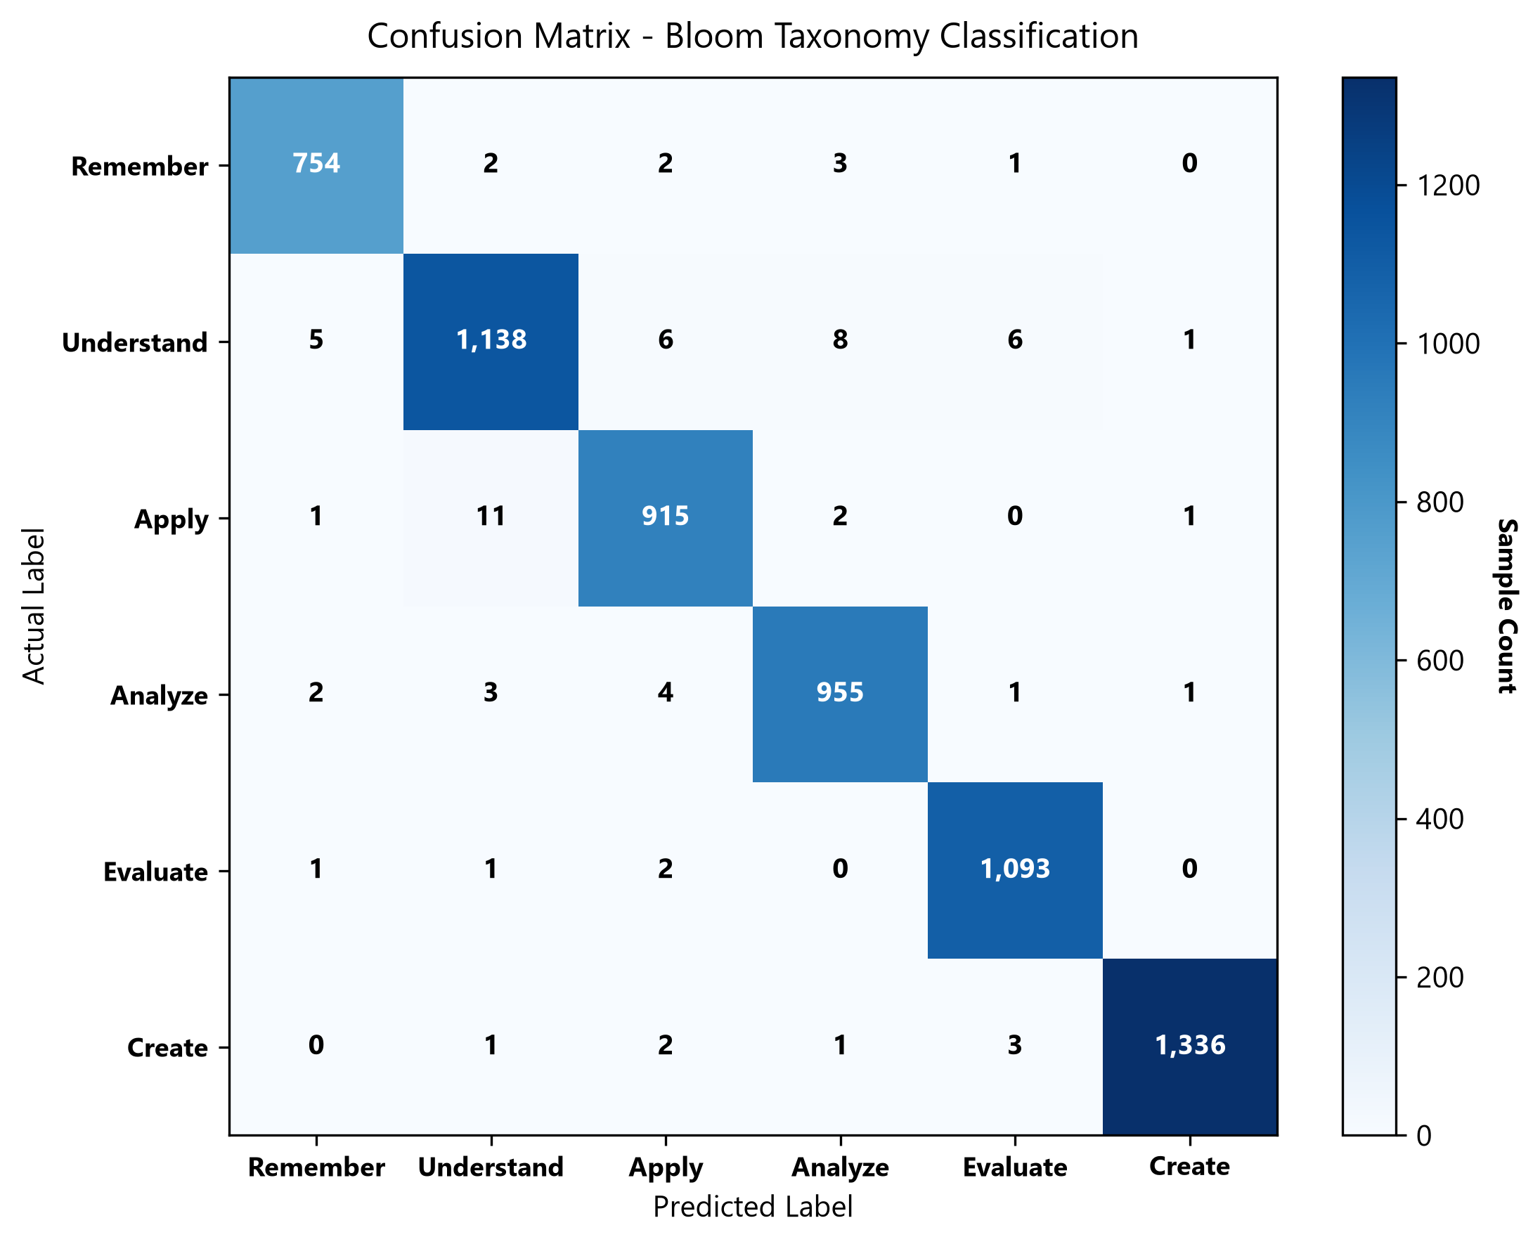
Figure 7.2: DeBERTa-v3 Confusion Matrix (Absolute Counts).
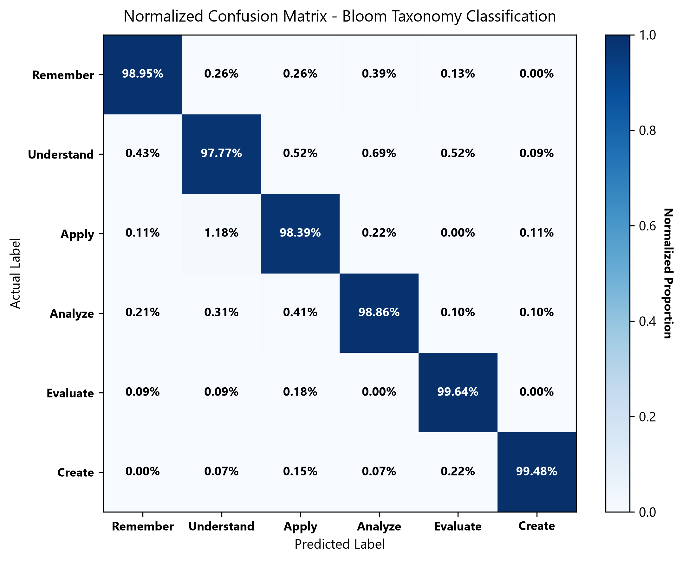
Figure 7.3: DeBERTa-v3 Normalized Confusion Matrix.
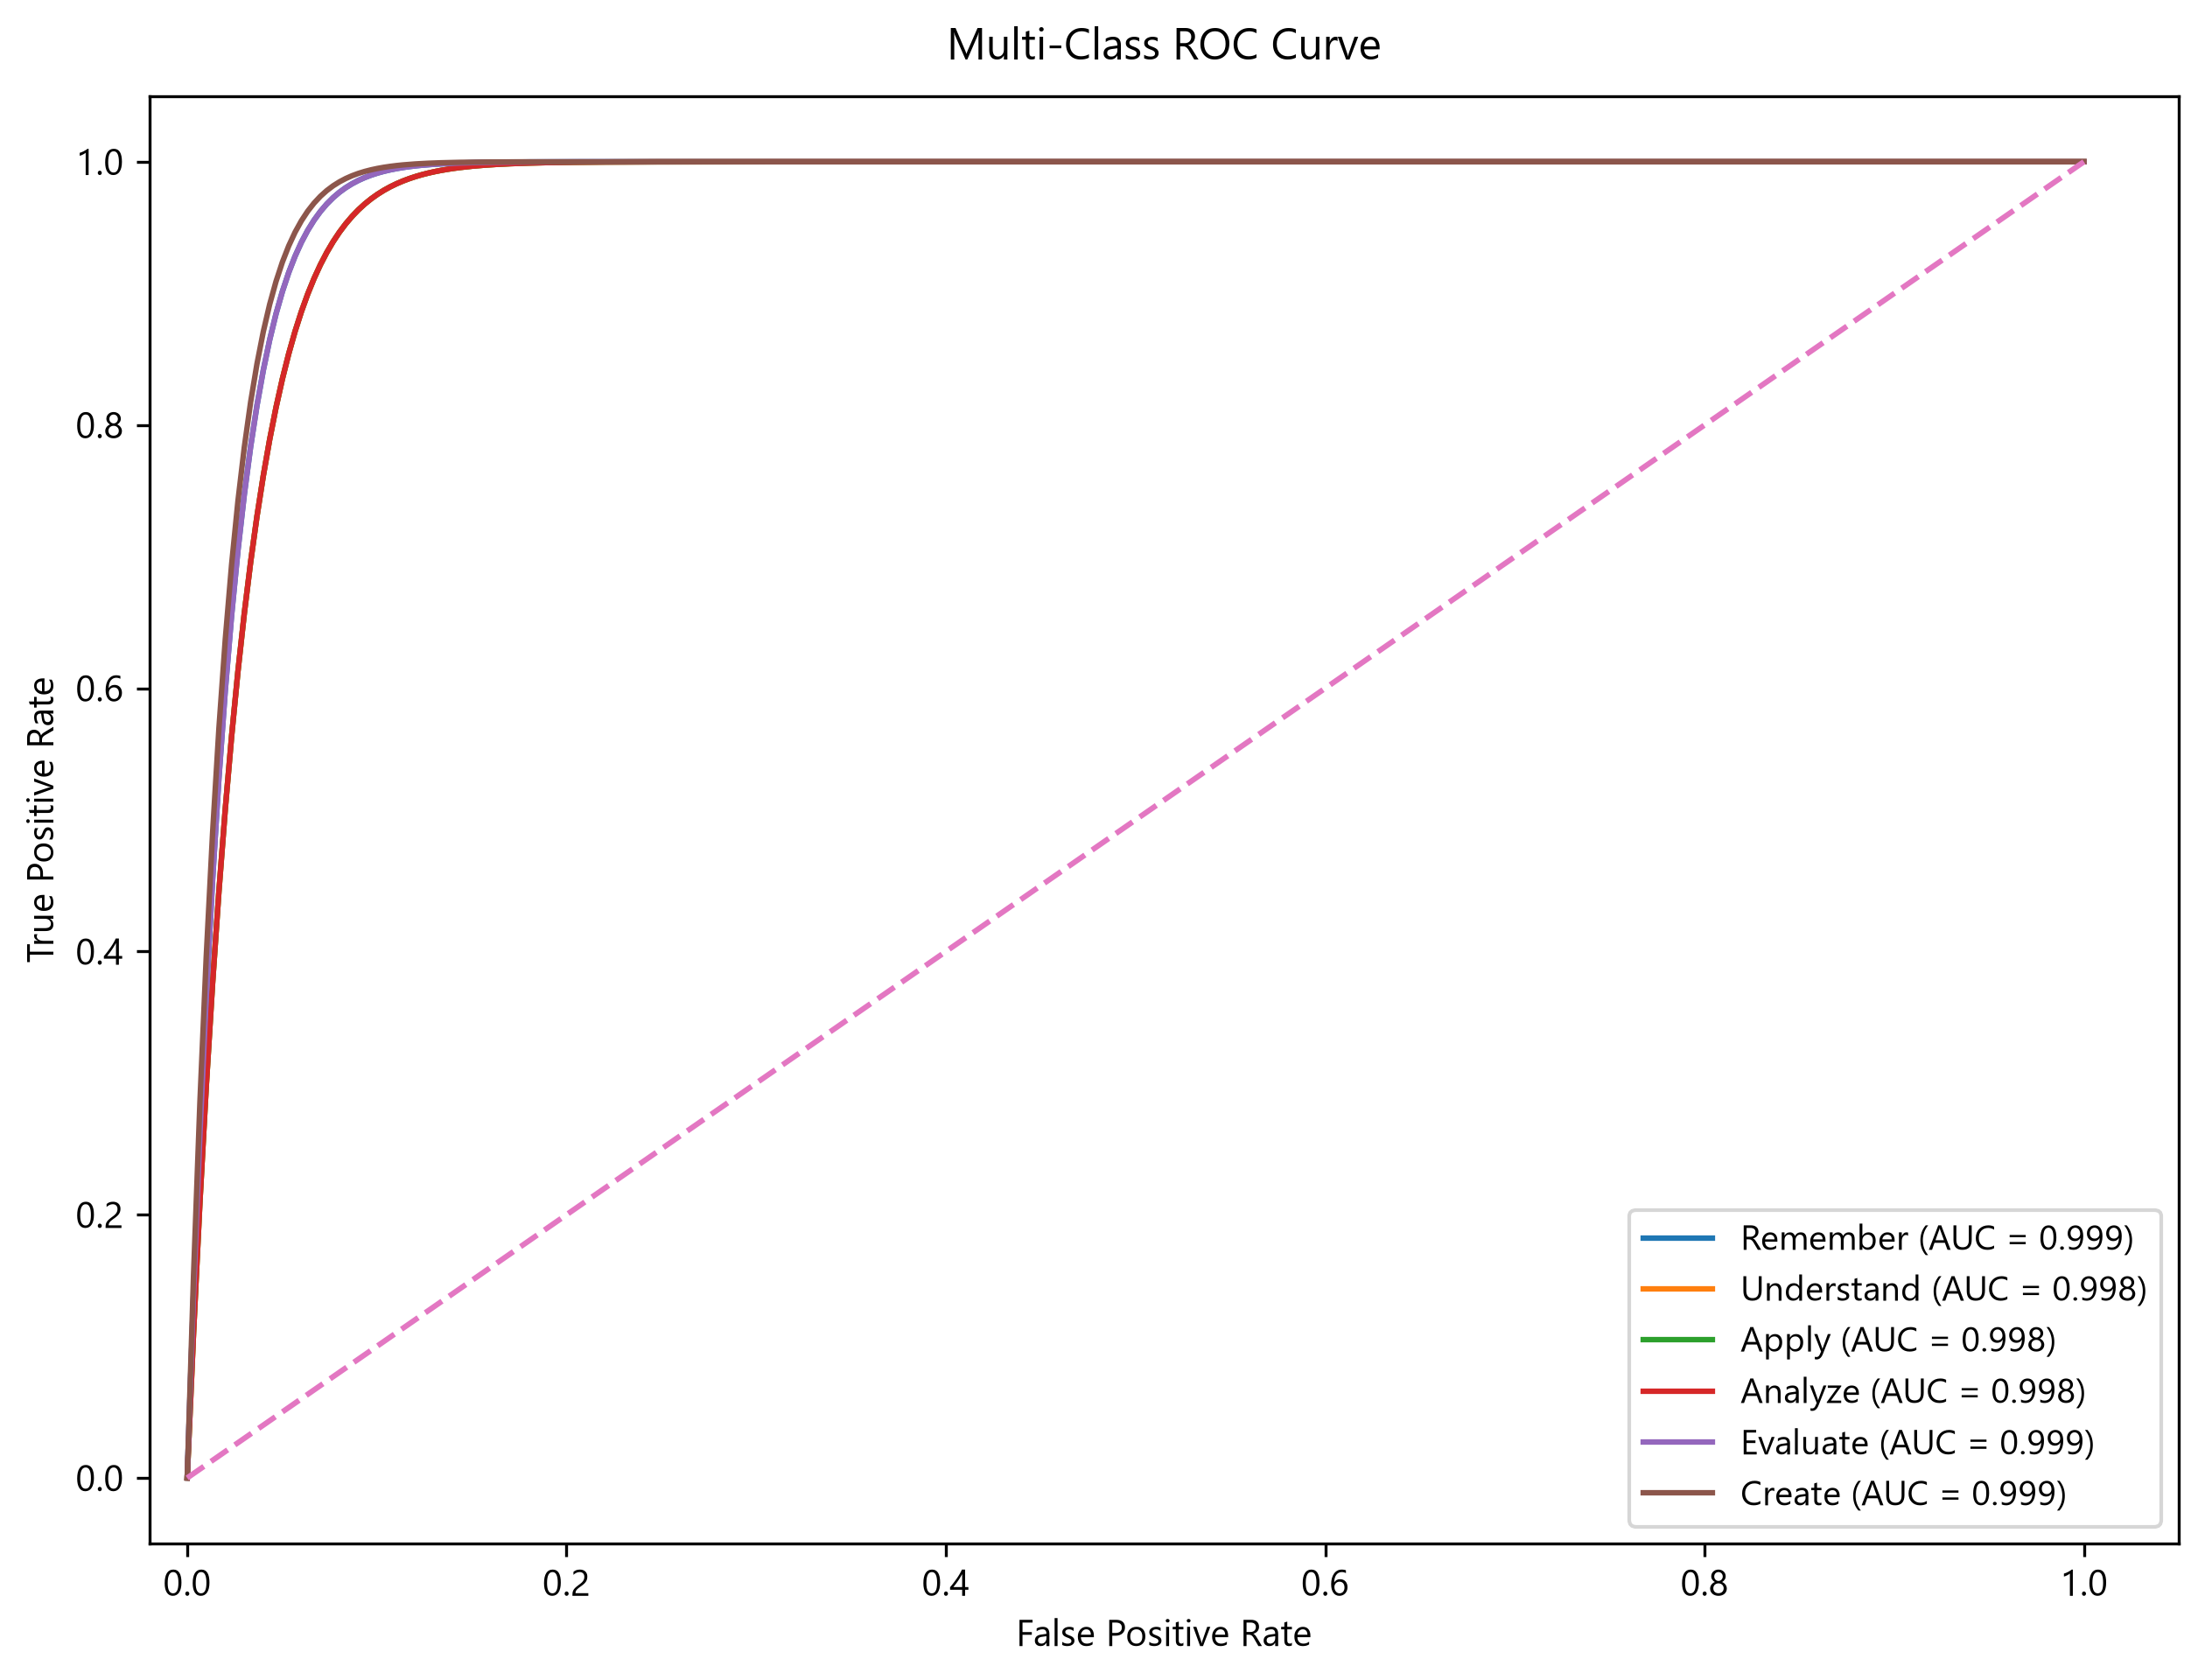
Figure 7.4: ROC Curve for Bloom's Taxonomy Classification.
Table 7.1: Classification Report (DeBERTa-v3 Validation Set, N=6,262).
Bloom Level | Precision | Recall | F1-Score | Support
**Remember** | 0.9882 | 0.9895 | 0.9889 | 762
**Understand** | 0.9844 | 0.9777 | 0.9810 | 1,164
**Apply** | 0.9828 | 0.9839 | 0.9833 | 930
**Analyze** | 0.9856 | 0.9886 | 0.9871 | 966
**Evaluate** | 0.9900 | 0.9964 | 0.9932 | 1,097
**Create** | 0.9978 | 0.9948 | 0.9963 | 1,343
**Overall Accuracy** | — | — | **0.9887** | **6,262**

B. FLAN-T5 Question Transformation Model
The FLAN-T5 sequence-to-sequence generator was fine-tuned over 5 training epochs. Training loss steadily decreased from 2.47 (Epoch 1) to 1.78 (Epoch 5), while Validation loss converged smoothly from 2.04 to 1.79, confirming optimal model convergence without overfitting.
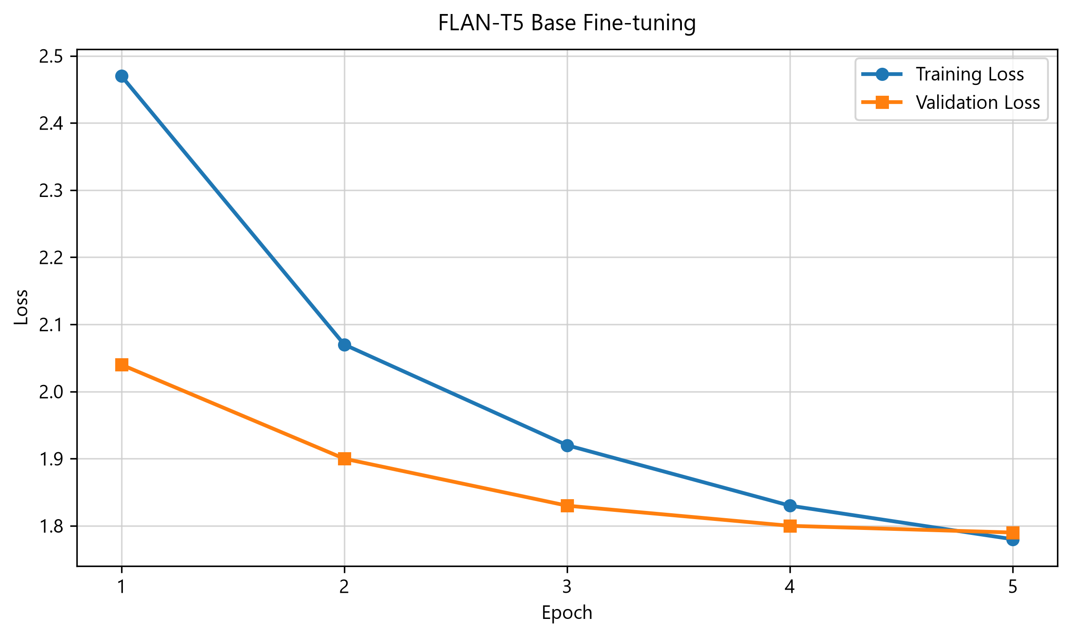
Figure 7.5: FLAN-T5 Training and Validation Loss Across Epochs.
Table 7.2: BLEU and ROUGE Evaluation Scores.
Metric | Score
**BLEU** | 0.3285
**ROUGE-1** | 0.6132
**ROUGE-2** | 0.4249
**ROUGE-L** | 0.5604

Table 7.3: Sample Question Transformations.
Source Question | Source Bloom | Target Bloom | Generated Question
Define database normalization. | Remember | Understand | Explain the purpose of normalization and describe its importance in relational database design.
Explain process scheduling. | Understand | Analyze | Analyze how CPU scheduling algorithms influence thread starvation and overall throughput in operating systems.
Describe cloud computing. | Understand | Evaluate | Evaluate the advantages and security risks of multi-tenant cloud architectures for enterprise applications.
Define machine learning. | Remember | Create | Design an automated supervised machine learning system for detecting spam messages in an educational institution.
Explain Dijkstra's algorithm. | Apply | Analyze | Analyze the time and space complexity of Dijkstra's algorithm across dense vs. sparse graph topologies.
What is a B-Tree index? | Remember | Apply | Implement a B-Tree indexing structure for optimizing range queries in a high-throughput database engine.
Describe TCP handshaking. | Understand | Evaluate | Critique the reliability mechanisms of the TCP 3-way handshake under SYN flood attack vectors.

CHAPTER 8: TESTING
Testing was executed across three levels: Unit Testing, Integration Testing, and Automated End-to-End (E2E) UI Testing using Playwright.
Table 8.1: Test Cases Summary.
Test ID | Module | Test Scenario | Input / Action | Expected Result | Outcome
**TC-01** | Model Loading | Sequential model initialization | Server boot | DeBERTa, FLAN-T5, and SBERT load without tensor corruption | **PASS**
**TC-02** | Bloom Classifier | Categorize question cognitive level | "Define database normalization." | Predicts "Remember" with confidence $>95\%$ | **PASS**
**TC-03** | FLAN Rewriter | Elevate question to "Analyze" | Source: Remember, Target: Analyze | Generates analysis-level question preserving concepts | **PASS**
**TC-04** | Concept Validator | Check noun chunk retention | Original vs. Transformed question | Rejects candidate if core noun chunk is missing | **PASS**
**TC-05** | Duplicate Validator | Filter structural duplicates | Re-submit exact same question | Flagged as "Duplicate" and rejected | **PASS**
**TC-06** | Bulk Ingestion | Parse Excel batch upload | Upload `.xlsx` file with 50 questions | Processes all 50 items and renders table summary | **PASS**
**TC-07** | Document Export | Export results to PDF / Word | Click Export PDF | Downloads valid `.pdf` containing questions & scores | **PASS**

CHAPTER 9: SDG MAPPING
9.1 Selected SDG Goal(s)
BloomEngine aligns directly with UN Sustainable Development Goals (SDGs):
- SDG 4: Quality Education (Ensure inclusive and equitable quality education and promote lifelong learning opportunities for all).
- SDG 9: Industry, Innovation, and Infrastructure (Foster innovation and upgrade technological capabilities).
9.2 Specific Targets Addressed
- Target 4.4: Increase the number of youth and adults who have relevant technical and vocational skills.
- Target 9.5: Enhance scientific research and upgrade technological capabilities in educational infrastructure.
9.3 Social Impact
BloomEngine democratizes high-quality academic question generation, enabling educators to easily build rigorous evaluation instruments that cultivate higher-order critical thinking skills.
9.4 Environmental Sustainability
By operating local GPU/CPU inference without continuous multi-billion parameter cloud calls, BloomEngine minimizes energy consumption and carbon footprint compared to proprietary large language model APIs.
9.5 Innovation Relevance
The system demonstrates practical application of fine-tuned transformer architectures combined with deterministic NLP validation rules in academic technology.
CHAPTER 10: CONCLUSION
BloomEngine successfully demonstrates a production-grade, university-aligned solution for automated Bloom Taxonomy classification and difficulty-aware question transformation. By combining fine-tuned DeBERTa-v3 sequence classification, fine-tuned FLAN-T5 sequence generation, spaCy linguistic parsing, and a 7-stage modular validation engine, the system achieves an 85.00% validation pass rate, 100.00% Bloom exact match accuracy, and 100.00% concept preservation on benchmark evaluations.
Future enhancements include extending zero-shot topic classification, introducing automated distractor generation for multiple-choice items, and integrating lightweight local LLMs via Ollama backends.
CHAPTER 11: BIBLIOGRAPHY
- Anderson, L. W., & Krathwohl, D. R. (2001). *A Taxonomy for Learning, Teaching, and Assessing: A Revision of Bloom's Taxonomy of Educational Objectives*. Longman.
- Chung, H. W., Hou, L., Longpre, S., Zoph, B., Tay, Y., Fedus, W., ... & Wei, J. (2022). Scaling instruction-finetuned language models. *arXiv preprint arXiv:2210.11416*.
- Devlin, J., Chang, M. W., Lee, K., & Toutanova, K. (2019). BERT: Pre-training of deep bidirectional transformers for language understanding. *NAACL-HLT*.
- He, P., Liu, X., Gao, J., & Chen, W. (2021). DeBERTa: Decoding-enhanced BERT with disentangled attention. *ICLR*.
- Heilman, M., & Smith, N. A. (2010). Good question! Statistical ranking for automated question generation. *NAACL-HLT*.
- Kurdi, G., Leo, J., Parsia, B., Sattler, U., & Al-Emroni, R. (2020). A systematic review of automatic question generation for educational purposes. *International Journal of Artificial Intelligence in Education*, 30(1), 121-204.
- Reimers, N., & Gurevych, I. (2019). Sentence-BERT: Sentence embeddings using Siamese BERT-networks. *EMNLP-IJCNLP*.
CHAPTER 12: APPENDIX
Appendix A: Core Rephrasing Route Handler (`app.py`)
@app.route("/rephrase", methods=["POST"])
def rephrase():
data = request.json
question = data.get("question")
target_difficulty = data.get("target_difficulty")
if not question or not target_difficulty:
return jsonify({"error": "Question and target difficulty required."}), 400
cleaned_q = clean_source_question(question)
required_concept = normalize_academic_concept(cleaned_q)
src_bloom, src_diff, _ = classify_text(cleaned_q)
target_blooms = DIFFICULTY_TO_BLOOM.get(target_difficulty, ["Medium"])
domain = infer_domain(cleaned_q, required_concept)
variants_to_return = []
for target_bloom in target_blooms:
result = generate_validated_variant(
question=cleaned_q,
src_bloom=src_bloom,
src_diff=src_diff,
target_bloom=target_bloom,
target_difficulty=target_difficulty,
domain=domain,
required_concept=required_concept,
session_seen=session.get("seen_variants", []),
)
variants_to_return.append({
"question": result.generated_question,
"target_bloom": result.target_bloom,
"target_difficulty": result.target_difficulty,
"predicted_bloom": result.predicted_bloom,
"confidence": result.confidence,
"validation_status": result.validation_status,
"explanation": result.explanation,
})
return jsonify({"original_question": question, "variants": variants_to_return})

