CSA0502 — Query Processing for Data Science
Laboratory Record — Programs 9 & 10

This record presents Pandas-based data science lab exercises covering pivot table aggregation and conditional styling of DataFrames, with algorithmic explanation, executable code, and program output.
Program 9: Pivot Table for Region, Manager and Salesman-wise Sales

Aim
To write a Pandas program that constructs a pivot table from sales data and computes the total sale amount grouped by region, manager, and salesman.
Problem Statement
Given a dataset containing individual sales transactions with region, manager, salesman and sale amount fields, summarize the total sales for every region-manager-salesman combination using a pivot table.
Algorithm
- Import the pandas library.
- Create a DataFrame containing Region, Manager, Salesman and Sale_Amount columns.
- Call pandas.pivot_table() with index=['Region','Manager','Salesman'] and values='Sale_Amount', using aggfunc='sum'.
- Display the resulting pivot table.
Requirements
Python Version: 3.10 or above
Required Libraries:
- pandas
Dataset Description
A synthetic sales dataset with 10 transaction records across four regions, three managers and four salesmen.
Sample Dataset
Region | Manager | Salesman | Sale_Amount
East | Amit | Ravi | 12000
West | Priya | Kiran | 15000
East | Amit | Suman | 9500
South | Rahul | Deepa | 18000
West | Priya | Kiran | 21000
North | Sneha | Vikas | 7500
East | Amit | Ravi | 13500
South | Rahul | Deepa | 16000
North | Sneha | Vikas | 8200
West | Priya | Kiran | 19000

Dataset Column Explanation
- Region: Geographic sales zone (East, West, North, South).
- Manager: Manager responsible for the sales team in that region.
- Salesman: Individual salesperson who closed the transaction.
- Sale_Amount: Value of the transaction in rupees.
Python Program
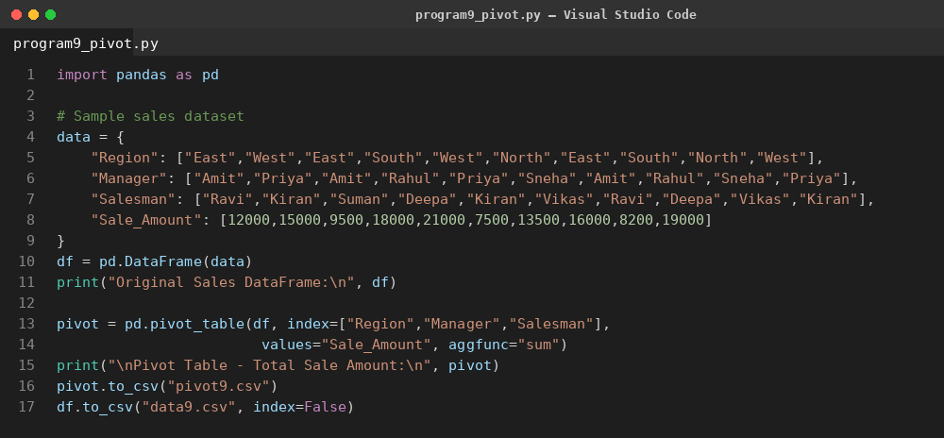
Code Explanation
- A dictionary of sales records is converted into a pandas DataFrame.
- pd.pivot_table() aggregates Sale_Amount using sum, grouped hierarchically by Region, Manager, and Salesman.
- The resulting multi-index pivot table is printed to the console.
Output
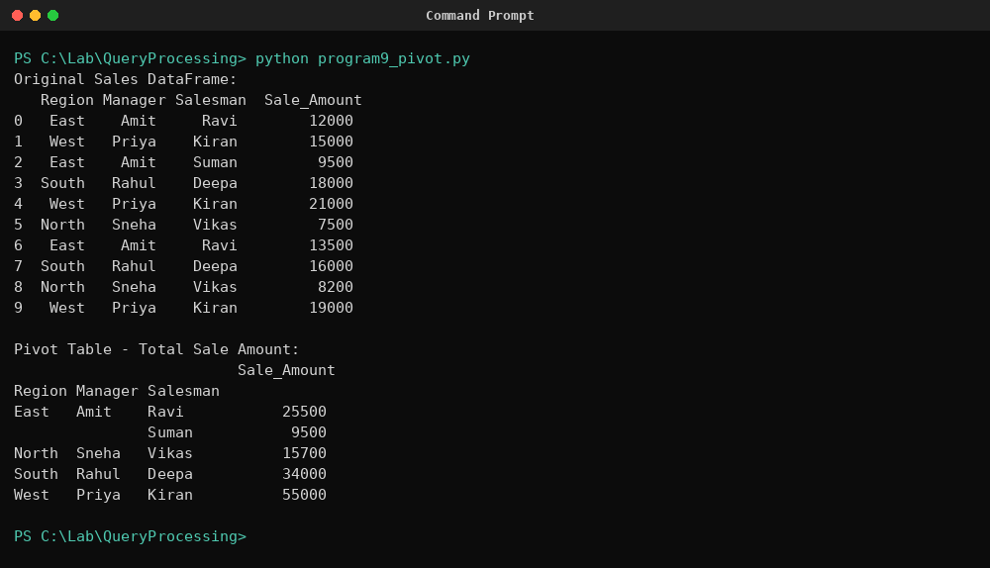
Result
The program successfully generated a hierarchical pivot table showing the total sale amount for every region, manager, and salesman combination, confirming correct aggregation of sales data.

Program 10: Highlighting Negative and Positive Values in a DataFrame

Aim
To create a 10x4 DataFrame of random values and highlight negative numbers in red and positive numbers in black using Pandas styling.
Problem Statement
Given a DataFrame of random positive and negative integers, apply conditional text-color styling so that negative values are visually distinguished from positive values.
Algorithm
- Import pandas and numpy.
- Generate a 10x4 DataFrame of random integers using numpy.random.randint in range (-50, 50).
- Define a function highlight_sign(val) that returns 'color: red' for negative values and 'color: black' otherwise.
- Apply the function to every cell using DataFrame.style.map().
- Display the styled DataFrame.
Requirements
Python Version: 3.10 or above
Required Libraries:
- pandas
- numpy
Dataset Description
A randomly generated numeric dataset of 10 rows and 4 columns (Metric_A to Metric_D) containing values between -50 and 49, used to demonstrate conditional styling.
Sample Dataset
Metric_A | Metric_B | Metric_C | Metric_D
-3 | 18 | -25 | 17
33 | -27 | 42 | 7
-36 | -27 | 22 | 39
-8 | 40 | -42 | -11
18 | -2 | -43 | -6
-50 | 25 | 5 | -44
-31 | 10 | -6 | 13
19 | 6 | -26 | 5
3 | 11 | 14 | -16
6 | 23 | 28 | -12

Dataset Column Explanation
- Metric_A – Metric_D: Randomly generated numeric metrics used to demonstrate conditional formatting; no real-world meaning is implied.
Python Program
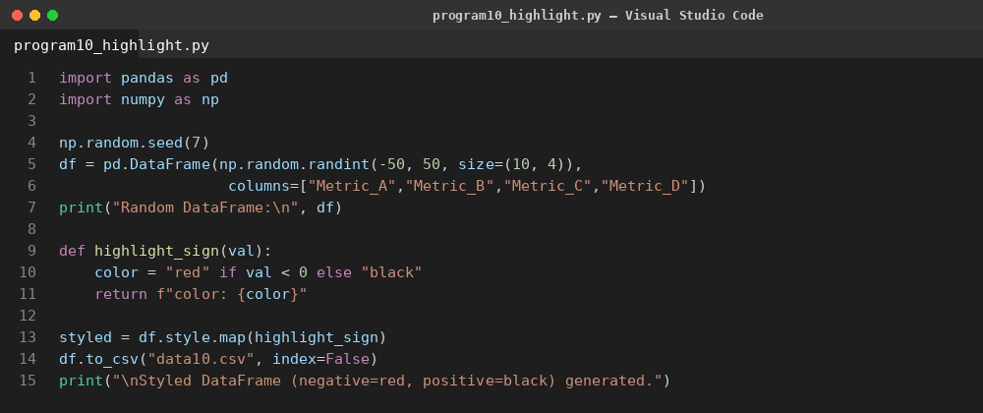
Code Explanation
- numpy.random.randint generates a reproducible 10x4 integer DataFrame (seeded).
- The highlight_sign() function inspects each cell value and returns a CSS color string.
- DataFrame.style.map() applies the function element-wise across the DataFrame.
- The styled object renders with red text for negative numbers and black text for positive numbers.
Output
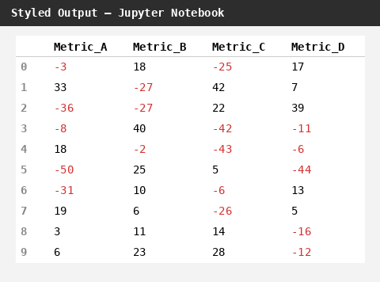
Result
The program successfully rendered a styled DataFrame in which every negative value appears in red and every positive value appears in black, verifying the conditional styling logic.

