CSA0502 — Query Processing for Data Science
Laboratory Record — Programs 11 & 12

This record presents Pandas-based data science lab exercises covering highlighting of missing (NaN) values and full DataFrame background/font color styling, with algorithmic explanation, executable code, and program output.
Program 11: Highlighting NaN Values in a DataFrame

Aim
To create a 10x4 DataFrame of random values containing some NaN entries and write a Pandas program to highlight the NaN values.
Problem Statement
Given a numeric DataFrame in which certain cells are missing (NaN), visually highlight those missing cells so they are easy to identify at a glance.
Algorithm
- Import pandas and numpy.
- Generate a 10x4 DataFrame of random integers and convert to float.
- Manually assign numpy.nan to a few selected cells to simulate missing data.
- Define a function highlight_nan(val) that returns 'background-color: yellow' when the value is NaN, and an empty string otherwise.
- Apply the function to every cell using DataFrame.style.map().
- Display the styled DataFrame.
Requirements
Python Version: 3.10 or above
Required Libraries:
- pandas
- numpy
Dataset Description
A 10x4 quiz-score dataset (Quiz1–Quiz4) with four cells deliberately set to NaN to represent missing student scores.
Sample Dataset
Quiz1 | Quiz2 | Quiz3 | Quiz4
34.0 | 13.0 | 66.0 | 82.0
10.0 | 31.0 | NaN | 84.0
51.0 | 20.0 | 31.0 | 48.0
NaN | 54.0 | 49.0 | 24.0
36.0 | 91.0 | 32.0 | 76.0
12.0 | 73.0 | 70.0 | NaN
61.0 | 79.0 | 39.0 | 34.0
72.0 | 17.0 | 53.0 | 43.0
89.0 | NaN | 47.0 | 30.0
59.0 | 31.0 | 88.0 | 38.0

Dataset Column Explanation
- Quiz1 – Quiz4: Scores obtained by a student in four quizzes.
- NaN: Represents a quiz that was missed or not graded.
Python Program
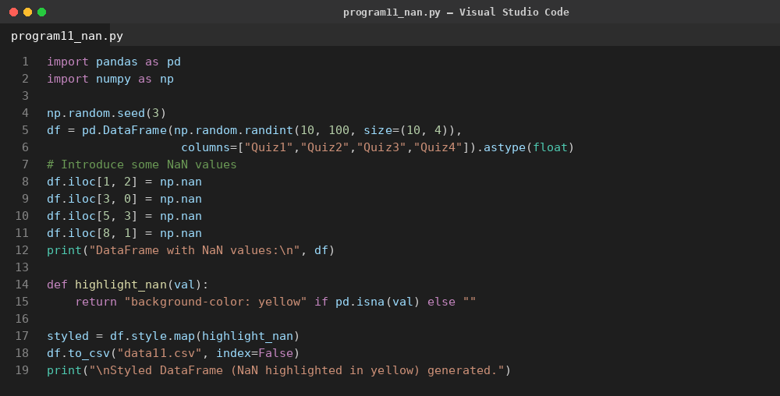
Code Explanation
- A 10x4 float DataFrame is created and a few cells are explicitly set to numpy.nan.
- highlight_nan() checks each value with pd.isna() and returns a yellow background style for missing cells.
- DataFrame.style.map() applies the styling function element-wise across the DataFrame.
- The styled DataFrame renders with all NaN cells shaded yellow for quick visual identification.
Output
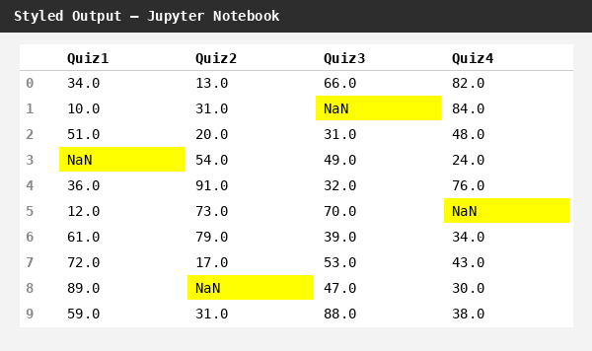
Result
The program successfully highlighted every NaN cell in yellow, allowing missing quiz scores to be identified immediately without scanning the raw data.

Program 12: Setting DataFrame Background to Black and Font to Yellow

Aim
To create a 10x4 DataFrame of random values and write a Pandas program to set the DataFrame's background color to black and font color to yellow.
Problem Statement
Given a numeric DataFrame, apply a uniform dark theme by setting the background color of every cell to black and the font color to yellow for improved contrast and presentation.
Algorithm
- Import pandas and numpy.
- Generate a 10x4 DataFrame of random integers between 1 and 100.
- Call DataFrame.style.set_properties() with background-color='black' and color='yellow'.
- Display the styled DataFrame.
Requirements
Python Version: 3.10 or above
Required Libraries:
- pandas
- numpy
Dataset Description
A randomly generated sensor-reading dataset with 10 rows and 4 columns (Sensor1–Sensor4), used to demonstrate uniform DataFrame styling.
Sample Dataset
Sensor1 | Sensor2 | Sensor3 | Sensor4
26 | 64 | 81 | 92
82 | 56 | 14 | 77
34 | 72 | 83 | 25
93 | 49 | 33 | 46
5 | 35 | 13 | 2
75 | 38 | 85 | 82
92 | 25 | 18 | 68
71 | 44 | 65 | 80
97 | 24 | 28 | 71
90 | 11 | 58 | 28

Dataset Column Explanation
- Sensor1 – Sensor4: Simulated numeric readings from four independent sensors.
Python Program
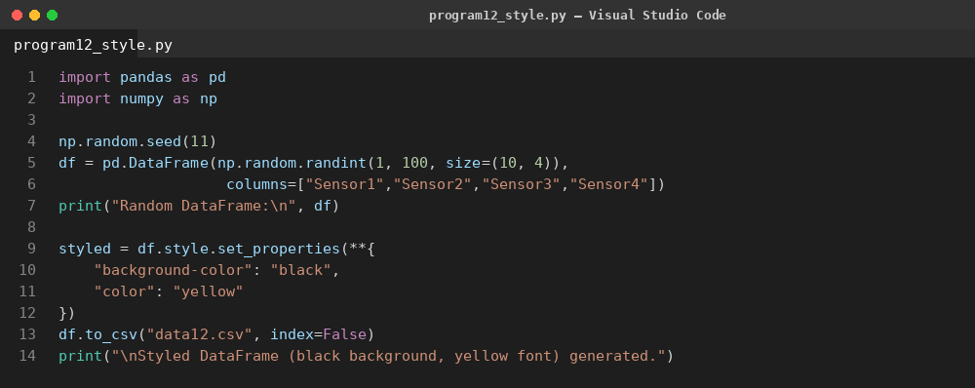
Code Explanation
- A 10x4 integer DataFrame of random sensor readings is generated.
- DataFrame.style.set_properties() applies a CSS-like dictionary of properties to every cell.
- background-color is set to black and color (font) is set to yellow for the entire table.
- The resulting styled DataFrame renders with a consistent dark theme.
Output
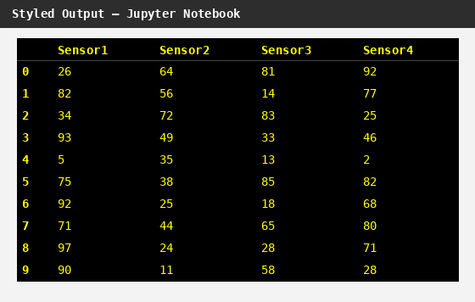
Result
The program successfully applied a black background with yellow font across the entire DataFrame, producing a consistent, high-contrast dark-themed table.

