CSA0502 — Query Processing for Data Science
Laboratory Record — Programs 13 & 14

This record presents Pandas-based data science lab exercises covering detection of missing values and replacement of missing values in a student marks dataset, with algorithmic explanation, executable code, and program output.
Program 13: Detecting Missing Values in a DataFrame

Aim
To write a Pandas program that detects missing values in a given DataFrame and displays True or False for every cell.
Problem Statement
Given a DataFrame of student marks containing some missing entries, identify exactly which cells are missing by producing a boolean mask of the same shape as the original DataFrame.
Algorithm
- Import pandas and numpy.
- Create a DataFrame containing StudentID, Name, Math and Science columns, with a few missing (NaN) marks.
- Call DataFrame.isna() to obtain a boolean DataFrame where True marks a missing cell.
- Display the boolean DataFrame.
Requirements
Python Version: 3.10 or above
Required Libraries:
- pandas
- numpy
Dataset Description
A student marks dataset with 8 records containing StudentID, Name, and Math and Science marks, with several marks deliberately missing.
Sample Dataset
StudentID | Name | Math | Science
101 | Ravi | 78.0 | 82.0
102 | Anu | NaN | 90.0
103 | Kiran | 88.0 | NaN
104 | Divya | 92.0 | 88.0
105 | Suresh | NaN | 79.0
106 | Meena | 65.0 | NaN
107 | Arjun | 74.0 | 91.0
108 | Neha | NaN | 85.0

Dataset Column Explanation
- StudentID: Unique roll number of the student.
- Name: Student's name.
- Math / Science: Marks scored, with some entries missing (not recorded).
Python Program
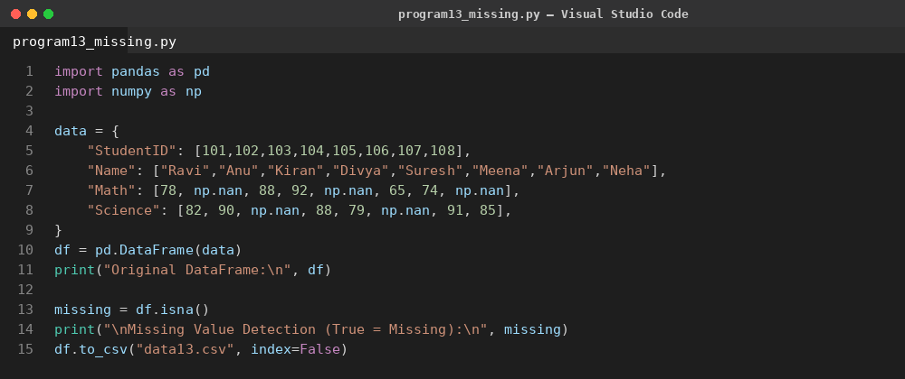
Code Explanation
- A DataFrame of student marks is created with numpy.nan representing unrecorded marks.
- DataFrame.isna() returns an element-wise boolean DataFrame, True where a value is missing.
- The boolean mask is printed, making every missing entry immediately visible as True.
Output
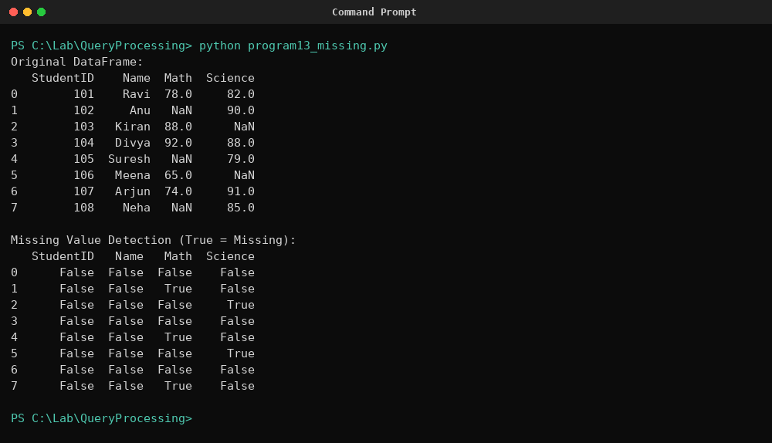
Result
The program successfully produced a boolean DataFrame correctly flagging every missing Math and Science mark as True, confirming accurate missing-value detection.

Program 14: Finding and Replacing Missing Values in a DataFrame

Aim
To write a Pandas program that finds and replaces missing values in a given DataFrame that do not carry any valuable information.
Problem Statement
Given a DataFrame of student marks with missing entries, replace those missing values with a statistically meaningful substitute (the column mean) so the dataset can be used for further analysis without loss of usable rows.
Algorithm
- Import pandas and numpy.
- Create the same student marks DataFrame containing NaN values in the Math and Science columns.
- Compute the mean of each column using Series.mean(), which automatically ignores NaN values.
- Use Series.fillna() to replace NaN entries in each column with that column's mean.
- Display the DataFrame after replacement.
Requirements
Python Version: 3.10 or above
Required Libraries:
- pandas
- numpy
Dataset Description
The same student marks dataset used in Program 13, with missing Math and Science values replaced by the respective column mean.
Sample Dataset
StudentID | Name | Math | Science
101 | Ravi | 78.0 | 82.0
102 | Anu | NaN | 90.0
103 | Kiran | 88.0 | NaN
104 | Divya | 92.0 | 88.0
105 | Suresh | NaN | 79.0
106 | Meena | 65.0 | NaN
107 | Arjun | 74.0 | 91.0
108 | Neha | NaN | 85.0

Dataset Column Explanation
- StudentID / Name: Identify each student record.
- Math / Science: Original marks before replacement; NaN cells will be filled with the column mean.
Python Program
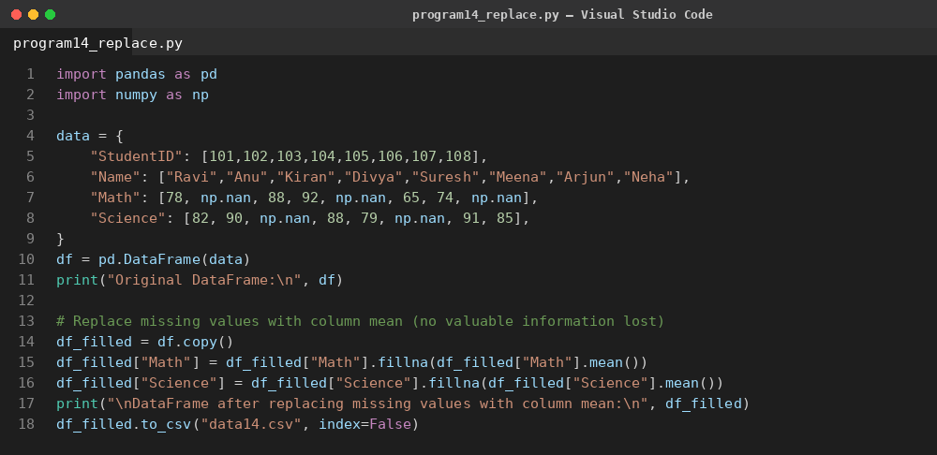
Code Explanation
- The Math and Science columns are copied, and their mean is computed while automatically excluding NaN values.
- fillna() replaces every NaN in each column with that column's computed mean.
- The updated DataFrame no longer contains missing values, preserving all eight student rows.
Output
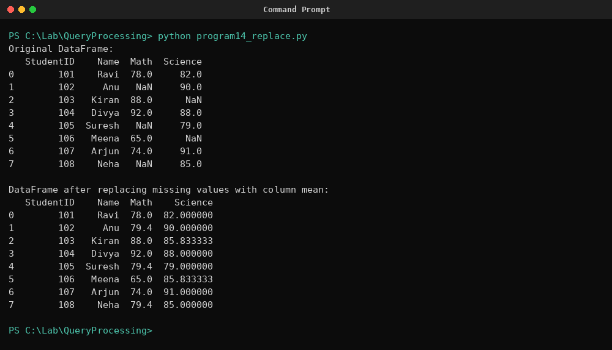
Result
The program successfully replaced all missing Math and Science marks with their respective column means, producing a complete dataset with no information loss.

