CSA0502 — Query Processing for Data Science
Laboratory Record — Programs 15 & 16

This record presents Pandas-based data science lab exercises covering row filtering based on the count of missing values and grouping a DataFrame using GroupBy, with algorithmic explanation, executable code, and program output.
Program 15: Keeping Rows With At Least Two NaN Values

Aim
To write a Pandas program that keeps only the rows containing at least two NaN values in a given DataFrame.
Problem Statement
Given a DataFrame of student marks across three subjects with several missing entries, filter out rows that are mostly complete and retain only those rows with two or more missing marks, since they are the least reliable for analysis.
Algorithm
- Import pandas and numpy.
- Create a DataFrame with StudentID, Math, Science and English columns, containing several NaN values.
- Use DataFrame.isna().sum(axis=1) to count the number of missing values in each row.
- Filter the DataFrame using boolean indexing where this row-wise count is >= 2.
- Display the filtered DataFrame.
Requirements
Python Version: 3.10 or above
Required Libraries:
- pandas
- numpy
Dataset Description
A student marks dataset with 8 records across Math, Science and English, several of which contain multiple missing marks.
Sample Dataset
StudentID | Math | Science | English
201 | 78.0 | 82.0 | NaN
202 | NaN | NaN | NaN
203 | NaN | 91.0 | 88.0
204 | 92.0 | NaN | 90.0
205 | NaN | NaN | 79.0
206 | 65.0 | NaN | NaN
207 | NaN | 74.0 | NaN
208 | 88.0 | 85.0 | 91.0

Dataset Column Explanation
- StudentID: Unique roll number of the student.
- Math / Science / English: Marks in each subject; NaN indicates the mark was not recorded.
Python Program
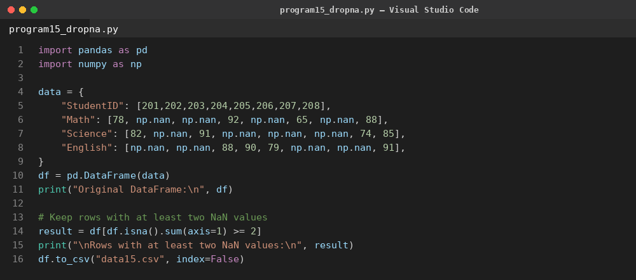
Code Explanation
- A DataFrame with three subject columns and multiple NaN entries is created.
- isna().sum(axis=1) counts, for every row, how many of its cells are missing.
- Boolean indexing df[condition] retains only rows whose missing-value count is 2 or more.
- The filtered result contains only the least-complete student records.
Output
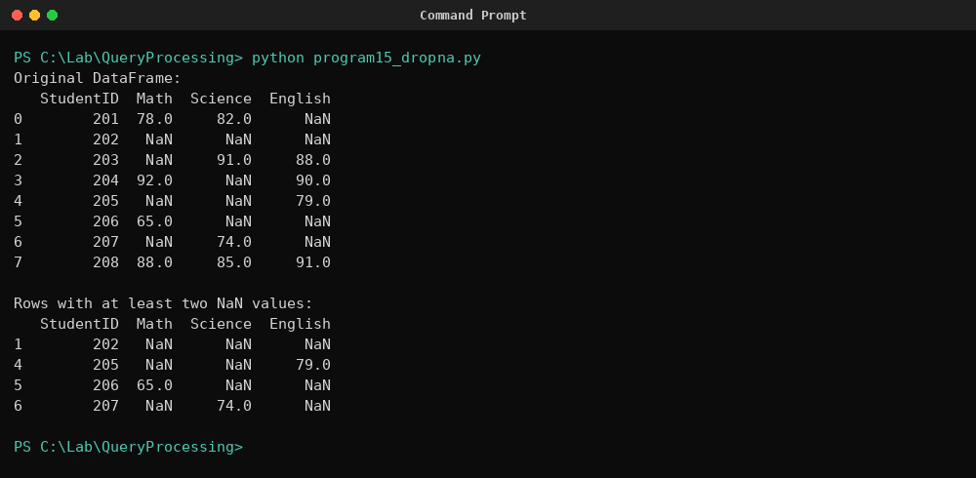
Result
The program successfully filtered the dataset down to only the rows containing two or more missing marks, correctly excluding rows with fewer than two NaN values.

Program 16: Splitting a DataFrame Into Groups by School Code

Aim
To write a Pandas program that splits a given DataFrame into groups based on school code and checks the type of the resulting GroupBy object.
Problem Statement
Given a DataFrame containing student records from multiple schools, split the dataset into groups keyed by school code so that each group's records can be examined separately, and confirm the underlying object type produced by the operation.
Algorithm
- Import pandas.
- Create a DataFrame containing SchoolCode, StudentName and Marks columns.
- Call DataFrame.groupby('SchoolCode') to split the DataFrame into groups.
- Print the type of the returned object using type().
- Iterate over the GroupBy object to display each group's records separately.
Requirements
Python Version: 3.10 or above
Required Libraries:
- pandas
Dataset Description
A student dataset with 8 records spread across three school codes (S01, S02, S03), used to demonstrate DataFrame grouping.
Sample Dataset
SchoolCode | StudentName | Marks
S01 | Ravi | 78
S02 | Anu | 85
S01 | Kiran | 92
S03 | Divya | 67
S02 | Suresh | 73
S01 | Meena | 88
S03 | Arjun | 91
S02 | Neha | 80

Dataset Column Explanation
- SchoolCode: Identifier of the school the student belongs to.
- StudentName: Name of the student.
- Marks: Marks scored by the student.
Python Program
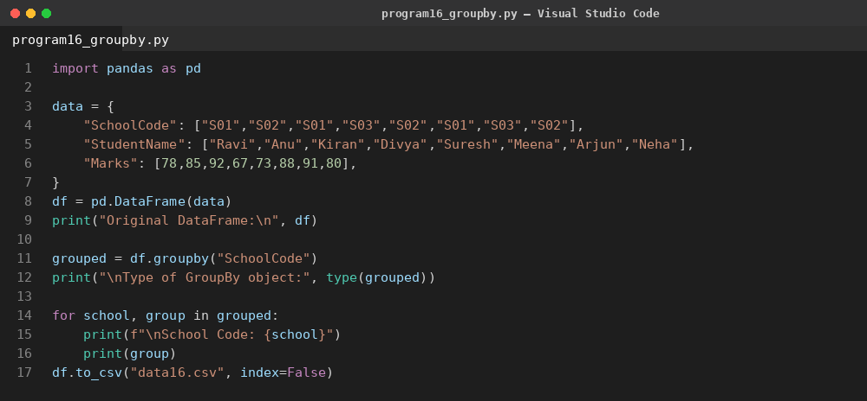
Code Explanation
- A DataFrame of students from three different schools is created.
- groupby('SchoolCode') partitions the DataFrame internally by unique school code without immediately computing an aggregate.
- type(grouped) confirms the object returned is a pandas DataFrameGroupBy instance.
- Iterating over the GroupBy object with a for loop yields each school code together with its corresponding sub-DataFrame.
Output
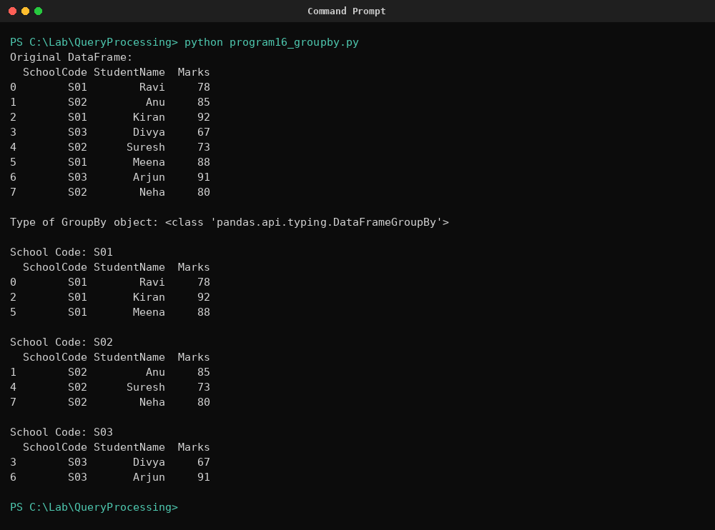
Result
The program successfully split the DataFrame into three school-wise groups and confirmed that groupby() returns a DataFrameGroupBy object, verifying correct use of Pandas grouping.

