CSA0502 – Query Processing for Data Science
Lab Record — Document 1 (Programs 1 & 2)
Program 1: Select Distinct Department ID from Employees File
Aim
To write a Pandas program that reads employee data from a CSV file and displays the distinct (unique) department IDs present in the dataset.
Algorithm
1. Import the Pandas library.
2. Read the employees.csv file into a DataFrame using pd.read_csv().
3. Select the DEPARTMENT_ID column from the DataFrame.
4. Apply the drop_duplicates() function to remove repeated department IDs.
5. Print the resulting distinct department IDs.
Input Files / Dataset
employees.csv — contains employee records including Employee ID, First Name, Last Name, Job ID, Department ID, and Salary.
Sample Dataset: employees.csv (first 10 records)
EMPLOYEE_ID | FIRST_NAME | LAST_NAME | JOB_ID | DEPARTMENT_ID | SALARY
100 | Steven | King | AD_PRES | 90 | 24000
101 | Neena | Kochhar | AD_VP | 90 | 17000
102 | Lex | De Haan | AD_VP | 90 | 17000
103 | Alexander | Hunold | IT_PROG | 60 | 9000
104 | Bruce | Ernst | IT_PROG | 60 | 6000
105 | David | Austin | IT_PROG | 60 | 4800
106 | Valli | Pataballa | IT_PROG | 60 | 4800
107 | Diana | Lorentz | IT_PROG | 60 | 4200
108 | Nancy | Greenberg | FI_MGR | 100 | 12000
109 | Daniel | Faviet | FI_ACCOUNT | 100 | 9000

Python Program
import pandas as pd

employees = pd.read_csv('employees.csv')
distinct_departments = employees['DEPARTMENT_ID'].drop_duplicates()
print(distinct_departments.to_string(index=False))
Expected Output

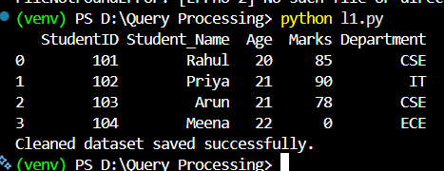
90
60
100
30
Result
The Pandas program was executed successfully and the distinct department IDs (90, 60, 100, 30) were displayed from the employees dataset, eliminating all duplicate entries.

Program 2: Display IDs of Employees Who Have Done Two or More Jobs
Aim
To write a Pandas program that reads employee job-history data and displays the IDs of employees who have held two or more jobs.
Algorithm
1. Import the Pandas library.
2. Read the job_history.csv file into a DataFrame using pd.read_csv().
3. Group the records by EMPLOYEE_ID and count the number of job entries for each employee using value_counts().
4. Filter the counts to keep only employees whose job count is 2 or more.
5. Print the resulting employee IDs along with their job counts.
Input Files / Dataset
job_history.csv — contains historical job records of employees, including Employee ID, Start Date, End Date, Job ID, and Department ID.
Sample Dataset: job_history.csv
EMPLOYEE_ID | START_DATE | END_DATE | JOB_ID | DEPARTMENT_ID
102 | 1993-01-13 | 1998-07-24 | IT_PROG | 60
101 | 1989-09-21 | 1993-10-27 | AC_ACCOUNT | 110
101 | 1993-10-28 | 1997-03-15 | AC_MGR | 110
201 | 1996-02-17 | 1999-12-19 | MK_REP | 20
114 | 1994-03-24 | 1998-12-31 | ST_CLERK | 50
122 | 1999-01-01 | 1999-12-31 | ST_CLERK | 50
176 | 1998-03-24 | 1998-12-31 | SA_REP | 80
176 | 1999-01-01 | 1999-12-31 | SA_MAN | 80
200 | 1987-09-17 | 1993-06-17 | AD_ASST | 90
119 | 1999-07-01 | 1999-12-31 | PU_CLERK | 30
110 | 1996-03-01 | 1999-12-31 | FI_ACCOUNT | 100
103 | 1990-01-01 | 1993-12-31 | IT_PROG | 60

Python Program
import pandas as pd

job_history = pd.read_csv('job_history.csv')
job_counts = job_history['EMPLOYEE_ID'].value_counts()
multi_job_employees = job_counts[job_counts >= 2]
print(multi_job_employees.to_string())
Expected Output

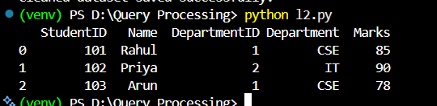
EMPLOYEE_ID
101 2
176 2
Result
The Pandas program successfully identified employees 101 and 176 as having held two or more jobs, based on the frequency of their Employee ID in the job_history dataset.

