CSA0502 – Query Processing for Data Science
Lab Record — Document 2 (Programs 3 & 4)
Program 3: Display Details of Jobs in Descending Sequence on Job Title
Aim
To write a Pandas program that reads job data from a CSV file and displays the job details sorted in descending order based on Job Title.
Algorithm
1. Import the Pandas library.
2. Read the jobs.csv file into a DataFrame using pd.read_csv().
3. Apply the sort_values() function on the JOB_TITLE column with ascending=False.
4. Print the sorted DataFrame showing all job details.
Input Files / Dataset
jobs.csv — contains job details including Job ID, Job Title, Minimum Salary, and Maximum Salary.
Sample Dataset: jobs.csv
JOB_ID | JOB_TITLE | MIN_SALARY | MAX_SALARY
AD_PRES | President | 20000 | 40000
AD_VP | Administration Vice President | 15000 | 30000
AD_ASST | Administration Assistant | 3000 | 6000
FI_MGR | Finance Manager | 8200 | 16000
FI_ACCOUNT | Accountant | 4200 | 9000
AC_MGR | Accounting Manager | 8200 | 16000
AC_ACCOUNT | Public Accountant | 4200 | 9000
SA_MAN | Sales Manager | 10000 | 20000
SA_REP | Sales Representative | 6000 | 12000
PU_MAN | Purchasing Manager | 8000 | 15000
PU_CLERK | Purchasing Clerk | 2500 | 5500
ST_MAN | Stock Manager | 5500 | 8500
ST_CLERK | Stock Clerk | 2000 | 5000
IT_PROG | Programmer | 4000 | 10000
MK_MAN | Marketing Manager | 9000 | 15000
MK_REP | Marketing Representative | 4000 | 9000

Python Program
import pandas as pd

jobs = pd.read_csv('jobs.csv')
sorted_jobs = jobs.sort_values('JOB_TITLE', ascending=False)
print(sorted_jobs.to_string(index=False))
Output
JOB_ID JOB_TITLE MIN_SALARY MAX_SALARY
ST_MAN Stock Manager 5500 8500
ST_CLERK Stock Clerk 2000 5000
SA_REP Sales Representative 6000 12000
SA_MAN Sales Manager 10000 20000
PU_MAN Purchasing Manager 8000 15000
PU_CLERK Purchasing Clerk 2500 5500
AC_ACCOUNT Public Accountant 4200 9000
IT_PROG Programmer 4000 10000
AD_PRES President 20000 40000
MK_REP Marketing Representative 4000 9000
MK_MAN Marketing Manager 9000 15000
FI_MGR Finance Manager 8200 16000
AD_VP Administration Vice President 15000 30000
AD_ASST Administration Assistant 3000 6000
AC_MGR Accounting Manager 8200 16000
FI_ACCOUNT Accountant 4200 9000
Result
The Pandas program successfully sorted and displayed all job records in descending alphabetical order of Job Title, starting with 'Stock Manager' and ending with 'Accountant'.

Program 4: Line Plot of Historical Stock Prices of Alphabet Inc. Between Two Specific Dates
Aim
To write a Pandas program that creates a line plot showing the historical closing stock prices of Alphabet Inc. between two specific dates.
Algorithm
1. Import the Pandas and Matplotlib libraries.
2. Read the alphabet_stock.csv file into a DataFrame using pd.read_csv().
3. Convert the Date column to datetime format using pd.to_datetime().
4. Filter the DataFrame to keep only rows between the given start date and end date.
5. Plot the Close price against Date using plt.plot().
6. Add a title, X-axis label, and Y-axis label to the plot.
7. Display/save the line plot.
Input Files / Dataset
alphabet_stock.csv — contains historical stock data of Alphabet Inc. with fields Date, Open, High, Low, Close, and Volume.
Sample Dataset: alphabet_stock.csv (first 10 records)
Date | Open | High | Low | Close | Volume
2020-06-01 | 1401.50 | 1418.30 | 1396.20 | 1413.18 | 1523400
2020-06-02 | 1416.00 | 1433.60 | 1410.10 | 1428.92 | 1487200
2020-06-03 | 1432.00 | 1450.75 | 1425.30 | 1439.60 | 1602300
2020-06-04 | 1435.00 | 1442.00 | 1418.90 | 1424.10 | 1398700
2020-06-05 | 1440.00 | 1465.20 | 1436.00 | 1461.30 | 1789600
2020-06-08 | 1465.00 | 1478.90 | 1452.10 | 1472.40 | 1654200
2020-06-09 | 1470.00 | 1481.30 | 1458.60 | 1465.20 | 1421900
2020-06-10 | 1468.00 | 1489.00 | 1460.30 | 1481.75 | 1732800
2020-06-11 | 1450.00 | 1462.10 | 1398.20 | 1403.60 | 2210500
2020-06-12 | 1410.00 | 1432.50 | 1392.00 | 1418.30 | 1965100

Python Program
import pandas as pd
import matplotlib.pyplot as plt

stock_data = pd.read_csv('alphabet_stock.csv')
stock_data['Date'] = pd.to_datetime(stock_data['Date'])

start_date = '2020-06-01'
end_date = '2020-06-26'
mask = (stock_data['Date'] >= start_date) & (stock_data['Date'] <= end_date)
filtered_data = stock_data.loc[mask]

plt.plot(filtered_data['Date'], filtered_data['Close'], marker='o', color='blue')
plt.title('Alphabet Inc. Stock Price (Jun 1 - Jun 26, 2020)')
plt.xlabel('Date')
plt.ylabel('Closing Price (USD)')
plt.xticks(rotation=45)
plt.tight_layout()
plt.show()
Output
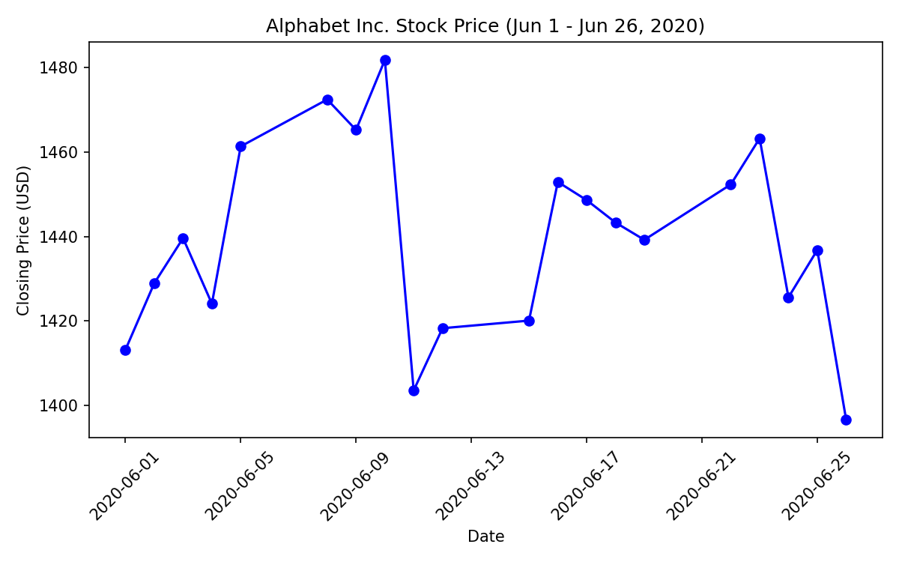
Result
The Pandas program successfully generated a line plot titled 'Alphabet Inc. Stock Price (Jun 1 - Jun 26, 2020)', with Date on the X-axis and Closing Price (USD) on the Y-axis, clearly showing the stock price trend over the selected period.

