CSA0502 – Query Processing for Data Science
Lab Record — Document 3 (Programs 5 & 6)
Program 5: Bar Plot of Trading Volume of Alphabet Inc. Stock Between Two Specific Dates
Aim
To write a Pandas program that creates a bar plot showing the trading volume of Alphabet Inc. stock between two specific dates.
Algorithm
1. Import the Pandas and Matplotlib libraries.
2. Read the alphabet_stock.csv file into a DataFrame using pd.read_csv().
3. Convert the Date column to datetime format using pd.to_datetime().
4. Filter the DataFrame to keep only rows between the given start date and end date.
5. Plot the Volume against Date using plt.bar().
6. Add a title, X-axis label, and Y-axis label to the plot.
7. Display/save the bar plot.
Input Files / Dataset
alphabet_stock.csv — contains historical stock data of Alphabet Inc. with fields Date, Open, High, Low, Close, and Volume.
Sample Dataset: alphabet_stock.csv (first 10 records)
Date | Open | High | Low | Close | Volume
2020-06-01 | 1401.50 | 1418.30 | 1396.20 | 1413.18 | 1523400
2020-06-02 | 1416.00 | 1433.60 | 1410.10 | 1428.92 | 1487200
2020-06-03 | 1432.00 | 1450.75 | 1425.30 | 1439.60 | 1602300
2020-06-04 | 1435.00 | 1442.00 | 1418.90 | 1424.10 | 1398700
2020-06-05 | 1440.00 | 1465.20 | 1436.00 | 1461.30 | 1789600
2020-06-08 | 1465.00 | 1478.90 | 1452.10 | 1472.40 | 1654200
2020-06-09 | 1470.00 | 1481.30 | 1458.60 | 1465.20 | 1421900
2020-06-10 | 1468.00 | 1489.00 | 1460.30 | 1481.75 | 1732800
2020-06-11 | 1450.00 | 1462.10 | 1398.20 | 1403.60 | 2210500
2020-06-12 | 1410.00 | 1432.50 | 1392.00 | 1418.30 | 1965100

Python Program
import pandas as pd
import matplotlib.pyplot as plt

stock_data = pd.read_csv('alphabet_stock.csv')
stock_data['Date'] = pd.to_datetime(stock_data['Date'])

start_date = '2020-06-01'
end_date = '2020-06-26'
mask = (stock_data['Date'] >= start_date) & (stock_data['Date'] <= end_date)
filtered_data = stock_data.loc[mask]

plt.bar(filtered_data['Date'], filtered_data['Volume'], color='teal')
plt.title('Alphabet Inc. Trading Volume (Jun 1 - Jun 26, 2020)')
plt.xlabel('Date')
plt.ylabel('Volume')
plt.xticks(rotation=45)
plt.tight_layout()
plt.show()
Output
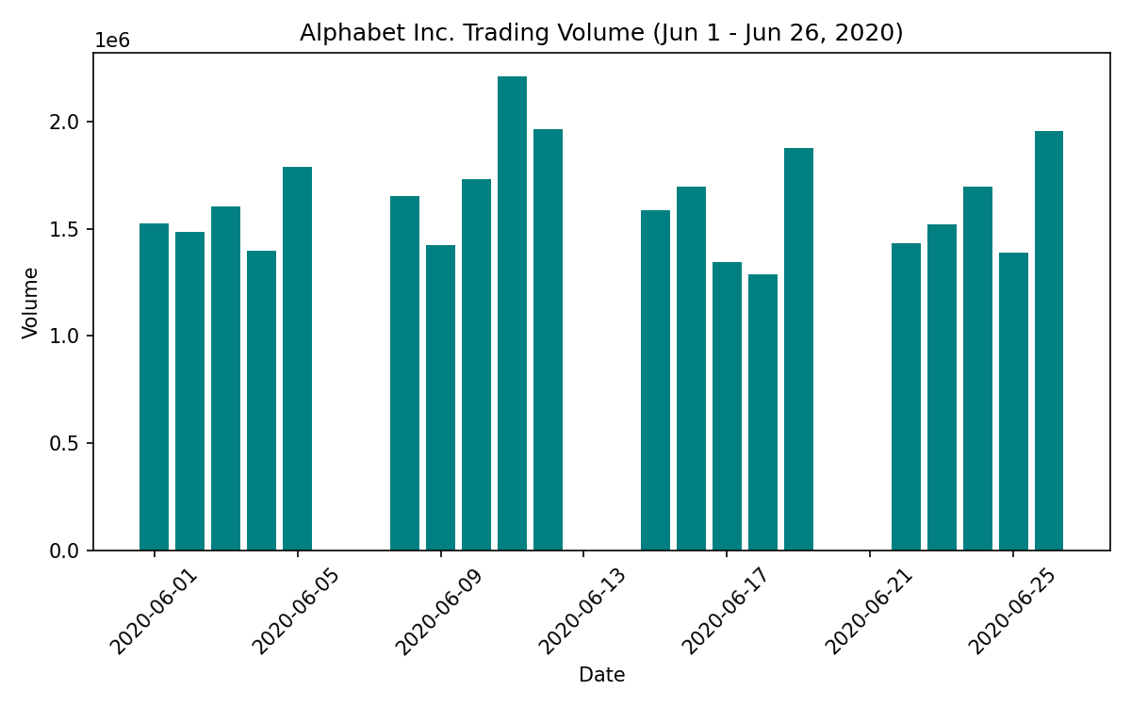
Result
The Pandas program successfully generated a bar plot titled 'Alphabet Inc. Trading Volume (Jun 1 - Jun 26, 2020)', with Date on the X-axis and Volume on the Y-axis, clearly displaying the daily trading volume over the selected period.

Program 6: Scatter Plot of Trading Volume vs Stock Price of Alphabet Inc. Stock Between Two Specific Dates
Aim
To write a Pandas program that creates a scatter plot showing the relationship between trading volume and closing stock price of Alphabet Inc. between two specific dates.
Algorithm
1. Import the Pandas and Matplotlib libraries.
2. Read the alphabet_stock.csv file into a DataFrame using pd.read_csv().
3. Convert the Date column to datetime format using pd.to_datetime().
4. Filter the DataFrame to keep only rows between the given start date and end date.
5. Plot Volume against Close price using plt.scatter().
6. Add a title, X-axis label, and Y-axis label to the plot.
7. Display/save the scatter plot.
Input Files / Dataset
alphabet_stock.csv — contains historical stock data of Alphabet Inc. with fields Date, Open, High, Low, Close, and Volume.
Sample Dataset: alphabet_stock.csv (first 10 records)
Date | Open | High | Low | Close | Volume
2020-06-01 | 1401.50 | 1418.30 | 1396.20 | 1413.18 | 1523400
2020-06-02 | 1416.00 | 1433.60 | 1410.10 | 1428.92 | 1487200
2020-06-03 | 1432.00 | 1450.75 | 1425.30 | 1439.60 | 1602300
2020-06-04 | 1435.00 | 1442.00 | 1418.90 | 1424.10 | 1398700
2020-06-05 | 1440.00 | 1465.20 | 1436.00 | 1461.30 | 1789600
2020-06-08 | 1465.00 | 1478.90 | 1452.10 | 1472.40 | 1654200
2020-06-09 | 1470.00 | 1481.30 | 1458.60 | 1465.20 | 1421900
2020-06-10 | 1468.00 | 1489.00 | 1460.30 | 1481.75 | 1732800
2020-06-11 | 1450.00 | 1462.10 | 1398.20 | 1403.60 | 2210500
2020-06-12 | 1410.00 | 1432.50 | 1392.00 | 1418.30 | 1965100

Python Program
import pandas as pd
import matplotlib.pyplot as plt

stock_data = pd.read_csv('alphabet_stock.csv')
stock_data['Date'] = pd.to_datetime(stock_data['Date'])

start_date = '2020-06-01'
end_date = '2020-06-26'
mask = (stock_data['Date'] >= start_date) & (stock_data['Date'] <= end_date)
filtered_data = stock_data.loc[mask]

plt.scatter(filtered_data['Volume'], filtered_data['Close'], color='crimson')
plt.title('Alphabet Inc. Volume vs Closing Price (Jun 1 - Jun 26, 2020)')
plt.xlabel('Volume')
plt.ylabel('Closing Price (USD)')
plt.tight_layout()
plt.show()
Output
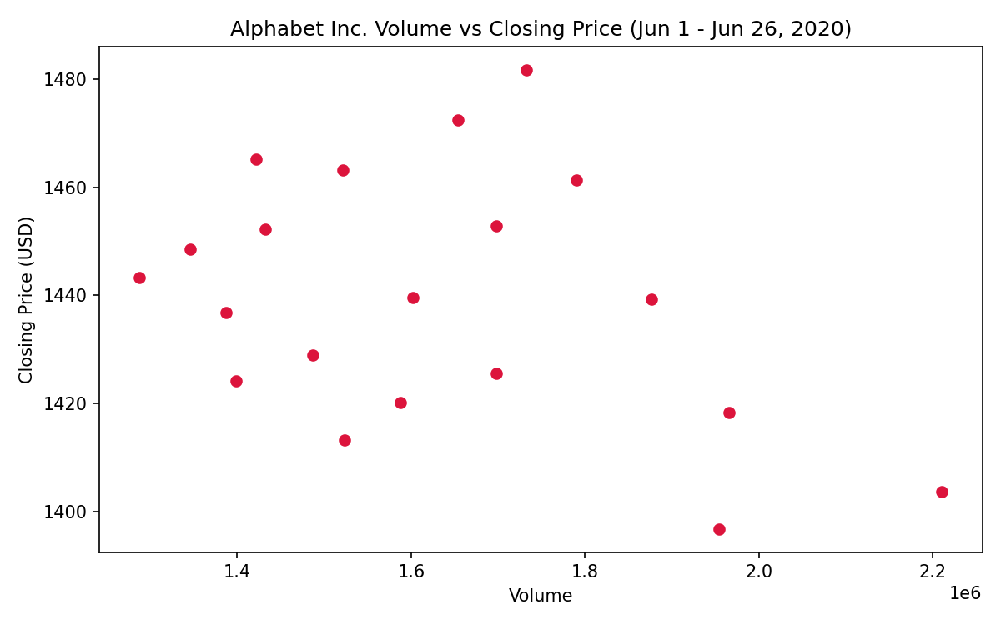
Result
The Pandas program successfully generated a scatter plot titled 'Alphabet Inc. Volume vs Closing Price (Jun 1 - Jun 26, 2020)', with Volume on the X-axis and Closing Price on the Y-axis, revealing the relationship between trading volume and stock price during the selected period.

