**BACHELOR OF TECHNOLOGY**

**IN**

# Artificial Intelligence and Machine Learning

**CyberGuard: A Deep Learning-Based Cyberbullying Detection System**

**Batch Number:** 18

**Project Guide Batch Names & Roll Numbers**

**Dr.S.Satyanarayana**

C. Sahithi - 2011CS020071

Ch. Siddhu Vinay - 2011CS02072

Ch.Tharun reddy – 2011CS020073

C.Ashritha – 2011CS020074



**Department of AIML, School of Engineering**

**Malla Reddy University**

# Abstract

* The objective of this study is to develop an MLP model for cyberbullying detection and prevention.
* A dataset containing instances of cyberbullying and non-cyberbullying content is collected and preprocessed for training and testing the MLP model.
* The MLP architecture consists of multiple layers of interconnected nodes, enabling it to learn complex patterns and classify instances as cyberbullying or non-cyberbullying.
* Features such as text content, user information, and online behavior are extracted and used as input to the MLP model.
* The MLP model is trained using a supervised learning approach, optimizing its weights and biases to accurately classify instances.

## Introduction

* The rise of social media and other online platforms has brought about new opportunities for communication and social interaction. However, it has also created new forms of harassment and bullying, known as cyberbullying
* Cyberbullying can have serious consequences for its victims, including anxiety, depression, and even suicide. Unfortunately, cyberbullying can be challenging to detect and prevent, as it can happen in private online spaces and is often disguised as jokes or harmless teasing.
* Machine learning and deep learning techniques can be used to develop an application that can detect cyberbullying and provide early warnings to prevent it from escalating.

# Literature Survey

* Cyberbullying: A review of the literature" by Amanda Lenhart. The paper provides a comprehensive review of existing research on cyberbullying. The author analyzes various definitions of cyberbullying, prevalence rates, risk factors, and impacts on victims.
* "Prevalence and effects of cyberbullying among primary and secondary school students in China: A metaanalysis" by Qingqing Hu, Qian Wang, and Ying Liu. The paper provides a meta-analysis of studies conducted on cyberbullying among primary and secondary school students in China. The authors analyze prevalence rates and the effects of cyberbullying on victims' mental health.
* "Cyberbullying in schools: A research review" by L. Sophia Lin and Yi-Hui Christine Huang. The paper provides a review of research on cyberbullying in schools. The authors analyze various types of cyberbullying, the role of gender and age, and interventions to prevent cyberbullying.

# Proposed Methodology

**Multi-layer Perceptron :**

* MLP is a feedforward neural network, where information flows in one direction, from the input layer through one or more hidden layers to the output layer.
* Each neuron in MLP receives inputs, applies an activation function to the weighted sum of inputs, and produces an output signal.
* MLP utilizes a supervised learning approach, where it is trained on labeled data to make predictions or classify input patterns into different classes.
* The hidden layers in MLP allow it to learn and capture complex nonlinear relationships between input and output data.
* MLP employs the backpropagation algorithm to adjust the weights of connections between neurons during training, minimizing the difference between predicted and actual outputs.

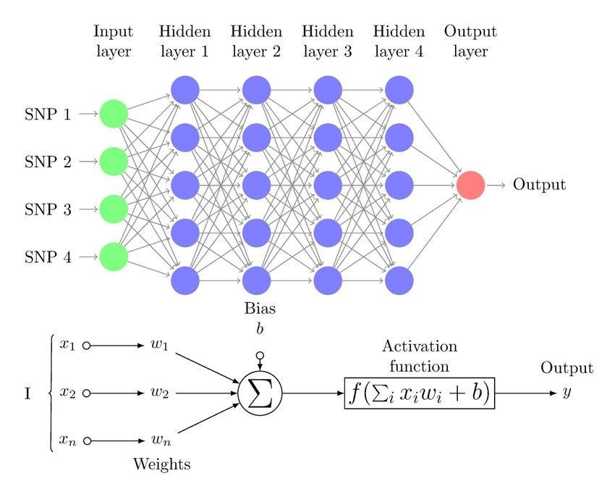

**Fig : 1.1 Architecture of MLP model**

# Results & Discussion

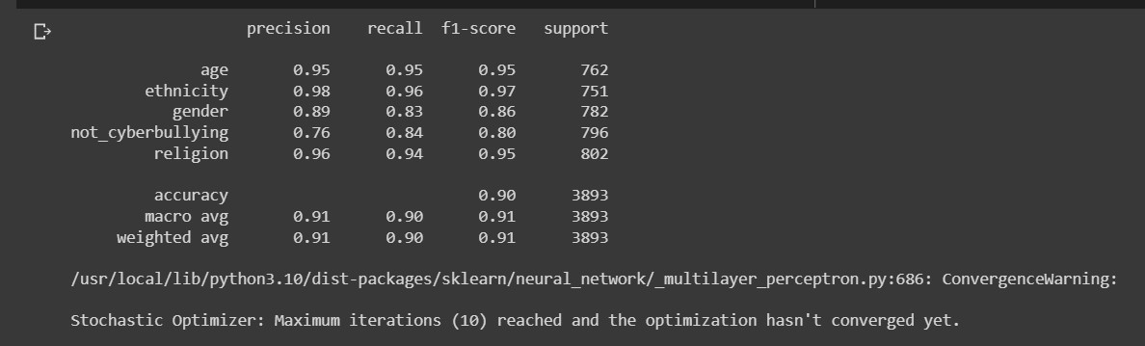

**Fig : 1.2 Performance metrix of cyberbullying**

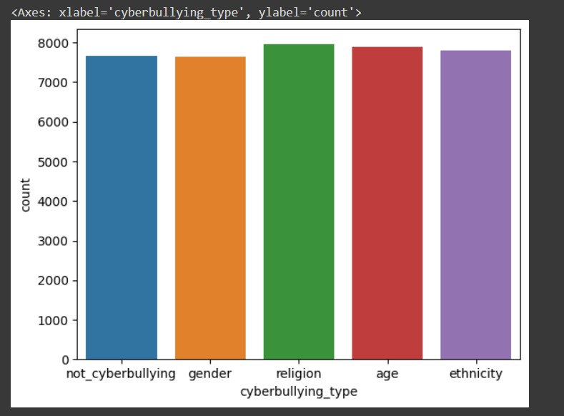 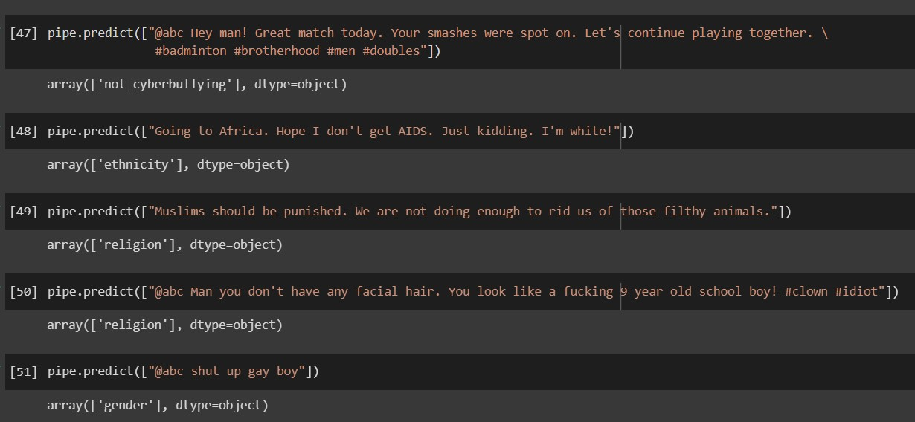

# Conclusion

We have built an MLP based model for cyberbullying detection and we would like to extend this project to a bigger application like cyberbullying eradication by using Deep learning models like ANN , RNN , LSTM .As our application development is limted to cyberbullying detection .This data model can be utilized in several applications where this could be included as a module like in whatsapp text messages , instagram text messages and other social media platforms .