**PHASE 3 PROJECT SUBMISSION**

**PROJECT 1 - WEBSITE TRAFFIC ANALYSIS**

**TEAM MEMBERS:**

1. Nethaji K – 2021504531
2. Rohith M U – 2021504538
3. Sripushkalai S – 2021504547
4. Tharunsarwin U G – 2021504554

**PROBLEM DEFINITION:**

The project involves analyzing website traffic data to gain insights into user behavior, popular pages, and traffic sources. The goal is to help website owners enhance the user experience by understanding how visitors interact with the site. This project encompasses defining the analysis objectives, collecting website traffic data, using IBM Cognos for data visualization, and integrating Python code for advanced analysis.

**PHASE OBJECTIVE:**

During Phase 3, the task involves enhancing the provided dataset by cleaning and refining it for greater relevance. Additionally, preprocessing steps will be applied to optimize the dataset. Subsequently, a range of analyses and visualizations will be conducted using IBM Cognos to extract meaningful insights.

**DATASET LINK:**

<https://www.kaggle.com/datasets/bobnau/daily-website-visitors>

**SOURCE CODE:**

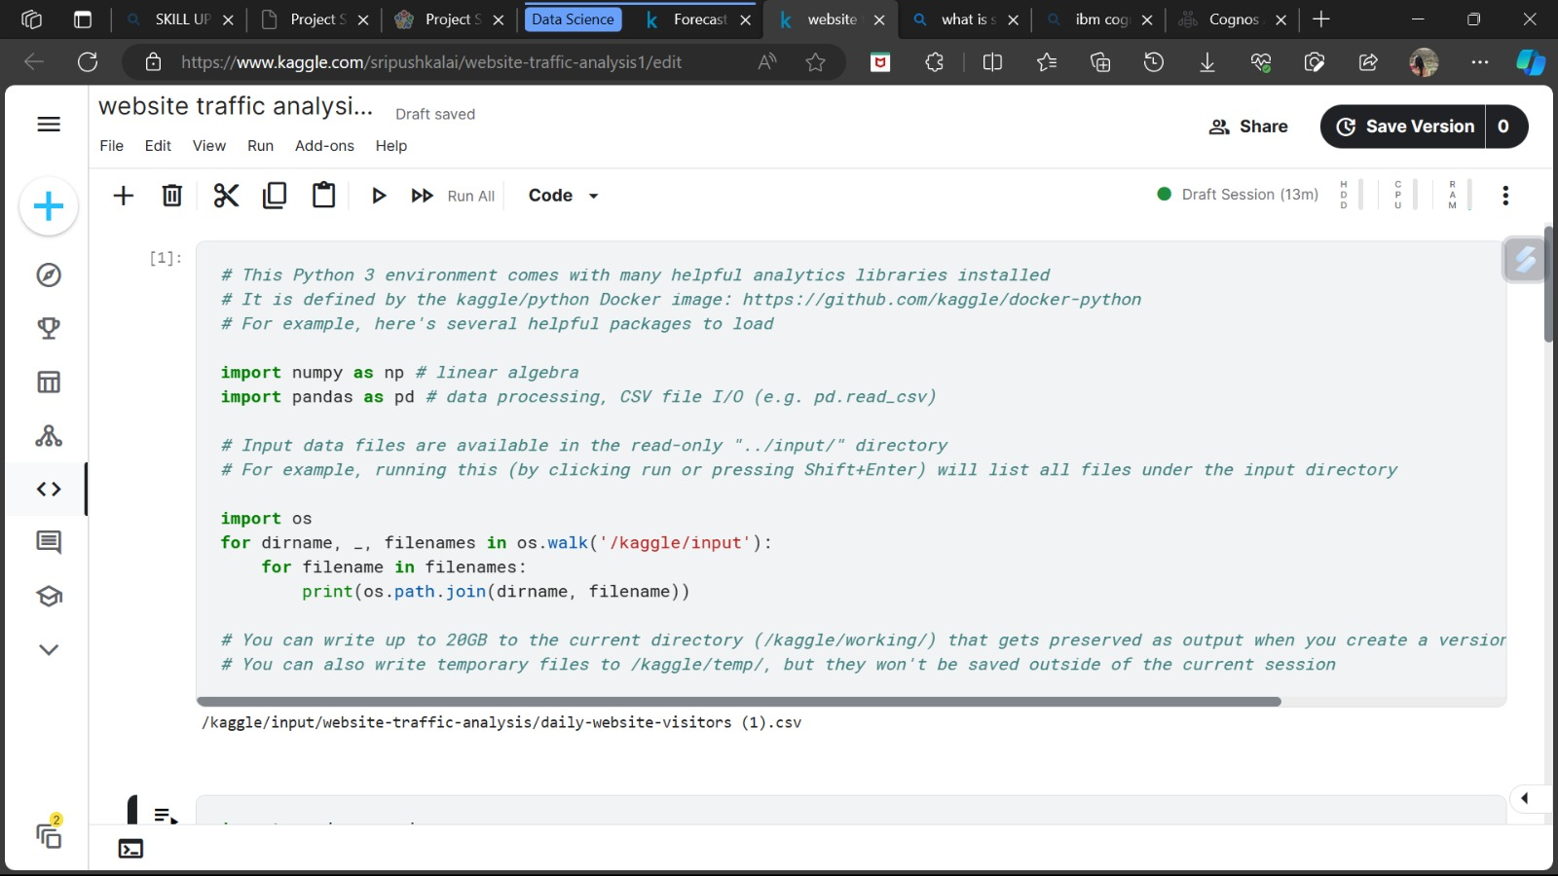

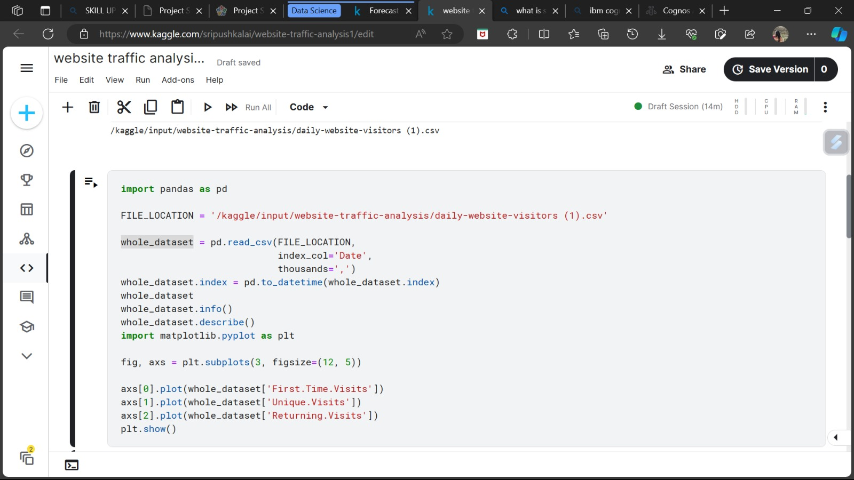

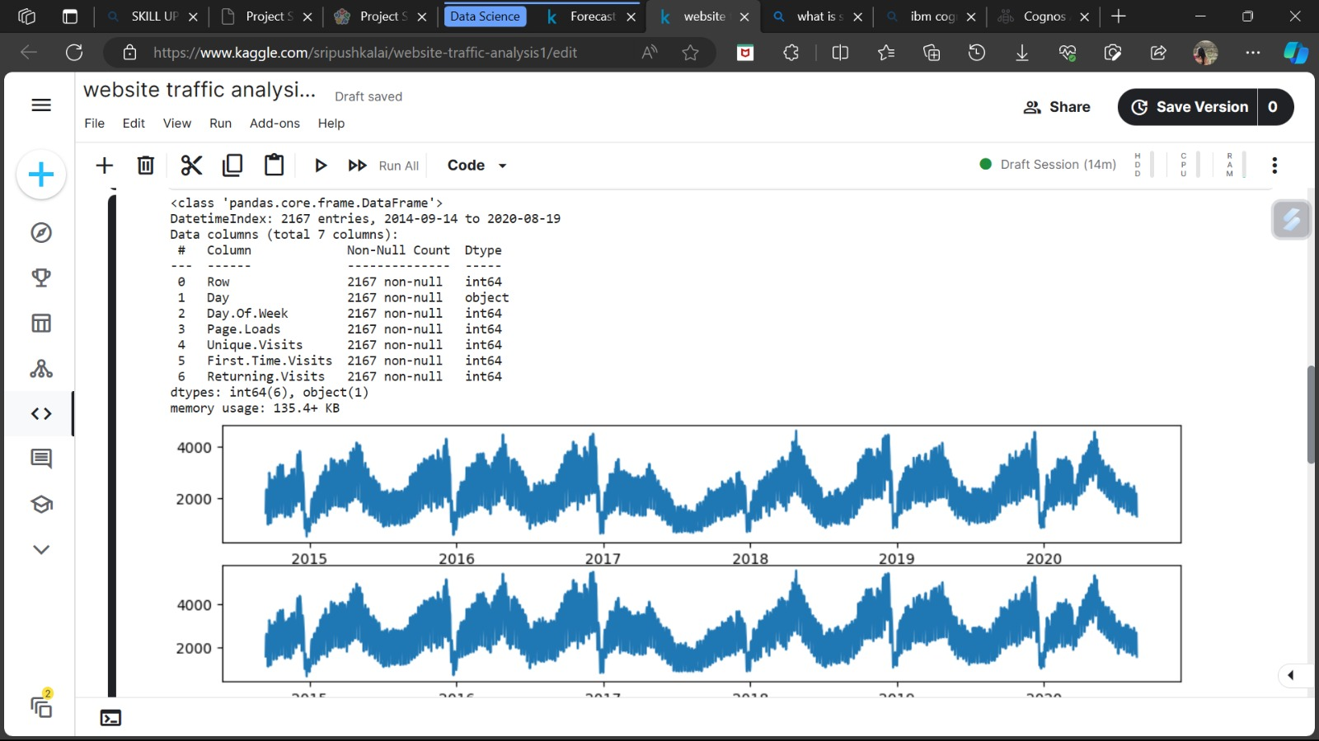

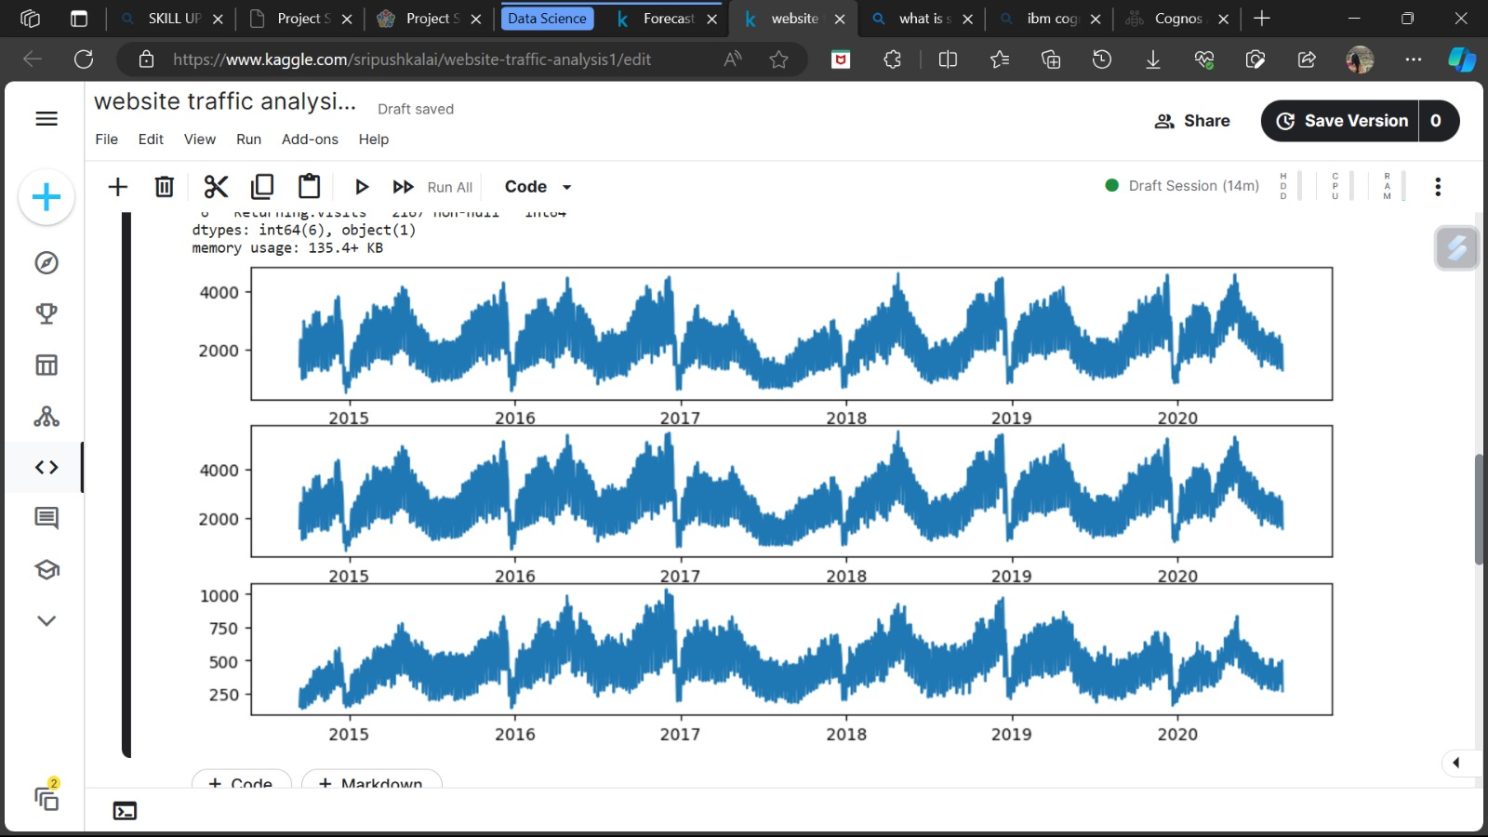

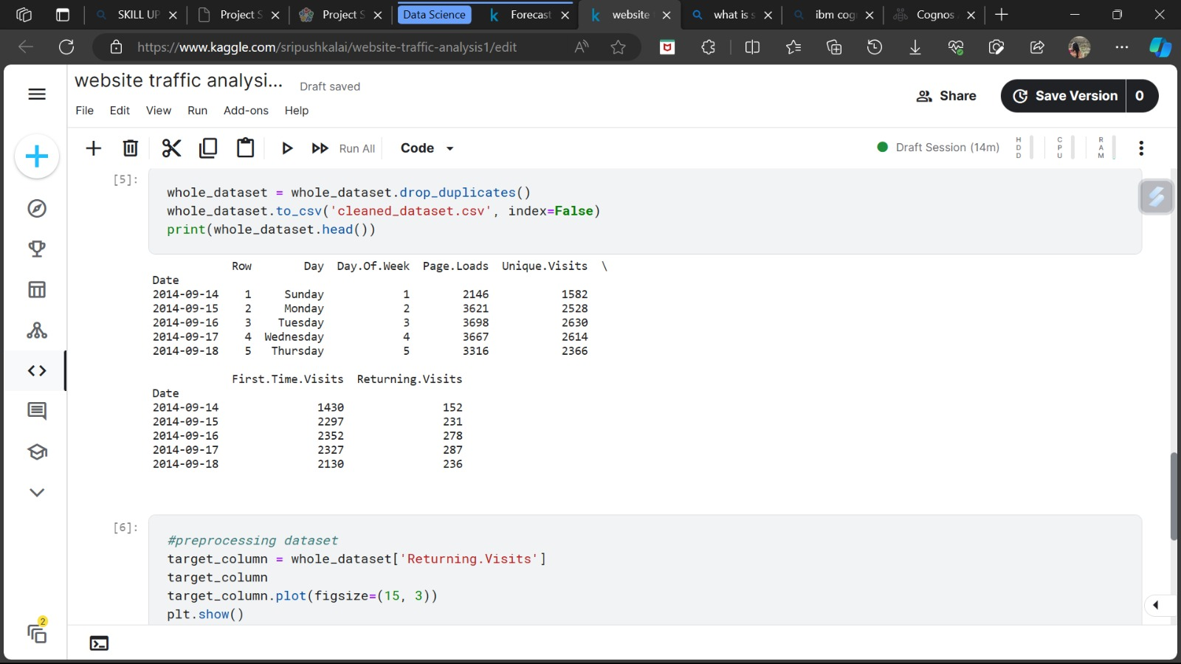

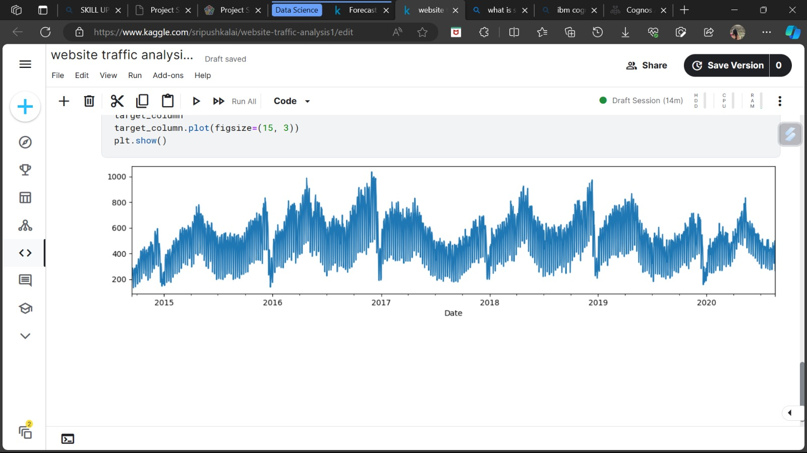

The above code was successfully executed. This was then uploaded to IBM Cognos for visualization and the following graphs were plotted for visualizing the output csv file.

**The following are the insights obtained from IBM Cognos:**

* A pie chart was plotted for number of pages loaded daily:

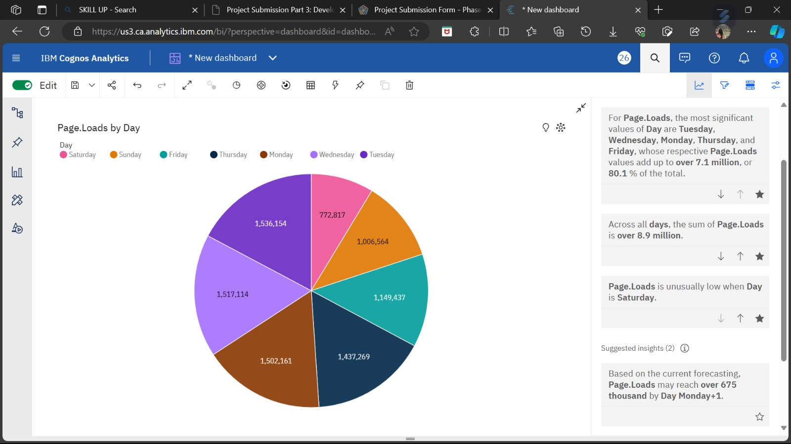

* It is observed that the number of pages loaded was high on Monday, Tuesday and Wednesday.
* Least number of pages were loaded on Saturday.
* A bar graph is plotted for number of webpages loaded daily:

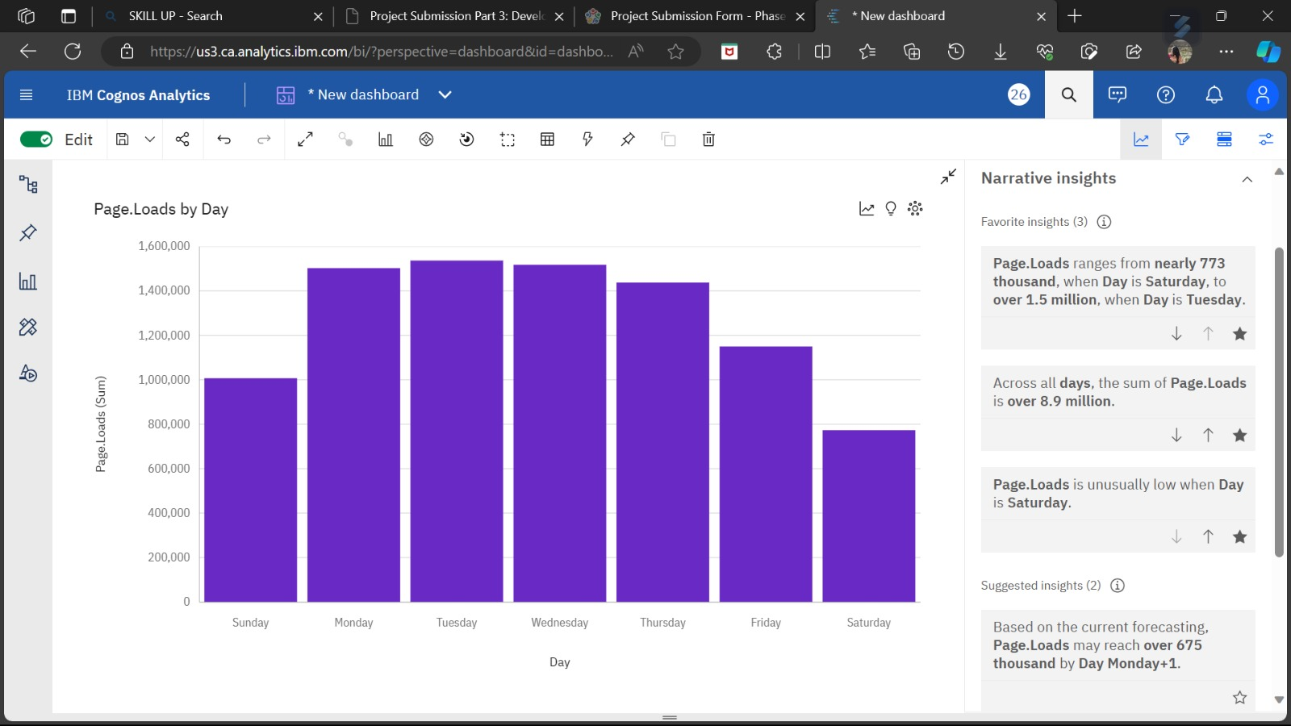

**CONCLUSION:**

Thus the given dataset was cleaned and visualised using IBM Cognos successfully.