`timescale 1ns / 1ps
//////////////////////////////////////////////////////////////////////////////////
// Company:
// Engineer:
//
// Create Date: 13.04.2026 23:35:05
// Design Name:
// Module Name: eqs
// Project Name:
// Target Devices:
// Tool Versions:
// Description:
//
// Dependencies:
//
// Revision:
// Revision 0.01 - File Created
// Additional Comments:
//
//////////////////////////////////////////////////////////////////////////////////

module FA(input a,b,cin, output sum, carry);
assign sum = a ^ b ^ cin;
assign carry = (a & b) | (b & cin) | (a & cin);
endmodule

`timescale 1ns / 1ps
//////////////////////////////////////////////////////////////////////////////////
// Company:
// Engineer:
//
// Create Date: 13.04.2026 23:36:01
// Design Name:
// Module Name: tre
// Project Name:
// Target Devices:
// Tool Versions:
// Description:
//
// Dependencies:
//
// Revision:
// Revision 0.01 - File Created
// Additional Comments:
//
//////////////////////////////////////////////////////////////////////////////////

module CSA_32 (
input [31:0] A, B, C,
output [31:0] SUM,
output [31:0] CARRY
);

genvar i;
generate
for(i=0;i<32;i=i+1) begin
FA fa(A[i], B[i], C[i], SUM[i], CARRY[i]);
end
endgenerate

endmodule

`timescale 1ns / 1ps
//////////////////////////////////////////////////////////////////////////////////
// Company:
// Engineer:
//
// Create Date: 13.04.2026 23:36:39
// Design Name:
// Module Name: yt
// Project Name:
// Target Devices:
// Tool Versions:
// Description:
//
// Dependencies:
//
// Revision:
// Revision 0.01 - File Created
// Additional Comments:
//
//////////////////////////////////////////////////////////////////////////////////

module partial_products (
input [15:0] A, B,
output [31:0] pp0,pp1,pp2,pp3,
output [31:0] pp4,pp5,pp6,pp7,
output [31:0] pp8,pp9,pp10,pp11,
output [31:0] pp12,pp13,pp14,pp15
);

assign pp0 = B[0] ? (A << 0) : 0;
assign pp1 = B[1] ? (A << 1) : 0;
assign pp2 = B[2] ? (A << 2) : 0;
assign pp3 = B[3] ? (A << 3) : 0;
assign pp4 = B[4] ? (A << 4) : 0;
assign pp5 = B[5] ? (A << 5) : 0;
assign pp6 = B[6] ? (A << 6) : 0;
assign pp7 = B[7] ? (A << 7) : 0;

assign pp8 = B[8] ? (A << 8) : 0;
assign pp9 = B[9] ? (A << 9) : 0;
assign pp10 = B[10] ? (A << 10) : 0;
assign pp11 = B[11] ? (A << 11) : 0;
assign pp12 = B[12] ? (A << 12) : 0;
assign pp13 = B[13] ? (A << 13) : 0;
assign pp14 = B[14] ? (A << 14) : 0;
assign pp15 = B[15] ? (A << 15) : 0;

endmodule

`timescale 1ns / 1ps
//////////////////////////////////////////////////////////////////////////////////
// Company:
// Engineer:
//
// Create Date: 13.04.2026 23:37:25
// Design Name:
// Module Name: jh
// Project Name:
// Target Devices:
// Tool Versions:
// Description:
//
// Dependencies:
//
// Revision:
// Revision 0.01 - File Created
// Additional Comments:
//
//////////////////////////////////////////////////////////////////////////////////

module compressor_tree (
input [31:0] pp0,pp1,pp2,pp3,
input [31:0] pp4,pp5,pp6,pp7,
input [31:0] pp8,pp9,pp10,pp11,
input [31:0] pp12,pp13,pp14,pp15,
output [31:0] SUM,
output [31:0] CARRY
);

wire [31:0] s1,c1,s2,c2,s3,c3;

// Stage 1
CSA_32 c1a(pp0,pp1,pp2,s1,c1);
CSA_32 c1b(pp3,pp4,pp5,s2,c2);
CSA_32 c1c(pp6,pp7,pp8,s3,c3);

// Stage 2
wire [31:0] s4,c4,s5,c5;
CSA_32 c2a(s1, c1<<1, s2, s4, c4);
CSA_32 c2b(c2<<1, s3, c3<<1, s5, c5);

// Stage 3
wire [31:0] s6,c6;
CSA_32 c3a(s4, c4<<1, s5, s6, c6);

// Final combine
assign SUM = s6 + (c6<<1) + pp9 + pp10 + pp11 + pp12 + pp13 + pp14 + pp15;
assign CARRY = 32'b0;

endmodule

`timescale 1ns / 1ps
//////////////////////////////////////////////////////////////////////////////////
// Company:
// Engineer:
//
// Create Date: 13.04.2026 23:38:13
// Design Name:
// Module Name: oi
// Project Name:
// Target Devices:
// Tool Versions:
// Description:
//
// Dependencies:
//
// Revision:
// Revision 0.01 - File Created
// Additional Comments:
//
//////////////////////////////////////////////////////////////////////////////////

module hybrid_adder_32bit (
input [31:0] A, B,
output [31:0] SUM
);

assign SUM = A + B; // Synthesized as fast prefix adder

endmodule

`timescale 1ns / 1ps
//////////////////////////////////////////////////////////////////////////////////
// Company:
// Engineer:
//
// Create Date: 13.04.2026 23:38:58
// Design Name:
// Module Name: nh
// Project Name:
// Target Devices:
// Tool Versions:
// Description:
//
// Dependencies:
//
// Revision:
// Revision 0.01 - File Created
// Additional Comments:
//
//////////////////////////////////////////////////////////////////////////////////

module multiplier_16bit_hybrid (
input clk,
input [15:0] A, B,
output reg [31:0] P
);

wire [31:0] pp0,pp1,pp2,pp3;
wire [31:0] pp4,pp5,pp6,pp7;
wire [31:0] pp8,pp9,pp10,pp11;
wire [31:0] pp12,pp13,pp14,pp15;

wire [31:0] sum, carry, result;

// Partial products
partial_products pp_gen(
A,B,
pp0,pp1,pp2,pp3,
pp4,pp5,pp6,pp7,
pp8,pp9,pp10,pp11,
pp12,pp13,pp14,pp15
);

// Compressor tree
compressor_tree ct(
pp0,pp1,pp2,pp3,
pp4,pp5,pp6,pp7,
pp8,pp9,pp10,pp11,
pp12,pp13,pp14,pp15,
sum, carry
);

// Hybrid adder
hybrid_adder_32bit ha(sum, carry, result);

// Pipeline (IMPORTANT)
reg [31:0] stage1;

always @(posedge clk) begin
stage1 <= result;
P <= stage1;
end

endmodule

create_clock -name clk -period 10.000 [get_ports clk]

`timescale 1ns / 1ps
//////////////////////////////////////////////////////////////////////////////////
// Company:
// Engineer:
//
// Create Date: 13.04.2026 23:40:25
// Design Name:
// Module Name: hgf
// Project Name:
// Target Devices:
// Tool Versions:
// Description:
//
// Dependencies:
//
// Revision:
// Revision 0.01 - File Created
// Additional Comments:
//
//////////////////////////////////////////////////////////////////////////////////

module tb;

reg clk;
reg [15:0] A,B;
wire [31:0] P;

multiplier_16bit_hybrid uut(clk,A,B,P);

initial clk=0;
always #5 clk=~clk;

initial begin
A=10; B=5; #30;
A=25; B=4; #30;
A=100; B=20; #30;
$finish;
end

Endmodule

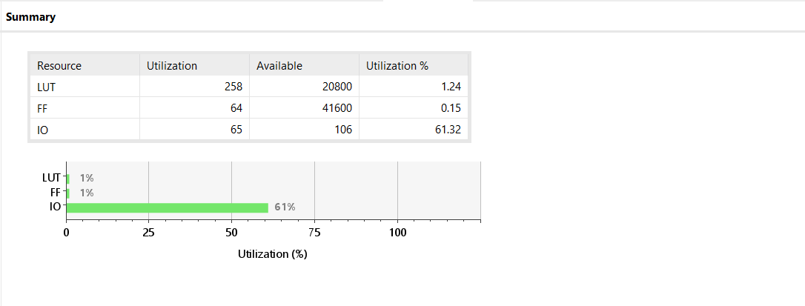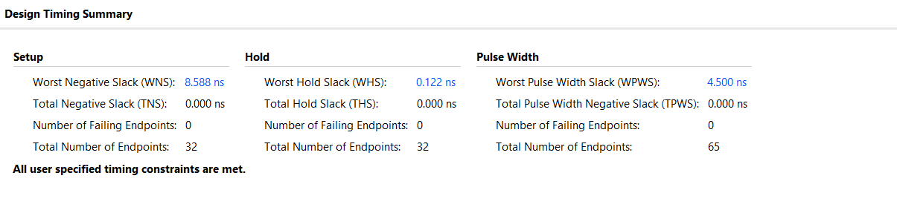

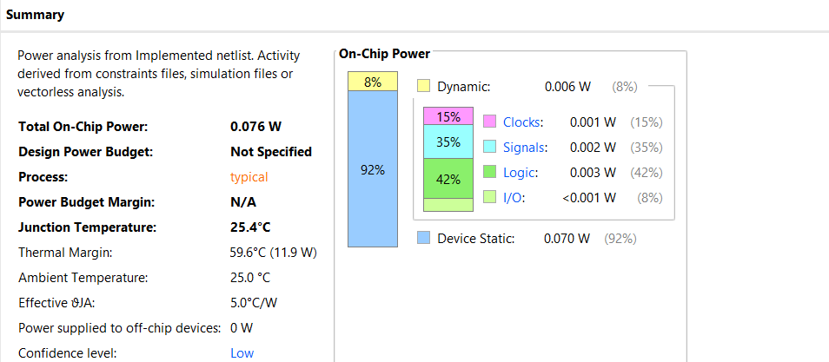

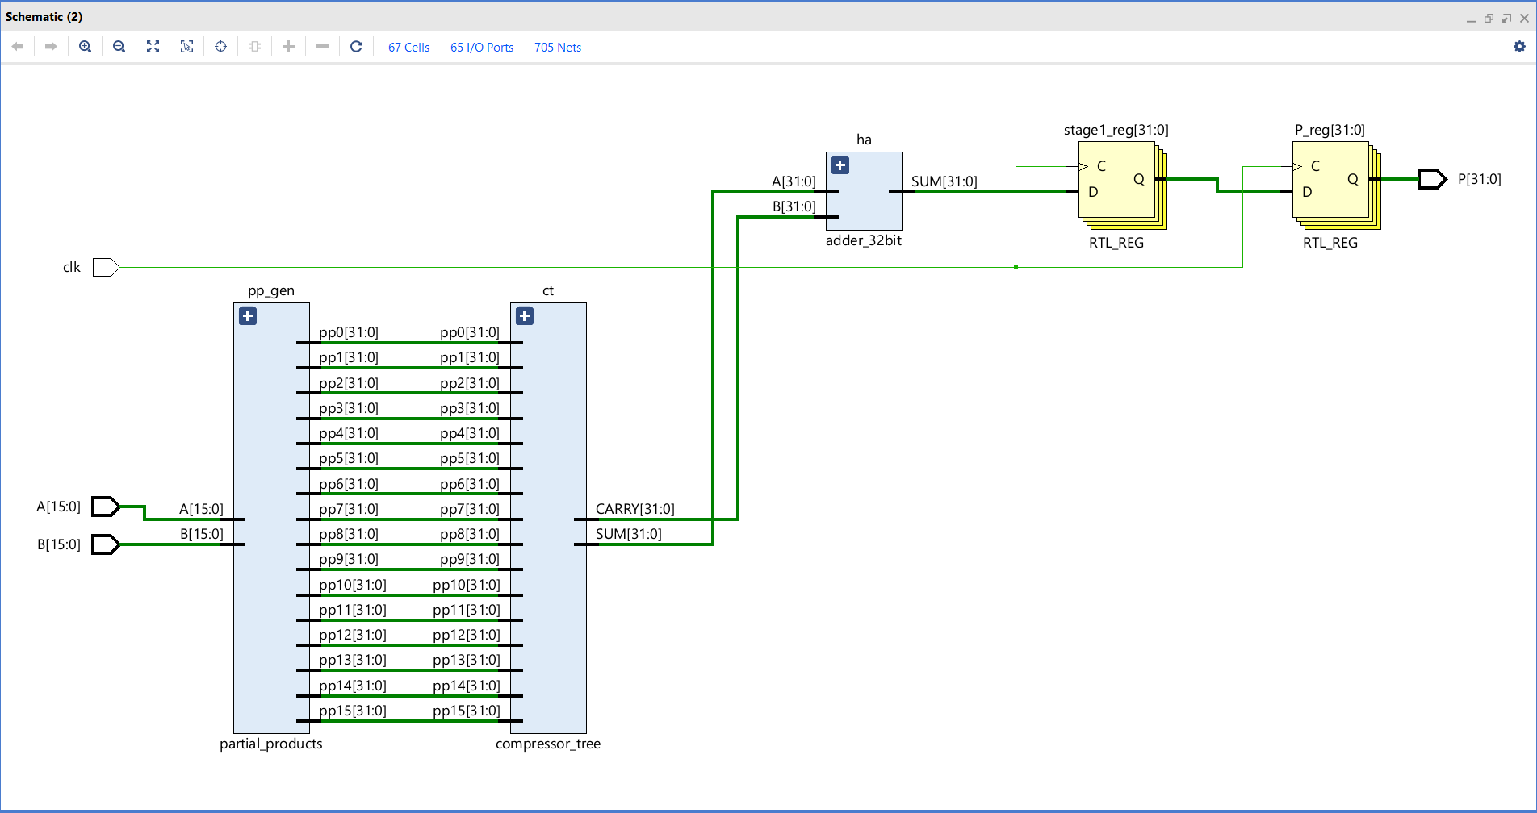
Data Path Delay: 1.288ns (logic 0.518ns (40.228%) route 0.770ns (59.772%))
