### **Podcast Plus: A Redux-Inspired Podcast App With Dynamic Themes For Android**

# INTRODUCTION

## Overview:

Podcast Plus is a Redux-inspired podcast application for Android that allows users to listen to and manage their favorite podcasts. The app features dynamic themes that adapt to the time of day and user preferences. This documentation will guide you through the installation process and explain the app's features..

## Purpose:

The purpose of Podcast Plus is to provide Android users with a Redux-inspired podcast app that offers a variety of features to make it easy to discover, manage, and listen to podcasts. The app's dynamic themes, personalized playlists, and offline playback features make it a convenient and user-friendly option for podcast enthusiasts. Its interface is designed to be visually pleasing and customizable, while its cross-device syncing feature allows users to seamlessly transition between devices. Overall, the purpose of Podcast Plus is to provide a comprehensive and enjoyable podcast listening experience for Android users.

**PROBLEM DEFINITION & DESIGN THINKING**

**2.1 Empathy Map**

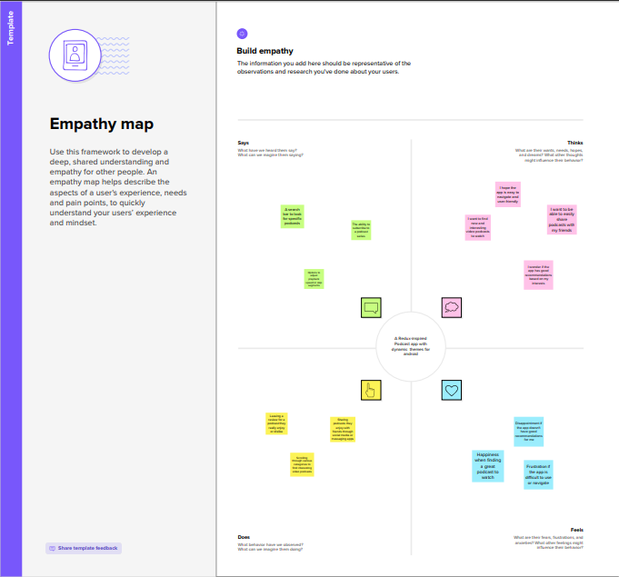

Empathy Map :

**2.2 Ideation & Brainstroming Map**

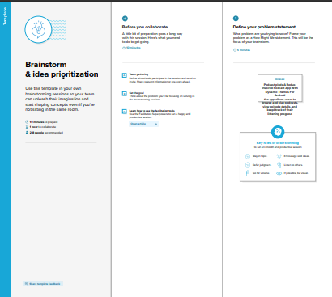

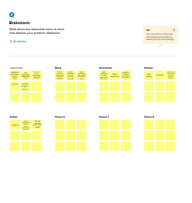

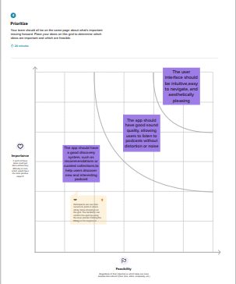

**RESULT :**

**3.1 SCREENSHOTS :**

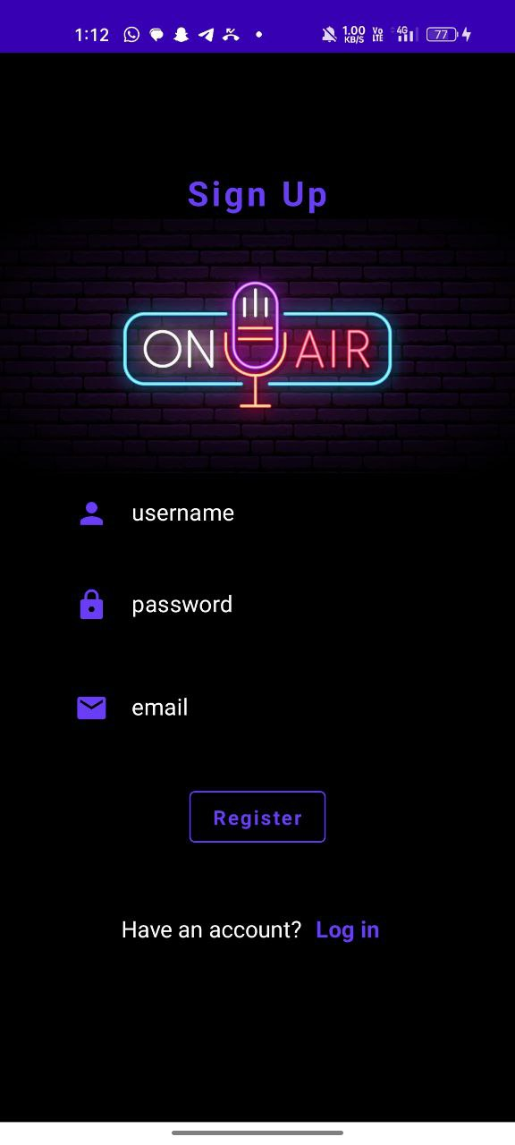**­­­­­­**

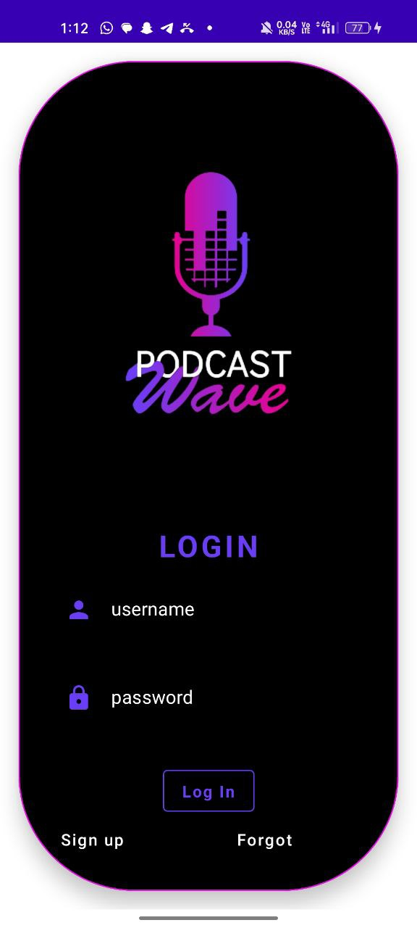



**ADVANTAGES & DISADVANTAGES**

**Advantages**

• Ease of communication: Podcast allows users to communicate with their

contacts in real-time, making it easier for them to stay connected with friends,

family, or colleagues.

• User-friendly interface: The user-friendly interface of Podcast makes it

easy for users to navigate the app and find the features they need.

• Secure communication: The app uses Firebase backend for user

authentication, which provides a secure way for users to log in and protect

their account information.

• Personalization: The user profile feature in Podcast allows users to

personalize their profile picture, status, and other personal information to

make the app more personalized and engaging.

• Real-time messaging: With Firebase Realtime Database, Podcast

provides real-time messaging, ensuring that users receive messages as soon as

they are sent, which can enhance communication and collaboration.

• Accessibility: Podcast is an Android-native app, which means it is

accessible to a wide range of users who own an Android device.

• Customization: As the developer, you can customize Podcast to suit your

user's needs and preferences, adding new features or functionality as needed.

**4.2 Disadvantages**

• Ease Limited functionality: Podcast has limited functionality and is only

designed for basic communication and messaging features. Users may prefer

to use other apps for more advanced features.

• Network connectivity: Podcast requires a stable internet connection to

function correctly. Poor network connectivity can result in slow message

delivery or lost messages.

• Dependency on Firebase: Podcast's backend is dependent on Firebase. If

Firebase experiences downtime or other issues, the app may not function

correctly.

• Limited platform support: Podcast is an Android-native app, which

means it is not available on other platforms like iOS or Windows, potentially

limiting the user base.

• Security risks: As with any messaging app, there is a risk of users sharing

sensitive or personal information, leading to security risks. It is essential to

have measures in place to protect user data and privacy.

• User adoption: With so many messaging apps available, it may be challenging

to attract and retain users to use Podcast as their primary messaging app.

• Maintenance and updates: As the developer, you will need to ensure that the

app is maintained and updated regularly to fix bugs, add new features and stay

current with platform change

**APPLICATIONS**

• Personal communication: Podcast can be used by individuals for

personal communication with friends and family, allowing them to stay in

touch in real-time.

• Business communication: Podcast can be used by businesses for internal

communication, allowing employees to collaborate and share information in

real-time.

• Education: Podcast can be used in educational settings for teacher-

student communication, enabling teachers to provide students with timely

feedback and support.

• Customer support: Podcast can be used by businesses to provide

customer support, allowing customers to communicate with support

representatives in real-time.

• Social networking: Podcast can be used as a social networking platform,

enabling users to connect with new people and make friends.

• Group communication: Podcast can be used for group communication,

allowing users to create groups for different interests and topics, and

communicate with multiple people at once.

• Community-building: Podcast can be used to build online communities

around specific interests, hobbies, or causes, enabling users to connect with

like-minded people and share ideas and experiences.

**CONCLUSION :**

Podcast is a chatting application developed for Android using Kotlin and

Firebase backend. It is designed to enable real-time communication between users,

allowing them to chat and exchange messages in a secure and user-friendly manner.

Podcast provides features such as user authentication, real-time messaging,

user profile, and a simple messaging interface.

While Podcast has several potential advantages, such as ease of

communication, personalization, and real-time messaging, it also has a few potential

disadvantages, including limited functionality, network connectivity dependency,

and limited platform support.

Overall, Podcast can be used for a variety of applications, including personal

communication, business communication, education, customer support, social

networking, group communication, and community-building. With ongoing

maintenance and updates, Podcast has the potential to be a useful tool for

facilitating communication and collaboration among its users.

**FUTURE SCOPE :**

1. Location sharing: By adding location sharing features, users can share their

location with friends or family members, making it easier to meet up or find

each other in real-time.

2. File sharing: The ability to share files through Podcast can be useful for

businesses or individuals who need to share documents or images quickly and

easily.

3. Group messaging: Group messaging allows users to communicate with

multiple people at once, which can be useful for collaboration, event planning,

or socializing.

4. Voice and video calling: By adding voice and video calling features,

Podcast can compete with other popular messaging apps and offer users

more ways to communicate with their contacts.

5. Advanced security features: With the increasing concerns over online privacy

and security, adding advanced security features such as end-to-end

encryption, two-factor authentication, or self-destructing messages can attract

more users and enhance the app's reputation.

6. Integration with other services: Integrating Podcast with other services

such as social media platforms or productivity tools can make it more useful

for users and increase engagement.

7. Artificial Intelligence: Implementing AI in the Podcast app can add more

personalization features such as intelligent chatbots, predictive text, or

personalized recommendations.

By adding these features, Podcast can become a more comprehensive and

competitive messaging app, attracting more users and increasing user engagement.