**Write a code in cpp swapping two  value**

**// Pass by value**

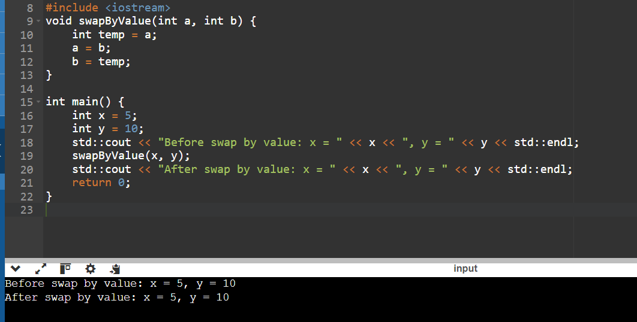

**//Pass by reference**

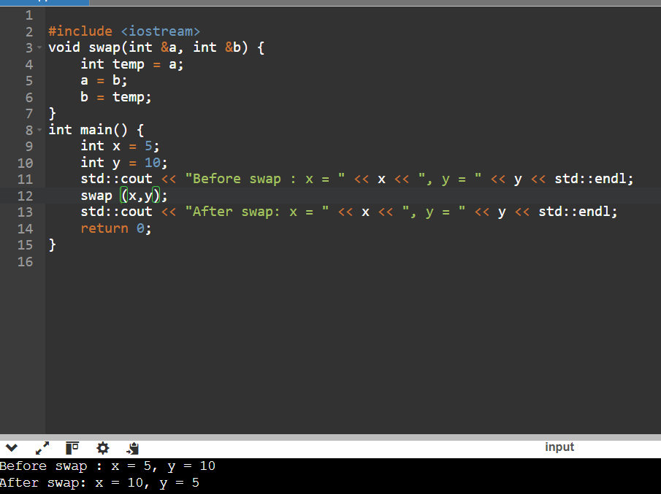

**Ambiguity in function overloading**

#include <iostream>

using namespace std;

void test(int a) {

cout << "x is " << a << endl;

}

void test(int a, int b = 7) {

cout << "x is " << a << endl << "y is " << b << endl;

}

int main() {

int x = 5, y = 7;

test(x); // Calls the single parameter function

test(x, y); // Calls the two-parameter function

return 0;

}

Problem Statement: Distance Calculation Using Operator Overloading You are required to implement a program that calculates distances using operator overloading in C++. The program should be able to perform the following operations on distances: Addition of Distances: Implement an addition operator (+) that adds two distances together. The distance should be represented in feet and inches. Subtraction of Distances: Implement a subtraction operator (-) that subtracts one distance from another. Ensure that the subtraction operation handles cases where the result may involve negative values or borrowing (like in subtraction of inches). Comparison of Distances: Implement comparison operators (==, !=, <, >, <=, >=) to compare distances based on their total length (combined feet and inches). Use these operators to determine which distance is greater, less than, or equal to another. Requirements: Distance Class: Implement a Distance class with appropriate member variables (feet and inches). Constructors: Implement constructors to initialize distances. Member Functions: Implement member functions for display and any other necessary operations. Operator Overloading: Overload the necessary operators (+, -, ==, !=, <, >, <=, >=) inside the Distance class to perform the specified operations. Testing: Create a main() function to test the implemented Distance class and its operator overloading functionality. Test various scenarios including addition, subtraction, and comparison of distances

#include <iostream>

using namespace std;

class Distance {

private:

int feet;

int inches;

public:

// Constructor

Distance(int ft = 0, int in = 0) : feet(ft), inches(in) {

normalize(); // Normalize the distance to ensure inches < 12

}

// Getter functions

int getFeet() const {

return feet;

}

int getInches() const {

return inches;

}

// Overloading addition operator (+)

Distance operator+(const Distance& other) const {

int totalFeet = feet + other.feet;

int totalInches = inches + other.inches;

return Distance(totalFeet, totalInches);

}

// Overloading subtraction operator (-)

Distance operator-(const Distance& other) const {

int totalFeet = feet - other.feet;

int totalInches = inches - other.inches;

if (totalInches < 0) {

totalFeet--; // Borrow one foot

totalInches += 12; // Convert negative inches to positive

}

return Distance(totalFeet, totalInches);

}

// Comparison operators

bool operator==(const Distance& other) const {

return (feet == other.feet && inches == other.inches);

}

bool operator!=(const Distance& other) const {

return !(*this == other);

}

bool operator<(const Distance& other) const {

if (feet < other.feet) {

return true;

} else if (feet == other.feet) {

return inches < other.inches;

} else {

return false;

}

}

bool operator>(const Distance& other) const {

return !(*this < other || *this == other);

}

bool operator<=(const Distance& other) const {

return (*this < other || *this == other);

}

bool operator>=(const Distance& other) const {

return !(*this < other);

}

// Display function

void display() const {

cout << feet << " feet " << inches << " inches";

}

private:

// Helper function to normalize distance (inches should be < 12)

void normalize() {

if (inches >= 12) {

feet += inches / 12;

inches %= 12;

} else if (inches < 0) {

int borrowFeet = (abs(inches) + 11) / 12;

feet -= borrowFeet;

inches += borrowFeet * 12;

}

}

};

// Main function to test Distance class

int main() {

Distance d1(5, 8);

Distance d2(3, 10);

// Addition

Distance sum = d1 + d2;

cout << "Sum: ";

sum.display();

cout << endl;

// Subtraction

Distance diff = d1 - d2;

cout << "Difference: ";

diff.display();

cout << endl;

// Comparisons

cout << "Comparison: ";

d1.display();

if (d1 == d2) {

cout << " is equal to ";

} else if (d1 != d2) {

cout << " is not equal to ";

}

d2.display();

cout << endl;

cout << "Comparison: ";

d1.display();

if (d1 < d2) {

cout << " is less than ";

} else if (d1 > d2) {

cout << " is greater than ";

} else {

cout << " is equal to ";

}

d2.display();

cout << endl;

return 0;

}

**OUTPUT:**

Sum: 9 feet 6 inches

Difference: 1 feet 10 inches

Comparison: 5 feet 8 inches is not equal to 3 feet 10 inches

Comparison: 5 feet 8 inches is greater than 3 feet 10 inches

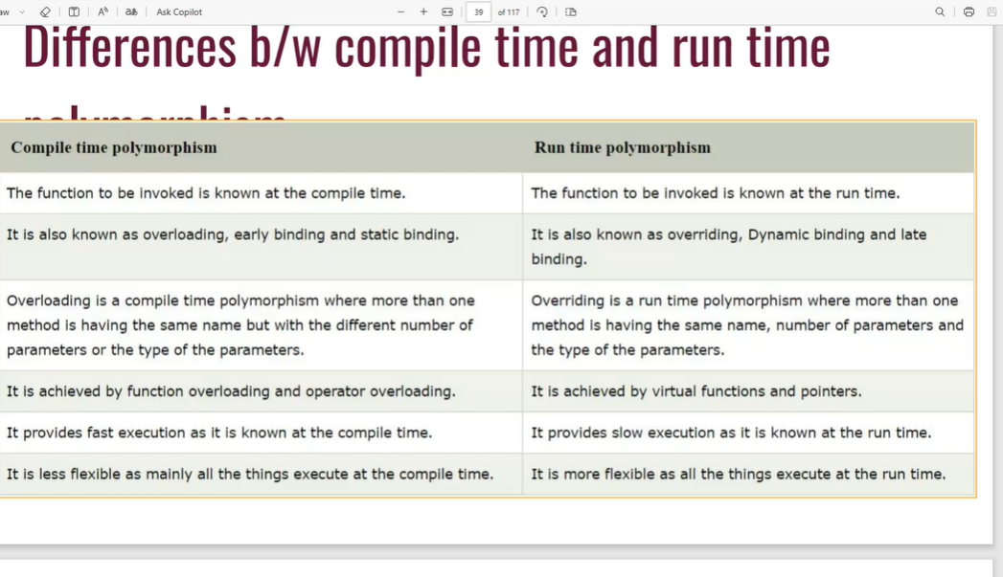

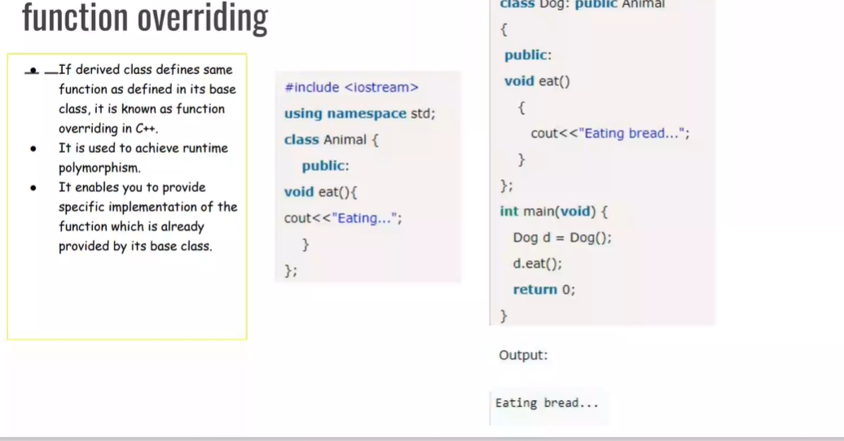

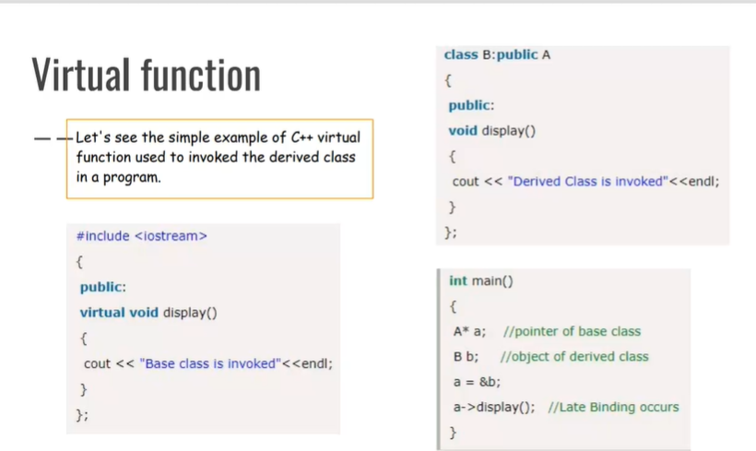

**Q.Create a base class Shape with a pure virtual function draw() that has no implementation. Derive classes Square, Circle, and Triangle from Shape. Each derived class should override draw() to provide its specific drawing behavior (e.g., printing "*" for square, "OOO" for circle, etc.). Write a function printShape(Shape shape) that takes a base class pointer and calls draw() on it. Demonstrate polymorphism by creating objects of the derived classes, storing them in a Shape* array, and calling printShape() on each element.**

#include <iostream>

#include <vector>

using namespace std;

class Shape {

public:

virtual void draw() const = 0;

virtual ~Shape() = default;

};

class Square : public Shape {

public:

void draw() const override {

cout << "****\n* *\n****" << endl;

}

};

class Circle : public Shape {

public:

void draw() const override {

cout << " OOO \nO O\n OOO " << endl;

}

};

class Triangle : public Shape {

public:

void draw() const override {

cout << " * \n * * \n*****" << endl;

}

};

void printShape(const Shape* shape) {

shape->draw();

}

int main() {

Square square;

Circle circle;

Triangle triangle;

vector<Shape*> shapes = {&square, &circle, &triangle};

for (const auto& shape : shapes) {

printShape(shape);

cout << endl;

}

return 0;

}

**OUTPUT:**

****

* *

****

OOO

O O

OOO

*

* *

*****

**Design a base class Animal with a pure virtual function makeSound() that returns a string representing the animal's sound. Derive classes like Dog, Cat, and Bird from Animal, each overriding makeSound() with the appropriate sound ("Woof!", "Meow!", "Chirp!"). Create a function playAnimalSound(Animal* animal) that takes an Animal pointer and calls makeSound(). Populate an Animal* array with various animal objects and use playAnimalSound() to hear their sounds polymorphically.**

#include <iostream>

#include <string>

using namespace std;

// Base class Animal

class Animal {

public:

virtual string makeSound() = 0; // Pure virtual function

};

// Derived class Dog

class Dog : public Animal {

public:

string makeSound() override {

return "Woof!";

}

};

// Derived class Cat

class Cat : public Animal {

public:

string makeSound() override {

return "Meow!";

}

};

// Derived class Bird

class Bird : public Animal {

public:

string makeSound() override {

return "Chirp!";

}

};

// Function to play animal sound

void playAnimalSound(Animal* animal) {

cout << animal->makeSound() << endl;

}

int main() {

// Create objects of derived classes

Dog dog;

Cat cat;

Bird bird;

// Array of Animal pointers

Animal* animals[] = { &dog, &cat, &bird };

// Call playAnimalSound() on each element

for (int i = 0; i < 3; ++i) {

playAnimalSound(animals[i]);

}

return 0;

}

**OUTPUT:**

Woof!

Meow!

Chirp!

Copy Constructor:

