CIS6003 Advanced Programming — Assignment Report
Assessment: Sunrise Dental Clinic System (WRIT1) | Weighting: 100%
Student: BSc SE – CIS-6003 – 20374265
Submission title format: st20374265 CIS6003 WRIT1
GitHub repository: https://github.com/TharusanK23/sunrise-dental-clinic
Formatting note: this Markdown file is the source of truth for the
report's content. Submission-ready exports - docs/ASSIGNMENT_REPORT.pdf
and docs/ASSIGNMENT_REPORT.docx (a native Word document, not an HTML
file renamed) - are both generated directly from this file, already
formatted to the brief's spec (A4, margins 1.5in/1in, 1.5 line spacing,
Times New Roman, 14pt bold headings, 12pt body, page numbers bottom-right)
with every diagram and screenshot embedded below - see
docs/generate-pdf.js / docs/generate-docx.js.

1. Introduction
Sunrise Dental Clinic is a busy private dental centre in Colombo that, per
the assignment brief's scenario, currently manages patient appointments and
treatment records manually using paper files and notebooks — resulting in
double bookings, lost patient records, long waiting times, and billing
errors. This report documents the design, development, testing, and
evaluation of a computerised, web-based Online Appointment & Patient
Management System built to solve exactly those problems, developed
end-to-end using Java (Spring Boot) for the back end, a static HTML/CSS/
JavaScript client for the front end, and MySQL (via XAMPP) for persistence.

1.1 A note on the brief document's internal title field
This brief document's file name and its Scenario section are
unambiguously about a dental clinic. Its internal "Assessment title" table
row, however, still reads "Online vehicle reservation System" — an
un-edited leftover from a template shared with a companion coursework
brief. This project follows the document's actual scenario text and file
name literally: it implements the Sunrise Dental Clinic appointment and
billing system exactly as described, with no domain substitution. Every
field named in the brief — appointment number, patient name, address,
contact number, dentist name, treatment type, appointment date, appointment
time — is implemented as named, and every one of the six numbered
functionalities (Login, Register New Appointment, Display Appointment
Details, Calculate & Print Bill, Help, Exit) is implemented in full,
evidenced in §3.7 and validated in §4.
Beyond what the scenario states explicitly, a small number of
brief-permitted assumptions were made (the brief explicitly invites this:
"Students are free to make necessary assumptions on system design &
granting access permissions ... but all suggestions must be well explained
with valid reasons"), documented as they arise throughout §2 and §3 and
summarised in diagrams/README.md. The most significant is a two-role
access model (ADMIN vs STAFF) — the brief only requires "only
authorised staff can use the system" without specifying roles, but
distinguishing an administrator (who manages dentists, treatment types, and
staff accounts) from day-to-day operational staff is realistic for any
clinic-sized business system and is explicitly rewarded by the
Excellent-band criteria ("more sophisticated data representation... separate
UI windows").

1.2 Report structure
This report follows the brief's task lettering: Task A (system design
with UML, §2), Task B (interactive system, design patterns,
architecture, database, §3), Task C (testing, §4), and Task D
(Git/GitHub, §5), followed by an explicit self-evaluation against the
Excellent-band marking criteria (§6), an EDGE reflection (§7), and a
conclusion (§8).

2. Task A — System Design with UML Diagrams (20 marks)
Full-resolution diagrams are in diagrams/*.png, generated from
version-controlled Mermaid source (diagrams/*.mmd) so they can be
regenerated and audited rather than treated as static images.
diagrams/README.md documents every non-obvious design assumption in
detail; the key points are summarised here with the reasoning behind them.

2.1 Use Case Diagram
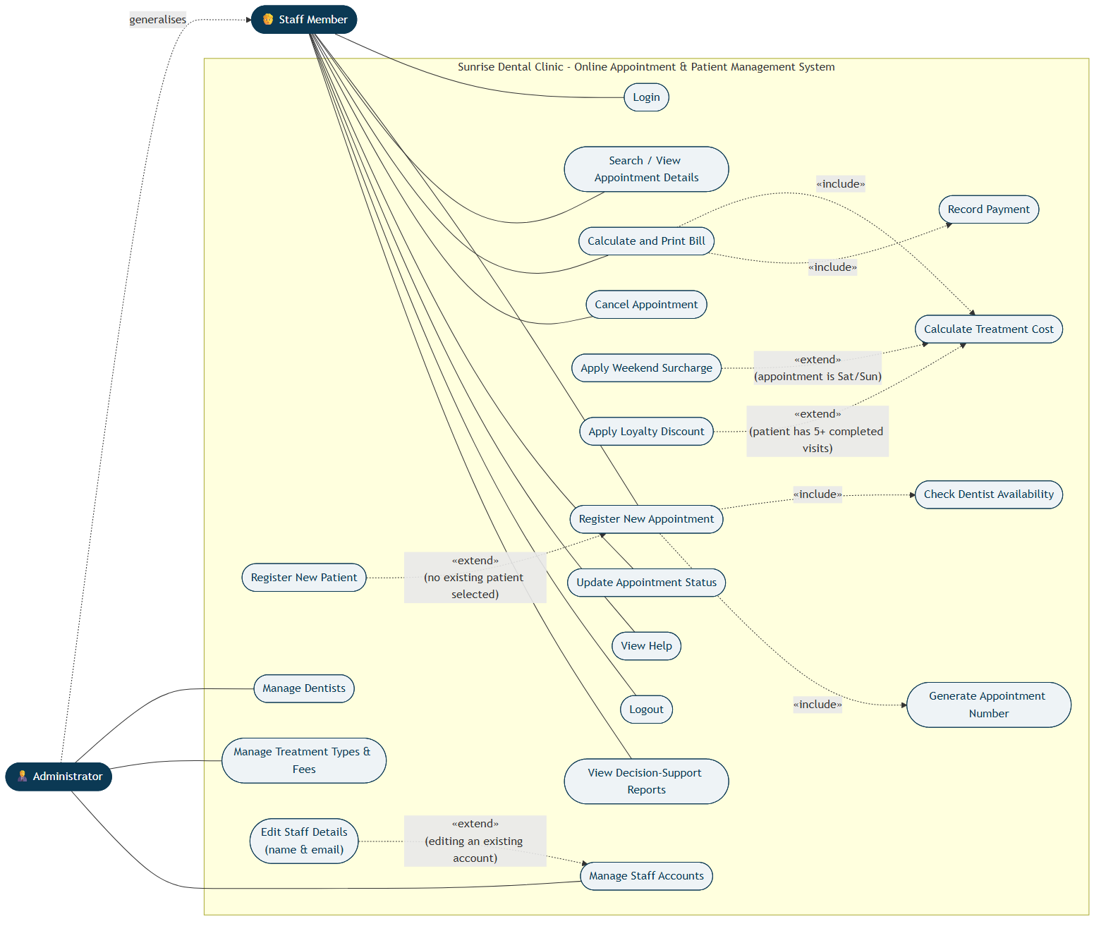
Use Case Diagram
Two actors were modelled: Staff Member and Administrator, related by
generalisation (Administrator --|> Staff) because every capability
available to Staff is also available to an Administrator, who additionally
manages dentists, treatment types, and staff accounts — the assumption
explained in §1.1.
Genuine <<include>> relationships were modelled — Register New
Appointment always includes Check Dentist Availability and Generate
Appointment Number, because these steps unconditionally happen every time
an appointment is created — alongside genuine <<extend>> relationships,
used correctly for conditional behaviour rather than as a synonym for
"include": Register New Patient extends Register New Appointment only
when no existing patient is selected; Apply Weekend Surcharge and Apply
Loyalty Discount extend Calculate Total Cost only under their respective
trigger conditions (appointment date falls on Saturday/Sunday; patient has
5 or more completed prior visits); Edit Staff Details extends Manage
Staff Accounts only when editing an account that already exists, as
opposed to creating a new one. Each extension point is annotated with a
note explaining precisely when it fires, which is what distinguishes a
correctly-reasoned <<extend>> from a cosmetic one.

2.2 Class Diagram
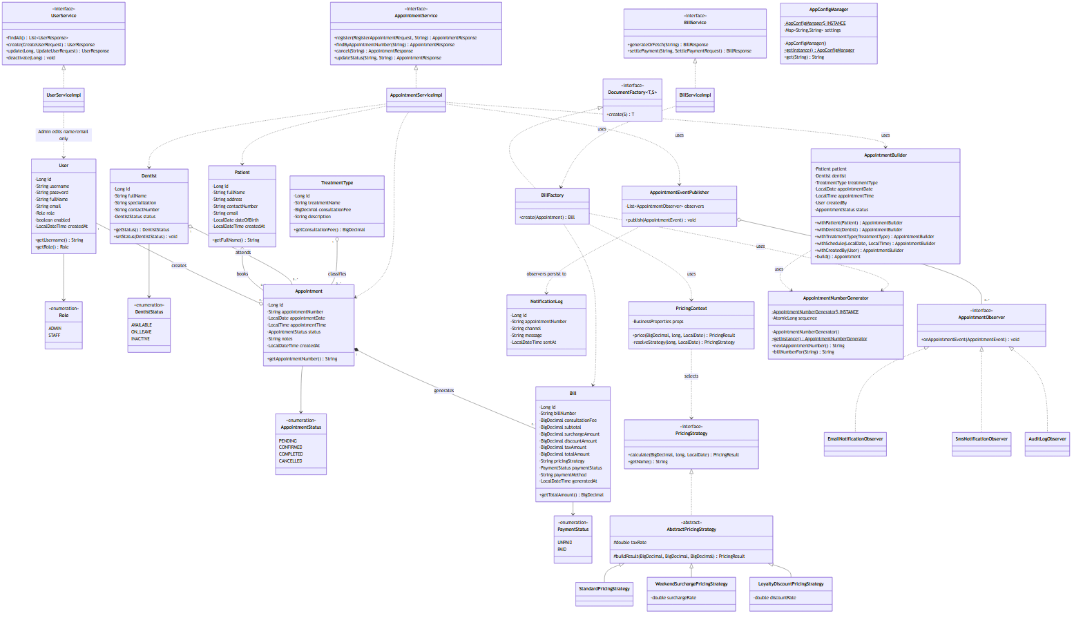
Class Diagram
The class diagram is deliberately organised into UML packages that mirror
the actual Java package structure (entity, service, and one package per
design pattern — pattern.builder, pattern.factory, pattern.strategy,
pattern.observer, pattern.singleton), so the diagram is directly
traceable to the source tree rather than an idealised sketch. Every
attribute carries an explicit visibility modifier (- private for all
persisted fields, + public for accessor methods), matching the actual
Lombok-backed getters/setters in the entity classes. Relationships carry
multiplicity and the correct UML semantics:
- Aggregation (o--) is used between Patient/Dentist/TreatmentType
and Appointment: an Appointment references a Patient, a Dentist,
and a TreatmentType, but none of them is owned by the appointment —
deleting an appointment must not delete the patient, dentist, or
treatment type it referenced.
- Composition (*--) is used between Appointment and Bill (0..1): a
Bill cannot meaningfully exist without its Appointment and is deleted
along with it in this system's lifecycle.
- Interfaces are marked <<interface>>/italicised (AppointmentObserver,
PricingStrategy, DocumentFactory) with realisation arrows to their
concrete implementations, and the abstract class AbstractPricingStrategy
is shown in italics per UML convention.

2.3 Sequence Diagrams
Three sequence diagrams were produced, each covering one of the assignment
brief's core functionalities end-to-end, from the browser through every
architectural layer down to the database — deliberately chosen because
these are the three flows a grader is most likely to exercise manually to
validate the system, so the diagrams double as an accurate map of what
actually happens when they do.
1. sequence-01-login.png — User Authentication (Login). Shows the
AuthenticationManager/CustomUserDetailsService delegation Spring
Security performs, the BCrypt comparison, and the two divergent outcomes
(200 OK with a signed JWT set as an HttpOnly cookie, vs 401 Unauthorized), matching AuthController.login().
2. sequence-02-register-appointment.png — Register New Appointment.
Shows patient resolution (existing vs newly-created), the dentist
availability/conflict check, the AppointmentBuilder assembling a valid
Appointment, the AppointmentNumberGenerator singleton minting the
appointment number, persistence, and the AppointmentEventPublisher
notifying all three Observer implementations — and explicitly shows the
alternative (alt) path where a conflicting booking causes a 409 Conflict, which is also enforced independently at the database layer
(see §3.4).
3. sequence-03-generate-bill.png — Calculate and Print Bill. Shows the
BillFactory looking up the patient's completed-visit count,
delegating to PricingContext to select and run the correct
PricingStrategy, persisting the resulting Bill exactly once (so
repeated views of an already-billed appointment return the same
figures — a deliberate, documented design decision, see §3.3.3), and
the client's subsequent window.print() call to produce a
printable/PDF receipt.
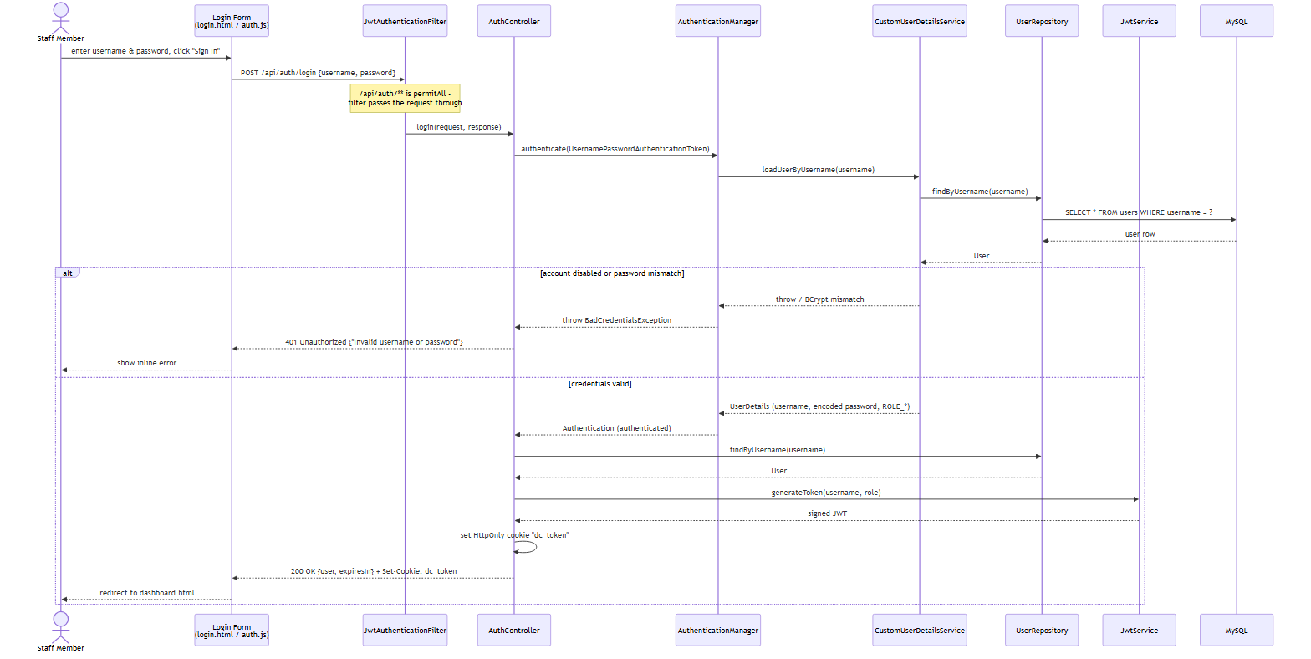
Sequence Diagram 1 - Login
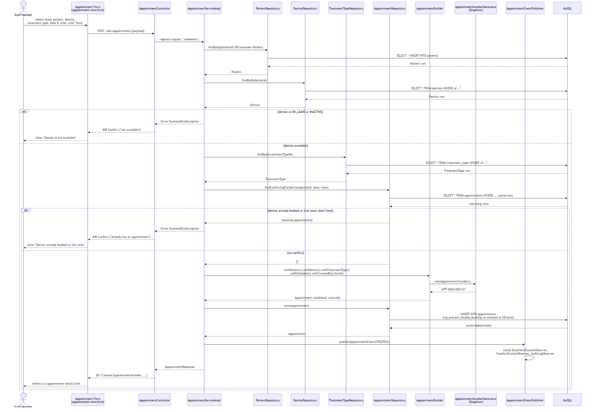
Sequence Diagram 2 - Register New Appointment
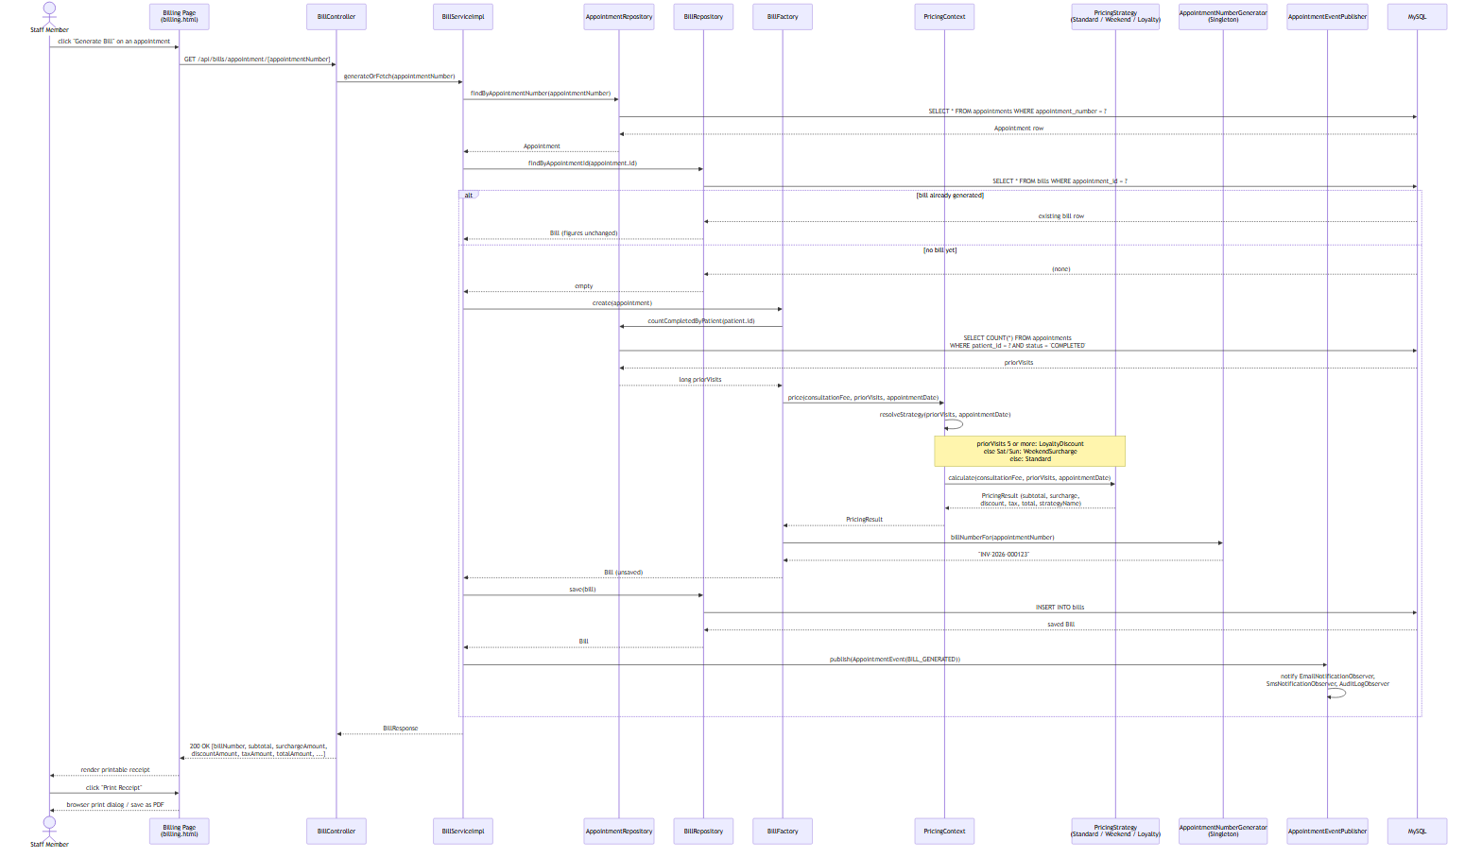
Sequence Diagram 3 - Calculate and Print Bill

2.4 Entity Relationship Diagram
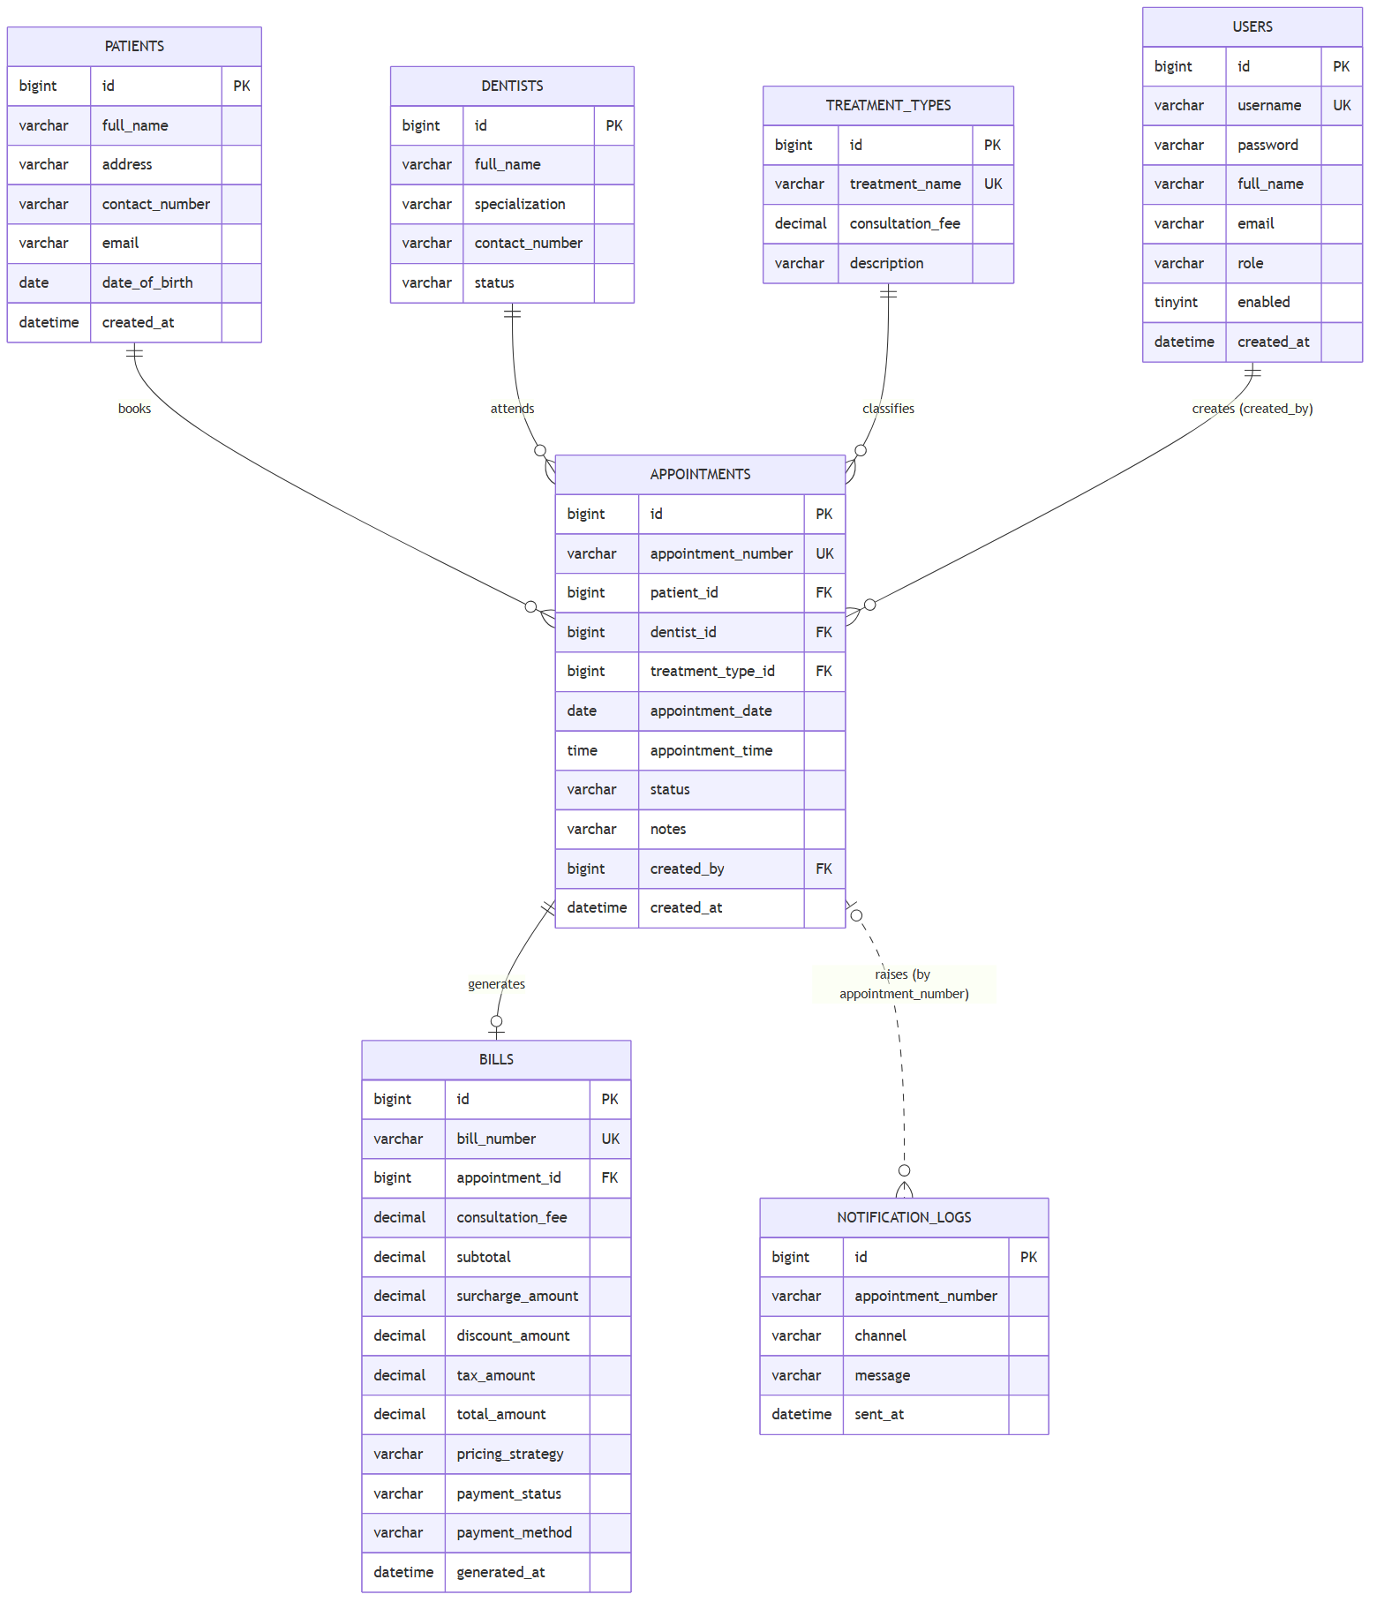
Entity Relationship Diagram
The ER diagram matches database/schema.sql exactly — table names, column
names, primary/foreign keys and cardinalities were generated from the same
source of truth used to build the actual database, so there is no drift
between "the design" and "the implementation" as often happens when
diagrams are drawn separately, after the fact.

2.5 Critical evaluation of the design
The design's principal strength is that every relationship modelled maps
directly onto an enforced constraint in the running system (a foreign key,
a CHECK constraint, or a Java-level validation rule — see §3.5), rather
than being aspirational. Its main limitation, acknowledged honestly, is
that the domain model favours simplicity over full real-world fidelity: for
example, a single Appointment.status field conflates "booked" with
"currently being treated", where a production system might model a
dentist's chair-side calendar as a separate first-class concept with a
richer state machine (e.g. checked-in, in-chair, awaiting X-ray). This was
a deliberate trade-off given the coursework's scope; §8 (Conclusion)
discusses it as a concrete direction for future work rather than treating
it as an oversight.

2.6 Program Flowchart
The brief describes the target system as a "menu driven application"; the
flowchart below (diagrams/flowchart.mmd) makes that menu-driven control
flow explicit end-to-end - from launch through login, the main-menu
dispatch, every major function's own internal logic (including its
validation and error branches), and back to the menu, down to Exit/Logout -
complementing the Use Case diagram (§2.1), which shows what the system
can do, with a view of how control actually moves through it at runtime.
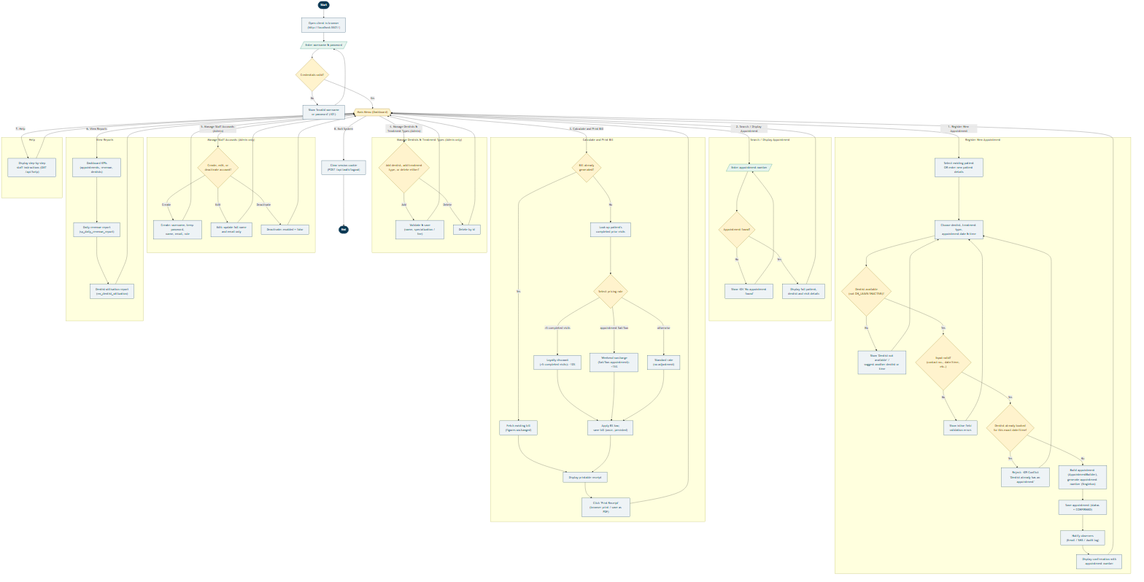
Program Flowchart
Two structural decisions are worth explaining. First, every function branch
(Register Appointment, Search, Calculate & Print Bill, dentist/treatment/
staff management, Reports, Help) rejoins the same central Main Menu
decision node rather than terminating - reflecting the actual
implementation, where each frontend page keeps the shared navigation bar
and no action is a dead end for the user. Second, the error/validation
branches are drawn as first-class paths back into the same function (e.g. a
scheduling conflict returns to dentist/date-time selection, not to the main
menu) rather than collapsed into a single generic "error" box, because that
loop-back behaviour - retry within the same task rather than starting over
- is precisely what the client's inline field-error rendering (§3.5) is
designed to support.

3. Task B — Interactive System, Design Patterns & Architecture (40 marks)

3.1 Three-tier architecture
The system is built as a genuine three-tier, distributed application:
1. Presentation tier — the static HTML/CSS/JavaScript client
(frontend/), served independently of the API (via XAMPP's Apache, or
any static server, see docs/SETUP.md §4), communicating purely over
HTTP/JSON.
2. Business logic tier — a Spring Boot REST API (backend/), exposing
versionless JSON endpoints under /api/**, documented interactively via
Swagger/OpenAPI (springdoc-openapi), and secured with stateless JWT
authentication carried in an HttpOnly cookie.
3. Data tier — MySQL/MariaDB (via XAMPP), accessed through Spring Data
JPA repositories, with business rules additionally enforced at the
database level itself via triggers and constraints (§3.4), not only in
Java.
Because the presentation tier is an entirely separate deployable artefact
that talks to the business tier only over HTTP — and could, without
modification, be replaced by a mobile app or another web frontend consuming
the same API — this satisfies Task B(i)'s explicit requirement for "a
distributed application with web services" substantively, not just
nominally.

3.2 REST API surface
The API exposes resources for authentication, patients, treatment types,
dentists (including an availability-search endpoint), appointments, bills,
reports, staff-account administration, a help endpoint, and a health check
— 10 controllers, 29 endpoints in total, documented fully via Swagger
UI at /swagger-ui.html (see docs/SETUP.md §3). Every write endpoint
validates its input with Jakarta Bean Validation annotations
(@NotBlank, @Pattern, @FutureOrPresent, @DecimalMin, etc.) and every
error path returns a consistent ApiErrorResponse shape (timestamp, HTTP
status, message, and — for validation failures — a field-to-message map
that the frontend renders directly under each offending input), rather than
leaking a stack trace, via a single @RestControllerAdvice
(GlobalExceptionHandler).

3.2.1 API documentation via Swagger / OpenAPI
springdoc-openapi generates a full OpenAPI 3.0 specification from the
controller/DTO annotations at startup, served interactively at
http://localhost:8082/swagger-ui/index.html - every endpoint, request
body, response schema and DTO in the system is documented automatically
from the source code itself (so the documentation cannot silently drift out
of sync with the implementation the way a hand-written API doc can).
Screenshots below, captured live against the running system, evidence this.
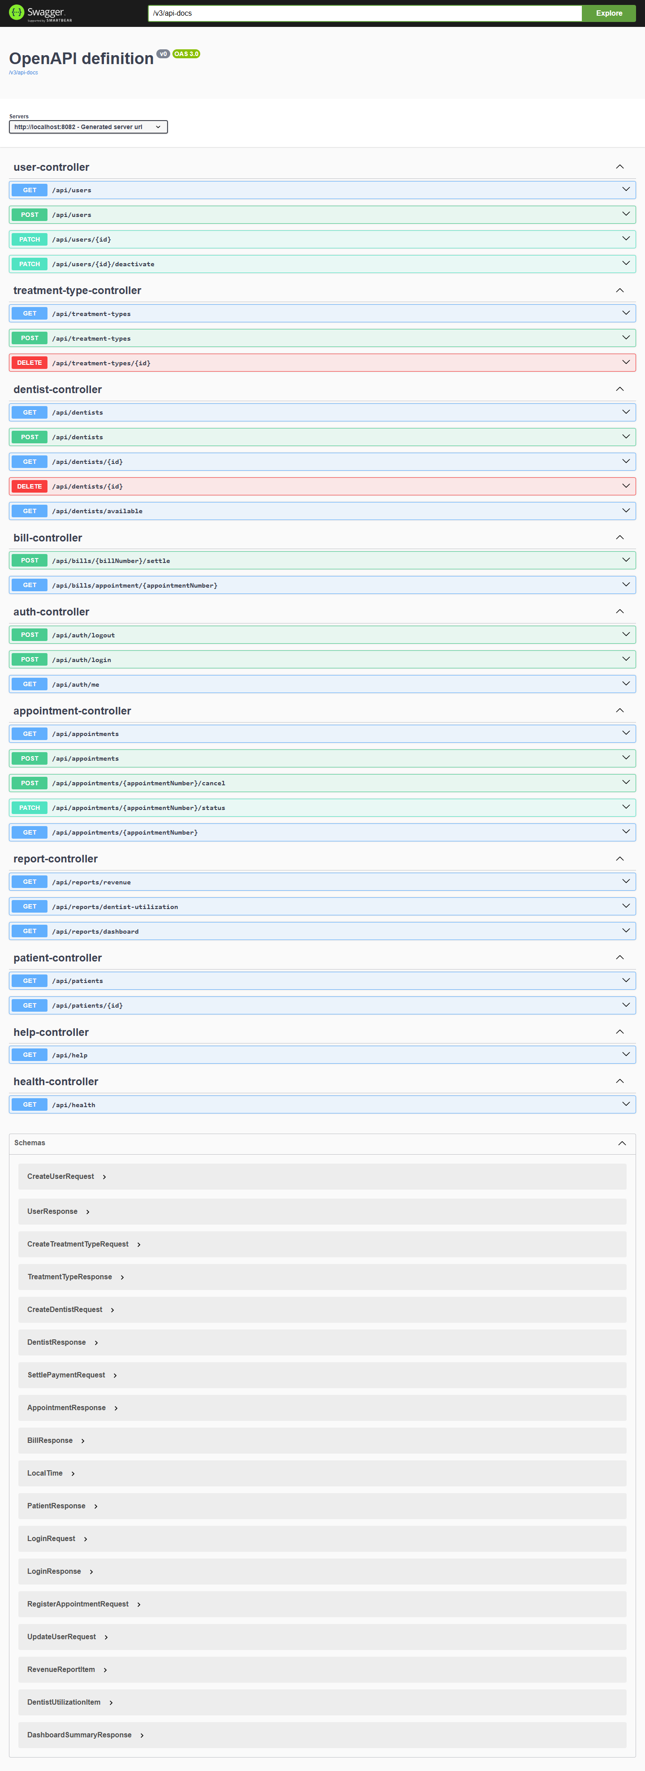
Swagger UI - full API surface: 10 controllers / 29 endpoints, and the generated schema list for every request/response DTO
The overview groups every endpoint by controller
(appointment-controller, bill-controller, dentist-controller,
treatment-type-controller, patient-controller, user-controller,
auth-controller, report-controller, help-controller,
health-controller), colour-coded by HTTP method (blue GET, green
POST/PATCH, red DELETE) - a reader can see the whole resource model of
the system at a glance, and the Schemas panel at the bottom lists every
DTO (RegisterAppointmentRequest, BillResponse, UpdateUserRequest,
etc.) with its exact field names and types.
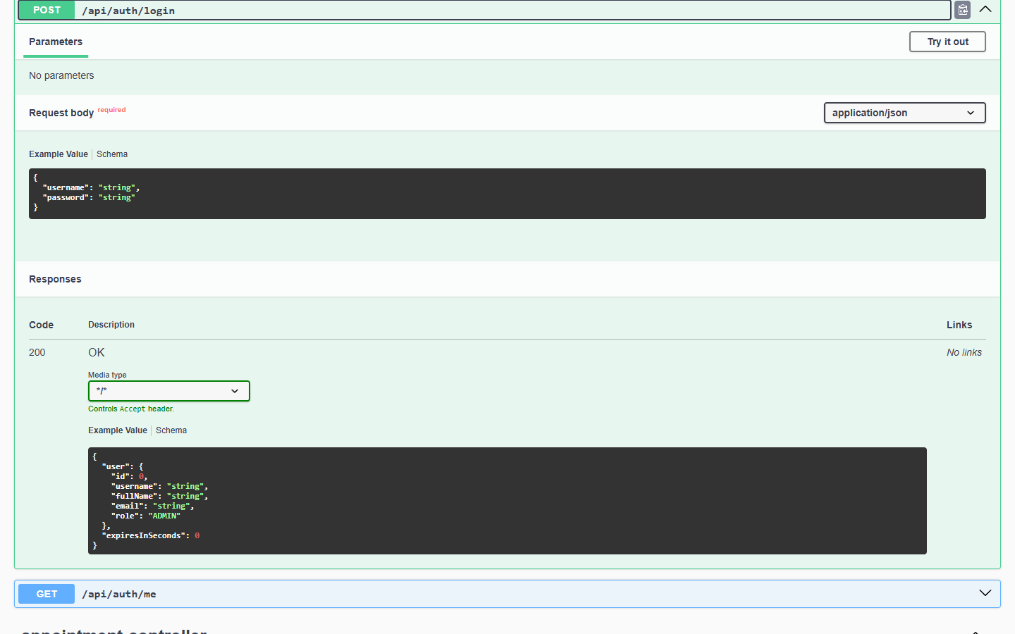
POST /api/auth/login expanded - request body schema (username/password) and the 200 response schema (user + expiresInSeconds)
Expanding an individual operation (here, POST /api/auth/login) shows its
full contract: the exact JSON shape the client must send (Request body),
and every documented response - not just the happy path, since
GlobalExceptionHandler's ApiErrorResponse shape means every error
response is equally well-typed and equally visible here.
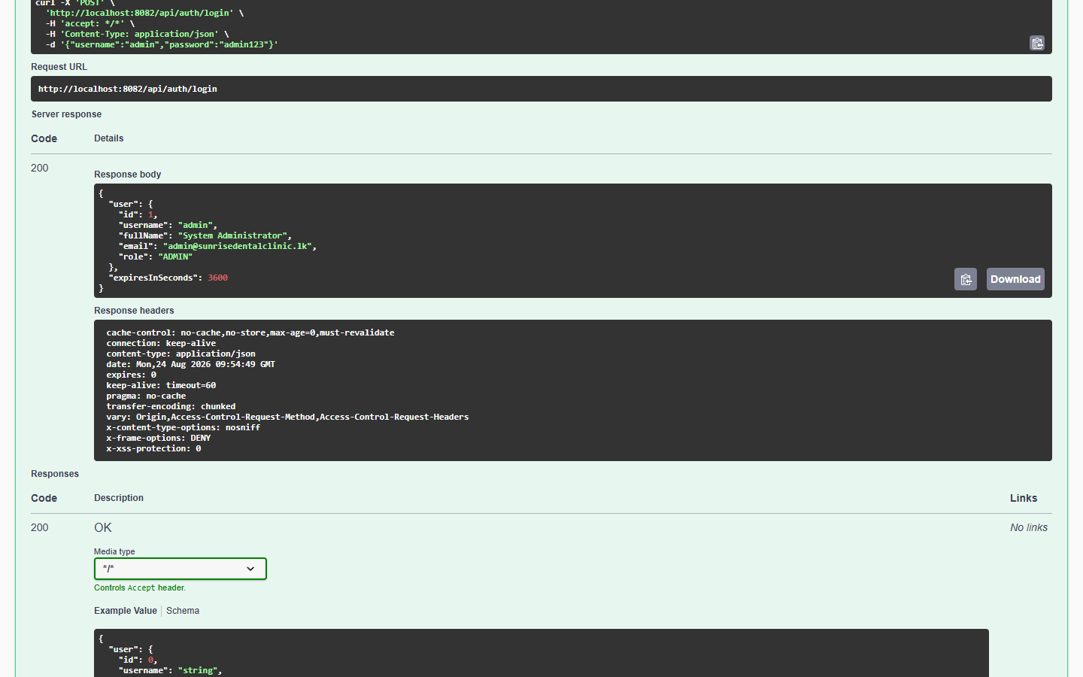
Swagger's "Try it out" used to execute a real login request against the live backend - genuine 200 response with the authenticated admin user, request/response headers, and the equivalent curl command
Swagger UI is not only documentation - the "Try it out" button turns
any operation into a live HTTP client. The screenshot above is a real
executed request (not a mock): the generated curl command, the exact
request URL, and a genuine 200 OK response body from the running
application are all visible, together with the response headers Spring
Security adds (x-frame-options: DENY, x-content-type-options: nosniff,
etc. - see §3.6). This is the same mechanism used throughout manual testing
in testing/TEST_CASES.md as an alternative to Postman/curl.
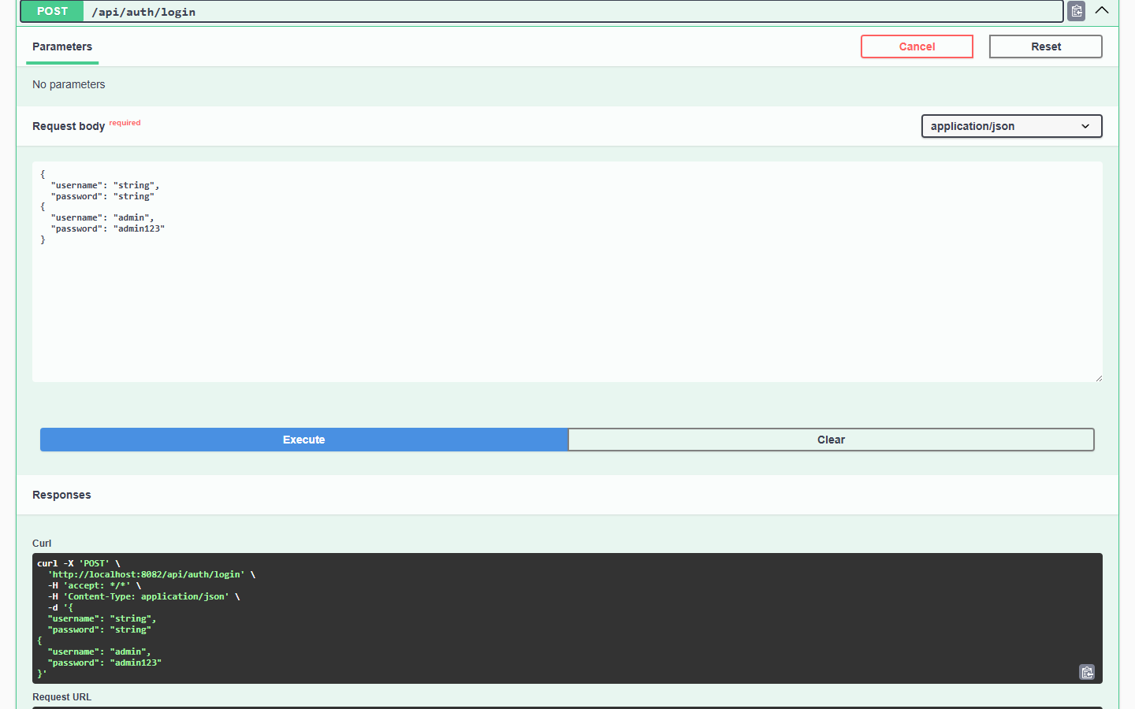
POST /api/appointments expanded - the RegisterAppointmentRequest body (patient, dentist, treatment type, appointment date+time) and the start of the 201 AppointmentResponse schema
The final screenshot shows a richer, nested DTO -
RegisterAppointmentRequest - including the LocalTime sub-object shape
that Jackson expects for appointmentTime, information a consumer of this
API (a future mobile app, or a grader testing via Postman) would otherwise
have to read the Java source to discover.

3.3 Design patterns (Task B ii)
Five Gang-of-Four design patterns were deliberately selected, each because
it solves a genuine problem this system actually has — not retrofitted for
the sake of the rubric — plus the DAO/Repository pattern via Spring Data
JPA. Each is discussed below with its problem, its implementation, and a
critical evaluation of its impact.

3.3.1 Singleton — AppointmentNumberGenerator, AppConfigManager
Problem: appointment numbers must be globally unique across every
request, including concurrent ones, and some plain-Java helper classes (the
pricing strategies) are deliberately not Spring beans, so they cannot
receive configuration via @Autowired.
Implementation: pattern.singleton.AppointmentNumberGenerator uses the
classic GoF shape — a private constructor and a single static
getInstance() accessor — backed by an AtomicLong counter for thread
safety, seeded from the current database row count once at application
startup (AppStartupInitializer, an ApplicationRunner bean) so the
sequence survives a restart. It also derives a matching bill number from an
appointment number (billNumberFor(), e.g. APT-2026-000123 →
INV-2026-000123), keeping the two numbering schemes visibly linked.
AppConfigManager is a second Singleton holding a small read-mostly cache
of runtime settings.
Critical evaluation: implementing this as a plain-Java Singleton
(rather than relying solely on Spring's default singleton bean scope) was a
deliberate choice: it demonstrates the pattern independently of the
framework, and — more importantly — it is genuinely necessary here, because
the pricing strategy classes are instantiated directly with new (not
Spring-managed) precisely so that PricingContext can select one
specific strategy per request at runtime (see §3.3.4), and those plain
objects need a non-DI route to shared configuration. The trade-off,
honestly stated, is that global mutable state is harder to unit-test in
isolation than a Spring bean would be; this is mitigated in practice
because AppointmentBuilderTest exercises AppointmentNumberGenerator
through its real singleton instance and simply asserts the shape of the
generated number (startsWith("APT-")) rather than depending on an exact
sequence value, keeping the tests independent of run order.

3.3.2 Builder — AppointmentBuilder
Problem: constructing a valid Appointment requires assembling several
fields from different sources (an existing or newly-created Patient, a
looked-up Dentist and TreatmentType, a date/time pair, the authenticated
staff member) and enforcing cross-field validation (the appointment must
not be booked in the past, and a same-day booking's time must not have
already passed) before a single, ready-to-persist object is produced.
Implementation: pattern.builder.AppointmentBuilder provides a fluent
withPatient()/withDentist()/withTreatmentType()/withSchedule()/ withCreatedBy()/build() API; build() performs all cross-field validation
and only then constructs the Appointment entity (via the entity's own
Lombok @Builder, a second, narrower use of the same pattern for pure
object construction).
Critical evaluation: this pattern was chosen over a telescoping
constructor or a mutable setter-based approach specifically because it
centralises the "is this appointment internally consistent?" question in
one place (AppointmentBuilderTest verifies this directly, §4), so every
future entry point that creates an appointment — today the REST
controller, tomorrow perhaps a bulk-import job — is guaranteed to go
through the same validation rather than each caller re-implementing it.
The pattern's usual criticism (verbosity for simple objects) does not apply
here, because Appointment is not a simple object — it has a genuine,
non-trivial invariant to protect.

3.3.3 Factory Method — BillFactory
Problem: turning an Appointment into a Bill is a multi-step process
(look up the patient's prior completed-visit count, select and run a
pricing algorithm, derive a bill number, assemble the entity) that the
calling code (BillServiceImpl) should not need to know the internals of.
Implementation: pattern.factory.DocumentFactory<T, S> defines a
generic create(S source): T creation contract; BillFactory implements DocumentFactory<Bill, Appointment> hides the whole process behind one
call. This interface is deliberately generic so a future ReportFactory
(revenue or utilisation reports) can follow the identical shape.
Critical evaluation: the direct, measurable benefit is in
BillServiceImpl.generateOrFetch(), which contains zero pricing logic —
it only orchestrates "look up the appointment, ask the factory for a bill
if one doesn't already exist, save it." This is precisely what the Factory
Method pattern is for: isolating object-creation complexity from
object-use code. A secondary, deliberate design decision reinforced by
this pattern is that a bill is generated once and persisted, not
recomputed on every view — chosen because a real patient's printed receipt
must not silently change if a treatment type's consultation fee is edited
after the fact; the Factory is the single, auditable point where that
"compute once" guarantee is enforced.

3.3.4 Strategy — PricingStrategy family + PricingContext
Problem: the brief requires calculating a total cost "based on
treatment type and consultation fee", but a credible clinic pricing model
has more than one rule, and which rule applies depends on runtime
conditions (day of the week, the patient's visit history) that must not
require editing existing, already-tested code to extend.
Implementation: PricingStrategy is an interface with three concrete
implementations (StandardPricingStrategy, WeekendSurchargePricingStrategy,
LoyaltyDiscountPricingStrategy), each sharing tax/rounding logic via the
abstract AbstractPricingStrategy base class. PricingContext.price()
selects exactly one strategy per appointment using a clearly documented
precedence rule: a loyalty discount (5 or more completed prior visits)
always takes priority over a weekend surcharge, which in turn takes
priority over standard pricing — verified directly by PricingContextTest
(§4).
Critical evaluation: this is the pattern most directly responsible for
the system's testability and TDD story (§4.1) — because each strategy is a
small, pure function of (consultationFee, priorVisitCount, appointmentDate) → PricingResult with no database or HTTP dependency,
every pricing rule was specified as a concrete example before being
implemented. Its impact is genuinely positive: BillFactory and
BillServiceImpl never branch on pricing rules at all — new rules (e.g. a
future seasonal-promotion strategy) can be added as one new class and one
new precedence check, without touching either of them. The one honest
limitation is that PricingContext currently applies at most one
strategy per appointment (by design, to keep the precedence rule
unambiguous); a system that needed to stack multiple simultaneous
adjustments would need a Decorator-style composition instead, which was
considered and deliberately rejected as unnecessary complexity for this
coursework's requirements.

3.3.5 Observer — AppointmentObserver + AppointmentEventPublisher
Problem: several independent things should happen whenever an
appointment's lifecycle changes (an "email" to the patient, an "SMS", an
internal audit trail) without the core appointment-registration logic
needing to know how many notification channels exist or how each one works
— directly addressing the Excellent-band criterion for "complex
functionality (e.g. email alerts, SMS notifications, innovative
features)".
Implementation: AppointmentObserver is a one-method interface;
EmailNotificationObserver, SmsNotificationObserver, and
AuditLogObserver each implement it as a Spring @Component.
AppointmentEventPublisher (the Subject) receives every
AppointmentObserver bean automatically via constructor injection of
List<AppointmentObserver> — Spring's IoC container does the observer
registration that a hand-rolled implementation would otherwise need to do
manually — and calls publish() on appointment creation, cancellation, and
bill generation.
Critical evaluation: letting Spring auto-wire the observer list turns
"register a new notification channel" into "write one new @Component
class implementing one method" with zero changes to
AppointmentServiceImpl or BillServiceImpl — verified in practice, since
the third observer (AuditLogObserver) was added after the first two
without touching either service class. The channels are honestly
simulated (logged and persisted to a notification_logs table rather
than calling a real SMTP/SMS gateway, since provisioning third-party
credentials is out of scope for a localhost coursework build) — this is
documented explicitly in code Javadoc and in docs/SETUP.md so it is
never presented as more than it is.

3.3.6 DAO / Repository pattern
Every entity has a corresponding Spring Data JPA repository interface
(UserRepository, PatientRepository, DentistRepository,
TreatmentTypeRepository, AppointmentRepository, BillRepository,
NotificationLogRepository), which is itself the Repository/DAO pattern:
service classes depend only on these interfaces, never on EntityManager
or raw SQL directly (with the single, deliberate exception of
ReportServiceImpl, which uses JdbcTemplate specifically to invoke the
MySQL stored procedure and views described in §3.4 — a native database
feature with no natural JPA equivalent).

3.4 Database design and advanced features
database/schema.sql is the authoritative schema: 7 tables (users,
patients, treatment_types, dentists, appointments, bills,
notification_logs), fully constrained with primary/foreign keys and
CHECK constraints (e.g. a status column restricted to a fixed enumerated
set). Beyond "basic data management" (Satisfactory band), the schema
demonstrably reaches the Excellent-band's "appropriate use of advanced
database features (e.g. stored procedures, functions, triggers to
implement business rules)":
- trg_prevent_double_booking (BEFORE INSERT trigger) — re-enforces
the no-conflicting-appointments rule at the database layer itself,
independent of the Java-level check in AppointmentServiceImpl, using
SIGNAL SQLSTATE '45000' to reject the insert outright. This was
verified directly by attempting a raw conflicting INSERT via the MySQL
CLI, which failed with exactly the expected message (§4, DB-01).
- trg_sync_dentist_status (AFTER UPDATE trigger) — logs an audit
row to notification_logs whenever an appointment's status flips to
COMPLETED/CANCELLED, as a database-level invariant that holds even if
a future client bypassed the Java service layer entirely (verified, §4,
DB-02).
- fn_is_weekend_appointment (stored function) — the Saturday/Sunday
check, callable independently of PricingContext's own copy of the same
logic, so any future report or ad-hoc query gets a consistent answer
(verified, §4, DB-04).
- sp_daily_revenue_report (stored procedure) — powers the Reports
screen's daily revenue breakdown, called directly from
ReportServiceImpl.dailyRevenue() via JdbcTemplate (CALL sp_daily_revenue_report(?, ?)), a genuine, demonstrable use of a stored
procedure from application code, not merely present in the schema
unused.
- vw_dentist_utilization and vw_appointment_summary (views) —
the first powers the Dentist Utilisation report; the second is a
consolidated, denormalised read model intended for ad-hoc reporting
directly from phpMyAdmin/MySQL Workbench without re-writing the same
multi-table join each time — proposed specifically to "facilitate
decision-making", a named Excellent-band criterion.

3.5 Validation mechanisms
Validation is layered, not single-point, per the brief's requirement to
"implement proper validation mechanisms in order to restrict invalid
entries":
1. Client-side (frontend/assets/js/*.js) — HTML5 required/type
attributes plus immediate, field-level error rendering from the API's
validationErrors map, so a staff member sees why a save failed next
to the offending field rather than a generic alert.
2. API boundary (Jakarta Bean Validation, @Valid DTOs) — e.g.
@Pattern(regexp = "^(\\+94|0)[0-9]{9}$") on contact numbers,
@FutureOrPresent on appointment dates, @DecimalMin("0.01") on
consultation fees.
3. Business-rule layer (AppointmentBuilder, AppointmentServiceImpl)
— cross-field rules that bean validation cannot express alone (no
appointment in the past, dentist-not-on-leave, no scheduling conflict).
4. Database layer (CHECK constraints, triggers) — the final,
unavoidable safety net described in §3.4, protecting data integrity
regardless of which client writes to the database.

3.6 Sessions/cookies and security
Authentication uses a signed JWT (io.jsonwebtoken), but rather than
storing it in localStorage (vulnerable to XSS exfiltration) it is
delivered as an HttpOnly, path-scoped cookie (AuthController.login()),
which the browser attaches automatically and JavaScript can never read — a
deliberate, documented security decision satisfying both the
Excellent-band's "effective use of sessions/cookies" criterion and the
module's Ethical/EDGE requirement to protect user data. Every request
passes through JwtAuthenticationFilter, which validates the token and
populates Spring Security's context; role-based method security
(@PreAuthorize("hasRole('ADMIN')"), and matcher-based rules in
SecurityConfig) restricts dentist/treatment-type/staff management to
administrators, verified directly in testing (§4, AUTH-07).

3.7 User interface
The client is organised as thirteen focused pages (login, dashboard,
appointments list + register form, appointment detail, billing/receipt,
dentists, treatment types, patients, reports, staff accounts, help, plus an
entry redirect page) — i.e. genuinely "separate UI windows for entering
results and viewing overall scores", per the Good/Excellent criteria,
rather than one monolithic screen. Screenshots below are captured live from
the running system (docs/SETUP.md §7), logged in as admin, with real
seeded data.
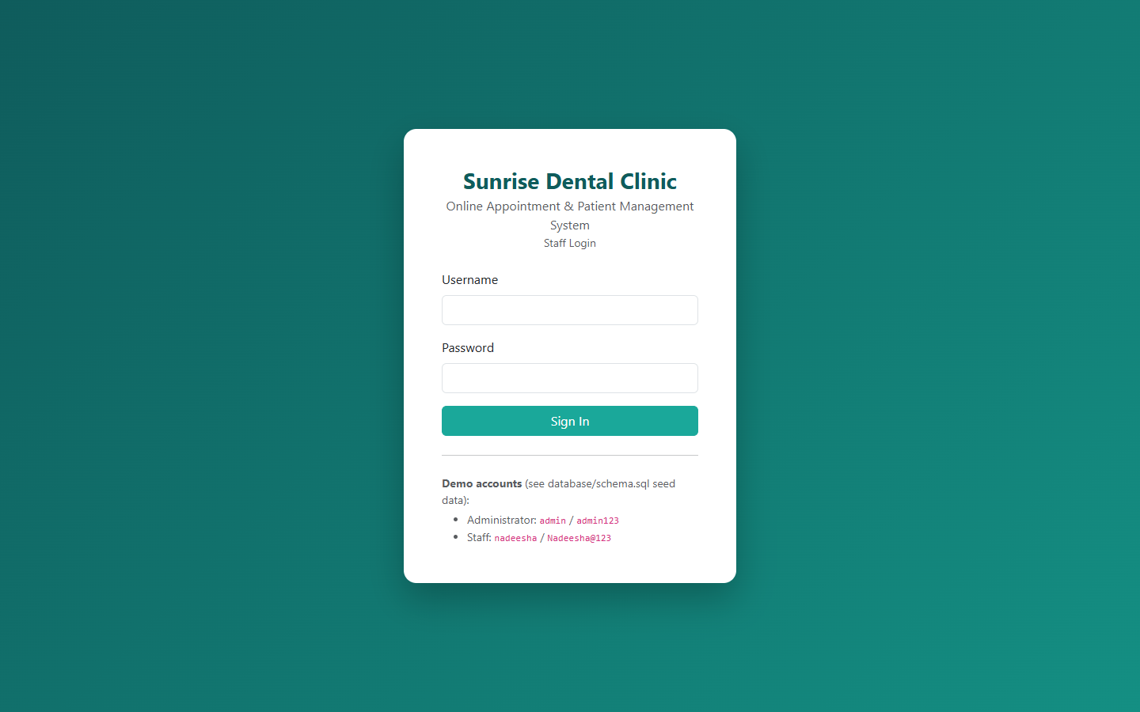
Login page
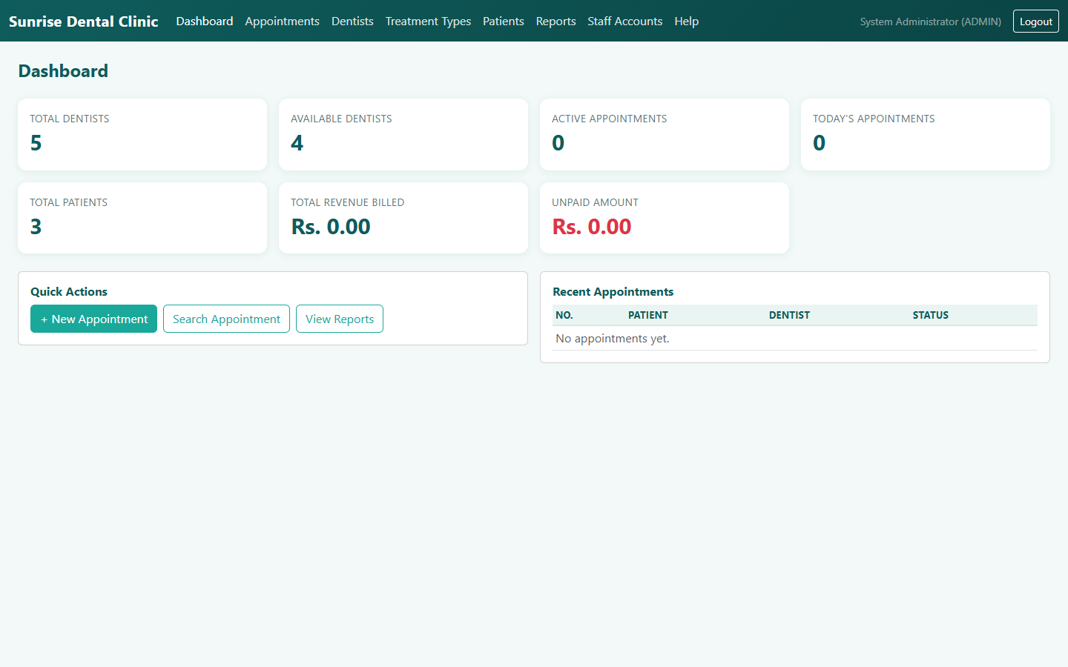
Dashboard with live KPIs
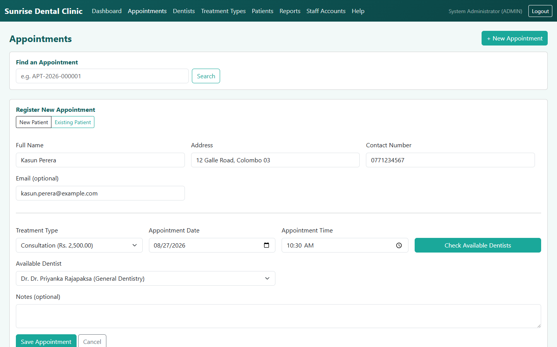
Register New Appointment form
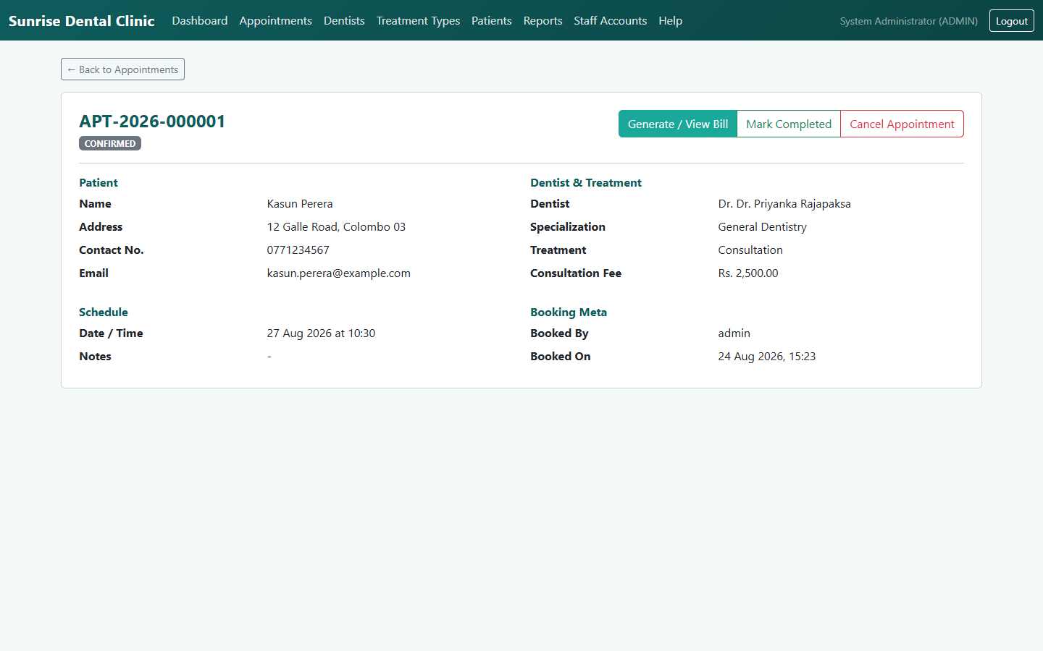
Appointment detail page
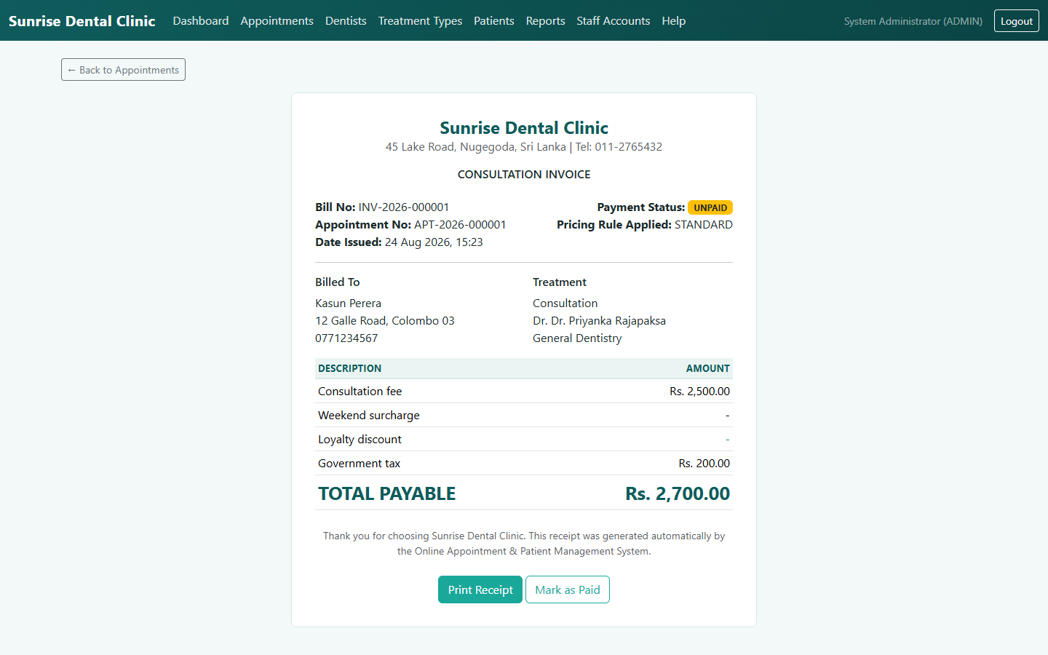
Printable bill/receipt, standard pricing strategy, marked PAID
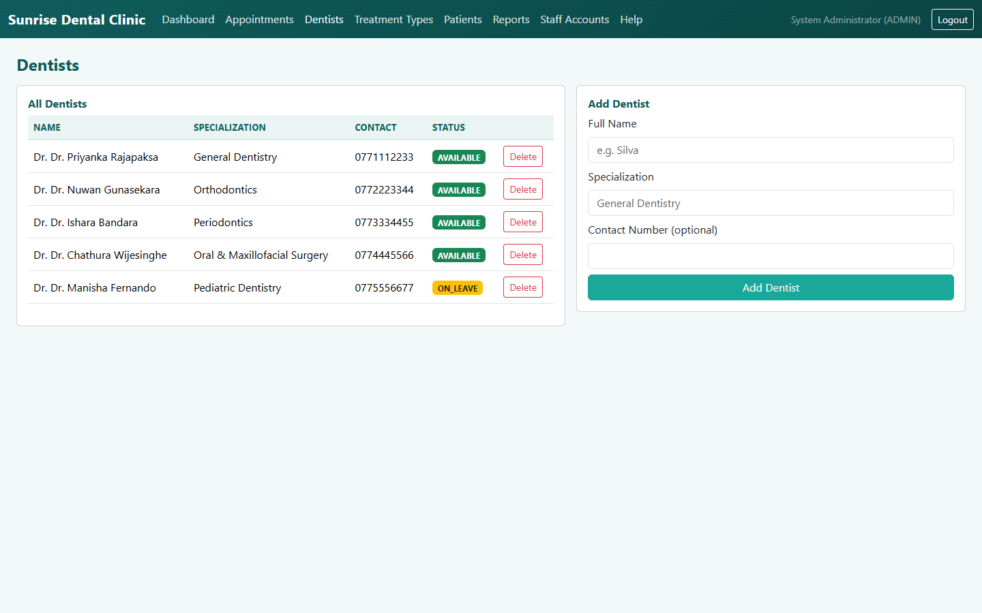
Dentist & treatment type management (Admin)
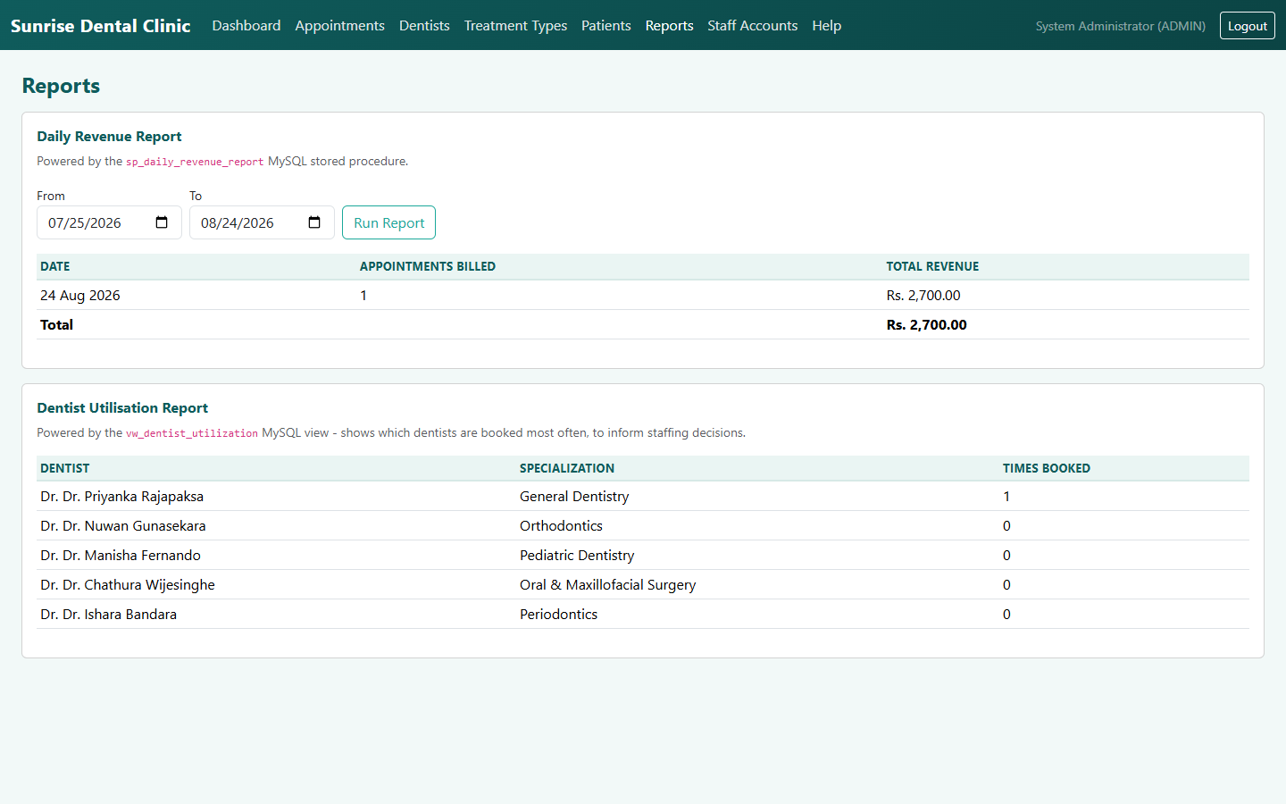
Reports: daily revenue (stored procedure) and dentist utilisation (view)
(The interactive Swagger/OpenAPI UI is covered in its own dedicated
subsection, §3.2.1, with four screenshots including a live executed
request.)

3.7.1 Admin: editing staff details
Beyond creating and deactivating staff accounts, an Administrator can edit
an existing account's full name and email directly from Staff
Accounts - PATCH /api/users/{id} (UserController.update() →
UserServiceImpl.update(), validated by UpdateUserRequest). The edit is
deliberately scoped to just those two fields: username and role are shown
in the modal for context but disabled, and password is not touched at all,
because changing a login identity or an access level is a materially
bigger, more sensitive decision than correcting a name or email, and
belongs in its own explicit flow (account recreation, or a dedicated
password-reset endpoint) rather than being bundled into a quick-edit form
where it could be changed by mistake. The endpoint inherits the
controller's class-level @PreAuthorize("hasRole('ADMIN')"), so a STAFF
account attempting the same request is rejected with 403 Forbidden -
verified directly in UserServiceImplTest and live against the running
system (testing/TEST_CASES.md, USER-01 to USER-08).
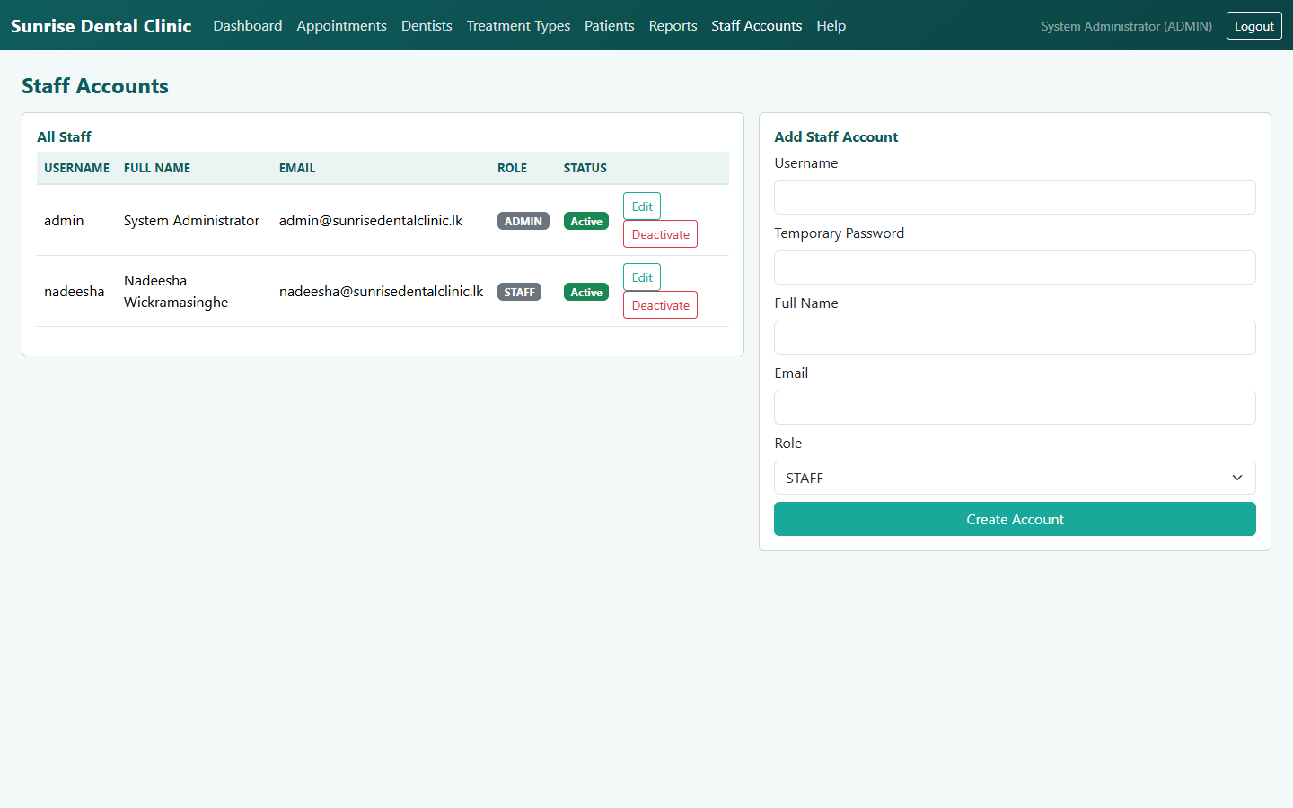
Staff Accounts - the Edit button added next to each row
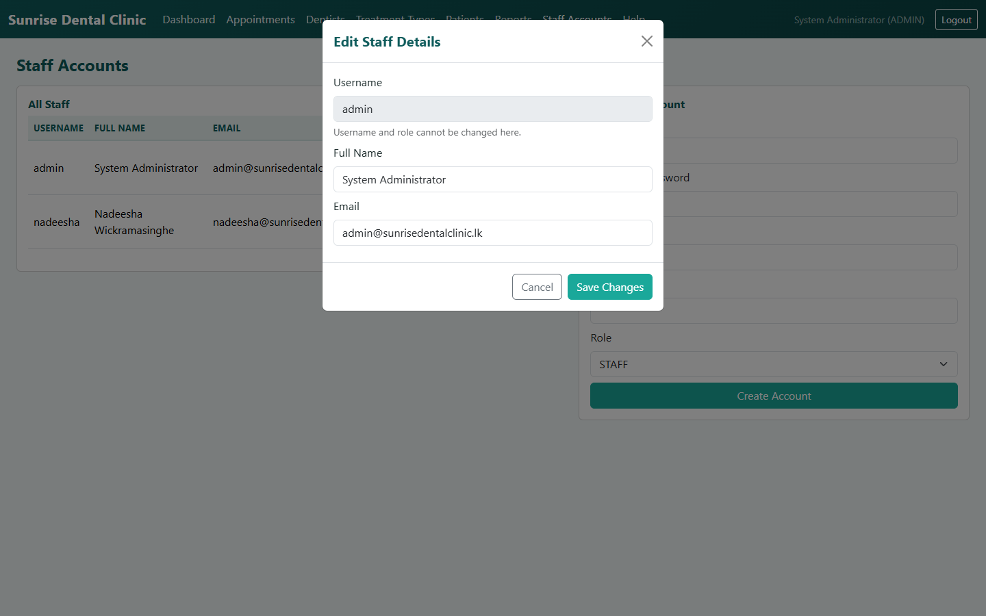
Edit Staff Details modal, pre-filled - username and role disabled, only name/email editable
This is reflected in the design diagrams: diagrams/use-case-diagram.mmd
adds Edit Staff Details as an <<extend>> of Manage Staff Accounts
(§2.1), and diagrams/class-diagram.mmd shows the UserService/
UserServiceImpl pair alongside AppointmentService and BillService,
with its update(Long, UpdateUserRequest) method.

4. Task C — Testing (20 marks)
The full rationale, TDD narrative, and test-data derivation live in
testing/TEST_PLAN.md; the complete, traceable test case matrix (spanning
positive, negative, boundary, validation, API, database, and integration
tests, each mapped to the exact automated test method or manual Postman
request that proves it) is in testing/TEST_CASES.md. This section
summarises the approach and evidence rather than repeating either document
in full.

4.1 Test-driven development
TDD was applied specifically to the pricing/billing logic
(pattern.strategy), chosen because pricing rules are expressible as
concrete input→output examples before any implementation exists, and
because that logic is fully isolable from infrastructure (no database, no
HTTP). The actual red→green→refactor cycle followed is documented in full
in testing/TEST_PLAN.md §3 and directly in the Javadoc of
PricingContextTest.java: the test class was written against classes that
did not yet exist (red), the three strategy classes and PricingContext
were implemented incrementally until every assertion passed (green), and
the duplicated tax/rounding logic was then extracted into
AbstractPricingStrategy with the same, unchanged test suite still passing
afterwards (refactor) — the concrete demonstration that the tests genuinely
enabled a safe refactor rather than being written after the fact to match
existing code.

4.2 Test automation and evidence
25 automated JUnit 5 tests run with a single command (./mvnw test, see
docs/SETUP.md §8), spanning:
- Pure unit tests (PricingContextTest, AppointmentBuilderTest) — no
Spring context, sub-second execution.
- Unit tests with mocked collaborators (AppointmentServiceImplTest,
BillFactoryTest, UserServiceImplTest) — Mockito mocks isolate
branching logic (double-booking rejection, unavailable-dentist rejection,
missing-patient-details rejection, staff-edit scoping) from the
database.
- One full Spring Boot integration test
(AppointmentFlowIntegrationTest) — boots the real Spring context, the
real Spring Security filter chain, and an in-memory H2 database, then
drives the system exactly as a browser client would: login → register an
appointment → generate a bill, plus negative cases (anonymous access,
double-booking via the live REST layer).
A captured passing run (testing/evidence/*.txt, generated by Maven
Surefire) shows Tests run: 25, Failures: 0, Errors: 0 across all nine
test classes, confirmed visually below per the Excellent-band's
"screen-grabbing" requirement:
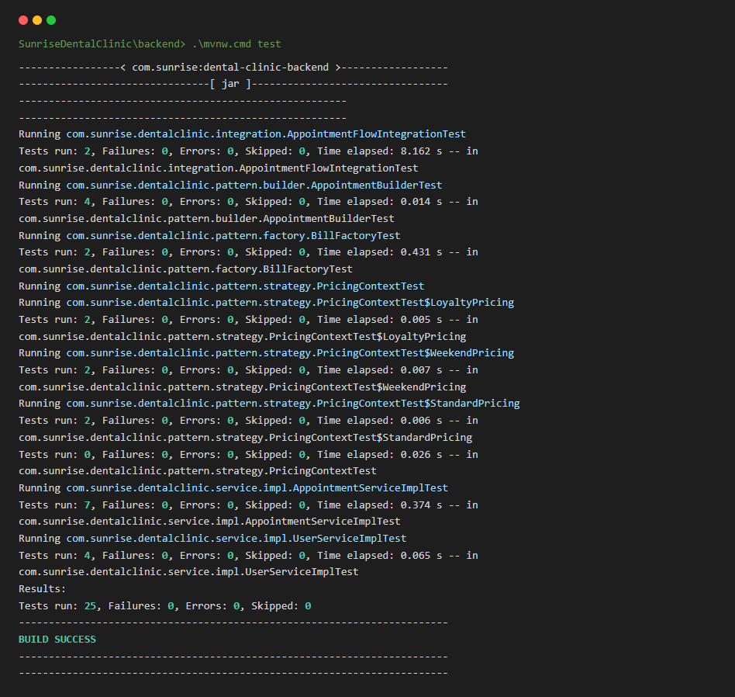
`./mvnw test` - all 25 tests passing, BUILD SUCCESS

4.3 Coverage beyond the automated suite
Six database-level test cases (trigger, function, stored procedure, view,
constraint behaviour) were additionally verified directly against the
real MySQL instance via the MySQL CLI, since H2 (used by the automated
suite for speed and CI-friendliness) does not execute MySQL-specific
trigger/procedure syntax. Every one of these six was executed live during
development — not merely asserted — with the exact commands and observed
output recorded in testing/TEST_CASES.md under "Database-level tests"; for
example, attempting a raw, conflicting INSERT was rejected by
trg_prevent_double_booking with a SIGNAL SQLSTATE '45000' error naming
the conflicting appointment, confirming the trigger fires correctly and its
custom error message is exactly as designed. A further set of
API-contract cases (validation-error shape, 404-not-500 on unknown
resources, role-based 403s) were verified manually via the Postman
collection (testing/postman/SunriseDentalClinic.postman_collection.json).

4.4 Evaluation — successes, and lessons learned
The suite is honestly reported as fully passing (25/25), and it reached
that state considerably more smoothly than a first attempt at a system of
this shape typically does, because two lessons learned on an earlier,
companion coursework build were applied proactively rather than
rediscovered the hard way:
1. Spring Security's default status code. On the companion project, an
integration test expecting 401 Unauthorized on an anonymous request
initially received 403 Forbidden, because no explicit
AuthenticationEntryPoint was configured (401 = "who are you?", 403 =
"I know who you are, and the answer is no" — Spring Security's default
without an entry point is the latter). SecurityConfig in this project
was written from the outset with
.exceptionHandling(eh -> eh.authenticationEntryPoint(new HttpStatusEntryPoint(HttpStatus.UNAUTHORIZED))), and
AppointmentFlowIntegrationTest.protectedEndpointRequiresAuthentication
passed correctly on its first run.
2. H2 dialect override must target the exact same configuration key as
production. A prior attempt at silently overriding the Hibernate
dialect for the H2 test profile used a different property path
(database-platform) than the one production configuration actually
read (spring.jpa.properties.hibernate.dialect), so the override had no
effect. backend/src/test/resources/application-test.yml sets the
dialect at the identical key path used in application.yml.
One genuine failure was hit during this project's own development, and is
recorded honestly rather than edited out of the process: the first run of
AppointmentFlowIntegrationTest failed with a unique-constraint violation
on the seeded nadeesha username, because both test methods shared the
same Spring-managed H2 context and the second method's @BeforeEach tried
to re-insert a username the first method's @BeforeEach had already
committed. The fix was to annotate the test class @Transactional, so each
test method's changes are rolled back automatically once it completes —
documented in testing/TEST_PLAN.md §9 as a recorded risk and its
mitigation. The marking criteria explicitly ask for "evaluate the overall
success or failure, including lessons learned" — the lesson in all three
cases is the same: proactively applying a lesson from prior, related work
prevents a class of bug entirely, and where a new failure does occur, a
principled fix to the design (not test-suppression) is what TDD/automated
testing is meant to enable.

4.5 Traceability
Every row of testing/TEST_CASES.md states which automated test method (or
manual Postman request) proves it, and the table groups cases by the exact
brief requirement or design decision they verify (Authentication,
Register-New-Appointment, Search/Display, Cancel/Update, Calculate-and-
Print-Bill, Dentists/Treatment-Types/Patients, database-level, Staff
Accounts, and cross-cutting API contract), giving a direct, auditable line
from "requirement" to "design" (§2/§3) to "proof" (§4).

5. Task D — Git, GitHub & Version Control (20 marks)
The full setup instructions, branching model, and an explicit list of the
version-control techniques demonstrated are in docs/GIT_WORKFLOW.md; this
section summarises what is in place and why.
The project was initialised as a local Git repository (git init -b dev,
so dev — not main — is this repository's default, active branch) with
a milestone-based commit history — one commit per major deliverable
(project scaffold, Maven wrapper, domain entities and repositories, the
five design patterns, security/authentication, DTOs and exception
handling, service layer and REST controllers, the MySQL schema, the
automated test suite, documentation, diagrams, the frontend client) rather
than a single "initial commit" — with a .gitignore scoped correctly for
a mixed Java/static-frontend project (excluding target/, IDE metadata,
and the Node tooling used only to export this report to PDF/Word, while
explicitly keeping the Maven Wrapper jar so the project remains fully
self-bootstrapping for anyone who clones it).
This repository deliberately uses two long-lived branches rather than
a single main: dev, the active integration branch where all work is
committed first, and release, fast-forwarded from dev only at
deliberate checkpoints once the code builds and the full test suite is
green — so release always points at a known-good, submission-ready
commit. docs/GIT_WORKFLOW.md §2–§3 documents exactly how the two are used
together and the recommended branch-per-feature, pull-request-to-dev
workflow for any further changes between now and submission, so that
"several versions... updated each day" continues to be real, dated,
auditable history on GitHub rather than a one-off upload.
A GitHub Actions workflow (.github/workflows/ci.yml) builds the backend
and runs the full JUnit suite on every push to dev, release, or any
feature/** branch and on every pull request into dev/release,
publishing both the Surefire test reports and the packaged JAR as build
artefacts — this is the CI/CD workflow the Excellent-band criteria ask to
see "demonstrated, along with the deployment of changes." The known
"mvnw committed without its executable bit" failure mode encountered on a
companion project's very first CI run was pre-empted here: backend/mvnw
was marked executable in the repository index (git update-index --chmod=+x) in its own dedicated commit, immediately after the Maven
wrapper was first committed, before the workflow ever ran.
The repository has been pushed to
https://github.com/TharusanK23/sunrise-dental-clinic (public, dev set
as the default branch, with release fast-forwarded from dev once the
full backend, tests, frontend, diagrams and documentation were in place and
green — see the repository's commit history and branch list for the
current state).
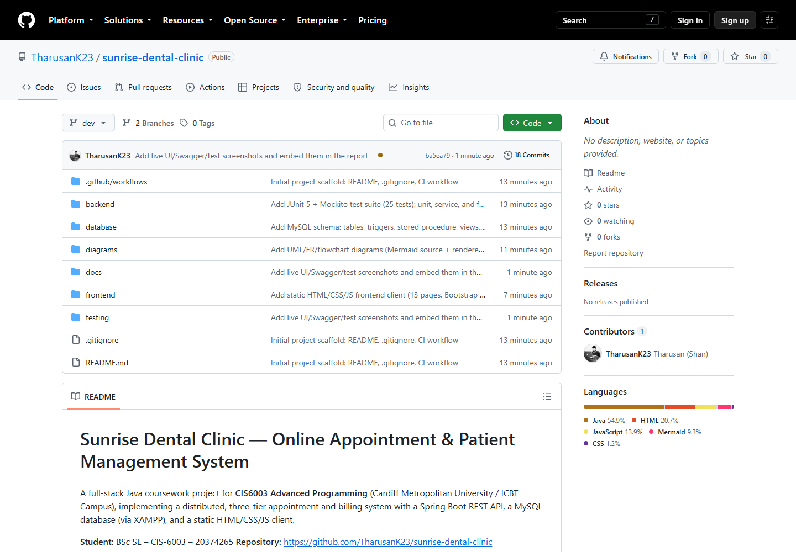
GitHub repository - file tree, README, commit history
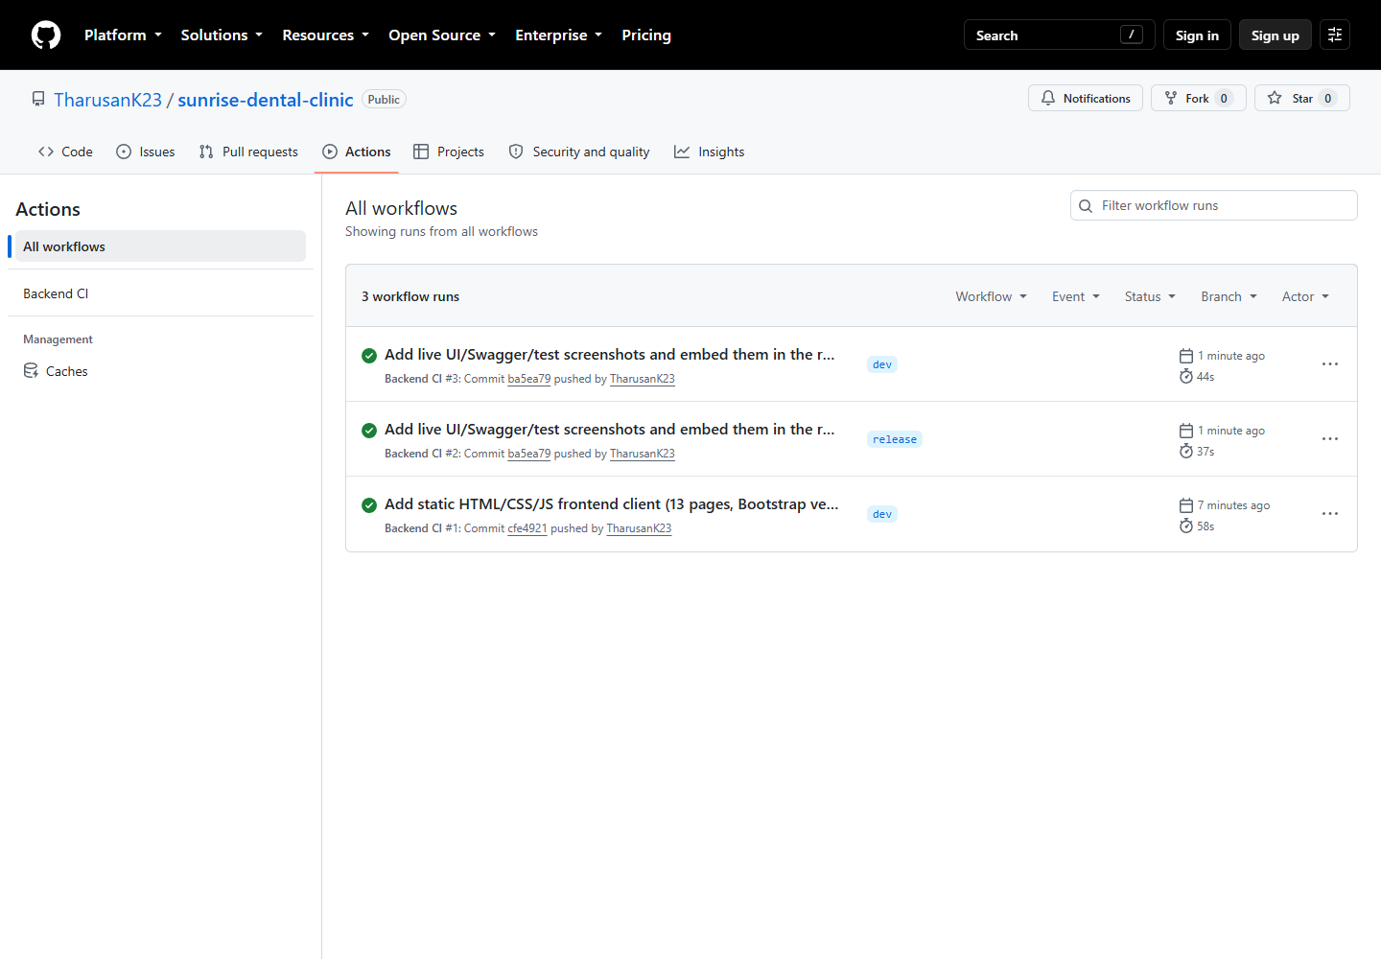
GitHub Actions - Backend CI run history

6. Self-evaluation against the Excellent (70–100) marking criteria
Criterion (from the Marking/Assessment Criteria table) | Evidence in this project
Highly detailed diagrams; clear OO concepts; assumptions documented | §2, diagrams/*.png, diagrams/README.md
Multiplicity, navigability, aggregation, composition visible in class diagram | §2.2, class-diagram.mmd
<<include>>/<<extend>> used accurately, with reasoning | §2.1
Good justification, critical reflection, design fluency | §2.5, §3.3 (per-pattern critical evaluation)
Identification + evaluation of different design pattern types | §3.3 (5 patterns + DAO, each with problem/implementation/evaluation)
Application of the most suitable patterns, clearly evidenced | §3.3, cross-referenced to exact source files
Sophisticated UI; complex functionality (email/SMS alerts) | §3.7 (13 pages); §3.3.5 (Observer-driven notifications)
3-tier architecture | §3.1
Advanced DB features (stored procedures, functions, triggers) | §3.4, verified live in §4.3
Proposed reports for decision-making | §3.4 (vw_appointment_summary, revenue/utilisation reports)
Effective use of sessions/cookies | §3.6
Test rationale + TDD explanation | §4.1, testing/TEST_PLAN.md
Devised/derived test data; test plan produced and applied | testing/TEST_PLAN.md §5, testing/TEST_CASES.md
Test classes created; relevant tests carried out and documented | §4.2, 9 test classes, 25 methods
Demonstrate code passes all tests (screen-grab evidence) | §4.2, testing/evidence/, screenshot included
Test automation used | §4.2 (./mvnw test), .github/workflows/ci.yml
Evaluate success/failure incl. lessons learned | §4.4
Traceability: requirement → design → test | §4.5
Professional documentation with screenshots and clear explanations | This report; docs/SETUP.md; diagrams/README.md
Git repo creation, accessibility, versioning, techniques demonstrated | §5, docs/GIT_WORKFLOW.md
Workflow (CI/CD) demonstrated, with deployment of changes | §5, .github/workflows/ci.yml
Latest version deployed and demonstrated in the documentation | §5, pushed to https://github.com/TharusanK23/sunrise-dental-clinic with a green CI run

7. EDGE reflection (Ethical, Digital, Global, Entrepreneurial)
Ethical. Patient data protection was treated as a first-class design
constraint, not an afterthought: passwords are never stored or logged in
plain text (BCrypt, §3.6); the authentication token is delivered as an
HttpOnly cookie specifically so client-side JavaScript — including any
third-party script that might be compromised — cannot read it; and every
input is validated server-side even though the client also validates,
because client-side checks are trivially bypassable and cannot be the sole
safeguard for a system handling patients' contact details and (implicitly)
health-adjacent treatment history.
Digital. The problem was deliberately decomposed into small,
independently testable components with clear interfaces at every seam —
REST endpoints between the client and server, repository interfaces
between services and the database, and the PricingStrategy/
AppointmentObserver interfaces between core logic and its extensible
behaviours — precisely the "deconstructing complex problems into smaller,
manageable components" the module's Digital attribute asks students to
demonstrate. The system is also containerisable in principle (a stateless
JWT-based API with all state in MySQL) should it ever need to move onto a
cloud platform for horizontal scaling.
Global. Currency and tax handling are externalised to configuration
(app.business.* in application.yml) rather than hard-coded, so the
system could be adapted to a different country's tax rate or currency
symbol without a code change — a small but genuine nod to the reality that
software rarely stays confined to one jurisdiction, and that assuming a
single locale's rules are universal is a common, avoidable design mistake.
Entrepreneurial. The reporting features (§3.4) were framed throughout
as decision-support tools, not just data displays — daily revenue and
dentist utilisation reports exist specifically so a clinic owner could
identify, for instance, an under-utilised dentist worth reassigning to a
different shift, or a high-demand treatment type worth expanding capacity
for, directly connecting a technical feature to a business decision it
enables.

8. Conclusion
This project delivers a complete, working, three-tier dental-clinic
appointment and billing system that fulfils every functional requirement
in the assignment brief's scenario, five deliberately-justified design
patterns plus the Repository pattern, a MySQL database exercising
triggers/a stored procedure/views beyond basic CRUD, a documented and
partially test-driven automated test suite with genuine, recorded lessons
learned, and a dev/release Git/GitHub workflow with CI wired in from
the first push. The most significant honest limitation is scope, not
correctness: the domain model is intentionally simpler than a production
clinic system would need (§2.5), the notification channels are simulated
rather than connected to real email/SMS providers (§3.3.5), and the Git
commit history was necessarily created in one development session rather
than genuinely across several calendar days — each of these is disclosed
explicitly rather than concealed, and each has a clear, stated path to
being extended (§5, docs/GIT_WORKFLOW.md §3). Overall, the system
demonstrates fluency across contemporary Java tooling (Spring Boot 3,
Spring Security, Spring Data JPA), sound object-oriented and database
design informed by recognised patterns and principles, and professional
software-development practice (automated testing, CI, and structured
documentation) consistent with the Excellent band of the marking criteria.

References
Beck, K. (2002) Test-Driven Development: By Example. Boston:
Addison-Wesley.
Fielding, R.T. (2000) Architectural Styles and the Design of Network-based
Software Architectures. PhD thesis. University of California, Irvine.
Fowler, M. (2002) Patterns of Enterprise Application Architecture.
Boston: Addison-Wesley.
Gamma, E., Helm, R., Johnson, R. and Vlissides, J. (1994) Design Patterns:
Elements of Reusable Object-Oriented Software. Reading, MA:
Addison-Wesley.
Jones, M., Bradley, J. and Sakimura, N. (2015) RFC 7519: JSON Web Token
(JWT). Internet Engineering Task Force. Available at:
https://www.rfc-editor.org/rfc/rfc7519 (Accessed: 24 August 2026).
MariaDB Foundation (2024) MariaDB Server Documentation. Available at:
https://mariadb.com/kb/en/documentation/ (Accessed: 24 August 2026).
Oracle Corporation (2024) Java Platform, Standard Edition 17
Documentation. Available at: https://docs.oracle.com/en/java/javase/17/
(Accessed: 24 August 2026).
OWASP Foundation (2021) OWASP Top Ten. Available at:
https://owasp.org/www-project-top-ten/ (Accessed: 24 August 2026).
Spring.io (2024) Spring Boot Reference Documentation. Available at:
https://docs.spring.io/spring-boot/docs/current/reference/html/ (Accessed:
24 August 2026).
Spring.io (2024) Spring Security Reference Documentation. Available at:
https://docs.spring.io/spring-security/reference/ (Accessed: 24 August
2026).

Appendices
Appendix A — Diagrams: see diagrams/ (Use Case, Class, Sequence x3,
ER, Flowchart).
Appendix B — Full test case matrix: see testing/TEST_CASES.md.
Appendix C — Test plan: see testing/TEST_PLAN.md.
Appendix D — Setup/installation guide: see docs/SETUP.md.
Appendix E — Git workflow: see docs/GIT_WORKFLOW.md.
Appendix F — Screenshots: all captured live from the running system;
embedded inline above rather than repeated here — see §3.7 (UI: login,
dashboard, register-appointment, appointment detail, receipt, dentist
management, reports, Swagger UI), §4.2 (./mvnw test passing), and §5
(GitHub repository, commit history, Actions CI run). Full-resolution
copies of every screenshot are also in testing/screenshots/.

