

SE4010 – Current Trends in Software Engineering – 2026
BSc (Hons) in Software Engineering
Assignment 2

Group: Y4S2-SE-WE

Group ID: 56

Student ID | Name | Email
IT22125248 | Annesiyani Srikanthan | it22125248@my.sliit.lk
IT22099518 | Hemapriya H. A . N. S | it22099518@my.sliit.lk
IT22167378 | H.I.G.Amith Hasintha | it22167378@my.sliit.lk
IT22083296 | E.K.K.Tharushi Nethmini Edirisinghe | it22083296@my.sliit.lk

Table of Contents
1 Introduction and Problem Domain 2
2 System Architecture 2
2.1 Architectural Rationale 2
2.2 Agent Roles and Responsibilities 2
2.3 Workflow Diagram 3
3 Multi-Agent Design 4
3.1 Coordinator Agent 4
3.2 Web Scraper Agent 4
3.3 Price Analyzer Agent 5
3.4 Report Generator Agent 5
3.5 Interaction Strategy 6
3.6 What the Agents Actually Do During a Run 6
4 Custom Tools and Integration 7
4.1 Integration Flow Across Tools 7
4.2 Coordinator Tool 7
4.3 Web Scraping Tool 8
4.4 Price Analysis Tool 8
4.5 File Interaction Tool 9
5 State Management 10
6 Orchestration, Observability and Evaluation 11
6.1 Orchestration Framework 11
6.2 Observability and Logging 11
6.3 Testing and Evaluation 11
7 Individual Contribution 12
8 Links 13
8.1 GitHub Link 13
8.2 YouTube Video Link 13

Introduction and Problem Domain

In modern e-commerce and grocery shopping, users often compare prices across multiple websites before purchasing. Performing this process manually is repetitive, time-consuming, and error-prone, especially when product variants, units, or seller details are inconsistent. As a result, users may miss better deals or make suboptimal decisions.
This project proposes a locally hosted Multi-Agent System (MAS) that automates end-to-end price comparison. Instead of using a single generic chatbot, the solution uses a team of specialized agents that collaborate to process user requests, collect product-price data, analyze pricing patterns, and generate a structured final report. For example, a request such as "Compare prices for coconut" is transformed into actionable outputs, including best price, best store, and summary statistics.
A multi-agent design is selected because the workflow naturally separates into coordination, data collection, analysis, and reporting tasks. This role specialization improves modularity, testability, and reliability compared with a single-agent pipeline.
The system runs fully on local infrastructure using Ollama-based SLM inference and LangGraph orchestration, ensuring zero paid API dependency.

System Architecture

Architectural Rationale

A multi-agent architecture was selected because each stage requires different capabilities:
- Request understanding and routing.
- Data acquisition and normalization.
- Numerical/statistical reasoning.
- User-facing result synthesis and persistence.
Separating these roles makes the system easier to test, debug, and extend than a monolithic single-agent design.

Agent Roles and Responsibilities

Coordinator Agent:
- Accepts and validates the user request.
- Extracts and normalizes the product query.
- Initializes shared state for downstream processing.
Web Scraper Agent:
- Collects product-related data from configured sources.
- Extracts and normalizes price entries.
- Filters malformed or irrelevant records.
Price Analyzer Agent:
- Validates numeric inputs.
- Computes best price, best store, minimum, maximum, and average.
- Produces analysis summary for reporting.
Report Generator Agent:
- Converts processed state into a structured report.
- Saves report files to local storage.
- Preserves run metadata for traceability.

Workflow Diagram

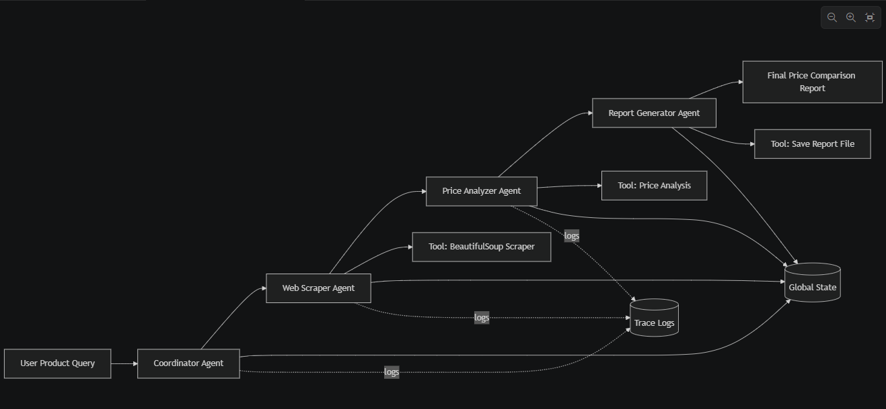

Multi-Agent Design

All system prompts are centralized in a dedicated prompt module to improve maintainability and visibility.

Coordinator Agent

Role: Orchestrates workflow and initializes shared state.

Responsibilities:
- Parse user request.
- Extract product intent.
- Prepare normalized product query and source list.
- Trigger downstream processing sequence.

System prompt:
You are a Coordinator Agent for a smart price comparison MAS. Your job is to extract the product name from the user request and prepare structured input for downstream agents. Rules: Always return structured fields only. Do not include unnecessary text. If product is unclear, default to keyword extraction.

Constraints and Reasoning Strategy:
- Keep output schema-driven.
- Avoid verbose text to reduce downstream parsing errors.
- Use fallback keyword extraction when intent ambiguity is high.

Web Scraper Agent

Role and objective: Collect and normalizes product-price entries from offline or online sources.

Responsibilities:
Fetch offline or online source content.
Parse text/HTML for price patterns.
Return normalized records (store, title, price, currency).

System prompt:
You are a Web Scraper Agent. Your job is to collect product price entries relevant to the given product name. Rules: Extract only valid positive numeric prices. Return normalized fields: store, title, price, currency. Ignore irrelevant content and malformed values.

Constraints and Reasoning Strategy:
- Reject malformed and non-positive prices.
- Apply deterministic normalization to improve reproducibility.
- Operate in offline-safe mode for demo stability.

Price Analyzer Agent

Role and objective: Computes best offer and summary statistics from validated scraped data.

Responsibilities:
- Validate numeric records.
- Calculate minimum, maximum, and average.
- Determine best store and best price.
- Produce concise analysis summary text.

System prompt:
You are a Price Analyzer Agent. Your job is to compute best offer and summary statistics from scraped prices. Rules: Compute min, max, average, best price, and best store. Validate numeric consistency before output. Return concise analysis summary text.
Constraints and Reasoning Strategy:
- Analyze only validated numeric entries.
- Enforce consistency checks (best within min-max bounds).
- Raise controlled errors for empty valid sets.

Report Generator Agent

Role and objective: Produce final user-facing output and persists report artifacts.

Responsibilities:
- Format final analysis in markdown.
- Save output to local files.
- Preserve trace metadata and summary details.

System prompt:
You are a Report Generator Agent. Your job is to generate the final price comparison report from shared state. Rules: Include user request, scraped entries, and analysis outputs. Save report path and preserve traceability details. Keep output concise and professional.

Constraints and Reasoning Strategy:
- Preserve provenance by including trace identifiers.
- Avoid omission of computed fields.
- Produce consistent output format for automated checks.

Interaction Strategy

The interaction strategy is sequential delegation through shared state:
- Coordinator writes request-derived fields.
- Web Scraper appends scraped_items.
- Price Analyzer enriches state with computed statistics.
- Report Generator creates final_report and persistence metadata.
This pattern minimizes role overlap and keeps each component independently testable.

What the Agents Actually Do During a Run

For an input such as "Compare prices for coconut", the runtime behavior is:
1. Coordinator Agent
- Reads user_request from state.
- Extracts product_name with regex and fallback logic.
- Normalizes query into normalized_product_query for downstream tools.
- Preserves source_urls and passes handoff state.
2. Web Scraper Agent
- Reads normalized_product_query and source_urls.
- Calls scraping tool to collect product entries from offline profile or web sources.
- Filters malformed/non-positive prices and returns normalized records in scraped_items.
- Writes research_notes summary of collection outcome.
3. Price Analyzer Agent
- Reads scraped_items.
- Validates numeric price values and removes invalid entries.
- Computes best_store, best_price, min_price, max_price, average_price.
- Produces analysis_summary for user-facing interpretation.
4. Report Generator Agent
- Reads all finalized fields from shared state.
- Generates final_report markdown content.
- Saves markdown and PDF artifacts locally.
- Logs tool calls and returns saved_report_path and saved_report_pdf_path.

Custom Tools and Integration

The system uses custom Python tools to ensure agents interact with the environment rather than relying on model-only responses.

Integration Flow Across Tools

Tool calls are integrated as a strict chain aligned with agent responsibilities:
1. Coordinator Agent uses local LLM helper for optional query refinement.
2. Web Scraper Agent invokes scraping/parsing utilities to build scraped_items.
3. Price Analyzer Agent invokes numerical analysis utility to compute statistics.
4. Report Generator Agent invokes file, PDF, and safe shell utilities for final artifacts.
This explicit mapping ensures each agent uses at least one concrete tool and avoids a purely prompt-only implementation.

Coordinator Tool

File: src/mas/tools/query_tools.py

Functions:
def extract_product_name(...)
def normalize_product_query(...)
Functionality Overview:
- Extracts and normalizes product names from user queries
- Handles variations, typos, and synonyms for robust query matching
- Ensures consistent product references across agents
Example usage:
product = extract_product_name("Find me the best coconut oil")
query = normalize_product_query(product)

Integration:
Used by Coordinator Agent → product_query

Web Scraping Tool

File: src/mas/tools/public_api.py

Functions:
def extract_prices_from_html(...)
def scrape_prices(...)
Functionality Overview:
- Extracts product prices from HTML content
- Filters and validates price values
- Returns structured data for further processing
Example usage:
items = scrape_prices("coconut", offline_mode=True)

Integration:
Used by Web Scraper Agent → scraped_items

Price Analysis Tool

File: src/mas/tools/price_tools.py
Functions:
def analyze_prices(items)
Functionality Overview:
- Filters invalid data
- Calculates min, max, average, best price
- Raises error if no valid data
- Produces consistent outputs
Example usage:
summary = analyze_prices(items)

Integration:
Used by Price Analyzer Agent

File Interaction Tool

File: src/mas/tools/file_tools.py
Functions:
def save_markdown_file(...)
def load_json_file(...)
Functionality Overview:
- Auto-creates directories
- Validates JSON data
- Returns clear file paths
- Prevents file errors
Example usage:
save_markdown_file("report.md", content)

Integration:
Used by Report Generator Agent

State Management

Global context is preserved via a typed dictionary (MASState) with fields including:
- trace_id, model, user_request
- product_name, normalized_product_query, source_urls
- scraped_items, analysis_summary
- best_price, best_store, min_price, max_price, average_price
- final_report, saved_report_path, saved_report_pdf_path

Example state snapshot:
state = {
"product_name": "coconut",
"scraped_items": [
{"store": "Glomark", "title": "Fresh Coconut", "price": 120.0, "currency": "LKR"},
{"store": "Keells", "title": "Coconut", "price": 135.5, "currency": "LKR"},
{"store": "Arpico", "title": "Coconut", "price": 110.0, "currency": "LKR"},
],
"best_price": 110.0,
"best_store": "Arpico",
"min_price": 110.0,
"max_price": 135.5,
"average_price": 121.83,
}

Handoff strategy:
- Each agent updates only its owned fields
- Dowstream agents read prior outputs from the shared object
- Deterministic graph edges prevent context skips

Orchestration, Observability and Evaluation

Orchestration Framework

LangGraph is used for deterministic and extensible multi-agent control with the following behavior:
- Structured node routing with explicit edges.
- Shared-state transitions between agents.
- Reproducible workflow execution.
Current execution route:
- coordinator → web_scraper → price_analyzer → report_generator

Observability and Logging

The system includes structured observability with per-run and per-event tracking.
Tracked events:
- Agent inputs and outputs.
- Tool invocation details.
- Run start and completion metadata.
Generated artifacts:
- logs/trace_<trace_id>.jsonl – Newline-delimited JSON event stream.
- logs/summary_<trace_id>.json - – Compact run summary for quick reference.

Testing and Evaluation

The project uses a layered testing and evaluation strategy.
Validation Layers:
1. Tool-level unit tests.
2. Agent behaviour tests.
3. End-to-end graph smoke tests.
4. Evaluation harness in evaluation.py.
Evaluation Scenarios:
- Compare prices for coconut
- Compare prices for rice
- Find best deal for milk powder

Core Quality Assertions:
- Product extraction is present and non-empty.
- Scraped dataset exists with valid items.
- Analysis summary is generated.
- Best price is positive and within [min_price, max_price].
- Report output persists to local storage.
- Unsafe shell commands are blocked by allowlist.

Individual Contribution

Name | Agent Developed | Tool Implemented | Challenges Faced
Annesiyani Srikanthan | Coordinator Agent | query_tools.py (Query normalization helper) | Ambiguous product requests
Hemapriya H.A.N.S | Web Scraper Agent | public_api.py (scrape_prices, HTML extraction) | Inconsistent source structures
H.I.G.Amith Hasintha | Price Analyzer Agent | price_tools.py (analyze_prices) | Invalid numeric values in scraped records
E.K.K.Tharushi Nethmini Edirisinghe | Report Generator Agent | file_tools.py (report persistence, summary generation) | Preserving complete context in final output

Links

GitHub Link

https://github.com/Tharushi-Nethmini/MAS.git

YouTube Video Link

