SENIOR PROJECT PA4-2024

Automatic Neovascularization Detection in Optical Coherent Tomography (OCT) images

Project Concept

Submitted to

School of Information, Computer and Communication Technology Sirindhorn International Institute of Technology

Thammasat University

October 2024

By

Woraseth Limwanich 6422782621

Pasin Suksang 6422780252

Guythong Kongthong 6422781219

Thas Tayapongsak 6422770188

Advisor: Dr.Pakinee Aimmanee

**Project Overview**

## Abstract

This project aims to develop an automated system for detecting neovascularization (NV) in retinal Optical Coherence Tomography (OCT) images, addressing a critical need for faster diagnosis of retinal diseases. Neovascularization is a hallmark of several serious conditions, including diabetic retinopathy and age-related macular degeneration (AMD), both of which are leading causes of vision impairment and blindness. Early detection of NV is essential, as these abnormal blood vessels can lead to retinal swelling, bleeding, and eventual vision loss if left untreated. Traditional diagnostic methods rely heavily on manual examination by ophthalmologists, which can be time-consuming, and difficult to scale for large screening programs.

The proposed system will leverage advanced image processing techniques, including corner detection, to automatically identify and segment abnormal blood vessels associated with neovascularization in OCT images. By automating this process, the system will reduce diagnostic time and increase efficiency, making it a valuable tool in both clinical settings and large-scale screening efforts. Additionally, the automated nature of the system can help alleviate the burden on specialists, particularly in areas where access to expert care is limited.

This project aims to streamline the diagnostic workflow by providing a reliable, consistent, and scalable solution for NV detection. The ultimate goal is to improve patient outcomes by facilitating earlier diagnosis and intervention, thereby reducing the risk of severe vision loss. The system’s performance will be evaluated using metrics such as accuracy, precision, recall, and F1-score, ensuring that it meets the high standards required for clinical application.

# Introduction

Neovascularization (NV) in the retina is a critical indicator of serious diseases such as diabetic retinopathy and age-related macular degeneration (AMD), both of which are leading causes of vision impairment and blindness. NV occurs when new, abnormal blood vessels form in the retina, often in response to a lack of oxygen. These vessels are fragile and prone to leaking, causing retinal swelling, bleeding, and scarring. Early detection of NV is crucial to reducing the risk of severe vision loss.

In Figure 1.1, a normal Optical Coherence Tomography (OCT) image is shown, where the retinal layers are well-defined and uniform. In contrast, Figure 1.2 shows an OCT image with neovascularization, where abnormal areas of the retina are visible due to swelling, fluid accumulation, and the presence of new blood vessels. In this OCT image, neovascularization manifests as a raised, irregular structure. This appearance is abnormal when compared to the smooth retinal tissue surrounding it.

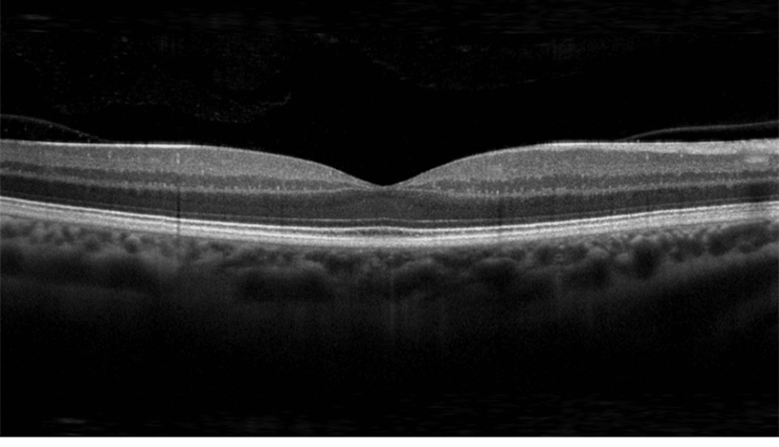

Figure 1.1: A normal, healthy macular OCT image.

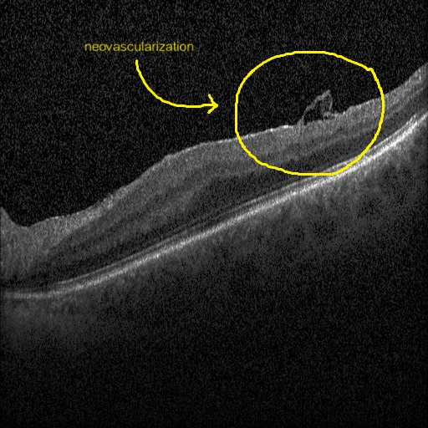

Figure 1.2: OCT image showing Neovascularization (NV) in the Retina The OCT scan shows several layers of the retina in cross-section, where the top curved line represents the retinal surface and the deeper layers are visible below.

While traditional methods for detecting NV involve manual examination by specialists, these methods are time-consuming and susceptible to human error, especially when scaling to large populations. Automated detection methods, particularly using advanced image processing techniques like corner detection, offer a solution by improving the efficiency and speed of NV diagnosis. By automating this process, we aim to streamline the diagnosis of retinal conditions, enabling faster and more consistent detection of NV across large screening programs. This approach is particularly valuable in areas with limited access to specialized care. Our project focuses on developing a system that automatically detects NV in OCT images, reducing diagnostic time and making early interventions more accessible.

## Framework

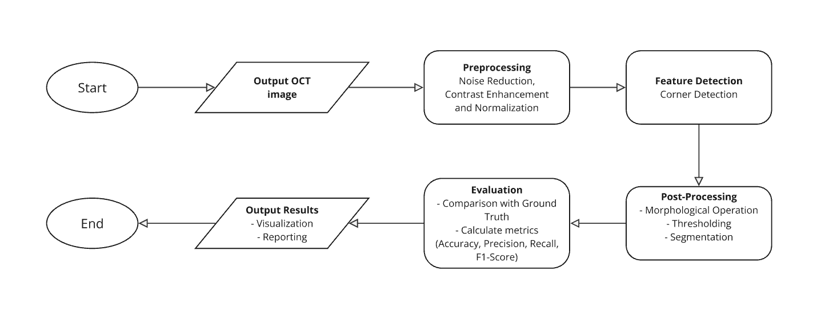

Figure 2: Flowchart illustrates the procedures of the project

The framework for the project involves several key stages:

1. Preprocessing:

* Enhancing image quality by removing noise and improving contrast to make relevant features more distinguishable.
* Ensuring the OCT images are suitable for further analysis.

2. Detection Techniques:

* Corner Detection: Used to locate points of interest, such as the boundary of abnormal blood vessels.

3. Post-Processing:

* Refining the detected regions to eliminate false positives and to segment the areas with neovascularization more accurately.

4. Evaluation Metrics:

The system will be evaluated using the following metrics:

* Accuracy: Proportion of correctly identified neovascularization regions.
* Precision: The ratio of true positives (correctly identified NV) to all positives (detected NV).
* Recall: The ratio of true positives to the actual number of images with NV regions.
* F1-Score: A harmonic mean of precision and recall to provide a balanced measure of the system's performance.

## The formulas for these evaluations are as follows.

* Accuracy =
* Precision =
* Recall =
* F1-Score =

## Methodology

As part of the project to develop an automated system for detecting neovascularization (NV) in Optical Coherence Tomography (OCT) images, several preprocessing and detection steps were applied to a set of OCT images. The following summarizes the preliminary results:

#### 1. Raw Image Acquisition

### The foundation of this study begins with acquiring high-resolution Optical Coherence Tomography (OCT) images. These images capture the intricate structures of the retina, serving as the primary dataset for the neovascularization detection pipeline. The dataset comprises multiple OCT images with varying degrees of retinal abnormalities, ensuring diversity in input data and robustness in evaluating the methodology. Figure 3.1 illustrates representative examples of raw OCT images used in this project. These raw images exhibit noise, intensity variations, and structural artifacts that necessitate preprocessing.

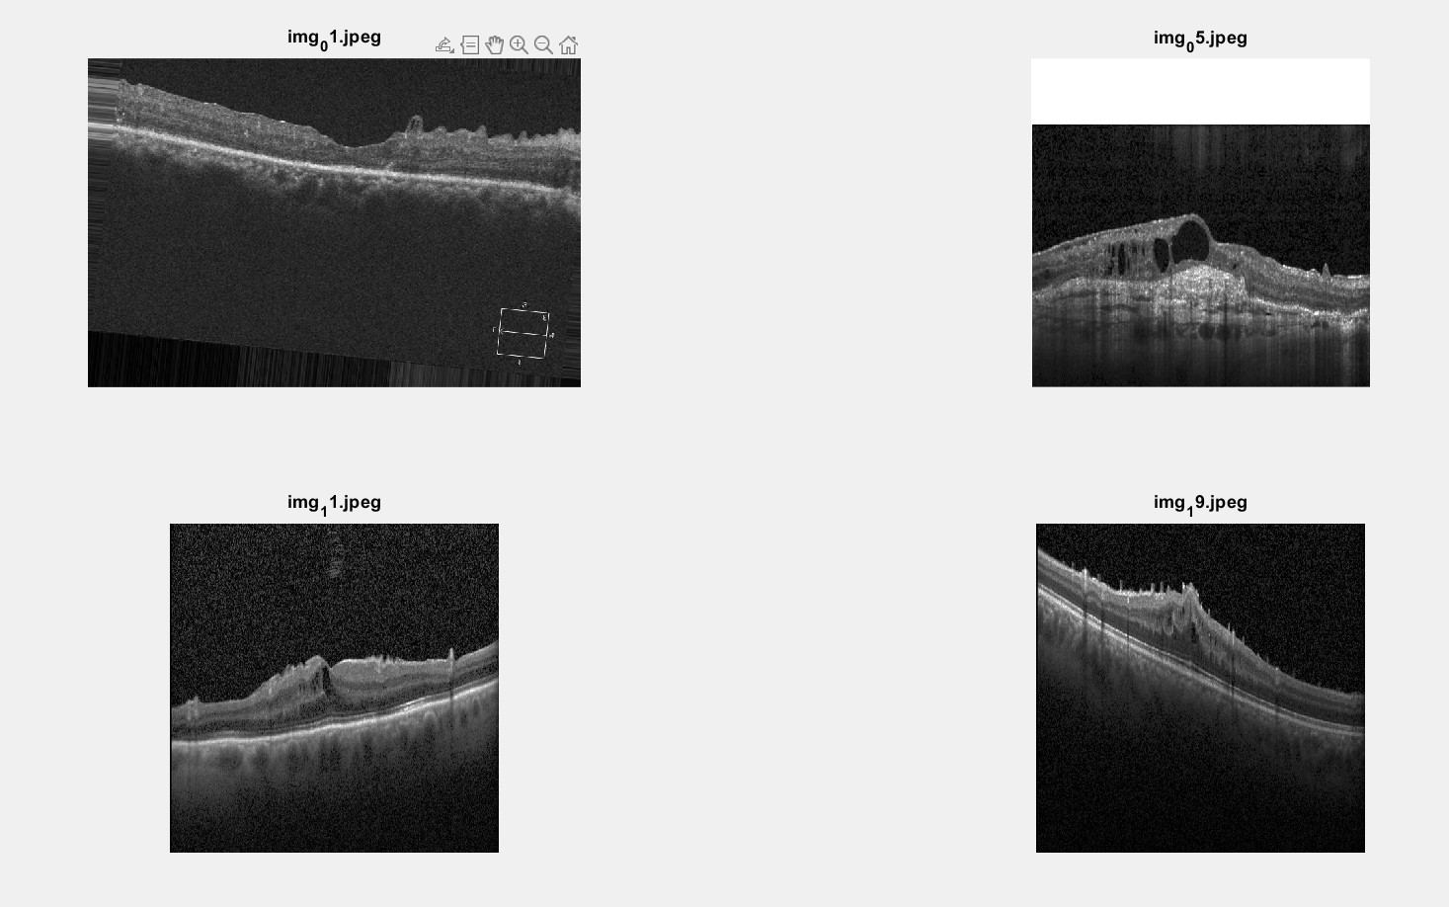Figure 3.1: Raw OCT Images

This figure shows examples of raw OCT images used in the study. These images exhibit noise, intensity variations, and structural artifacts, necessitating preprocessing before analysis.

#### 2. Preprocessing

### Preprocessing is a critical step to prepare raw OCT images for corner detection. This step focuses on enhancing image quality and removing irrelevant artifacts.

### Removing White Borders Raw OCT images often include white borders that obscure retinal structures and skew detection algorithms. To address this, a white border removal process was applied to isolate the region of interest (ROI) within the OCT scans. The adjusted images (see Figure 3.2) provide cleaner, focused input for subsequent analysis.

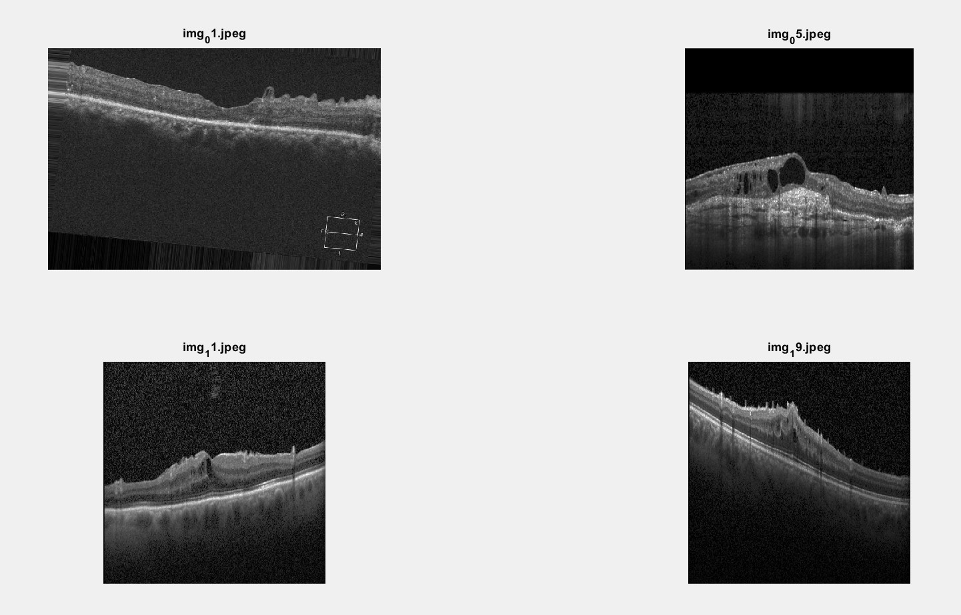

Figure 3.2: Images After White Border Removal

OCT images after removing the white borders to isolate the region of interest (ROI). This step ensures that the analysis focuses solely on retinal structures.

### Intensity Adjustments To enhance visibility of retinal features, the intensity levels of the images were adjusted. This step increases the contrast between key structures and the background, facilitating more precise segmentation.

### Noise Reduction Noise in OCT images can interfere with edge detection and corner identification. To mitigate this:

### A median filter was applied to suppress salt-and-pepper noise while preserving edges.

### A Gaussian filter was subsequently applied to smoothen the images further and reduce high-frequency noise. These filtered outputs (see Figure 3.3) ensure that key structural details of the retina are retained.

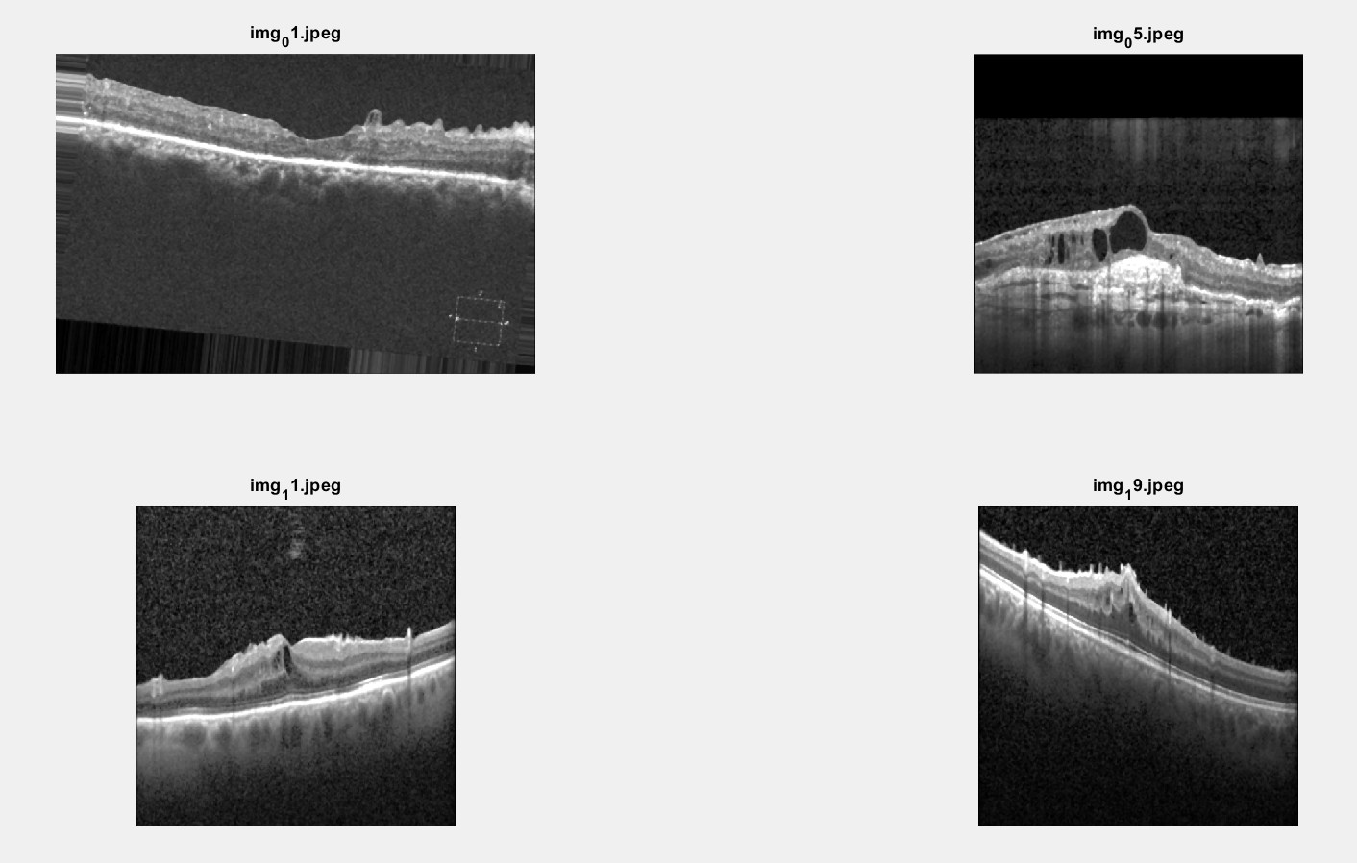Figure 3.3: Images After Applying Median and Gaussian Filters

Filtered images following the application of a median filter (to suppress noise) and a Gaussian filter (to smooth high-frequency noise). These operations preserve structural details while reducing artifacts.

#### 3. Binarization

### Binarization converts grayscale images into binary format, highlighting areas of interest by segmenting the retinal structures from the background. This was achieved using a carefully calibrated global thresholding approach, where pixel intensities below the threshold were set to black (background), and those above it were set to white (foreground). Figure 3.4 demonstrates the binarized outputs, which form the foundation for morphological operations and feature detection.

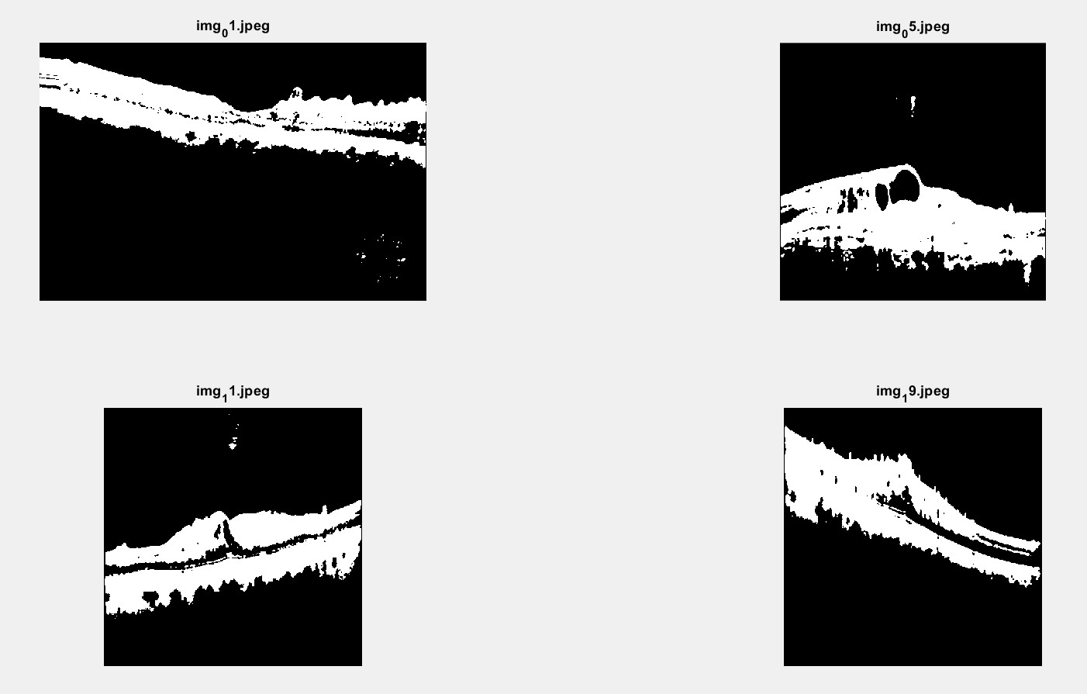Figure 3.4: Binarized OCT Images

Binarized images highlighting retinal structures segmented from the background. This transformation enables subsequent morphological refinements.

#### 4. Morphological Operations

### Following binarization, morphological operations were performed to refine the segmented regions, address irregularities, and ensure a cleaner input for corner detection:

### Closing: Closing operations were applied to eliminate small gaps or discontinuities in the segmented retinal regions, particularly at the edges. This step improved the continuity of structures.

### Hole Filling: Small internal gaps or voids within the binary structures were filled using hole-filling operations. This ensures that the retinal areas are represented as solid, continuous regions, critical for accurate corner detection.

### Bottom Filling: The base of the segmented region was filled to account for lower retinal layers. This operation ensures the structural integrity of the segmented region, as shown in Figure 3.5.

### These morphological refinements improved the accuracy and reliability of subsequent corner detection processes.

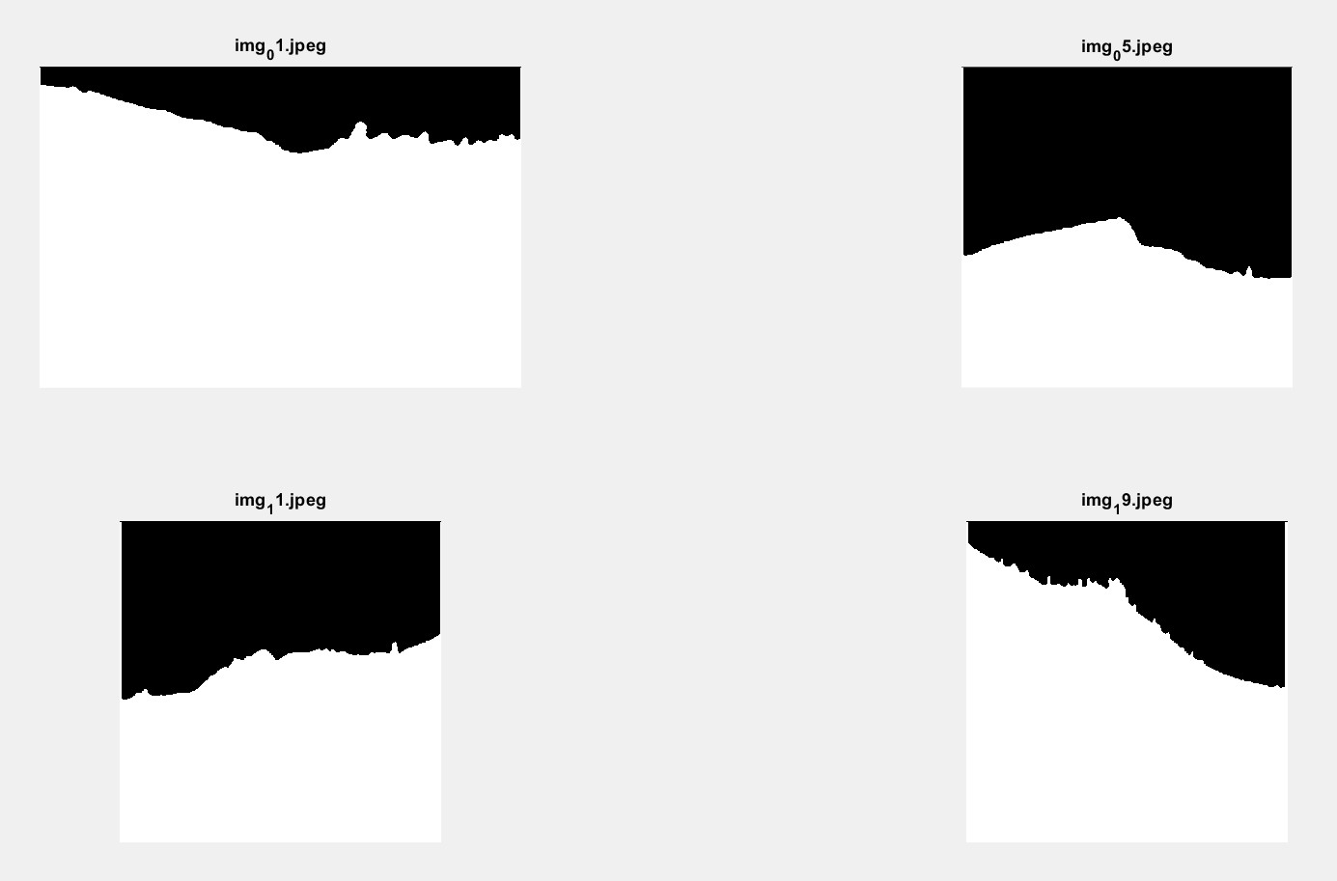Figure 3.5: Morphologically Processed Images (Closing, Hole Filling, and Bottom Filling)

Segmented retinal structures after applying morphological operations, including closing, hole filling, and bottom filling. These operations enhance the continuity and integrity of the segmented regions.

#### 5. Harris Corner Detection

### With the preprocessed and segmented images prepared, the Harris Corner Detection algorithm was employed to identify points of interest within the retinal structures. This algorithm is well-suited for detecting corners, a critical feature for locating regions potentially indicative of neovascularization.

### Parameter Selection: For optimal performance, the following parameters were carefully chosen:

### Filter size: 7

### Minimum quality threshold: 0.4

### Maximum corners retained: Top 10

### These parameters provided a balance between sensitivity and specificity, ensuring both precision and recall in identifying NV regions. Figure 3.6 shows examples of detected corners superimposed on the processed images, highlighting areas of interest.

### The Harris Corner Detector effectively localized points of structural significance, including possible NV regions, while minimizing false positives.

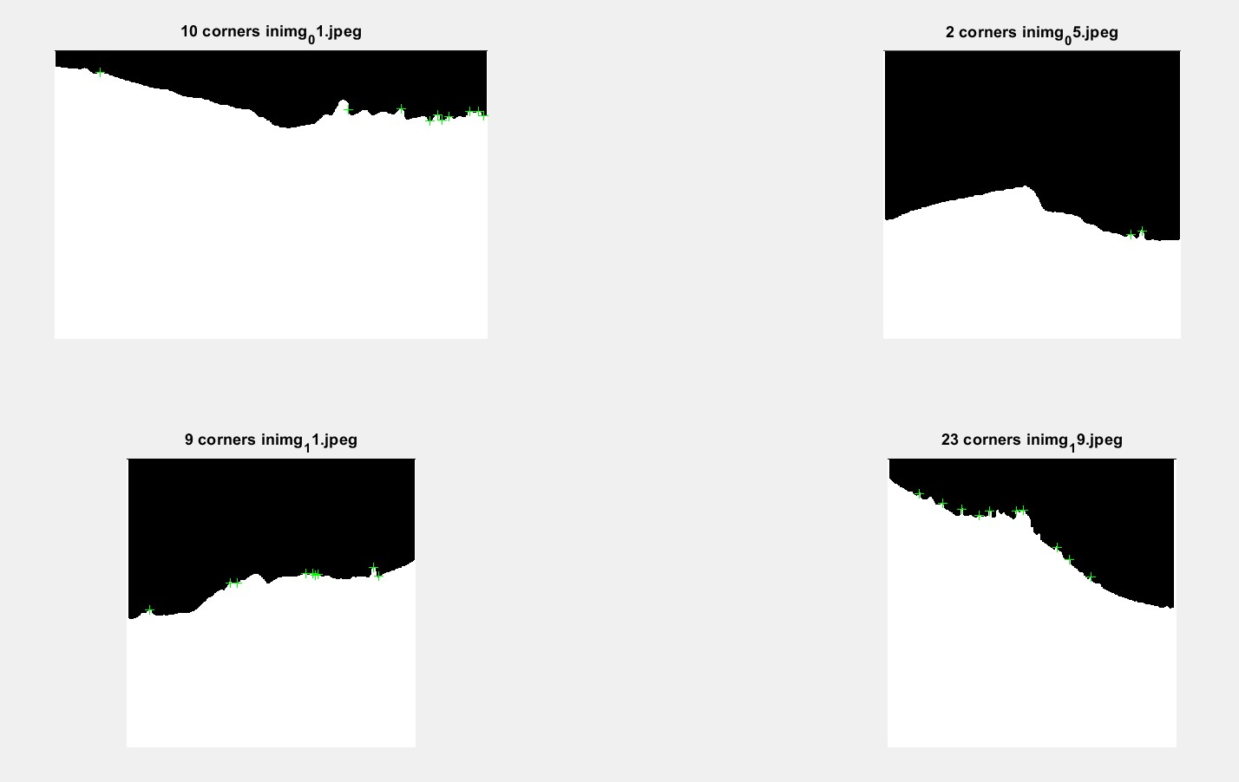Figure 3.6: Harris Corner Detection Results

Detected corners using the Harris Corner Detection algorithm overlaid on the preprocessed OCT images. Green crosses indicate detected corners, which align with structural points of interest.

#### 6. Validation Against Ground Truth

### The final step involved validating the detected corners against ground truth annotations to quantify the performance of the methodology. Ground truth annotations, provided in the dataset, mark the known locations of neovascularization regions. The detected corners were overlaid on the original OCT images, with ground truth regions highlighted using red ovals. This overlay is illustrated in Figure 3.7.

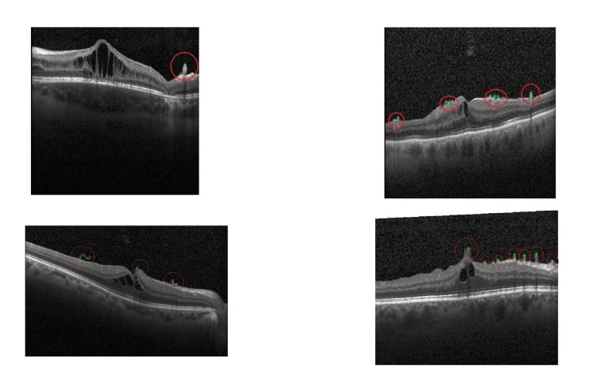

Figure 3.7: Detected Corners Validated Against Ground Truth

Validation of detected corners against ground truth annotations, shown as red ovals. This overlay helps evaluate the system’s accuracy, precision, and other performance metrics.

### Performance Metrics: To evaluate the detection system, several performance metrics were calculated:

### Accuracy: The proportion of correctly detected corners.

### Precision: The percentage of detected corners that correctly align with NV regions.

### Recall: The ability of the system to detect all NV regions.

### Specificity: The system’s ability to avoid false positives.

### F1-Score: A harmonic mean of precision and recall, providing a balanced measure of performance.

### These metrics provided a comprehensive evaluation of the system’s performance across various parameter settings, with detailed trends presented in the Results section.

### This step-by-step methodology ensured that the detection process was systematic, robust, and optimized for the unique challenges posed by OCT images. By leveraging advanced preprocessing techniques, refined segmentation, and a reliable corner detection algorithm, this methodology achieved reliable detection of neovascularization regions while providing actionable insights for further refinement.

### 

### Results

The results of the neovascularization detection system were evaluated across various kernel sizes (3, 5, and 7) and quality thresholds (ranging from 0.2 to 0.7). To assess the effectiveness of the proposed methodology, key metrics including Accuracy, Precision, Recall, Specificity, and F1 Score were analyzed. These metrics provide a detailed understanding of the trade-offs between true positive detection rates, false positives, and false negatives, helping us identify the most effective settings for the system.

#### 

#### Accuracy

#### Accuracy measures the overall correctness of the system in detecting neovascularization. The results, summarized in Table 1, show that kernel size 7 outperformed smaller kernels for quality thresholds between 0.3 and 0.5, achieving the highest accuracy of 83.67% at a threshold of 0.4. However, at thresholds above 0.5, the performance of kernel size 7 declined, suggesting a trade-off between capturing fine-grained details and sensitivity at higher thresholds. Kernel size 5 demonstrated moderate performance consistency, while kernel size 3 showed relatively stable, though lower, accuracy across all thresholds.

**Table 1: Accuracy Across Kernel Sizes and Quality Thresholds**

|  | | Quality Threshold | | | | | |
| --- | --- | --- | --- | --- | --- | --- | --- |
|  | | **0.2** | **0.3** | **0.4** | **0.5** | **0.6** | **0.7** |
| **Kernel Size** | **3** | 49.85% | 49.85% | 49.85% | 49.85% | 54.05% | 56.30% |
| **5** | 59.22% | 59.22% | 60.89% | 68.97% | 63.97% | 60.80% |
| **7** | 57.63% | 72.63% | **83.67%** | 71.67% | 55.34% | 50.67% |

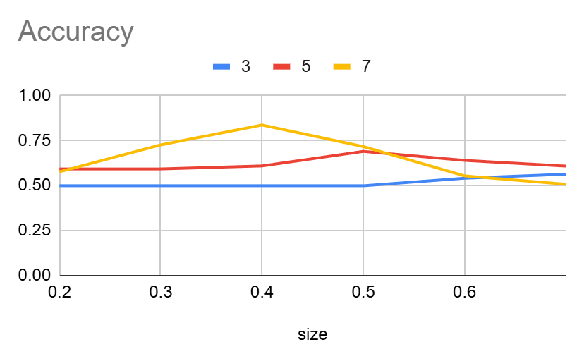

Figure 4.1: Accuracy Trends Across Kernel Sizes and Quality Thresholds  
The plot illustrates accuracy trends for neovascularization detection, varying across kernel sizes (3, 5, and 7) and quality thresholds (0.2 to 0.7). It demonstrates that larger kernel sizes, particularly size 7, achieve higher accuracy at moderate thresholds, while accuracy decreases at higher thresholds for the same kernel size.

The trend suggests that larger kernels initially provide better performance due to their ability to capture more context. However, this benefit diminishes at higher thresholds, possibly due to the increased emphasis on strict quality conditions, which reduce the number of positively identified regions.

#### Precision

Precision evaluates the system’s ability to minimize false positives while accurately identifying true positives. As shown in **Table 2**, kernel size 7 achieved the highest precision of **87.44%** at a quality threshold of 0.4, outperforming kernel sizes 5 and 3. However, at thresholds above 0.5, precision for kernel size 7 decreased sharply, highlighting difficulties in maintaining a low false-positive rate as detection became stricter. Kernel size 5 showed steady performance, while kernel size 3 maintained relatively lower precision across thresholds.

**Table 2: Precision Across Kernel Sizes and Quality Thresholds**

|  | | Quality Threshold | | | | | |
| --- | --- | --- | --- | --- | --- | --- | --- |
|  | | **0.2** | **0.3** | **0.4** | **0.5** | **0.6** | **0.7** |
| **Kernel Size** | **3** | 53.04% | 53.04% | 53.04% | 53.04% | 60.25% | 61.92% |
| **5** | 62.33% | 62.33% | 63.17% | 70.67% | 68.33% | 57.50% |
| **7** | 62.02% | 72.86% | **87.44%** | 78.83% | 52.50% | 35.00% |

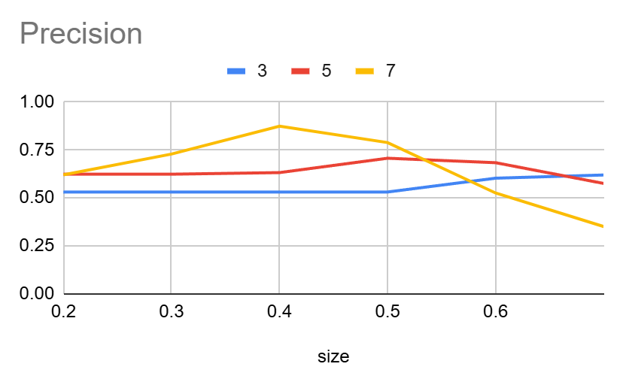Figure 4.2: Precision Trends Across Kernel Sizes and Quality Thresholds  
The plot shows precision trends for neovascularization detection, varying with kernel sizes (3, 5, and 7) and quality thresholds (0.2 to 0.7). Larger kernel sizes, such as size 7, exhibit higher precision at intermediate thresholds, peaking at 0.4, but experience a sharp decline as the quality threshold increases further. Smaller kernel sizes maintain relatively stable but lower precision values across thresholds.

#### Recall

Recall measures the system's sensitivity to detecting true positive cases, emphasizing its ability to minimize false negatives. As detailed in **Table 3**, kernel size 7 maintained a recall above **90%** for thresholds ranging from 0.2 to 0.4, with the highest recall of **92.24%** at thresholds 0.2 and 0.3. However, recall declined significantly at thresholds above 0.5 for kernel sizes 5 and 7, indicating reduced sensitivity under stricter conditions. Kernel size 3 demonstrated relatively stable recall but was consistently lower than larger kernels.

**Table 3: Recall Across Kernel Sizes and Quality Thresholds**

|  | | Quality Threshold | | | | | |
| --- | --- | --- | --- | --- | --- | --- | --- |
|  | | **0.2** | **0.3** | **0.4** | **0.5** | **0.6** | **0.7** |
| **Kernel Size** | **3** | 75.31% | 75.31% | 75.31% | 75.31% | 61.48% | 61.48% |
| **5** | 91.28% | 91.28% | 88.78% | 81.28% | 51.94% | 42.05% |
| **7** | **92.24%** | **92.24%** | 91.53% | 65.66% | 33.01% | 15.23% |

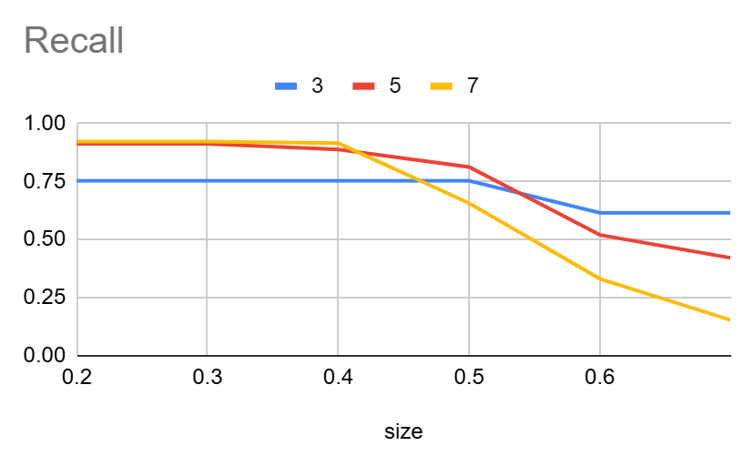Figure 4.3: Recall Trends Across Kernel Sizes and Quality Thresholds  
The plot highlights the recall performance for neovascularization detection, demonstrating that larger kernel sizes (5 and 7) achieve consistently higher recall at lower quality thresholds, with size 7 peaking at 0.2. However, as the quality threshold increases, recall decreases significantly, particularly for size 7. In contrast, size 3 maintains a steady recall performance across all thresholds, albeit at a lower level compared to larger kernel sizes.

These trends highlight a key trade-off: larger kernels excel in recall at lower thresholds but struggle to maintain performance at higher thresholds.

#### Specificity

Specificity reflects the system's ability to correctly identify true negatives, thus minimizing false positives. As shown in **Table 4**, kernel size 7 achieved the highest specificity of **92.5%** at a threshold of 0.7, surpassing the performance of kernel sizes 3 and 5. This suggests that larger kernels are better at correctly excluding non-neovascularization areas under stricter conditions.

**Table 4: Specificity Across Kernel Sizes and Quality Thresholds**

|  | | Quality Threshold | | | | | |
| --- | --- | --- | --- | --- | --- | --- | --- |
|  | | **0.2** | **0.3** | **0.4** | **0.5** | **0.6** | **0.7** |
| **Kernel Size** | **3** | 25.92% | 25.92% | 25.92% | 25.92% | 53.17% | 57.33% |
| **5** | 29.17% | 29.17% | 34.17% | 55.83% | 77.50% | 80.00% |
| **7** | 25.42% | 52.92% | 72.50% | 80.00% | 82.50% | **92.50%** |

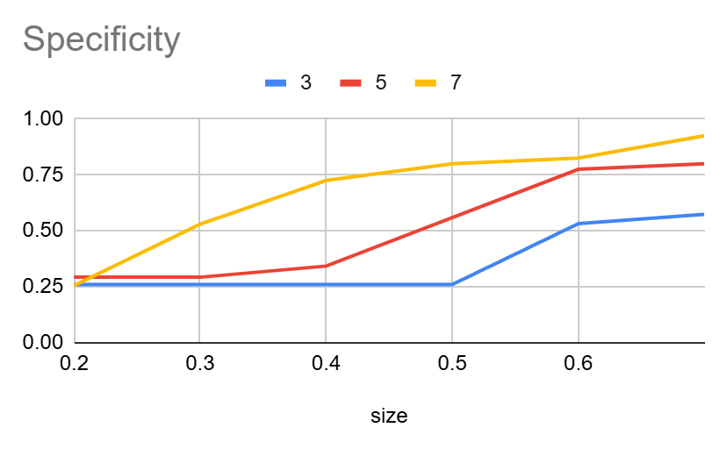Figure 4.4: Specificity Trends Across Kernel Sizes and Quality Thresholds  
The plot illustrates specificity trends for neovascularization detection, showing the ability to correctly identify non-neovascularization regions. Larger kernel sizes (5 and 7) demonstrate a substantial increase in specificity as the quality threshold rises, with size 7 achieving the highest specificity at 0.7. Kernel size 3 shows the lowest specificity across all thresholds, indicating limitations in minimizing false positives under stricter quality conditions.

#### F1 Score

The F1 Score evaluates the balance between precision and recall. As shown in **Table 5**, kernel size 7 achieved the highest F1 score of **87.28%** at a threshold of 0.4. This demonstrates an optimal balance between sensitivity and precision at this configuration. Beyond threshold 0.4, the F1 score dropped significantly for kernel size 7, reflecting difficulties in maintaining balance under stricter criteria.

**Table 5: F1 Score Across Kernel Sizes and Quality Thresholds**

|  | | Quality Threshold | | | | | |
| --- | --- | --- | --- | --- | --- | --- | --- |
|  | | **0.2** | **0.3** | **0.4** | **0.5** | **0.6** | **0.7** |
| **Kernel Size** | **3** | 58.39% | 58.39% | 58.39% | 58.39% | 56.18% | 57.18% |
| **5** | 69.87% | 69.87% | 69.87% | 72.21% | 55.56% | 45.24% |
| **7** | 69.61% | 78.11% | **87.28%** | 67.76% | 37.97% | 19.61% |

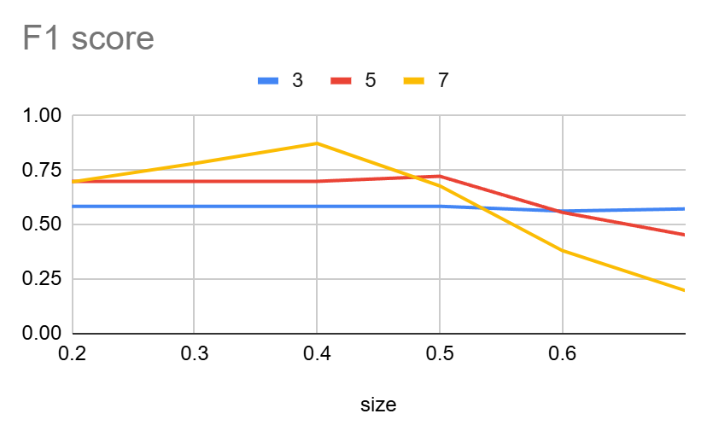Figure 4.5: F1 Score Trends Across Kernel Sizes and Quality Thresholds  
The plot presents the F1 score trends, representing the balance between precision and recall for neovascularization detection. Kernel size 7 achieves the highest F1 score at a quality threshold of 0.4, indicating an optimal balance between sensitivity and precision. As the quality threshold increases, the F1 score for size 7 declines sharply. Kernel size 5 shows moderate but stable F1 scores across thresholds, while size 3 exhibits the lowest F1 scores with minimal variation.

### Summary of Results

Overall, kernel size 7 outperformed the smaller kernels in most metrics, particularly at quality thresholds between 0.3 and 0.4. At these settings, the system achieved its highest accuracy (83.67%), precision (87.44%), recall (92.24%), and F1 score (87.28%). These results demonstrate that kernel size 7 is most effective at balancing detection sensitivity and precision when the quality threshold is moderate. However, as the threshold increased beyond 0.5, kernel sizes 3 and 5 exhibited more stable performance, emphasizing their resilience under stricter conditions.

**Conclusion**

The proposed automatic neovascularization (NV) detection system represents a significant step toward improving the diagnostic process for retinal diseases such as diabetic retinopathy and age-related macular degeneration (AMD). By leveraging advanced image processing techniques, the system successfully identified NV regions in optical coherence tomography (OCT) images with acceptable levels of accuracy, precision, and recall across various kernel sizes and quality thresholds.

### Key Achievements

1. **Improved Diagnostic Efficiency**: The system reduces reliance on manual examinations, offering faster and more scalable solutions for NV detection in clinical settings.
2. **Optimal Performance Settings**: Through extensive evaluation, the system demonstrated that kernel size 7 at a quality threshold of 0.4 achieved the best balance across all performance metrics, making it the most suitable configuration for practical applications.
3. **Quantitative Insights**: Metrics such as precision (87.44%), recall (92.24%), and F1 score (87.28%) at optimal settings highlight the system’s capability to accurately detect NV regions while minimizing false positives and negatives.

### Challenges and Limitations

Despite its success, the system faces certain limitations that need to be addressed in future work:

* **Noise Sensitivity**: The system’s performance was affected by noise and artifacts in lower-quality OCT images, leading to false positives or missed detections.
* **Limited Generalizability**: The algorithm requires fine-tuning to adapt to different datasets and imaging conditions, which could limit its broad applicability without further development.

### Future Directions

Building on the findings of this study, future research could focus on the following areas:

1. **Integration of Deep Learning Techniques**: Incorporating convolutional neural networks (CNNs) or other advanced machine learning approaches to enhance the detection of subtle NV patterns and improve robustness against noise.
2. **Refinement of Detection Algorithms**: Improving corner detection algorithms to reduce false positives and negatives while maintaining high sensitivity and specificity.
3. **Expansion of Dataset Diversity**: Testing the system on a larger and more diverse dataset to improve generalizability and validate its performance in real-world clinical scenarios.

### Conclusion Summary

The developed NV detection system lays the groundwork for more effective and efficient diagnostic workflows in ophthalmology. By enabling early detection of NV regions, the system has the potential to significantly improve patient outcomes by facilitating timely interventions. While challenges remain, the study’s findings provide a solid foundation for future advancements, aiming toward a fully automated and reliable NV detection tool that can be seamlessly integrated into clinical practice.

**References**

*Age-Related Macular Degeneration - EyeWiki*. (2024, September 1). https://eyewiki.org/Age-Related_Macular_Degeneration

*Corneal neovascularization - EyeWiki*. (2024, March 20). https://eyewiki.org/Corneal_Neovascularization

*Diabetic retinopathy - Symptoms & causes - Mayo Clinic*. (2023, February 21). Mayo Clinic. https://www.mayoclinic.org/diseases-conditions/diabetic-retinopathy/symptoms-causes/syc-20371611

Ellis, R. R. (2024, September 11). *Age-Related Macular Degeneration (AMD)*. WebMD. https://www.webmd.com/eye-health/macular-degeneration/age-related-macular-degeneration-overview

Estopinal, C. B., Ausayakhun, S., Ausayakhun, S., Jirawison, C., Bhosai, S. J., Margolis, T. P., & Keenan, J. D. (2013). Access to ophthalmologic care in Thailand: a regional analysis. *Ophthalmic Epidemiology*, *20*(5), 267–273. https://doi.org/10.3109/09286586.2013.821498

Fletcher, J. (2023, April 4). *What is neovascularization and why does it occur in diabetic retinopathy?* https://www.medicalnewstoday.com/articles/neovascularization-diabetic-retinopathy

LaetitiaVanCauwenberge. (2016, February 20). *11 Important model evaluation techniques Everyone should know*. Data Science Central. https://www.datasciencecentral.com/7-important-model-evaluation-error-metrics-everyone-should-know/

Mehta, S. (2024, April 10). *Diabetic retinopathy*. MSD Manual Consumer Version. https://www.msdmanuals.com/home/eye-disorders/retinal-disorders/diabetic-retinopathy

*Model evaluation: Everything you need to know when assessing model evaluation skills*. (n.d.). https://www.alooba.com/skills/concepts/machine-learning/model-evaluation/

*Model Evaluation Metrics: Methods & Approaches*. (n.d.). https://www.markovml.com/blog/model-evaluation-metrics

*Neovascularization of the eye*. (2024a, November 15). Cleveland Clinic. https://my.clevelandclinic.org/health/diseases/24131-neovascularization-of-the-eye

*Neovascularization of the eye*. (2024b, November 15). Cleveland Clinic. https://my.clevelandclinic.org/health/diseases/24131-neovascularization-of-the-eye

*OpenCV: Harris Corner Detection*. (n.d.). https://docs.opencv.org/4.x/dc/d0d/tutorial_py_features_harris.html

Resnikoff, S., Lansingh, V. C., Washburn, L., Felch, W., Gauthier, T., Taylor, H. R., Eckert, K., Parke, D., & Wiedemann, P. (2019). Estimated number of ophthalmologists worldwide (International Council of Ophthalmology update): will we meet the needs? *British Journal of Ophthalmology*, *104*(4), 588–592. https://doi.org/10.1136/bjophthalmol-2019-314336

Statista. (2024a, July 29). *Share of aging population Thailand 2023-2040*. https://www.statista.com/statistics/713667/thailand-forecast-aging-population/

Statista. (2024b, August 16). *Number of diabetic patients Thailand 2016-2022*. https://www.statista.com/statistics/1113630/thailand-number-of-diabetic-patients/

Wang, X., Zhou, J., Cai, X., Li, T., Long, D., & Wu, Q. (2022). Optical coherence tomography angiography for the detection and evaluation of ptic disc neovascularization: a retrospective, observational study. *BMC Ophthalmology*, *22*(1). https://doi.org/10.1186/s12886-022-02351-9