Task 1: Connect to the Red Hat EC2 instance by using SSH

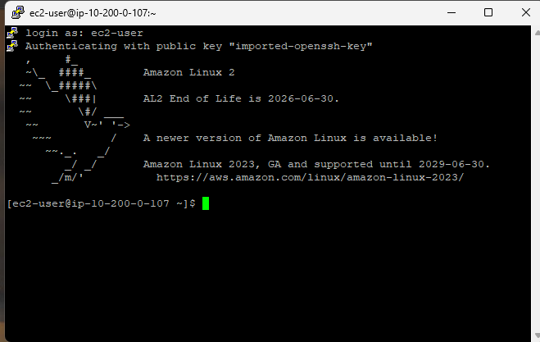
Ec-2 connection

Task 2: Install the AWS CLI on Red Hat Linux
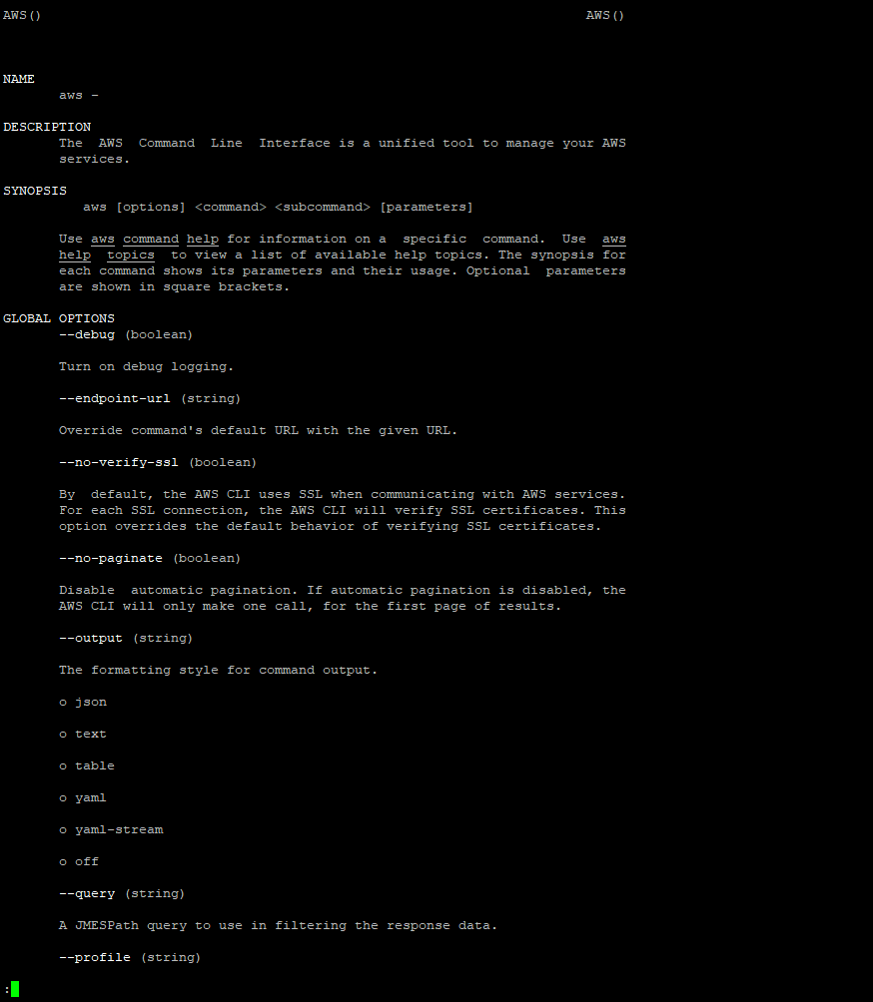
Task 3: Observe IAM configuration details in the AWS Management Console

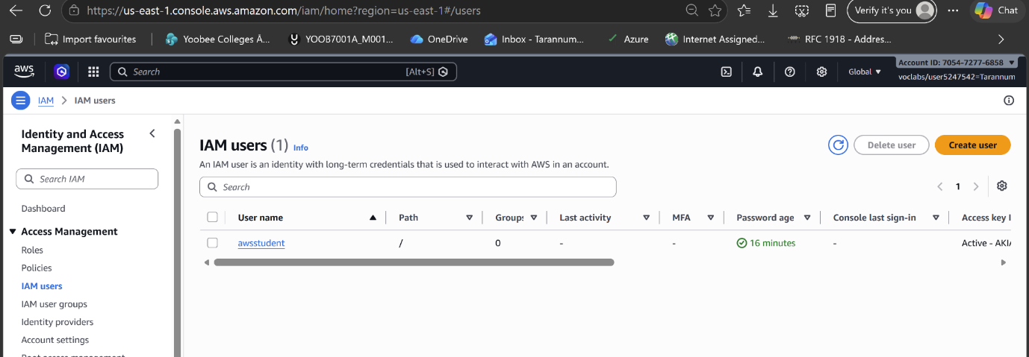

Lab policy

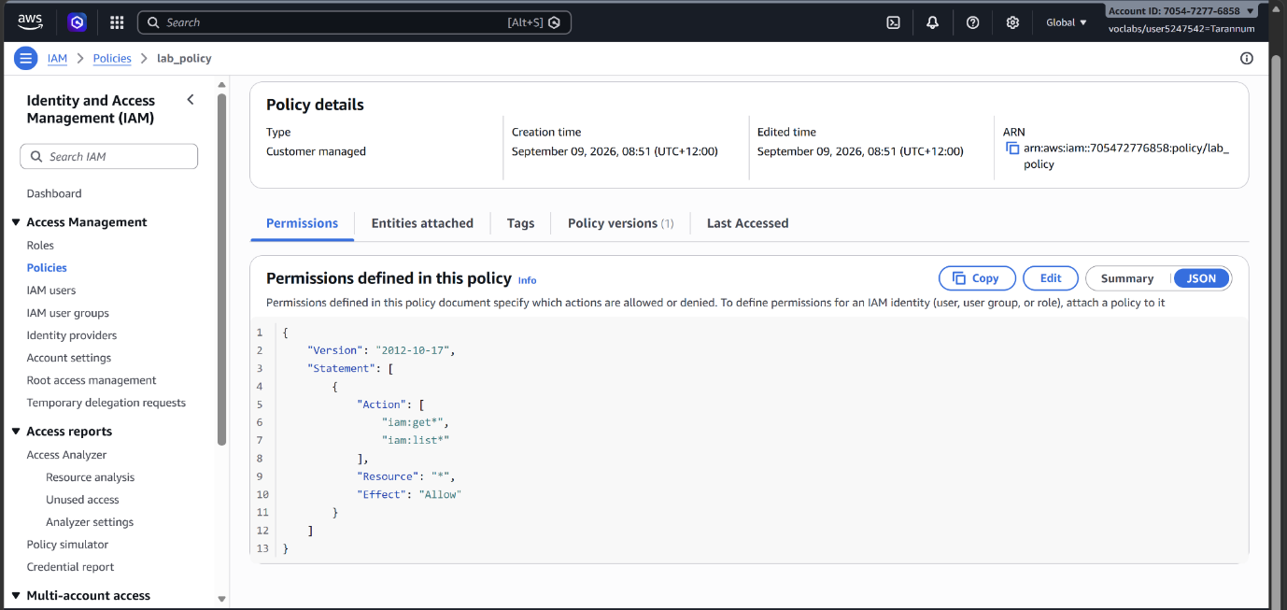
This IAM policy grants the awsstudent user access to specific AWS services in this account under security tab.
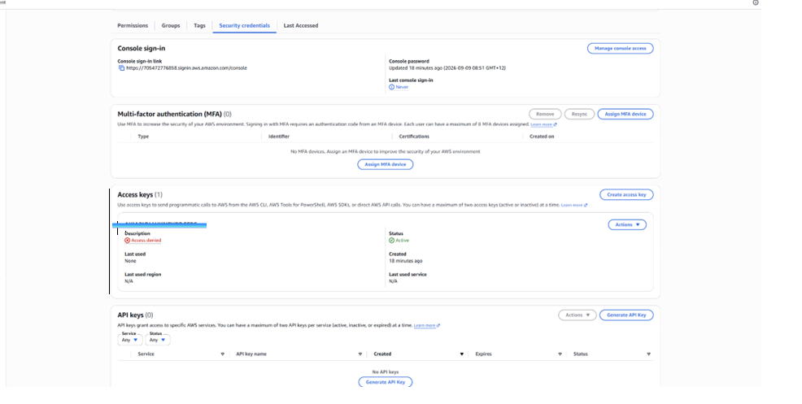

The Access key ID is displayed. There is no way to retrieve the secret access key that must be used with it, unless it was captured at the time that the key was created.
Task 4: Configure the AWS CLI to connect to your AWS Account

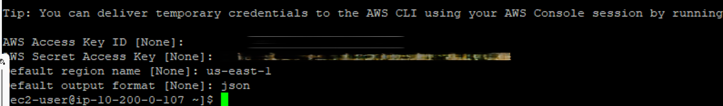
Task 5: Observe IAM configuration details by using the AWS CLI
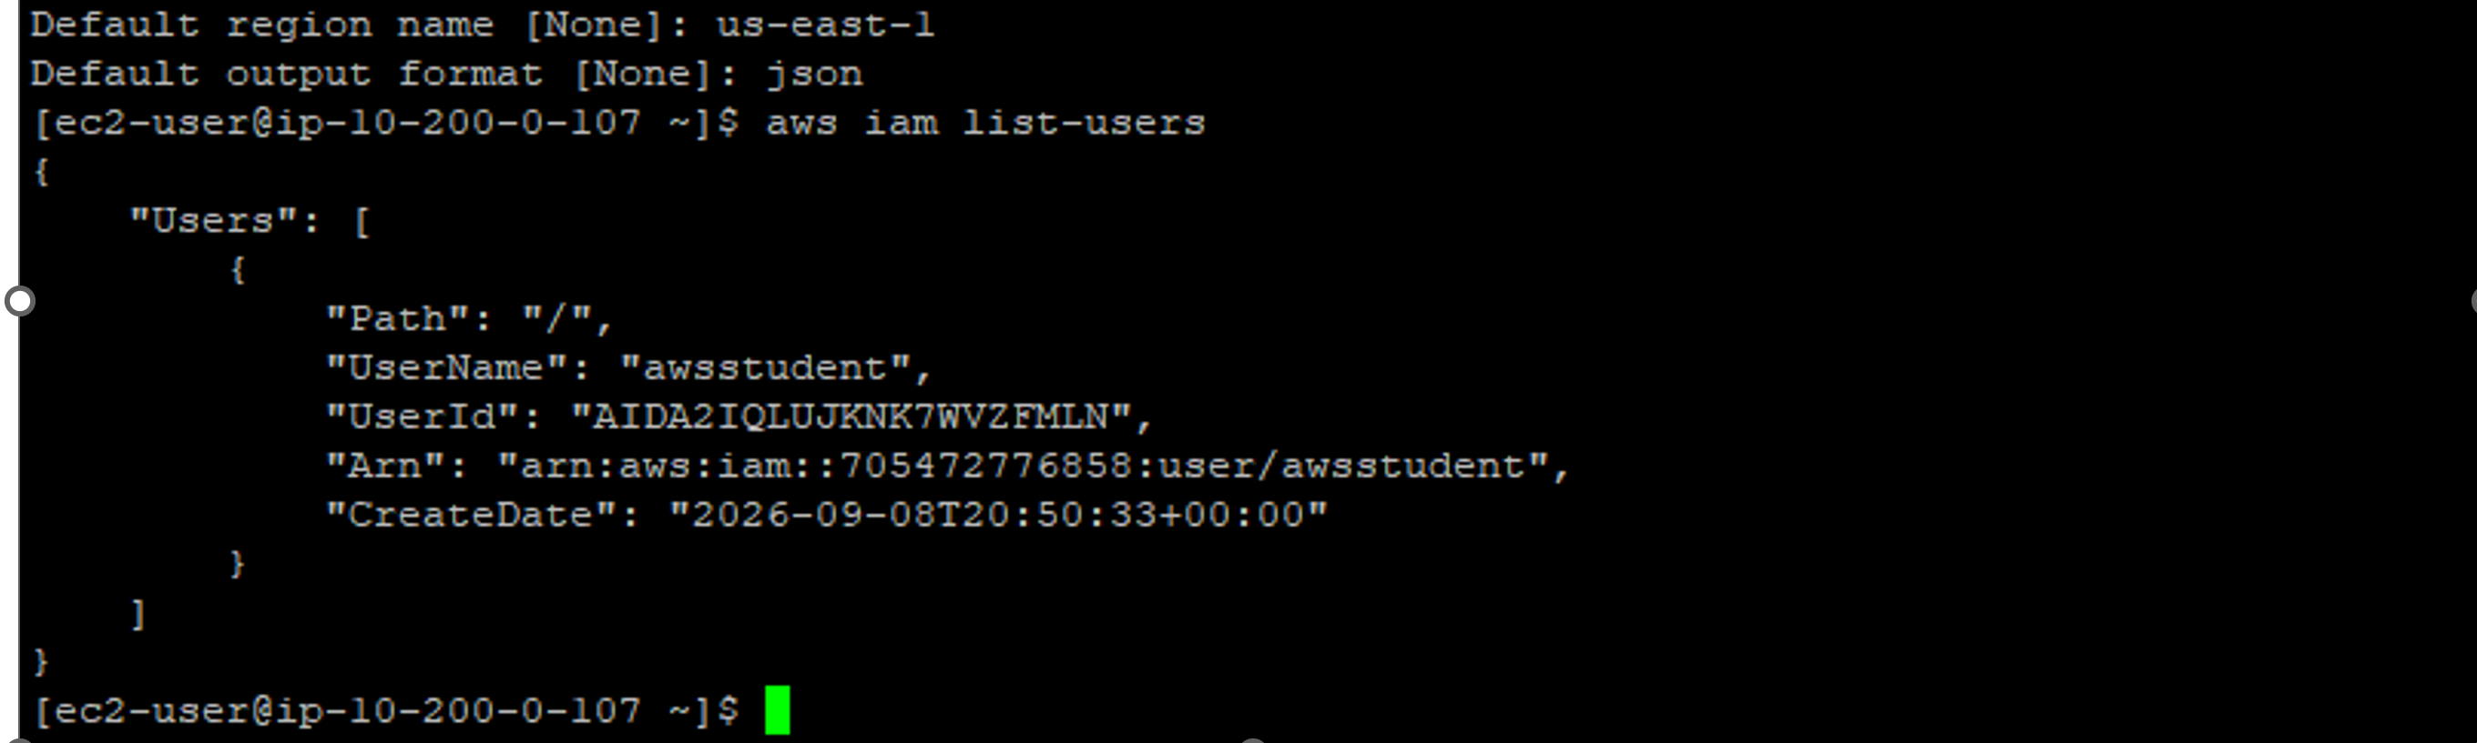

Activity 1
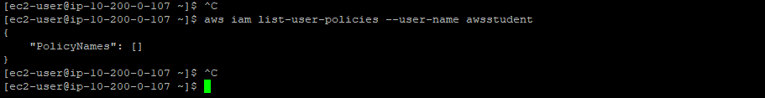

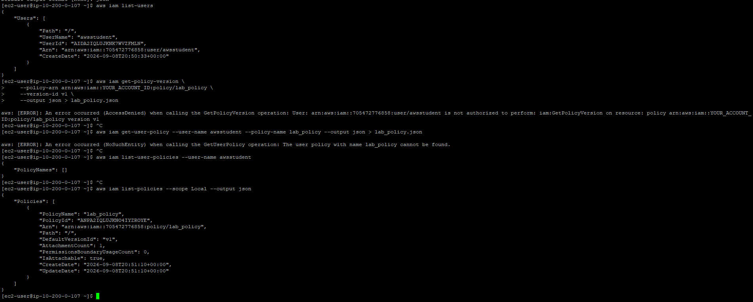

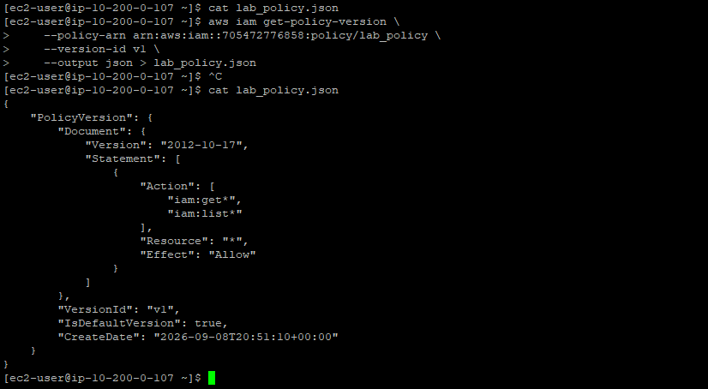

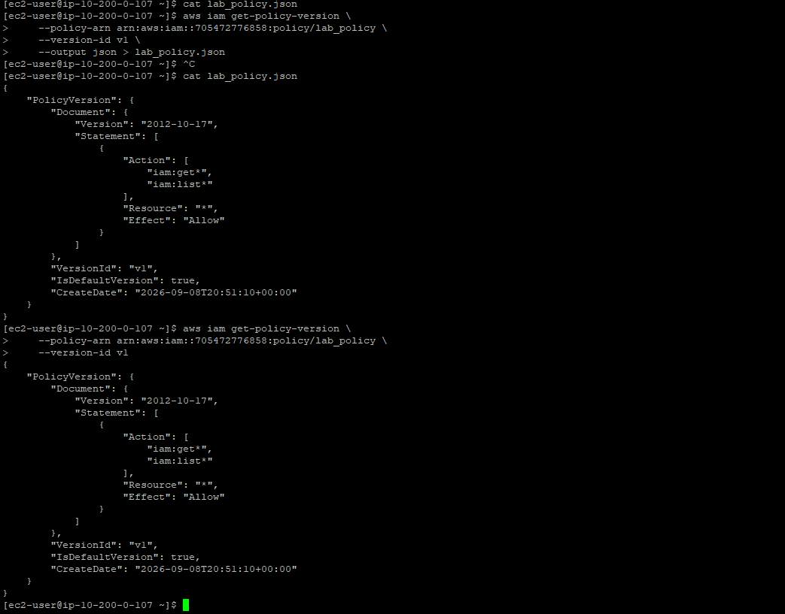
Before you can get the actual JSON representation of the IAM policy to display, you will need to know the policy version. Return to the list of available commands in the documentation to see if any of them look like they might return a policy document.|

