Task 2

Case Scenario A newly appointed CTO of the organisation realised that there are some resources for which the costs can be cut by retiring them and replace them with more efficient and cost–effective modern business solutions micros services like containers. As an Azure Administrator, you have been asked to manage and maintain a repository of these containers’ images. You also need to test that all the repositories transferred to the Azure Container Registries are tested, with updated versioning and are transferred using the open source Docker platform. To perform this activity, you need the following: 1. Docker Engine in running state on your desktop 2. Visual Study Code latest version preferred, with all required extensions installed, like Docker, Azure services including containers and .NET, C# and their plugins if any. 3. Please note, all Azure services installed on the VS Code must only be Microsoft published. For this activity you are required to perform the following task activity and record all screenshots:

Introduction

Organizations frequently face the challenge of high operational costs and resource inefficiencies tied to legacy monolithic systems and underutilized Virtual Machines (VMs). To address this, leadership initiated a modernization strategy aimed at retiring inefficient infrastructure and replacing it with lightweight, cost-effective containerized microservices.

This report documents the successful implementation of a containerized .NET web application workflow. Utilizing the open-source Docker platform, the application was developed locally, packaged via a secure multi-stage build process, stored centrally in Azure Container Registry (ACR), and deployed globally via Azure Container Instances (ACI). By transitioning to serverless container architecture, the organization eliminates idle server costs, optimizes resource utilization, and achieves rapid, scalable deployment capabilities aligned with modern business needs

2. Local Development & .NET Containerization
The first phase of the modernization process focused on establishing a standardized development environment using Visual Studio Code and the .NET platform.

Application Setup and Customization
- Project Initialization: A new .NET web application was initialized from the terminal using the command-line interface (dotnet new webapp).
- Code Modification: The default user interface (index.cshtml) was customized to include specific institutional markers and student identification details (271062825), ensuring traceability and ownership of the deployed asset.
- Local Execution & Verification: The application was built and executed locally, binding to port 8080. Local validation was performed by navigating to http://localhost:8080, confirming that the routing, Razor pages, and dependencies functioned correctly prior to containerization.

Transition to Containerization
To bridge the local application to a portable format, a structured Dockerfile was introduced leveraging official Microsoft .NET 10.0 SDK and runtime images. This established the foundation for reproducible builds across any host environment.

App running

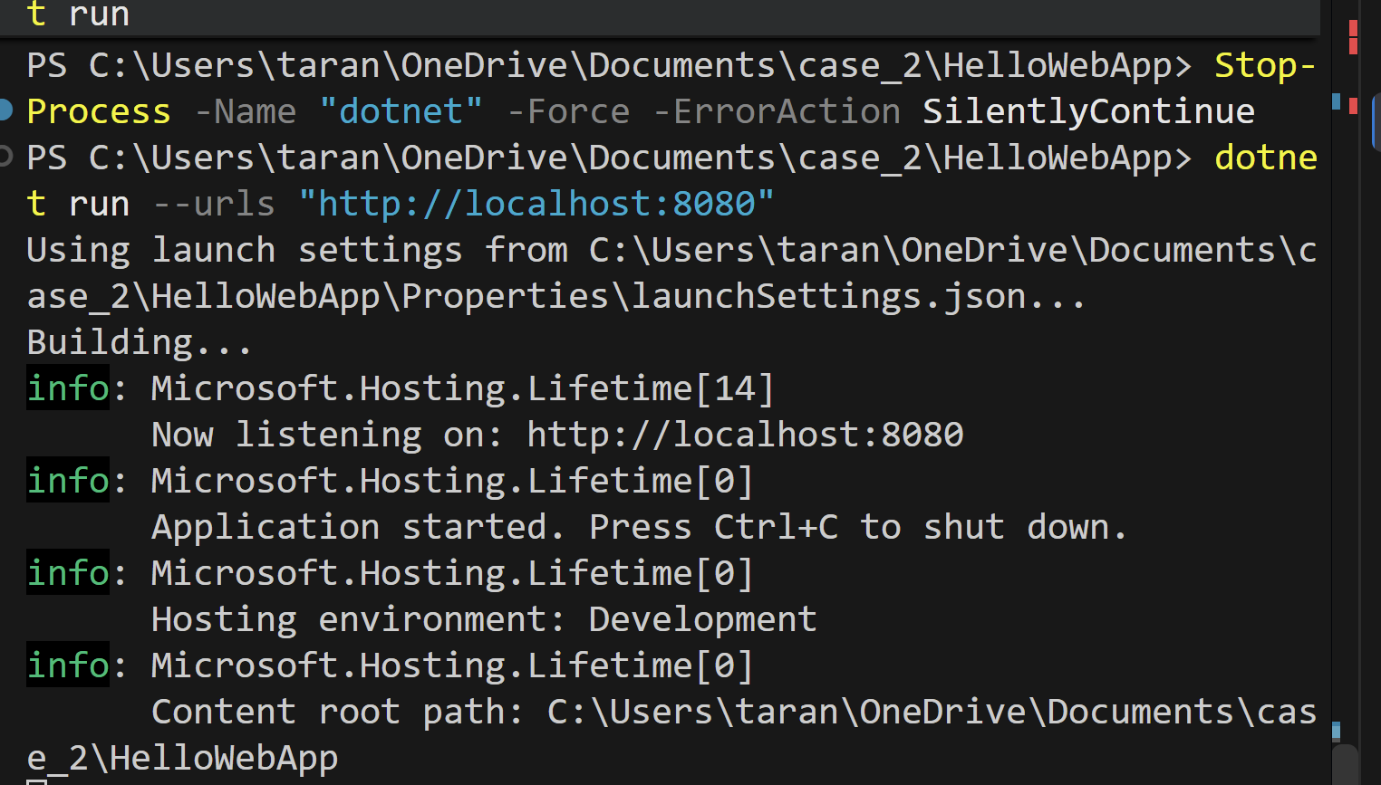

The terminal output confirms that the application successfully stopped any lingering processes, built the project, and is now actively listening on http://localhost:8080.

Docker is currently building container image using the instructions defined in the Docker file.

Downloading Base Images: Docker is pulling down the official Microsoft .NET 10.0 SDK and ASP.NET runtime base images from the Microsoft Container Registry (mcr.microsoft.com).

Multi-Stage Build Execution:
- Stage 1 (Build): Docker uses the SDK image to restore the project's dependencies and compile the application into production-ready release files.
- Stage 2 (Runtime): Docker takes those compiled files and places them into a much lighter, secure ASP.NET runtime image (final) to keep the final container size as small and efficient as possible.
Context Transfer: It is bundling the source files from the HelloWebApp folder into the build context.

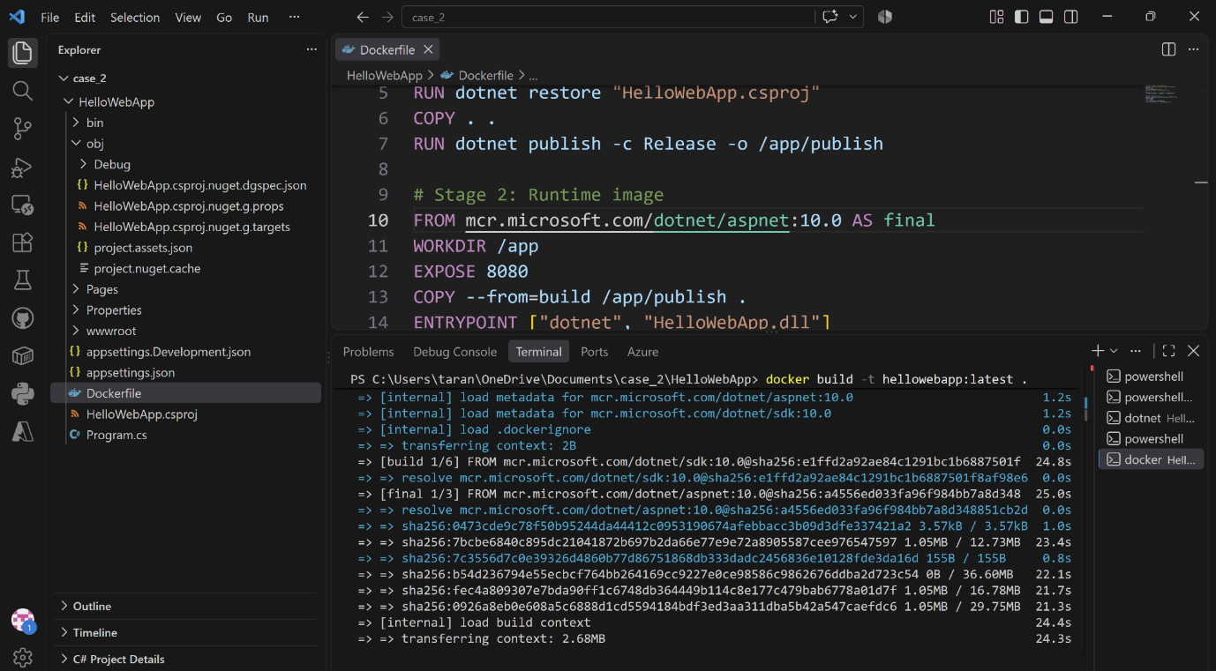

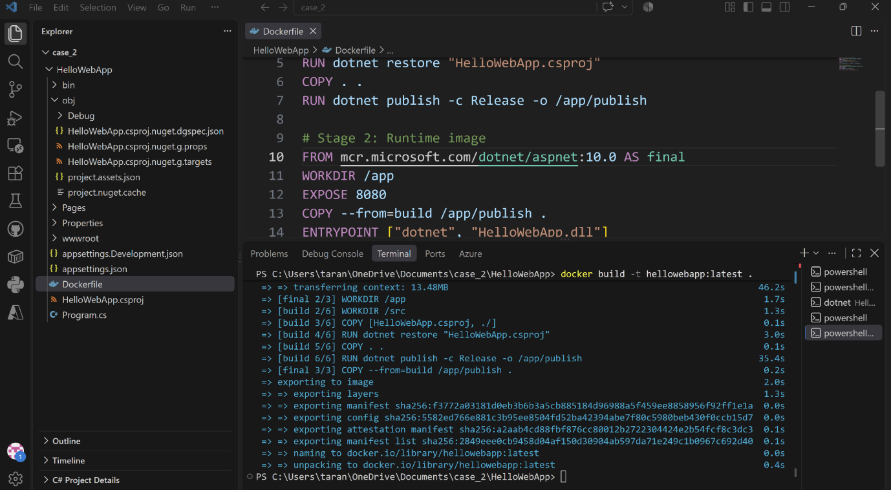

container image is now fully built and saved locally on the Docker engine.

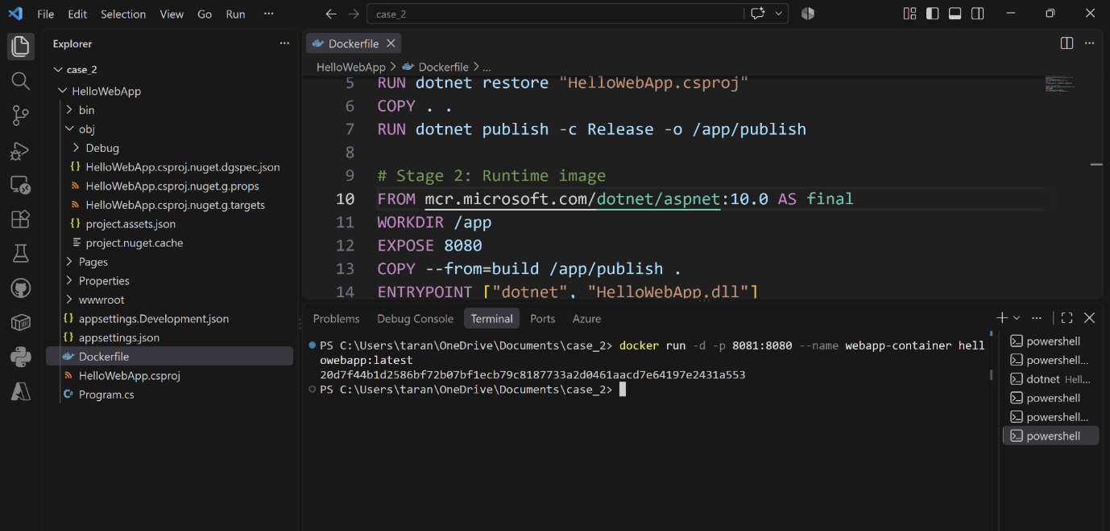

20d7f44b1d2586bf72b07bf1ecb79c8187733a2d0461aacd7e64197e2431a553
is the container id

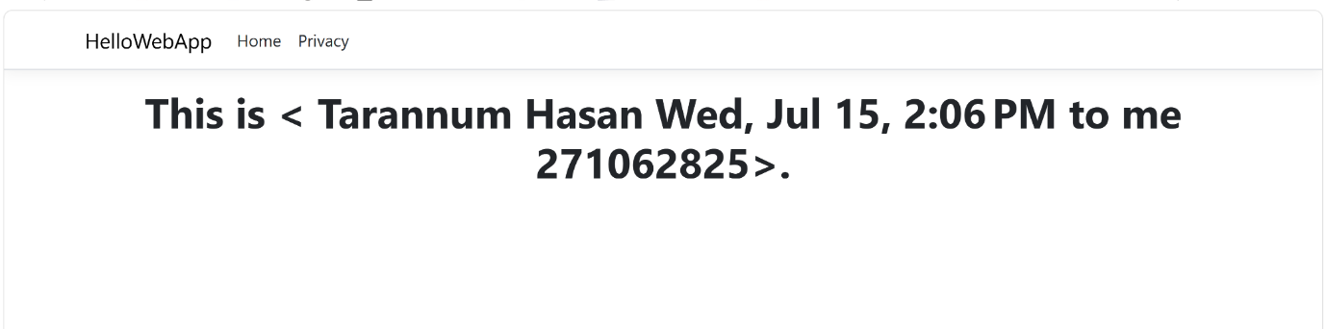
Local host8080

publishing the container image to Azure so it can be deployed as an Azure Container Instance (ACI).

Create a Resource Group and Azure Container Registry (ACR)

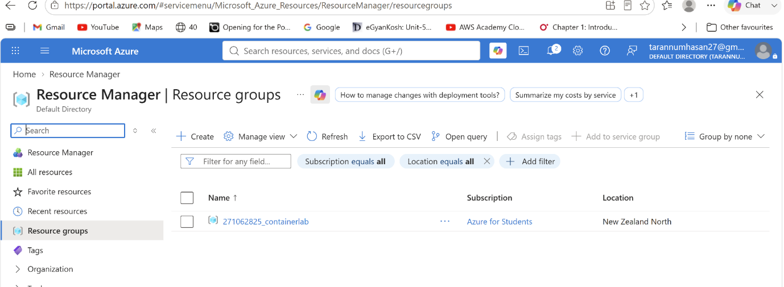

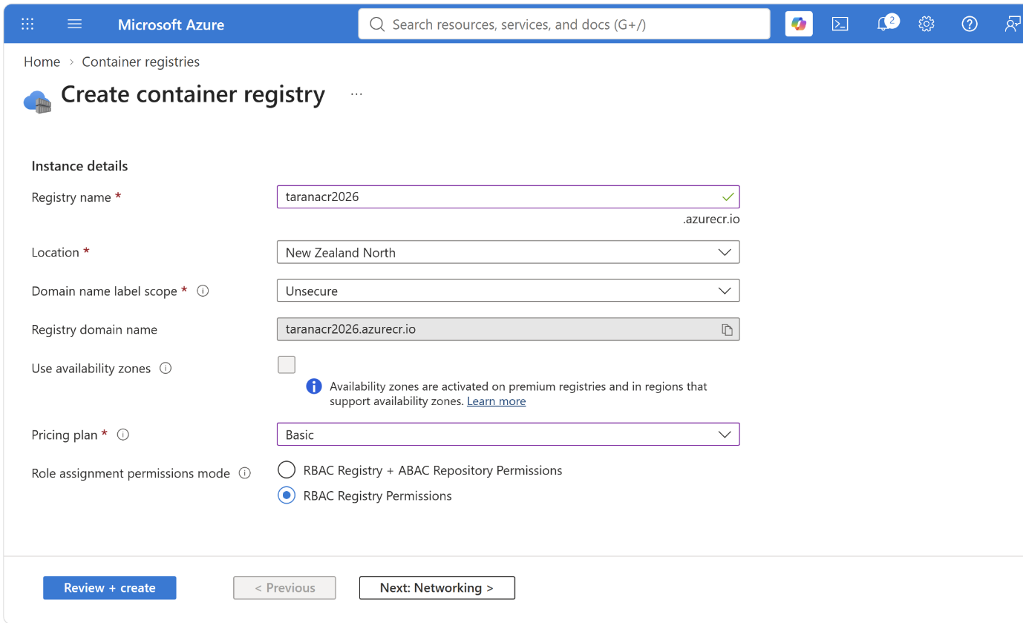

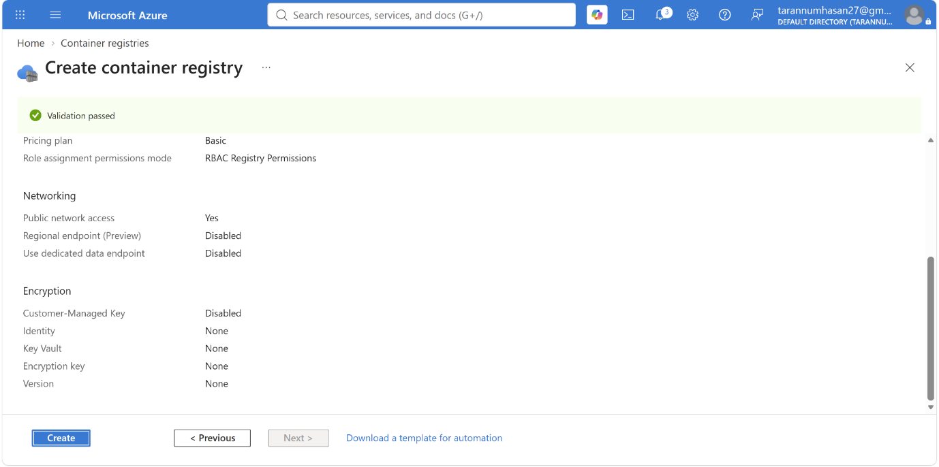

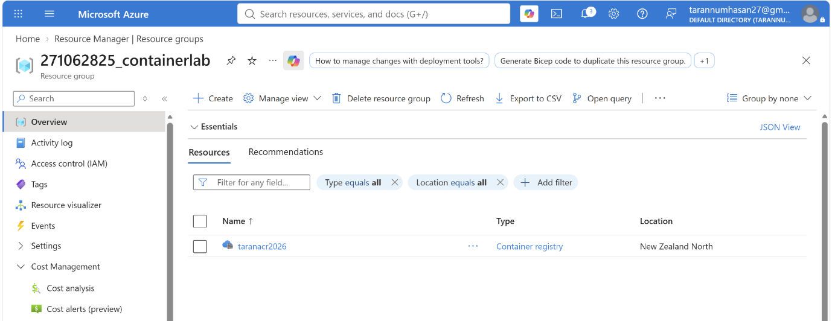

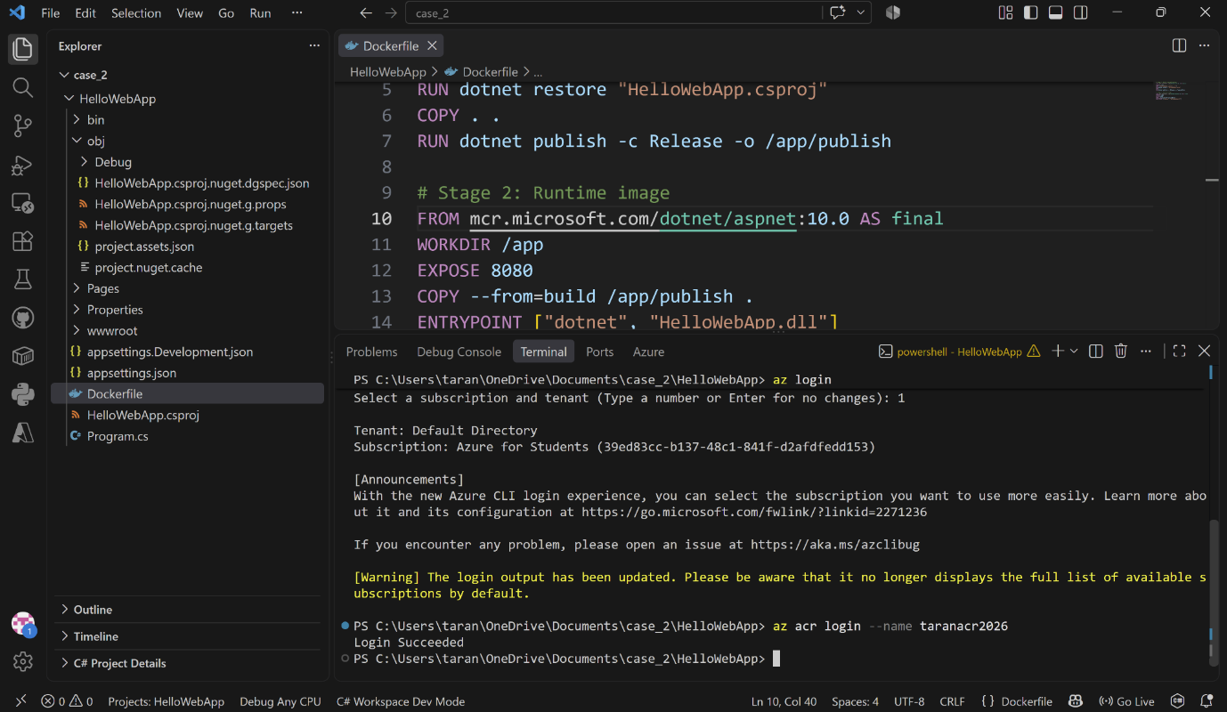

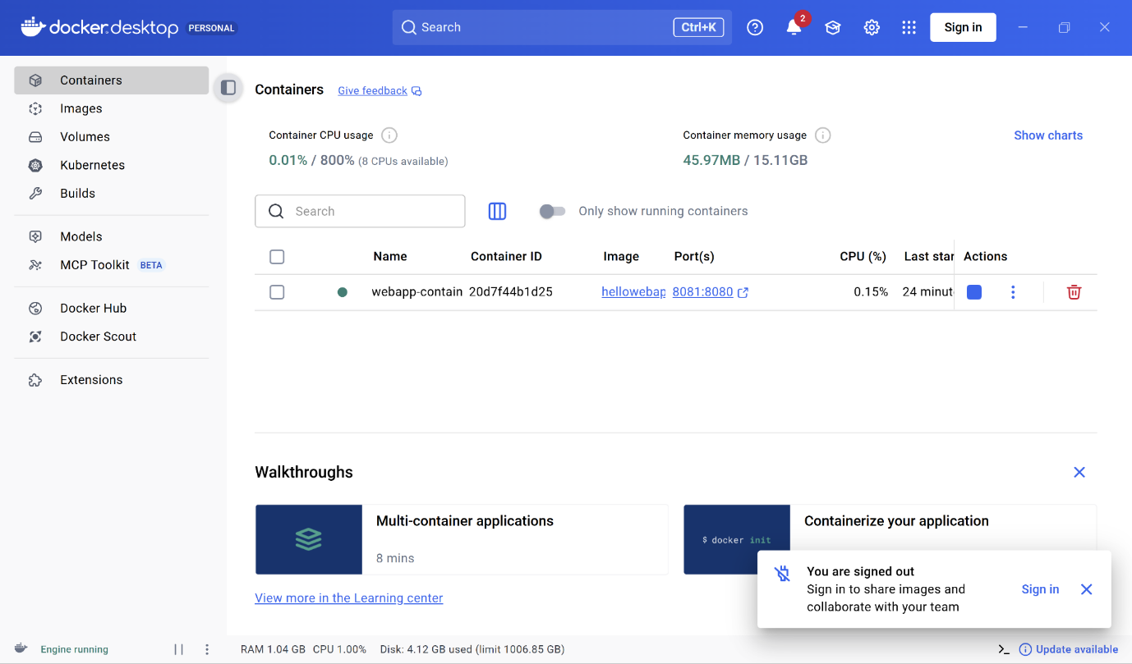

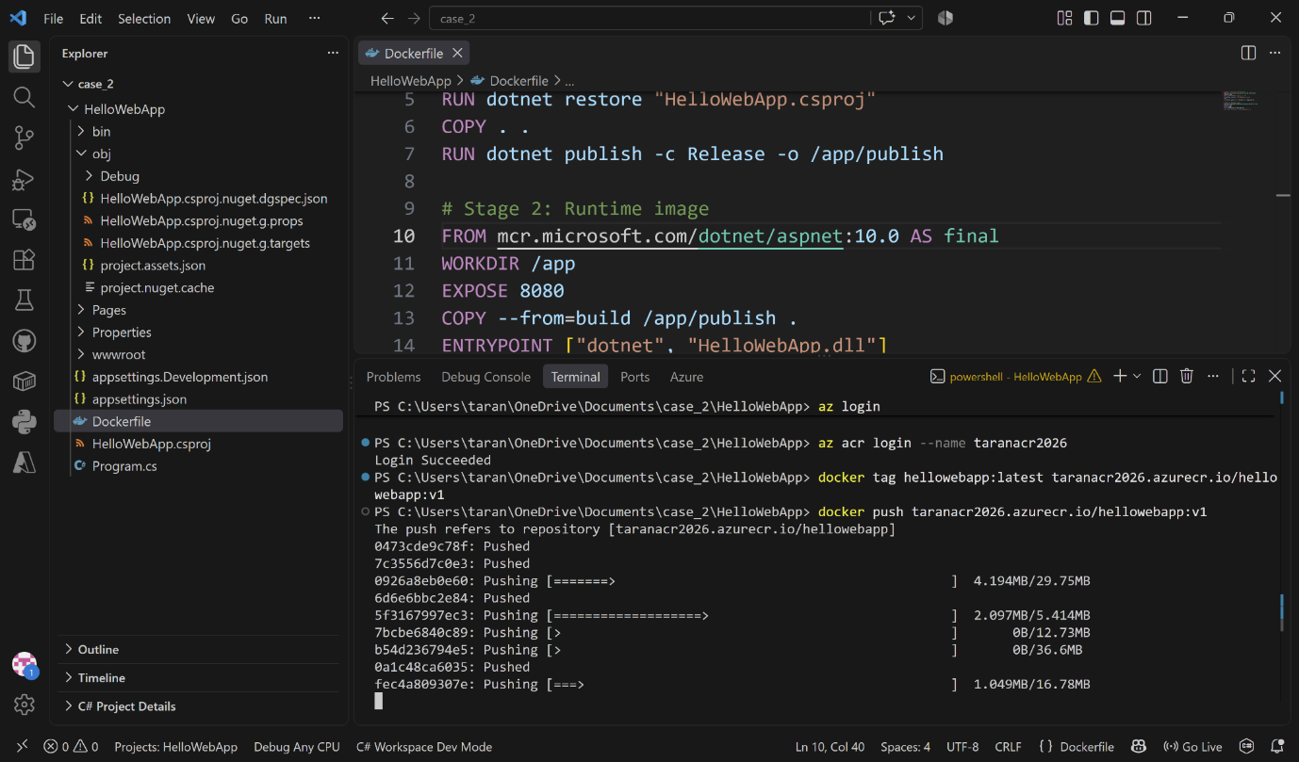

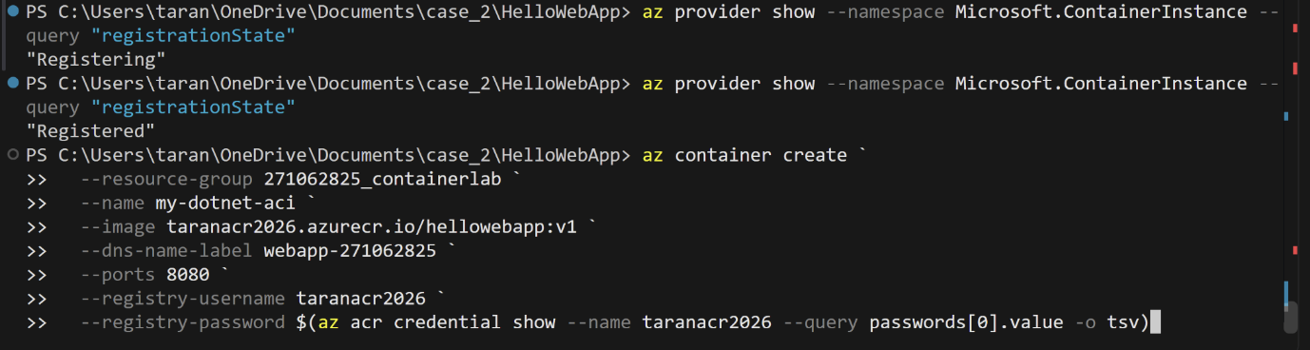

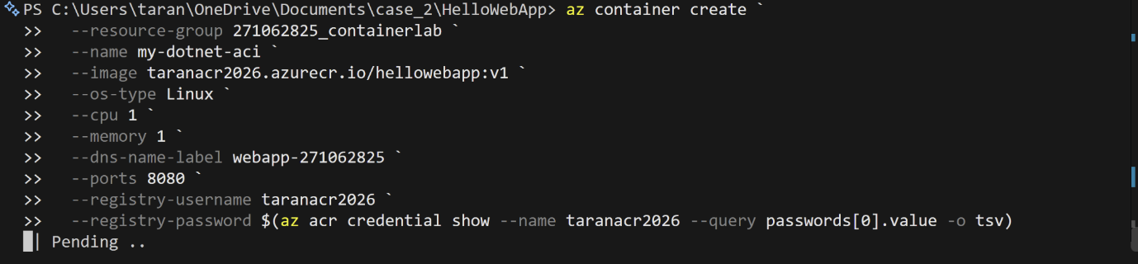

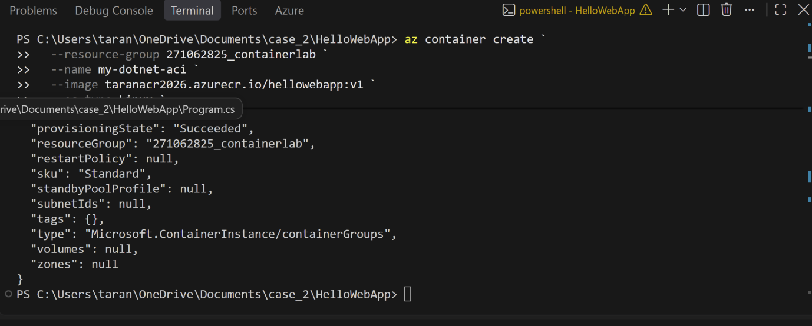
Container is successfully deployed live in Azure Container Instances! This is a massive accomplishment.

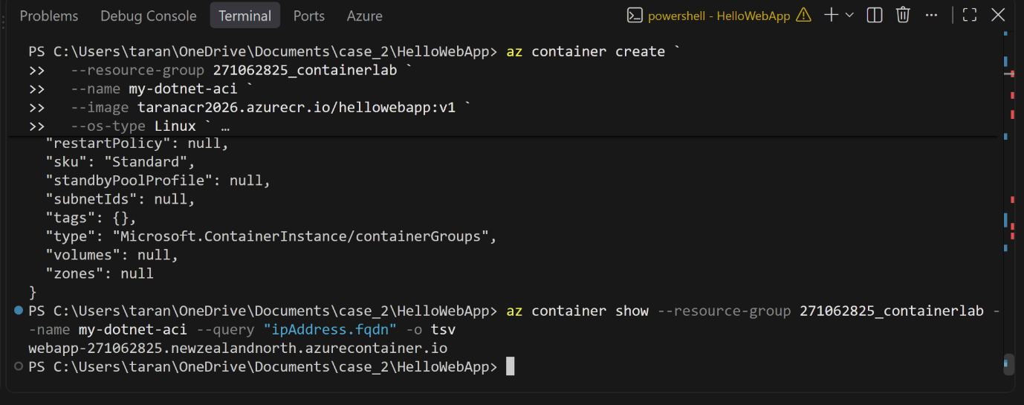
webapp-271062825.newzealandnorth.azurecontainer.io

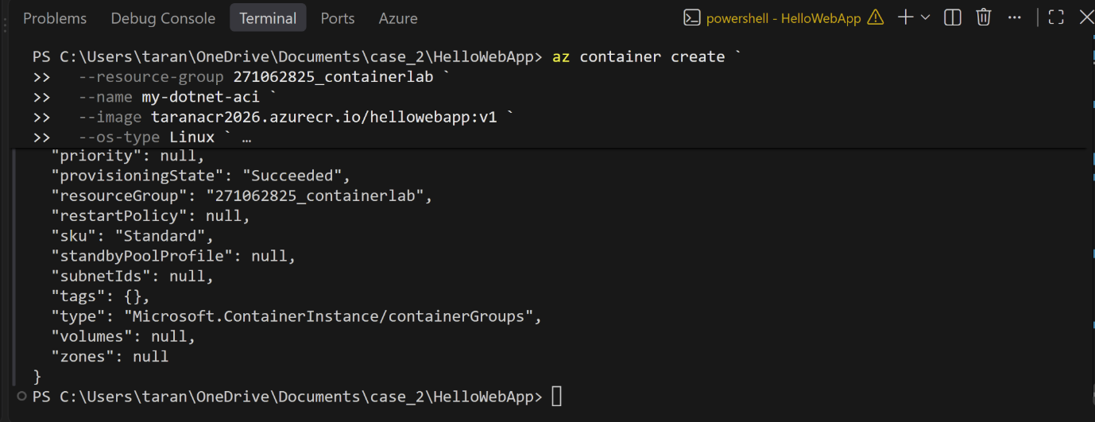

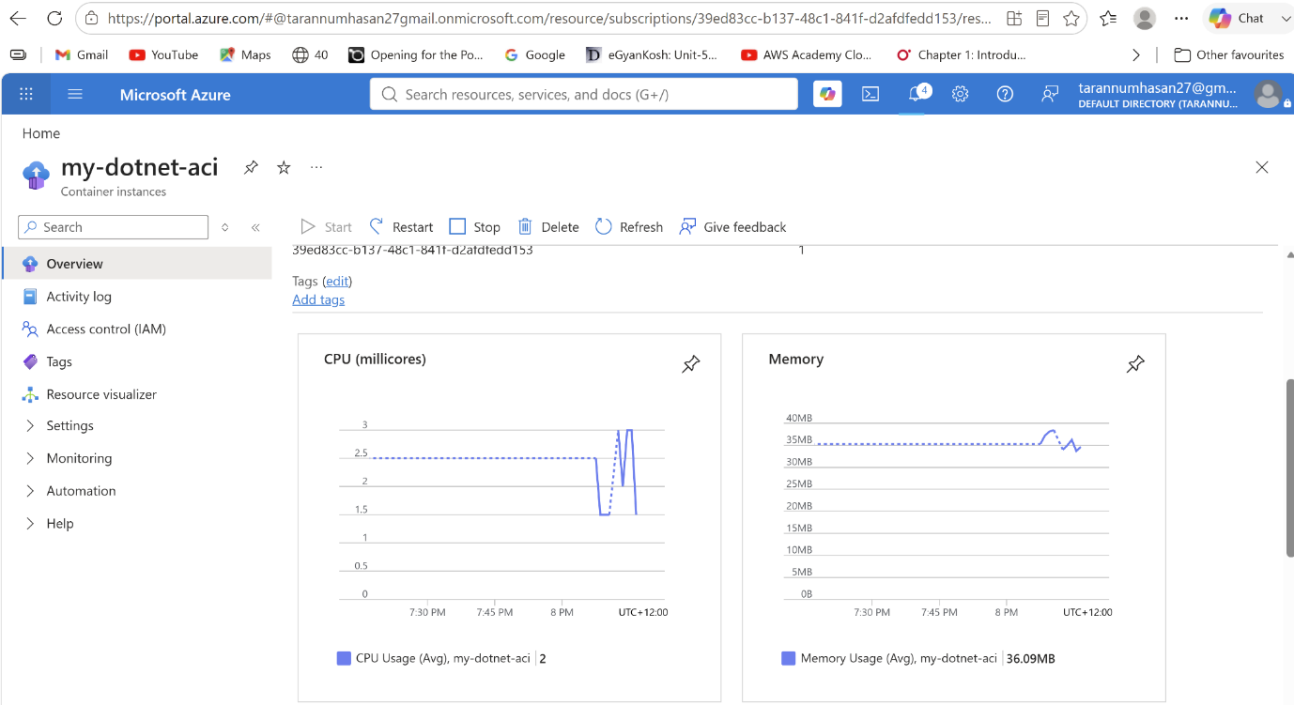

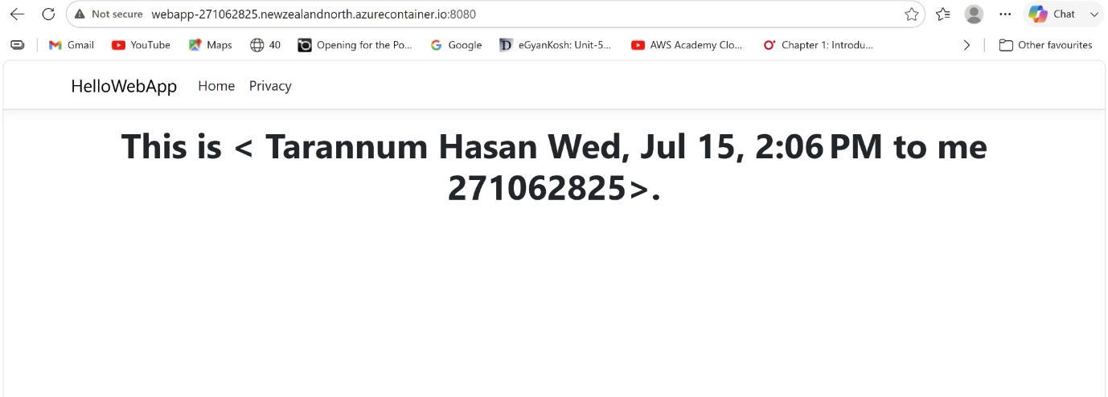

The custom .NET web application is successfully containerized, pushed to the Azure Container Registry, deployed to Azure Container Instances, and running live on the internet!

