TEMPERATURE AND HUMIDITY SENSOR:

### ****Working Principle of DHT11 Sensor****

DHT11 sensor consists of a capacitive humidity sensing element and a thermistor for sensing temperature.  The humidity sensing [capacitor](https://www.elprocus.com/construction-of-capacitor-with-working/) has two electrodes with a moisture holding substrate as a dielectric between them. Change in the capacitance value occurs with the change in humidity levels. The IC measure, process this changed resistance values and change them into digital form.

or measuring temperature this sensor uses a Negative Temperature coefficient thermistor, which causes a decrease in its resistance value with increase in temperature. To get larger resistance value even for the smallest change in temperature, this sensor is usually made up of semiconductor ceramics or polymers.

The temperature range of DHT11 is from 0 to 50 degree Celsius with a 2-degree accuracy. Humidity range of this sensor is from 20 to 80% with 5% accuracy. The sampling rate of this sensor is 1Hz .i.e. it gives one reading for every second.  DHT11 is small in size with operating voltage from 3 to 5 volts. The maximum current used while measuring is 2.5mA.

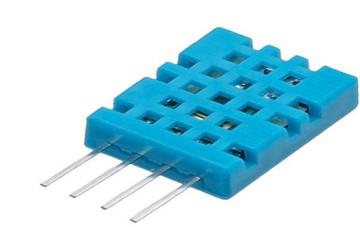DHT11 Sensor

DHT11 sensor has four pins- VCC, GND, Data Pin and a not connected pin. A pull-up resistor of 5k to 10k ohms is provided for communication between sensor and micro-controller.

#include <dht.h>

#define dht_apin A0 // Analog Pin sensor is connected to

dht DHT;

void setup(){

Serial.begin(9600);

delay(500);//Delay to let system boot

Serial.println("DHT11 Humidity & temperature Sensor\n\n");

delay(1000);//Wait before accessing Sensor

}//end "setup()"

void loop(){

//Start of Program

DHT.read11(dht_apin);

Serial.print("Current humidity = ");

Serial.print(DHT.humidity);

Serial.print("% ");

Serial.print("temperature = ");

Serial.print(DHT.temperature);

Serial.println("C ");

delay(5000);//Wait 5 seconds before accessing sensor again.

//Fastest should be once every two seconds.

}// end loop(

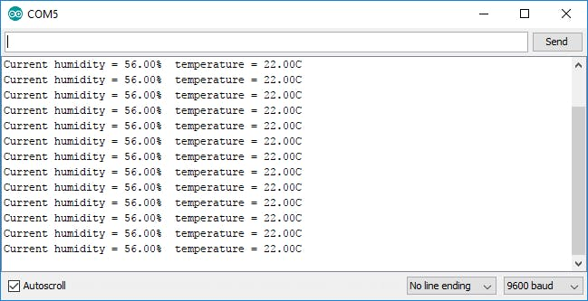

PIN DIAGRAM:

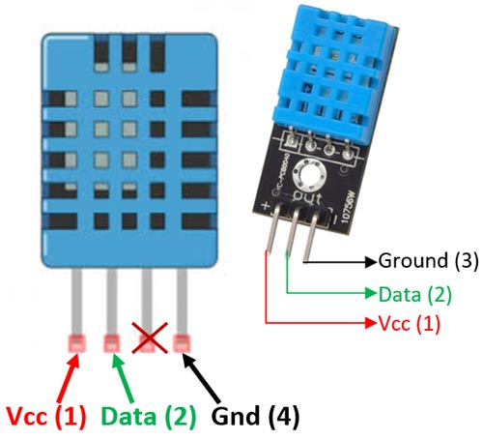

SOIL MOISTURE SENSOR:

## What is a Soil Moisture Sensor?

The soil moisture sensor is one [kind of sensor](https://www.elprocus.com/accelerometer-sensor-working-and-applications/) used to gauge the volumetric content of water within the soil. As the straight gravimetric dimension of soil moisture needs eliminating, drying, as well as sample weighting. These sensors measure the volumetric water content not directly with the help of some other rules of soil like dielectric constant, electrical resistance, otherwise interaction with neutrons, and replacement of the moisture content.

The relation among the calculated property as well as moisture of soil should be adjusted & may change based on ecological factors like temperature, type of soil, otherwise electric conductivity. The microwave emission which is reflected can be influenced by the moisture of soil as well as mainly used in agriculture and remote sensing within hydrology.

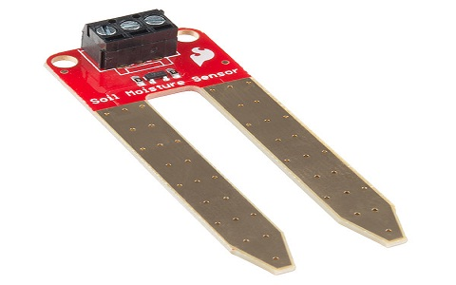

soil-moisture-sensor-device

These [sensors](https://www.elprocus.com/types-of-sensors-with-circuits/) normally used to check volumetric water content, and another group of sensors calculates a new property of moisture within soils named water potential. Generally, these sensors are named as soil water potential sensors which include gypsum blocks and tensiometer.

**Soil Moisture Sensor Pin Configuration**

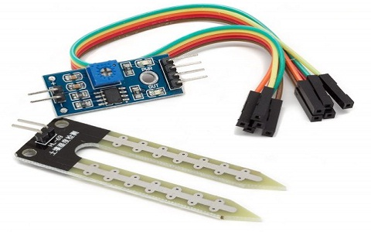The FC-28 soil moisture sensor includes 4-pins

soil-moisture-sensor

* VCC pin is used for power
* A0 pin is an analog output
* D0 pin is a digital output
* GND pin is a Ground

This module also includes a potentiometer that will fix the threshold value, & the value can be evaluated by the [comparator-LM393](https://www.elprocus.com/lm393-ic-pin-configuration-circuit-diagram-and-its-working/). The [LED](https://www.elprocus.com/bipolar-led-driver-circuit-working-application/) will turn on/off based on the threshold value.

## "<yoastmark

## ****Soil Moisture Sensor Module Pin Diagram****

|  |  |  |
| --- | --- | --- |
| **Pin Number** | **Pin Name** | **Description** |
| 1 | **VCC** | +5 v power supply |
| 2 | **GND** | Ground (-) power supply |
| 3 | **DO** | Digital Output  (0 or 1) |
| 4 | **AO** | Analog Output  (range 0 to 1023) |

### Working Principle

This sensor mainly utilizes capacitance to gauge the water content of the soil (dielectric permittivity). The working of this sensor can be done by inserting this sensor into the earth and the status of the water content in the soil can be reported in the form of a percent.

This sensor makes it perfect to execute experiments within science courses like environmental science, agricultural science, biology, soil science, botany, and horticulture.

**Circuit Diagram**

[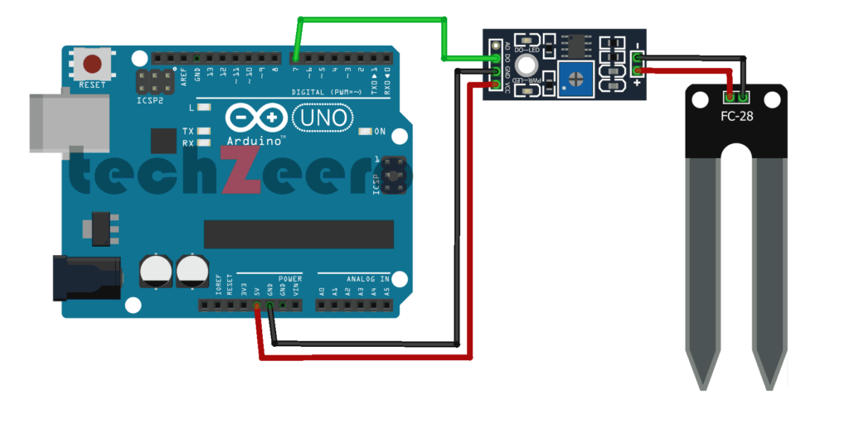](https://techzeero.com/wp-content/uploads/2019/12/circuit-soil-moisture-with-arduino-digital-1024x512.png)

**Code – Digital Output**

Upload the code to the Arduino board. When the value of the sensor is high, the inbuild led will on.

|  |
| --- |
| /* |
| Soil Moisture with Arduino - Digital Output |
| For more details, visit: https://techzeero.com/arduino-tutorials/soil-moisture-sensor-arduino/ |
| */ |
|  |
| int sensorPin = 7; |
| int ledPin = 13; |
|  |
| void setup() |
| { |
| pinMode(ledPin, OUTPUT); |
| pinMode(sensorPin, INPUT); |
| Serial.begin(9600); |
| Serial.println("Reading Data From the Sensor ..."); |
| delay(2000); |
| } |
|  |
| void loop() |
| { |
| if(digitalRead(sensorPin) == HIGH) |
| { |
| digitalWrite(ledPin, HIGH); |
| } |
| else |
| { |
| digitalWrite(ledPin, LOW); |
| delay(1000); |
| } |
| }  ULTRASONIC SENSOR: Ultrasonic Sensor Working Principle Ultrasonic sensors emit short, high-frequency sound pulses at regular intervals. These propagate in the air at the velocity of sound. If they strike an object, then they reflected back as an echo signal to the sensor, which itself computes the distance to the target based on the time-span between emitting the signal and receiving the echo.  Ultrasonic-sensor-working-  Ultrasonic[**sensors**](https://robu.in/product-category/sensor/ultrasonic-sensor/) are excellent at suppressing background interference. Virtually all materials which reflect sound can be detected, regardless of their colour. Even transparent materials or thin foils represent no problem for an ultrasonic sensor.  microsonic ultrasonic sensors are suitable for target distances from 20 mm to 10 m and as they measure the time of flight they can ascertain a measurement with pinpoint accuracy. Some of our sensors can even resolve the signal to an accuracy of 0.025 mm. Ultrasonic sensors can see through dust-laden air and ink mists. Even thin deposits on the sensor membrane do not impair its function.  PIN DIAGRAM:  HC-SR04 Ultrasonic Sensor Working, Pinout, Features & Datasheet |

#define echoPin 2 // attach pin D2 Arduino to pin Echo of HC-SR04

#define trigPin 3 //attach pin D3 Arduino to pin Trig of HC-SR04

// defines variables

long duration; // variable for the duration of sound wave travel

int distance; // variable for the distance measurement

void setup() {

pinMode(trigPin, OUTPUT); // Sets the trigPin as an OUTPUT

pinMode(echoPin, INPUT); // Sets the echoPin as an INPUT

Serial.begin(9600); // // Serial Communication is starting with 9600 of baudrate speed

Serial.println("Ultrasonic Sensor HC-SR04 Test"); // print some text in Serial Monitor

Serial.println("with Arduino UNO R3");

}

void loop() {

// Clears the trigPin condition

digitalWrite(trigPin, LOW);

delayMicroseconds(2);

// Sets the trigPin HIGH (ACTIVE) for 10 microseconds

digitalWrite(trigPin, HIGH);

delayMicroseconds(10);

digitalWrite(trigPin, LOW);

// Reads the echoPin, returns the sound wave travel time in microseconds

duration = pulseIn(echoPin, HIGH);

// Calculating the distance

distance = duration * 0.034 / 2; // Speed of sound wave divided by 2 (go and back)

// Displays the distance on the Serial Monitor

Serial.print("Distance: ");

Serial.print(distance);

Serial.println(" cm");

}

OUTPUT:

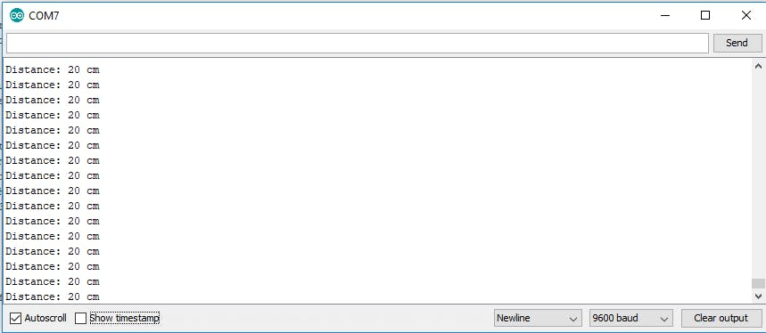

IR SENSOR:

## ****IR Sensor Working Principle****

There are different types of infrared transmitters depending on their wavelengths, output power and response time. An IR sensor consists of an IR LED and an IR Photodiode, together they are called as PhotoCoupler or OptoCoupler.

**IR Transmitter or IR LED**

Infrared Transmitter is a light emitting diode (LED) which emits infrared radiations called as IR LED’s. Even though an IR LED looks like a normal LED, the radiation emitted by it is invisible to the human eye.

The picture of an Infrared LED is shown below.

[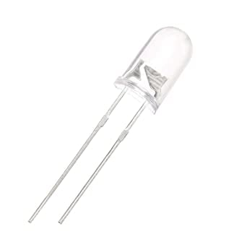](https://robu.in/wp-content/uploads/2020/05/51fibl-5xL._SX342_.jpg)

**IR Receiver or Photodiode**

Infrared receivers or infrared sensors detect the radiation from an IR transmitter. IR receivers come in the form of photodiodes and phototransistors. Infrared Photodiodes are different from normal photo diodes as they detect only infrared radiation. Below image shows the picture of an IR receiver or a photodiode,

[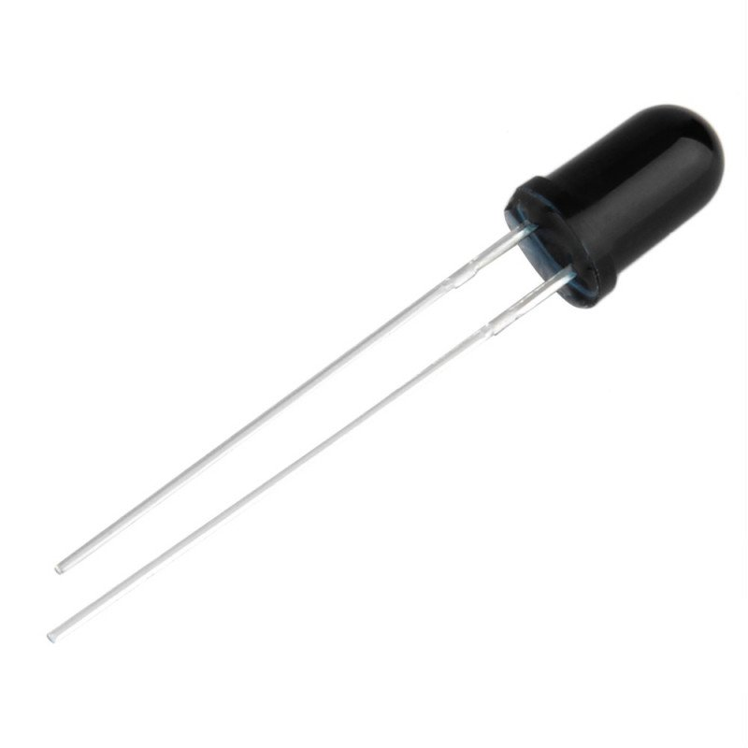](https://robu.in/wp-content/uploads/2020/05/SN-IR-R-0-1-1-800x800-1.jpg)

Different types of IR receivers exist based on the wavelength, voltage, package, etc. When used in an infrared transmitter – receiver combination, the wavelength of the receiver should match with that of the transmitter.

[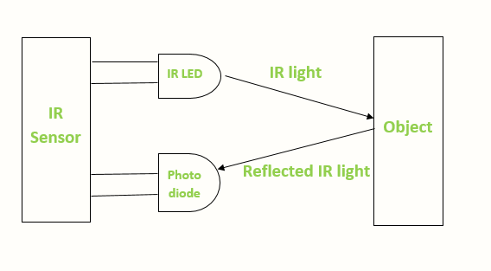](https://robu.in/wp-content/uploads/2020/05/IR-sensor-Working.png)The emitter is an IR LED and the detector is an IR photodiode. The IR photodiode is sensitive to the IR light emitted by an IR LED. The photo-diode’s resistance and output voltage change in proportion to the IR light received. This is the underlying working principle of the IR sensor.

When the IR transmitter emits radiation, it reaches the object and some of the radiation reflects back to the IR receiver. Based on the intensity of the reception by the IR receiver, the output of the [**sensor**](https://robu.in/product-category/sensor/) defines.

PIN DIAGRAM:

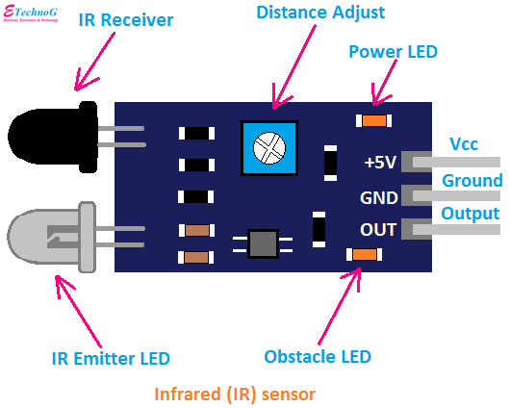

const int ProxSensor=2;

int inputVal = 0;

void setup()

{

 pinMode(13, OUTPUT);          // Pin 13 has an LED connected on most Arduino boards:

 pinMode(ProxSensor,INPUT);    //Pin 2 is connected to the output of proximity sensor

**Serial**.begin(9600);

}

void loop()

{

 if(digitalRead(ProxSensor)==HIGH)      //Check the sensor output

 {

   digitalWrite(13, HIGH);   // set the LED on

 }

 else

 {

   digitalWrite(13, LOW);    // set the LED off

 }

inputVal = digitalRead(ProxSensor);

**Serial**.println(inputVal);

delay(1000);              // wait for a second

}

OUTPUT:

PIR SENSOR:

## PIR Sensor Working Principle

The passive infrared sensor does not radiate energy to space. It receives the  infrared radiation from the human body to make an alarm. Any object with temperature is constantly radiating infrared rays to the outside world. The surface temperature of the human body is between 36° C - 27 ° C and most of its radiant energy concentrated in the wavelength range of 8 um-12 um.

[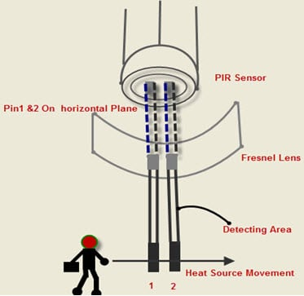](https://robu.in/wp-content/uploads/2020/05/9-10-2014-10-30-47-AM.jpg)

[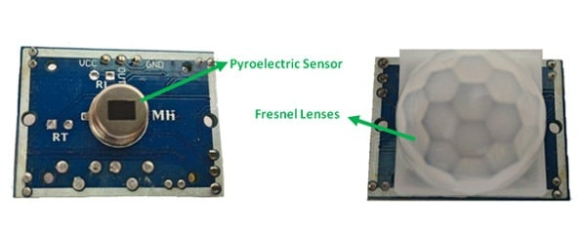](https://robu.in/wp-content/uploads/2020/05/main-qimg-80b474beb656c28373fbb8258a9968e9.jpg)Passive infrared alarms classified into[infrared detectors](https://robu.in/product-category/sensor/ir-and-pir-sensor/) (infrared probes) and alarm control sections. The most widely used infrared detector is a pyroelectric detector. It uses as a sensor for converting human infrared radiation into electricity. If the human infrared radiation is directly irradiated on the detector, it will, of course, cause a temperature change to output a signal. But in doing all this, the detection distance will not be more. In order to lengthen the detection distance of the detector, an optical system  must be added to collect the infrared radiation. Usually, plastic optical reflection system or plastic **Fresnel lens** used as a focusing system for infrared radiation.

In the detection area, the lens of the detector receives the infrared radiation energy of the human body through the clothing and focused on the pyroelectric sensor. When the human body moves in this surveillance mode, it enters a certain field of view in sequence and then walks out of the field of view. The[**pyroelectric sensor**](https://www.sciencedirect.com/topics/engineering/pyroelectric-sensor) sees the moving human body for a while and then does not see it, so the infrared radiation of human body constantly changes the temperature of the pyroelectric material. So that it outputs a corresponding signal, which is the alarm signal.

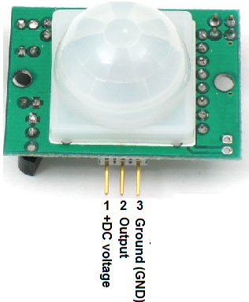PIN DIAGRAM:

int led = 13; // the pin that the LED is atteched to

int sensor = 2; // the pin that the sensor is atteched to

int state = LOW; // by default, no motion detected

int val = 0; // variable to store the sensor status (value)

void setup() {

pinMode(led, OUTPUT); // initalize LED as an output

pinMode(sensor, INPUT); // initialize sensor as an input

Serial.begin(9600); // initialize serial

}

void loop(){

val = digitalRead(sensor); // read sensor value

if (val == HIGH) { // check if the sensor is HIGH

digitalWrite(led, HIGH); // turn LED ON

delay(500); // delay 100 milliseconds

if (state == LOW) {

Serial.println("Motion detected!");

state = HIGH; // update variable state to HIGH

}

}

else {

digitalWrite(led, LOW); // turn LED OFF

delay(500); // delay 200 milliseconds

if (state == HIGH){

Serial.println("Motion stopped!");

state = LOW; // update variable state to LOW

}

}

}

##### **PIR Motion sensor with Led**

