AI & Screen Time Impact on Students' Academic Performance and Well-Being
End-to-End Data Analytics Project Report with Dashboard Screenshots
Author: Thasleem Sadik | GitHub: Thasleemsadik/AI-SCREEN-TIME-IMPACT-ON-STUDENT-S-PERFORMANCE | Location: Chennai, India | Date: August 2026

1. Executive Summary
This project analyzes how AI usage, screen time, study habits, sleep, physical activity, anxiety, attention, and lifestyle affect student GPA. Raw dataset: 7,380 records with missing values, duplicate Student_IDs, inconsistent formatting. After cleaning with Python Pandas: 7,200 clean records. Built interactive 2-page Power BI dashboard. Screenshots included in this report.

2. Project Objectives
- Analyze screen time vs academic performance
- Study hours vs GPA
- Screen time vs anxiety
- Sleep vs anxiety
- Physical activity vs GPA
- Performance across age groups
- Technology usage patterns
- Interactive Power BI dashboard

3. Data Cleaning Workflow
Tools: Python, Pandas, NumPy
1. df.shape, df.isnull().sum(), duplicated()
2. Removed 180 duplicate Student_IDs (7380 → 7200)
3. str.strip() for text columns
4. Standardized Gender, City, AI Tool names
5. Filled numeric nulls with median, categorical with mode
6. Created levels: AI_Usage_Level, Screen_Level, Study_Level, Sleep_Level, GPA_Level, Anxiety_Level, Age_Group etc.
7. Saved to data/cleaned/cleaned_dataset_7200_rows.xlsx

4. Dashboard - Page 1: Overview (Screenshot)
This page shows overall KPIs and key relationships: GPA by Age Group, Screen Time vs Study Level, GPA by Physical Activity, Sleep vs Anxiety, Screen Time vs GPA.
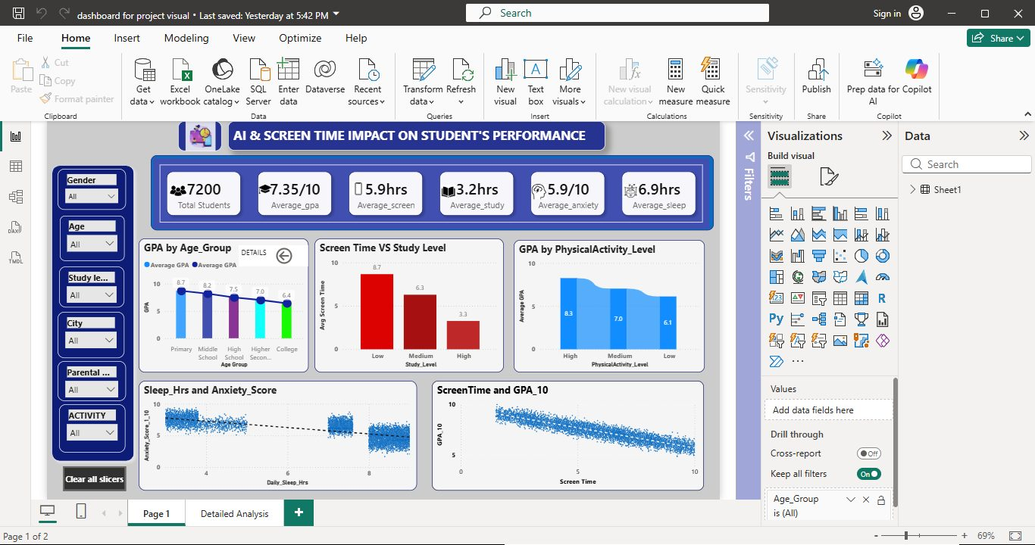
Figure 1: Power BI Overview Dashboard - Shows 7,200 students, Avg GPA 7.35, Avg Screen Time 5.9 hrs, Avg Study 3.2 hrs

Key Insights from Page 1
- GPA decreases with age: Primary 8.7 → College 6.4
- Low Study Level = 8.7 hrs screen time, High Study Level = 3.3 hrs screen (Strong negative)
- High Physical Activity = 8.3 GPA vs Low Activity = 6.1 GPA
- Sleep <6 hrs → Anxiety 7.2, Sleep >8 hrs → Anxiety 4.3
- Screen Time 3 hrs → GPA 8.5, Screen Time 9 hrs → GPA 5.9

5. Dashboard - Page 2: Detailed Analysis by Age Group (Screenshot)
Detailed breakdown by Primary, Middle, High, College: AI Tool usage distribution, Study Time trends, Anxiety distribution.
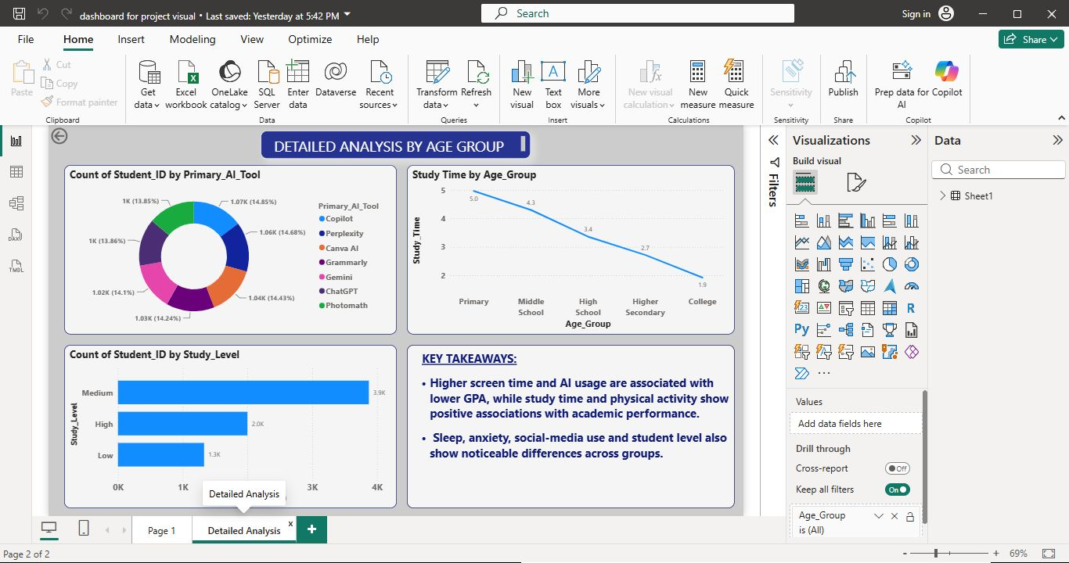
Figure 2: Detailed Analysis Dashboard - AI Tool usage (ChatGPT, Gemini, Copilot, etc.), Study Time by Age Group, Study Level Distribution

Key Insights from Page 2
- AI Tools evenly used (~13-14% each): ChatGPT, Gemini, Copilot, Perplexity, Canva AI, Grammarly, Photomath
- Study time drops: Primary 5.0 hrs → College 1.9 hrs
- Study_Level: Medium 3.9K, High 2.0K, Low 1.3K students
- Anxiety highest in College (6.8) vs Primary (4.2)
- Attention highest in Primary (8.1) vs College (5.9)

6. Final Takeaways
- Balanced digital lifestyle wins: Low Screen + High Study + Good Sleep + High Physical Activity = GPA >8.5
- Screen time is the strongest negative predictor of GPA
- Physical activity is a protective factor for both GPA and mental health
- Sleep is directly linked to anxiety management
- Interventions should target College students most

7. Repo Structure
data/raw/Dirty_Student_Dataset_7380_With_Levels.xlsx
data/cleaned/cleaned_dataset_7200_rows.xlsx
scripts/data_cleaning.py
powerbi/dashboard.pbix
images/dashboard_page1_overview.png
images/dashboard_page2_detailed.png
docs/Project_Report_With_Screenshots.docx (this file)
README.md
requirements.txt

8. How to Run
pip install -r requirements.txt
python scripts/data_cleaning.py
Open powerbi/dashboard.pbix
Made with ❤️ by Thasleem Sadik - Beginner Data Analyst Journey

