useMemo

useMemo is a hook that returns a memoized value. It takes two arguments: a function that returns a value and a dependency array. It will call the function and return its result only if one of the dependencies has changed.

Here's an example of how you might use the useMemo hook:

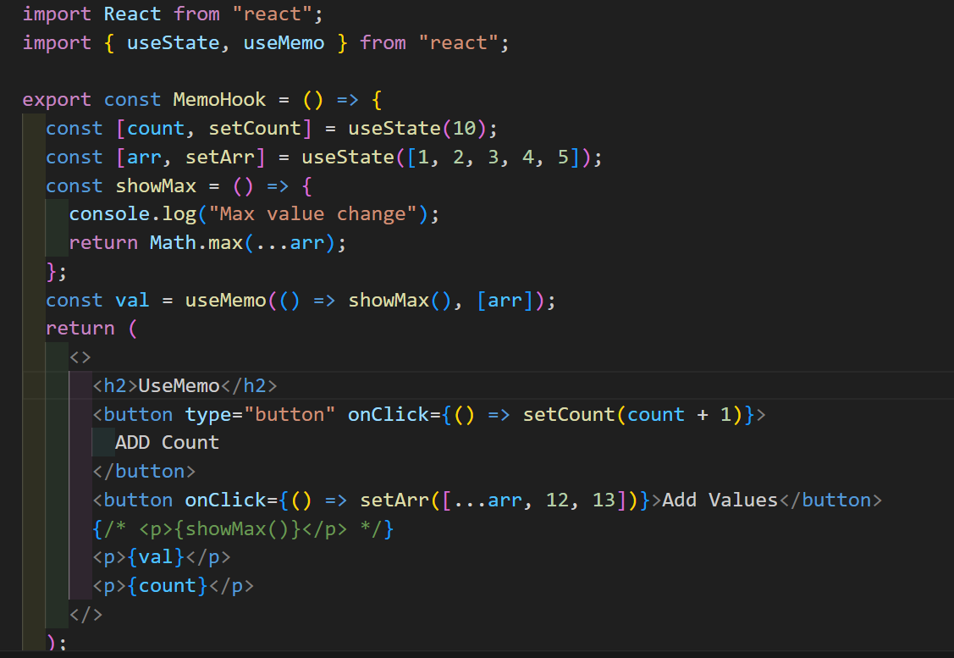

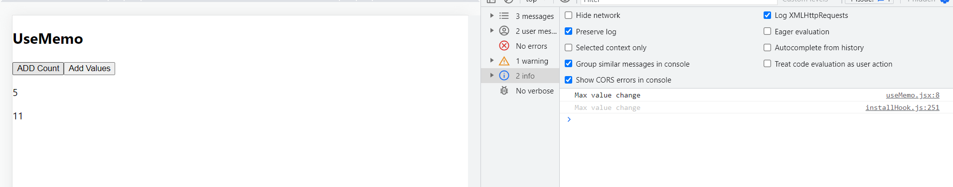

When I increate the count the Show Max will not re-created until the arr value changes.

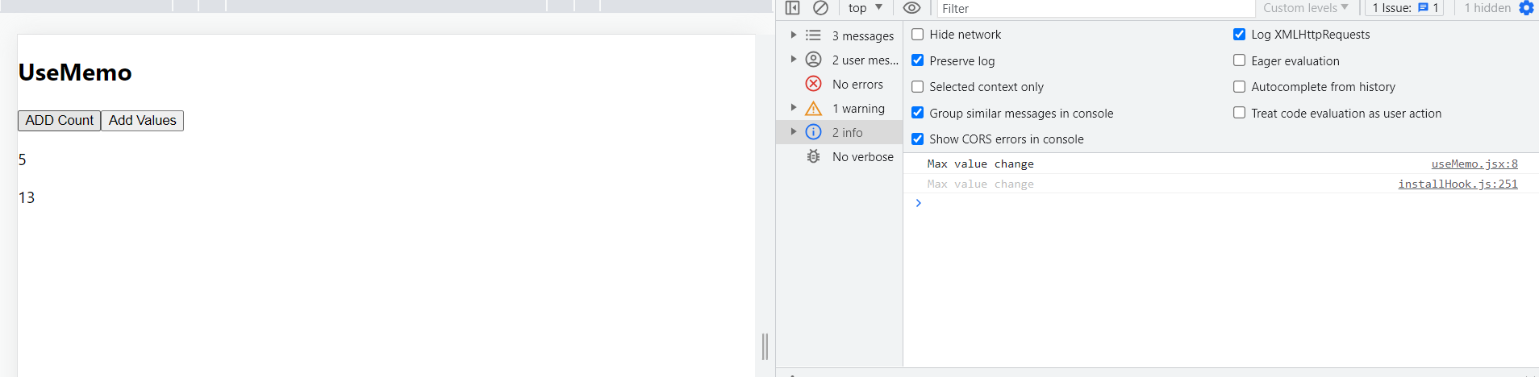

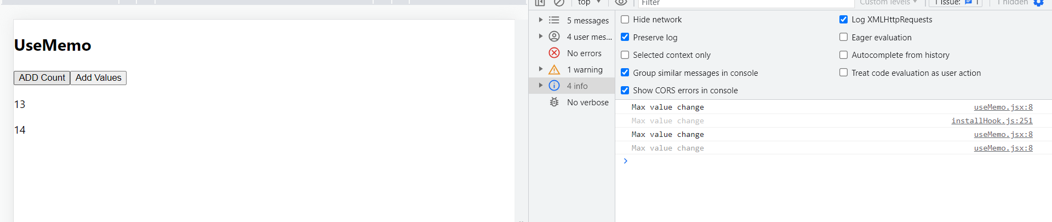

useReducer:

The useReducer hook is used for complex state and state transitions. It takes a reducer function and an initial state as input and returns the current state and a dispatch function as output

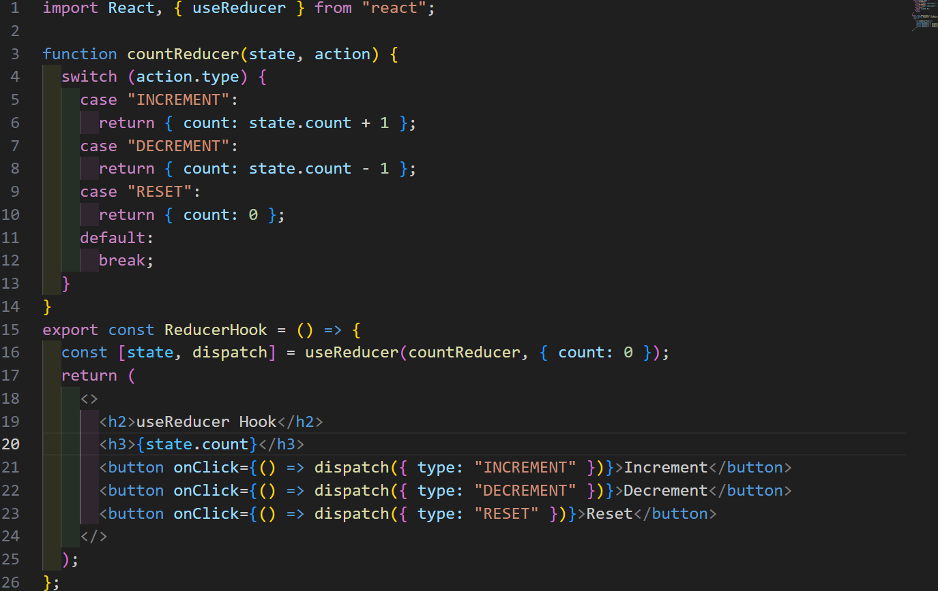

The useReducer Hook is the better alternative to the useState hook and is generally more preferred over the useState hook when you have complex state-building logic or when the next state value depends upon its previous value or when the components are needed to be optimized.

Based on what actions we dispatched that particular operation will performed based on previous state value

It will reduces the multiple re-renders on using using setState

