**Phase 2 – Salesforce Subscription Setup**

**Admin:** Syed Fathima Thasneem  
**Date:** 24/09/2025

## 1. Objects Created

### **1.1 Contact (Standard Object)**

* Stores customer details.
* Standard Salesforce object used for managing customer information.

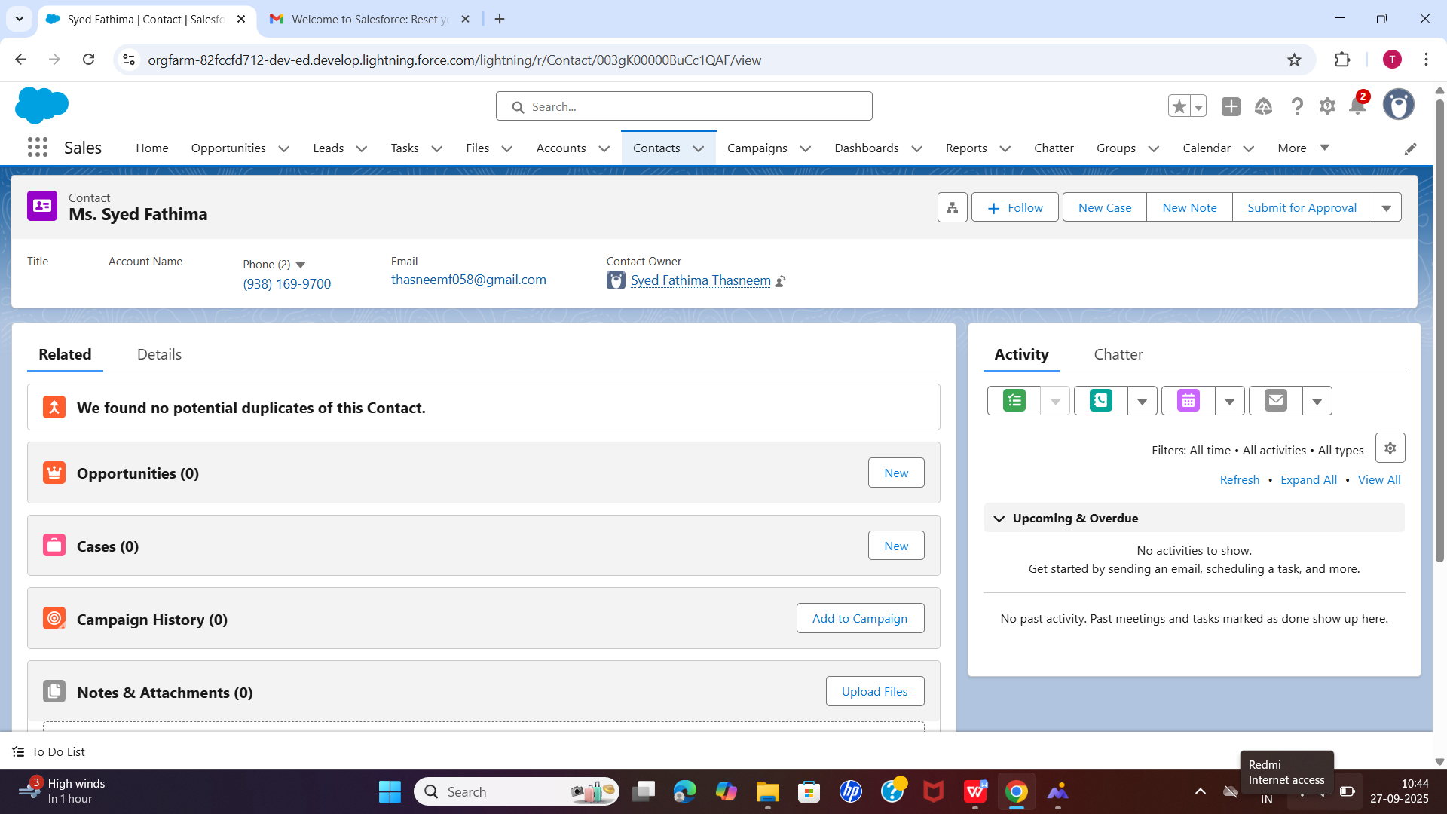

### **1.2 Plan (Custom Object)**

* **API Name:** Plan__c
* **Fields Created:**
  + **Plan Number** (Auto Number)
  + **Price** (Currency – INR)
  + **Duration** (Picklist: Monthly, Quarterly, Yearly)
  + **Description** (Text Area)
* **Purpose:** Represents subscription plans available for customers.

### 

### **1.3 Subscription (Custom Object)**

* **API Name:** Subscription__c
* **Fields Created:**
  + **Subscription Number** (Auto Number)
  + **Contact** (Lookup → Contact)
  + **Plan** (Lookup → Plan__c)
  + **Status** (Picklist: Active, Inactive, Cancelled)
  + **Start Date** (Date)
  + **End Date** (Date)
  + **Owner** (Standard Owner field)
* **Purpose:** Connects a Contact with a Plan, tracks subscription period and status.

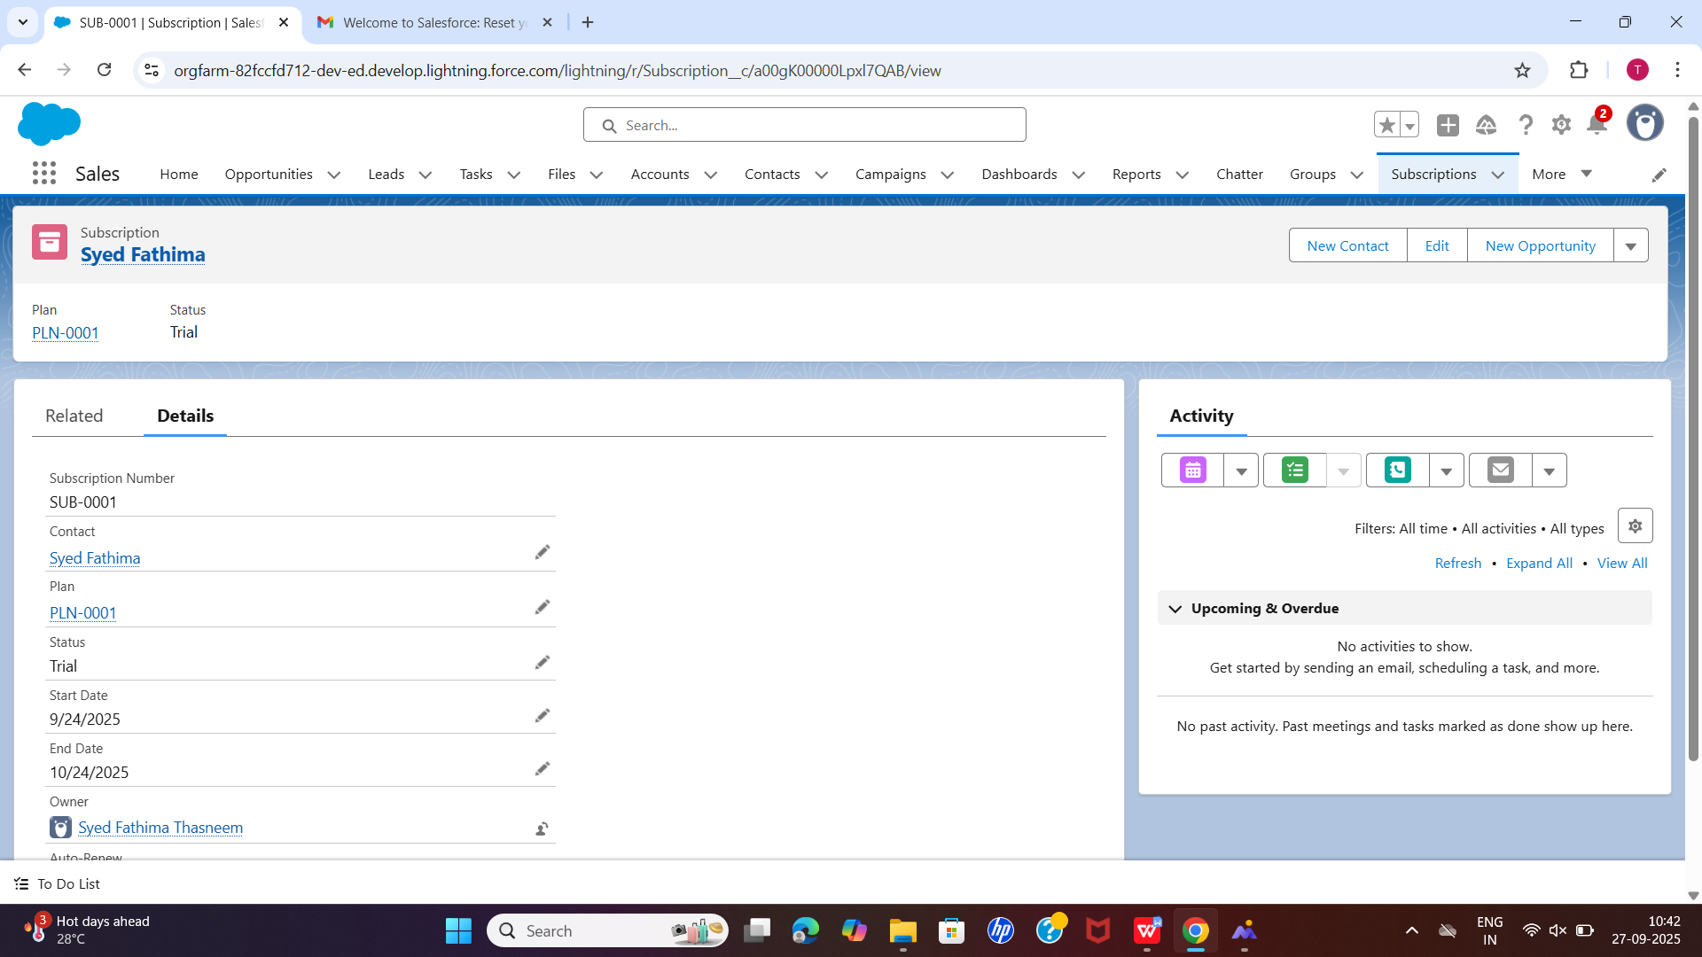

## 2. Relationships Established

* **Contact → Subscription**
  + Relationship: **Lookup** (each subscription belongs to one Contact).
  + Function: Tracks which customer has taken the subscription.
* **Plan → Subscription**
  + Relationship: **Lookup** (each subscription is linked to one Plan).
  + Function: Identifies which Plan the customer has subscribed to.

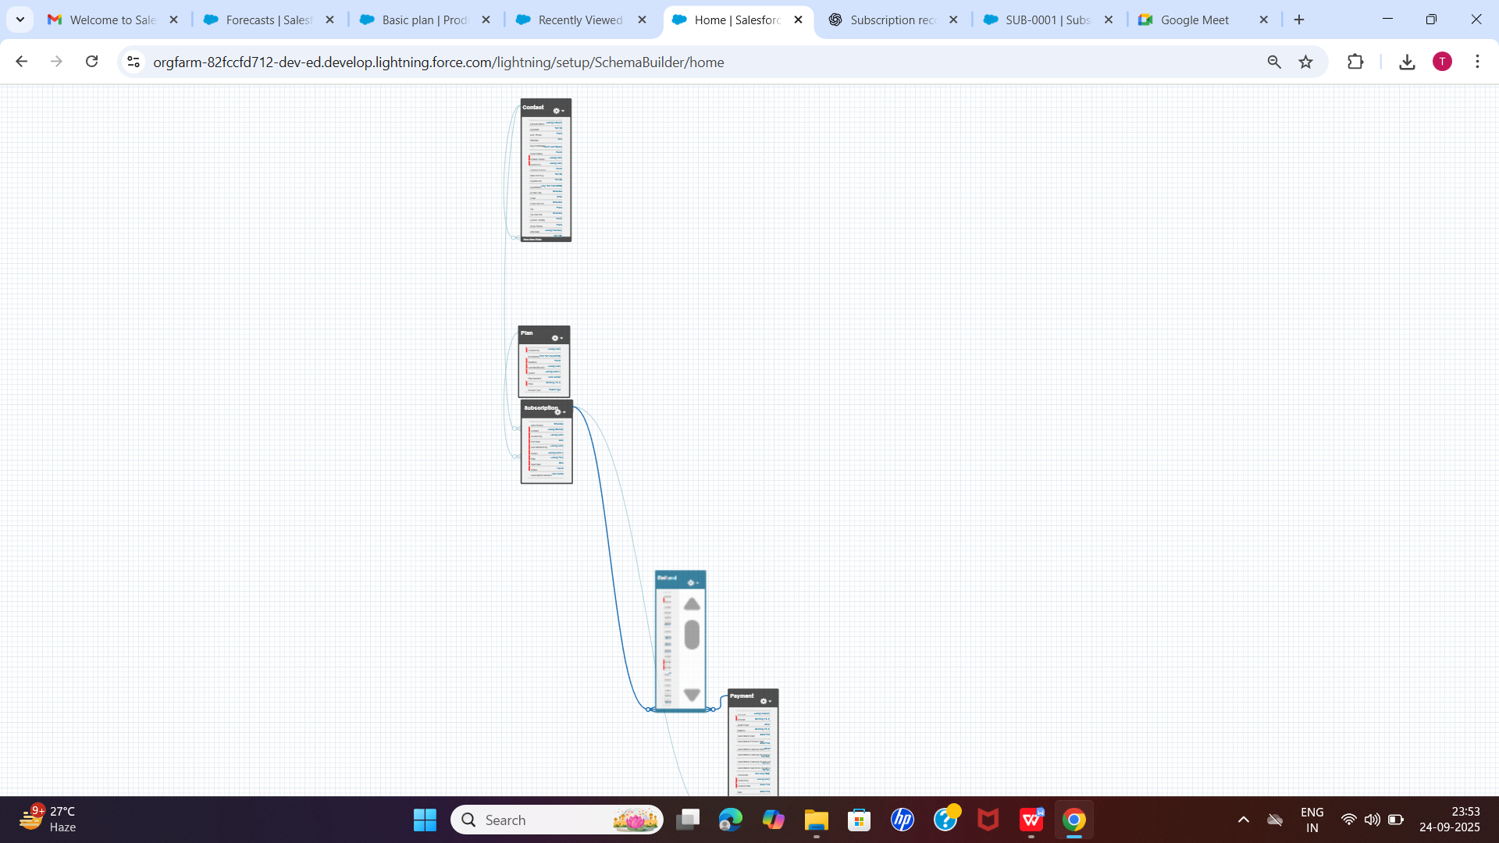

## 3. Records Created

### **3.1 Contact Record**

| Contact Name | Details |
| --- | --- |
| Syed Fathima | Sample contact used for subscription creation |

### 

### **3.2 Plan Record**

| Plan Name | Plan Number | Price (INR) | Duration | Description |
| --- | --- | --- | --- | --- |
| Premium Plan | PLN-0001 | 500 | Monthly | Premium subscription with full features |

### **3.3 Subscription Record**

| Subscription Number | Contact | Plan | Status | Start Date | End Date | Owner |
| --- | --- | --- | --- | --- | --- | --- |
| GEN-2004-001234 | Syed Fathima | PLN-0001 | Active | 24/09/2025 | 24/10/2025 | Syed Fathima Thasneem |

## 4. Functional Steps Completed

1. Created a **Contact** in Salesforce.
2. Created a **Plan (Product)** with Price, Duration, and Description.
3. Created a **Subscription** linked to the Contact and Plan.
4. Verified the **lookup relationships** between Subscription → Contact and Subscription → Plan.
5. Confirmed the subscription is functional and saved correctly.

## 5. Notes

* **Price** entered in **Indian Rupees (INR)**.
* **Plan duration** options used: Monthly, Quarterly, Yearly.
* Phase 2 is **functionally complete** with working relationships between all objects.