**Sustainable Supply Chain Performance: Week One Task**

**Overview:**

This report focuses on the task of analyzing and transforming data for the Sustainable Supply Chain Performance project. The dataset used, titled Sustainable Supply Chain Performance.csv, contains 23 columns related to various aspects of the supply chain, including product details, manufacturing costs, supplier information, shipping, and more. The goal of the task was to organize this data into four distinct tables: Inventory, Manufacturing, Supplier, and Supply Chain.

To achieve this, I utilized Power BI for data transformation. The first step involved loading the dataset into Power BI, followed by the duplication of the dataset four times. Each duplicated table was customized by removing unnecessary columns, leaving only the relevant data for each specific table. The final result was four tables, each containing only the necessary information to support detailed analysis of various supply chain components. These tables provide a structured and optimized way to analyze inventory levels, manufacturing data, supplier relationships, and overall supply chain performance.

Additionally, the transformation process ensured that each table was tailored to specific aspects of the supply chain, improving both the accessibility and clarity of the data. This structured approach will allow for more efficient decision-making and a better understanding of the overall supply chain performance. The analysis of these tables will provide insights into areas such as inventory management, supplier performance, and manufacturing efficiency, all of which are key factors in maintaining a sustainable and efficient supply chain.

**Introduction:**

* The dataset "Sustainable Supply Chain Performance.csv" was utilized to analyze and create specific tables to enhance the understanding of supply chain dynamics. This dataset comprises 23 columns, including vital metrics such as Product Type, SKU, Price, Availability, Revenue Generated, Supplier Information, Manufacturing Data, and Transportation Details. This task aimed to extract and organize the data into four distinct tables: Inventory, Manufacturing, Supplier, and Supply Chain. Each table focuses on specific aspects of the supply chain to streamline analysis and decision-making.
* Supply chain management plays a critical role in ensuring the efficient movement of goods and services from suppliers to customers. By leveraging data, businesses can identify bottlenecks, optimize resources, and enhance overall operational efficiency. This dataset provides a comprehensive view of key performance indicators that impact supply chain sustainability and effectiveness.
* The project aims to demonstrate how data-driven decision-making can help organizations minimize costs, improve lead times, and reduce environmental impact. The structured approach adopted for this task ensures clarity and precision in analyzing the data, ultimately aiding in achieving sustainable supply chain goals.
* Furthermore, the integration of manufacturing and supplier data into the analysis allows for a holistic view of the supply chain. Understanding the relationship between suppliers, production processes, and inventory levels enables companies to anticipate issues and respond proactively.

**Steps Performed in Power BI**

1. **Loading the Dataset:** The first step involved loading the dataset "Sustainable Supply Chain Performance.csv" into Power BI. This provided the foundation for data transformation and analysis.
2. **Data Transformation in Power BI Query Editor:** In the Query Editor, the dataset was transformed through the following steps:
   * **Dataset Duplication:** The dataset was duplicated four times to create separate tables for Inventory, Manufacturing, Supplier, and Supply Chain.
   * **Column Removal:** Unnecessary columns were removed from each duplicated dataset, ensuring that only the required columns remained for each table.

**The columns retained for each table are as follows:**

**Inventory Table:**

* + Product Type
  + SKU
  + Availability
  + Number of Products Sold
  + Customer Demographics
  + Stock Levels
  + Lead Times
  + Order Quantities
  + Lead Time
  + Revenue Generated

**Manufacturing Table:**

* + Product Type
  + SKU
  + Production Volumes
  + Manufacturing Lead Time
  + Manufacturing Costs
  + Inspection Results
  + Defect Rates

**Supplier Table:**

* + Supplier Name
  + Location
  + Lead Time
  + Transportation Modes
  + Routes

**Supply Chain Table:**

* + Product Type
  + SKU
  + Price
  + Availability
  + Number of Products Sold
  + Revenue Generated
  + Customer Demographics
  + Stock Levels
  + Lead Times
  + Order Quantities
  + Shipping Times
  + Shipping Carriers
  + Shipping Costs
  + Supplier Name
  + Location
  + Lead Time
  + Transportation Modes
  + Routes

1. **Naming the Tables:** Each transformed dataset was appropriately named based on its purpose: Inventory, Manufacturing, Supplier, and Supply Chain. This step ensured clarity and organization within Power BI.
2. **Analysing the Data:** After the transformation, four well-structured tables were created, each containing the relevant columns for their respective analyses. Screenshots of the outputs were taken to serve as visual references and to document the task's results. These tables are now ready for further analysis and reporting to support sustainable supply chain performance insights.
3. **Validation of Data:** The final tables were reviewed to ensure the correctness of data and alignment with the project’s objectives. This included verifying column data types, checking for missing values, and confirming the logical consistency of entries.

.

**Outputs and Results:**

**Screenshot 1: Loading the Dataset**

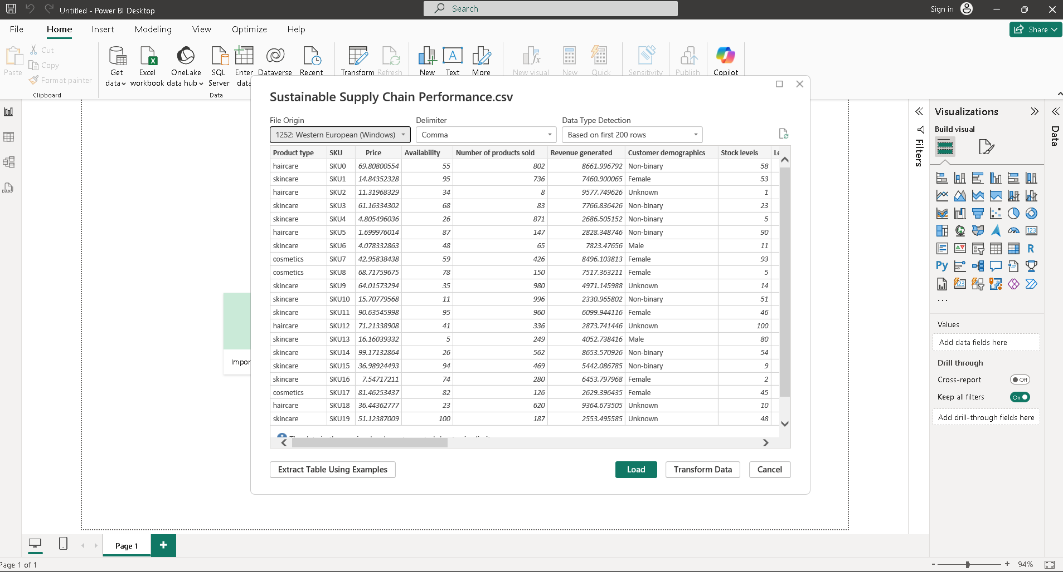

**Screenshot 2: Duplicating the dataset**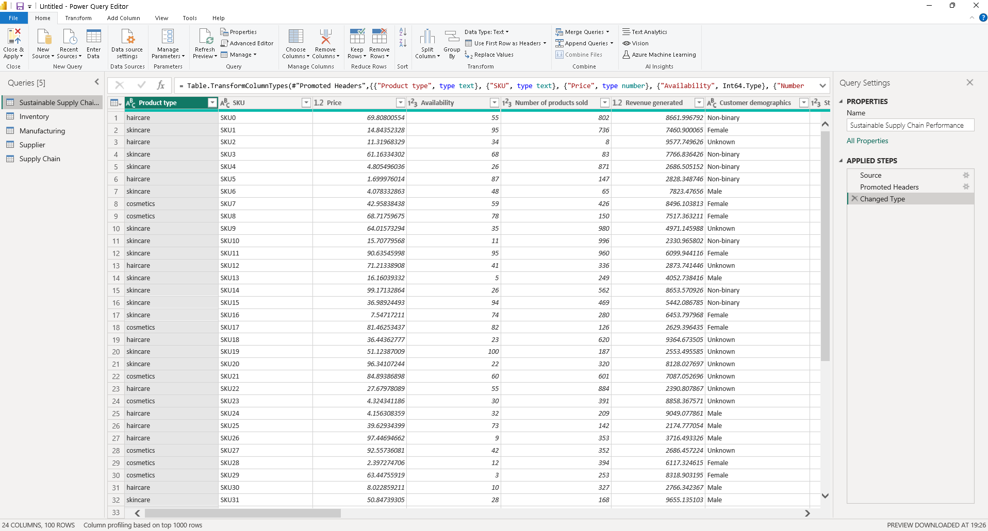

**Screenshot 3: Creating Inventory table by duplicating the dataset; removing unnecessary columns.**

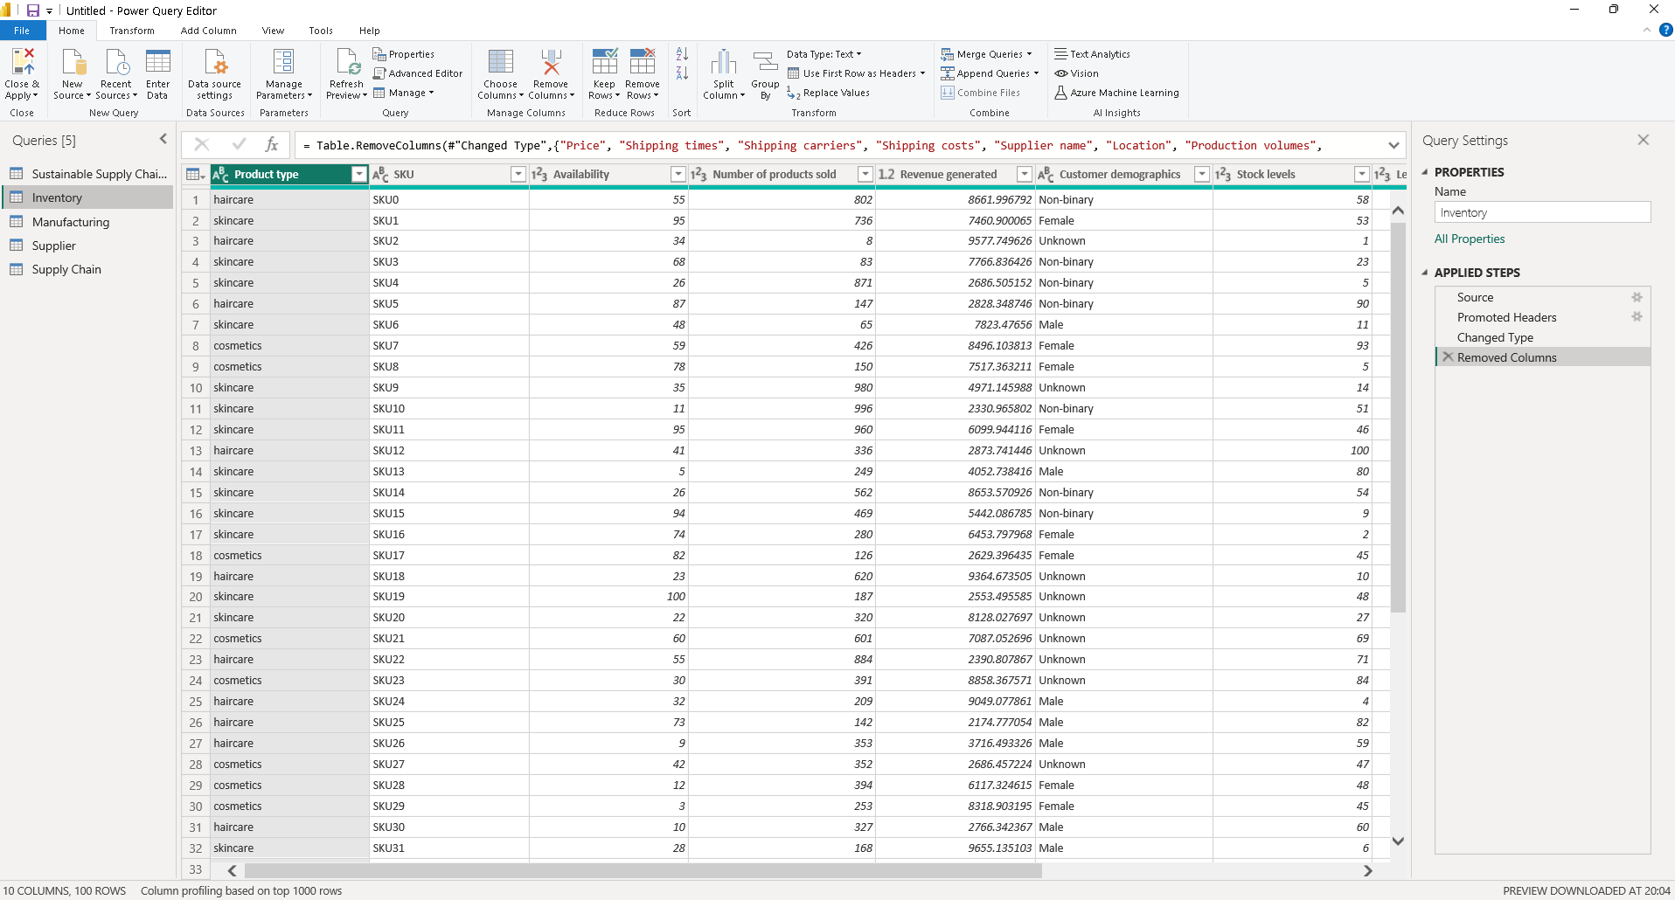

**Screenshot 4: Creating Manufacturing table by duplicating the dataset; removing unnecessary columns.**

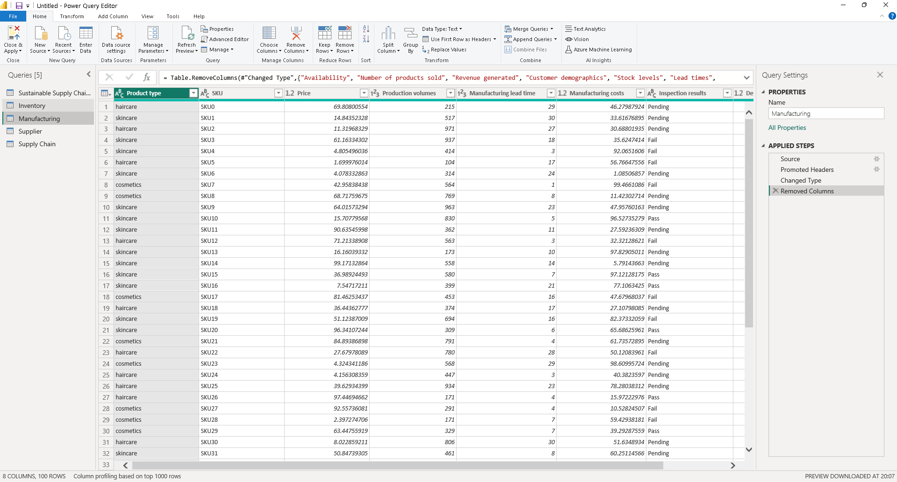

**Screenshot 5: Creating Supplier table by duplicating the dataset; removing unnecessary columns.**

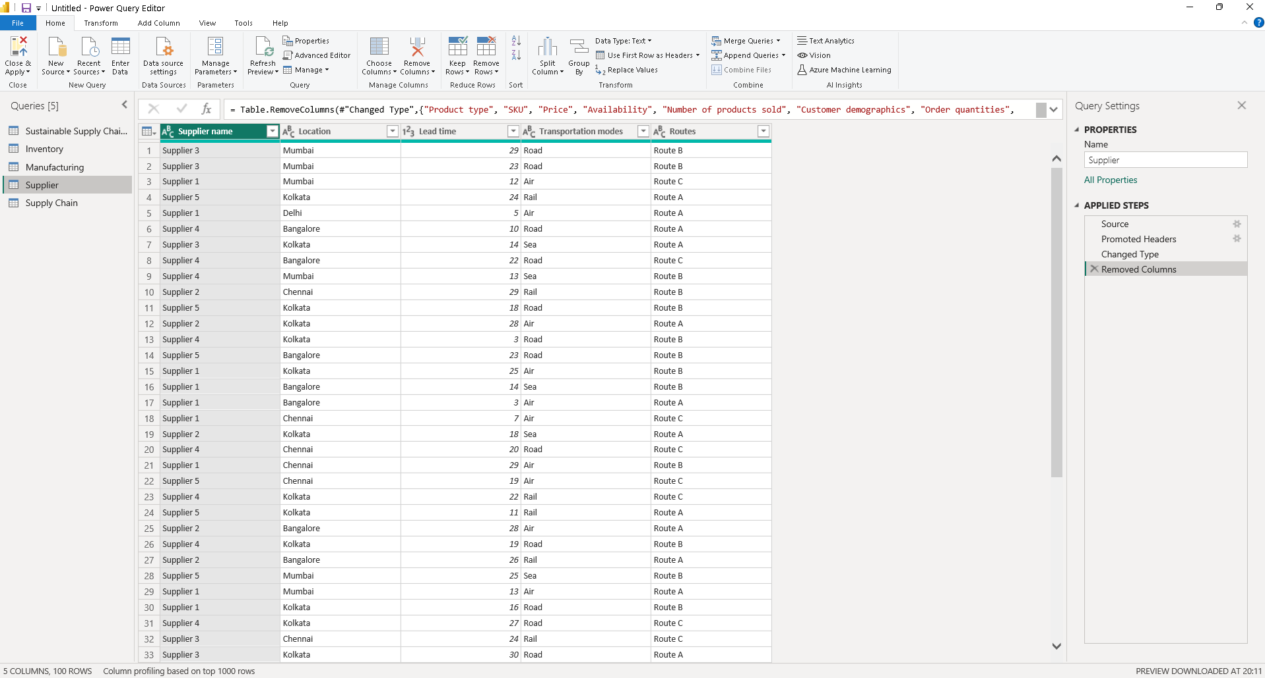

**Screenshot 6: Creating Supply Chain table by duplicating the dataset; removing unnecessary columns.**

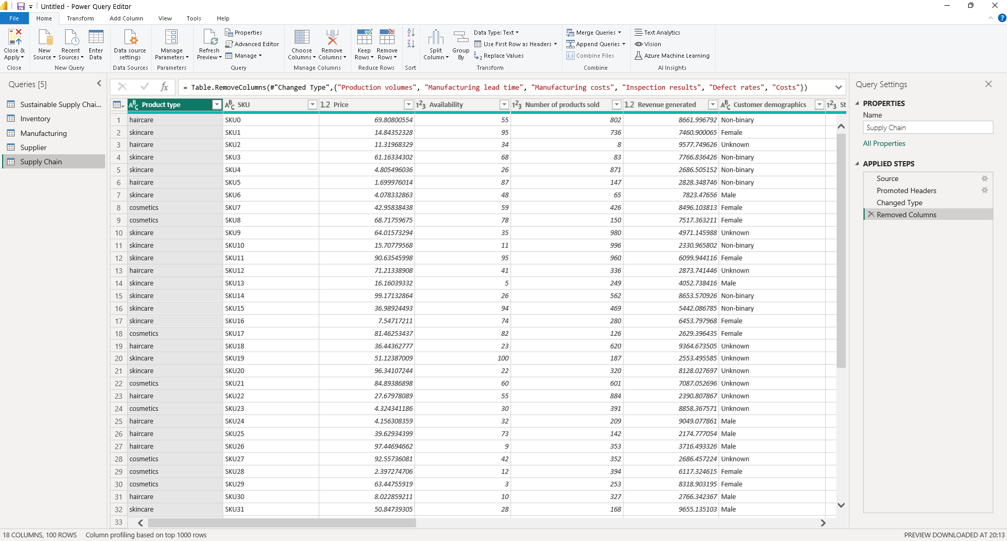

**Conclusion:**

The process of loading, transforming, and organizing the data in Power BI provided a streamlined approach to preparing the dataset for analysis. By creating four specific tables tailored to Inventory, Manufacturing, Supplier, and Supply Chain metrics, this task lays the groundwork for deeper insights into supply chain dynamics. The captured screenshots ensure a comprehensive record of the outputs for reference and validation.

This methodical approach highlights the importance of data transformation in breaking down complex datasets into manageable components. It enables targeted analysis, enhances decision-making, and ensures alignment with organizational goals. Furthermore, the project’s focus on sustainable practices underscores the growing significance of environmental responsibility in supply chain management. By leveraging tools like Power BI, organizations can achieve greater transparency, improved performance, and long-term sustainability.