|  |  |
| --- | --- |
|  | **SREE NARAYANA GURUKULAM**  **COLLEGE OF ENGINEERING**  **KADAYIRUPPU, KOLENCHERY 682311** |

**---------------------------------------**

**LABORATORY RECORD**

**YEAR:** 2022  **TO**  2023

**NAME:** THASNIM VA

**SEMESTER:** 3 **ROLL NO:** 35

**BRANCH:** COMPUTER APPLICATIONS

Certified that this is a Bonafide Record of Practical work done in partial fulfillment of the requirements for the award of the Degree in Master of Computer Applications of Sree Narayana Gurukulam College of Engineering.

Kadayiruppu

Date:

Head of the Department Course Instructor

Submitted for University Practical Examination

**Reg. No:** SNG21MCA-2037 **on-----------------**

External Examiner Internal Examiner

**INDEX PAGE**

|  |  |  |
| --- | --- | --- |
| **NO** | **PROGRAM** | **DATE** |
| **COURSE OUTCOME 1** | | |
| 1 | LOGIN FORM | 30/08/22 |
| 2 | ACTIVITY LIFECYCLE | 03/09/22 |
| 3 | SIMPLE CALCULATOR | 10/09/22 |
| 4 | FORM VALIDATION | 20/09/22 |
| **COURSE OUTCOME 2** | | |
| 5 | INTENT AND SHARED PREFERENCES | 25/09/22 |
| 6 | GRID CALCULATOR | 30/09/22 |
| 7 | FACEBOOK PAGE | 05/10/22 |
| 8 | TOGGLE IMAGE | 20/10/22 |
| **COURSE OUTCOME 3** | | |
| 9 | INTENT | 30/10/22 |
| 10 | MENU | 10/11/22 |
| **COURSE OUTCOME 5** | | |
| 11 | DATABASE MANAGEMENT | 20/11/22 |

**PROGRAM NO:**5

**DATE:**25/09/22

**INTENTS AND SHARED PREFERENCES**

**AIM:**Design a registration activity and store registration details in local memory of phone using Intents and SharedPreferences

**PAGE 1**

**XML CODE:**

<?xml version="1.0" encoding="utf-8"?>

<LinearLayout xmlns:android="http://schemas.android.com/apk/res/android"

xmlns:app="http://schemas.android.com/apk/res-auto"

xmlns:tools="http://schemas.android.com/tools"

android:layout_width="match_parent"

android:layout_height="match_parent"

android:orientation="vertical"

tools:context=".MainActivity">

<TextView

android:layout_width="match_parent"

android:layout_height="wrap_content"

android:gravity="center"

android:background="@color/black"

android:textColor="@color/white"

android:text="ENTER THE DETAILS"

android:layout_marginTop="30px"

android:textSize="25sp"

/>

<EditText

android:id="@+id/fullname"

android:layout_width="match_parent"

android:layout_height="wrap_content"

android:ems="10"

android:layout_marginTop="30sp"

android:inputType="textPersonName"

android:hint="FULL NAME" />

<EditText

android:id="@+id/email"

android:layout_width="match_parent"

android:layout_height="wrap_content"

android:ems="10"

android:layout_marginTop="30sp"

android:hint="EMAIL"

android:inputType="textPersonName" />

<EditText

android:id="@+id/location"

android:layout_width="match_parent"

android:layout_height="wrap_content"

android:ems="10"

android:layout_marginTop="30sp"

android:inputType="textPersonName"

android:hint="LOCATION" />

<Button

android:id="@+id/button"

android:layout_width="match_parent"

android:layout_height="wrap_content"

android:layout_marginTop="30sp"

android:onClick="reg"

android:text="REGISTER" />

</LinearLayout>

**JAVA CODE:**

package com.example.registration_intent_shared;

import androidx.appcompat.app.AppCompatActivity;

import android.content.Intent;

import android.content.SharedPreferences;

import android.os.Bundle;

import android.view.View;

import android.widget.EditText;

import android.widget.Toast;

public class MainActivity extends AppCompatActivity {

EditText name,email,location;

SharedPreferences sp;

@Override

protected void onCreate(Bundle savedInstanceState) {

super.onCreate(savedInstanceState);

setContentView(R.layout.activity_main);

name=findViewById(R.id.fullname);

email=findViewById(R.id.email);

location=findViewById(R.id.location);

sp=getSharedPreferences("register",MODE_PRIVATE);

}

public void reg(View view) {

Toast.makeText(this,"REGISTERED

SUCCESSFULLY",Toast.LENGTH_SHORT).show();

Intent i=new Intent(MainActivity.this,MainActivity2.class);

String val1=name.getText().toString();

String val2=email.getText().toString();

i.putExtra("name",val1);

i.putExtra("email",val2);

SharedPreferences.Editor ed=sp.edit();

ed.putString("location",location.getText().toString());

ed.commit();

startActivity(i);

}

}

**PAGE 2**

**XML CODE:**

<?xml version="1.0" encoding="utf-8"?>

<LinearLayout xmlns:android="http://schemas.android.com/apk/res/android"

xmlns:app="http://schemas.android.com/apk/res-auto"

xmlns:tools="http://schemas.android.com/tools"

android:layout_width="match_parent"

android:layout_height="match_parent"

android:orientation="vertical"

tools:context=".MainActivity2">

<TextView

android:id="@+id/det"

android:layout_width="match_parent"

android:layout_marginTop="30px"

android:fontFamily="serif"

android:textStyle="bold"

android:textColor="@color/white"

android:gravity="center"

android:background="@color/black"

android:textSize="25sp"

android:layout_height="wrap_content"

android:text="REGISTRATION DETAILS" />

<TextView

android:id="@+id/name"

android:layout_width="match_parent"

android:layout_marginTop="30px"

android:fontFamily="serif"

android:textStyle="bold"

android:textColor="#5981f7"

android:gravity="center"

android:textSize="25sp"

android:layout_height="wrap_content"

android:text="NAME" />

<TextView

android:id="@+id/email"

android:textColor="#5981f7"

android:fontFamily="serif"

android:layout_marginTop="30px"

android:textSize="25sp"

android:textStyle="bold"

android:gravity="center"

android:layout_width="match_parent"

android:layout_height="wrap_content"

android:text="EMAIL" />

<TextView

android:id="@+id/location"

android:textColor="#5981f7"

android:fontFamily="serif"

android:layout_marginTop="30px"

android:textSize="25sp"

android:textStyle="bold"

android:gravity="center"

android:layout_width="match_parent"

android:layout_height="wrap_content"

android:text="LOCATION" />

</LinearLayout>

**JAVA CODE:**

package com.example.registration_intent_shared;

import androidx.appcompat.app.AppCompatActivity;

import android.content.Intent;

import android.content.SharedPreferences;

import android.os.Bundle;

import android.widget.TextView;

public class MainActivity2 extends AppCompatActivity {

TextView t1,t2,t3;

SharedPreferences sp;

@Override

protected void onCreate(Bundle savedInstanceState) {

super.onCreate(savedInstanceState);

setContentView(R.layout.activity_main2);

t1=findViewById(R.id.name);

t2=findViewById(R.id.email);

t3=findViewById(R.id.location);

sp=getSharedPreferences("register",MODE_PRIVATE);

Intent intent=getIntent();

String val1=intent.getStringExtra("name");

String val2=intent.getStringExtra("email");

String val3=sp.getString("location","");

t1.setText("NAME: "+val1);

t2.setText("EMAIL: "+val2);

t3.setText("LOCATION: "+val3);

}

}

**OUTPUT**

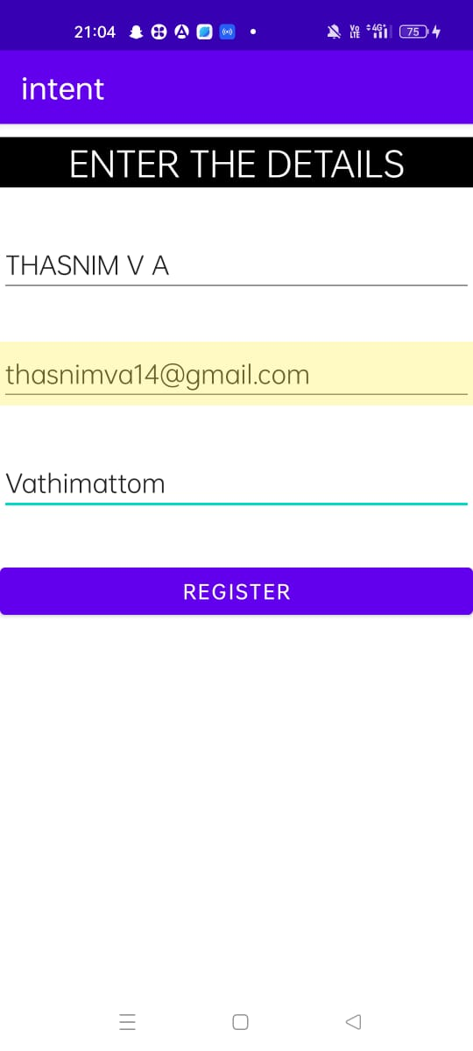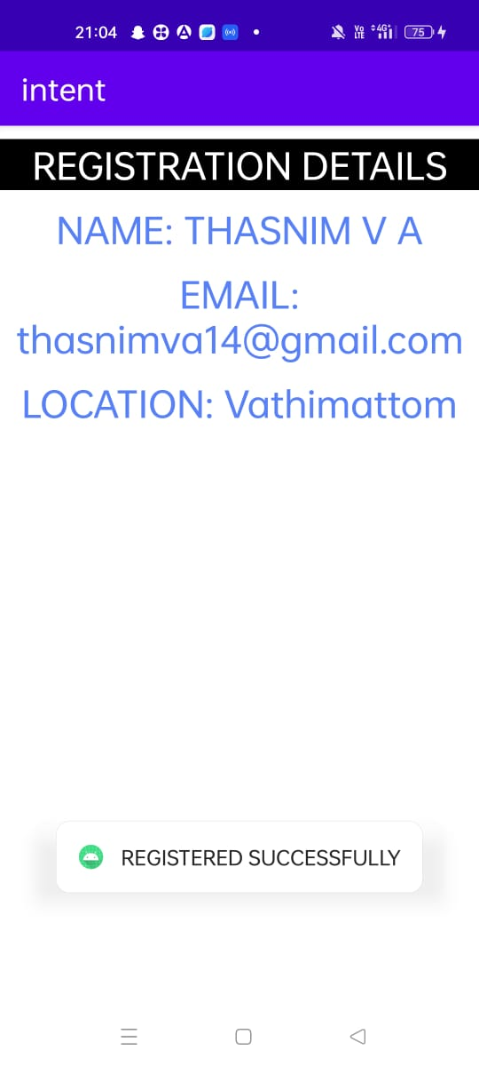

**PROGRAM NO:**6

**DATE:**30/09/22

**GRID CALCULATOR**

**AIM:**Design a simple Calculator using GridLayout and Cascaded LinearLayout

**XML CODE:**

<?xml version="1.0" encoding="utf-8"?>

<LinearLayout xmlns:android="http://schemas.android.com/apk/res/android"

xmlns:app="http://schemas.android.com/apk/res-auto"

xmlns:tools="http://schemas.android.com/tools"

android:layout_width="match_parent"

android:layout_height="match_parent"

android:orientation="vertical"

tools:context=".MainActivity">

<TextView

android:id="@+id/textView"

android:layout_width="match_parent"

android:layout_marginTop="5dp"

android:layout_height="40dp"

android:background="#16B7CA"

android:gravity="center"

android:textColor="#0E0E0D"

android:text="WELCOME" />

<EditText

android:id="@+id/display"

android:layout_marginTop="30dp"

android:layout_width="390dp"

android:layout_gravity="center"

android:layout_height="80dp"

android:gravity="center"

android:hint="Result"

android:inputType="textPersonName"

/>

<androidx.gridlayout.widget.GridLayout

android:layout_width="wrap_content"

android:layout_height="wrap_content"

android:layout_marginTop="30dp"

android:layout_gravity="center">

<Button

android:id="@+id/b7"

android:layout_width="wrap_content"

android:layout_height="54dp"

android:backgroundTint="#6e7778"

android:text="7"

app:layout_column="0"

app:layout_row="0" />

<Button

android:id="@+id/b8"

android:layout_width="wrap_content"

android:layout_height="54dp"

android:layout_marginLeft="10dp"

android:backgroundTint="#6e7778"

android:text="8"

app:layout_column="1"

app:layout_row="0" />

<Button

android:id="@+id/b9"

android:layout_width="wrap_content"

android:layout_height="54dp"

android:layout_marginLeft="10dp"

android:backgroundTint="#6e7778"

android:text="9"

app:layout_column="2"

app:layout_row="0" />

<Button

android:id="@+id/div"

android:layout_width="wrap_content"

android:layout_height="54dp"

android:layout_marginLeft="10dp"

android:backgroundTint="#3C393B"

android:text="/"

app:layout_column="3"

app:layout_row="0" />

<Button

android:id="@+id/b4"

android:layout_width="wrap_content"

android:layout_height="54dp"

android:backgroundTint="#6e7778"

android:text="4"

app:layout_column="0"

app:layout_row="1" />

<Button

android:id="@+id/b5"

android:layout_width="wrap_content"

android:layout_height="54dp"

android:layout_marginLeft="10dp"

android:backgroundTint="#6e7778"

android:text="5"

app:layout_column="1"

app:layout_row="1" />

<Button

android:id="@+id/b6"

android:layout_width="wrap_content"

android:layout_height="54dp"

android:layout_marginLeft="10dp"

android:backgroundTint="#6e7778"

android:text="6"

app:layout_column="2"

app:layout_row="1" />

<Button

android:id="@+id/mul"

android:layout_width="wrap_content"

android:layout_height="54dp"

android:layout_marginLeft="10dp"

android:backgroundTint="#3C393B"

android:text="x"

app:layout_column="3"

app:layout_row="1" />

<Button

android:id="@+id/b1"

android:layout_width="wrap_content"

android:layout_height="54dp"

android:backgroundTint="#6e7778"

android:text="1"

app:layout_column="0"

app:layout_row="2" />

<Button

android:id="@+id/b2"

android:layout_width="wrap_content"

android:layout_height="54dp"

android:layout_marginLeft="10dp"

android:backgroundTint="#6e7778"

android:text="2"

app:layout_column="1"

app:layout_row="2" />

<Button

android:id="@+id/b3"

android:layout_width="wrap_content"

android:layout_height="54dp"

android:layout_marginLeft="10dp"

android:backgroundTint="#6e7778"

android:text="3"

app:layout_column="2"

app:layout_row="2" />

<Button

android:id="@+id/sub"

android:layout_width="wrap_content"

android:layout_height="54dp"

android:layout_marginLeft="10dp"

android:backgroundTint="#3C393B"

android:text="-"

app:layout_column="3"

app:layout_row="2" />

<Button

android:id="@+id/clr"

android:layout_width="wrap_content"

android:layout_height="54dp"

android:backgroundTint="#3C393B"

android:text="clr"

app:layout_column="0"

app:layout_row="3" />

<Button

android:id="@+id/b0"

android:layout_width="wrap_content"

android:layout_height="54dp"

android:layout_marginLeft="10dp"

android:backgroundTint="#6e7778"

android:text="0"

app:layout_column="1"

app:layout_row="3" />

<Button

android:id="@+id/equal"

android:layout_width="wrap_content"

android:layout_height="54dp"

android:layout_marginLeft="10dp"

android:backgroundTint="#3C393B"

android:text="="

app:layout_column="2"

app:layout_row="3" />

<Button

android:id="@+id/add"

android:layout_width="wrap_content"

android:layout_height="54dp"

android:layout_marginLeft="10dp"

android:backgroundTint="#3C393B"

android:text="+"

app:layout_column="3"

app:layout_row="3" />

</androidx.gridlayout.widget.GridLayout>

</LinearLayout>

**JAVA CODE:**

package com.example.gridcalculator;

import androidx.appcompat.app.AppCompatActivity;

import android.os.Bundle;

import android.view.View;

import android.widget.Button;

import android.widget.EditText;

public class MainActivity extends AppCompatActivity implements View.OnClickListener {

EditText number;

double num1=0;

double num2=0;

String op="";

Button b1, b2, b3, b4, b5, b6, b7, b8, b9, b0, sum, sub, mul, div,equal, clear;

@Override

protected void onCreate(Bundle savedInstanceState) {

super.onCreate(savedInstanceState);

setContentView(R.layout.activity_main);

number = findViewById(R.id.display);

b0 = findViewById(R.id.b0);

b1 = findViewById(R.id.b1);

b2 = findViewById(R.id.b2);

b3 = findViewById(R.id.b3);

b4 = findViewById(R.id.b4);

b5 = findViewById(R.id.b5);

b6 = findViewById(R.id.b6);

b7 = findViewById(R.id.b7);

b8 = findViewById(R.id.b8);

b9 = findViewById(R.id.b9);

sum = findViewById(R.id.add);

sub = findViewById(R.id.sub);

mul = findViewById(R.id.mul);

div = findViewById(R.id.div);

equal = findViewById(R.id.equal);

clear = findViewById(R.id.clr);

b0.setOnClickListener(this);

b1.setOnClickListener(this);

b2.setOnClickListener(this);

b3.setOnClickListener(this);

b4.setOnClickListener(this);

b5.setOnClickListener(this);

b6.setOnClickListener(this);

b7.setOnClickListener(this);

b8.setOnClickListener(this);

b9.setOnClickListener(this);

mul.setOnClickListener(this);

div.setOnClickListener(this);SSSSS

sub.setOnClickListener(this);

sum.setOnClickListener(this);

clear.setOnClickListener(this);

equal.setOnClickListener(this);

}

@Override

public void onClick(View view) {

Button b= (Button) view;

if(view==clear)

{

number.setText("");

}

else if(view==sub||view==sum||view==mul||view==div)

{

num1=Integer.parseInt(number.getText().toString());

op=b.getText().toString();

number.setText("");

}

else if(view==equal)

{

num2=Integer.parseInt(number.getText().toString());

if(op.equals("+"))

{

number.setText(num1+num2+"");

}

else if(op.equals("-"))

{

number.setText(num1-num2+"");

}

else if(op.equals("x"))

{

number.setText(num1*num2+"");

}

else if(op.equals("/"))

{

number.setText(num1/num2+"");

}

}

else

{

String s=number.getText().toString();

number.setText(s+b.getText().toString());

}

}

}

**OUTPUT**

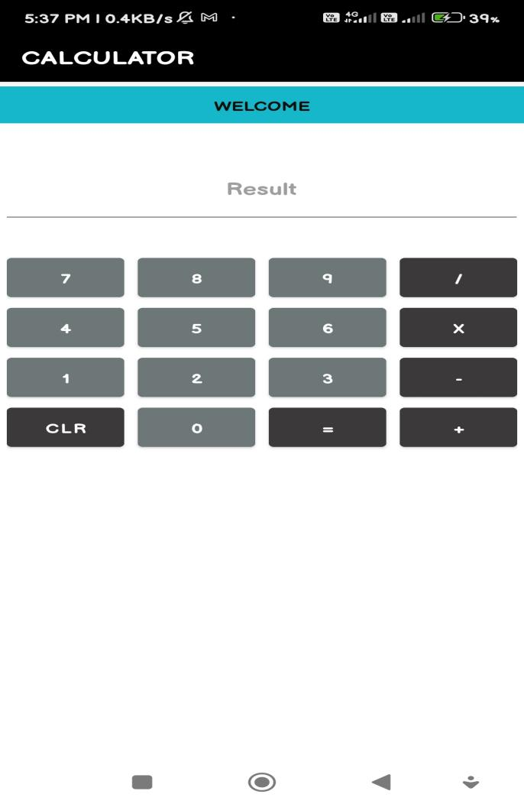

**PROGRAM NO:**7

**DATE:**05/10/22

**FACEBOOK PAGE**

**AIM:**Create a Facebook page using RelativeLayout; set properties using .xml file

**XML CODE:**

<?xml version="1.0" encoding="utf-8"?>

<RelativeLayout xmlns:android="http://schemas.android.com/apk/res/android" xmlns:app="http://schemas.android.com/apk/res-auto"

xmlns:tools="http://schemas.android.com/tools"

android:layout_width="match_parent"

android:layout_height="match_parent"

android:background="#3e52ab"

tools:context=".MainActivity">

<ImageView

android:id="@+id/imageView"

android:layout_width="match_parent"

android:layout_height="100dp"

android:layout_gravity="center"

android:layout_marginTop="40dp"

app:srcCompat="@drawable/facebook" />

<EditText

android:id="@+id/username"

android:layout_width="match_parent"

android:layout_height="50dp"

android:layout_below="@+id/imageView"

android:layout_marginLeft="10dp"

android:layout_marginRight="10dp"

android:layout_marginTop="60dp"

android:background="@drawable/back"

android:ems="10"

android:hint="Email or Phone Number"

android:inputType="textPersonName"

android:paddingLeft="30dp"

android:textColor="@color/white"

android:textColorHint="@color/white"

android:textSize="19sp" />

<EditText

android:id="@+id/password"

android:layout_width="match_parent"

android:layout_height="50dp"

android:layout_below="@+id/username"

android:layout_marginLeft="10dp"

android:layout_marginTop="10dp"

android:layout_marginRight="10dp"

android:background="@drawable/back"

android:ems="10"

android:hint="password"

android:inputType="textPersonName"

android:paddingLeft="30dp"

android:textColor="@color/white"

android:textColorHint="@color/white"

android:textSize="19sp" />

<Button

android:id="@+id/button"

android:layout_width="260dp"

android:layout_height="55dp"

android:layout_below="@+id/password"

android:layout_centerHorizontal="true"

android:layout_marginTop="40dp"

android:backgroundTint="#46b082"

android:text="Login"

android:textSize="18sp" />

<TextView

android:id="@+id/textView"

android:layout_width="wrap_content"

android:layout_height="wrap_content"

android:layout_below="@id/button"

android:layout_centerHorizontal="true"

android:layout_marginTop="15dp"

android:text="Forgot account?"

android:textColor="@color/white"

android:textSize="22dp" />

<View

android:layout_width="match_parent"

android:layout_height="2dp"

android:layout_below="@+id/textView"

android:layout_marginTop="20dp"

android:background="#94918e" />

<Button

android:id="@+id/button2"

android:layout_width="260dp"

android:layout_height="55dp"

android:layout_below="@+id/textView"

android:layout_centerHorizontal="true"

android:layout_marginTop="70dp"

android:backgroundTint="#46b082"

android:text="Create New Account" />

</RelativeLayout>

<?xml version="1.0" encoding="utf-8"?>

<shape xmlns:android="http://schemas.android.com/apk/res/android"

android:shape="rectangle" >

<!-- View background color -->

<solid

android:color="#3e52ab" >

</solid>

<!-- View border color and width -->

<stroke

android:width="1dp"

android:color="@color/white" >

</stroke>

<!-- The radius makes the corners rounded -->

<corners

android:radius="4dp" >

</corners>

</shape>

**OUTPUT**

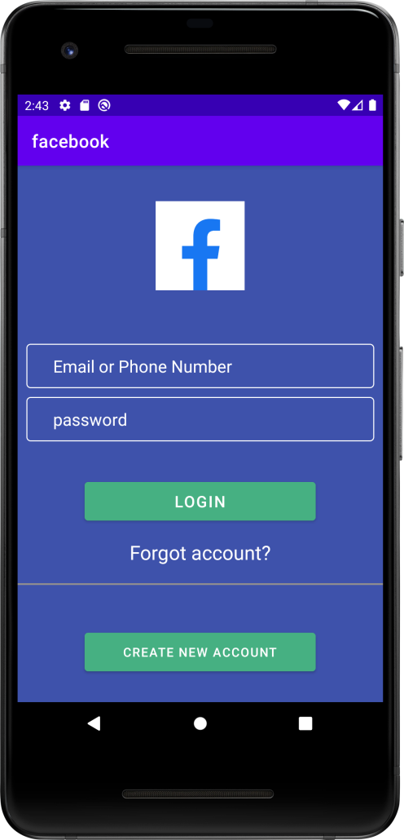

**PROGRAM NO:**8

**DATE:**20/10/22

**TOGGLE IMAGE**

**AIM:**Develop an application that toggles image using FrameLayout

**XML CODE:**

<?xml version="1.0" encoding="utf-8"?>

<FrameLayout xmlns:android="http://schemas.android.com/apk/res/android"

xmlns:app="http://schemas.android.com/apk/res-auto"

xmlns:tools="http://schemas.android.com/tools"

android:layout_width="match_parent"

android:layout_height="match_parent"

tools:context=".MainActivity">

<LinearLayout

android:layout_width="match_parent"

android:layout_height="match_parent"

android:orientation="vertical">

<ImageView

android:id="@+id/image1"

android:layout_width="match_parent"

android:layout_height="100dp"

app:srcCompat="@android:drawable/btn_star" />

<ImageView

android:id="@+id/image2"

android:layout_width="match_parent"

android:layout_height="100dp"

app:srcCompat="@android:drawable/ic_lock_idle_lock" />

</LinearLayout>

</FrameLayout>

**JAVA CODE:**

package com.example.imagetoggle;

import androidx.appcompat.app.AppCompatActivity;

import android.os.Bundle;

import android.view.View;

import android.widget.ImageView;

public class MainActivity extends AppCompatActivity implements View.OnClickListener {

ImageView img1,img2;

@Override

protected void onCreate(Bundle savedInstanceState) {

super.onCreate(savedInstanceState);

setContentView(R.layout.activity_main);

img1=findViewById(R.id.image1);

img2=findViewById(R.id.image2);

img1.setOnClickListener(this);

img2.setOnClickListener(this);

}

@Override

public void onClick(View v) {

if(v==img1)

{

img1.setVisibility(View.GONE);

img2.setVisibility(View.VISIBLE);

}

else

{

img2.setVisibility(View.GONE);

img1.setVisibility(View.VISIBLE);

}

}

}

**OUTPUT**

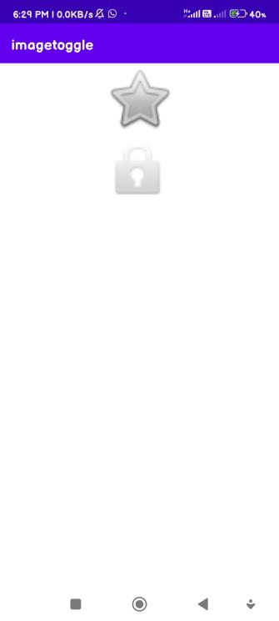 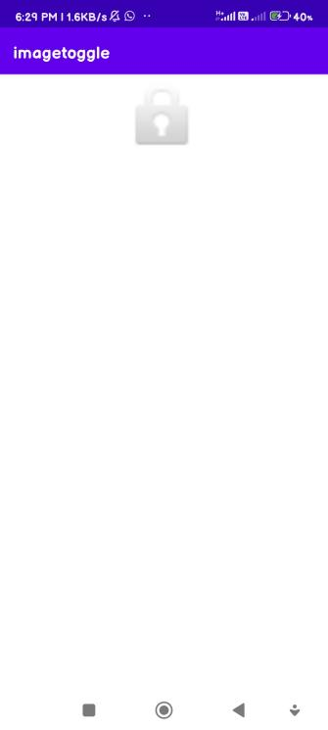 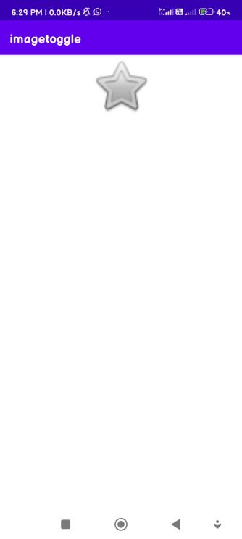

**PROGRAM NO:**9

**DATE:**30/10/22

**INTENT**

**AIM:**Implement Intent to navigate between multiple activities

**PAGE 1**

**XML CODE:**

<?xml version="1.0" encoding="utf-8"?>

<androidx.constraintlayout.widget.ConstraintLayout xmlns:android="http://schemas.android.com/apk/res/android"

xmlns:app="http://schemas.android.com/apk/res-auto"

xmlns:tools="http://schemas.android.com/tools"

android:layout_width="match_parent"

android:layout_height="match_parent"

tools:context=".MainActivity">

<Button

android:id="@+id/button"

android:layout_width="wrap_content"

android:layout_height="wrap_content"

android:text="Next Page"

android:onClick="click"

tools:layout_editor_absoluteX="144dp"

tools:layout_editor_absoluteY="157dp"

tools:ignore="MissingConstraints" />

</androidx.constraintlayout.widget.ConstraintLayout>

**JAVA CODE:**

package com.example.intent;

import androidx.appcompat.app.AppCompatActivity;

import android.content.Intent;

import android.os.Bundle;

import android.view.View;

import android.widget.Button;

public class MainActivity extends AppCompatActivity {

Button b1;

@Override

protected void onCreate(Bundle savedInstanceState) {

super.onCreate(savedInstanceState);

setContentView(R.layout.activity_main);

b1=findViewById(R.id.button);

}

public void click(View view) {

Intent i=new Intent(MainActivity.this,MainActivity2.class);

startActivity(i);

}

}

**PAGE 2**

**XML CODE:**

<?xml version="1.0" encoding="utf-8"?>

<androidx.constraintlayout.widget.ConstraintLayout Sxmlns:android="http://schemas.android.com/apk/res/android"

xmlns:app="http://schemas.android.com/apk/res-auto"

xmlns:tools="http://schemas.android.com/tools"

android:layout_width="match_parent"

android:layout_height="match_parent"

tools:context=".MainActivity2">

<Button

android:id="@+id/button2"

android:layout_width="wrap_content"

android:layout_height="wrap_content"

android:text="previous page"

android:onClick="click"

tools:layout_editor_absoluteX="149dp"

tools:layout_editor_absoluteY="113dp" />

</androidx.constraintlayout.widget.ConstraintLayout>

**JAVA CODE:**

package com.example.intent;

import androidx.appcompat.app.AppCompatActivity;

import android.content.Intent;

import android.os.Bundle;

import android.view.View;

public class MainActivity2 extends AppCompatActivity {

@Override

protected void onCreate(Bundle savedInstanceState) {

super.onCreate(savedInstanceState);

setContentView(R.layout.activity_main2);

}

public void click(View view) {

Intent i=new Intent(MainActivity2.this,MainActivity.class);

startActivity(i);

}

}

**OUTPUT**

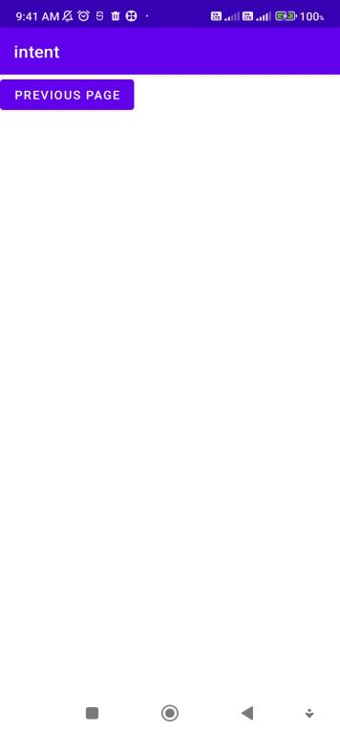 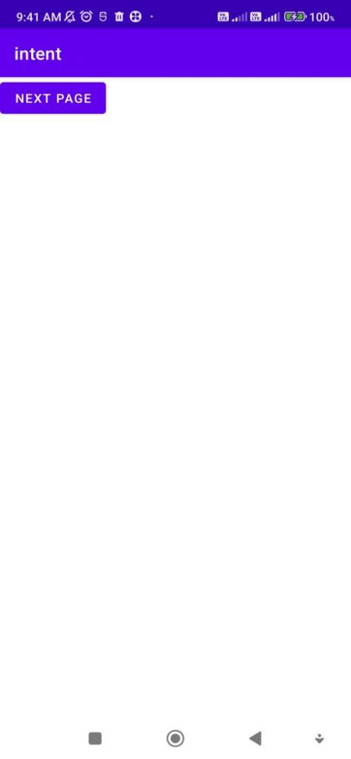

**PROGRAM NO:**10

**DATE:**10/11/22

**MENU**

**AIM:**Implement Options Menu to navigate to activities

**MENU**

<?xml version="1.0" encoding="utf-8"?>

<menu xmlns:android="http://schemas.android.com/apk/res/android">

<item

android:id="@+id/item1"

android:title="DEPARTMENT">

<menu>

<item

android:id="@+id/inside1"

android:title="MCA" />

<item

android:id="@+id/inside2"

android:title="MBA" />

</menu>

</item>

<item

android:id="@+id/item2"

android:title="STUDENTS" />

</menu>

**XML CODE:**

<?xml version="1.0" encoding="utf-8"?>

<androidx.constraintlayout.widget.ConstraintLayout xmlns:android="http://schemas.android.com/apk/res/android"

xmlns:app="http://schemas.android.com/apk/res-auto"

xmlns:tools="http://schemas.android.com/tools"

android:layout_width="match_parent"

android:layout_height="match_parent"

tools:context=".MainActivity">

<TextView

android:layout_width="wrap_content"

android:layout_height="wrap_content"

android:text="Hello World!"

app:layout_constraintBottom_toBottomOf="parent"

app:layout_constraintEnd_toEndOf="parent"

app:layout_constraintStart_toStartOf="parent"

app:layout_constraintTop_toTopOf="parent" />

</androidx.constraintlayout.widget.ConstraintLayout>

**JAVA CODE:**

package com.example.menu;

import androidx.annotation.NonNull;

import androidx.appcompat.app.AppCompatActivity;

import android.os.Bundle;

import android.view.Menu;

import android.view.MenuInflater;

import android.view.MenuItem;

import android.widget.Toast;

public class MainActivity extends AppCompatActivity {

@Override

protected void onCreate(Bundle savedInstanceState) {

super.onCreate(savedInstanceState);

setContentView(R.layout.activity_main);

}

@Override

public boolean onCreateOptionsMenu(Menu menu) {

MenuInflater inflater=getMenuInflater();

inflater.inflate(R.menu.menu,menu);

return true;

}

@Override

public boolean onOptionsItemSelected(@NonNull MenuItem item) {

switch (item.getItemId()){

case R.id.inside1:

Toast.makeText(this,"mca department",Toast.LENGTH_LONG).show();

break;

case R.id.inside2:

Toast.makeText(this, "mba department", Toast.LENGTH_SHORT).show();

break;

case R.id.item2:

Toast.makeText(this, "students", Toast.LENGTH_SHORT).show();

break;

}

return true;

}

}

**OUTPUT**

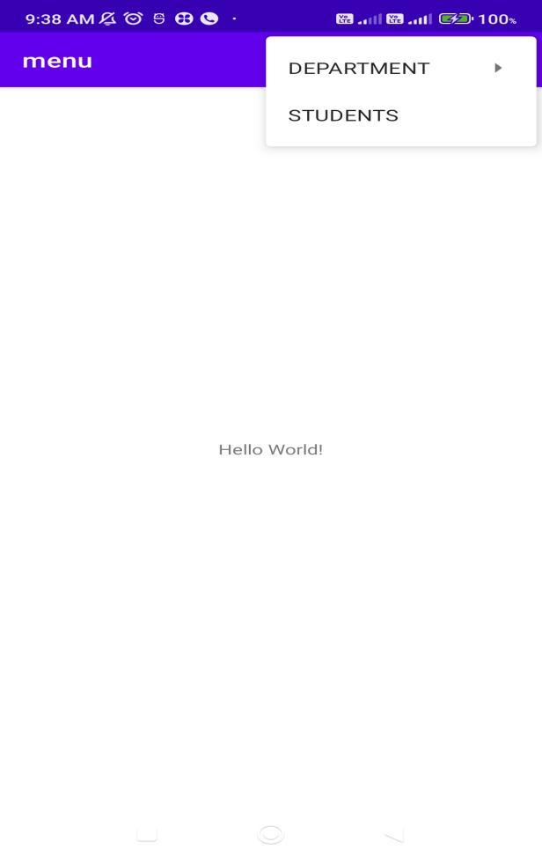

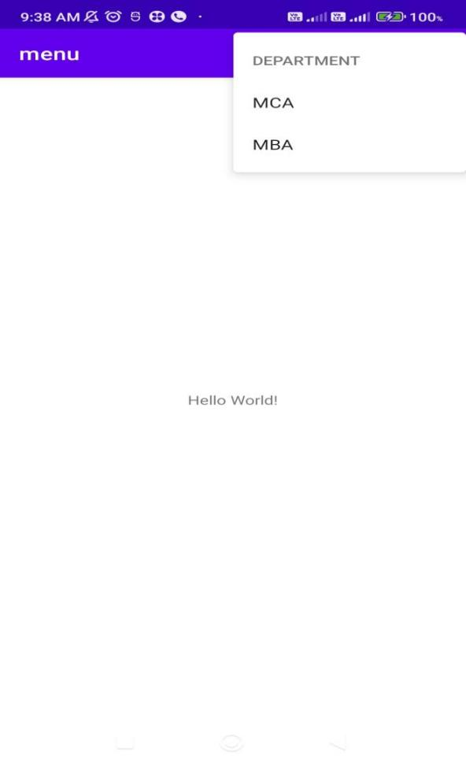

**PROGRAM NO:**11

**DATE:2**0/11/22

**DATABASE MANAGEMENT**

**AIM:**Create database using SQLite and perform INSERT,SELECT,UPDATE AND DELETE

**XML CODE:**

<?xml version="1.0" encoding="utf-8"?>

<LinearLayout xmlns:android="http://schemas.android.com/apk/res/android"

xmlns:app="http://schemas.android.com/apk/res-auto"

xmlns:tools="http://schemas.android.com/tools"

android:layout_width="match_parent"

android:layout_height="match_parent"

android:orientation="vertical"

tools:context=".MainActivity">

<TextView

android:id="@+id/textView"

android:layout_width="match_parent"

android:layout_height="wrap_content"

android:text="TextView" />

<EditText

android:id="@+id/id"

android:layout_width="match_parent"

android:layout_height="wrap_content"

android:ems="10"

android:inputType="textPersonName"

android:hint="id" />

<EditText

android:id="@+id/name"

android:layout_width="match_parent"

android:layout_height="wrap_content"

android:ems="10"

android:inputType="textPersonName"

android:hint="name" />

<EditText

android:id="@+id/place"

android:layout_width="match_parent"

android:layout_height="wrap_content"

android:ems="10"

android:inputType="textPersonName"

android:hint="place" />

<Button

android:id="@+id/insert"

android:layout_width="match_parent"

android:layout_height="wrap_content"

android:text="insert" />

<Button

android:id="@+id/select"

android:layout_width="match_parent"

android:layout_height="wrap_content"

android:text="select" />

<Button

android:id="@+id/update"

android:layout_width="match_parent"

android:layout_height="wrap_content"

android:text="update" />

<Button

android:id="@+id/delete"

android:layout_width="match_parent"

android:layout_height="wrap_content"

android:text="delete" />

<Button

android:id="@+id/clear"

android:layout_width="match_parent"

android:layout_height="wrap_content"

android:text="clear" />

</LinearLayout>

**JAVA CODE:**

package com.example.database_management;

import androidx.appcompat.app.AlertDialog;

import androidx.appcompat.app.AppCompatActivity;

import android.database.Cursor;

import android.database.sqlite.SQLiteDatabase;

import android.os.Bundle;

import android.view.View;

import android.widget.Button;

import android.widget.EditText;

import android.widget.Toast;

public class MainActivity extends AppCompatActivity {

EditText id,name,place;

Button insert,select,update,delete,clear;

AlertDialog.Builder builder;

SQLiteDatabase db;

@Override

protected void onCreate(Bundle savedInstanceState) {

super.onCreate(savedInstanceState);

setContentView(R.layout.activity_main);

id = findViewById(R.id.id);

name = findViewById(R.id.name);

place = findViewById(R.id.place);

insert = findViewById(R.id.insert);

select = findViewById(R.id.select);

update = findViewById(R.id.update);

delete = findViewById(R.id.delete);

clear = findViewById(R.id.clear);

builder = new AlertDialog.Builder(this);

try {

db=openOrCreateDatabase("empdb",MODE_PRIVATE,null);

db.execSQL("create table employee(id integer primary key,name Text,place Text)");

Toast.makeText(getApplicationContext(),

"table created successfully",Toast.LENGTH_SHORT).show();

} catch (Exception e) {

}

insert.setOnClickListener(new View.OnClickListener() {

@Override

public void onClick(View view) {

try {

db.execSQL("insert into employee values(" + id.getText().toString() + ",'" + name.getText().toString() + "','" + place.getText().toString() + "')");

Toast.makeText(getApplicationContext(),

"inserted successfully", Toast.LENGTH_SHORT).show();

}

catch(Exception e)

{

Toast.makeText(getApplicationContext(),

"error", Toast.LENGTH_SHORT).show();

}

}

});

clear.callOnClick();

select.setOnClickListener(new View.OnClickListener() {

@Override

public void onClick(View view) {

Cursor c=db.rawQuery("select * from employee",null);

if(c.getCount()==0)

{

Toast.makeText(getApplicationContext(),

"no record", Toast.LENGTH_SHORT).show();

}

else

{

StringBuffer b=new StringBuffer();

while(c.moveToNext())

{

b.append("id:"+c.getString(0)+"\n");

b.append("name:"+c.getString(1)+"\n");

b.append("place:"+c.getString(2)+"\n");

Toast.makeText(getApplicationContext(),

b.toString(), Toast.LENGTH_SHORT).show();

builder.setMessage(b.toString());

AlertDialog alert=builder.create();

alert.setTitle("Employee data");

alert.show();

}

}

}

});

update.setOnClickListener(new View.OnClickListener() {

@Override

public void onClick(View view) {

db.execSQL("update

employee set name='"+name.getText().toString()+"',place='"+place.getText().toString()+"' where id="+id.getText().toString()+"");

Toast.makeText(getApplicationContext(),

"updated....", Toast.LENGTH_SHORT).show();

}

});

delete.setOnClickListener(new View.OnClickListener() {

@Override

public void onClick(View view) {

db.execSQL("delete from employee where id="+id.getText().toString());

Toast.makeText(getApplicationContext(),"ItemDeleted", Toast.LENGTH_SHORT).show();

}

});

clear.setOnClickListener(new View.OnClickListener() {

@Override

public void onClick(View view) {

id.setText("");

name.setText("");

place.setText("");

}

});

clear.callOnClick();

}

}

**OUTPUT**

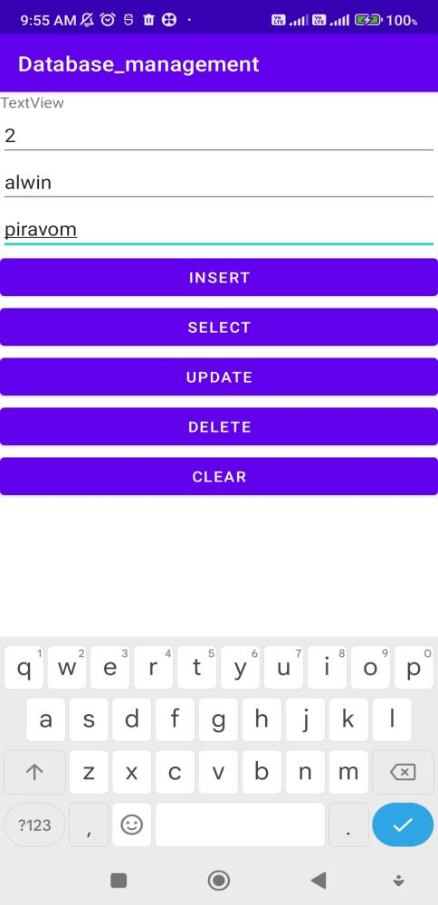 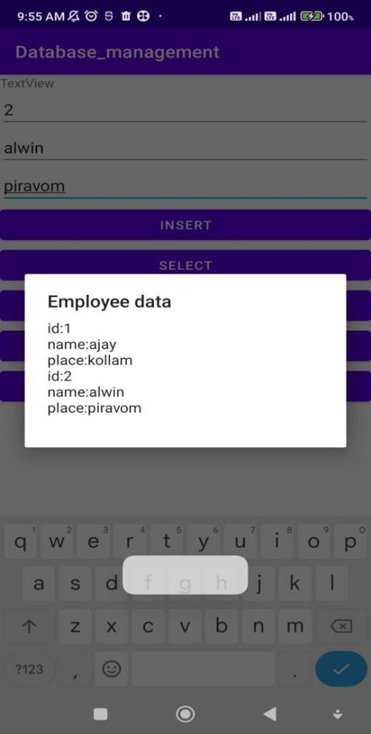

**COURSE OUTCOME 1**

**COURSE OUTCOME 2**

**COURSE OUTCOME 3**

**COURSE OUTCOME 5**