CO5

# 1. Write a Python program to read a file line by line and store it into a list.

f1=open("firstfile.txt","w")

f1.write("This is my first file in python.\nWant to work with files.\n This is my third")

f1.close()

f1=open("firstfile.txt","r")

f1.seek(0,0)

ff=f1.readlines()

for x in range(0,len(ff)):

print(ff[x])

print()

#f1.seek(0,0)

#ff=f1.readlines() #return list of all lines

print(ff)

f1.close()

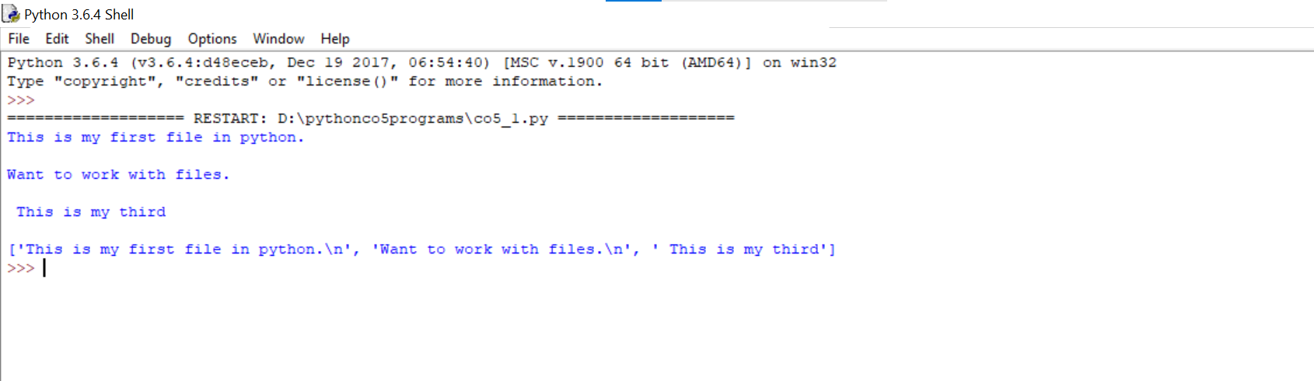

#2. Python program to copy odd lines of one file to other

f1=open("firstfile.txt","r")

for x in f1:

print(x)

f1.seek(0,0)

print()

f2=open("odd.txt","w")

ff=f1.readlines()

with open('odd.txt','w') as f2:

for x in range(0,len(ff)):

if(x%2!=0):

print(ff[x])

f2.write(ff[x])

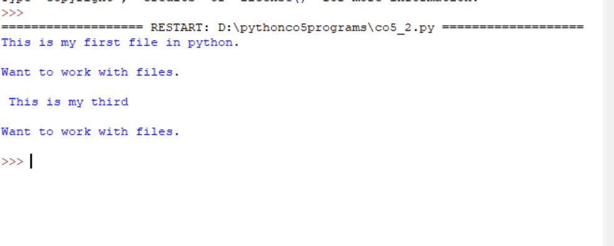

#3Write a python program to read each row from agiven csv file and print a list of strings

import csv

with open('movie1.csv','w',newline='')as file:

writer=csv.writer(file)

writer.writerow(["SN","Movie","Rating"])

writer.writerow([1,"Lord of the Rings",5])

writer.writerow([2,"Harrypotter",6])

with open('movie1.csv')as csvfile:

data=csv.reader(csvfile)

for row in data:

print(','.join(row))

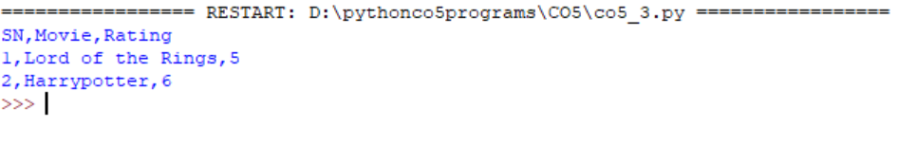

#4Write a python program to read specific columns of a given csv file and print the content of columns

import csv

f=open("fruits.csv","w")

writer=csv.DictWriter(f,fieldnames=["fruit","count"])

writer.writeheader()#writeheader() write headers to the csvfile

writer.writerow({"fruit":"Apple","count":"1"})

writer.writerow({"fruit":"Banana","count":"2"})

f.close()

c=0

f=open("fruits.csv")

reader=csv.DictReader(f)

for row in reader:

if c==0:

print(f'{" ".join(row)}')

print(f'{row["fruit"]},{row["count"]}')

f.close()

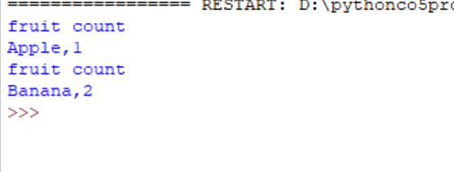

#5Write a python program to write a python dictionary to csv file.After writing the csv file read the csv file and display the contents

import csv

field_names=['ROLLNO','NAME','COURSE']

data=[{'ROLLNO':101,'NAME':'Thasni','COURSE':'MCA'},{'ROLLNO':102,'NAME':'Sithara','COURSE':'MCA'},{'ROLLNO':103,'NAME':'shirin','COURSE':'MCA'}]

with open('Details.csv','w', newline='')as csvfile:

writer = csv.DictWriter(csvfile, fieldnames = field_names)

writer.writeheader()

writer.writerows(data)

with open('Details.csv', 'r') as file:

reader = csv.reader(file)

for row in reader:

print(row)

