1a)import calendar

mm=int(input("enter month:"))

yy=int(input("enter the year:"))

print(calendar.month(yy,mm))

print(calendar.calendar(2022))

print("===============")

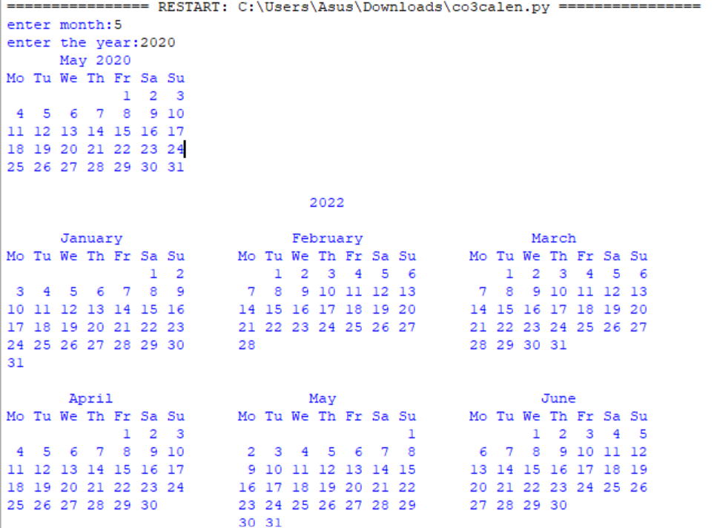

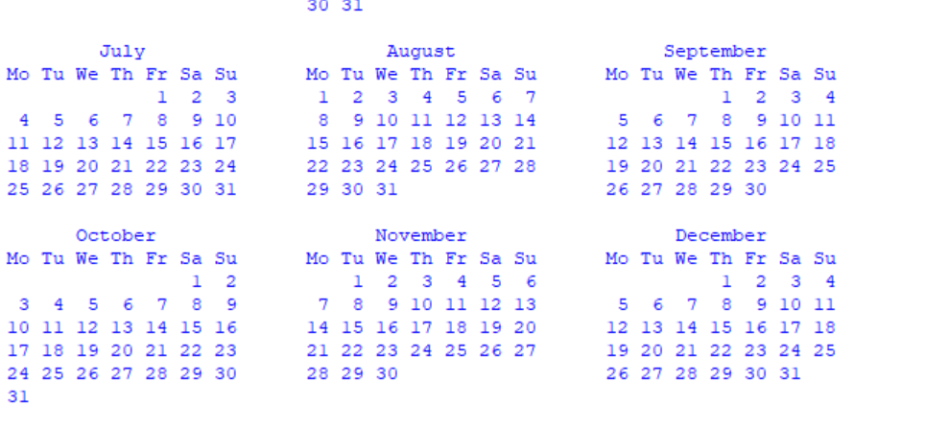

b)

import datetime

t=datetime.time(22,56,44)

print(t)

print("hour",t.hour)

print("min",t.minute)

print("se",t.second)

print("mis",t.microsecond)

print("***********************")

d=datetime.date.today()

print(d)

print("year",d.year)

print("month",d.month)

print("day",d.day)

print(":::::")

d1=datetime.date.today()

print(d1)

td=datetime.timedelta(days=2)

print(td)

d2=d1+td

print(d2)

print("====")

dt=datetime.datetime.combine(d,t)

print(dt)

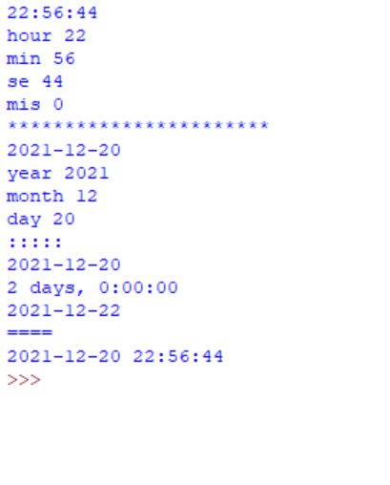

c)import time

print("current time in second",time.time())

print("===============")

print("current time",time.ctime())

print("===============")

print("current time after 30 sec:",time.ctime(time.time()+30))

print("===============")

t=time.localtime()

print("time:",t)

print("===============")

print("current month",t.tm_mon)

print("current year",t.tm_year)

print("current day",t.tm_mday)

print("current hour",t.tm_hour)

print("current miniut",t.tm_min)

print("current second",t.tm_sec)

print("===============")

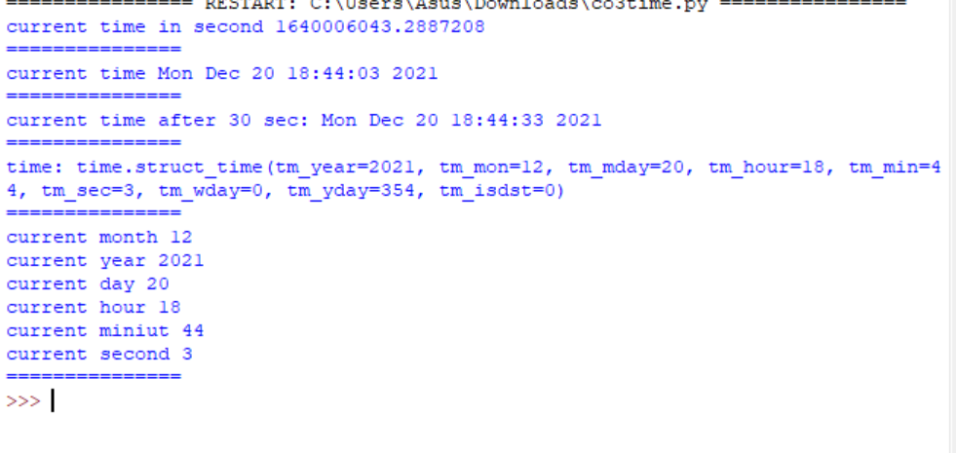

d) import math

print(math.pi)

import math as m

print(m.pi)

print("===============")

from math import pi,sqrt

print(math.pi)

print(sqrt(4))

print("===============")

print("cos",math.cos(90))

print("===============")

print("sin",math.sin(90))

print("===============")

print("tan",math.tan(0))

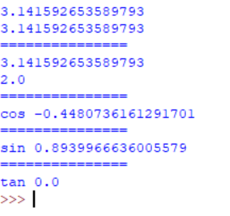

e)import random

list1 = [1, 2, 3, 4, 5, 6]

print(random.choice(list1))

print("*************")

import random

random.seed(5)

print(random.random())

print(random.random())

print("***********")

import random

r1 = random.randint(5, 15)

print("Random number between 5 and 15 is % s" % (r1))

r2 = random.randint(-10, -2)

print("Random number between -10 and -2 is % d" % (r2))

print("**************")

import random

list1 = [1, 2, 3, 4, 5, 6]

print(random.choice(list1))

string = "geeks"

print(random.choice(string))

tuple1 = (1, 2, 3, 4, 5)

print(random.choice(tuple1))

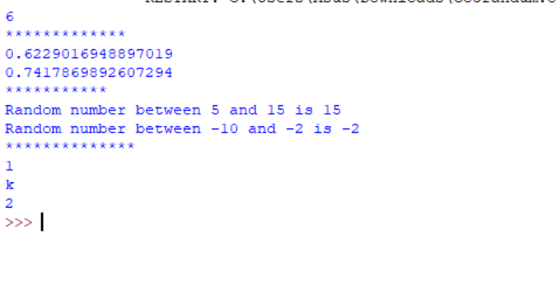

f)import statistics

l1=[1,2,3,4,4]

print("mean",statistics.mean(l1))

print("median",statistics.median(l1))

print("mode",statistics.mode(l1))

print("harmonic_mean",statistics.harmonic_mean(l1))

print("statistics_varience",statistics.variance(l1))

print("statistics_median_low",statistics.median_low([-11,5.5,-3.4,7.1,-9,22]))

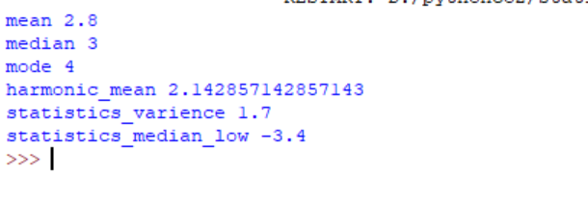

2) pi=3.14

def area(pi,r):

return pi*r*r

def perimeter(pi,r):

return 2*pi*r

__init__

def area(a,b):

return a*b

def perimeter(a,b):

return 2*(a+b)

from graphicsuse import Rectangle

from graphicsuse import circle

print("Read values:\nRectangle:\n")

l=int(input("Enter length"))

b=int(input("Enter breadth"))

r_area=Rectangle.area(l,b)

r_perimeter=Rectangle.perimeter(l,b)

print("Circle:\n")

r=int(input("Enter radius:"))

area=circle.area(circle.pi,r)

perimeter=circle.perimeter(circle.pi,r)

print("Area of rectangle:",r_area)

print("Area of circle:",area)

print("Perimeter of Rectangle:",r_perimeter)

print("perimeter of Circle:",perimeter)

