Beginner Level (6 questions)
- Create an unordered list of vegetables
  - Build a valid HTML page titled "Vegetables" that displays an unordered list (<ul>) with at least 5 items (e.g., Beetroot, Ginger, Potato...).
  - Add a short description paragraph above the list.
  - Expected: browser shows the title, paragraph and bulleted list.
CODE -
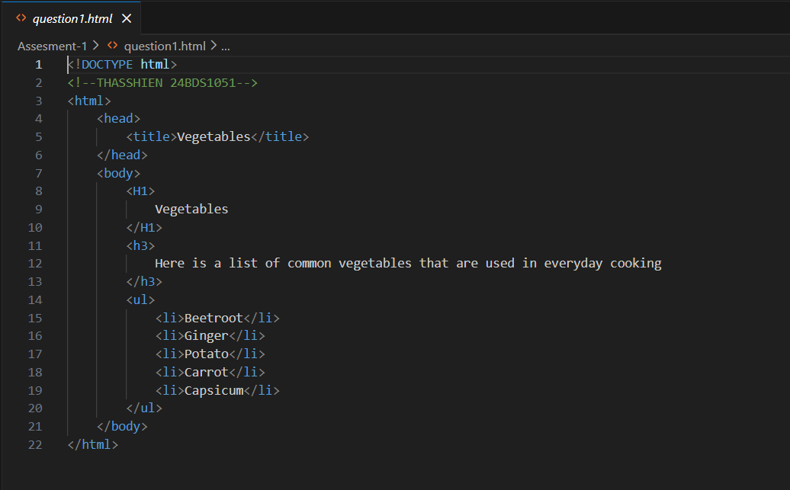
OUTPUT-
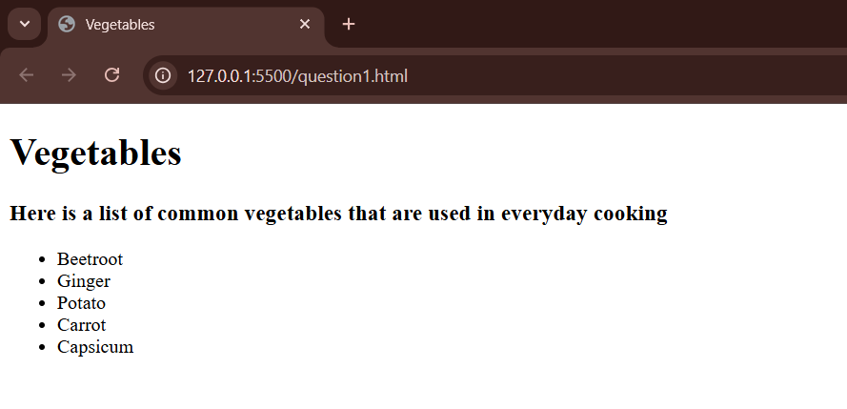

- Create an ordered list of steps
  - Create a page with a numbered (<ol>) list of 5 steps for making tea.
  - Ensure proper <!DOCTYPE html> and <title>.
  - Expected: steps appear numbered in order.
CODE-
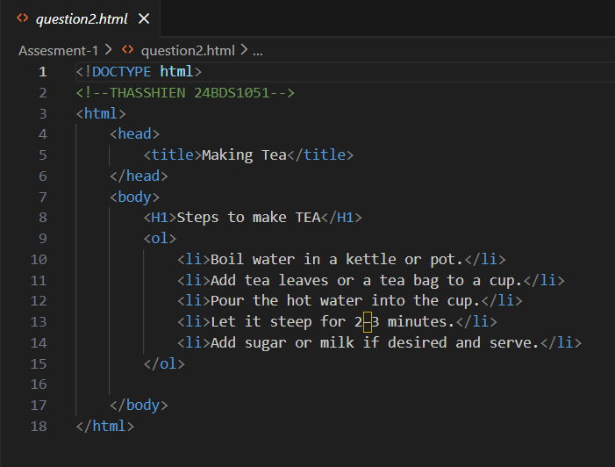
OUTPUT-
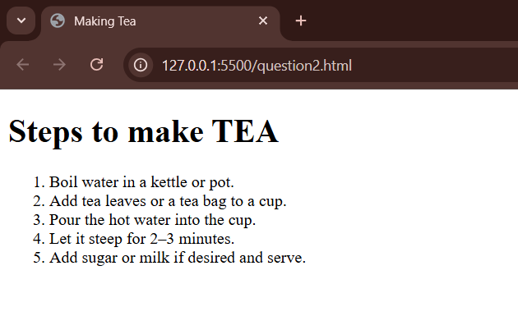

- Definition (glossary) list
  - Build a glossary page using <dl>, <dt>, and <dd> for the terms: HTML (each with a one-line definition).
  - Expected: terms and definitions shown like a dictionary.
CODE –
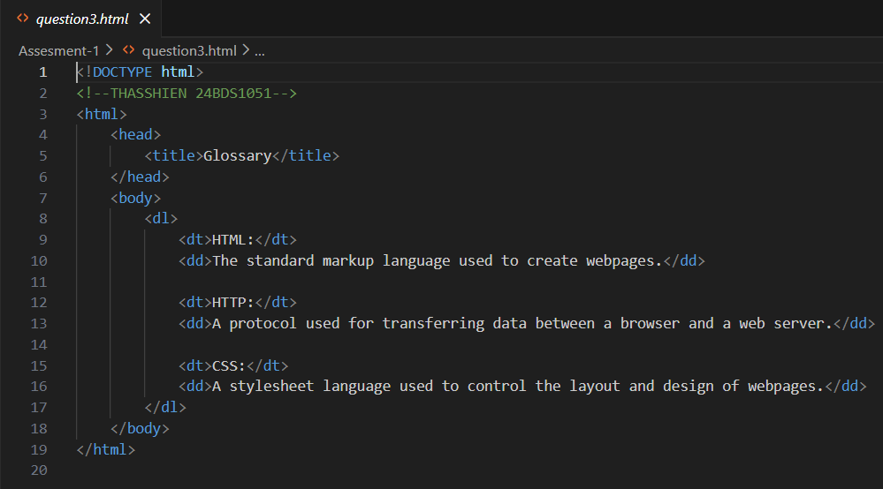
OUTPUT-
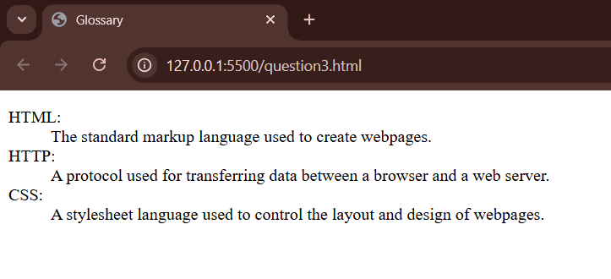

- Simple table with headings
  - Create a table with a header row (<th>) and two data rows. Columns: Name, Salary. Add border="1".
  - Expected: header cells bold/centered and two data rows visible.
CODE –
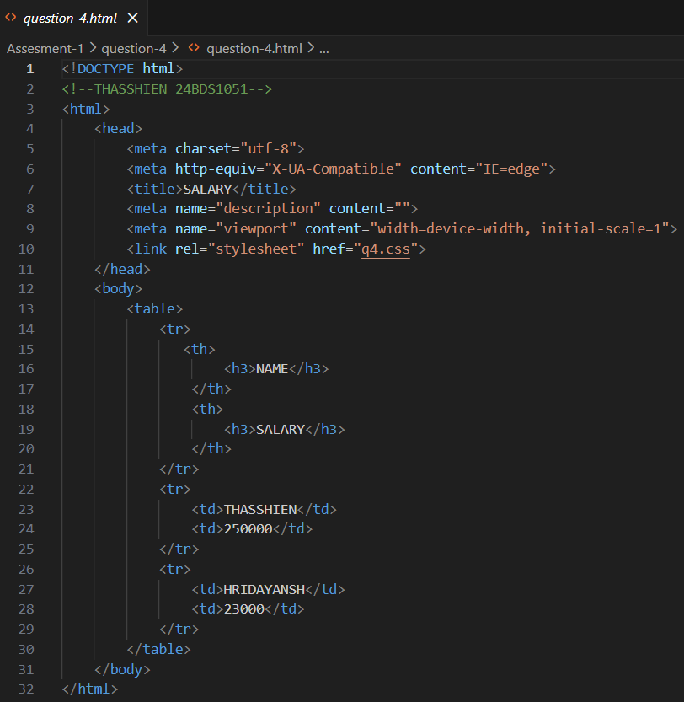
CSS-
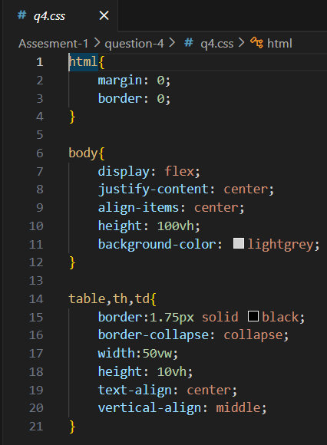
OUTPUT-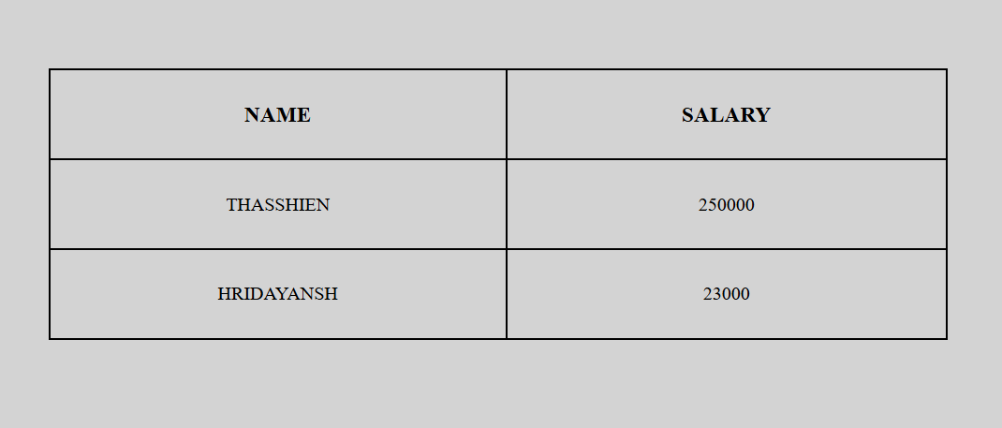

- Formatting text elements
  - Make a short paragraph that demonstrates at least five formatting tags from the lecture: <b>, <em>, <strong>, <i>, <sup>, <sub>, or <code>.
  - Expected: each formatting style rendered correctly.
CODE-
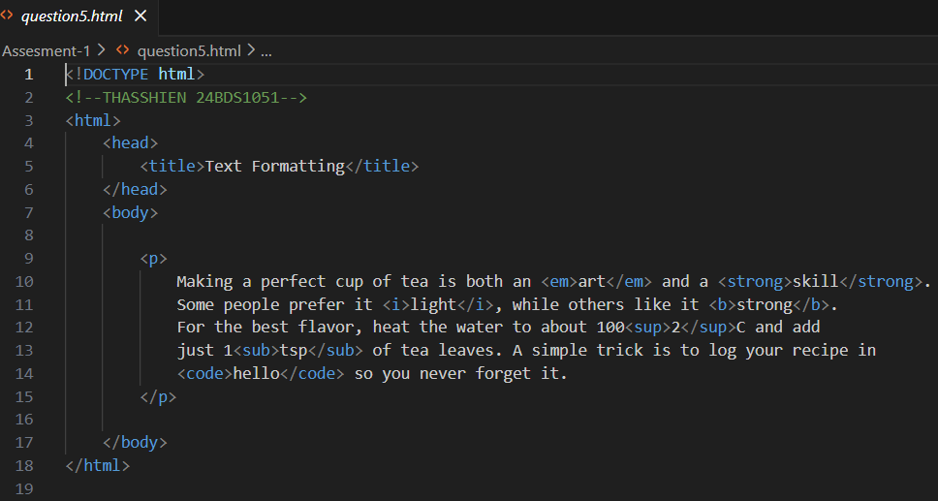
OUTPUT-
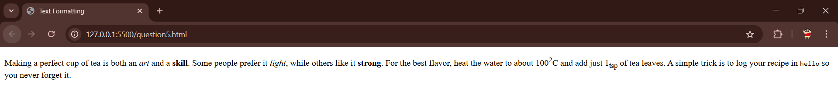
- Navigation bar using <nav>
  - Create a horizontal navigation block with 4 anchor links (they can be # hrefs). Place it inside a <nav> element and add a heading above.
  - Expected: links displayed inline.
CODE-
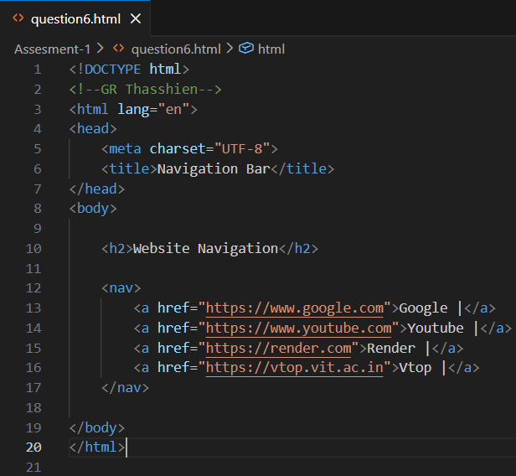
OUTPUT-
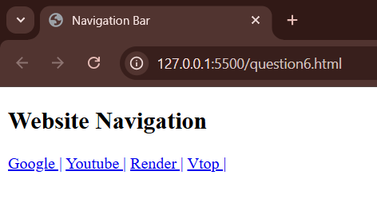

Intermediate Level
- Table with colspan and styled borders
  - Create a table where the first header row has Name and a Contact header that spans two columns (colspan="2").
  - Use an internal <style> block to show borders (e.g., table, th, td { border:1px solid black; border-collapse: collapse; }).
  - Expected: Contact spans two columns; borders are collapsed and visible.
CODE-
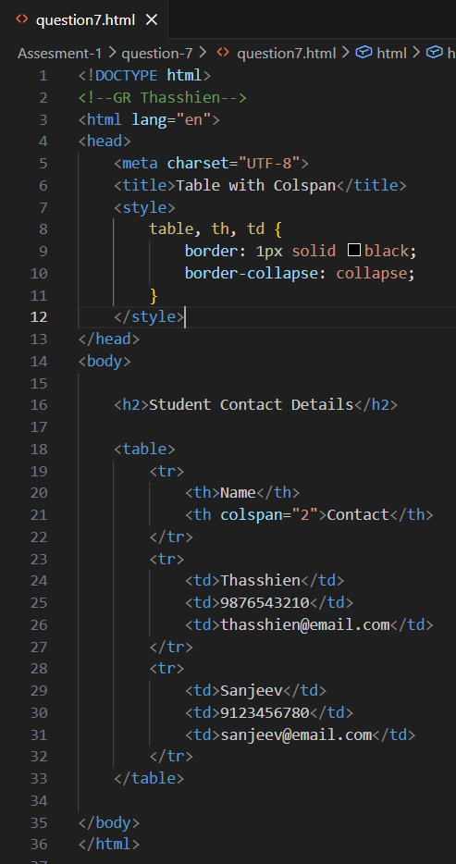
OUTPUT-
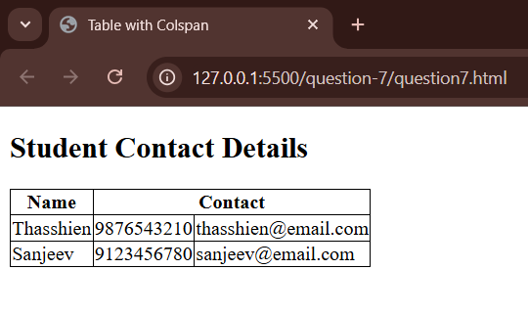

- Image with alt text and caption
  - Add an image using <img> with a meaningful alt. Wrap it in <figure> and add <figcaption>. (You can reference a local image filename.)
  - Expected: image with caption displays; alt present for accessibility.
CODE-
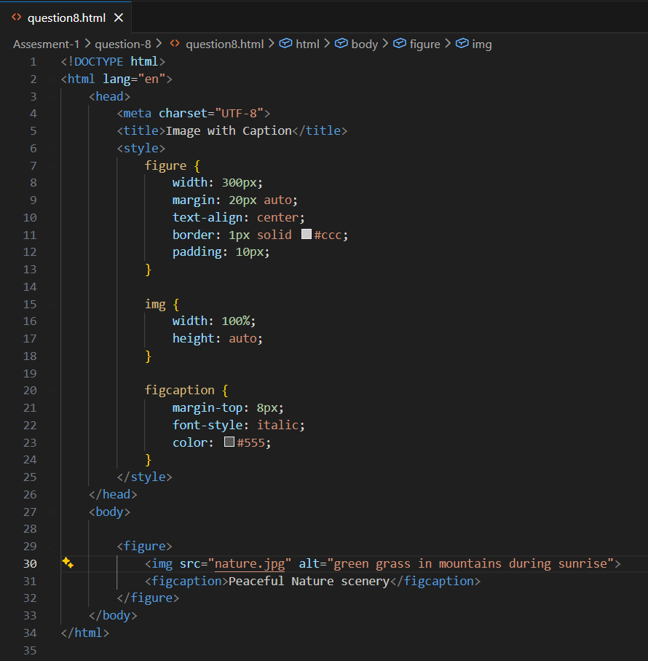
OUTPUT-
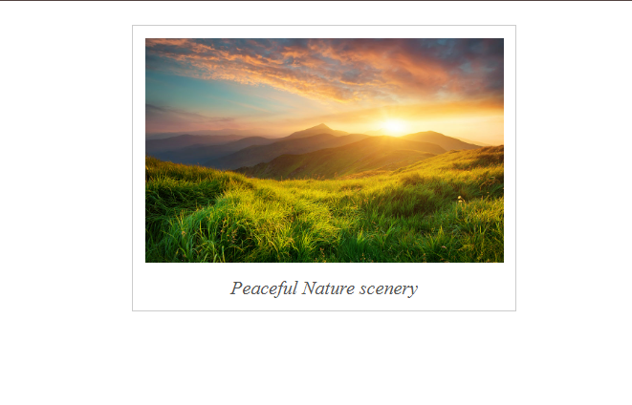
- Build a registration form (fieldset + legend)
  - Create a registration form with a <fieldset> and <legend> titled "User Information". Include: Full Name (text), Email (type="email"), Password (type="password"), Gender (radio buttons), Hobbies (checkboxes), Address (<textarea>), and a Submit button.
  - Use name attributes for inputs and set method="post" action="submit.html".
  - Expected: form collects all fields and submits to submit.html.

CODE-
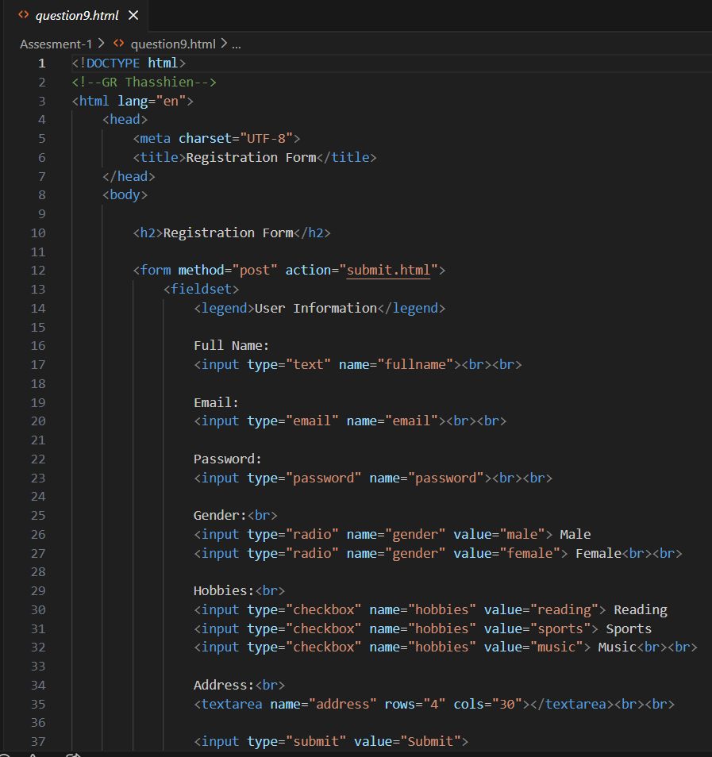
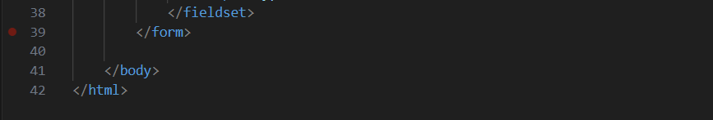
OUTPUT-
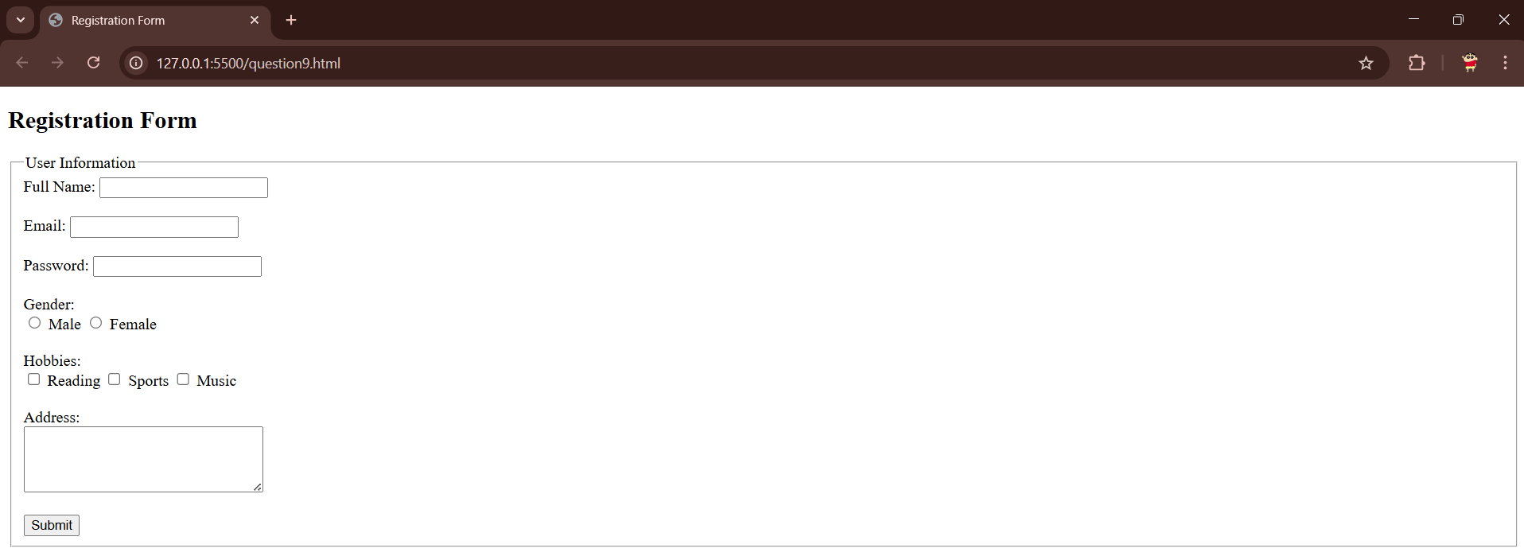

- Demonstrate HTML5 input types & attributes
  - Create a form that uses at least four HTML5 input types: email, date, number, url, tel, or color. Include autocomplete="on" on the <form>.
  - Expected: each control displays the HTML5-specific picker/validation in supporting browsers.
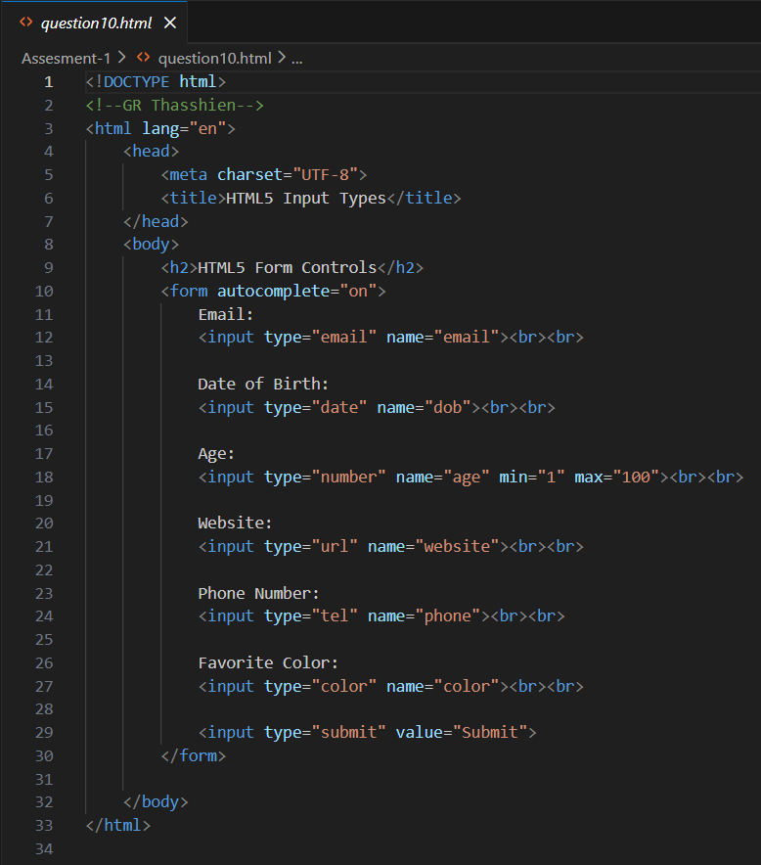
OUTPUT-
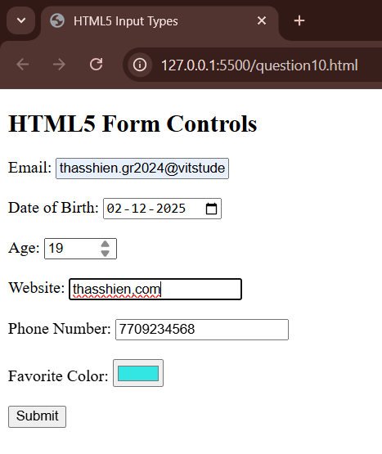
- Create a contact table with cell padding and spacing
  - Make a table of 3 contacts. Use HTML to set padding: 15px; for th, td and border-spacing: 5px for the table.
  - Expected: cells have extra padding and spacing between cells.
CODE-
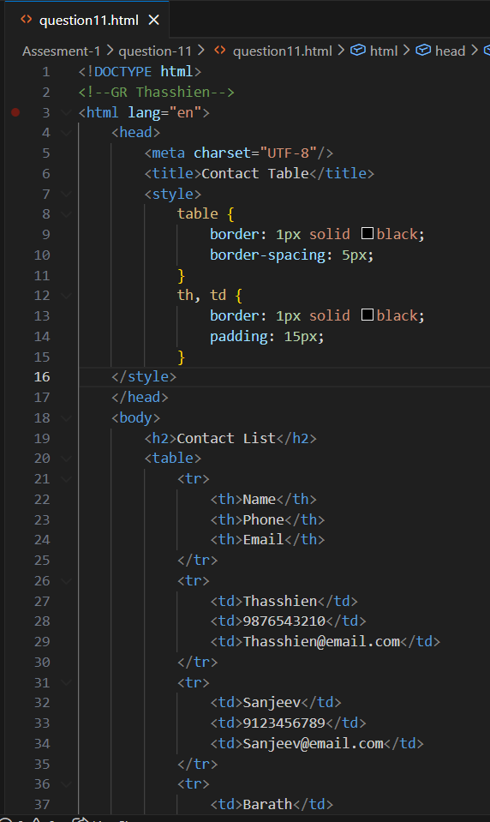
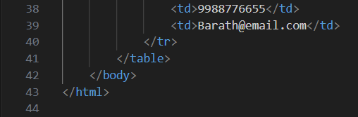
OUTPUT-
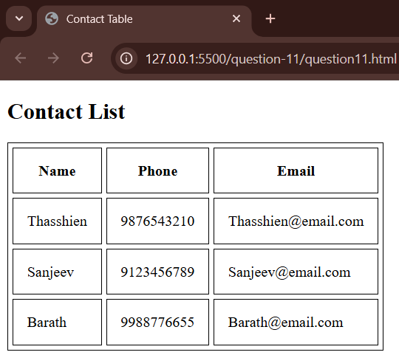

- Use semantic layout: header, nav, section, article, aside, footer
  - Build a one-page semantic layout: a <header> with the site title, a <nav> of links, a main <section> containing one <article> (with a heading and paragraph), an <aside> (short note), and a <footer> with copyright text.
  - Expected: correct semantic elements present and hierarchical structure is clear.
CODE-
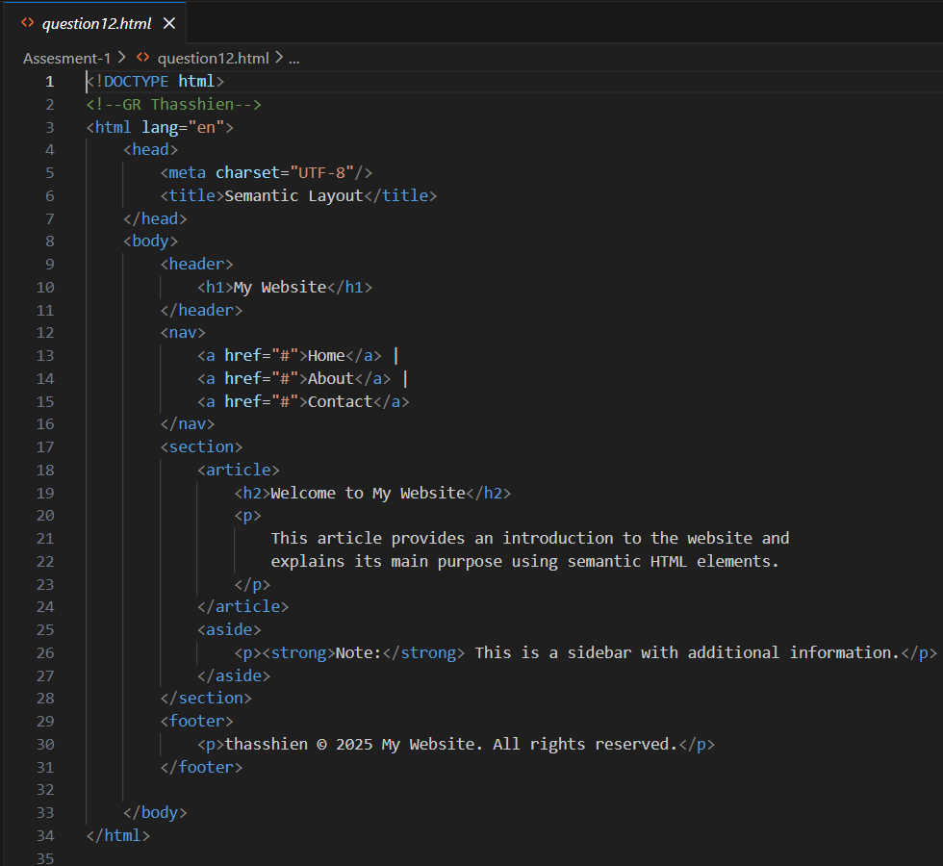
OUTPUT-
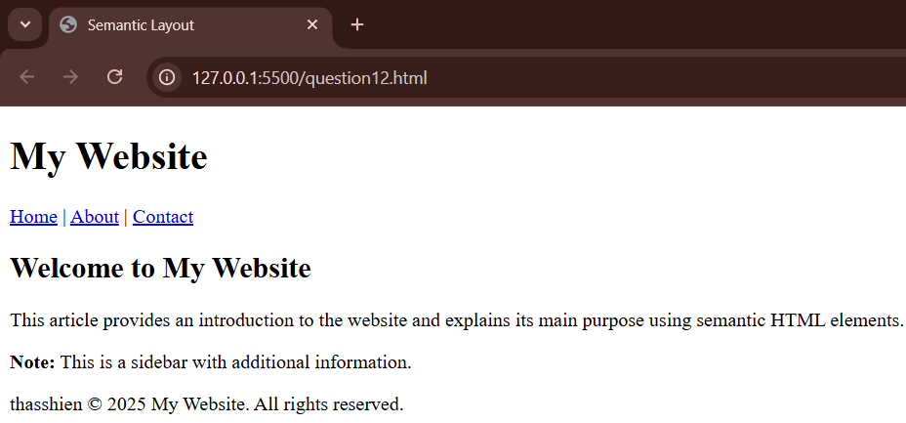

- Character references and special characters
  - Create a short paragraph that includes at least five special characters using character/entity references (e.g., &amp;, &lt;, &gt;, &copy;, &euro;, &#169;).
  - Expected: symbols render correctly (e.g., & displays as &).
CODE-
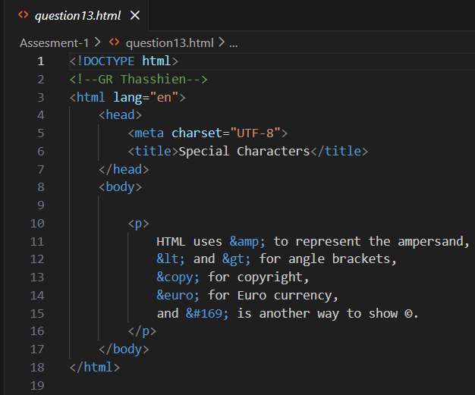
OUTPUT-
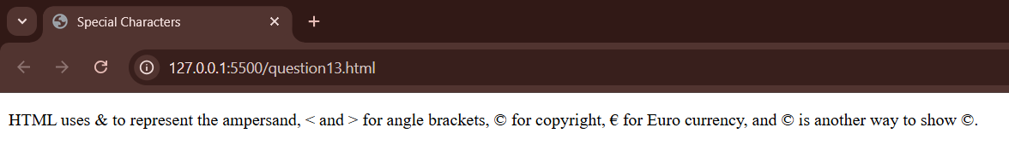

Advanced Level
- Complex form with client-side validation attributes (HTML-only)
  - Build a signup form that enforces constraints using HTML attributes (no JavaScript): required, pattern for a simple password rule, min/max for a number field, minlength/maxlength, and novalidate toggle demonstration. Provide two forms on the same page: one with normal validation, one with novalidate.
  - Expected: browser blocks submission for the validated form when constraints are violated; the novalidate form allows submission regardless.
CODE-
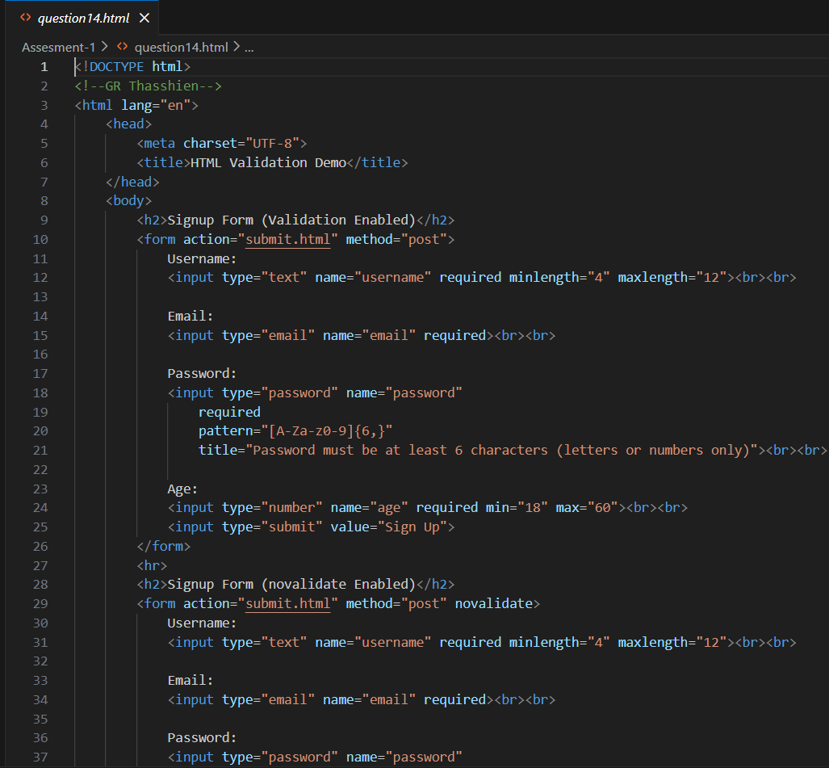
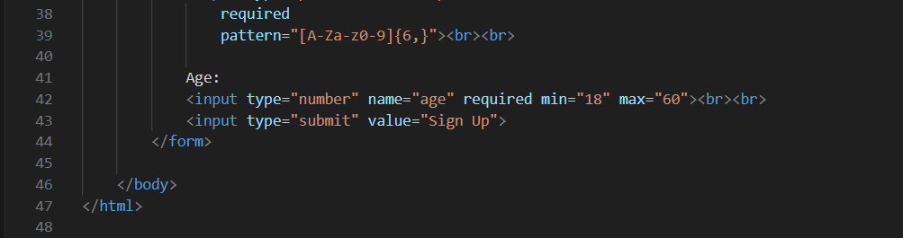
OUTPUT-
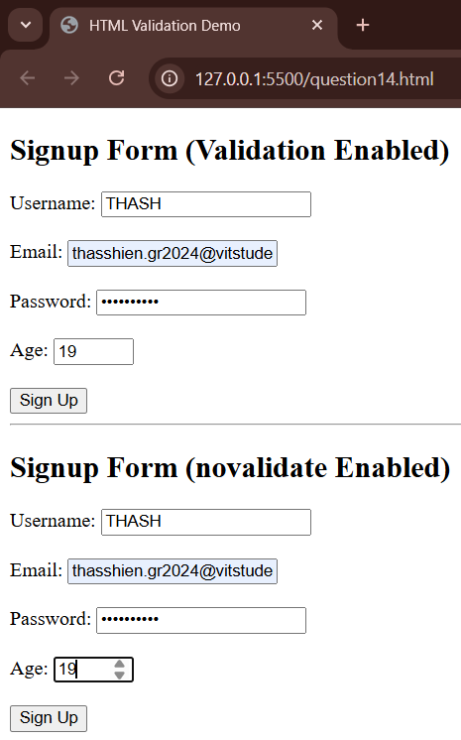

- Interactive quiz (HTML form + radio answers) — submit to results page
  - Create a 5-question multiple-choice quiz using <form> and radio buttons (one correct per question). Form submits to results.html via POST. Include a visible legend and grouping (<fieldset> per question). (No JS required for grading here — instructor may grade manually or use server-side script.)
  - Expected: user can select one choice per question and submit.
CODE-
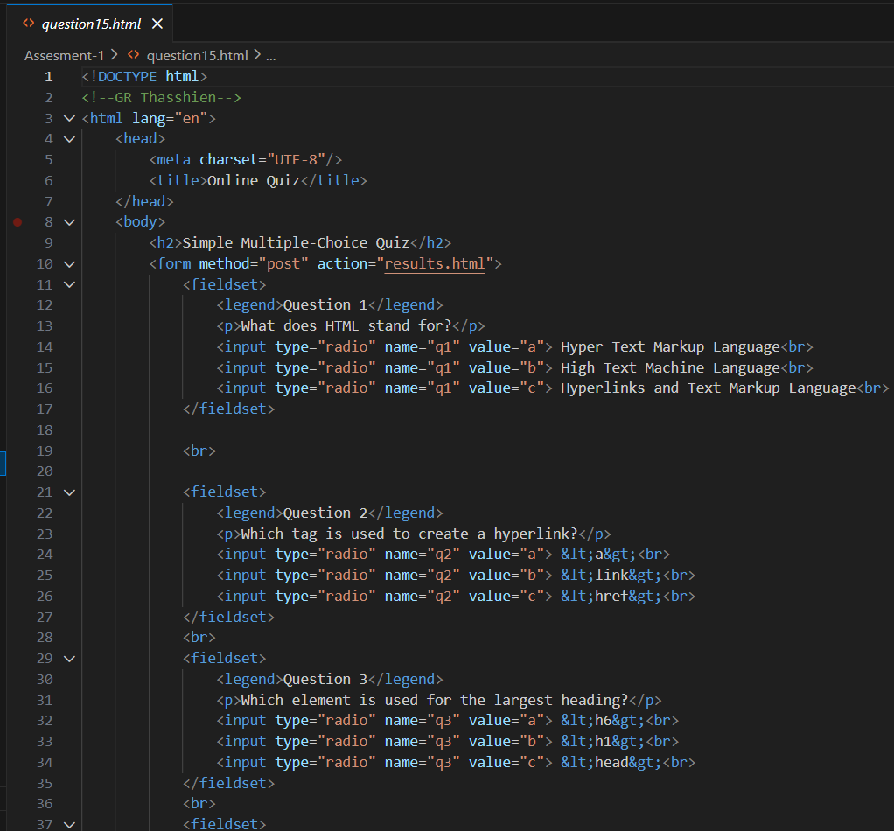
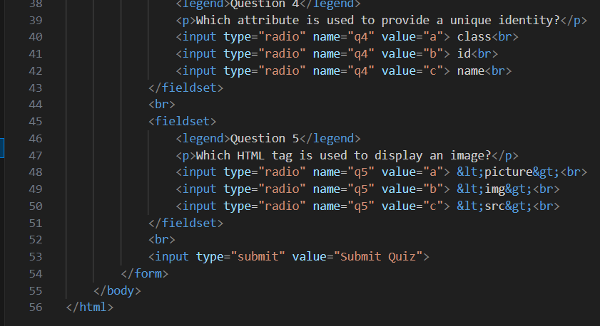
OUTPUT-
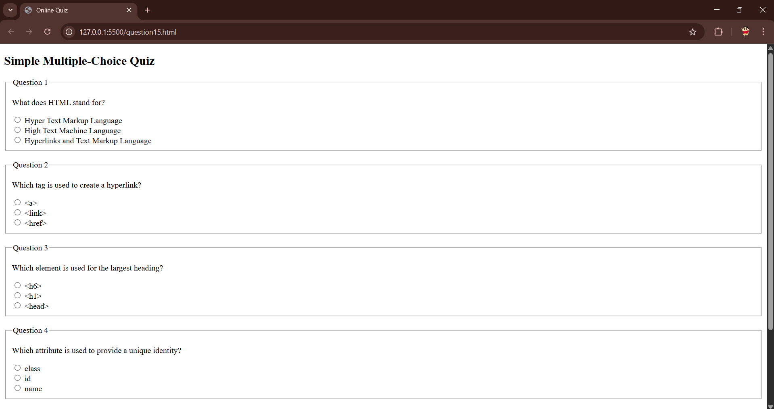
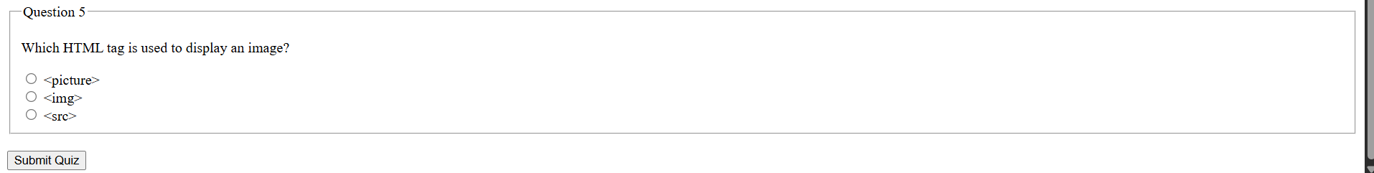

- Accessible image gallery using semantic markup
  - Make a gallery of 4 images using an ordered list or <figure> blocks. Each image must include alt text. Provide keyboard-accessible links to open each image in a new tab (target="_blank" rel="noopener"). Ensure filenames are lowercase and include title attributes.
  - Expected: accessible gallery with proper semantics and safe target="_blank" usage.
CODE-
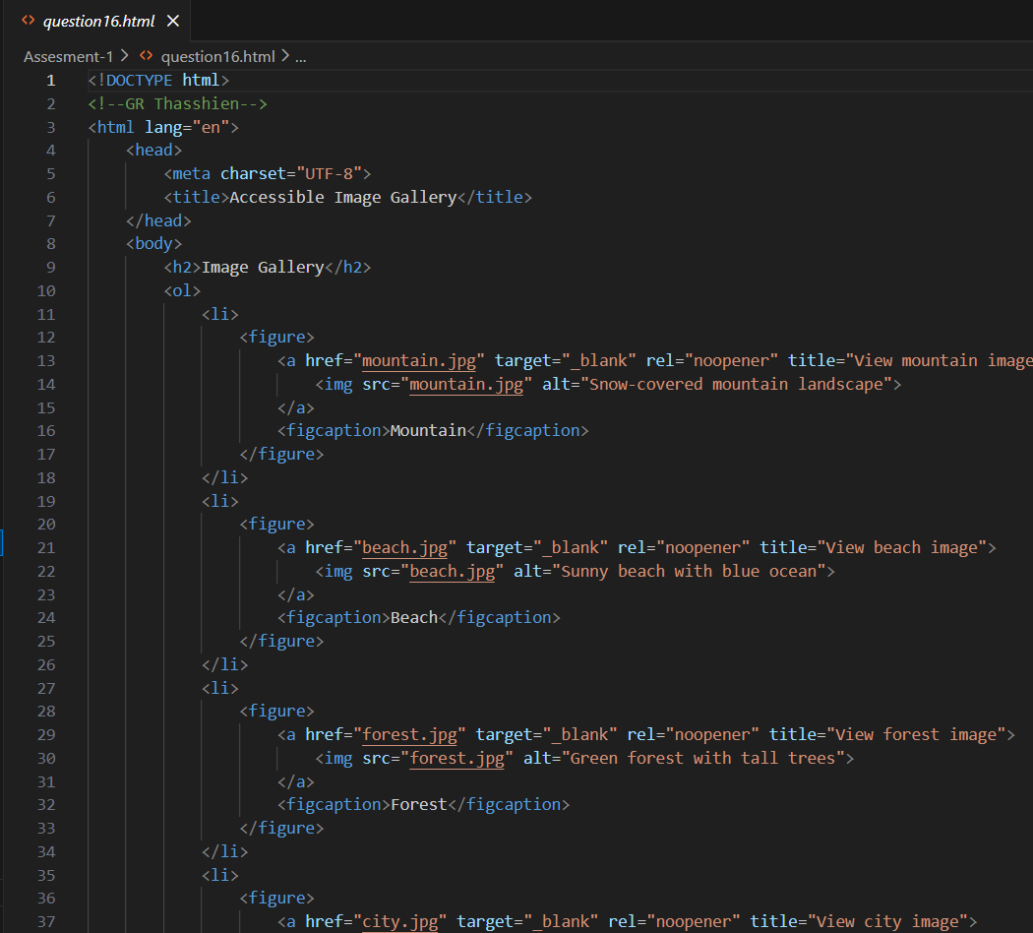
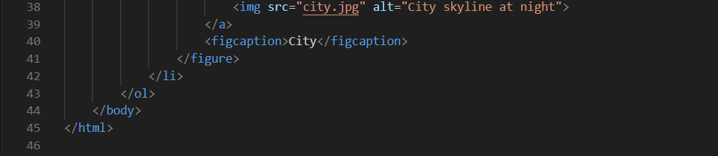
OUTPUT-
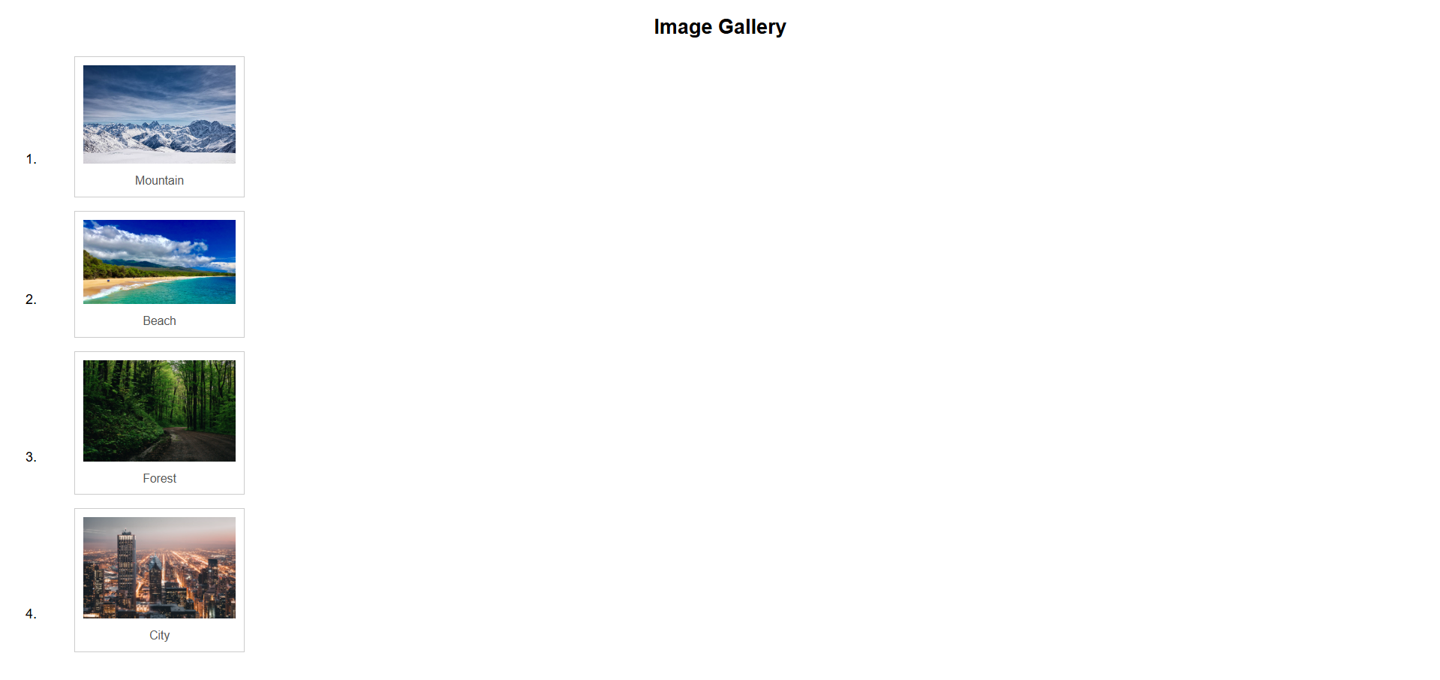

- Build a multi-column pricing table with header rows and footer
  - Create a responsive-like layout using a <table> for a 3-column pricing comparison. Include header (<th>), a body with features, and a footer row with "Buy Now" buttons (these can be plain <button> or <a> links). Use HTML to ensure column headers are visually distinct.
  - Expected: clear comparison table with header, body, and footer rows.
CODE-
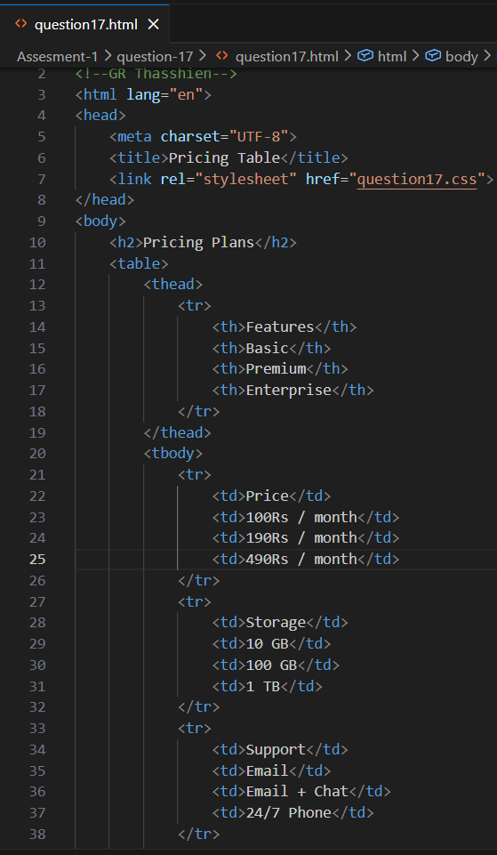
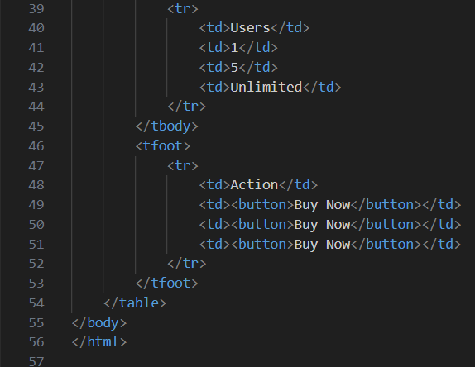
CSS-
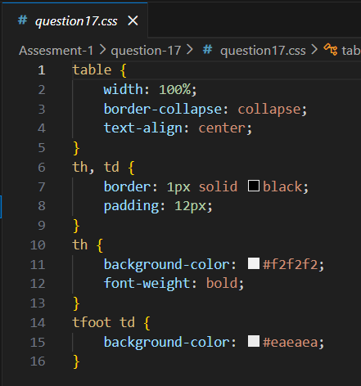
OUTPUT-
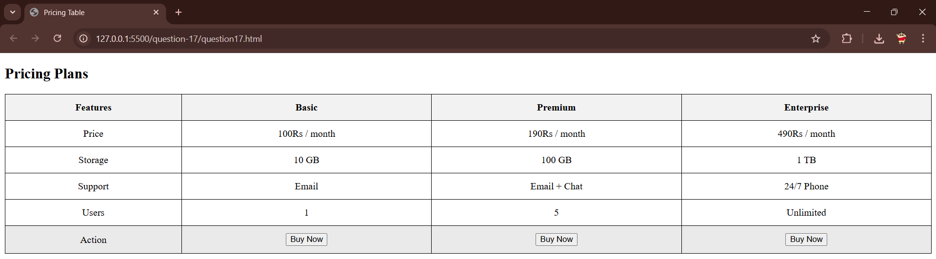

- Complete semantic blog post page with metadata and canonical HTML best-practices
  - Build a full HTML page for a blog post that includes: correct <!DOCTYPE html>, <html lang="en">, <meta charset="utf-8">, <title>, <meta name="description">, a <header> with author and date, an <article> with headings, images with alt, an <aside> for tags, a <nav> for related posts, and a <footer> with contact info. Follow the coding conventions from the lecture (lowercase element names, quoted attributes, close empty tags if XHTML-style, meaningful title).
  - Expected: a semantically correct, well-formed HTML page following the conventions.
CODE-
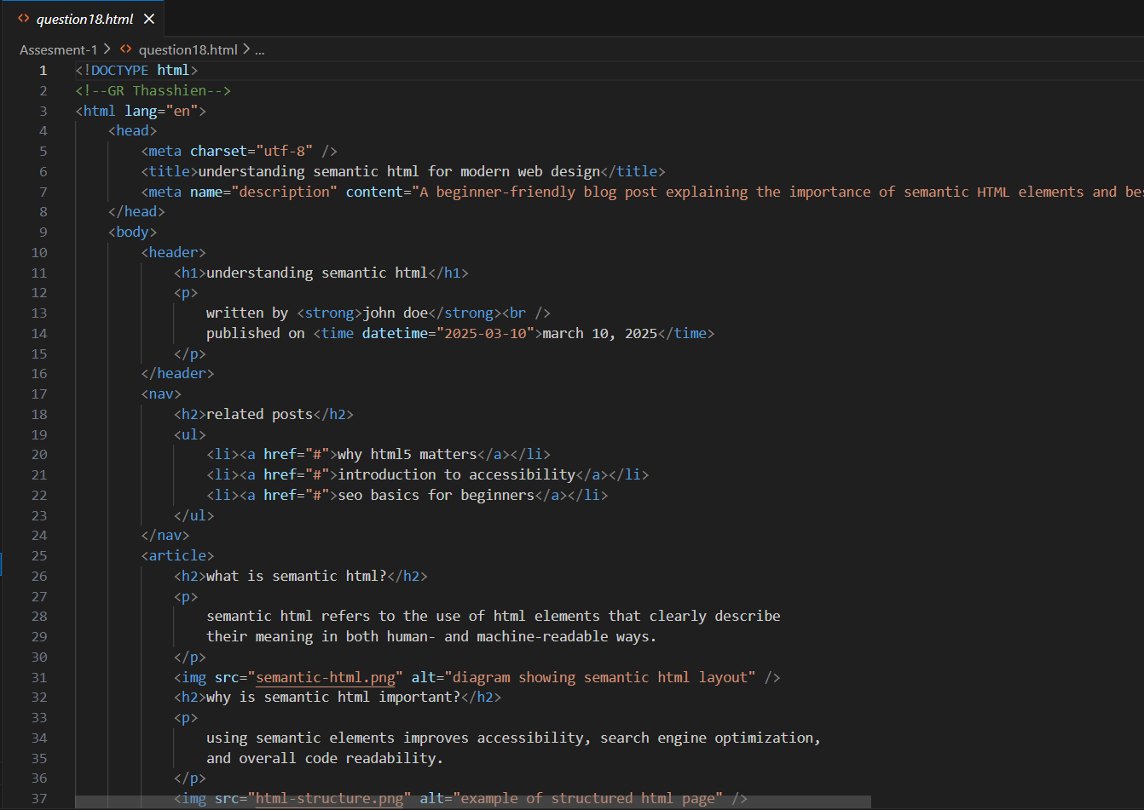
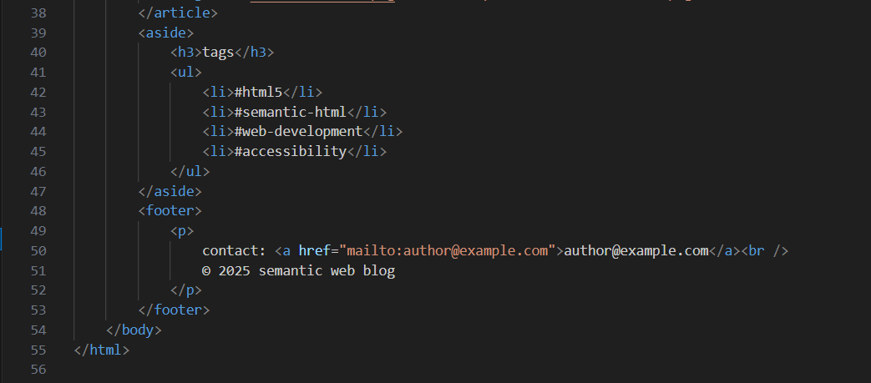
OUTPUT-
