ASSINGMENT-1

SQL-Introduction-Table creation

Name – GR Thasshien
Regno – 24BDS1051

Q1. Create a table Department with the following requirements:
• DeptID – Primary Key
• DeptName – Cannot be NULL
• Location – Should have a default value ‘AB1’
Write the SQL DDL to create the table.

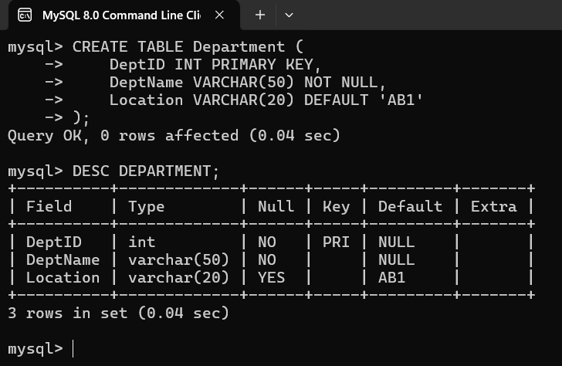

Q2. Create a table Faculty with the following constraints:
FacultyID – Primary Key
FacultyName – Not Null
Email – Unique
Salary – Must be greater than 50000 (use CHECK)
DeptID – Foreign key referencing Department(DeptID)
Designation – Default 'Assistant Professor'

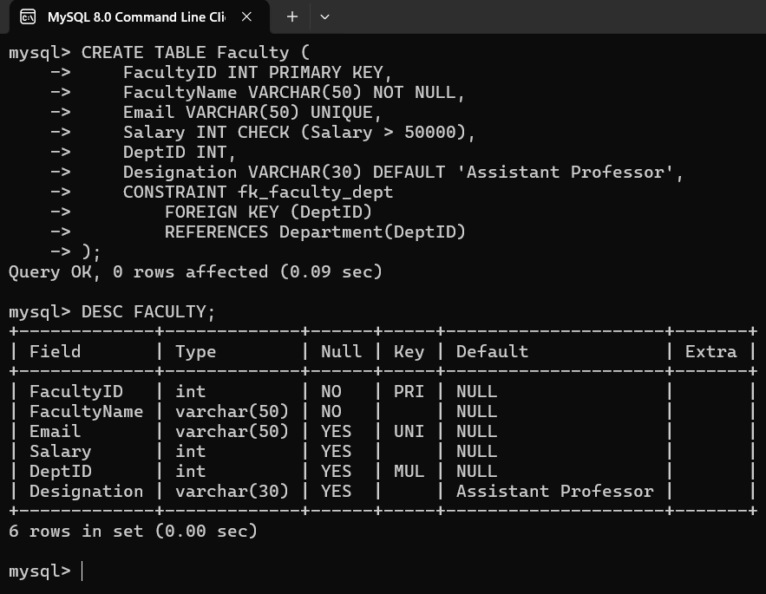

Q3. Create a simple Department table with only column names first.
Then alter the table to add:
• Primary key
• Unique constraint
• Default
• Check condition
(Refer: DeptID, DeptName, Strength must be ≥ 10, Location default 'AB1')

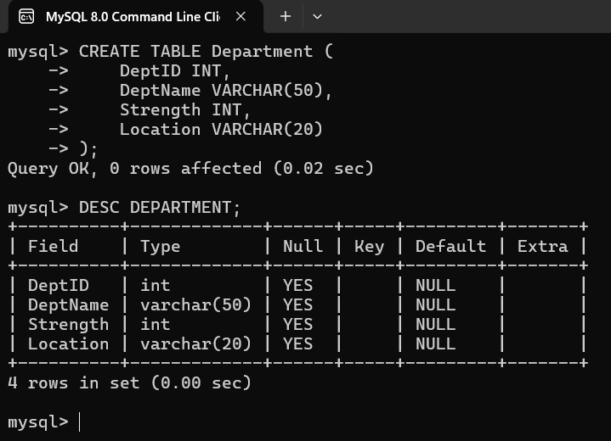
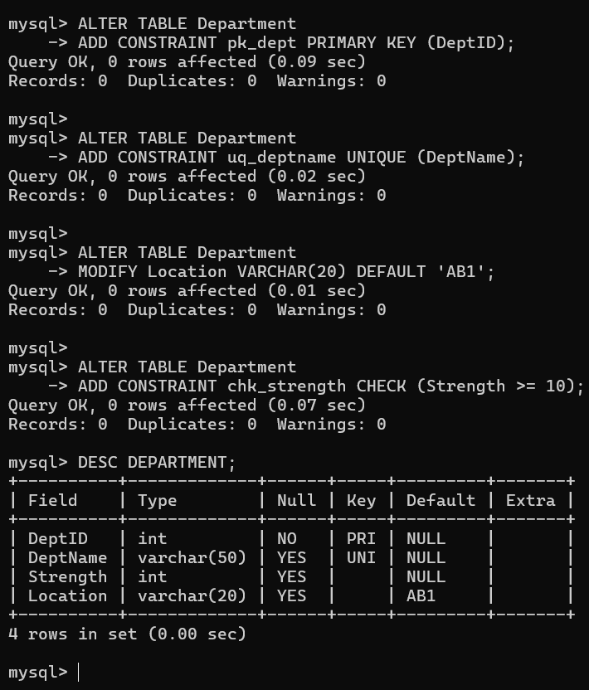

Q4. Create a Faculty table using the following rules:
• FacultyID – Primary Key
• Name – NOT NULL
• Email – UNIQUE
• Gender – Must be either 'M' or 'F' (CHECK constraint)
• Age – Must be between 25 and 70
• DeptID – Foreign Key referencing Department table
• JoiningDate – Default current date

