Lê Minh Thật 21086061
docker –version
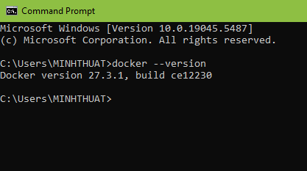
docker run hello-world
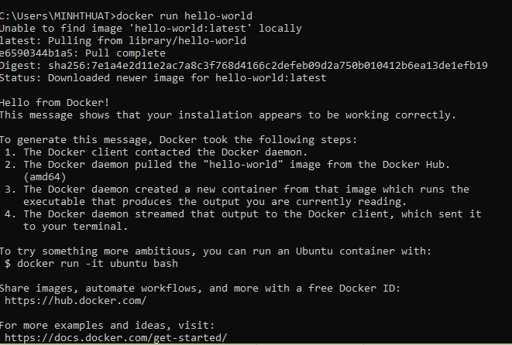
docker pull nginx

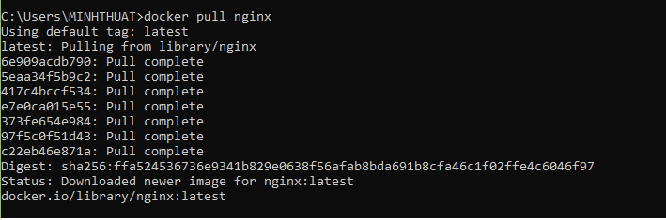
docker images
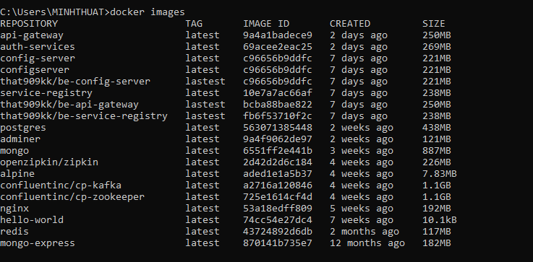
docker run -d nginx
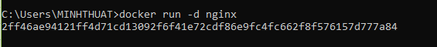
docker ps
docker ps –a
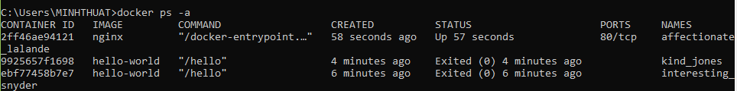
docker logs <container_id>
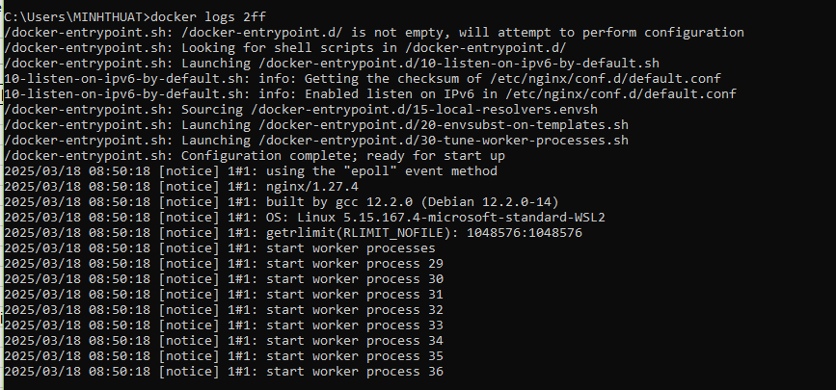
docker exec -it <container_id> /bin/sh
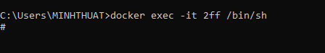
docker stop <container_id>
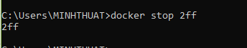
docker restart <container_id>
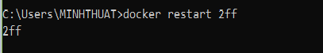
docker rm <container_id>
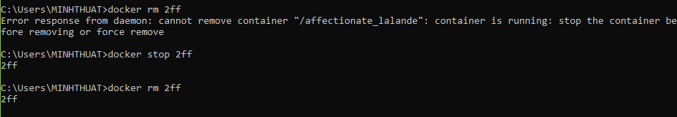
docker container prune
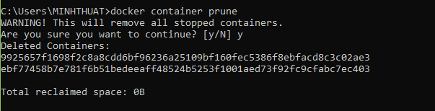
docker rmi <image_id>
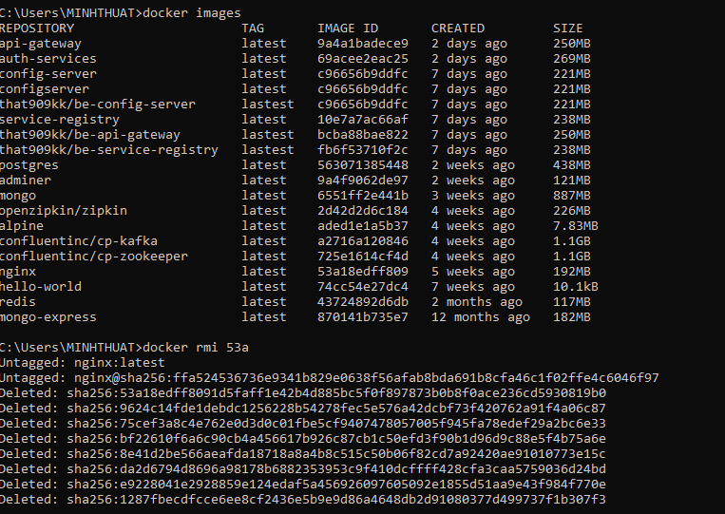
docker image prune –a
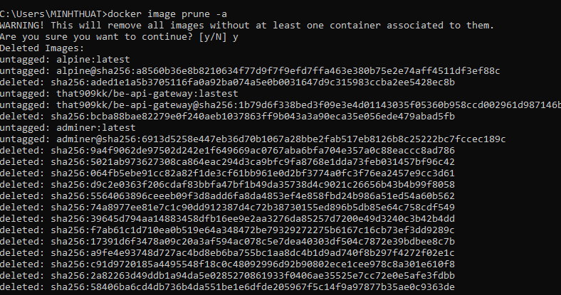
docker run -d -p 8080:80 nginx
docker inspect <container_id>
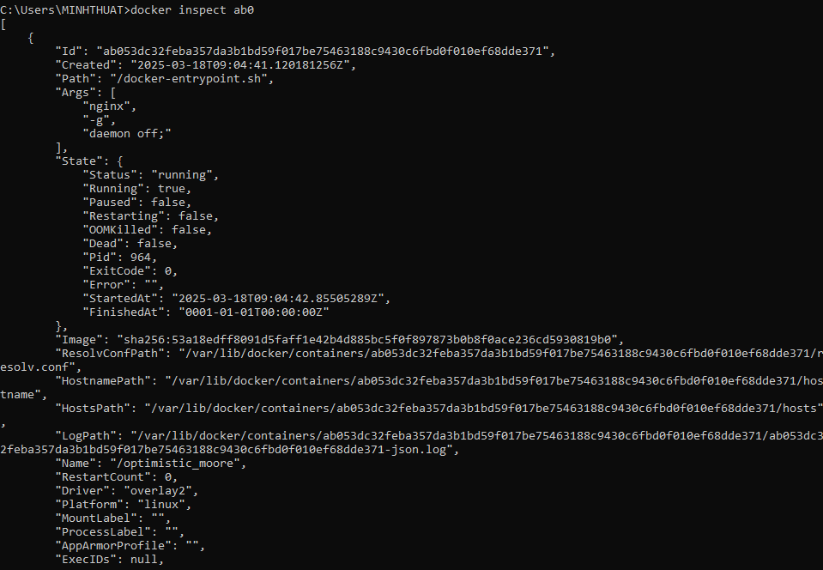
docker run -d -v mydata:/data nginx
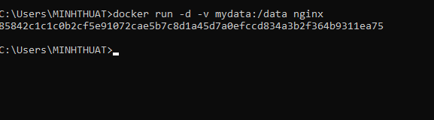
docker volume ls
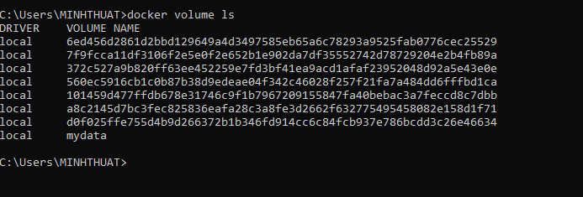
docker volume prune
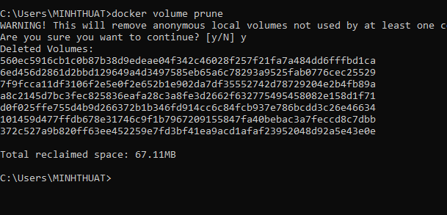
docker run -d --name my_nginx nginx
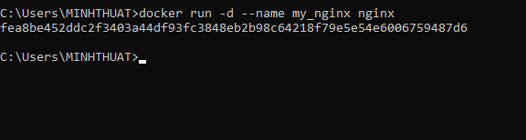
docker stats
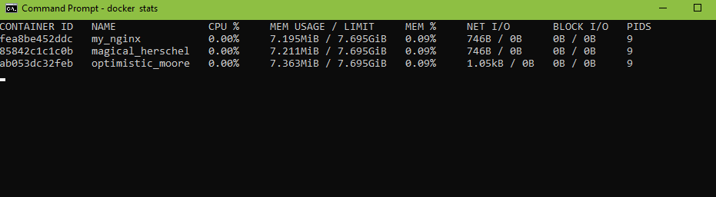
docker network ls
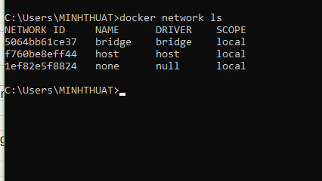
docker network create my_network
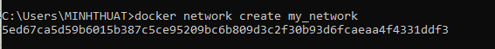
docker run -d --network my_network --name my_container nginx

docker network connect my_network my_nginx
docker run -d -e MY_ENV=hello_world nginx
docker logs -f my_nginx
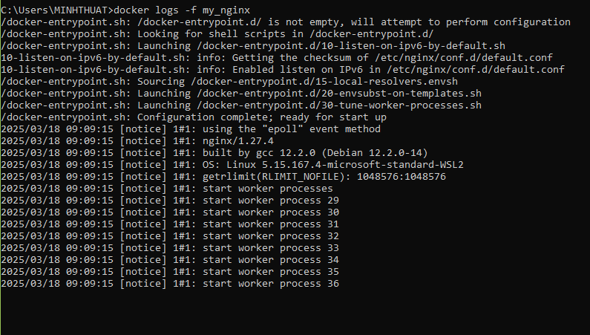
FROM nginx
COPY index.html /usr/share/nginx/html/index.html
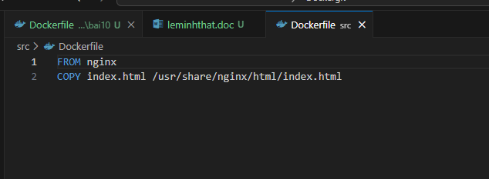
docker build -t my_nginx_image .
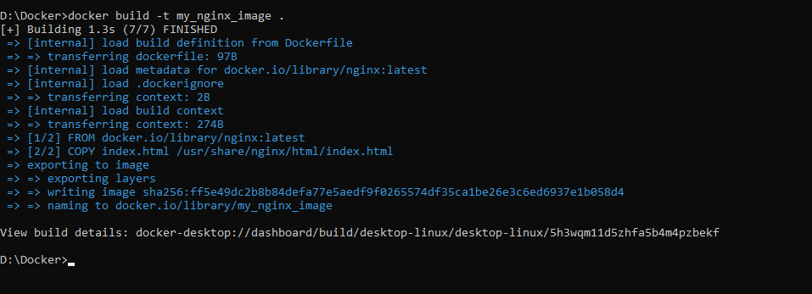
docker run -d -p 8080:80 my_nginx_image
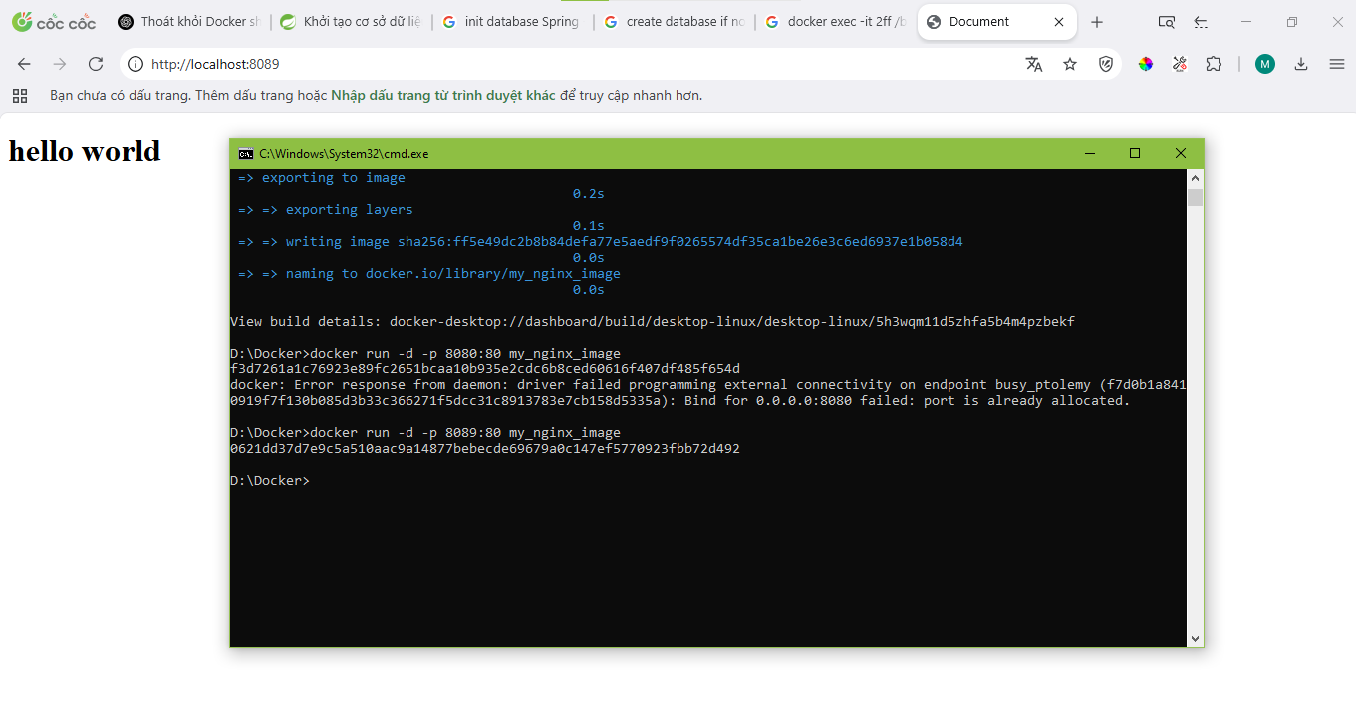
Bài 1:
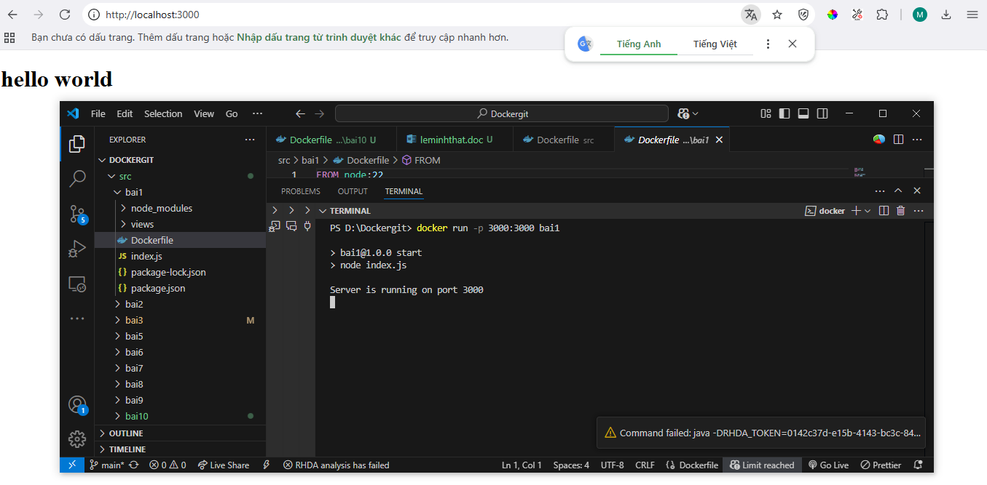
Bài 2:
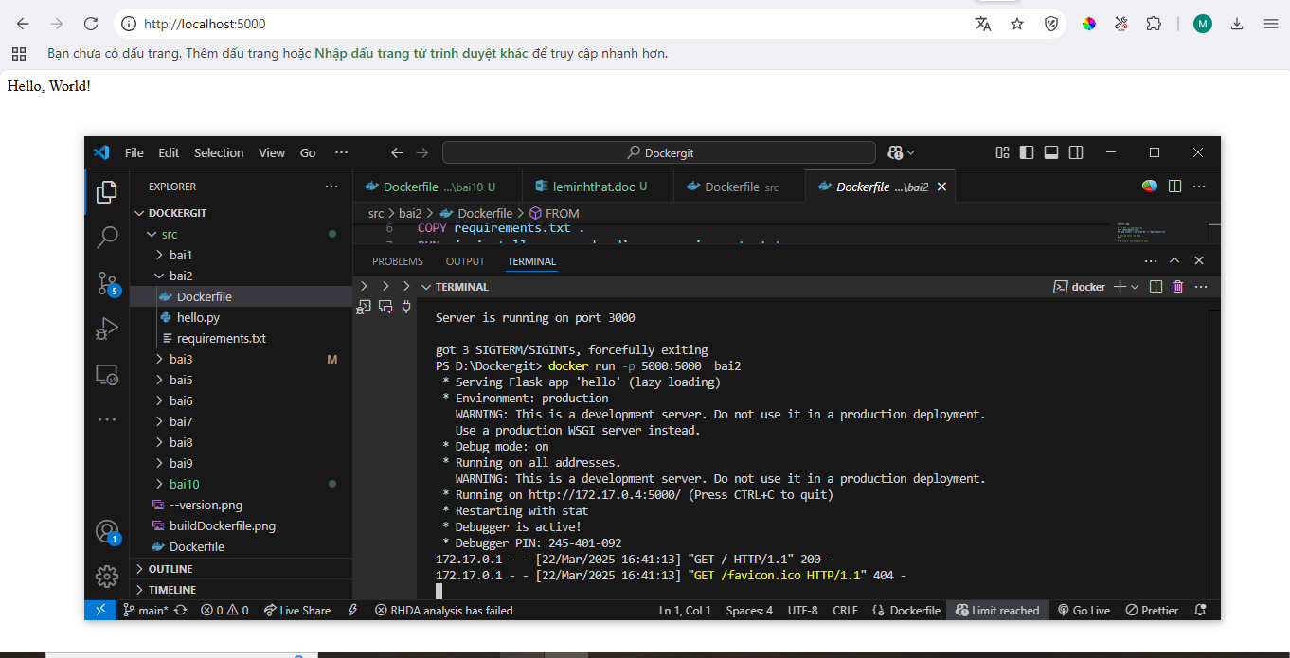
Bài 3:
Bài 4:
Bài 5:
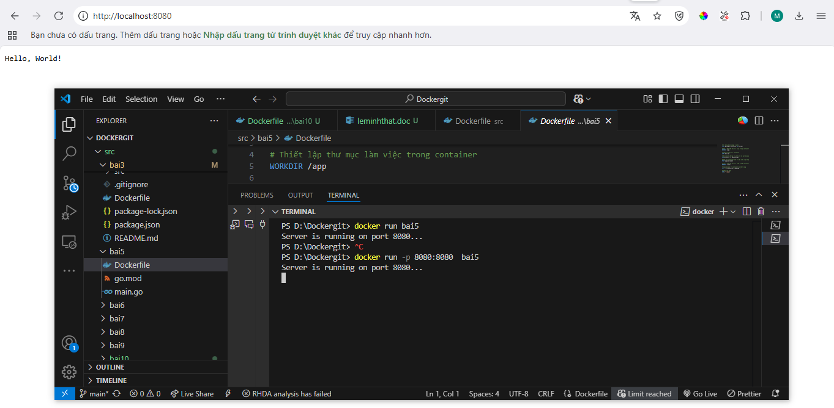
Bài 6:
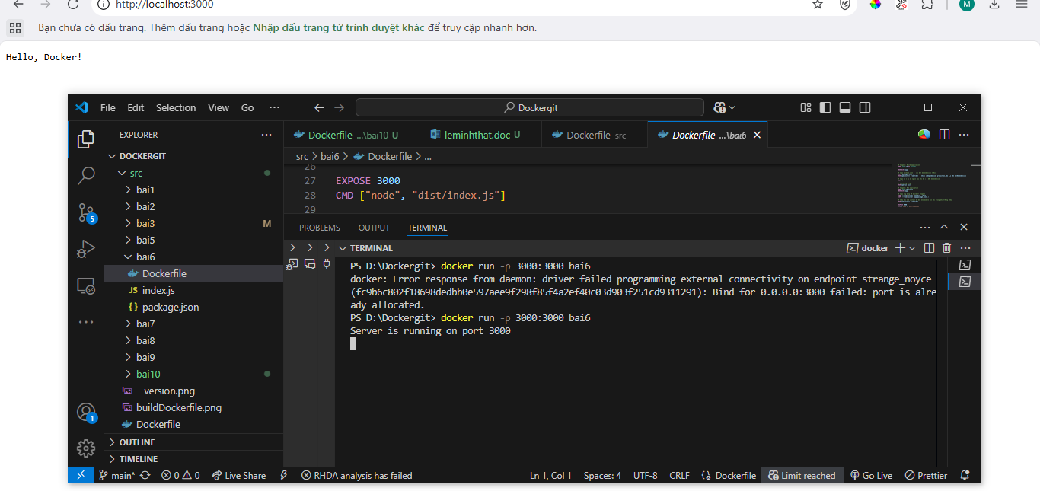
Bài 7:
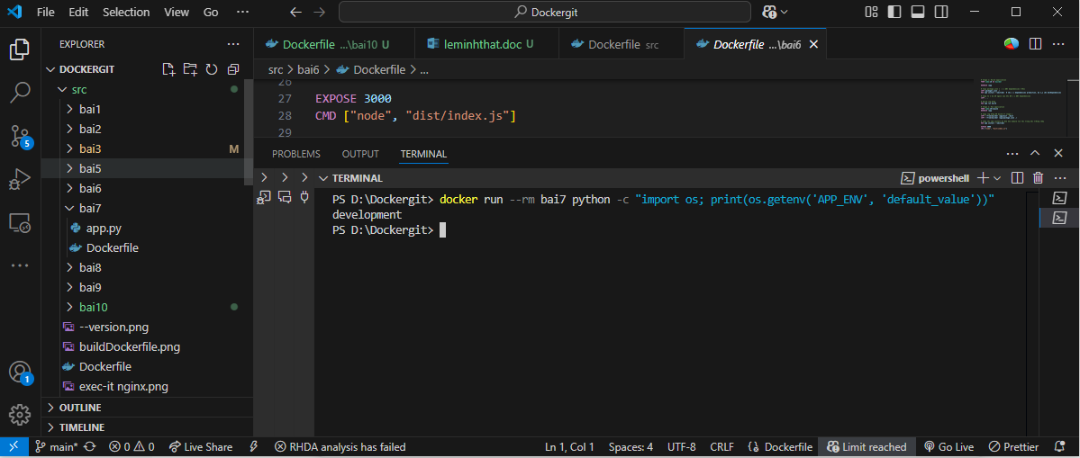
Bài 8:
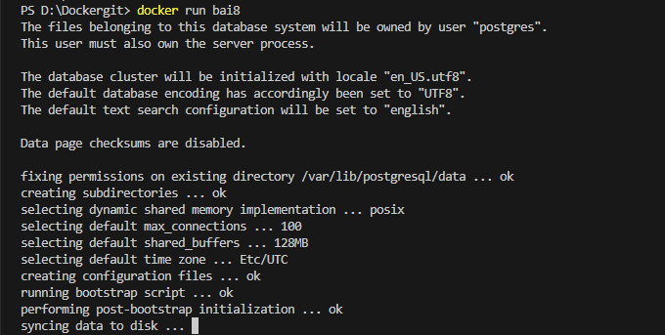
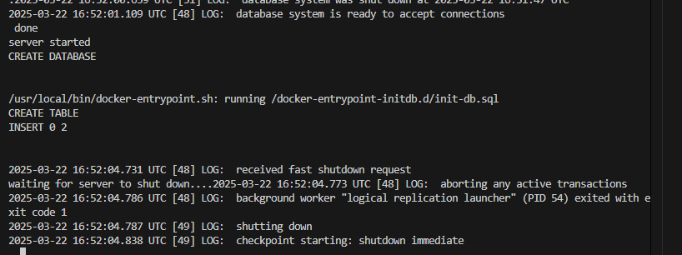
Bài 9:
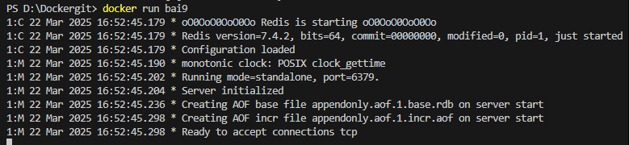
Bài 10:
