Case Study
Project Overview
MM Technologies is a fictional ecommerce storefront created within BigCommerce. This was created as part of a technical assessment with the goal being to configure the store and demonstrate platform knowledge. The following were the criteria given.

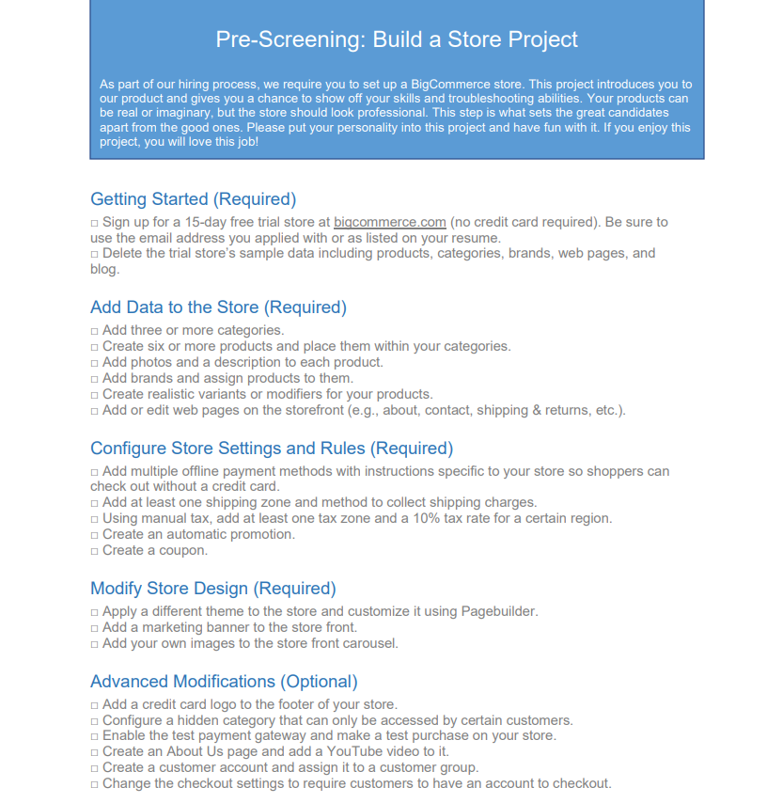
Storefront Build
Within the storefront, I created several categories each with their own products with brands. The website also contains an About page, Contact page, and a Shipping & Returns page. The ability to sign in, add to cart and check out.
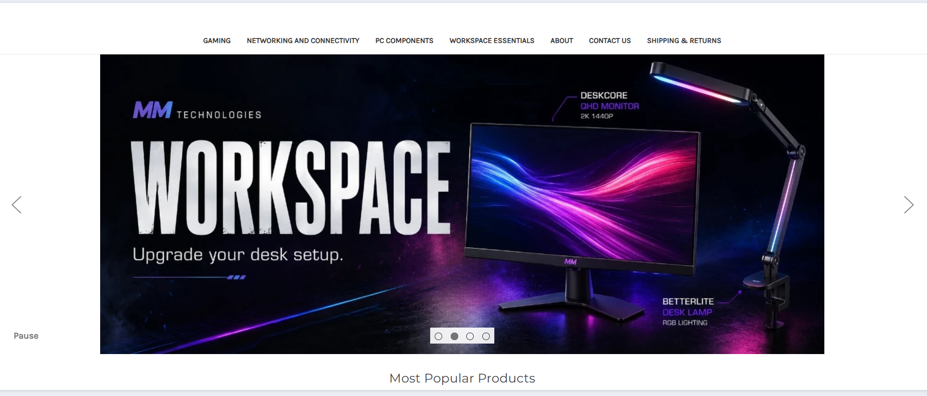
Technical Decisions
When creating this I found that only certain products should have modifiers and variants. I wanted to ensure that there were modifiers for things such as color options for keyboards and mice, and variants for things like RAM and hard drives. I made sure that the products were organized within the correct categories, that the checkout and account settings worked, and I wanted to ensure I made a webpage that was realistic and believable, rather than just a test page. QA testing was very important when I finished and throughout the project to ensure it was up to standard.
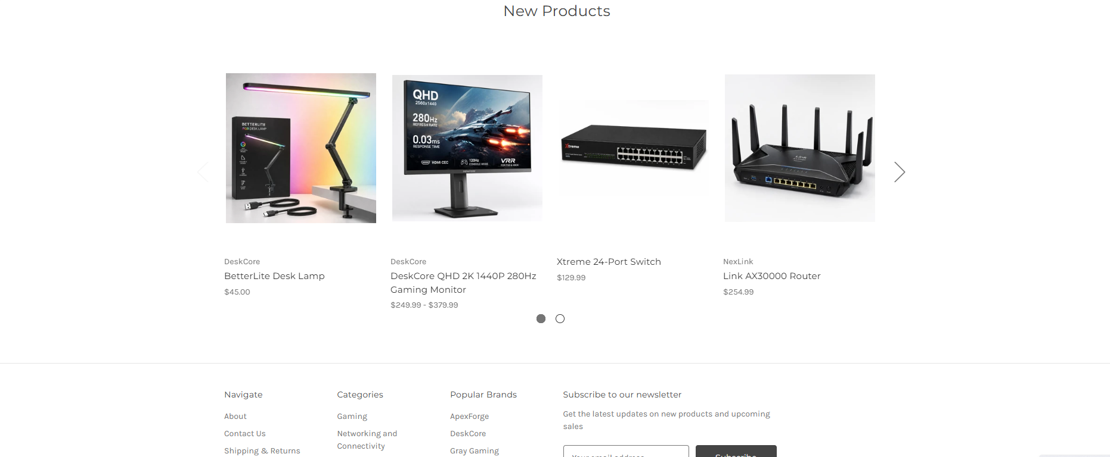
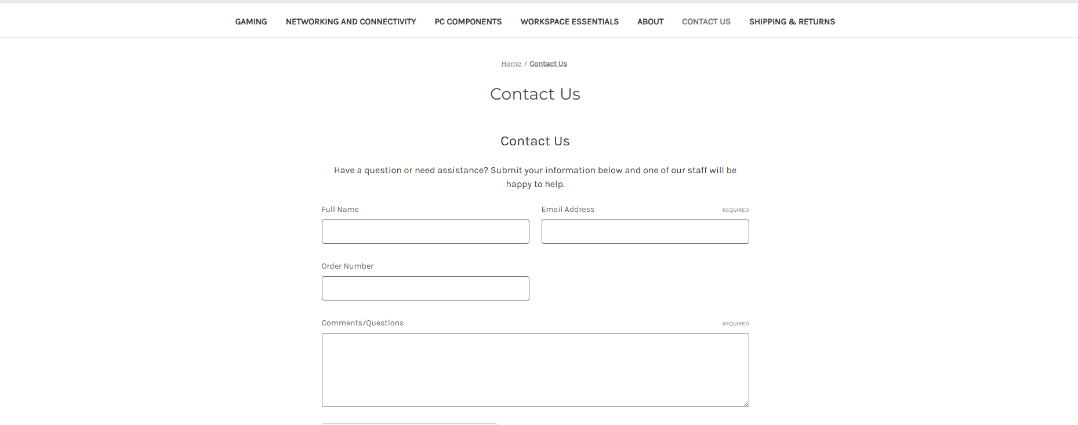

Outcome
The project gave me hands-on experience configuring a complete ecommerce storefront and strengthened my understanding of product organization, customer settings, checkout configuration, promotions, and QA. More importantly, it taught me how to approach an unfamiliar platform, research its features, and build a storefront that functions like a real customer-facing site rather than simply completing a checklist.

