CUSTOMER CHURN PREDICTION
A Machine Learning Approach to Predicting Telecom Customer Attrition
Project Report
submitted in fulfilment of the requirements of the
IBM SkillsBuild Data Analytics with AI
Academic Internship Program
conducted by BharatCares in association with AICTE

Submitted by
Prashant Sharma
October 2026
Repository: github.com/ThatGUY12034/Customer-churn-prediction

Declaration
I, Prashant Sharma, hereby declare that this project report titled “Customer Churn Prediction” is my own work, carried out as part of the IBM SkillsBuild Data Analytics with AI Academic Internship Program, conducted by BharatCares in association with AICTE. The analysis, code, and results presented in this report were developed by me using the publicly available Telco Customer Churn dataset, and all external sources referenced have been duly acknowledged.

Table of Contents
1. Introduction
2. Problem Statement
3. Objectives
4. Dataset Description
5. Tools and Technologies Used
6. Methodology
7. Exploratory Data Analysis
8. Model Building
9. Model Evaluation and Results
10. Feature Importance Analysis
11. Conclusion
12. Future Scope
13. References

1. Introduction
Customer churn — the rate at which customers stop doing business with a company — is one of the most closely watched metrics in subscription-based industries such as telecommunications. Acquiring a new customer typically costs significantly more than retaining an existing one, so the ability to identify at-risk customers before they leave gives a business a direct, measurable way to protect revenue.
This project applies supervised machine learning to historical customer data from a telecom operator to predict which customers are likely to churn. Beyond building a predictive model, the project also investigates which customer attributes are the strongest drivers of churn, so that the findings can inform practical retention strategies.

2. Problem Statement
Given a dataset of customer demographics, account information, subscribed services, and billing details, the task is to build a binary classification model that predicts whether a customer will churn (“Yes”) or stay (“No”). The model should be evaluated not just on overall accuracy but on its ability to correctly identify the minority — and business-critical — churn class, since the dataset is imbalanced (approximately 73% of customers stay and 27% churn).

3. Objectives
- Perform data cleaning and exploratory data analysis (EDA) to understand the factors associated with churn.
- Build and compare multiple classification models for churn prediction.
- Tune the best-performing model to improve predictive performance.
- Evaluate models using metrics appropriate for imbalanced classification (precision, recall, F1-score, ROC-AUC), not accuracy alone.
- Identify the features most strongly associated with churn and translate them into actionable business recommendations.

4. Dataset Description
The project uses the Telco Customer Churn dataset, IBM’s publicly available sample telecom dataset, hosted on Kaggle by user blastchar (https://www.kaggle.com/datasets/blastchar/telco-customer-churn). It contains 7,043 customer records with 21 attributes, summarised below.
Attribute | Description
customerID | Unique customer identifier (dropped before modelling)
gender, SeniorCitizen, Partner, Dependents | Customer demographics
tenure | Number of months the customer has stayed with the company
PhoneService, MultipleLines | Phone service subscription details
InternetService, OnlineSecurity, OnlineBackup,  DeviceProtection, TechSupport, StreamingTV, StreamingMovies | Internet service and add-ons subscribed
Contract, PaperlessBilling, PaymentMethod | Account / billing terms
MonthlyCharges, TotalCharges | Billing amounts
Churn | Target label — whether the customer left within the last month (Yes/No)

Data quality note: the TotalCharges column is stored as text and contains 11 blank values, all belonging to customers with zero tenure (i.e. brand-new accounts not yet billed). These were converted to numeric and median-imputed within the modelling pipeline rather than dropped, to avoid discarding otherwise complete records.

5. Tools and Technologies Used
- Python 3 — programming language
- pandas, NumPy — data loading, cleaning and manipulation
- scikit-learn — preprocessing pipeline, model training, hyperparameter tuning, evaluation
- matplotlib, seaborn — data visualisation
- Jupyter Notebook — interactive development and reporting environment

6. Methodology
The project follows a standard supervised-learning workflow:
- Data cleaning — type correction and missing-value handling for TotalCharges; dropping the non-predictive customerID column.
- Train/test split — 80/20 stratified split on the target, so both sets preserve the 73/27 class ratio.
- Preprocessing pipeline — a scikit-learn ColumnTransformer that median-imputes and standard-scales the three numeric features (tenure, MonthlyCharges, TotalCharges), and most-frequent-imputes plus one-hot-encodes the remaining categorical features. Wrapping this in a Pipeline together with each classifier ensures preprocessing is fit only on training data, preventing data leakage.
- Baseline modelling — five classifiers trained and compared: Logistic Regression, Decision Tree, Random Forest, Gradient Boosting, and an RBF-kernel SVM, all using class_weight="balanced" where supported to counter class imbalance.
- Hyperparameter tuning — 5-fold GridSearchCV on the best baseline model (Gradient Boosting), optimising ROC-AUC over n_estimators, learning_rate and max_depth.
- Evaluation — accuracy, precision, recall, F1-score, ROC-AUC, confusion matrix and ROC curves on the untouched 20% test set.
- Interpretation — feature-importance analysis of the final tuned model.

7. Exploratory Data Analysis
The target class is imbalanced: 73.5% of customers in the dataset stayed with the company (“Retained”) and 26.5% churned. This imbalance motivated the choice of evaluation metrics and the use of class-weighted models throughout.
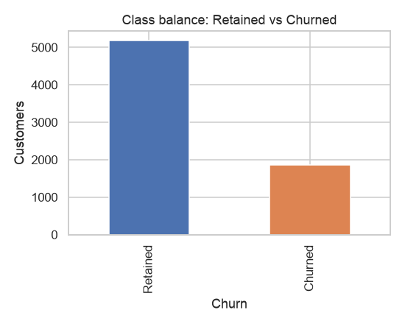
Figure 1. Class balance — retained vs. churned customers.

7.1 Numeric feature distributions
Churned customers are heavily concentrated at low tenure and tend to have higher monthly charges, while long-tenure, lower-total-charge customers rarely churn — consistent with loyalty or contract lock-in effects.
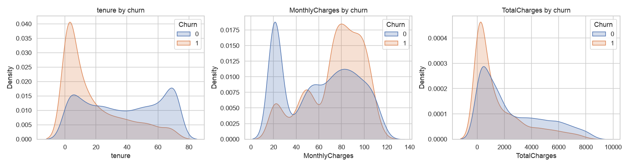
Figure 2. Distribution of tenure, MonthlyCharges and TotalCharges, split by churn.

7.2 Churn rate by contract type and internet service
Two categorical features show especially strong relationships with churn: contract type and internet service. Customers on flexible month-to-month contracts churn far more than those on one- or two-year contracts, since there is no cancellation penalty. Customers with fibre-optic internet also churn more than DSL customers, likely reflecting a mix of price sensitivity and service reliability issues.
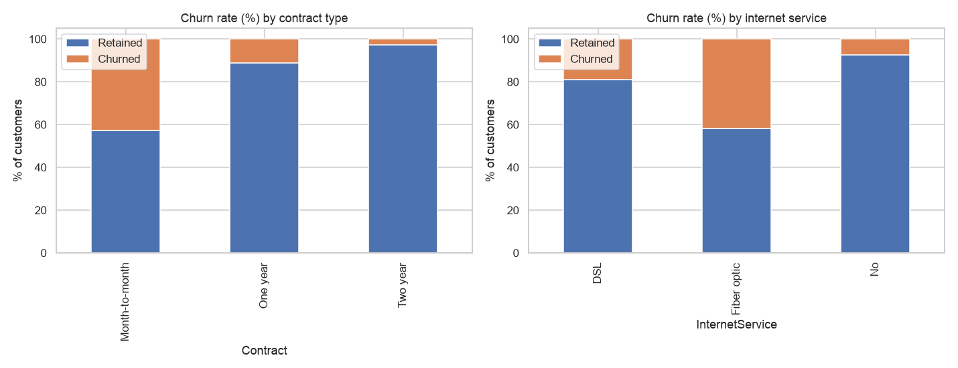
Figure 3. Churn rate (%) by contract type (left) and internet service (right).

7.3 Correlation analysis
Among the numeric features, tenure shows a moderate negative correlation with churn, while MonthlyCharges shows a positive correlation, reinforcing the patterns seen in the distribution plots.
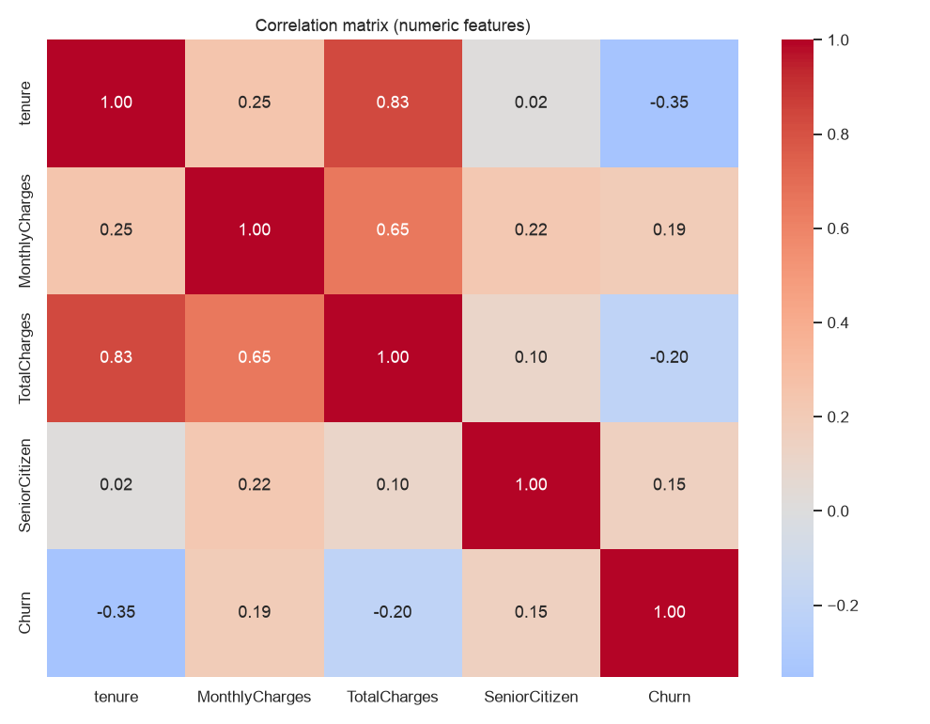
Figure 4. Correlation matrix of numeric features and the churn target.

8. Model Building
Five classifiers were trained through an identical preprocessing pipeline on the same 80/20 stratified train/test split, so results are directly comparable:
- Logistic Regression — a linear baseline, fast to train and easy to interpret.
- Decision Tree — a single interpretable tree, depth-limited to reduce overfitting.
- Random Forest — an ensemble of 300 decision trees.
- Gradient Boosting — a sequential ensemble that fits new trees to the residual errors of previous ones.
- Support Vector Machine (RBF kernel) — a margin-based classifier suited to non-linear boundaries.

9. Model Evaluation and Results

9.1 Baseline comparison
Test-set performance of all five baseline models, ranked by ROC-AUC:
Model | Accuracy | Precision | Recall | F1 | ROC-AUC
Gradient Boosting | 0.806 | 0.674 | 0.524 | 0.589 | 0.843
Logistic Regression | 0.737 | 0.503 | 0.783 | 0.613 | 0.841
Decision Tree | 0.741 | 0.508 | 0.791 | 0.619 | 0.829
SVM (RBF) | 0.745 | 0.513 | 0.773 | 0.617 | 0.821
Random Forest | 0.768 | 0.555 | 0.639 | 0.594 | 0.821

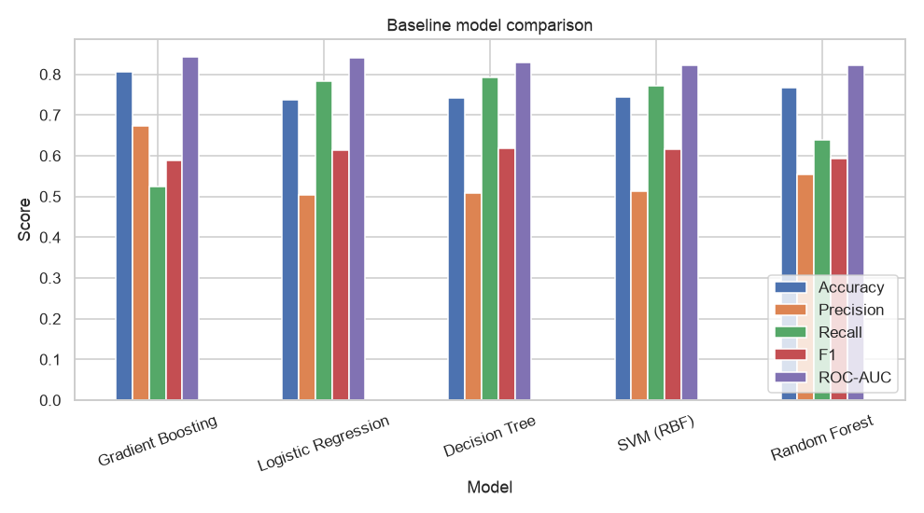
Figure 5. Baseline model comparison across five evaluation metrics.
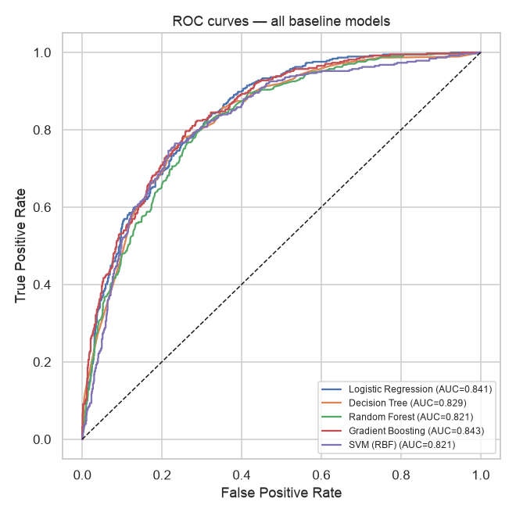
Figure 6. ROC curves for all baseline models.
Gradient Boosting achieved the highest ROC-AUC (0.843) and was carried forward for hyperparameter tuning. Logistic Regression performed nearly as well despite being the simplest model, suggesting the relationship between the features and churn is largely monotonic and well captured even by a linear decision boundary.

9.2 Hyperparameter tuning
A 5-fold grid search over n_estimators ∈ {100, 200}, learning_rate ∈ {0.05, 0.1} and max_depth ∈ {2, 3} was run on the Gradient Boosting pipeline, optimising for ROC-AUC. The best configuration found was n_estimators=200, learning_rate=0.05, max_depth=2, with a cross-validated ROC-AUC of 0.849.
Final performance of the tuned model on the held-out test set (1,409 customers):
Metric | Value
Accuracy | 0.799
Precision (Churn) | 0.661
Recall (Churn) | 0.500
F1-score (Churn) | 0.569
ROC-AUC | 0.846

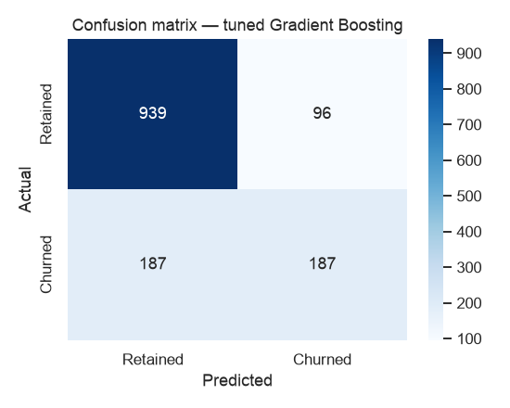
Figure 7. Confusion matrix — tuned Gradient Boosting on the test set.
Of the 374 customers who actually churned in the test set, the model correctly identified 187 (recall = 50.0%), while correctly recognising 939 of the 1,035 customers who stayed (specificity ≈ 90.7%). The precision/recall trade-off reflects the class imbalance and the inherent overlap between churners and non-churners near the decision boundary; a deployment would tune the classification threshold based on the relative cost of a missed churner versus an unnecessary retention offer.

10. Feature Importance Analysis
The tuned Gradient Boosting model's built-in feature importances reveal which factors most influence its churn predictions:
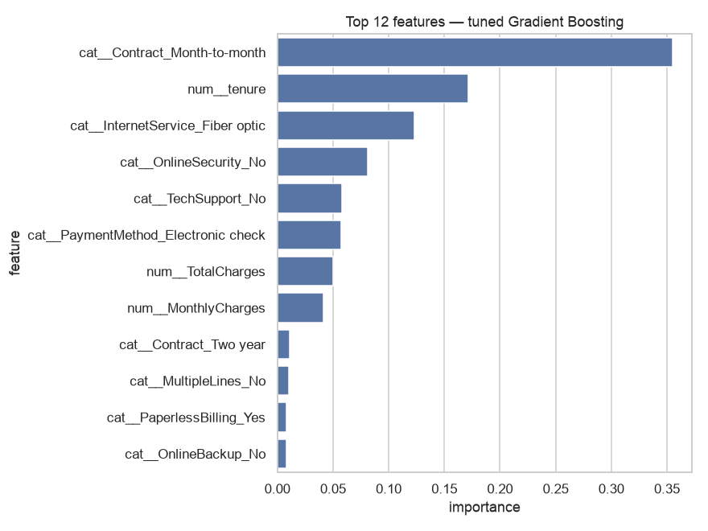
Figure 8. Top 12 features by importance — tuned Gradient Boosting.
- Contract = Month-to-month — by far the strongest predictor of churn.
- Tenure — newer customers are substantially more likely to leave.
- Internet service = Fibre optic — associated with higher churn.
- Absence of an Online Security add-on.
- Absence of a Tech Support add-on.
- Payment method = Electronic check.
These findings align closely with the EDA in Section 7: customers on flexible, no-commitment contracts, without support add-ons, form the highest-risk segment for churn.

11. Conclusion
This project built and compared five machine-learning classifiers for predicting telecom customer churn. A tuned Gradient Boosting model achieved the best overall performance, with ~80% accuracy and a ROC-AUC of approximately 0.85 on unseen data — a clear improvement over a majority-class baseline that would achieve ~73% accuracy while providing no ability to rank customers by churn risk.
Based on the model's feature importances and the exploratory analysis, the following recommendations follow directly from the data:
- Prioritise retention outreach toward new, month-to-month customers, who form the highest-risk segment.
- Promote online security and tech support add-ons, which correlate with lower churn and are a low-cost retention lever to test.
- Incentivise migration from month-to-month to annual contracts, since contract type is the single strongest churn predictor.

12. Future Scope
- Apply resampling techniques such as SMOTE to explicitly balance the training classes and compare against the class-weighting approach used here.
- Use SHAP values to generate per-customer explanations, so retention teams understand why a specific customer was flagged as high-risk.
- Tune the classification threshold against an explicit cost matrix (cost of a missed churner vs. cost of an unnecessary retention offer) rather than using the default 0.5 cutoff.
- Deploy the model behind a simple API or dashboard and retrain periodically as customer behaviour evolves.

13. References
1. Telco Customer Churn dataset — Kaggle. https://www.kaggle.com/datasets/blastchar/telco-customer-churn
2. Pedregosa et al., “Scikit-learn: Machine Learning in Python”, Journal of Machine Learning Research, 2011.
3. IBM SkillsBuild — Data Analytics with AI Academic Internship Program documentation, BharatCares / AICTE.
4. Project notebook: notebook/PrashantSharma_CustomerChurnPrediction.ipynb (this repository).

