**Software Engineering and Testing**

**Lab 5:** Map Class Diagram from Use Case Spec

**Outline:**

The purpose of this lab is to begin a drafted version of the design documentation by starting with the core classes.

That is, the proposal, use cases, requirements specs, feasibility should be used to develop your class diagram (with attributes and methods). It should be shown and mapped to an implemented set of core classes that have been derived from you Use Case specifications.

**Please also ensure that when making your diary entry you have followed the project diary format as outlined in the initial lecture. Template is available on Moodle.**

**Pre-requisites:**

Requirements document (Assignment 2) must be **mostly** completed with appropriate sub-systems determined for the project before this lab can be completed successfully. Please consult your lecturer/project supervisor if you have not yet begun Assignment 2 (Requirements).

**Keywords:** *Daily Scrum Meeting, Sprint, Use Cases, Use Case Specification, Actors, User, System, Client.*

**Tasks:**

**Part (1) Daily Scrum Meeting/Presentation**:

Assign a scrum master to facilitate the 3-minute status presentation and all members should convey the current status of their project to their project supervisor. For example, have you made any changes to your proposal? Prepare the following questions (All members should be prepared to answer):

*What have I done last week to move the project forward?*

*What will I do today and Why?*

*What are any impediments I need to raise?*

**Part (2) Objective of Today’s Sprint:**

The objective of today is

You are asked to justify (***via your upload document for lab 5***) to the major stakeholders how your systems have been verified as correct for the creation of the objects that will comprise your overall project.

Think of the class diagram as diagram of the overall project and the use cases as the individual user systems that will be implemented by means of the class diagram. (Note: Classes are not a one for one mapping to Use Cases)

At the end of this session, each group is asked to show the results of today’s sprint, the primary objective being to **create a usable set of core objects** based on a sound design. Select from your class diagram the core classes that must be created and begin developing these first.

**Sprint Tasks**

1. Map all tasks from

*Proposal 🡪 Major Systems 🡪 Use Case Models 🡪 Class Diagram*

*i.e. Show how you derived all objects, attributes and methods from your Use Cases and Requirements Spec.*

1. Create and implement the core classes in PHP/Pseudo code based on a sound class diagram
2. Demonstrate the implemented artifacts from Sprint Session to stakeholder

**At the end of this session you should present a working, shippable artifact in the form of a correctly designed and implemented class diagram.**

**(a)**

|  |  |  |  |
| --- | --- | --- | --- |
| **System 1**  **Name:** | **Objects Discovered :** | **Attributes Discovered :** | **Methods Discovered :** |
| Usersystem | **User**  **Customer**  **Admin**  **Printer**  **////////**  **Address** | **Email**  **Password**  **fName**  **sName** |  |
| **System 2**  **Name:** | **Objects Discovered :** | **Attributes Discovered :** | **Methods Discovered :** |
| Contentsystem | **Editor**  **Card**  **Gallery** |  |  |

|  |  |  |  |
| --- | --- | --- | --- |
| **System 3**  **Name:** | **Objects Discovered :** | **Attributes Discovered :** | **Methods Discovered :** |
| **Shippingsystem** | **Order**  **Shipment** |  |  |

**(b)**

**Class Diagram (Draft)**

***Core Classes indicated in red - You can paste your own class diagram below***

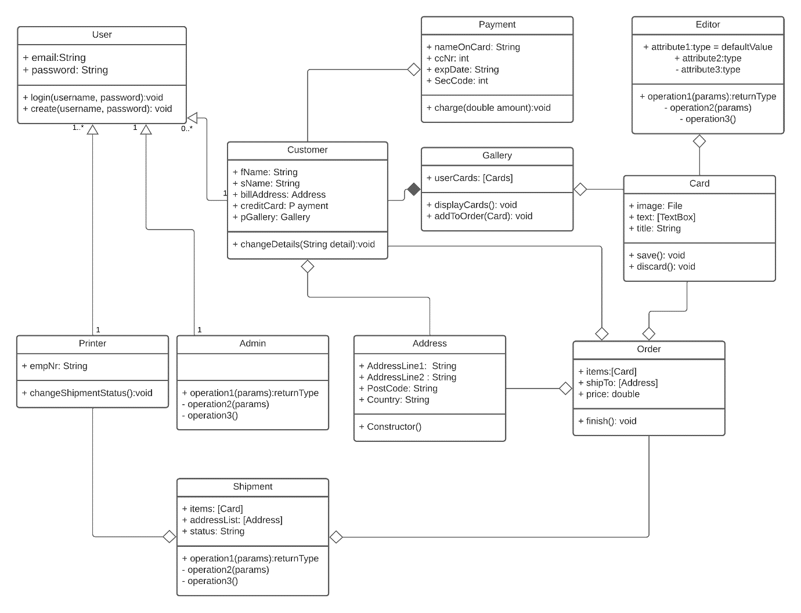

**(c)**

**Code for Implemented Core Classes**

**(PHP / Pseudo code) *You can paste your own code/pseudo code to create your classes below***

**Upload today’s draft on Moodle under Lab 5.**

**NB: UPLOAD PDF FORMAT ONLY**

**(Use Case Diagrams + Use Case Specs)**

Guidelines for completion of Assignment 3 – Design and Implementation - are provided in the brief and template for assignment 3 on Moodle