CSC 2045 Software engineering Week 11 Report

|  |  |  |
| --- | --- | --- |
| Name | Student Number | QUB Email Address |
| Peter Gilfedder | 40204792 | Pgilfedder01@qub.ac.uk |
| Michael McKeown | 40178244 | mmckeown681@qub.ac.uk |
| Aimee Millar | 40173637 | amillar2006@qub.ac.uk |
| Daniel Nelis | 40205171 | Dnelis01@qub.ac.uk |
| Kalvin Johnston | 40206866 | kjohnston44@qub.ac.uk |
| Philip Murphy | 40201928 | Pmurphy708@qub.ac.uk |

Use case Diagram

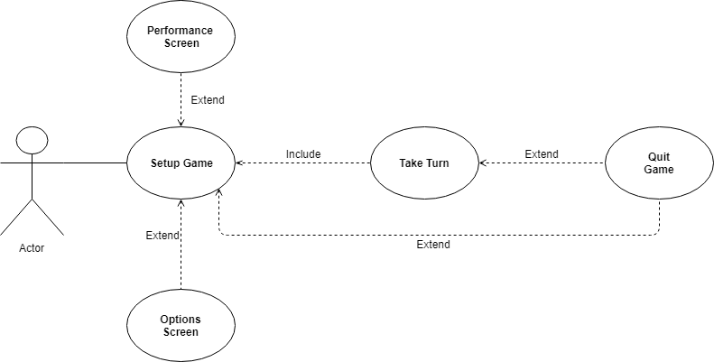

|  |  |
| --- | --- |
| **Flow of Events for the Performance screen use-case** | |
| Objective | To view performance stats |
| Pre-Conditions | Clicking the performance button |
| Main Flow | 1. The user clicks plus to increase rectangle size 2. The user clicks minus to decrease rectangle size |
| Alternative flow | The user clicks return to return to the menu |
| Post Conditions | The rectangles are increased or decreased in size |

|  |  |
| --- | --- |
| **Flow of Events for the Options screen use-case** | |
| Objective | To change settings |
| Pre-Conditions | Clicking the options button |
| Main Flow | 1. Pressing the volume button to mute and unmute |
| Alternative flow | 1a. Back button pressed to return to main menu |
| Post Conditions | Volume is muted or unmuted |

|  |  |
| --- | --- |
| **Flow of Events for the Setup Game use-case** | |
| Objective | To select what to do with the app |
| Pre-Conditions | App started |
| Main Flow | 1. Start game button pressed 2. Players roll dice to decide who goes first 3. Fields are allocated to the players 4. Players place 1 team on every field they own 5. Players take turns to place remaining teams on their fields   <<Take turn Inclusion Point>> |
| Alternative flow | 1a. Options screen button pressed <<Options extension point>>  1b. Performance screen button pressed <<Performance screen Extension point>>  1c. Quit game is selected <<Quit game Extension point>> |
| Post Conditions | Proceed to first dice roll |

|  |  |
| --- | --- |
| **Flow of Events for the Take turn use-case** | |
| Objective | For the player to perform redeployment of teams, attacks and relocation of teams. |
| Pre-Conditions | All fields have 1 team, and all other teams are allocated |
| Main Flow | 1. Player receives new teams based on number of fields owned 2. Player places these teams on any owned field 3. Then the player decides who to attack 4. Player chooses how many teams to attack with 5. Attacking player and Defending player perform dice rolls to attack and defend the chosen field 6. Battle continues until attacker victory or attacker surrender 7. Player decides whether to attack again, until all attacks are complete 8. Player chooses whether or not to relocate a group of teams from on field to an adjacent field 9. If player has taken a field player receives a risk card |
| Alternative flow | 1a. Quit game is selected <<Quit game Extension point>>  1b. Player presses end Turn without attacking, Next player begins take turn  9a. If Player doesn’t take a field, no risk card given  8a. Player may choose to not relocate any teams |
| Post Conditions | Player has had turn and next player goes |

|  |  |
| --- | --- |
| **Flow of Events for the Quit Game use-case** | |
| Objective | To quit the current risk game |
| Pre-Conditions | Player pressed quit |
| Main Flow | 1. Player leaves the game |
| Alternative flow | 1a. Player cancels quit |
| Post Conditions | Game report shows and game ends |

Gannt Charts





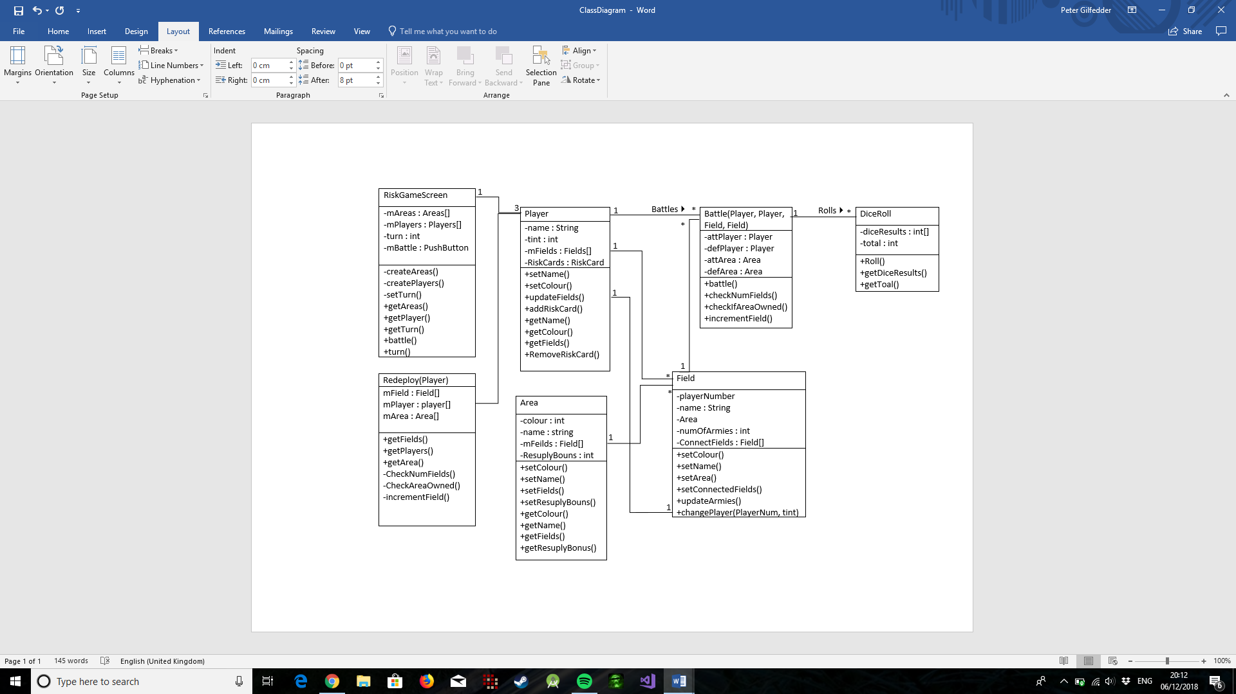Class Relationship Model

# Sequence Diagrams

# Updating Fields

# Deciding the First Turn

# Attacking Areas

Appendix

Team Minutes

# Minutes for Team G51__ Week commencing _ 8/10/18 Date of this minute _8/10/18_

The following team members were present

|  |  |
| --- | --- |
| Name (printed/typed) | Signature |
| Peter Gilfedder |  |
| Aimee Millar |  |
| Daniel Nelis |  |
| Kalvin Johnston |  |
| Michael McKeown |  |
| Philip Murphy |  |

Task Reporting (Briefly list the progress for each team member in the last week.*)

This was the beginning of our first sprint and so there was no work assigned or completed previous to this meeting

Actions Planned (Briefly list the actions required of each team member for the next week.)

Peter Gilfedder:

* User stories 15-19

Aimee Millar

* User stories 1-3 &9

Daniel Nelis

* User stories 12 - 14

Kalvin Johnston

* User story 20 - 22

Michael McKeown

* User stories 23-26

Philip Murphy

* User stories 4-8

# Minutes for Team G51__ Week commencing _22/10/18 Date of this minute _24/10/18

The following team members were present

|  |  |
| --- | --- |
| Name (printed/typed) | Signature |
| Peter Gilfedder |  |
| Aimee Millar |  |
| Daniel Nelis |  |
| Kalvin Johnston |  |
| Michael McKeown |  |
| Philip Murphy |  |

Task Reporting (Briefly list the progress for each team member in the last week.*)

Peter Gilfedder:

* User stories 15-17 completed

Aimee Millar

* User stories 1-2 completed

Daniel Nelis

* User stories 12 – 13 completed

Kalvin Johnston

* User story 22 completed

Michael McKeown

* User stories 23-26 completed

Philip Murphy

* User stories 4-8 completed

Actions Planned (Briefly list the actions required of each team member for the next week.)

Peter Gilfedder:

* Completion of sprint 1 documentation

Aimee Millar

* Working on furthering understanding of android development

Daniel Nelis

* Setting up Git repository

Kalvin Johnston

* Working on furthering understanding of android development

Michael McKeown

* Working on furthering understanding of android development

Philip Murphy

* Working on furthering understanding of android development

# Minutes for Team G51__ Week commencing _ 29/10/18 Date of this minute _29/10/18

The following team members were present

|  |  |
| --- | --- |
| Name (printed/typed) | Signature |
| Peter Gilfedder |  |
| Aimee Millar |  |
| Daniel Nelis |  |
| Kalvin Johnston |  |
| Michael McKeown |  |
| Philip Murphy |  |

Task Reporting (Briefly list the progress for each team member in the last week.*)

Peter Gilfedder:

* Sprint 1 completed and reported
* Git commit completed

Aimee Millar

* Git commit completed

Daniel Nelis

* Git repository made and project stored

Kalvin Johnston

* Git commit completed

Michael McKeown

* Git commit complete

Philip Murphy

* Git commit complete

Actions Planned (Briefly list the actions required of each team member for the next week.)

Peter Gilfedder:

* Pair with Philip Murphy for this sprint
* Splash Screen Stories 1-4

Aimee Millar

* Pair with Daniel Nelis for this sprint
* Options screen user stories

Daniel Nelis

* Pair with Aimee Millar for this sprint
* Options screen user stories

Kalvin Johnston

* Pair with Michael McKeown for this sprint
* Performance screen User stories

Michael McKeown

* Pair with Kalvin Johnston for this sprint
* Performance screen User stories

Philip Murphy

* Pair with Peter Gilfedder for this sprint
* Splash Screen Stories 1-4

# Minutes for Team G51__ Week commencing _12/11/18 Date of this minute _15/11/18

The following team members were present

|  |  |
| --- | --- |
| Name (printed/typed) | Signature |
| Peter Gilfedder |  |
| Aimee Millar |  |
| Daniel Nelis |  |
| Kalvin Johnston |  |
| Michael McKeown |  |
| Philip Murphy |  |

Task Reporting (Briefly list the progress for each team member in the last week.*)

Peter Gilfedder:

* Splash user stories completed

Aimee Millar

* Options user stories 3 & 6 completed

Daniel Nelis

* Options user stories 1&2 completed

Kalvin Johnston

* Performance user stories 1-6 completed

Michael McKeown

* Performance user stories 1-6 completed

Philip Murphy

* Splash user stories completed

Actions Planned (Briefly list the actions required of each team member for the next week.)

Peter Gilfedder:

* Complete Sprint 2 report document
* Final push to GIT

Aimee Millar

* Final push to GIT

Daniel Nelis

* Final push to GIT

Kalvin Johnston

* Final push to GIT

Michael McKeown

* Final push to GIT

Philip Murphy

* Final push to GIT

# Minutes for Team G51__ Week commencing 19/11/18_ Date of this minute __19/11/18

The following team members were present

|  |  |
| --- | --- |
| Name (printed/typed) | Signature |
| Peter Gilfedder |  |
| Aimee Millar |  |
| Daniel Nelis |  |
| Kalvin Johnston |  |
| Michael McKeown |  |
| Philip Murphy |  |

Task Reporting (Briefly list the progress for each team member in the last week.*)

Peter Gilfedder:

* Sprint 2 document completed and Handed in
* Final commits to sprint 2, pushed to GIT

Aimee Millar

* Final commits to sprint 2, pushed to GIT

Daniel Nelis

* Final commits to sprint 2, pushed to GIT

Kalvin Johnston

* Final commits to sprint 2, pushed to GIT

Michael McKeown

* Final commits to sprint 2, pushed to GIT

Philip Murphy

* Final commits to sprint 2, pushed to GIT

Actions Planned (Briefly list the actions required of each team member for the next week.)

Peter Gilfedder:

* Completion of sprint 3 user story to develop the field class
* Completion of week 11 Report document

Aimee Millar

* Completion of sprint 3 user story to develop the Area class
* Completion of week 11 Report document

Daniel Nelis

* Completion of sprint 3 user story to develop the Redeploy class
* Completion of week 11 Report document

Kalvin Johnston

* Completion of sprint 3 user story to develop the Player class
* Completion of week 11 Report document

Michael McKeown

* Completion of sprint 3 user story to develop the Battle class
* Completion of week 11 Report document

Philip Murphy

* Completion of sprint 3 user story to develop the Dice roll class
* Completion of week 11 Report document

# Minutes for Team G51__ Week commencing _26/11/18 Date of this minute __27/11/18

The following team members were present

|  |  |
| --- | --- |
| Name (printed/typed) | Signature |
| Peter Gilfedder |  |
| Aimee Millar |  |
| Daniel Nelis |  |
| Kalvin Johnston |  |
| Michael McKeown |  |
| Philip Murphy |  |

Task Reporting (Briefly list the progress for each team member in the last week.*)

Peter Gilfedder:

* Working on the field class still, first commit pushed to GIT

Aimee Millar

* Area Class completed and pushed to GIT

Daniel Nelis

* Redeploy class first commit pushed

Kalvin Johnston

* Player class completed and pushed

Michael McKeown

* Battle class design complete and first commit pushed

Philip Murphy

* Dice class complete and pushed
* Dice interface in progress

Actions Planned (Briefly list the actions required of each team member for the next week.)

Peter Gilfedder:

* Finish Field class
* Finish report work

Aimee Millar

* Finish report work

Daniel Nelis

* Finish Redeploy class
* Finish report work

Kalvin Johnston

* Finish report work

Michael McKeown

* Finish Battle class
* Finish report work

Philip Murphy

* Finish Dice Implementation
* Finish report work

# Minutes for Team G51__ Week commencing _ 3/12/18 Date of this minute 5/12/18

The following team members were present

|  |  |
| --- | --- |
| Name (printed/typed) | Signature |
| Peter Gilfedder |  |
| Aimee Millar |  |
| Daniel Nelis |  |
| Kalvin Johnston |  |
| Michael McKeown |  |
| Philip Murphy |  |

Task Reporting (Briefly list the progress for each team member in the last week.*)

Peter Gilfedder:

* Field class complete and pushed
* Report documentation complete

Aimee Millar

* Report documentation complete

Daniel Nelis

* Redeploy class complete and pushed
* Report documentation complete

Kalvin Johnston

* Report documentation complete

Michael McKeown

* Battle class complete and pushed
* Report documentation complete

Philip Murphy

* Dice interface complete and pushed
* Report documentation complete

Actions Planned (Briefly list the actions required of each team member for the next week.)

Peter Gilfedder:

* Final Report submission

Aimee Millar

* Continued work on the risk game

Daniel Nelis

* Continued work on the risk game

Kalvin Johnston

* Continued work on the risk game

Michael McKeown

* Continued work on the risk game

Philip Murphy

* Continued work on the risk game