Trey Phillips, Jaden Kandel, Jake Davis

November 28, 2019

CS Database System Management

Project Final – Rival Inventory Management

Description:

This database will be based on the inventory of a drive thru or gas station, which could grow to encompass other markets. It will store all products, with correlating barcodes, distributors, prices, stock, and orders. Customers will be anyone running a business that needs to organize and maintain their product stock. Users will typically be the employees of said stores for transactions, with managers using it to check stock and order new product.

Data Requirements:

Users will, if searching for a product, need to know its availability and price. They will also need a reference code (SKU) to apply the product to a POS (Point of Sale). Checking stock and confirming the size of new orders will be the responsibility of users in higher positions within the business. The database will also record the products by brand and size.

Functional Requirements:

There will need to be a search option as well as a login for standard and managerial employees. Stock will need to increase or decrease based on purchases or orders.

ER Diagram

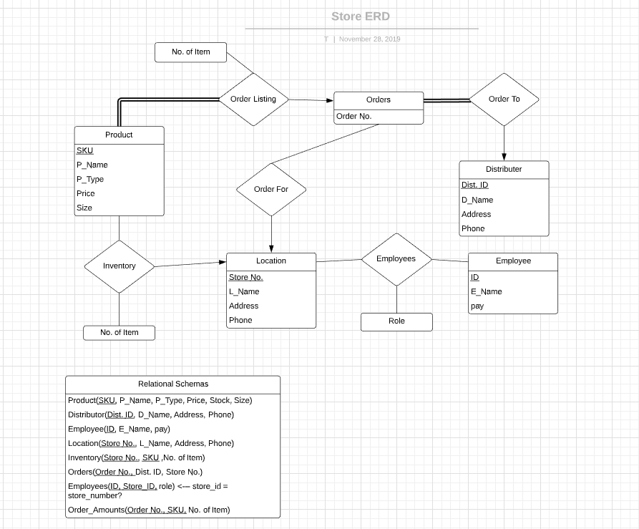

//The boxes show entity sets, the diamonds show relations between entity sets.

Relationships

* Inventory allows the user to know the products details, the stock of said items, and their location should multiple stores be implemented.
* Employees shows employee information, their level of access with Role, and the store they work at.
* Order For gives the order list for the specified location.
* Order Listing shows the products and amount that will be ordered.
* Order To divides the orders based on distributors, so as to be sent to the correct representative.

Physical Schema

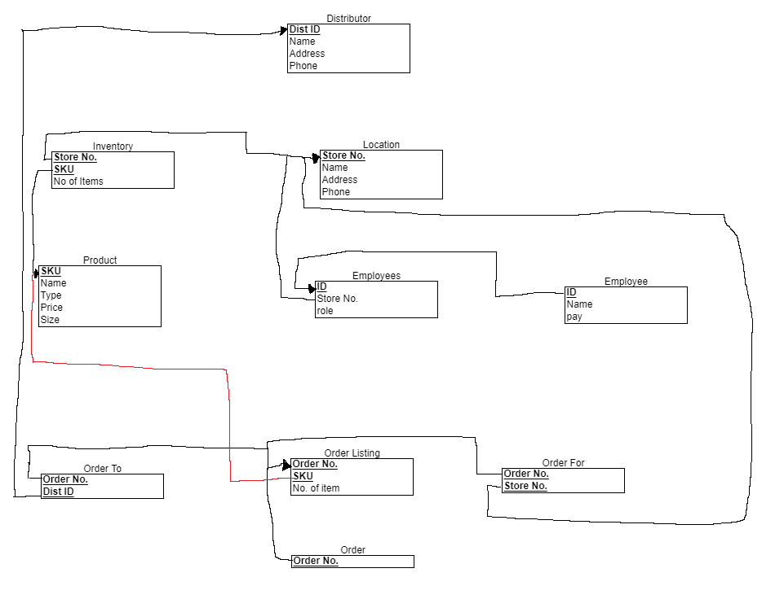

Store No. -> Name, Address, Phone

Dist. ID -> Name, Address, Phone

ID -> Name, pay

SKU -> Name, Type, Price, Size

Store No., SKU -> No. of Item

Order No. -> Store No., Dist. ID

Order No., SKU -> No. of Item

Store No., ID -> Role

BCNF:

Product

Distributor

Employee

Location

Inventory

Employees

3NF:

Product

Distributor

Employee

Location

Inventory

Employees

Not in BCNF:

Order

-OrderNo -> Store No, Dist ID violates BCNF as Order No is not superkey for table

Not in 3NF:

Order

-Order No -> Store No, Dist ID violates 3NF as Order No is not superkey for table and DistID, Store No is a set of non-key attributes

-Gives us tables Order(Order No., Dist. ID, Store No.) and Order_Amounts(Order No., SKU, No. of Item) instead of Order(Order No., SKU, Store No., Dist. ID, No. of Item)