William Te

J162548

TECHNICAL REQUIREMENTS FOR DATABASE APPLICATION

Navy Food Security

technical requirements for database application

UNIT ictsad505

OF

dIPLOMA OF SOFTWARE DEVELOPMENT

name of project

# business requirements

## purpose

This application will be developed with the objective of improving upon the current means of recording information in the process of sending food to the appropriate locations form the previous means of filling out a form in paper. The product will have the ability to save information based on the process of receiving an order, packing an order sending the order, dropping off the order and complete the order. This will include a reader function to allow for quick accessibility to the desired data.

## MODEL OF BUSINESS

This program is situated in the military field for the use of tracking food meals preparation and delivery. The application of this software will be designed around the logistical and food preparation sector communicating the contents of the order to the chefs and towards the needs of the driver to deliver the cargo to its respective location to the recording of information confirming completion of transport.

The primary stakeholder is Australian Defence Force – Royal Australian Navy through the representative Danny. Adrian Gould is the supervisor overseeing the project accompanying Kyana Bowers, Stephen Schrader and myself William Te.

## business requirements

The client for this project requires the application to be able to access a database to create, read, update, delete items. Allow said information to be displayed on an application that matches the parameters of the user e.g., a driver has information pertaining to the location and number of cargoes, while the chef will have the information required to prepare the cargo with the ability to finalise the number of cargoes. Also create orders from the app using a form to be filled with necessary information. These functions are implemented to ensure the fluid observation of food delivery from one location to another with inventory management.

## user INTERFACES

For the end users the important features being implemented will be the ability to scan a QR code and reading the information that QR code is pulling from the database. Following the pulling of information from the databases the next step will be the display of the information in the relevant format based on the role the user is currently acting. If a manager scans the QR code the information shown will be entire list, if a user working in the packer role uses the program it will automatically show all the relevant information to complete the packing process. If a driver role uses the application the information being provided will be the necessary information required to deliver the package.

The details of the API to be communicated will be an identifying id for the entire order, who has placed the order and date, who has packed the order, what the order parcel size is, whether there are any notes required.

# technical REQUIREMENTS

## hardware

The intended system that this application will be running on the Windows 10 platform and it will primarily be running on a web browser the application will be designed on the Chromium architecture however it should be compatible with other web browsers to an extent. In the current stage of this project the needs are a computer tower, monitor keyboard, mouse, scanner, printer. This is to utilize all aspects of the application.

## software

To develop this program, we will be using PhpStorm as the main IDE to develop the front-end solution. The code language being used will be PHP and we will be taking advantage of the Laravel framework to create the GUI as well with the Jetstream component in Laravel. The database will be stored in the MySQL system. We have taken inspiration from parcel logistical to assist in the understanding of the development of the system.

## NETWORK REQUIREMENTS

The application will be used by multiple users to communicate data therefore be tested on the local intranet and based on the results this application would be implemented on a more global network to be expanded onto the total military network needed.

## TECHNOLOGY OPTIONS CONSIDERED

The possible technological implementation determined as a potential input method to read data during the pre-interview stage has been listed.

Bluetooth connections this would be a handshake scenario where one device enters will trigger; however, this was a rejected system as it is not the appropriate for the scope of the project.

NFC chips was also an idea however the concept was not chosen, based on format of daily deliveries this would be a financial deficit due to the need of supplies of the chips.

The technology platform being considered would be the program be deployed on a computer as a standalone station and the users will login to update the status of the order, the program could be installed on a mobile device to be more mobile allowing for the users to control the information wherever they need to do so.

The current platform being developed is a web browser-based system. The next stage would be to develop the platform and allow access to the software using a mobile application. The use of the web-based browser application was a primary choice for to allow usage by the clients on location in a stable environment. The web browser would be a station where all users would sign in and scan the parcel to update the status of the order, once developed into a mobile application the process would become more mobile.

# technical solution

## Proposed solution

To satisfy the needs of this project the final solution that will proposed will begin with a web application development and continuing with a mobile development application, this application will be running off a PHP language environment using the framework Laravel with additional components installed specifically Livewire to support the development of the front-end and controller while we will be taking advantage of using MySQL to manage the database.

## technical specifications

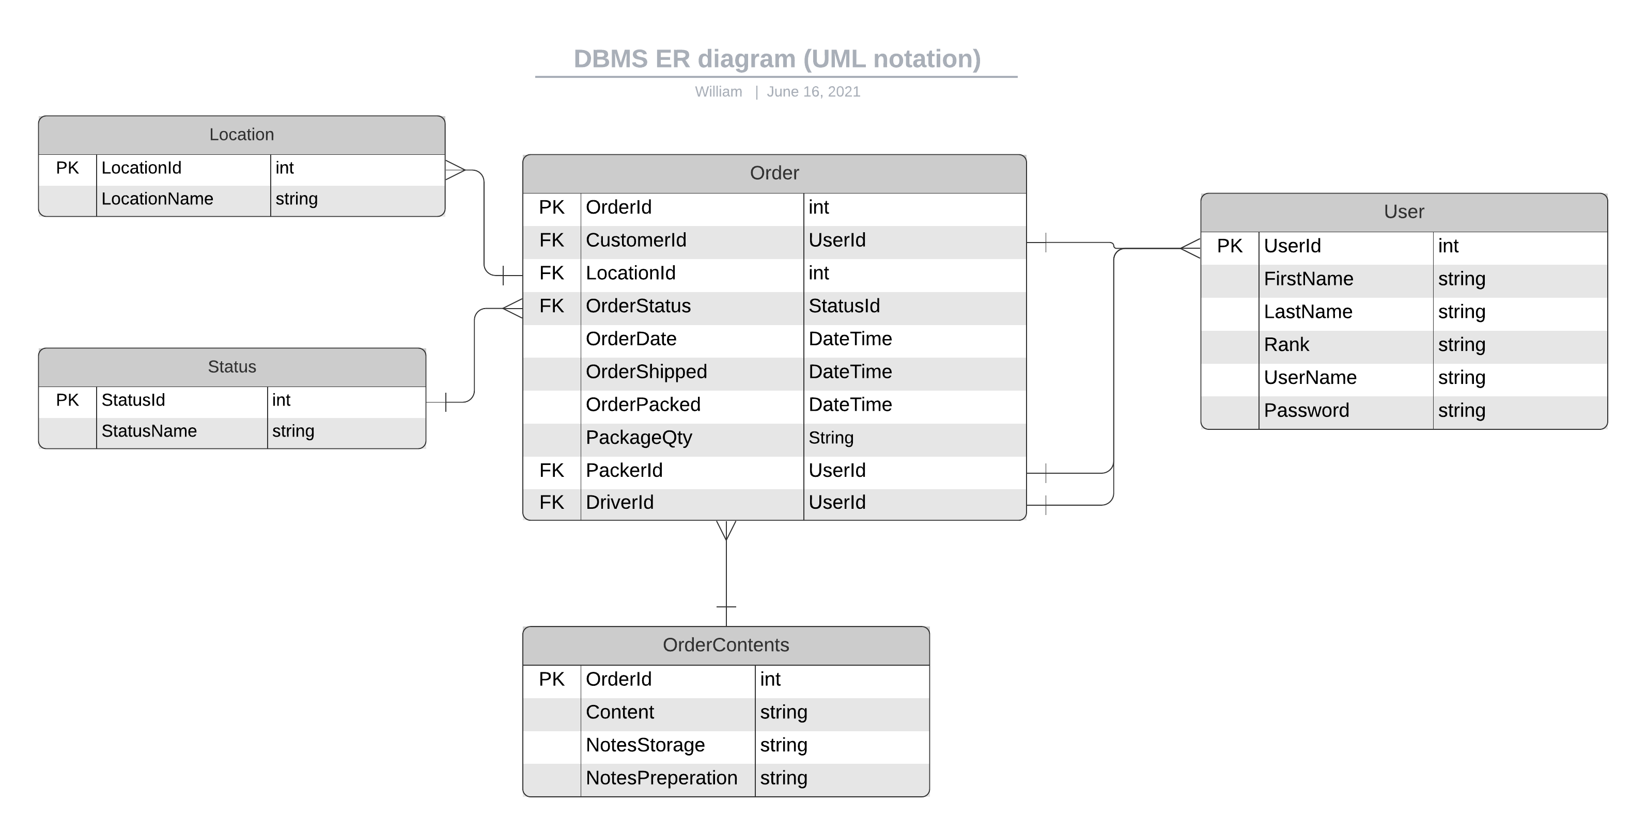

The application design will follow the MVC concept, where the information is stored in model and will be displayed via the controller, the information will be stored on the databased nominated and will be called when necessary. The information will be accessed internally on different applications to display the relevant information the device that is requesting the information. the Laravel controller will pull the information from the views to show the front-end webpage, when the user creates an order that information will be stored into the database as a model from the view. To retrieve the information the code being scanned will be the order id and get it form the database and display the right information for the correct user.

## SECURITY

For this project, the necessary security arrangements that would be necessary is the general protocol used by the navy network to control access to the application this would the primary external network security, specifically this would control any access to the program from another location, firewalls, unauthorised access. For internal security for the application the program the database entry permissions will be controlled by allowing only certain users to be allowed to add certain information to certain tables in the database. Configuring the application to be able to prevent an unknown user in registering an account.

## COPYRIGHT AND IP

As students of North Metro TAFE, we the group members Kyana, Stephen and William and our supervisor Adrian are obligated to follow the policies by this TAFE in following their online and work policy. Primarily following the Copyright Act 1968. As this project has a relationship with the Australian Defence Force – Royal Australian Navy this project will be bound to their policies regarding ICT solutions as well.

# implementation plan

## RESOURCES AND TIMELINES

The resources available to complete this project will be the hardware provided by TAFE which is access to a library of resources to supplied to the students and the Windows and Mac computer and personal computers to develop the program, sample data will be provided by Danny to provide insight into the process to the current process.

The timeline of this project is approximately ten weeks for the web application design prototype in those ten weeks the first couple of weeks is used to set out the database diagram and front-end design concept. After that it would be the development of the program, during this process we will organise periodic meetings to ensure the program will stay on track.

## COSTS OF IMPLEMENTATION

Cost of the implementation of this program will be relied a multiple of factors, in this case the cost of running the program either an on-site server running cost or paying for the program to be running on the cloud, these costs are the cost for managing to network, additional cost will include whether new computers or devices will be purchased to solely run the program.

## impact of change

The impact of this program will influence the current process by taking advantage of using technology to reduce processing time. The reduction of processing time will improve efficiency and logging, this will have the effect in allowing the staff to have more time on working on other things, the logging will allow the users to track the parcel’s status.

Once this program is operational there will be a reduce in the wastage of paper and reduce time for awaiting new orders by the chefs. By improving and reducing these process and supplies needed it will save money and allow better focus on other things.

## TRAINING NEEDS

Only basic training will be needed as the information displayed on the web site will be geared towards good User Experience. The basic process is straight forward, a user logs into the system and depending on role the user has the first page will show a scanner and when that user scans it would show the order status and will prompt the user to fill or complete certain parts of the form.

## PERFORMANCE benchmarkS

The testing of the performance will be tracked through the logging of response by the website and the database over time this will be the primary solution.

## validation and signoff

This plan will go through the process being checked by the supervisor and respective team members to confirm all the requirements and proposed solution. The process would process will begin with an initial confirmation with the team members, once all the members confirm the solution the team supervisor to confirm out action plan. Once confirmed we will take the plan to the sponsor to finalise the plan and provide alterations through the meetings with the sponsors to confirm new developments and needs to be applied to the plan.