**Overview**

Bunny Hop is a puzzle game that follows Franz, a Netherland Dwarf, in his adventures to find and rescue his family from the Eagle-Owl, Noctis, and his band of Night Owls.

Key Points

**Console:** PC???

**Genre:** Puzzle, RPG I guess

**Target Audience:** Late childhood (7+), casual gamers

**Gameplay:** *Paper Mario, Little Big Planet*

**Style:** Picturesque, illustrative, whimsical, colorful, similar style to bottom images

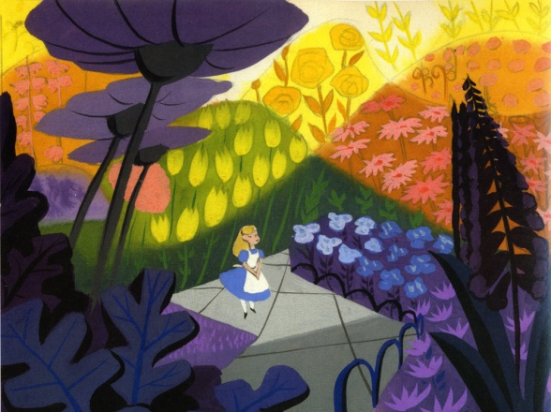

* Alice in Wonderland concept by Mary Blair (use her for inspiration)

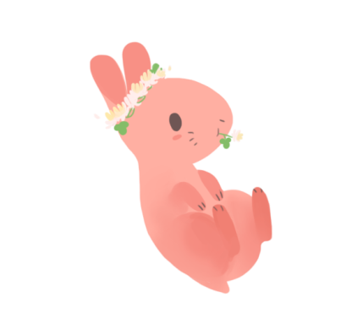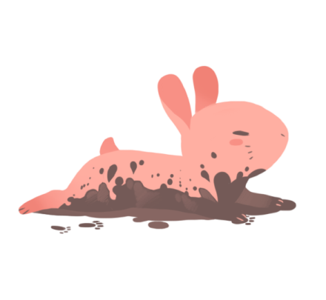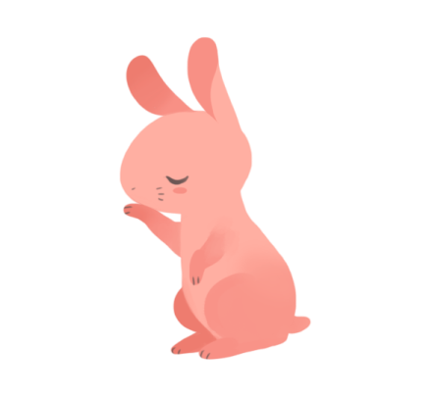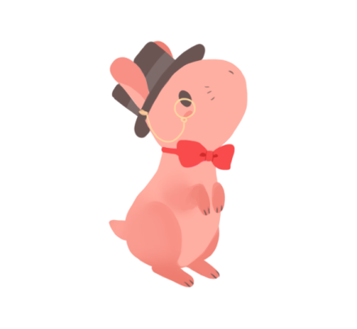

Above by Tumblr user [xfreischutz](http://xfreischutz.tumblr.com/post/114647921017/transparent-nugs-o-feel-free-to-use-as-long-as)

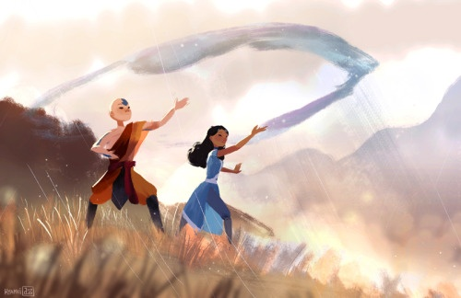

Above by Tumblr user [abbydraws](http://abbydraws.tumblr.com/post/125083019845)

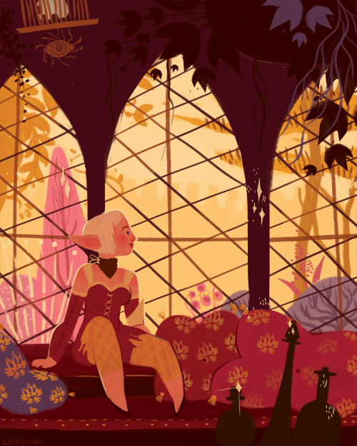

Above by Tumblr user [cerigg](http://cerigg.tumblr.com/post/127838349511)

Goals for *Bunny Hop*

* To allow the player to feel a sense of achievement after completing puzzles
* To allow the player to role-play as a rabbit
* To have the player become a prey and respond to their environment and the challenges that come with it
* To calm the player. The game shouldn’t be taken too seriously, but should still have enough difficultly

**The World of *Bunny Hop***

Primary Characters

|  |  |
| --- | --- |
| FRANZ | * Franz is the smallest rabbit in the Meadow. He is shy and a little apprehensive, but he has always dreamed of exploring what was outside of his world. He has two overprotective parents, and a feisty twin sister named Mindy. * Franz is a light brown, Netherland Dwarf. He has a dark brown spot behind his right ear. He is unusually small compared to other Netherland Dwarves. |
| MINDY | * Franz’s twin sister. She gets captured by Noctis, the Night Owl while exploring the Forbidden Forest with Franz. * Opposite of Franz, she is outgoing and very active. Her favorite things to do are run around and collect flowers. Just like her brother, she also dreams of exploring the world. * Mindy is a paler color than Franz, almost white/ivory. She likes to wear tiny flowers on her ears. |

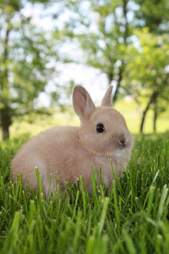

Look at the cute bunny! I want one.

Enemies

|  |  |
| --- | --- |
| NOCTIS | * The main antagonist of *Bunny Hop*. He is the one who kidnaps Mindy while she and Franz are wandering in the Forbidden Forest. Noctis is devious, intelligent, and essentially a “troll” (search the “terror owl”). He likes to stir trouble and create chaos wherever he goes. * Noctis is the one who creates the puzzles for Franz to solve. * Noctis is a Eurasian Eagle-Owl. Primarily covered in black-dark brown feathers with speckles of gold. His belly is primarily beige and gold. His eyes are a striking orange-red. |

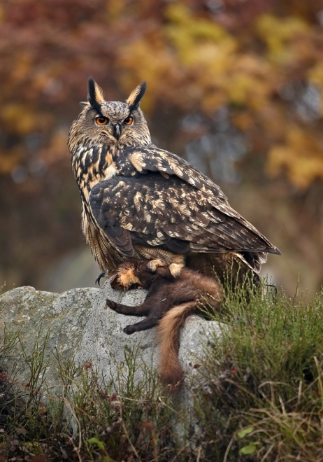

Holy snnaaap! Do you see dat? He killed dat. And he gonna eat it.