GlassQuill
Explainable Detection of AI-Generated Text
Case-Study Project Report (ESE)
Applications and Use Cases of Machine Learning (TE7483)
AIML Department, Symbiosis Institute of Technology, Pune
Batch 2024–28 · Semester V · October 2026
Submitted by
Name | PRN
Ranjan Verma | 24070126149
Rahul Narkhede | 24070126146
Priyansh Johri | 24070126142
Priyansh Pandey | 24070126143
Submitted to
Dr. Aniket Shahade, Dr. Shrikishna Kolhar, Dr. Sumanto Dutta
Code, models and results: github.com/ThatOneRahul/glassquill

Abstract
Large language models now write text that people cannot reliably tell apart from human writing. Colleges, newsrooms and hiring teams respond with AI-text detectors, but most of them return a bare score: a student who is wrongly flagged has no way to question it, and non-native English writers are flagged far more often than others. GlassQuill classifies an English text of 50 to 400 words as human-written or AI-generated and explains every decision.
We train four models that range from transparent to black box: a zero-shot GPT-2 perplexity threshold, TF-IDF with logistic regression, XGBoost on 18 interpretable style and perplexity features, and a fine-tuned DistilBERT. The data combines three public corpora, HC3, HAP-E and M4GT, covering ChatGPT (2022) and recent models such as GPT-4o, GPT-4, Llama-3, Mixtral and Gemma: 31,984 texts, balanced by class within each of 17 domains and split by question or document so that no topic leaks between training and testing. A first version scored above 99% because of formatting shortcuts in the data; removing them was the single most important step.
The deployed verdict, the mean of the two explainable models, reaches 97.4% accuracy, 0.974 F1 and a 2.0% false positive rate on 4,829 unseen test texts, ahead of DistilBERT (96.1% accuracy, 7.1% false positive rate), and every verdict comes with SHAP feature reasons and word-level evidence. On MAGE, a benchmark of 27 generators never seen in training, every model falls to 61–66% accuracy, and paraphrasing lowers recall from 98% to 93%; we report both as limits. The project is implemented as a reproducible eight-stage pipeline and a tested web application.
Keywords: AI-generated text detection, explainable machine learning, perplexity, stylometry, XGBoost, SHAP, NLP text classification.

Contents
Abstract 1
Contents 2
1. Introduction and Problem Statement 4
1.1 Problem statement 4
1.2 Real-world relevance 4
1.3 Objective 4
1.4 Research questions and hypotheses 4
1.5 Scope 5
1.6 Application domain and stakeholders 5
1.7 Refinement since Phase I 5
2. Background and Related Work 6
2.1 Key concepts 6
2.2 Related work 6
3. Dataset 7
3.1 Sources 7
3.2 Attributes, target variable and data types 7
3.3 Size, balance and exploratory analysis 7
3.4 Missing values and duplicates 8
3.5 Preprocessing and shortcut removal 8
3.6 Feature engineering 8
3.7 Feature selection 9
3.8 Validation strategy 9
4. Methodology and ML Pipeline 10
4.1 Pipeline overview 10
4.2 Model selection and justification 10
4.3 Training strategy and hyper-parameters 10
4.4 Evaluation method 11
4.5 Explanation method 11
5. Implementation 12
5.1 Tools and environment 12
5.2 Project structure 12
5.3 Workflow and reproducibility 12
5.4 The web application 12
5.5 Testing and security 13
6. Results and Comparative Analysis 14
6.1 In-domain test set 14
6.2 Results per corpus 14
6.3 Out-of-domain: MAGE 15
6.4 Paraphrase attack 15
6.5 Comparative analysis 15
6.6 Explanations 16
6.7 Answers to the research questions 17
7. Limitations and Ethical Considerations 18
8. Conclusion and Future Scope 19
8.1 Conclusion 19
8.2 Future scope 19
References 20
Appendix A. Rubric Coverage 21
Appendix B. Class Balance per Domain 22

1. Introduction and Problem Statement

1.1 Problem statement
Large language models (LLMs) such as ChatGPT, Gemini and Claude produce fluent text in seconds. Institutions that grade or publish writing have turned to automatic AI-text detectors, yet almost all of them output a single probability with no explanation. When such a detector is wrong, the cost falls on a real person: a student accused of cheating, or a writer whose work is rejected, cannot see or challenge the reasoning. Liang et al. (2023) showed that popular detectors flagged more than half of essays written by non-native English speakers as AI-generated [6].
Problem: build a detector that labels English text as human-written (0) or AI-generated (1), keeps the false positive rate (humans wrongly flagged as AI) low, and explains each decision in terms a non-expert can check.

1.2 Real-world relevance
- Education: universities use detectors in academic-integrity cases; an explanation turns a score into evidence that can be discussed.
- Publishing and moderation: platforms screen large volumes of submissions and need an audit trail for each decision.
- Hiring: cover letters and written tests are increasingly LLM-assisted, and employers need a fair second opinion.
- Research: most new detectors are black boxes; a transparent, well-documented baseline is useful for comparison.

1.3 Objective
Build and evaluate an explainable binary classifier for English text of 50 to 400 words that (a) achieves high accuracy with a low false positive rate, (b) explains every verdict through feature-level and word-level evidence, and (c) is tested for robustness on unseen generators and on paraphrased AI text; and deliver it as a reproducible pipeline and a working web application.

1.4 Research questions and hypotheses
ID | Research question
RQ1 | Which simple signals (perplexity, sentence rhythm, vocabulary, punctuation) separate human and AI text, and how strongly?
RQ2 | How close can an explainable model (XGBoost with SHAP) get to a black box (fine-tuned DistilBERT)?
RQ3 | How well do the detectors work on unseen LLMs and on paraphrased AI text?
RQ4 | Do two explanation methods (SHAP and LIME) agree on why a text was flagged?
Table 1: Research questions
Hypothesis | How it is tested
H1: AI text has lower perplexity | class means and SHAP direction of log_ppl
H2: AI text has lower burstiness (more even sentences) | class means and SHAP direction of burstiness and nll_std
H3: DistilBERT wins in-domain but drops most out-of-domain | F1 and FPR on the test set vs MAGE
H4: paraphrasing lowers recall for every model | recall on AI texts before vs after T5 paraphrasing
Table 2: Hypotheses

1.5 Scope
- In scope: English text, 50 to 400 words, two classes (human, AI), many genres: question answering, essays, news, fiction, academic writing, blogs, peer reviews, Reddit, WikiHow and Wikipedia.
- Out of scope: other languages, source code, documents that mix human and AI writing, and identifying which LLM wrote a text.

1.6 Application domain and stakeholders
The application domain is education and content moderation, and the ML task is binary NLP text classification.
Stakeholder | What they need from GlassQuill
Teachers and universities | a second opinion that comes with reasons, never a final verdict
Students and writers | a fair way to see and question why their text was flagged
Content platforms and newsrooms | screening of large volumes of text with a clear audit trail
Researchers | a transparent, reproducible baseline to compare new detectors against
Table 3: Stakeholders and their needs

1.7 Refinement since Phase I
The Phase I proposal planned a study on HC3 alone, with XGBoost as the main model and a Gradio demo built in Google Colab. Building and testing it exposed two serious problems, and the project was refined as follows.
Area | Phase I plan | Final project | Why it changed
Data | HC3 only (ChatGPT, Dec 2022), about 12,000 texts | HC3 + HAP-E + M4GT: 31,984 texts, 17 domains, 2024 models | the HC3-only model labelled a modern ChatGPT paragraph 100% human
Preprocessing | basic cleaning | systematic shortcut removal (Table 8) | the first full run scored above 99% by spotting formatting, not style
Verdict | XGBoost alone | mean of XGBoost and TF-IDF + LR, chosen on validation | false positive rate fell from 6.6% to 2.0%
Model behaviour | unconstrained trees | monotone constraints where theory and data agree | prevents rules like 'very even sentences mean human'
Implementation | Colab notebook and Gradio demo | 8-stage reproducible script, FastAPI + React web app, 28 automated tests | reproducibility, security and a usable interface
Table 4: Refinement from the Phase I plan to the final project

2. Background and Related Work

2.1 Key concepts
- Perplexity: the exponential of the mean negative log-probability of each token under a language model. LLMs choose likely tokens, so another language model finds their text easy to predict: AI text has lower perplexity. We use GPT-2 small [15] as the reader model.
- Burstiness: the standard deviation of sentence length divided by its mean. Human writers mix short and long sentences; LLM output is more even.
- Stylometry: measurable properties of writing style, such as vocabulary richness, word length, punctuation and function-word use.
- TF-IDF with logistic regression: each text becomes a weighted bag of words and word pairs; the linear model gives every n-gram an exact weight towards one class, so it is interpretable by construction.
- XGBoost: gradient-boosted decision trees [13], strong on tabular features and compatible with exact TreeSHAP explanations.
- DistilBERT: a compact transformer [14] fine-tuned end to end on the raw text; accurate but opaque.
- SHAP: Shapley values from cooperative game theory [10, 11]. The base value plus the sum of the SHAP values equals the model output, so every prediction is fully decomposed into feature contributions.
- LIME: perturbs the input, observes the prediction and fits a local linear model [12]; model-agnostic but approximate and random.

2.2 Related work
GLTR [7] visualised how often each token falls in a language model's top-k predictions, the idea behind our top-1 and top-10 features. DetectGPT [8] and Binoculars [9] detect AI text zero-shot from probability curvature and from the ratio of two models' perplexities. HC3 [1] introduced paired human and ChatGPT answers, MAGE [2] a 27-generator benchmark for detection in the wild, M4GT-Bench [4] multi-generator and multi-domain data, and HAP-E [3] parallel human and LLM continuations. RAID [5] showed that most detectors break under simple attacks such as paraphrasing. Few of these works explain individual decisions; GlassQuill combines a standard supervised setup with explanations, robustness tests and a strict focus on the false positive rate.

3. Dataset

3.1 Sources
Corpus | Source (Hugging Face) | Licence | AI writers | Domains | Split group
HC3 | Hello-SimpleAI/HC3 | CC BY-SA 4.0 | ChatGPT (2022) | Reddit ELI5, finance, medicine, open QA, CS Wikipedia | question
HAP-E | browndw/human-ai-parallel-corpus | MIT | GPT-4o, GPT-4o-mini, Llama-3 8B/70B | academic, news, fiction, spoken, blogs, TV/movie scripts | document
M4GT | Jinyan1/COLING_2025_MGT_en (M4GT part) | per source | GPT-4o, GPT-4, GPT-3.5, Mixtral, Llama-3, Gemma, Cohere | arXiv, essays, peer reviews, Reddit, WikiHow, Wikipedia | text
MAGE (test only) | yaful/MAGE (test split) | Apache 2.0 | 27 models incl. OPT, BLOOM, GPT-J, Flan-T5, LLaMA, GPT-3/3.5/4 | 14 domains | not used in training
Table 5: Dataset sources
The HC3 and MAGE parts of the COLING data are excluded so that MAGE remains a clean out-of-domain test. All corpora are downloaded automatically by the pipeline.

3.2 Attributes, target variable and data types
Attribute | Data type | Role | Description
text | string | input | the passage to classify
label | integer (0/1) | target | 0 = human-written, 1 = AI-generated
qid | string | grouping | question or source-document id; used only to split the data
source | categorical (17) | analysis | domain, e.g. hc3 finance, hape/news, m4gt/arxiv
generator | categorical | analysis | 'human' or the name of the model that wrote the text
corpus | categorical (3) | analysis | HC3, HAP-E or M4GT
n_words | integer | filter | number of words after cleaning (50 to 400)
Table 6: Attributes, target variable and data types
The models receive either the raw text (TF-IDF + LR, DistilBERT) or 18 numeric features engineered from it (XGBoost, section 3.6). The group id is never a model input.

3.3 Size, balance and exploratory analysis
Split | Texts | HC3 | HAP-E | M4GT | Share AI
Train (70%) | 22,371 | 8,412 | 5,565 | 8,394 | 0.500
Validation (15%) | 4,784 | 1,776 | 1,209 | 1,799 | 0.500
Test (15%) | 4,829 | 1,808 | 1,222 | 1,799 | 0.501
Total | 31,984 | 11,996 | 7,996 | 11,992 | 0.500
MAGE (out-of-domain) | 2,000 | – | – | – | 0.500
Table 7: Dataset size per split and corpus
Every one of the 17 domains contains exactly as many human as AI texts (Appendix B). Mean length is 256 words for human and 266 words for AI texts, so length alone is not a shortcut (Figure 1); the peak at 400 words comes from long texts being cut at the last full sentence.
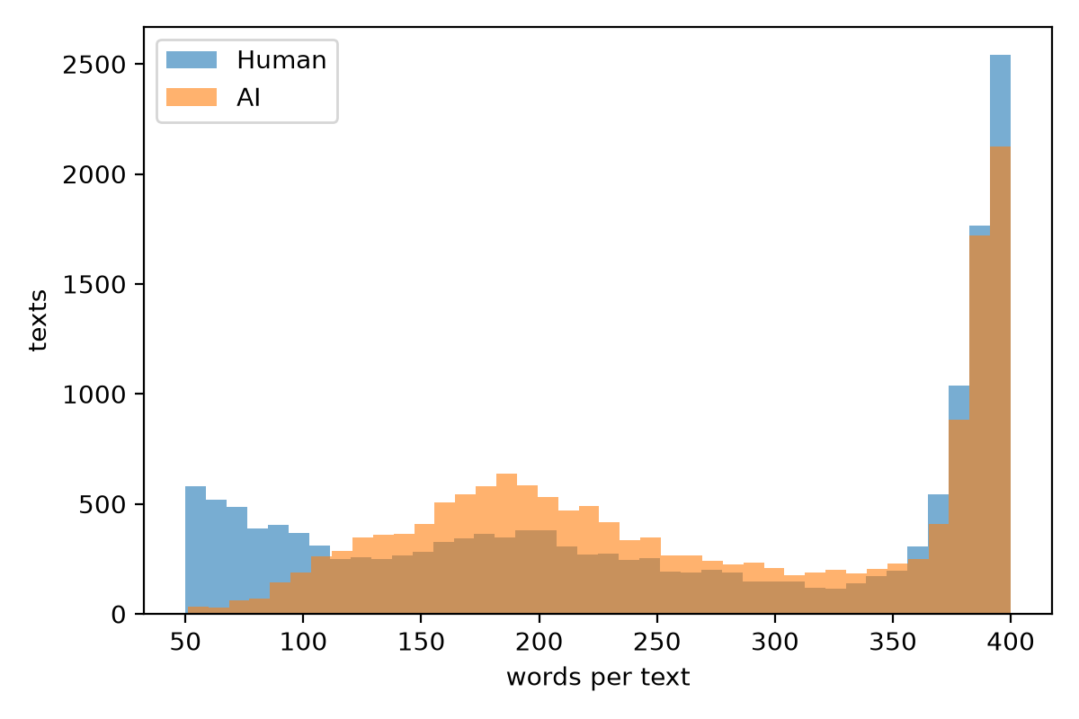
Figure 1: Distribution of text length (words) for human and AI texts

3.4 Missing values and duplicates
- Rows with empty or missing text are dropped (dropna), and exact duplicate texts are removed.
- After cleaning there are 0 missing values in any split; every attribute is fully populated.
- The engineered features cannot be missing: every rate divides by max(words, 1), and texts are at least 50 words long.

3.5 Preprocessing and shortcut removal
The cleaning function (clean_text in src/data.py) removes formatting that reveals the source of a text rather than its writing style. Each artifact below appeared mostly in one class and would let a model cheat; together they explained why the first full run scored 99.3%.
Artifact | Human texts | AI texts | Fix
literal "\n" line breaks (HC3 ChatGPT) | 0% | most | replace with a space
"do n't", "it 's" (tokenizer split) | 34% | 0.02% | rejoin
"( word )" spaced brackets | 35% | 0.01% | remove the spaces
URL_0 link placeholders | 11.6% | 0.07% | remove
markdown bold and # headings (M4GT) | 2% | 9% | remove
curly quotes, em dashes, [1] citations | more often | less often | normalise to plain ASCII
"As an AI language model…", "I hope this helps" | 0% | some | remove
Table 8: Shortcut artifacts removed during preprocessing
Further steps: texts outside 50–400 words are removed, while HAP-E and M4GT texts longer than 400 words are cut at the last full sentence so that long texts of both classes are kept the same way. Each domain is then balanced to equal human and AI counts; without this, HC3 open_qa had 20 human vs 764 AI texts and the topic alone predicted the label. Finally, MAGE's label convention (1 = human) is flipped to ours (1 = AI).

3.6 Feature engineering
XGBoost uses 18 hand-crafted features. Six come from GPT-2 (how predictable each token is) and twelve describe writing style. Table 9 lists them with their class means on the training set and the effect size (difference of class means in pooled standard deviations).
Group | Feature | Meaning | Human | AI | Effect
GPT-2 | log_ppl | log perplexity (mean surprise) | 3.57 | 2.61 | −1.39
 | top1_frac | share of tokens that were GPT-2's first guess | 0.34 | 0.46 | +1.36
 | top10_frac | share of tokens in GPT-2's top 10 | 0.67 | 0.79 | +1.35
 | nll_std | unevenness of surprise | 2.90 | 2.37 | −1.25
 | mean_entropy | GPT-2's uncertainty | 3.71 | 3.27 | −1.00
 | nll_max | most surprising token | 13.8 | 11.7 | −0.92
Rhythm | burstiness | std / mean sentence length | 0.53 | 0.38 | −0.72
 | std_sent_len | sentence length spread | 11.0 | 8.1 | −0.40
 | avg_sent_len | mean sentence length | 21.6 | 22.5 | +0.07
Vocabulary | type_token_ratio | unique / total words | 0.59 | 0.52 | −0.62
 | function_word_rate | the, of, and, … | 0.28 | 0.30 | +0.50
 | avg_word_len | letters per word | 4.64 | 4.87 | +0.42
Punctuation | punct_rate | punctuation per word | 0.19 | 0.16 | −0.37
 | comma_rate | commas per word | 0.050 | 0.058 | +0.27
Voice | contraction_rate | don't, it's, … | 0.018 | 0.014 | −0.19
 | first_person_rate | I, we, my, … | 0.016 | 0.012 | −0.16
Readability | flesch_reading_ease | Flesch reading ease | 56.6 | 49.0 | −0.33
 | fk_grade | Flesch-Kincaid grade | 10.3 | 11.5 | +0.25
Table 9: The 18 engineered features, class means and effect sizes (training set)

3.7 Feature selection
All 18 features are kept. Each was chosen in advance with a stated hypothesis about how AI text differs, tree ensembles are robust to correlated features, and SHAP (section 6.6) shows afterwards which features the model actually relies on. For ten features where theory and the training data agree on the direction (for example, lower perplexity and lower burstiness indicate AI), XGBoost is given monotone constraints, which acts as a soft form of feature control: these features may only push the prediction in the expected direction.

3.8 Validation strategy
- Group split 70/15/15 (GroupShuffleSplit) inside each corpus: all answers to one HC3 question, or all versions of one HAP-E document, land in the same split. The absence of overlap is asserted in code.
- 5-fold GroupKFold on the training set only, for hyper-parameter tuning, so tuning is leak-free too.
- Validation set for the perplexity threshold, the DistilBERT epoch and the choice of the deployed verdict rule.
- Test set used once, at the end. MAGE and the paraphrase set measure robustness.
- Fixed seed 42 for Python, NumPy, PyTorch, the splits and all sampling.

4. Methodology and ML Pipeline

4.1 Pipeline overview
Figure 2 shows the complete pipeline. Each numbered step is a function in run_pipeline.py; every step saves its output, so later steps can be rerun on their own.
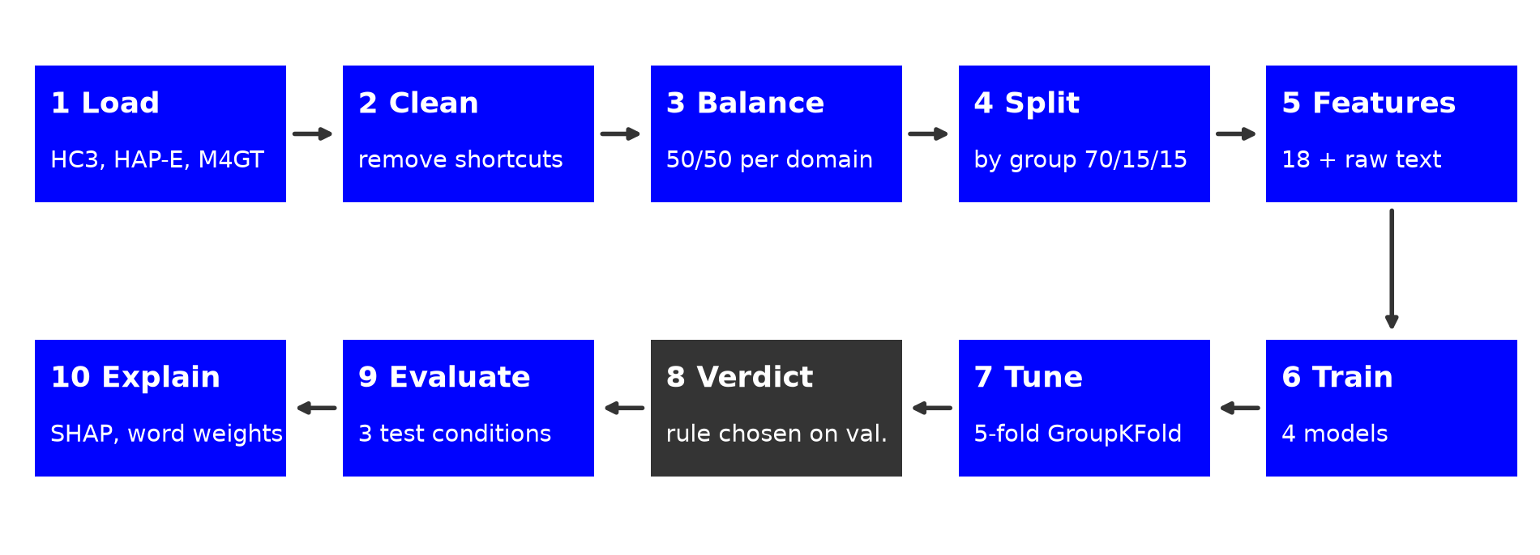
Figure 2: The GlassQuill ML pipeline (read the top row left to right, then the bottom row right to left)

4.2 Model selection and justification
The four models deliberately range from simple and transparent to powerful and opaque. This lets us measure what explainability costs (RQ2) instead of assuming it.
# | Model | Input | Why it is included | Explained with
1 | Perplexity threshold | log_ppl | zero-shot baseline: how far a single, well-known signal goes | the value itself
2 | TF-IDF (1–2-grams, 50k) + logistic regression | words | classic glass-box text model, strong on wording | exact weights (coefficient × TF-IDF)
3 | XGBoost (400 trees) | 18 features | strong on tabular data; every feature has a meaning | TreeSHAP (exact)
4 | DistilBERT (fine-tuned) | raw text, 256 tokens | strong black box to compare against | LIME, SHAP text
5 | Deployed verdict = mean of 2 and 3 | both | the two glass boxes make different mistakes, so averaging cancels errors | both explanations
Table 10: Models and the reason each one is included

4.3 Training strategy and hyper-parameters
Model | Training and tuning | Selected
Perplexity threshold | cut-off on validation by Youden's J (maximise TPR − FPR) | AI if log_ppl ≤ 2.98
TF-IDF + LR | C ∈ {0.1, 1, 10}; 5-fold GroupKFold; scored on F1 | C = 10
XGBoost | max_depth ∈ {3, 4, 6}, learning rate ∈ {0.05, 0.1}, 400 trees, subsample and colsample 0.8, monotone constraints; same CV | best grid point by F1
DistilBERT | learning rate 2e-5, batch 16, 2 epochs, max 256 tokens, weight decay 0.01 | epoch with best validation F1 (0.964)
Verdict rule | compared XGBoost, LR and their mean on the validation set | mean: accuracy 0.972, FPR 0.021
Table 11: Training strategy and selected hyper-parameters
On the validation set the mean of XGBoost and LR reached accuracy 0.972 at FPR 0.021, against 0.929 / 0.064 for XGBoost alone and 0.954 / 0.032 for LR alone, so it was chosen as the deployed rule before the test set was touched. The app reports AI for p ≥ 0.65, human for p ≤ 0.35, and 'unclear' in between, so weak evidence is shown as such instead of being forced into a class.

4.4 Evaluation method
Every model is scored by the same function on the same texts with accuracy, precision, recall, F1-score, ROC-AUC, confusion matrices, ROC curves and the false positive rate (FPR). FPR is reported next to every other metric because a false positive accuses a real person; accuracy alone can hide very different error profiles. Three test conditions are used: (a) the in-domain test set, overall and per corpus, (b) MAGE, per generator and per domain, and (c) AI texts before and after paraphrasing every sentence with a T5 paraphraser (humarin/chatgpt_paraphraser_on_T5_base).

4.5 Explanation method
- Global: TreeSHAP over the whole test set (beeswarm and bar plots) and the direction in which each feature pushes the prediction.
- Local: waterfall plots for one correct AI text, one correct human text, one false positive and one false negative.
- Words: exact per-word contributions of the logistic regression, shown as coloured text in the app.
- Agreement checks (RQ4): SHAP vs LIME on DistilBERT, and LIME vs the exactly known LR weights.

5. Implementation

5.1 Tools and environment
Python 3.11, PyTorch 2.11 (CUDA 12.8), Hugging Face Transformers 5.20, scikit-learn 1.9, XGBoost 3.2, SHAP 0.51, LIME 0.2, textstat and pandas; FastAPI for the API; React 19, TypeScript, Tailwind CSS and Motion for the website; pytest, ESLint and the TypeScript compiler for quality checks. Hardware: a laptop with an NVIDIA RTX 3050 (4 GB).

5.2 Project structure
Path | Responsibility
src/data.py | dataset URLs, loaders, clean_text, balancing (prepare), group_split
src/features.py | 12 stylometric features and the GPT-2 PerplexityScorer (6 features)
src/models.py | metrics (evaluate), perplexity threshold, TF-IDF + LR and XGBoost training with GroupKFold
src/train_distilbert.py | DistilBERT fine-tuning and batched prediction
src/explain.py | SHAP plots, exact word weights, highlights, LIME
src/robustness.py | T5 paraphraser for the paraphrase attack
src/detector.py | loads the saved models once and analyses one text for the app
run_pipeline.py | the whole study: 8 stages, cached outputs, --quick mode, fixed seed
server.py | FastAPI app: input validation, rate limiting, security headers, serves the website
web/ | React website: home, detector, results and method pages
tests/test_server.py | 28 automated API tests
models/, reports/ | trained models; result tables, figures and run logs
Table 12: Project structure

5.3 Workflow and reproducibility
The full study runs with one command. Each stage writes its outputs to disk and is skipped or reused on the next run, so any stage can be repeated alone:
python run_pipeline.py --quick # all 8 stages on a small sample, about 10 minutes
python run_pipeline.py # the full study, about 1.5 hours on the laptop GPU
python run_pipeline.py --stages evaluate ood paraphrase explain
python -m pytest tests -q # 28 API tests
python server.py # web app at http://127.0.0.1:8000

The stages are data → features → train → bert → evaluate → ood → paraphrase → explain. Datasets download automatically, GPT-2 features are cached per split, and all result tables are collected into reports/RESULTS.md. The trained models are committed, so the web app runs without retraining.

5.4 The web application
A user pastes a text; the server removes invisible characters, checks that the input is English prose of at least 50 words, computes the 18 features, runs XGBoost and the word model, and returns the verdict with an 'unclear' band, both model scores, the top reasons compared with typical human and AI values, a SHAP chart and word-level evidence (Figures 3 and 4). Each analysis takes about 0.1 s on the GPU. Pasted text is never stored or logged.
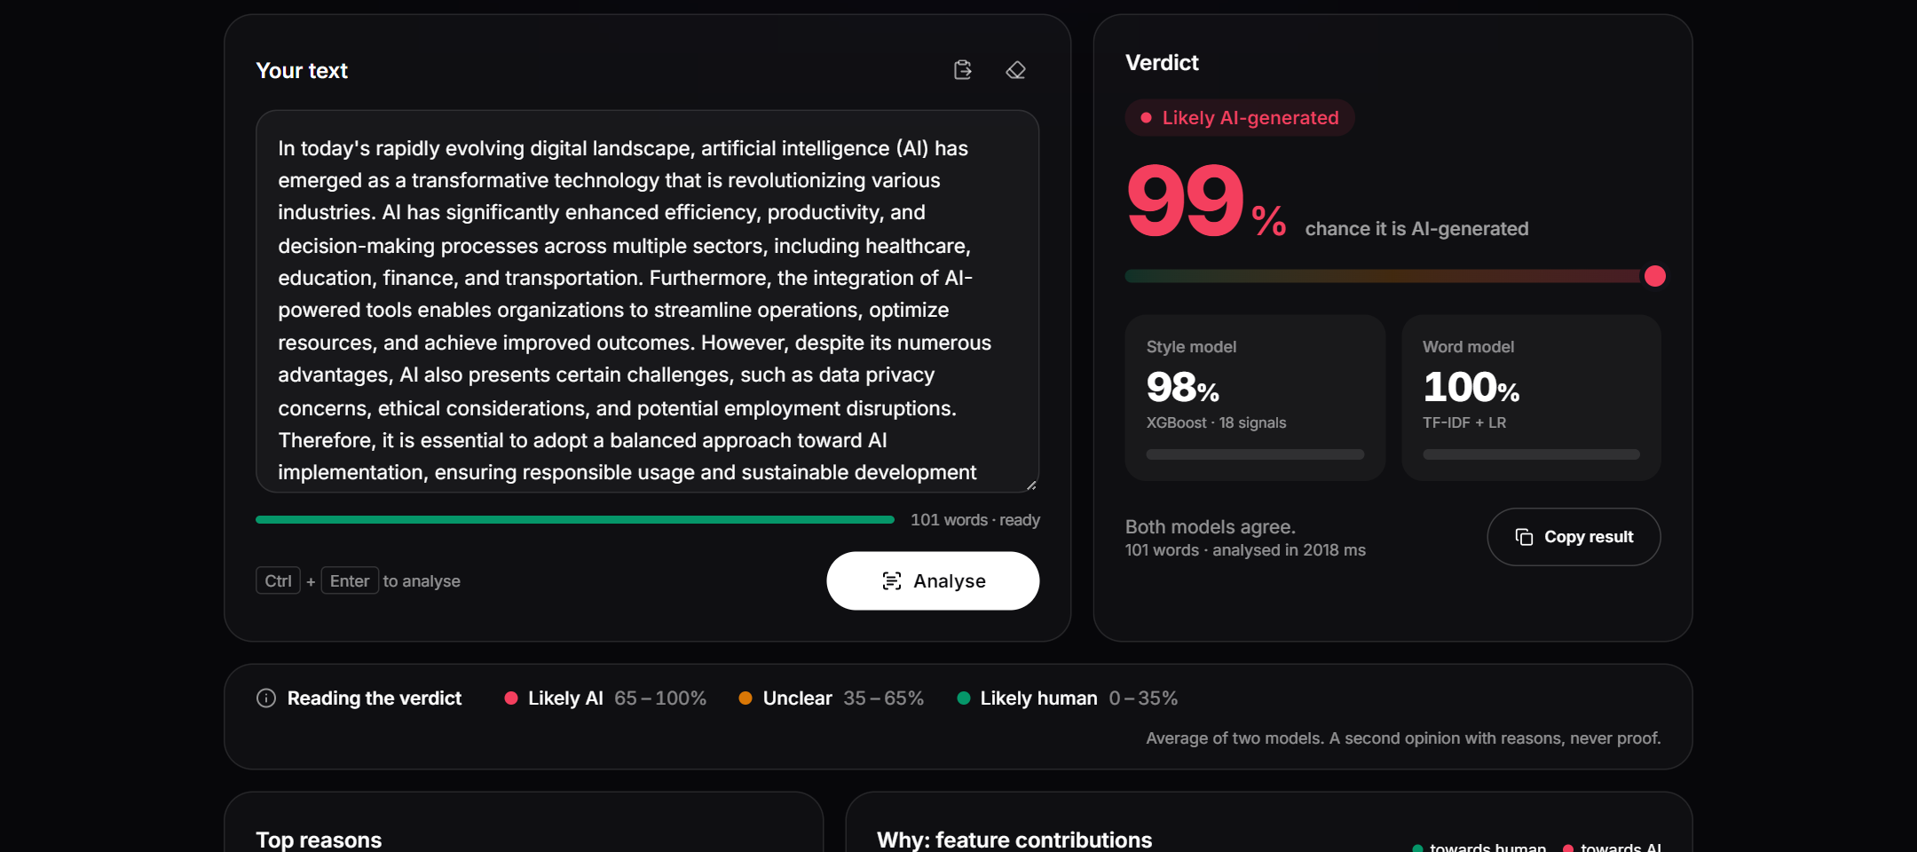
Figure 3: Detector page: verdict, unclear band and the scores of both models
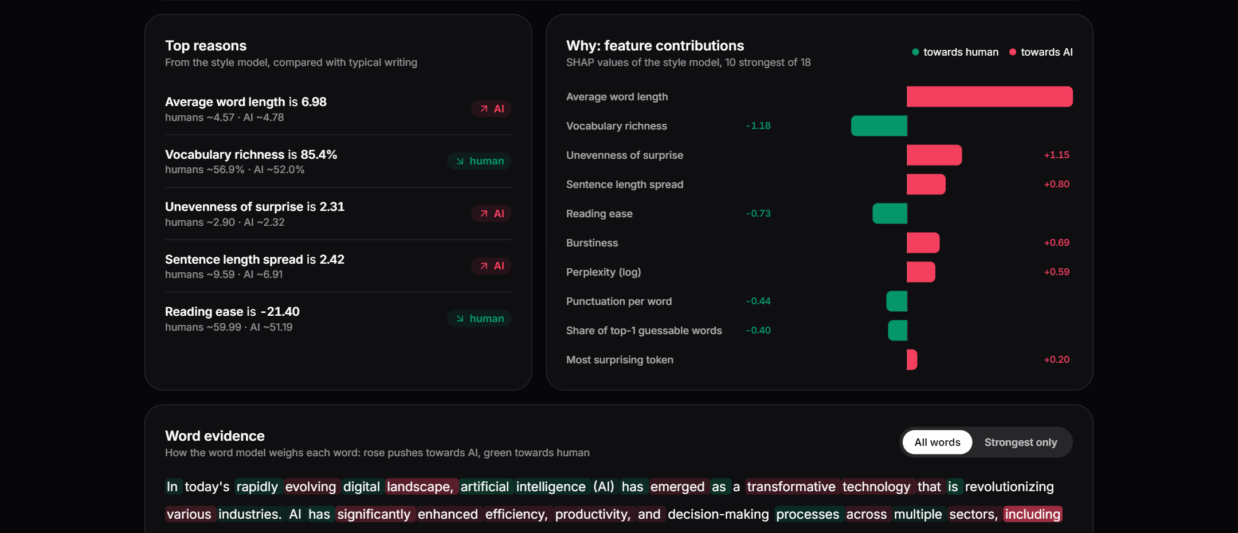
Figure 4: Explanations in the app: top reasons and SHAP feature contributions

5.5 Testing and security
- 28 automated tests cover input validation (too short, too long, wrong type, not English), behaviour (a known AI text is flagged and a human text is not; invisible characters do not change the verdict) and security.
- Security measures: request size cap, mandatory Content-Length, per-IP rate limit (20 analyses per minute), a strict Content-Security-Policy and other security headers, path-traversal protection, and error messages that never echo the submitted text.

6. Results and Comparative Analysis

6.1 In-domain test set
Model | Accuracy | Precision | Recall | F1 | ROC-AUC | FPR
Perplexity threshold | 0.839 | 0.892 | 0.771 | 0.827 | 0.902 | 0.093
TF-IDF + LR | 0.959 | 0.970 | 0.948 | 0.959 | 0.990 | 0.030
XGBoost | 0.923 | 0.933 | 0.912 | 0.923 | 0.978 | 0.066
DistilBERT | 0.961 | 0.934 | 0.993 | 0.963 | 0.997 | 0.071
GlassQuill verdict (XGBoost + LR) | 0.974 | 0.980 | 0.968 | 0.974 | 0.995 | 0.020
Table 13: Results on the in-domain test set (4,829 texts)
The deployed verdict has the best accuracy, precision and F1 and the lowest false positive rate. DistilBERT has the highest recall and ROC-AUC, but it wrongly flags 7.1% of human texts, three and a half times as many as the verdict. Averaging the two explainable models improves on both of them: XGBoost and the word model make different mistakes.
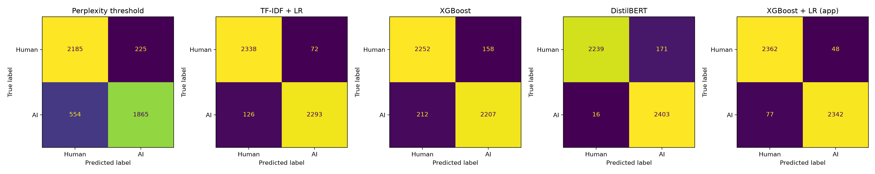
Figure 5: Confusion matrices on the test set (rows: true class, columns: predicted class)
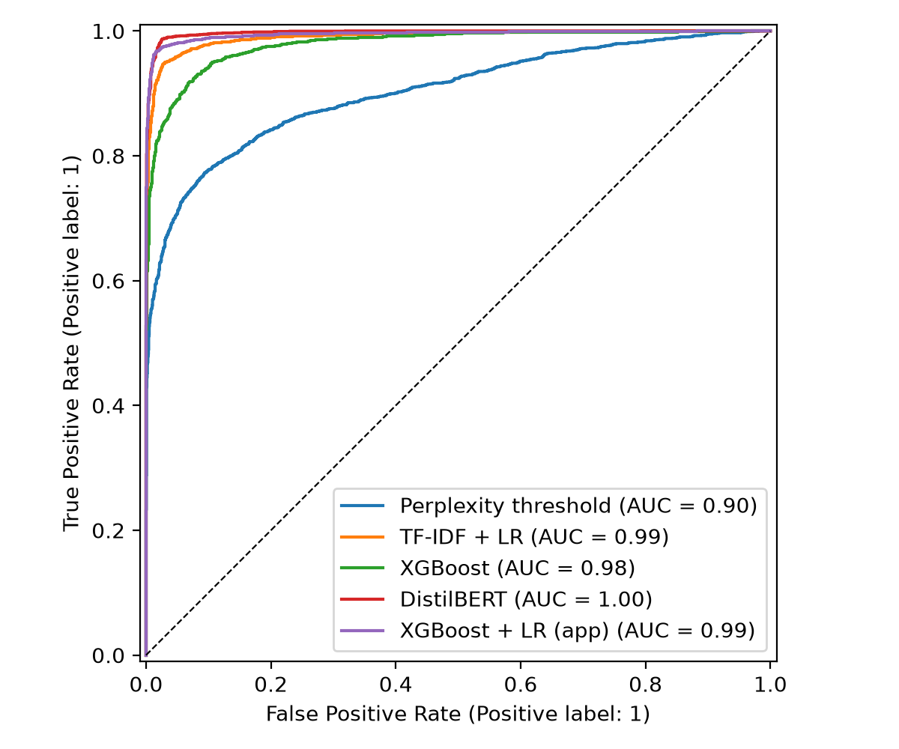
Figure 6: ROC curves on the test set

6.2 Results per corpus
Model | HC3 | HAP-E | M4GT
Perplexity threshold | 0.958 | 0.606 | 0.800
TF-IDF + LR | 0.973 | 0.977 | 0.932
XGBoost | 0.964 | 0.893 | 0.898
DistilBERT | 0.970 | 0.973 | 0.949
GlassQuill verdict | 0.987 | 0.981 | 0.956
Table 14: F1 score per corpus on the test set
The perplexity threshold works well on 2022 ChatGPT text (HC3) but drops to 0.61 F1 on HAP-E, where LLMs continue a human text in the same style. The verdict is the best model on every corpus.

6.3 Out-of-domain: MAGE
Model | Accuracy | Precision | Recall | F1 | ROC-AUC | FPR
Perplexity threshold | 0.656 | 0.792 | 0.422 | 0.551 | 0.681 | 0.111
TF-IDF + LR | 0.606 | 0.787 | 0.292 | 0.426 | 0.648 | 0.079
XGBoost | 0.634 | 0.736 | 0.416 | 0.532 | 0.611 | 0.149
DistilBERT | 0.655 | 0.734 | 0.486 | 0.585 | 0.696 | 0.176
GlassQuill verdict | 0.664 | 0.854 | 0.397 | 0.542 | 0.655 | 0.068
Table 15: Results on MAGE: 2,000 texts from 27 generators and 14 domains never used in training
Every model falls to 61–66% accuracy on unseen generators, which confirms that AI-text detection does not transfer easily. The verdict still has the best accuracy and precision and by far the lowest false positive rate (6.8%), while DistilBERT's FPR rises to 17.6%. Accuracy per generator family shows where the errors come from: GPT-4 0.91, GLM-130B 0.81, GPT-3.5 0.80, GPT-3 davinci 0.76, LLaMA 0.54, GPT-4 paraphrase 0.49, T0 0.47, Flan-T5 0.35, OPT 0.04, BLOOM 0.02, GPT-J/NeoX 0.00, and human texts 0.93. Instruction-tuned chat models, the ones students actually use, are caught; small base models that sample unusual words look human to every detector. Compared with the HC3-only Phase I model, GPT-4 detection rose from 0.55 to 0.91 and GPT-3.5 from 0.55 to 0.80.

6.4 Paraphrase attack
Model | Recall before | Recall after | Drop
Perplexity threshold | 1.00 | 0.93 | −0.07
TF-IDF + LR | 0.93 | 0.77 | −0.17
XGBoost | 1.00 | 0.95 | −0.05
DistilBERT | 1.00 | 1.00 | 0.00
GlassQuill verdict | 0.98 | 0.93 | −0.05
Table 16: Recall on 60 AI test texts before and after paraphrasing every sentence
Paraphrasing hurts the word model most (−17 points) because the exact words change; the perplexity and style features mostly survive (−5 to −7 points). DistilBERT is unaffected on this small set. The verdict still catches 93% of paraphrased AI texts.

6.5 Comparative analysis
- Explainable vs black box (RQ2): XGBoost alone trails DistilBERT (0.923 vs 0.963 F1), but the explainable verdict beats it (0.974 F1) with less than a third of its false positives, on every corpus.
- Precision–recall trade-off: DistilBERT is recall-oriented (0.993) at the cost of precision (0.934); the verdict is balanced (0.980 / 0.968), which is the right profile when false accusations are the costly error.
- Robustness: in-domain differences shrink out-of-domain, where all models land between 61% and 66%; the verdict's advantage there is its low FPR. Paraphrasing separates the models by what they read: words are fragile, style and perplexity are robust.
- Data quality vs model choice: removing shortcuts changed results more than any model change: the uncleaned data gave a misleading 99.3%, and adding modern corpora fixed the failure on current ChatGPT output.

6.6 Explanations
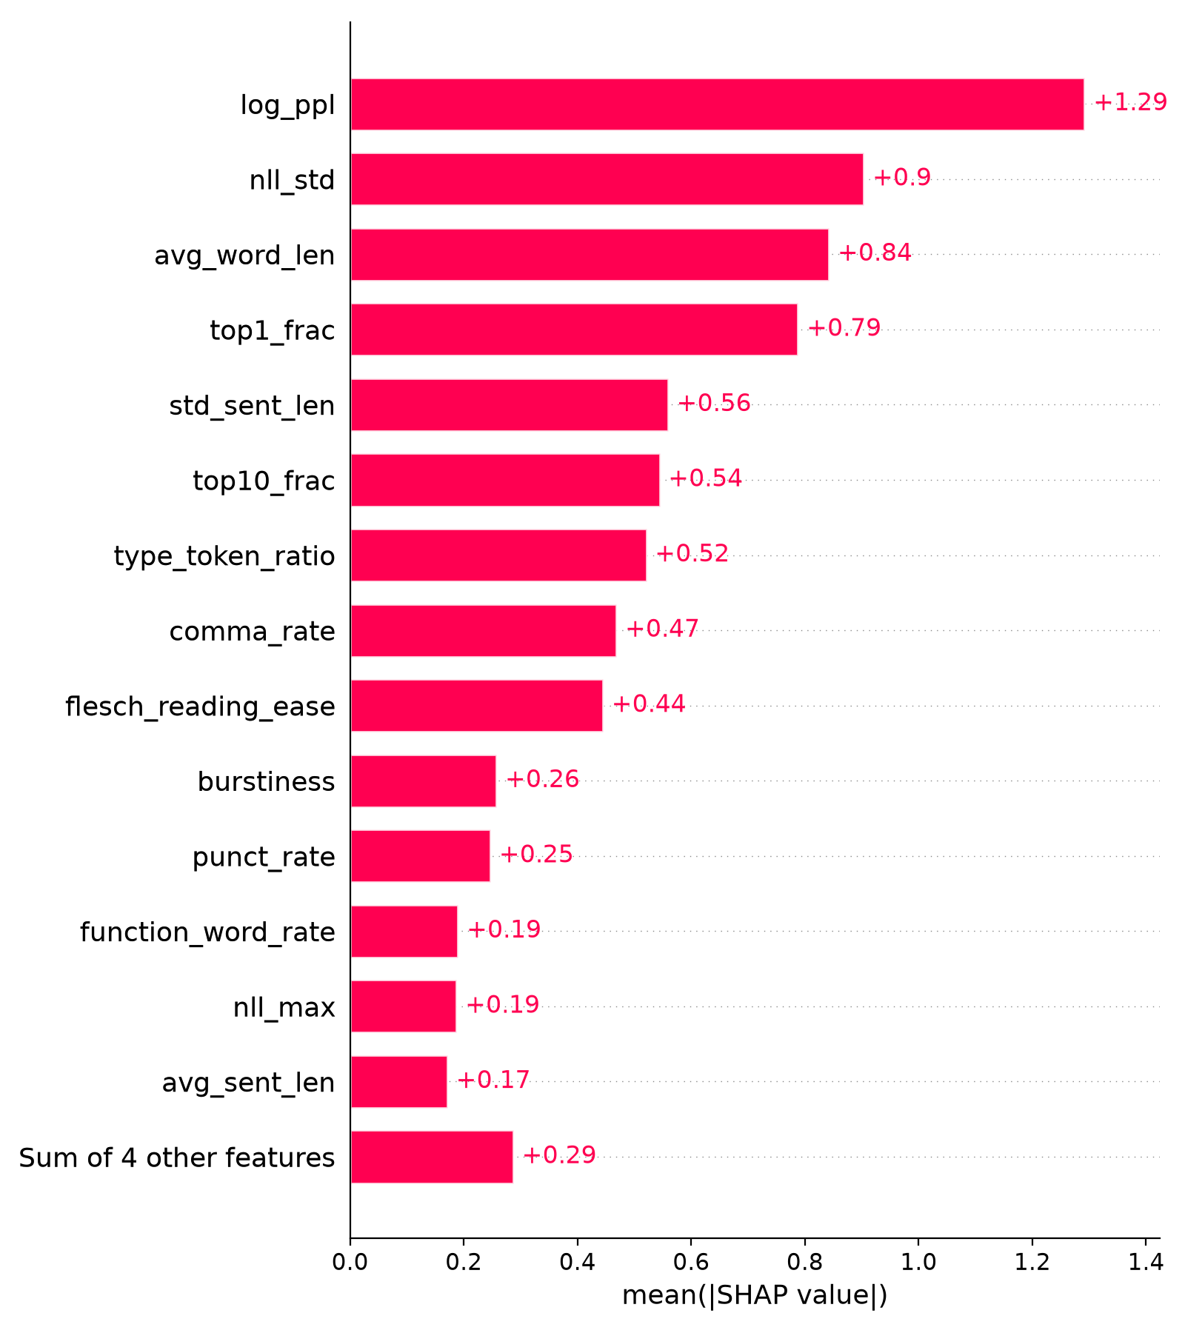
Figure 7: Global feature importance of XGBoost (mean |SHAP| over the test set)
- Global SHAP: the most important features are log perplexity (low → AI), nll_std (even surprise → AI), average word length (long words → AI), top1_frac (guessable words → AI) and sentence-length spread (even → AI).
- Glass-box words: the strongest AI words of the logistic regression include 'including', 'important to', 'overall' and 'significant'; human words include 'etc', 'basically', 'since' and 'thus'.
- SHAP vs LIME on DistilBERT: top-10 word overlap (Jaccard) is only 0.06, partly because DistilBERT works on word pieces while LIME removes whole words.
- LIME vs exact LR weights: LIME recovers 51% of the true top-10 words, so the app uses exact SHAP values and exact word weights instead.

6.7 Answers to the research questions
RQ | Answer
RQ1 | GPT-2 surprise features separate the classes best (about 1.3 SD: log perplexity, top-1/top-10 share, nll_std). Burstiness and vocabulary richness help moderately; sentence length alone does not. H1 and H2 are confirmed by both class means and SHAP direction.
RQ2 | An explainable system can match the black box: the verdict reaches 0.974 F1 at 2.0% FPR vs DistilBERT's 0.963 F1 at 7.1% FPR.
RQ3 | All models drop to 61–66% accuracy on unseen generators, but chat models are still caught (GPT-4 91%). Paraphrasing lowers recall for every model except DistilBERT (H4 mostly holds). H3 is partly confirmed: DistilBERT is not the best in-domain on accuracy, but has the highest FPR on MAGE (17.6%).
RQ4 | No. SHAP and LIME barely agree on DistilBERT (Jaccard 0.06), and LIME recovers only half of the known LR words.
Table 17: Answers to the research questions

7. Limitations and Ethical Considerations
- A detector score must never be the only evidence against a person. The app says so on every page and shows an 'unclear' band instead of guessing.
- Simple, predictable wording, common in non-native writing, has low perplexity and risks false positives. FPR is reported everywhere, but fairness on non-native essays was not tested directly.
- Small open models with sampled output (OPT, BLOOM, GPT-J) and paraphrasing tools fool all four models. New LLMs appear quickly and can make results stale.
- English only, and only the genres in the training corpora. Texts that mix human and AI writing are not handled.
- HAP-E's AI texts continue a human text in the same style, which is harder than detecting a normal chatbot answer, so results on it are a lower bound.
- Privacy: submitted text is processed in memory and never stored or logged.

8. Conclusion and Future Scope

8.1 Conclusion
GlassQuill shows that an explainable detector can match a fine-tuned transformer. Averaging an XGBoost model on 18 meaningful features with a word-level logistic regression gives 97.4% accuracy, 0.974 F1 and a 2.0% false positive rate on 4,829 unseen texts, ahead of DistilBERT, and every decision comes with feature-level and word-level reasons. Two findings mattered most: removing formatting shortcuts from the data turned a misleading 99.3% into an honest result, and training on modern LLM output with direction-constrained features fixed the failure of the Phase I model on current ChatGPT text. The main weaknesses are unseen generator families and paraphrasing. The project is delivered as a reproducible pipeline, a tested web application, and complete documentation.

8.2 Future scope
- Add a stronger reader model or Binoculars (a two-model perplexity ratio) as extra features; an early test gave +0.01 to +0.04 AUC at about 25 times the cost.
- Set the decision threshold for a fixed, very low false positive rate (for example 1%) instead of 0.5.
- Sentence-level scoring to locate AI-written passages inside human texts.
- Evaluate on the RAID benchmark and add newer generators to training.
- Calibrate probabilities so that '80%' means 80%, and test fairness on non-native English essays.
- Extend to Indian languages.

References
- B. Guo et al., "How close is ChatGPT to human experts? Comparison corpus, evaluation, and detection," arXiv:2301.07597, 2023.
- Y. Li et al., "MAGE: Machine-generated text detection in the wild," in Proc. ACL, 2024.
- A. Reinhart, D. W. Brown et al., "Do LLMs write like humans? Variation in grammatical and rhetorical styles," arXiv:2410.16107, 2024.
- Y. Wang et al., "M4GT-Bench: Evaluation benchmark for black-box machine-generated text detection," in Proc. ACL, 2024.
- L. Dugan et al., "RAID: A shared benchmark for robust evaluation of machine-generated text detectors," in Proc. ACL, 2024.
- W. Liang et al., "GPT detectors are biased against non-native English writers," Patterns, vol. 4, no. 7, 2023.
- S. Gehrmann, H. Strobelt and A. M. Rush, "GLTR: Statistical detection and visualization of generated text," in Proc. ACL System Demonstrations, 2019.
- E. Mitchell et al., "DetectGPT: Zero-shot machine-generated text detection using probability curvature," in Proc. ICML, 2023.
- A. Hans et al., "Spotting LLMs with Binoculars: Zero-shot detection of machine-generated text," in Proc. ICML, 2024.
- S. M. Lundberg and S.-I. Lee, "A unified approach to interpreting model predictions," in Proc. NeurIPS, 2017.
- S. M. Lundberg et al., "From local explanations to global understanding with explainable AI for trees," Nature Machine Intelligence, vol. 2, pp. 56–67, 2020.
- M. T. Ribeiro, S. Singh and C. Guestrin, "Why should I trust you? Explaining the predictions of any classifier," in Proc. KDD, 2016.
- T. Chen and C. Guestrin, "XGBoost: A scalable tree boosting system," in Proc. KDD, 2016.
- V. Sanh et al., "DistilBERT, a distilled version of BERT: smaller, faster, cheaper and lighter," arXiv:1910.01108, 2019.
- A. Radford et al., "Language models are unsupervised multitask learners," OpenAI technical report, 2019.

Appendix A. Rubric Coverage
ESE component (marks) | Where it is addressed
Problem refinement and use case relevance (3) | Ch. 1: problem, relevance, objective, scope, domain, stakeholders, refinement since Phase I (Table 4)
Dataset understanding, preprocessing, feature handling (4) | Ch. 3: sources, size, attributes, target, data types, missing values, preprocessing, feature engineering and selection, validation strategy
Methodology and ML pipeline design (5) | Ch. 4: pipeline figure, model selection and justification, training strategy, evaluation and explanation methods
Implementation / project execution (5) | Ch. 5: tools, project structure, reproducible workflow, web application, tests and security
Results, evaluation metrics, comparative analysis (5) | Ch. 6: accuracy, precision, recall, F1, ROC-AUC, FPR, confusion matrices, ROC curves, per-corpus, out-of-domain, paraphrase, explanations, RQ answers
Final report quality and documentation (3) | this report, plus README, code walkthrough and handoff guide in the repository
Communication and presentation (2) | slide deck (submissions/) with agenda, timing and live demo
Viva / project defence (3) | every design choice is justified in Ch. 3–4; limitations and future scope in Ch. 7–8
Table 18: Where each ESE rubric component is addressed

Appendix B. Class Balance per Domain
Domain | Human | AI
hc3: reddit_eli5 | 4,623 | 4,623
hc3: finance | 878 | 878
hc3: medicine | 273 | 273
hc3: wiki_csai | 191 | 191
hc3: open_qa | 33 | 33
hape/acad | 592 | 592
hape/blog | 736 | 736
hape/fic | 673 | 673
hape/news | 637 | 637
hape/spok | 830 | 830
hape/tvm | 530 | 530
m4gt/arxiv | 1,553 | 1,553
m4gt/reddit | 1,389 | 1,389
m4gt/wikihow | 1,385 | 1,385
m4gt/wikipedia | 1,327 | 1,327
m4gt/peerread | 196 | 196
m4gt/outfox | 146 | 146
Total (17 domains) | 15,992 | 15,992
Table 19: Number of human and AI texts per domain after cleaning and balancing

