

DHOLE PATIL COLLEGE OF ENGINEERING WAGHOLI, PUNE- 412207

**A**

**PROJECT REPORT ON**

**Hostel Database Management System**

in partial fulfillment of Second Year

**OF**

**BACHELOR OF ENGINEERING IN INFORMATION TECHNOLOGY AT**

Savitribai Phule Pune University, Pune

**Under The Guidance of Prof.**

**DEPARTMENT OF INFORMATION TECHNOLOGY 2021-2022**



**DHOLE PATIL COLLEGE OF ENGINEERING**

**WAGHOLI, PUNE- 412207**

**DEPARTMENT OF INFORMATION TECHNOLOGY**

**CERTIFICATE**

This is to certify that **Mr. Chetan Pathrabe**, **Mr. Roshan Narawade**, **Mr. Swapnil Puri**, **Mr. Pratik Gaikwad** of Branch Information Technology Engineering has successfully completed the work associated with Project Based Learning & mini project titled as “**HOSTEL DATABASE MANAGEMENT SYSTEM**” and has submitted the report under guidance of **Prof. Nehali Shinde,** in the partial fulfilment of Second Year Bachelor of Engineering of Savitribai Phule Pune University.

|  |  |  |
| --- | --- | --- |
|  |  |  |
|  |  |  |
|  |  |  |
|  |  |  |
|  |  |  |

Date: - 23-05-2022

Place: - DPCOE

Prof. Nehali Shinde (Project Guide)

Prof. Rahul Ghode (Head of Department)

(External Examiner)

**ACKNOWLEDGEMENT**

The completion of Project brings with and sense of satisfaction, but it is never completed without thanking the persons who are all responsible for its successful completion. First and foremost, we wish to express our deep sincere feelings of gratitude to our Institution, **Dhole Patil College of Engineering**, for providing us an opportunity to do our education.

We are thankful to **Prof. Nehali Shinde,** Department of Information Technology and Engineering, Dhole Patil College of Engineering, for her constant support and motivation.

Finally, we would like to thank all the Teaching, Technical faculty and supporting staff members of Department of Information Technology and Engineering, Dhole Patil College of Engineering, Pune, for their support.

* Chetan Pathrabe (Roll no: - 33 )

- Roshan Narawade (Roll no: - 28)

- Swapnil Puri (Roll no: - 37)

- Pratik Gaikwad (Roll no: - 56)

**ABSTRACT**

The “HOSTEL DATABASE MANAGEMENT SYSTEM” is a software developed for managing various activities in the hostel. For the past few years, the number of educational institutions is increasing rapidly. Thereby the number of hostels is also increasing for the accommodation of the students studying in these institutions. As a result, there is a lot of strain on the person who is running the hostel and software are not usually used in this context. This particular project deals with the problems on managing a hostel and avoids the problems which occur when carried manually.

So, the aim of Hostel Database Management System is to automate the Hostel management process to ensure smooth functionality and reduced paperwork. Through this application the admin can register new students to the hostel. The registration process involves collecting various data of the student like Name, Address & Phone, assigning rooms and storing it for further use. The software also keeps track of the fees paid and dues remaining of the residents of the hostel.

To run a Hostel the most important resource required is man power. The 'Hostel Management System' helps in easy execution of these tasks.

**Table of contents**

|  |  |  |
| --- | --- | --- |
| **SN** | **Titles** | **Page No.** |
| 1. | Introduction | 6 |
| 2. | Problem Statement | 7 |
| 3. | Objective | 7 |
| 4. | Feasibility Analysis | 8 |
| 5. | Requirement Analysis | 8 |
| 6. | Project Plan | 10 |
| 7. | DFDs | 12 |
| 8. | ER Diagram, Schema Diagram & Tables | 13 |
| 9. | Screenshots | 16 |
| 10. | Future Scope | 20 |
| 11. | Conclusion & Bibliography | 21 |

**1. Introduction**

With the advancement of technology, application areas of computer are rising day by day. Every sector desires its procurement for fast accurate and automated operations. Therefore, different program is developed to meet the requirement of various types of users i.e., related to any field.

Hostel Database Management is used for managing the complex data of any hostel through internet. Any person who is the owner of a hostel or a group of hostels can use it to decrease the complexity of its hostel management and reduce the stress and tension.

With this system in place, we can improve the efficiency of the system, thus overcome the drawbacks of the existing manual system. This system is designed in favour of the hostel management which helps them to save the records of the students about their rooms and other things. It helps them from the manual work from which it is very difficult to find the record of the students and the mess bills of the students, and the information of about those ones who had left the hostel years before.

In terms of security this software is totally secure as it doesn't give access to unauthorized user as the username and password facility is provided.

We chose Hostel Database Management software as the system seemed simple and easy to use. During its development we realized that we needed software that may help to manage hostel activities and various other adjustments.

**2. Problem statement & Motivation**

There are a lot of drawbacks in keeping and maintaining a hostel. Especially with a manual system. Since most hostels are being run by only one hostel manager, the number of students in a room are sometimes not known by the officer. He has to go room by room to ensure that a room is occupied or not. So, we have developed Hostel Database Management System which will able to keep student records, attendance information for each student along with their room number and hostel number details. This system will also calculate the bills for each student for food provided by the mess department of hostel.

**3. Objectives**

The main objective behind preparing this project is that to give hostel a complete facility that a hostel managerial team wants. It even helps the user to handle the managing system of the hostel properly. And it also gives the customer an easier way to have booking and other related activities in the hotel. Besides this there are many objectives like:

1. To manipulate the Hostel transactions with instant confirmation.
2. To save time.
3. To increase efficiency of students.
4. For fast access of data.
5. For secure and smooth running of the program.
6. For error free, effective and easy for database related works.
7. The application request for the check-in and check-out date and time, number of visitors, and his/her preferred room category.
8. Indicate the room availability and the location of the rooms.
9. If the visitor is satisfied with the room location, then confirm the booking, and
10. Upon confirmation, print the payment details and other necessary constraints.
11. To reduce material related cost.

**4. Feasibility Analysis**

Hostel management system development using DBMS, PHP, JS, CSS, HTML program has lots of codes, Using Internet in gathering information partially contributed to the success of this project. Due to the fact that PHP is an open-source program, development of hostel management system was not too difficult.  However, thanks to the cyber world (Internet) that makes it possible to study and make comparison in needs of some code function.

* **Technical Feasibility:** The technical feasibility in the proposed system deals with the technology used in the system. It deals with the hardware and software used in the system whether they are of latest technology. This system uses windows platform, Apache XAMPP server, MySQL for database, PHP as the language and html or xml as user interface. Thus, HOSTEL MANAGEMENT SYSTEM is technically feasible
* **Economic Feasibility:** Economic analysis is the most frequently used method for evaluating the effectiveness of a new system. More commonly known as cost/benefit analysis. PHP, html, xml and MySQL database are easily available on internet.

**5. Requirement Analysis**

* **Functional Requirements:**

1) User shall generate the users profile containing the following information users account no, full name, address, phone no & room no.

2) User will change dues status in database according to dues paid or not.

3) User must allow the warden to add new users to the system’s database.

4) User must allow the guardian to cancel the registration from the system’s database who will leave rooms.

* **Non-Functional Requirements:**

1) The system should be reliable. It should always beep and running.

2) The system should have high performance.

* **Hardware Requirements:** The section of hardware configuration is an important task related to the software development. Insufficient random-access memory may affect adversely on the speed and efficiency of the entire system. The process should be powerful to handle the entire operations. The hard disk should have sufficient capacity to store the file and application.

1) Users Processor: Pentium IV and above Processor speed: 1.4 GHz Onwards.

2) System Memory: 128 MB minimum (256 MB recommended) Cache size: 512 KB.

3) RAM: 512 MB (Minimum).

4) Network Card: Any card can provide a 100mbps speed Network connection: UTP or Coaxial cable connection Printer: Inkjet/Laser Colour printer provides at least 1000 Dpi Hard disk: 80 GB.

5) Mouse: 104 keys US Key Serial, USB or PS/2.

* **Software Configuration:** A major element in building a system is the section of compatible software since the software in the market is experiencing in geometric progression. Selected software should be acceptable by the firm and one user as well as it should be feasible for the system. This document gives a detailed description of the software requirement specification. The study of requirement specification is focused specially on the functioning of the system. It allows the developer or analyst to understand the system, function to be carried out the performance level to be obtained and corresponding interfaces to be established.

1) Technology Implemented: Apache Server.

2) Language Used: DBMS, HTML, PHP, JAVA SCRIPT, CSS or newer versions.

3) Database: MySQL XAMPP Server.

4) User Interface: HTML, DBMS, CSS.

5) Web Browser: Mozilla, Chrome or Internet Explorer 8(or newer).

6) Software: Apache & MySQL Server & XAMPP.

7) Operating System: Windows 7 or Higher Versions.

**6. Project Plan**

This project is aimed at developing a system for keeping records and showing information about or in a hostel. This system will help the hostel officer to be able to manage the affairs of the hostel. This system will provide full information about a student in the hostel. It will show rooms available or not and number of people in a particular room. This will also provide information on students who have paid in full or are still owing. This system will also provide a report on the summary detail regarding fees and bills students are owing. There will be an administrator module which will accessed by the administrator and has the ability to delete, add and edit student records. This system will be developed based on Software Development Life Cycle (SDLC) with PHP and XAMPP & MySQL server. PHP, HTML, CSS And JS is good for the development and design of web-based programs whiles XAMPP is good for databases because of its security and its advanced features and properties.

**1. Admin Panel**

**1.1 Administrator Login**

**Admin Login module:** This helps the admin login to the home page only if the username and password matches.

**Settings module: –**Only Admin can access this module. Admin has a unique account with much special access permissions over normal users. This module allows admin to add, edit or delete students’ records, Building and Block information, Room details, Course details, etc.

**1.2 Home**

The Administrator can:

1. Allot different students to the hostel.

2. Vacate the students for the hostel.

3. Control the status of the fee payment.

4. Edit the details of the students & modify the student records.

**1.3 Allotment of the hostels**

There will be pre-defined criteria for the admission to the hostel. Admin checks the attested application forms of the students obtained from the user registration forms and verify it with the student database. If the students are found eligible then they are allotted to the hostel.

**1.4 Vacating the rooms**

As the student’s course is over, they will vacate their rooms. So, it is required for the administrator to remove their records from the database tables. This section includes the option for the room vacation and the deletion of the particular record from the database.

**2 User Panel**

**2.1 User Login**

**My Profile module:** This helps the user login to the home page only if the username and password matches.

**Change password module:** Allows the user to change the password.

**Dashboard module: –** This module used to store student records. It contains the following information: i.e., Students Profile details, Contact information, educational details, etc. The Users can search the students from the database according to different criteria such as name, Course, Room number, etc.

**My Room & Fees module: –**This module which displays room fee records. Student dues status and balance amount status can be accessed here. This module also used to renew students room rent every semester.

**2.2 Home**

1. This consist of the different pop-up menus showing the details of the hostel

2. It allows the different users to access the registration forms.

3. He can view the student administration division of the hostel.

**2.3 Registration Form**

This section provides an online form to the students which can be filled by them, and a copy of the filled page can be taken in the printed form. This is later submitted to the Hostel authorities which can be verified by them before allotting them to the respective hostel rooms.

**7. Data Flow Diagram (DFD)**



Verification

Application Form

Hostel Management system

Admin

Student

Confirm Admission

Allotment

Fig 1 DFD For Allotment Process



Student

Username

Login

Access Student

Register

HMS

*Details*

Fig 2 DFD For Student Login

Fig 3 DFD For Student Registration



Personal Details

Application

Admin

Student

Application

Filling

**8. ER Diagram:**



Figure 4 DFD for Admin Module

Admin

Username

Eligible

Eligible

Application

verification

HMS

Allot of

Vacant

Database

Edit notice

board

Modify

Database

View

complaint

Database

Login

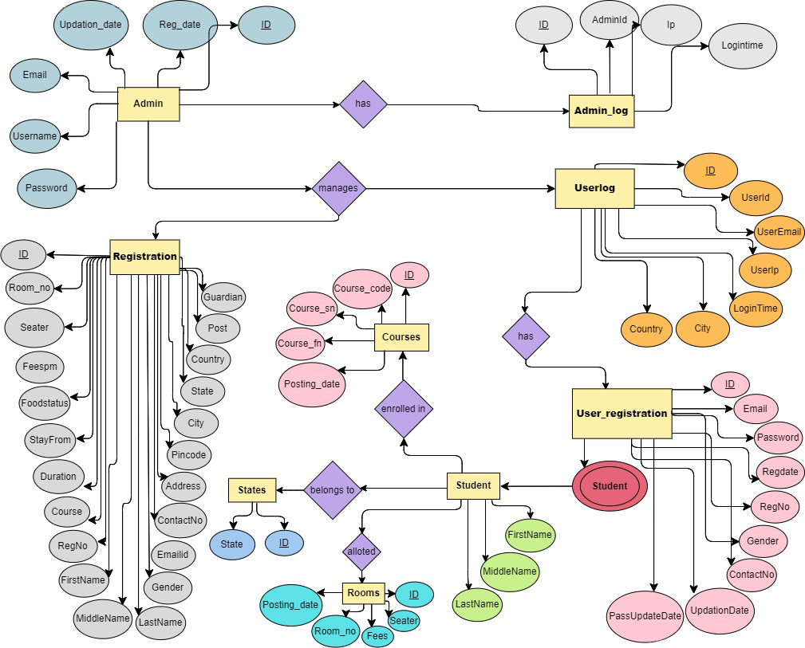

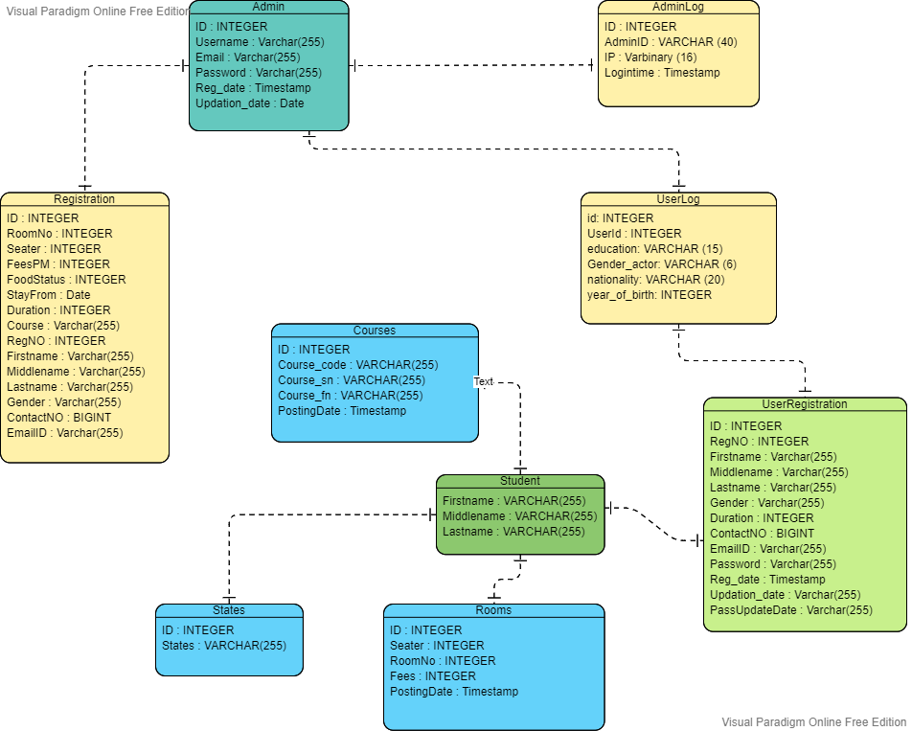

**8.1 Schema Diagram:**

**8.2 Tables:**

**Table of Admin:**

|  |  |  |
| --- | --- | --- |
| **Field** | **Type** | **Key** |
| ID | Int | PRI |
| Username | Varchar(255) |  |
| Email | Varchar(255) |  |
| Password | Varchar(255) |  |
| Reg_date | Timestamp |  |
| Updation_date | Date |  |

**Table of Adminlog:**

|  |  |  |
| --- | --- | --- |
| **Field** | **Type** | **Null** |
| ID | Int | No |
| Adminid | Int | No |
| Ip | Varbinary(16) | No |
| Logintime | Timestamp | No |

**Table of User_Registration:**

|  |  |  |
| --- | --- | --- |
| **Field** | **Type** | **Key** |
| ID | int | PRI |
| regNo | varchar(255) |  |
| firstName | varchar(255) |  |
| lastName | varchar(255) |  |
| gender | varchar(255) |  |
| contactNo | bigint |  |
| email | varchar(255) |  |
| password | varchar(255) |  |

**Table of Userlog:**

|  |  |  |
| --- | --- | --- |
| **Field** | **Type** | **Key** |
| ID | Int | PRI |
| userID | Int |  |
| userEmail | Varchar(255) |  |
| userIp | Varbinary(16) |  |
| City | Varchar(255) |  |
| Country | Varchar(255) |  |
| Logintime | timestamp |  |

**Table of rooms:**

|  |  |  |
| --- | --- | --- |
| **Field** | **Type** | **Key** |
| Id | int | PRI |
| Seater | Int |  |
| Room_no | Int |  |
| Fees | Int |  |
| Posting_date | timestamp |  |

**9. Screenshots:**

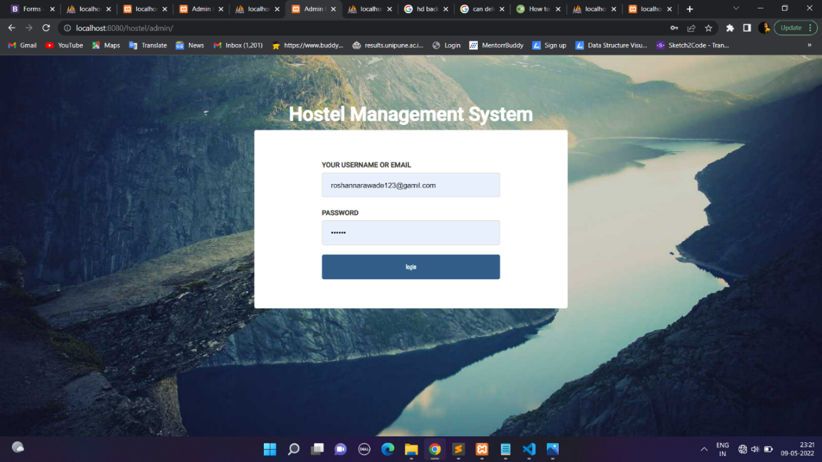

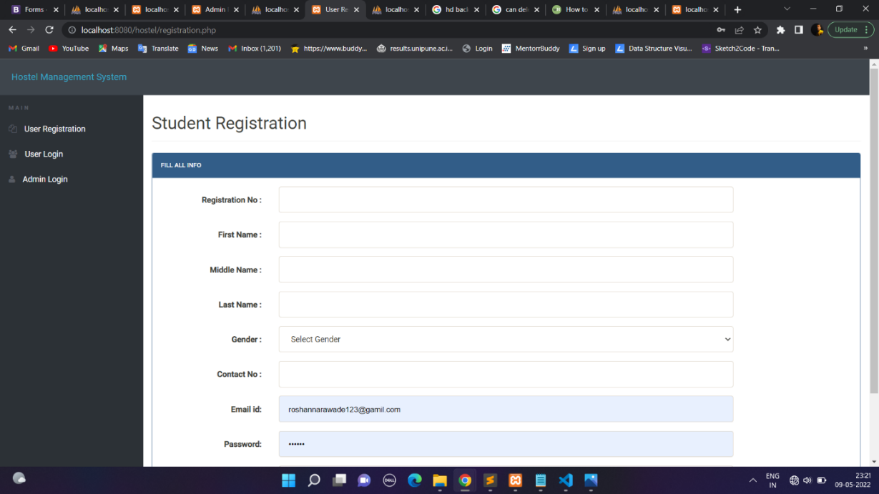

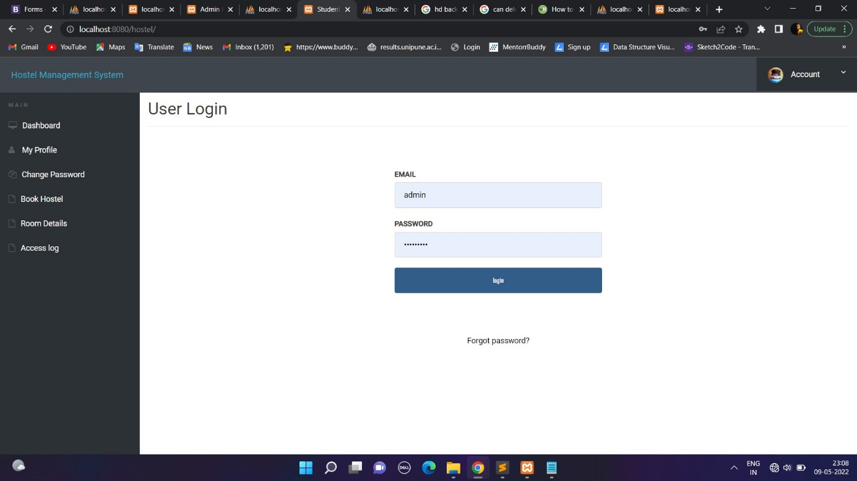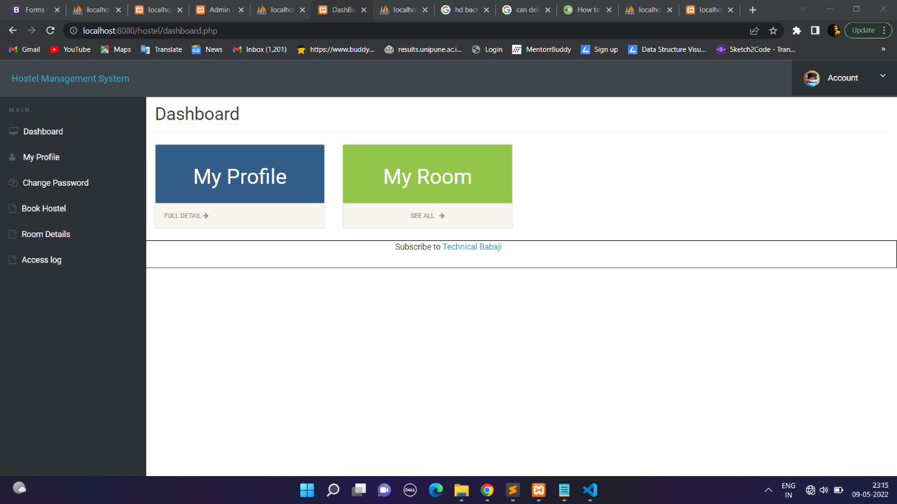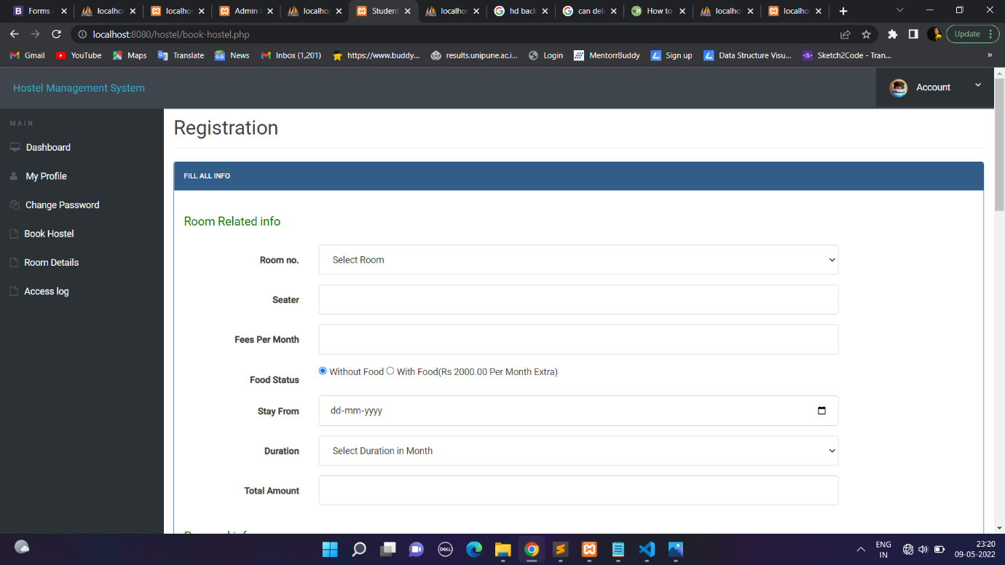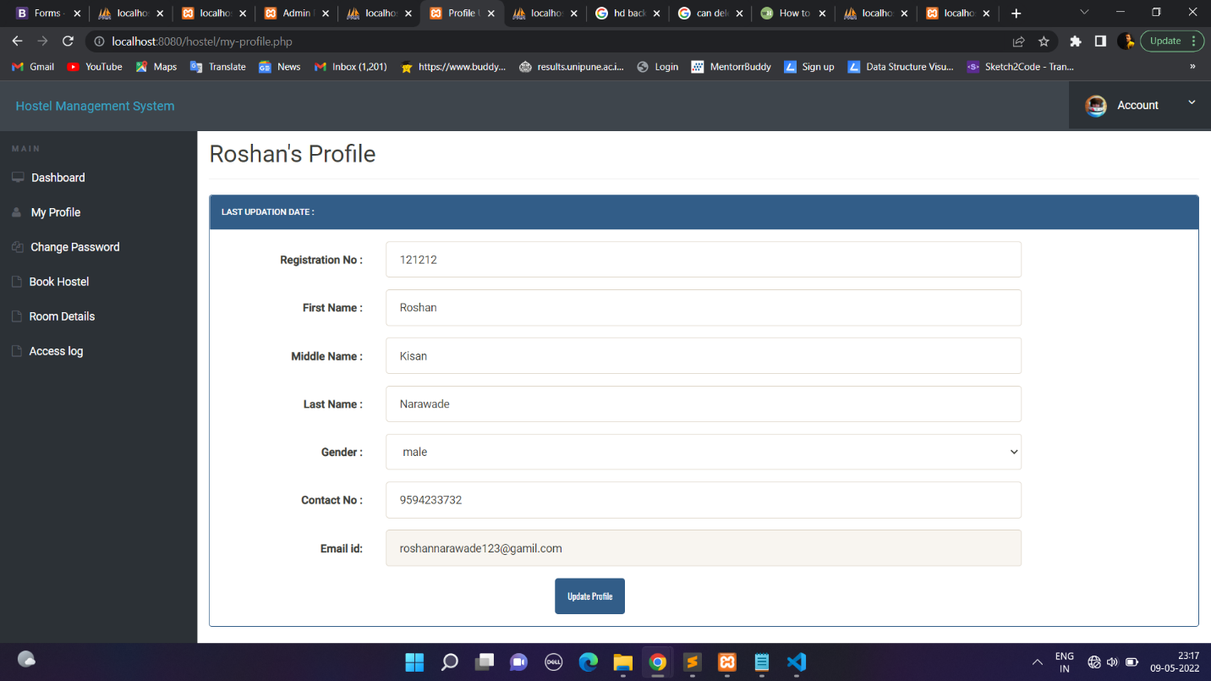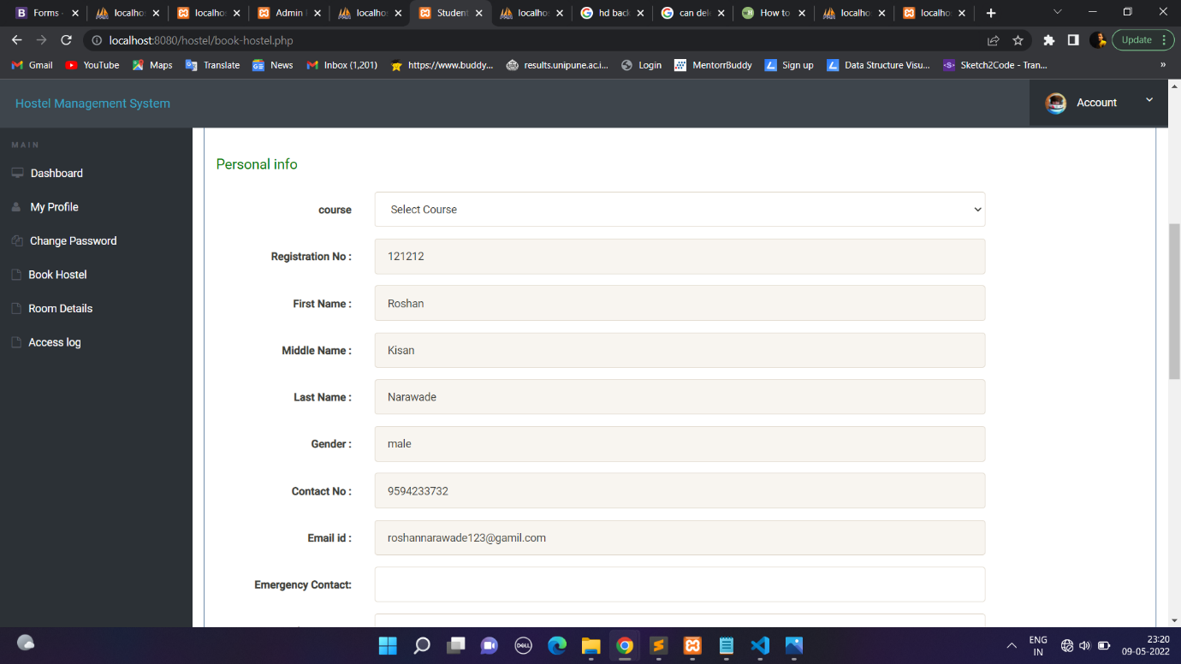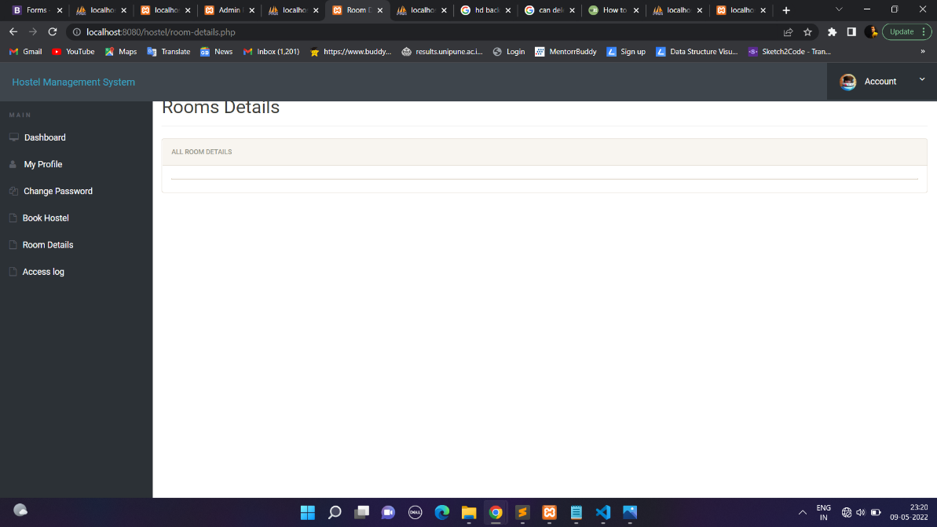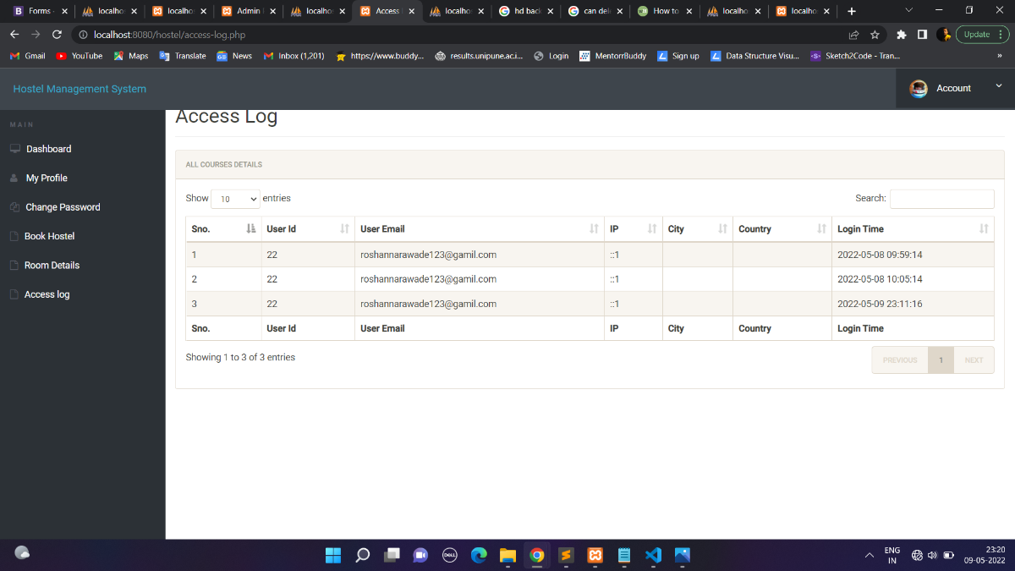

**10. Future Scope and Enhancement**

For the past few years, the numbers of educational institutions are increasing rapidly. Thereby the number of hostels is also increasing for the accommodation. And hence there is a lot of strain on the person who are running the hostel and software’s are not usually used in this context. This particular project deals with the problems on managing a hostel and avoids the problems which occur when carried manually.

It is easy to extend the system that we have proposed. A person could

see any of the issued, unissued or all the rooms according to his/her will. In

future we can implement some features for “HOSTEL DATABASE MANAGEMENT

SYSTEM” project. In this system it’s possible to categorize room rent for

middle class students and poor students. Some poor students are given a

particular concession for the entire year. Also, we can add feedback forms for

students about the system.

**11. Conclusion & Bibliography**

**Conclusion:**

To conclude the description about the project, the project, developed using PHP, CSS, HTML, JS with MySQL & XAMPP is based on the requirement specification of the user and the analysis of the existing system, with flexibility for future enhancement. HOSTEL MANAGEMENT SYSTEM is very useful for hostel allotment and mess fee calculation This hostel management software is designed for people who want to manage various activities in the hostel. For the past few years, the numbers of educational institutions are increasing rapidly Thereby the numbers of hostels are also increasing for the accommodation of the students studying in this institution. And hence there is a lot of strain on the person who are running the hostel and software’s are not usually used in this context. This particular project deals with the problems on managing a hostel and avoids the problems which occur when carried manually. Identification of the drawbacks of the existing system leads to the designing of computerized system that will be compatible to the existing system with the system which is more user friendly and more GUI oriented.

**Bibliography:**

*1.https://www.w3schools.com/bootstrap4/bootstrap_get_started.asp*

*2.https://cdnjs.com/libraries/font-awesome*

*3.https://getbootstrap.com/docs/4.3/components/forms*

*4.https://getbootstrap.com/docs/4.0/components/navbar/*

*5.https://github.com/bootstrap*

*6.https://developer.mozilla.org/en-US/docs/Web/API/CSSStyleSheet3*

*7.https://unsplash.com/s/photos/online*