Schema-Constrained Structured Extraction of Optical Observations
from GCN Circulars for Real-Time Ingestion into SkyPortal
Eric Phillips¹, Sushant Sharma Chaudhary¹, and [additional authors]¹
¹ School of Physics and Astronomy, University of Minnesota, Minneapolis, MN 55455, USA; phill923@umn.edu
Draft compiled 2026 July 15
Abstract
The General Coordinates Network (GCN) Circulars are human-written reports of time-domain and multimessenger observations; the archive of more than 40,500 prose Circulars is difficult to ingest into structured downstream systems. Building directly on the LLM-based analysis of the Circulars archive by Sharma et al. (2026, hereafter S25) — whose released topic labels, archive, and Swift-validated redshift table we adopt — we present Circex, a pipeline that converts optical Circulars into validated JSON conforming to a single output schema (nasa-gcn/gcn-schema). Extractors sharing that schema are compared on 500 rows of the S25 gold set: a transparent regular-expression baseline, and the same Mistral-7B-Instruct-v0.2 model used by S25, served locally with grammar-constrained decoding so the sampler cannot emit a token that violates the schema. The constrained model attains F1 = 0.935 on redshift extraction, against 0.690 for the identical model under free-form generation (Δ = +0.245) and 0.862 for the regex baseline. The improvement is confined to recall (0.559 → 0.937) at comparable precision (0.903 → 0.932): under free-form generation the model fails to emit parseable output that is then discarded, rather than extracting incorrectly. We conclude that the apparent weakness of open 7B models on this task is substantially an artifact of the output serialization rather than of the model, and that constrained decoding recovers extraction ability with no fine-tuning, retrieval, or larger model. The converse is also reported: on lexically regular event names the regex baseline (0.869) exceeds both language-model configurations, so the strongest system is a hybrid that routes each field to the extractor whose failure mode it can tolerate. We describe a live ingestion path that posts extracted photometry into SkyPortal in real time and release the pipeline as an installable package.
Unified Astronomy Thesaurus concepts: Time domain astronomy (2109); Transient sources (1851); Gamma-ray bursts (629); Astronomy data analysis (1858); Astronomy databases (83)

1. Introduction
Time-domain and multimessenger astronomy generate a continuous stream of human-written observation reports. NASA’s General Coordinates Network (GCN) distributes two products: machine-generated Notices, and free-text Circulars in which observers report follow-up of high-energy and multimessenger transients. The Circulars archive spans nearly three decades and exceeds 40,500 documents, of which roughly 18,600 report optical observations. Their prose format — magnitudes, filters, redshifts, and telescopes embedded in natural language — makes bulk ingestion into structured systems such as SkyPortal (van der Walt et al. 2019) laborious.
S25 established the modern treatment of this archive with large language models, contributing a neural topic-modeling pipeline, a contrastively fine-tuned classifier of observation wave bands, and a Mistral-based system for extracting gamma-ray burst redshifts, reporting 97.2% accuracy on redshift-containing Circulars retrieved by retrieval-augmented generation. We build directly on that work.
The present paper isolates a single design variable that S25 did not vary: the channel through which the language model’s output is obtained. Where S25 generate free-form text and parse it after the fact, we serve the identical model with grammar-constrained decoding, in which the sampler is masked at every step to tokens that continue a schema-valid string. Because the model is held fixed, the comparison measures the extraction harness rather than model capability. Two further contributions accompany this result: a transparent regular-expression baseline that establishes a floor on every field, and a live path that posts extracted photometry into SkyPortal as Circulars arrive.
Circex is released as an installable Python package with a reproducible evaluation harness.
2. Structured Representation and Regular-Expression Baseline
2.1. Methods
2.1.1. Output schema. — Every extractor emits one Pydantic v2 model, CircularExtraction, whose JSON Schema derives from and extends nasa-gcn/gcn-schema. The model carries event identity, sky localization, a list of photometry points (filter, magnitude, uncertainty, magnitude system, limiting magnitude, and observation epoch), classification, redshift, and an optional provenance map that grounds each extracted value at a (start, end) character range in the source text for audit. A single output contract is what makes the extractors of Sections 2 and 3 commensurable.
2.1.2. Regular-expression baseline. — Six sub-parsers cover event names, coordinates, redshift, photometry (single-mention, pipe-delimited, and fixed-width tables), classification, and time offsets. Each records the character span it consumed, populating the provenance map. The baseline is deterministic and transparent: it fabricates nothing, and its errors are inspectable.
2.1.3. Evaluation. — We score against the first 500 rows of the 13,593-row Swift-validated redshift table released by S25, using a null-aware comparator with per-field precision, recall, and F1. Numeric fields use tolerances; list fields use greedy matching. Both our extractors and the S25 predictions are scored against the same Actual columns, so all denominators are identical.
2.2. Results
On the three fields with non-zero gold support (Table 1), the regex baseline reaches F1 = 0.869 on event names and 0.862 on redshift, exceeding the published Mistral predictions by +0.020 and +0.171 respectively. That a transparent baseline already matches a language model on these fields is not a criticism of S25 but a calibration: it establishes the floor above which the constrained-decoding gain of Section 3 is measured.

Table 1
Per-field F1 on 500 rows of the S25 Swift-validated gold set. Support is the number of non-null gold values (TP + FN). The regex baseline does not attempt telescope-name extraction.
Field | Support | Regex (this work) | Mistral-7B, constrained (this work) | Mistral-7B (S25)
Event name (GRB number) | 400 | 0.869 | 0.767 | 0.849
Redshift value | 383 | 0.862 | 0.935 | 0.690
Telescope name | 400 | n/a | 0.094 | 0.098

3. Schema-Constrained Language Model Extraction
3.1. Methods
3.1.1. Model and serving. — We use the same Mistral-7B-Instruct-v0.2 model as S25 (Jiang et al. 2023), served locally through a llama.cpp server exposing an OpenAI-compatible interface on a single GPU. The prompt — an extraction policy and few-shot examples — is shared across all backends; only the output channel varies.
3.1.2. Two output configurations. — In the first, resembling the S25 harness, the schema is described in the prompt and the model is asked to comply in JSON mode; output is parsed afterward, with a single repair retry and a discard path on failure. This is a post-hoc constraint: nothing prevents malformed output, and when it occurs the extraction is lost. In the second, the schema is passed as a grammar (response_format: json_schema), so at each decoding step the sampler is restricted to tokens that can continue a schema-valid string (Willard & Louf 2023). The model cannot emit an unparseable response; no repair or discard path is required. This is the configuration reported as “constrained” throughout.
3.1.3. Grammar construction. — The grammar is not the full schema but a bounded derivation of it. Supplying the complete CircularExtraction schema produced generations exceeding a five-minute timeout: an unbounded array lets the model emit photometry rows indefinitely; an 18-field object is emitted in full, mostly null, per row; and an unbounded string invites rambling within one value. Our grammar exposes only the scored fields, caps array lengths, prunes each object to the fields the model should produce (PhotometryExt 18→7; Localization 9→2), and caps string lengths — 72% smaller than the schema from which it derives (Appendix A). Fields Circex derives itself (canonical bandpass, epoch, detection flag, taxonomy path) are withheld from the model.
3.2. Results
3.2.1. Redshift extraction. — The constrained Mistral-7B attains F1 = 0.935, exceeding both the regex baseline (0.862) and the identical model as published (0.690; Δ = +0.245). The mechanism is legible in the precision/recall decomposition (Table 2). Precision is comparable across the two Mistral configurations (0.903 and 0.932); the entire gap is in recall, which rises from 0.559 to 0.937. The published pipeline is not extracting redshifts incorrectly — it fails to emit them, because free-form generation from a small model yields output that cannot be parsed, is discarded, and is scored as a false negative on every field the Circular in fact contained. Constrained decoding removes that failure mode by construction, and the model’s latent ability, previously masked by an unreliable serialization step, is measured directly.
Table 2
Redshift extraction decomposed (383 gold values).
Extractor | Precision | Recall | F1
Regex | 0.870 | 0.854 | 0.862
Mistral-7B (constrained) | 0.932 | 0.937 | 0.935
Mistral-7B (S25) | 0.903 | 0.559 | 0.690
We state the finding plainly: the reported weakness of open 7B models on this task is substantially an artifact of the extraction harness rather than of the model. The same weights that score 0.690 score 0.935 when the decoder is constrained — a gain of +0.245 F1 with no fine-tuning, no retrieval, and no larger model. This also reconciles an apparent tension with the 97.2% headline of S25: that figure is conditional on Circulars known to contain a redshift, after retrieval, whereas the F1 here is unconditioned over the released predictions; both are scored against the same denominator as those predictions.
3.2.2. Event names and the hybrid. — The converse is equally clean. On event names the ordering inverts: regex (0.869) leads, the published Mistral (0.849) follows, and the constrained Mistral is worst (0.767). Its error decomposition (344 true positives, 153 false positives, 56 false negatives, versus regex’s 388/105/12) shows it both misses and invents more designations. A GCN event name is a lexically regular object — GRB followed by a six-digit date and an optional letter — which is precisely a regular expression’s task; constrained decoding guarantees well-formed output, not pattern-matching skill. Routing each field to the extractor that wins it — regex for event names, constrained Mistral for redshift — yields a hybrid that dominates every single extractor on every field with gold support, and is how the SkyPortal path of Section 4 is configured.
3.2.3. Cost and latency. — The constrained extractor runs at a median 1.5 s per Circular (p95 4.6 s) on one GPU, against 0.6 ms for regex. The 500-row evaluation completes in roughly fifteen minutes at zero marginal token cost, the model being served locally. At that throughput the full optical archive is a single-day backfill and live per-Circular ingestion is not throughput-bound.

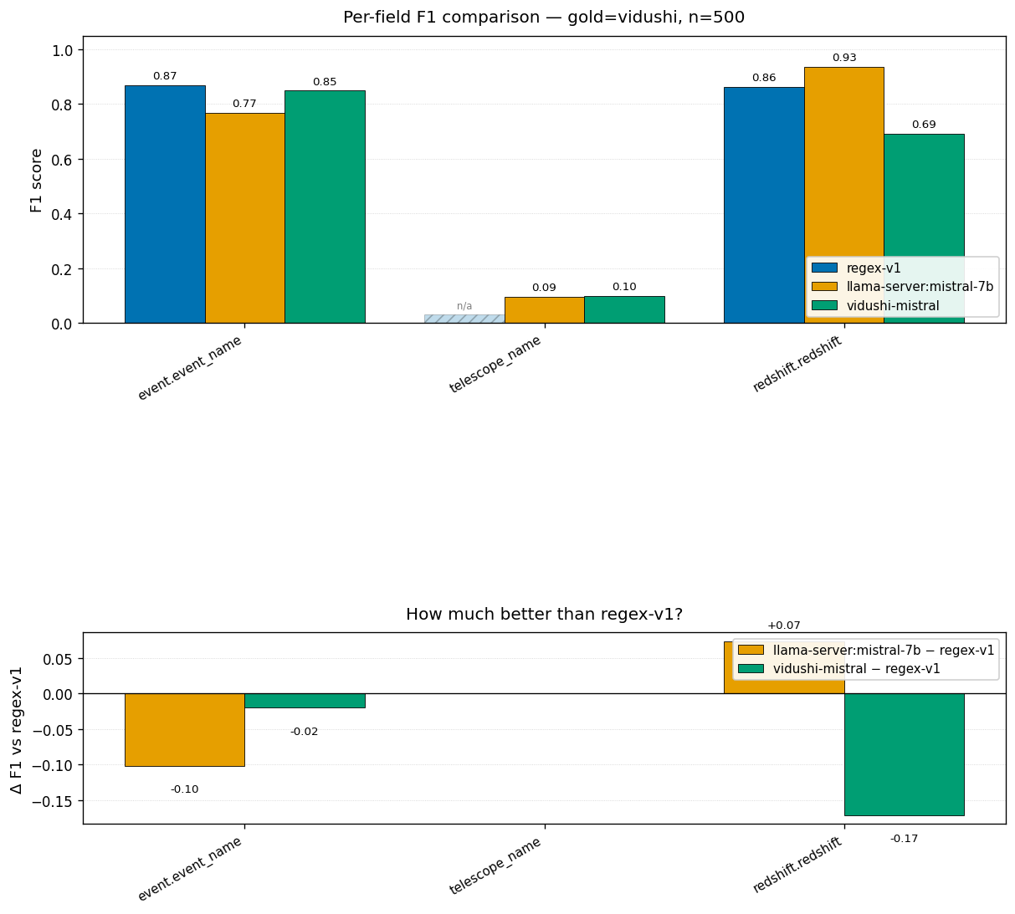
Figure 1.
Per-field F1 for the regex baseline, the grammar-constrained Mistral-7B extractor, and the published Mistral-7B predictions of S25 (top), and ΔF1 against the published baseline (bottom). Hatched bars denote a non-extracting extractor or zero gold support.

4. Deployment: Live Ingestion into SkyPortal
4.1. Methods
4.1.1. Event aggregation. — A transient is described across many Circulars: a discovery Circular carries the position, follow-ups carry the light curve. Circex reconstructs an event by walking the GCN cross-reference graph the extractor already recovers, then fuses the Circulars into one source — position preferring the refined optical counterpart over a coarse trigger box, photometry unioned and deduplicated with an epoch-tolerant key so the same observation reported at different epochs is not double-counted.
4.1.2. The consumer service. — A consumer subscribes to the gcn.circulars Kafka stream; for each incoming Circular it aggregates the event and posts the source, photometry, and classification into SkyPortal idempotently, tolerating individual failures without interrupting the stream.
4.2. Validation
The path was validated end-to-end against the live GCN stream and a production SkyPortal instance: a real gamma-ray burst was reconstructed from its Circulars and its multi-telescope, multi-band light curve posted, with idempotency confirmed on re-processing. The classification field is supplied by a lightweight Naive Bayes classifier trained on labels harvested from the archive, which abstains on Circulars carrying no supernova type — the failure mode that makes a naive regex classifier over-fire.
5. Discussion and Conclusion
Holding the model fixed and varying only the output channel isolates a result that we believe is favorable to the thesis of S25 rather than a correction to it: open 7B models are more capable at structured scientific extraction than free-form-generation numbers indicate, once the serialization bottleneck is removed. The +0.245 F1 recovered on redshift is obtained with the released weights, no fine-tuning, and no retrieval. Because the model is served locally, the marginal cost per Circular is zero and no text leaves the institution — removing both the recurring cost and the data-governance objection that would attach to a commercial API in a continuous observatory pipeline.
5.1. Challenges and Limitations
First, the redshift result is a lower bound on the constrained model’s advantage: the fields on which a language model should separate most sharply from regex — multi-row photometry tables, in-prose classification, unlabeled coordinates — are precisely those S25 did not extract, so no gold exists to score them. A hand-labeled set covering these fields is the natural next experiment. Second, constrained decoding must be engineered, not merely enabled: a naive schema-to-grammar conversion of a realistic Pydantic model does not work, and every unbounded degree of freedom becomes a way for a small model to exhaust its token budget (Appendix A). Third, telescope-name extraction remains weak for all extractors, reflecting a normalization gap between formal catalog codes and prose mentions rather than a failure of extraction as such.
Acknowledgments
We thank Sushant Sharma Chaudhary for deploying the Mistral-7B llama.cpp server used for the constrained-decoding experiments and for pointing us to grammar-constrained decoding through the server’s response_format interface, the mechanism on which the central result rests. The authors acknowledge the Minnesota Supercomputing Institute (MSI) at the University of Minnesota for providing the GPU resources that contributed to the results reported here. This work builds directly on S25 and uses their released Circulars archive, topic labels, and Swift-validated redshift table, together with the skyportal/timedomain-taxonomy controlled vocabulary. Portions of the SQLite/FTS indexer and the GCN poller were ported from the sjhend03/GCNMCP prototype with attribution.
References
Abbott, B. P., Abbott, R., Abbott, T. D., et al. 2017, ApJL, 848, L12
Gao, Y., Xiong, Y., Gao, X., et al. 2023, arXiv:2312.10997
Gehrels, N., Chincarini, G., Giommi, P., et al. 2004, ApJ, 611, 1005
Jiang, A. Q., Sablayrolles, A., Mensch, A., et al. 2023, arXiv:2310.06825
Lewis, P., Perez, E., Piktus, A., et al. 2020, in Advances in Neural Information Processing Systems, Vol. 33 (Red Hook, NY: Curran Associates), 9459
Sharma, V., Agarwala, R., Racusin, J. L., et al. 2026, ApJS, 283, 30
van der Walt, S., Crellin-Quick, A., & Bloom, J. S. 2019, JOSS, 4, 1247
Willard, B. T., & Louf, R. 2023, arXiv:2307.09702
Appendix A
Grammar Bounding
The grammar passed to the llama.cpp server is a bounded derivation of the CircularExtraction JSON Schema. Table 3 records the reduction. Beyond field pruning, array lengths are capped (maxItems: photometry 15, time_offsets 10), string lengths are capped (maxLength 128), and a hard generation limit (max_tokens 2048) provides a final backstop. Together these bound the grammar in all three dimensions — arrays, objects, and strings — each of which a small model will otherwise exploit until it exhausts the token budget.
Table 3
Schema reduction for grammar-constrained decoding.
Quantity | Full schema | Grammar (lean)
Serialized size (chars) | 21,350 | 5,786
Schema definitions ($defs) | 13 | 6
PhotometryExt fields | 18 | 7
Localization fields | 9 | 2

S25 code and data: https://github.com/GCN-Circulars-Analysis
pip install circex — https://pypi.org/project/circex/
SkyPortal: https://skyportal.io

