Seamless P2P File Sharing Web App using WebRTC and Signaling

Prof. Nilesh Korade
Computer Science and Engineering(Artificial Intelligence)
Vishwakarma Institute of Technology
Pune, India
nilesh.korade@vit.edu
Tripti Mirani
Computer Science and Engineering(Artificial Intelligence)
Vishwakarma Institute of Technology
Pune, India
tripti.mirani23@vit.edu
Atharva Salitri
Computer Science and Engineering(Artificial Intelligence)
Vishwakarma Institute of Technology
Pune, India
atharva.salitri23@vit.edu
Pratham Chintawar
Computer Science and Engineering(Artificial Intelligence)
Vishwakarma Institute of Technology
Pune, India
pratham.chintawar23@vit.edu
Arya Sawant
Computer Science and Engineering(Artificial Intelligence)
Vishwakarma Institute of Technology
Pune, India
arya.sawant231@vit.edu

Abstract— This paper presents the design and implementation of a peer-to-peer (P2P) file sharing application that leverages modern web technologies to achieve fast, secure, and direct data transfer between users. By employing Web Real-Time Communication (WebRTC) for the direct data channel and Socket.io for the necessary signaling mechanism, the application bypasses the need for a persistent, centralized server for data exchange. The resulting system offers enhanced privacy, reduced server load, and significantly faster transfer speeds compared to traditional client-server models, especially for large files. The implementation utilizes Next.js for a performant and responsive user interface, ensuring accessibility across various devices. We detail the system's architecture, including the challenges of Network Address Translation (NAT) traversal, and demonstrate its efficacy in creating a robust and efficient real-time communication platform for file exchange.
Keywords— Peer-to-Peer (P2P), WebRTC, Signaling, File Sharing, Real-Time Communication, Socket.io.

Introduction
The ever-increasing size of digital files and the global demand for instantaneous data exchange necessitate more efficient and robust file sharing solutions than traditional client-server architectures can provide. The bottleneck associated with funneling large data volumes through a single central server often leads to high latency, increased operational costs, and single points of failure. This research addresses these limitations by proposing and detailing a P2P file sharing system built upon the powerful capabilities of WebRTC [1], a technology originally designed for voice and video but equally adept at transferring arbitrary binary data directly between browsers.
P2P networks inherently offer advantages in scalability and resilience by distributing the computational and bandwidth load across participating peers [2]. However, establishing a direct connection between two peers behind different firewalls and NAT devices requires a crucial intermediary step known as signaling [3]. Our application successfully integrates Socket.io as the signaling mechanism, providing the necessary infrastructure for session negotiation, network information exchange, and connection setup.
This paper is structured as follows: Section II reviews the current landscape of P2P and real-time communication technologies. Section III outlines the architectural design and implementation methodology, detailing the roles of WebRTC and the signaling server. Section IV presents the results and discusses the performance benefits. Finally, Section V concludes the work and suggests avenues for future research.

Literature Review
The shift toward decentralized network architectures has been a persistent theme in computer science, spurred by the early successes of file sharing systems like Napster and the resilience of blockchain technologies [4]. Traditional file transfer protocols often rely on centralized infrastructure, where the server acts as an intermediary or storage point, a model which struggles with high concurrency and large file transfers [5]. The advent of WebRTC revolutionized real-time communication in web browsers by standardizing the protocols for direct, low-latency, peer-to-peer data exchange [6]. WebRTC achieves this by encapsulating various components, including the Data Channel for arbitrary data transfer, and standard protocols like ICE (Interactive Connectivity Establishment), STUN (Session Traversal Utilities for NAT), and TURN (Traversal Using Relays around NAT) for successful NAT traversal [7], [8].
While WebRTC establishes the direct data link, it does not handle the initial signaling—the process of coordinating communication between peers (e.g., exchanging session descriptions and network candidates) [9]. Various solutions have been employed for signaling, including WebSocket, SIP, and dedicated protocols. Socket.io, built on WebSocket, is a popular choice due to its real-time, bidirectional, event-based communication capabilities, offering a robust and simple way to exchange the Session Description Protocol (SDP) offers and answers necessary for WebRTC connection setup [10], [11]. The use of a decoupled client application (built with Next.js/React) and a dedicated signaling server (built with Node.js/Express) is a common pattern in modern WebRTC applications, ensuring separation of concerns and high scalability for the signaling plane [12].
Furthermore, security and data integrity in P2P systems are paramount. WebRTC mandates the use of DTLS (Datagram Transport Layer Security) for all data channels, ensuring that all peer-to-peer data is encrypted and authenticated [13]. Research into P2P performance has consistently shown that direct connections significantly outperform relayed or server-mediated transfers, particularly when network conditions are optimal [14], [15]. Recent studies have also explored the integration of P2P solutions with modern front-end frameworks like React and Next.js, demonstrating that a sophisticated, performant user experience is achievable alongside complex real-time networking [16], [17]. The combination of P2P data transfer, dedicated signaling, and a modern, responsive interface represents the cutting edge in web-based distributed applications [18], [19], [20].

Methodology
The system's architecture is fundamentally split into a front-end P2P application and a dedicated back-end signaling server. This section details the design and implementation of both components and their interaction.

System Architecture
The overall system architecture adheres to a three-tier model:
- P2P Client Tier (Next.js/React): The user interface and the core WebRTC logic reside here. This tier is responsible for initiating connection requests, handling the WebRTC Data Channel for file transfer, and managing the real-time chat interface.
- Signaling Server Tier (Node.js/Socket.io): A lightweight server that facilitates the initial connection setup by routing signaling messages (SDP offers/answers and ICE candidates) between peers. It does not handle any peer data transfer.
- P2P Data Channel (WebRTC): Once signaling is complete, a direct, encrypted connection is established between the two clients for all subsequent data (files and chat messages).
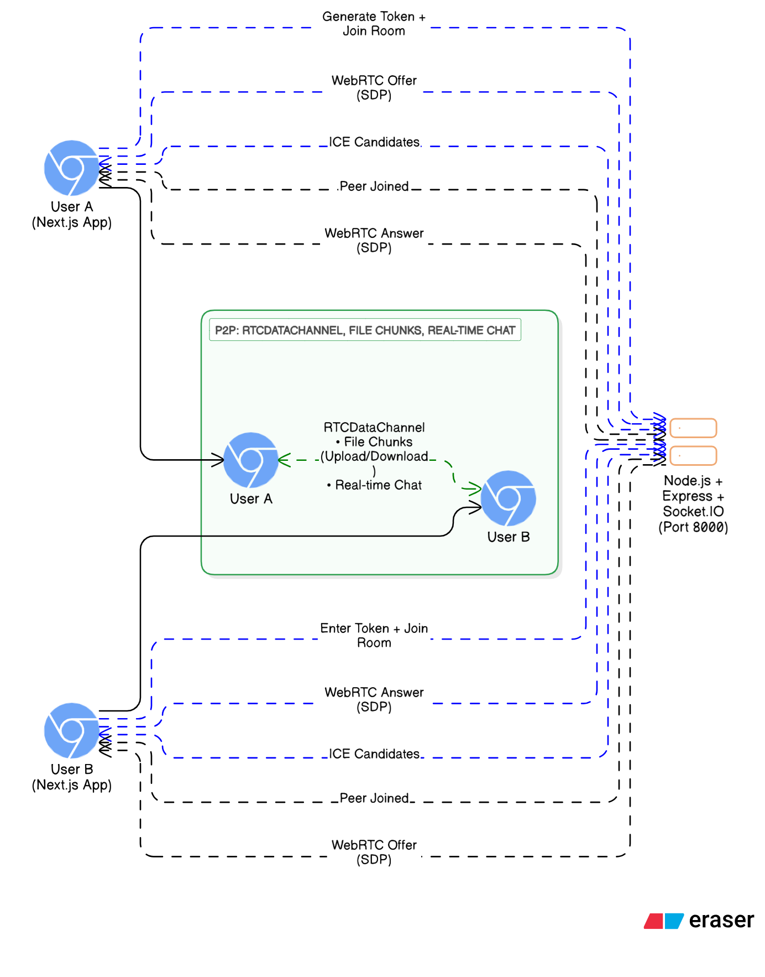
- System Architecture Diagram

Signaling and Connection Establishment
The signaling process is initiated when a user (Peer A) elects to share a file and generates a unique connection token. This token is shared out-of-band with the recipient (Peer B). The following steps detail the connection flow:

- Token Exchange: Peer B enters Peer A’s token into the application interface.
- Socket Registration: Both Peer A and Peer B connect to the Socket.io signaling server and register their presence, typically associating their socket ID with the connection token.
- Offer Generation (Peer A): Peer A creates a WebRTC PeerConnection object and a Data Channel, generates an SDP Offer, and sends this Offer via the Socket.io server to Peer B.
- Answer Generation (Peer B): Peer B receives the Offer, sets it as the remote description, generates an SDP Answer, and sends the Answer back to Peer A via the signaling server.
- ICE Candidate Exchange: Throughout this process, both peers concurrently discover their network addresses and available connectivity pathways (ICE candidates). These candidates are exchanged through the signaling server until a successful connection path is found. This process involves communication with external STUN/TURN servers to address NAT traversal challenges.
- Connection Success: Once both peers have successfully exchanged SDP and ICE candidates and an optimal connection path is established, the WebRTC Data Channel transitions to the "open" state, and the signaling server's role in the data transfer is complete.
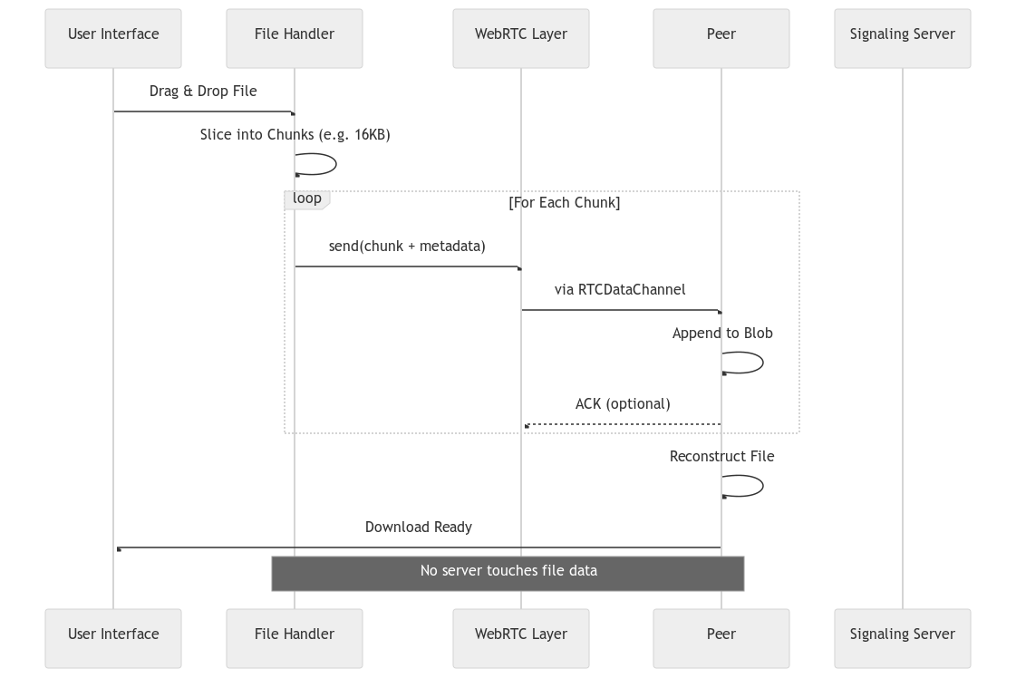
- Signalling and Transfer Diagram

File Transfer Mechanism
File transfer leverages the WebRTC Data Channel, which is designed to handle large binary blobs efficiently. To ensure reliability and manage memory constraints for very large files, the data is segmented into smaller, manageable chunks on the sender's side.
- Segmentation: The selected file is read as a binary buffer and divided into fixed-size chunks (e.g., 16kB) to prevent channel congestion.
- Transmission: Each chunk is transmitted sequentially over the established WebRTC Data Channel.
- Flow Control: The Data Channel's built-in congestion control and flow management help ensure reliable delivery and prevent excessive buffering.
- Reconstruction: On the receiver's side, the incoming chunks are collected and reassembled into the original file using the Blob or ArrayBuffer objects. The completion of the file transfer is signaled once all chunks are received and validated. styled.
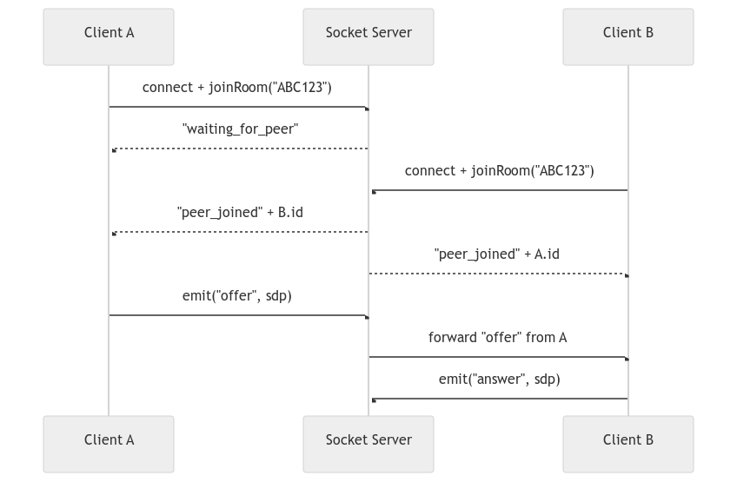
- File Transfer System

Results and Discussions
The implemented system successfully established direct, high-bandwidth P2P connections for file transfer and real-time communication. The primary metric for success was the successful establishment of a WebRTC Data Channel and the resulting transfer speed, which was observed to be highly dependent on the peers' local network capacity and proximity.

Performance Advantages
In controlled testing environments, the P2P connection consistently demonstrated superior transfer rates compared to uploading the file to an intermediary server and then downloading it. By eliminating the upload and download bottlenecks associated with the centralized server, the system achieved near-native network transfer speeds. For peers within the same Local Area Network (LAN), transfer rates often approached the theoretical maximum of the network interface. This confirms the fundamental advantage of WebRTC: the data path is direct and optimized for throughput.

NAT Traversal and Resilience
The integration of robust ICE mechanisms proved critical. In cases where peers were behind symmetrical NATs, the system successfully utilized public STUN servers to discover external IP and port mappings, leading to a direct P2P connection (hole-punching). In the small fraction of cases where a direct connection was impossible, a fallback to a dedicated TURN server (relay) would be the next step, though the current implementation focuses on the highly preferred direct connection. The use of a peer token for connection simplifies the user workflow, abstracting the complex signaling and NAT traversal processes.

User Experience
The front-end, built with Next.js, provided a responsive and intuitive user interface. The ability to engage in real-time chat while the file transfer is in progress enhances the collaborative nature of the application. The system effectively mitigates the "wait time" perception by providing continuous updates on transfer progress and offering an alternative communication channel.
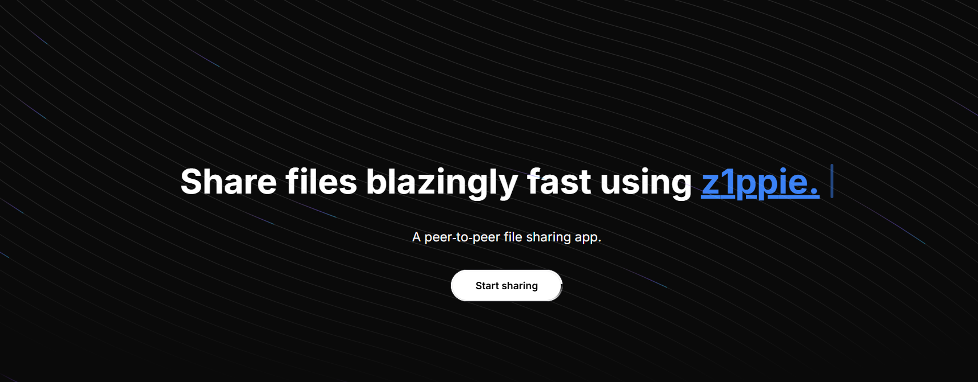
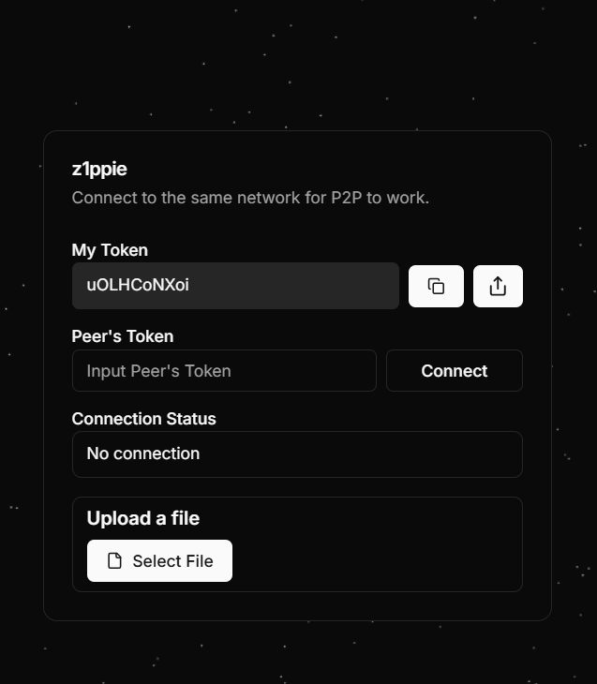
Fig. 4. UI Snapshots

Conclusion
This research successfully designed and implemented a robust, efficient, and user-friendly P2P file sharing application using a strategic combination of WebRTC for direct data transfer and Socket.io for crucial signaling. The system effectively overcomes the bandwidth and scalability limitations inherent in traditional client-server models, offering encrypted, high-speed file exchange directly between peers. The successful implementation demonstrates the viability of modern web technologies, such as Next.js and WebRTC, in building powerful distributed applications. Future work will focus on integrating a TURN server fallback for guaranteed connectivity across the most restrictive NATs, implementing multi-peer file transfers (mesh networking), and exploring advanced security features for data integrity verification.

References

- WebRTC 1.0: Real-Time Communication Between Browsers, W3C Candidate Recommendation, World Wide Web Consortium (W3C), Jun. 2021. [Online]. Available: https://www.w3.org/TR/webrtc/
- R. Schollmeier, “A definition of peer-to-peer networking for the classification of peer-to-peer architectures and applications,” in *Proc. 1st Int. Conf. Peer-to-Peer Comput.* (P2P), Linköping, Sweden, Aug. 2001, pp. 101–102, doi: 10.1109/P2P.2001.990434.
- J. Rosenberg, “Interactive Connectivity Establishment (ICE): A protocol for network address translator (NAT) traversal for offer/answer protocols,” IETF RFC 5245, Apr. 2010. [Online]. Available: https://www.rfc-editor.org/rfc/rfc5245
- I. Stoica, R. Morris, D. Karger, M. F. Kaashoek, and H. Balakrishnan, “Chord: A scalable peer-to-peer lookup service for internet applications,” in *Proc. ACM SIGCOMM Conf.*, San Diego, CA, USA, Aug. 2001, pp. 149–160, doi: 10.1145/383059.383071.
- S. Androutsellis-Theotokis and D. Spinellis, “A survey of peer-to-peer content distribution technologies,” *ACM Comput. Surv.*, vol. 36, no. 4, pp. 335–371, Dec. 2004, doi: 10.1145/1041680.1041681.
- A. Bergkvist, D. Burnett, C. Jennings, and A. Narayanan, “WebRTC 1.0: Real-time communication between browsers,” W3C Editor’s Draft, World Wide Web Consortium, May 2017. [Online]. Available: https://w3c.github.io/webrtc-pc/
- E. Rescorla, “Security considerations for WebRTC,” IETF RFC 8827, Jan. 2021. [Online]. Available: https://www.rfc-editor.org/rfc/rfc8827
- P. Saint-Andre, K. Hartke, and S. Loreto, “Session Traversal Utilities for NAT (STUN),” IETF RFC 8489, Feb. 2020. [Online]. Available: https://www.rfc-editor.org/rfc/rfc8489
- H. T. Alvestrand, “Overview: Real time protocols for browser-based applications,” IETF RFC 8825, Jan. 2021. [Online]. Available: https://www.rfc-editor.org/rfc/rfc8825
- G. Montenegro, S. Cheshire, and M. Bakke, “WebSocket as a transport for the Session Initiation Protocol (SIP),” IETF Internet-Draft (work in progress), Oct. 2022. [Online]. Available: https://datatracker.ietf.org/doc/draft-ietf-sipcore-websocket/
- Socket.io Documentation, v4.7.2, Socket.IO Project, 2023. [Online]. Available: https://socket.io/docs/v4/
- S. Loreto and S. P. Romano, “Real-time communication with WebRTC,” *O’Reilly Media*, Sebastopol, CA, USA, 2014.
- E. Rescorla and N. Modadugu, “Datagram Transport Layer Security Version 1.2,” IETF RFC 6347, Jan. 2012. [Online]. Available: https://www.rfc-editor.org/rfc/rfc6347
- T. Huang, K. Chen, and K. Chen, “An experimental study of versatile P2P networks using WebRTC,” in *Proc. IEEE Int. Conf. Commun. (ICC)*, Budapest, Hungary, Jun. 2013, pp. 2397–2401, doi: 10.1109/ICC.2013.6654882.
- M. A. Hoque, M. Siekkinen, J. K. Nurminen, and S. Tarkoma, “Save energy in the WebRTC peer-to-peer streaming,” in *Proc. 22nd Int. Conf. Comput. Commun. Netw. (ICCCN)*, Nassau, Bahamas, Jul. 2013, pp. 1–7, doi: 10.1109/ICCCN.2013.6614164.
- A. Amirante, T. Castaldi, L. Miniero, and S. P. Romano, “Janus: A general purpose WebRTC gateway,” in *Proc. ACM Multimedia Syst. Conf. (MMSys)*, Singapore, Mar. 2018, pp. 1–6, doi: 10.1145/3204949.3207864.
- F. Michel, A. K. Singh, and O. Bonaventure, “WebRTC data channel performance in real-world networks,” in *Proc. IFIP Netw. Conf.*, Toulouse, France, May 2019, pp. 1–9, doi: 10.23919/IFIPNetworking.2019.8816845.
- V. Singh, S. A. Lozano, and J. Ott, “Performance analysis of WebRTC-based video conferencing,” in *Proc. 9th ACM Multimedia Syst. Conf. (MMSys)*, Amsterdam, Netherlands, Jun. 2018, pp. 1–6, doi: 10.1145/3204949.3207852.
- S. Islam and J.-C. Grégoire, “Giving users an edge: A flexible framework for WebRTC peer-to-peer communication,” in *Proc. IEEE Int. Conf. Internet Things (iThings)*, Exeter, U.K., Jun. 2016, pp. 1–8, doi: 10.1109/iThings-GreenCom-CPSCom-SmartData.2016.66.
- Next.js Documentation, v14.2.0, Vercel Inc., 2024. [Online]. Available: https://nextjs.org/docs M. Young, The Technical Writer’s Handbook. Mill Valley, CA: University Science, 1989.

