**AI LAB ASSIGNMENT 5**

**Name: Atharva Salitri PRN: 12310120**

**Div : CSAI B Batch: 2 Roll No: 37**

**Implement Basics of PROLOG**

**CODE: (Animals, Mammals, Birds)**

% Facts

% Animals

animal(lion).

animal(tiger).

animal(elephant).

animal(dog).

animal(cat).

animal(eagle).

animal(sparrow).

animal(shark).

% Mammals

mammal(lion).

mammal(tiger).

mammal(elephant).

mammal(dog).

mammal(cat).

% Birds

bird(eagle).

bird(sparrow).

% Rules

% All mammals are animals

is_animal(X) :- mammal(X).

is_animal(X) :- bird(X).

% Check if an animal is a mammal

is_mammal(X) :- mammal(X).

% Check if an animal is a bird

is_bird(X) :- bird(X).

% Find all animals

all_animals(Animals) :- findall(X, animal(X), Animals).

% Find all mammals

all_mammals(Mammals) :- findall(X, mammal(X), Mammals).

% Find all birds

all_birds(Birds) :- findall(X, bird(X), Birds).

% Query Examples

% 1. Check if something is an animal

% ?- is_animal(dog).

% Expected output: true.

% 2. Check if something is a mammal

% ?- is_mammal(lion).

% Expected output: true.

% 3. Check if something is a bird

% ?- is_bird(eagle).

% Expected output: true.

% 4. List all animals

% ?- all_animals(Animals).

% Expected output: Animals = [lion, tiger, elephant, dog, cat, eagle, sparrow, shark].

% 5. List all mammals

% ?- all_mammals(Mammals).

% Expected output: Mammals = [lion, tiger, elephant, dog, cat].

% 6. List all birds

% ?- all_birds(Birds).

% Expected output: Birds = [eagle, sparrow].

**OUTPUT:**

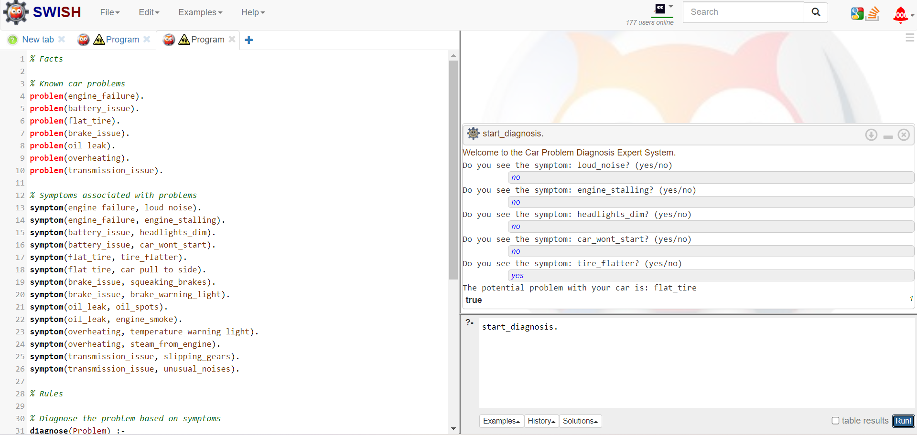

Facts, Rules, Queries:



