**AI LAB ASSIGNMENT 6**

**Name: Atharva Salitri PRN: 12310120**

**Div : CSAI B Batch: 2 Roll No: 37**

**Implement Expert System**

**CODE: (Car Diagnosis)**

% Facts

% Known car problems

problem(engine_failure).

problem(battery_issue).

problem(flat_tire).

problem(brake_issue).

problem(oil_leak).

problem(overheating).

problem(transmission_issue).

% Symptoms associated with problems

symptom(engine_failure, loud_noise).

symptom(engine_failure, engine_stalling).

symptom(battery_issue, headlights_dim).

symptom(battery_issue, car_wont_start).

symptom(flat_tire, tire_flatter).

symptom(flat_tire, car_pull_to_side).

symptom(brake_issue, squeaking_brakes).

symptom(brake_issue, brake_warning_light).

symptom(oil_leak, oil_spots).

symptom(oil_leak, engine_smoke).

symptom(overheating, temperature_warning_light).

symptom(overheating, steam_from_engine).

symptom(transmission_issue, slipping_gears).

symptom(transmission_issue, unusual_noises).

% Rules

% Diagnose the problem based on symptoms

diagnose(Problem) :-

symptom(Problem, Symptom),

ask_symptom(Symptom).

% Ask user about a symptom

ask_symptom(Symptom) :-

format('Do you see the symptom: ~w? (yes/no) ', [Symptom]),

read(Response),

(Response == yes -> true; fail).

% Start the diagnosis process

start_diagnosis :-

write('Welcome to the Car Problem Diagnosis Expert System.'), nl,

(diagnose(Problem) ->

format('The potential problem with your car is: ~w', [Problem])

;

write('No problems detected based on the symptoms provided.')).

% To start the diagnosis, call:

% ?- start_diagnosis.

**OUTPUT:**

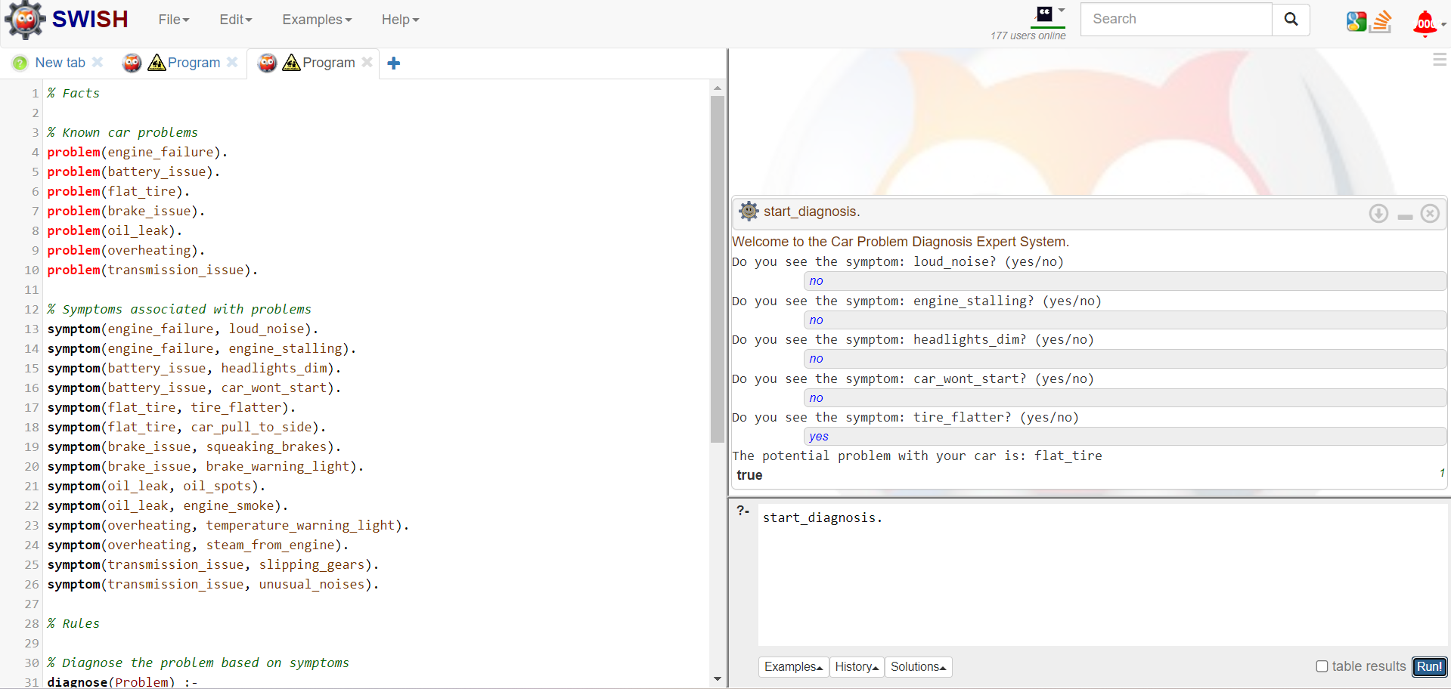

Facts, Rules, Queries:



