**Name: Atharva Salitri Division: CSAI B2**

**Roll No.: 37 PRN: 12310120**

**Subject: DBMS Lab Assignment 1**

**Title: DDL Commands**

**Question:**

-- LAB PRACTICE ASSIGNMENT:

-- 1. Create a table EMPLOYEE with following schema:

-- (Emp_no, E_name, E_address, E_ph_no, DoB,Dept_no,

-- Dept_name,Job_id , Salary)

-- 2. Add a new column; HIREDATE to the existing relation.

-- 3. Change the datatype of JOB_ID from char to varchar2.

-- 4. Change the name of column/field Emp_no to E_no.

-- 5. Modify the column width of the job field of emp table

**Code:**

CREATE TABLE EMPLOYEE (

Emp_no INT AUTO_INCREMENT KEY,

E_name VARCHAR(100),

E_address VARCHAR(255),

E_ph_no INT(10),

DoB VARCHAR(10),

Dept_no INT(3),

Dept_name VARCHAR(50),

Job_id CHAR,

Salary INT(30)

);

INSERT INTO EMPLOYEE(E_name, E_address, E_ph_no, DoB, Dept_no, Dept_name, Job_id, Salary)

VALUES ('Atharva Salitri','Pune',1234567890,'17/03/2005',10,'CSE_AI','I',10000000);

ALTER TABLE EMPLOYEE

ADD HIREDATE VARCHAR(10);

ALTER TABLE EMPLOYEE

MODIFY COLUMN Job_id VARCHAR(2);

ALTER TABLE EMPLOYEE

RENAME COLUMN Emp_no TO E_no;

ALTER TABLE EMPLOYEE

MODIFY COLUMN Job_id VARCHAR(30);

SELECT * FROM EMPLOYEE;

**OUTPUT:**

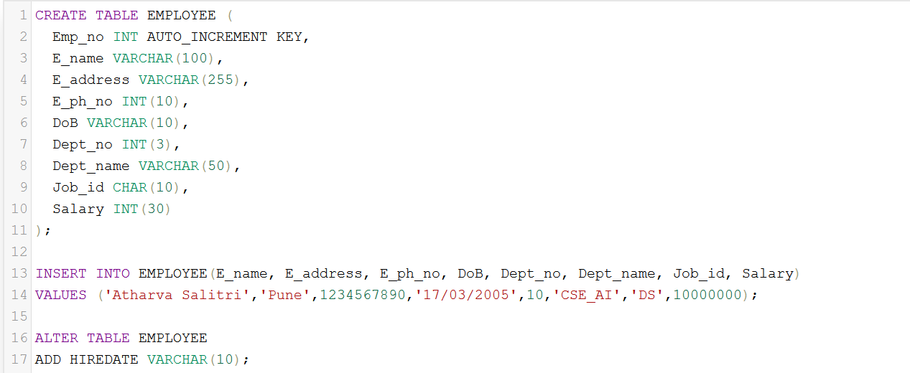

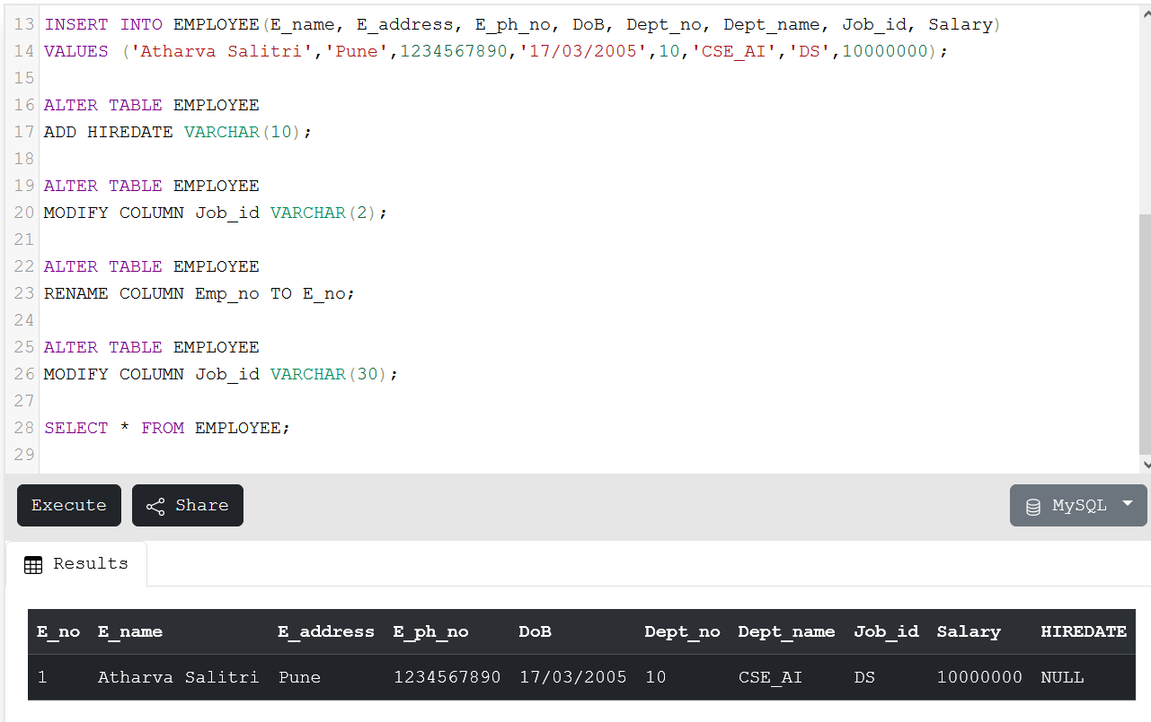

**Updating HIREDATE:**

