**Name: Atharva Salitri Division: CSAI B2**

**Roll No.: 37 PRN: 12310120**

**Subject: DBMS Lab Assignment 3**

**Title: DDL: Views**

**Complete Code:**

CREATE TABLE Student_Details (

id INT(11),

name VARCHAR(30),

address VARCHAR(80)

);

CREATE TABLE Student_Marks (

id INT(11),

name VARCHAR(30),

marks INT(50),

age INT(30)

);

INSERT INTO Student_Details

VALUES

(1, 'Ram', 'Pune'),

(2, 'Shyam', 'Pune'),

(3, 'Vijay', 'Nashik'),

(4, 'Vinay', 'Nagar'),

(5, 'Sameer', 'Nagar');

INSERT INTO Student_Marks

VALUES

(1, 'Ram', 89, 18),

(2, 'Shyam', 76, 19),

(3, 'Vijay', 83, 19),

(4, 'Vinay', 80, 18),

(5, 'Sameer', 67, 18);

CREATE VIEW v2 AS

SELECT name,address

FROM Student_Details;

CREATE VIEW v3 AS

SELECT id,name

FROM Student_Details

ORDER BY name;

CREATE VIEW Marksview AS

SELECT Student_Details.id,Student_Details.name, Student_Marks.marks

FROM Student_Details,Student_Marks

WHERE Student_Details.name=Student_Marks.name;

CREATE VIEW PoorPerformer AS

SELECT MIN(marks)

FROM Marksview;

CREATE VIEW BestPerformer AS

SELECT MAX(marks)

FROM Marksview;

CREATE OR REPLACE VIEW Marksview

AS SELECT Student_Details.id, Student_Details.name, Student_Marks.marks, Student_Marks.age

FROM Student_Details, Student_Marks

WHERE Student_Details.name=Student_Marks.name;

INSERT INTO v2(name,address) VALUES("Riya","Mumbai");

DELETE FROM v2 WHERE name="Vinay";

**OUTPUT:**

CREATE TABLE Student_Marks (

id INT(11),

name VARCHAR(30),

marks INT(50),

age INT(30)

);

DESC Student_Marks;

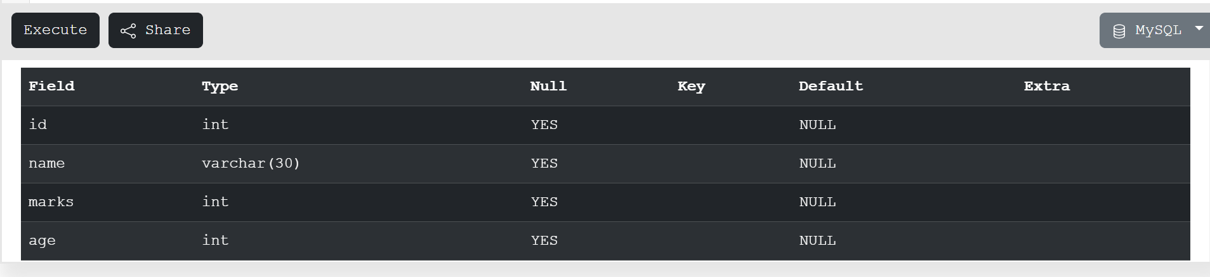

CREATE TABLE Student_Details (

id INT(11),

name VARCHAR(30),

address VARCHAR(80)

);

DESC Student_Details;

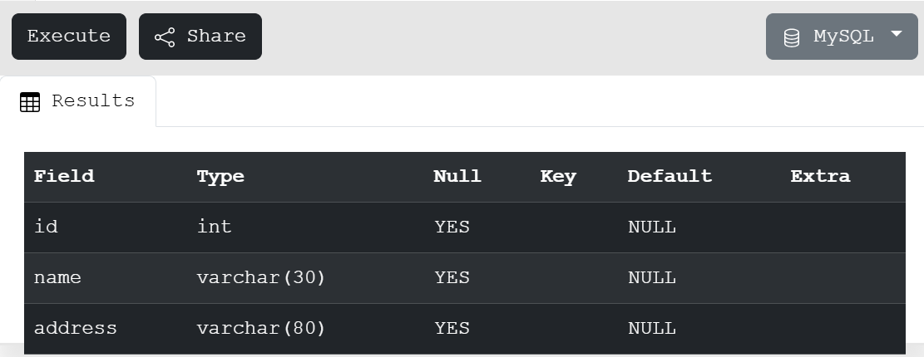

INSERT INTO Student_Marks

VALUES

(1, 'Ram', 89, 18),

(2, 'Shyam', 76, 19),

(3, 'Vijay', 83, 19),

(4, 'Vinay', 80, 18),

(5, 'Sameer', 67, 18);

SELECT * FROM Student_Marks;

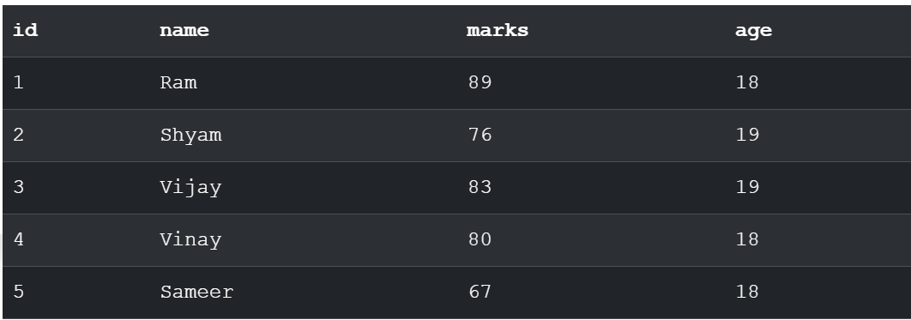

INSERT INTO Student_Details

VALUES

(1, 'Ram', 'Pune'),

(2, 'Shyam', 'Pune'),

(3, 'Vijay', 'Nashik'),

(4, 'Vinay', 'Nagar'),

(5, 'Sameer', 'Nagar');

SELECT * FROM Student_Details;

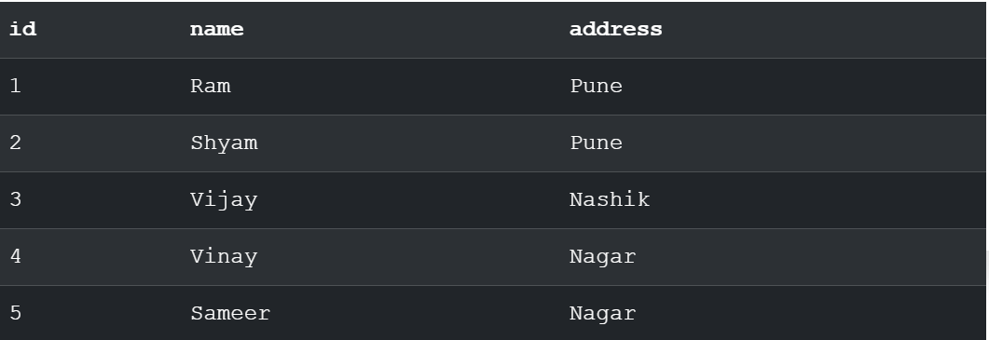

CREATE VIEW v2 AS

SELECT name,address

FROM Student_Details;

SELECT * FROM v2;

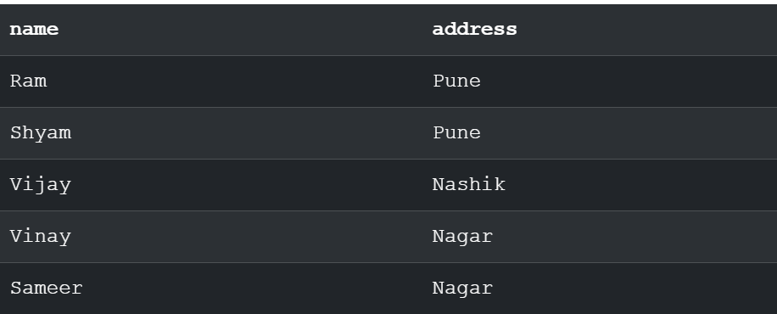

CREATE VIEW v3 AS

SELECT id,name

FROM Student_Details

ORDER BY name;

SELECT * FROM v3;

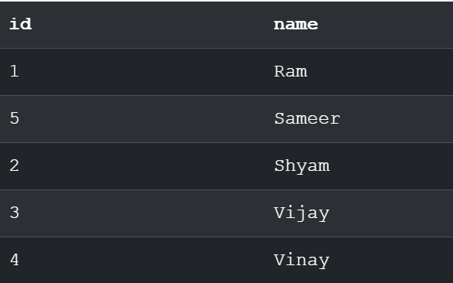

CREATE VIEW Marksview AS

SELECT Student_Details.id,Student_Details.name, Student_Marks.marks

FROM Student_Details,Student_Marks

WHERE Student_Details.name=Student_Marks.name;

SELECT * FROM Marksview;

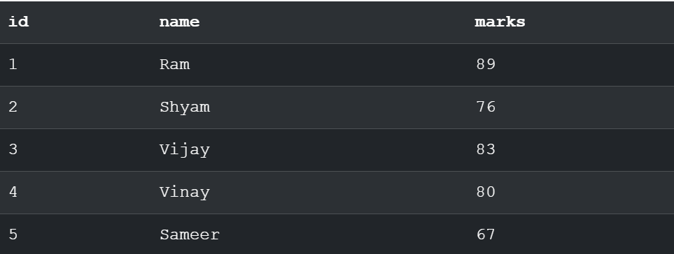

CREATE VIEW PoorPerformer AS

SELECT MIN(marks)

FROM Marksview;

SELECT * FROM PoorPerformer;



CREATE VIEW BestPerformer AS

SELECT MAX(marks)

FROM Marksview;

SELECT * FROM BestPerformer;



DROP VIEW v3;

SELECT * FROM v3;



CREATE OR REPLACE VIEW Marksview

AS SELECT Student_Details.id, Student_Details.name, Student_Marks.marks, Student_Marks.age

FROM Student_Details, Student_Marks

WHERE Student_Details.name=Student_Marks.name;

SELECT * FROM Marksview;

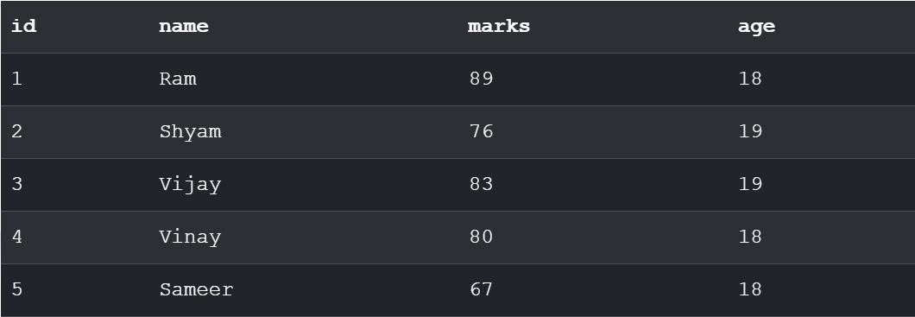

INSERT INTO v2(name,address) VALUES("Riya","Mumbai");

SELECT * FROM v2;

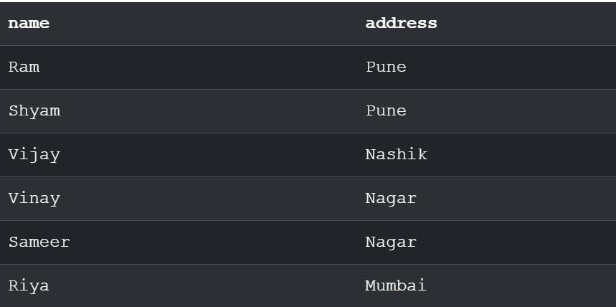

DELETE FROM v2 WHERE name="Vinay";

SELECT * FROM v2;

