DBMS

Lab 2: Implementation of DML commands

Name: Prasanna Khebade

Branch: SY CS AI

Div: B Roll no: 23

PRN: 12311687

Code:

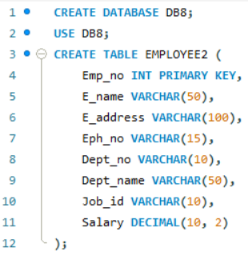

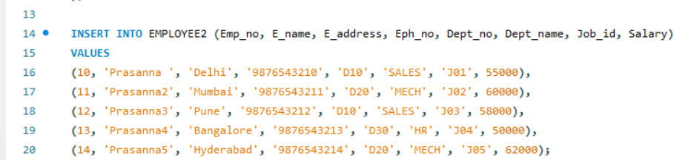

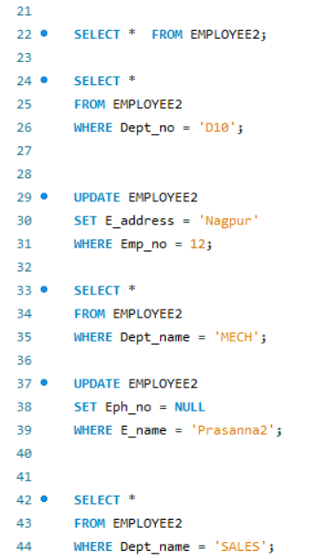

Output Tables:

1. Display all information of table:

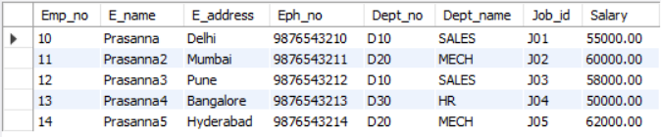

2.Display record of each employee who works in department D10:

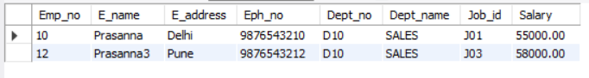

3.Update the City of Emp_no 12 with current city as nagpur:

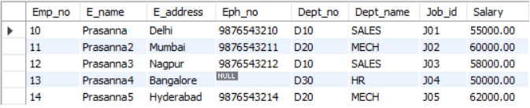

4.Display record of each employee who works in department MECH:

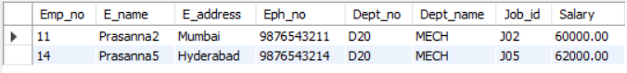

5.DELETE the phone number of employee Prasanna4:

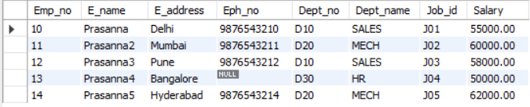

6.Display the complete record of employees working in SALES Department:

