Name : Atharva Salitri
Division : TY CSAI-B
Batch : B2
Roll No. : 029
PRN : 12310120
Subject : Computer Network Technology

Assignment No:1

Title: Setting up a small network (2PC/4 PC) and configuration for sharing resources.
Problem Statement: Setting up small wired computer network: Set up a small wired network of 2 to 4 computers using Hub/Switch/. It includes Preparation of Cables and setting up wired network.
Course Objective: To learn transmission mediums, networking devices and topologies used in the Internet.
Course Outcome: Select topology, essential components of physical layer and networking devices to design computer networks.
Tools Required: Computer, LAN Cards, RJ-45 Connectors, Hub/Switch, CAT-5 Cable, Cable tester, Crimping tool, etc.
Theory:
1. Introduction:
Computer Networks, the widespread sharing of information among groups of computers and their users, a central part of the information age. The popular adoption of the personal computer (PC) and the local area network (LAN) during the 1980s has led to the capacity to access information on a distant database; download an application from overseas; send a message to a friend in a different country; and share files with a colleague—all from a personal computer. The networks that allow all this to be done so easily are sophisticated and complex entities. They rely for their effectiveness on many cooperating components. The design and deployment of the worldwide computer network can be viewed as one of the great technological wonders of recent decades.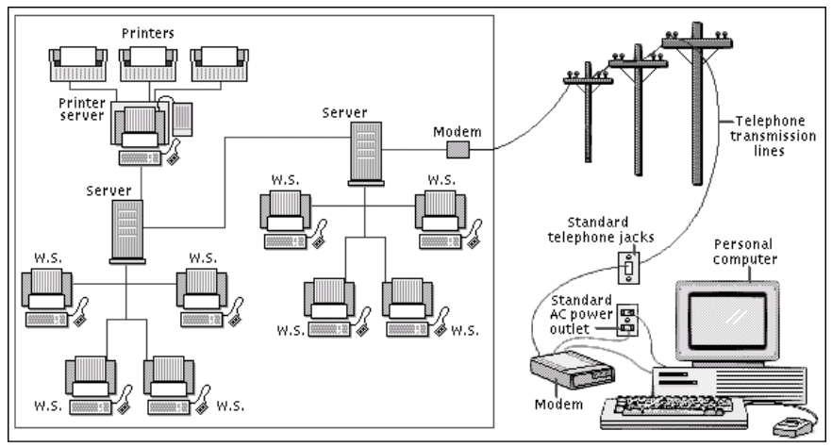
Fig 1.1. Computer Network
Networks are connections between groups of computers and associated devices that allow users to transfer information electronically. The local area network shown on the left is representative of the setup used in many offices and companies. Individual computers, called work stations (WS), communicate to each other via cable or telephone line linking to servers. Servers are computers exactly like the WS, except that they have an administrative function and are devoted entirely to monitoring and controlling WS access to part or all of the network and to any shared resources (such as printers). The red line represents the larger network connection between servers, called the backbone; the blue line shows local connections. A modem (modulator/demodulator) allows computers to transfer information across standard telephone lines. Modems convert digital signals into analogue signals and back again, making it possible for computers to communicate, or network, across thousands of miles.
2. Network Devices:
2.1 NIC (Network Interface Card): Each computer includes the File server or a Network will have a card plugged in the PCI Expunction slot or will have on-board NIC (Network Interface Card), which will provideConnectivity among the workstation in the network through cables.
Types of Cards:  Arc net card (2.5mbits/sec)  Ethernet card (10/100mbps)  Token Ring card (4-16mbits/sec) | 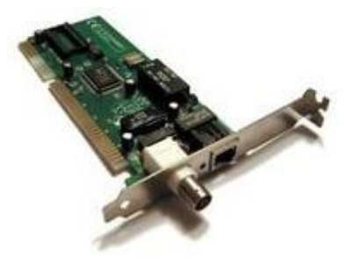  Fig 1.2. NIC Card

2.2 Hub
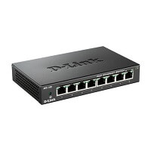
Fig 1.3. Hub
Hub is a central device that splits the network connection into multiple devices. When computer requests for information from a computer, it sends the request to the Hub. Hub distributes this request to all the interconnected computers.
There are three types of the hub that are given below:
- Passive Hub
- Active Hub
- Intelligent Hub
Passive Hub: The passive hubs are the connection point for wires that helps to make the physical network. It is capable of determining the bugs and faulty hardware. Simply, it accepts the packet over a port and circulates it to all ports. It includes connectors (10base-2 port and RJ-45) that can be applied as a standard in your network. This connector is connected to all local area network (LAN) devices. Additionally, the advanced passive hubs have AUI ports, which are connected as the transceiver according to the network design.
Active Hub: As compared to a passive hub, it includes some additional features. It is able to monitor the data sent to the connected devices. It plays an important role between the connected devices with the help of store technology, where it checks the data to be sent and decides which packet to send first.
It has the ability to fix the damaged packets when packets are sending, and also able to hold the direction of the rest of the packets and distribute them. If a port receives a weak signal, but still it is readable, then the active hub reconstructs the weak signal into a stronger signal before its sending to other ports. It can boost the signal if any connecting device is not working in the network. Therefore, it helps to make the continuity of services in LAN.
Intelligent Hub: It is a little smarter than passive and active hubs. These hubs have some kinds of management software that help to analyze the problem in the network and resolve them. It is beneficial to expend the business in networking; the management can assign users that help to work more quickly and share a common pool efficiently by using intelligent hubs. However, it offers better performance for the local area network. Furthermore, with any physical device, if any problem is detected, it is able to detect this problem easily.
Features of Hub
- It acts with shared bandwidth and broadcasting.
- It includes only one collision domain and broadcast domain.
- It works at the physical layer of the OSI model and also offers support for half-duplex transmission mode.
- It cannot create a virtual LAN and does not support spanning tree protocol.
- Furthermore, mainly packet collisions occur inside the hub.
- It also has a feature of flexibility, which means it includes a high transmission rate to different devices.
Applications of Hub
The important applications of a hub are given below:
- Hub is used to create small home networks.
- It is used for network monitoring.
- They are also used in organizations to provide connectivity.
- It can be used to create a device that is available thought out of the network.

2.3 Bridge
A Bridge is a kind of networking device that interconnects two or more networks together by dividing LAN into different segments. For this purpose it uses forwarding database or a bridge table. Unlike hubs, bridges does not simply broadcast traffic it effectively manages and it broadcasts traffic to network segments. Moreover it functions at datalink layer of the OSI model.
A bridge can be used in computer networks to interconnect two LANs together and separate network segments. Recall that a segment is a section of a network separated by bridges, switches, and routers. The bridge is a layer 2 device in the OSI model, meaning that it uses the MAC address information to make decisions regarding forwarding data packets. Only the data that needs to be sent across the bridge to the adjacent network segment is forwarded. This makes it possible to isolate or segment the network data traffic
Advantages of Bridges
- Network Extend : Sometimes bridges act as repeaters to extend a network. Networks with different architectures can be connected together using bridges.
- Increased Bandwidth: Few of the nodes present on a network share a separate collision domain. For these individual nodes, bridges increases bandwidth.
- High Reliability: Overall the network reliability is basically high in a bridge which makes it easier to maintain the network. And also network congestion can be reduced by dividing LAN into small segments.
- Frame Buffering : Different segments uses different MAC protocols. As a result it creates frame buffers. Therefore, bridges works to interconnect different segments.
- Protocol Transparency : Bridges generally functions at the MAC layer. This makes higher levels of protocol transparent.

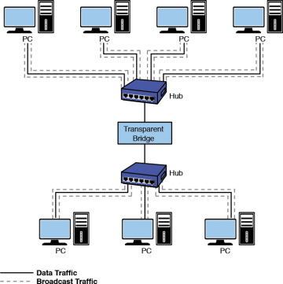
Fig 1.4. Bridge
Disadvantages of Bridges
- Cost: On average a bridge costs more than the hub and repeaters. That is the reason why it is only preferred when there is LAN network traffic load. In other situations of variable data load it is advisable to use either a hub or a repeater.
- Speed : A bridge does more buffering of frames and introduce more relays. This makes them slower compare to a repeater.
- Network Performance : Since bridges make extra processing by viewing all of the MAC addresses, they can potentially downgrade network performance.
- Broadcast Filtering : Bridges cannot individually filter the broadcast traffic. They simply forward broadcast packets.
- Broadcast Storms : Another downfall of simply forwarding broadcast traffic is that they can situation known as broadcast storms. Broadcast storms are nothing but high amount of broadcast traffic.

2.4 Switches
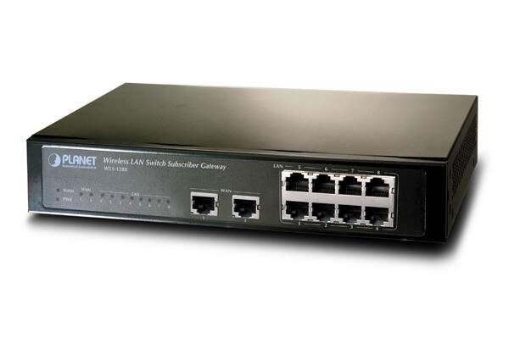
Fig 1.5. Switch
Switch is a networking device that groups all the devices over the network to transfer the data to another device. A switch is better than Hub as it does not broadcast the message over the network, i.e., it sends the message to the device for which it belongs to. Therefore, we can say that switch sends the message directly from source to the destination. It is networking device which transfers data only to the host where it is being addressed. It checks the destination address to route the packet appropriately. Following are features of the network switches.
- It operates at layer-2 (data link layer).
- It is available in various configurations and as per data transfer speeds such as 10/100/1000 Mbps or 10/100 Gbps.
- Operates in full duplex mode
- Packet collision is avoided due to port to port data transmission.
Advantages of Switches
Following are the benefits or advantages of Switches:
- They increase the available bandwidth of the network.
- They help in reducing workload on individual host PCs.
- They increase the performance of the network.
- Networks which use switches will have less frame collisions. This is due to the fact that switches create collision domains for each connection.
- Switches can be connected directly to workstations.=
Disadvantages of Switches
Following are the disadvantages of Switches:
- They are more expensive compare to network bridges.
- Network connectivity issues are difficult to be traced through the network switch.
Broadcast traffic may be troublesome.
- If switches are in promiscuous mode, they are vulnerable to security attacks e.g. spoofing IP address or capturing of ethernet frames.
- Proper design and configuration is needed in order to handle multicast packets.
While limiting broadcasts, they are not as good as routers.
  - Router
This networking device provides interconnection between two dissimilar networks. It operates at layer-3 of OSI stack and takes care of routing of packets based on routing table. It uses IP addressing for routing the packets. The IP address of each hosts contain two parts viz. network address and host address. The router checks destination host address, source host address and network address in order to route IP packet appropriately. Refer TCP-IP Packet format to know about various fields and their purpose in the networking system. A router is a device like a switch that routes data packets based on their IP addresses. The router is mainly a Network Layer device. Routers normally connect LANs and WANs together and have a dynamically updating routing table based on which they make decisions on routing the data packets. Router divide broadcast domains of hosts connected through it.
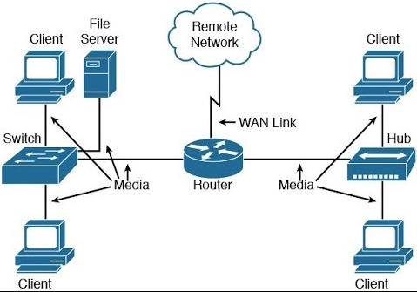
Fig 1.6. Router

Benefits or advantages of Routers
Following are the benefits or advantages of Routers:
- It provides connection between different network architectures such as ethernet & token ring etc.
- It can choose best path across the internetwork using dynamic routing algorithms.
- It can reduce network traffic by creating collision domains and also by creating broadcast domains.
- It provides sophisticated routing, flow control and traffic isolation.
- They are configurable which allows network manager to make policy based on routing decisions.
Drawbacks or disadvantages of Routers
Following are the drawbacks or disadvantages of Routers:
- They operate based on routable network protocols.
- They are expensive compare to other network devices.
- Dynamic router communications can cause additional network overhead. This results into less bandwidth for user data.
- They are slower as they need to analyze data from layer-1 through layer-3.
- They require considerable amount of initial configurations.
- They are protocol dependent devices which must understand the protocol they are forwarding.

3. Paring Rules and Colour Code:
The CAT 5 Cable consist of 8 wires which comes pares of White/Orange, Orange, White/Green, Green, White/Brown, Brown and they are coded for Straight and Cross combinations respectively.
Table 1. Straight Cable Paring
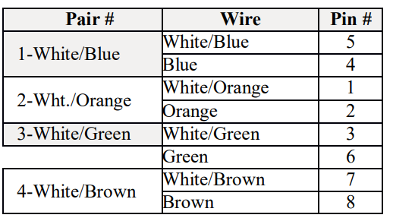

Table 2. Cross Cable Paring
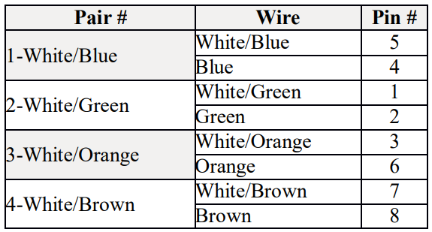
3.1 Connections among devices:-
Node to Node - Straight – Cross,
Switch to Node -Straight – Straight,
Switch to Switch -Straight –Cross.

3.3 How to Crimp a Cat 5 cable with RJ 45 Connector:-
- Skin off the cable jacket approximately 1" or slightly more.
- Un-twist each pair, and straighten each wire between the fingers.
- Place the wires in the order of one of the diagrams shown above .Bring all of the wires together, until they touch.
- At this point, recheck the wiring sequence with the diagram.
- Optional: Make a mark on the wires at 1/2" from the end of the cable jacket.
- Hold the grouped (and sorted) wires together tightly, between thumb and the thumb, and the forefinger.
- Cut all of the wires at a perfect 90 degree angle from the cable at 1/2" from the end of the cable jacket. This is a very critical step .If the wires are not cut straight, they may not all make contact. We suggest using a pair of scissors for this purpose.
- Conductors should be at a straight 90 degree angle, and be 1/2" long, prior to insertion into the connector.
- Insert the wires into the connector (pins facing up).
- Push moderately hard to assure that all of the wires have reached the end of the connector. Be sure that the cable jacket goes into the back of the connector by about3/16".
- Place the connector into a crimp tool, and squeeze hard so that the handle reaches its full swing.
- Repeat the process on the other end. For a straight through cable, use the same wiring.
- Use a cable tester to test for proper continuity.

3.4 Cable Testing Tool:
It is a tool used for testing weather there is no cut in between two terminals and to identify the type of pair crimp with.

4. Transmission Media:
On any network, the various entities must communicate through some form of media. Just as humans can communicate through telephone wires or sound waves in the air, computers can communicate through cables, light, and radio waves. Transmission media enable computers to send and receive messages but do not guarantee that the messages will be understood. Most common network transmission media are coaxial cable, shielded twisted-pair cable, and unshielded twisted-pair cable, fiber-optic cable and wireless communications.
Select the appropriate media for various situations. Media choices include the following:
• Twisted-pair cable
• Coaxial cable
• Fiber-optic cable
Wireless communications Situational elements include the following:
• Cost
• Distance limitations
• Number of nodes

4.1 Types of transmission media
In data communication terminology, a transmission medium is a physical path between the transmitter and the receiver i.e it is the channel through which data is sent from one place to another. Transmission Media is broadly classified into the following types.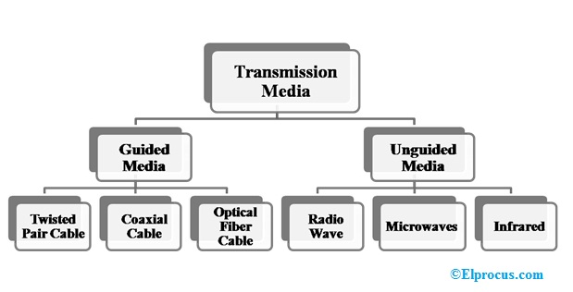
Fig 1.7 . Types of transmission media

Twisted pair
Twisted pair is a physical media made up of a pair of cables twisted with each other. A twisted pair cable is cheap as compared to other transmission media. Installation of the twisted pair cable is easy, and it is a lightweight cable. The frequency range for twisted pair cable is from 0 to 3.5KHz.
A twisted pair consists of two insulated copper wires arranged in a regular spiral pattern. The degree of reduction in noise interference is determined by the number of turns per foot. Increasing the number of turns per foot decreases noise interference.
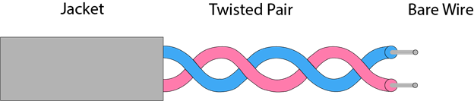
Fig 1.8. Twisted pair
Coaxial cable
Coaxial cable gets its name because it contains two conductors that are parallel to each other. The center conductor in the cable is usually copper. The copper can be either a solid wire or stranded martial. Outside this central Conductor is a non-conductive material. It is usually white, plastic material used to separate the inner Conductor form the outer Conductor. The other Conductor is a fine mesh made from Copper. It is used to help shield the cable form EMI.

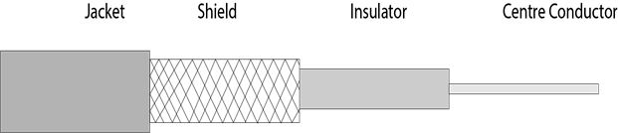
Fig 1.9. Coaxial cable

Fiber Optic Cable
These are similar to coaxial cable. It uses electric signals to transmit data. At the centre is the glass core through which light propagates. In multimode fibres, the core is 50microns, and In single mode fibres, the thickness is 8 to 10 microns. The core in fiber optic cable is surrounded by glass cladding with lower index of refraction as compared to core to keep all the light in core. This is covered with a thin plastic jacket to protect the cladding. The fibers are grouped together in bundles protected by an outer shield
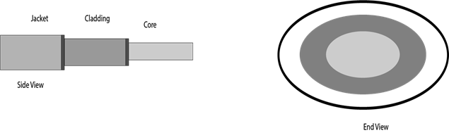
Fig 1.10. Fiber Optic Cable
5. Network Topology
Computers in a network have to be connected in some logical manner. The layout pattern of the interconnections between computers in a network is called network topology.
5.1 Bus topology
Bus topology uses one main cable to which all nodes are directly connected. The main cable acts as a backbone for the network. One of the computers in the network typically acts as the computer server. The first advantage of bus topology is that it is easy to connect a computer or peripheral device. The second advantage is that the cable requirements are relatively small, resulting in lower cost. One of the disadvantages is that if the main cable breaks, the entire network goes down. This type of network is also difficult to troubleshoot. For these reasons, this type of topology is not used for large networks.
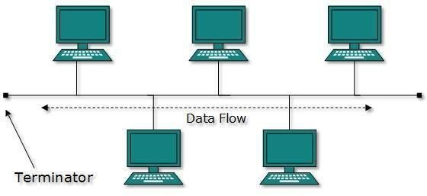
Fig 1.11. Bus topology
Advantages of Bus Topology
- It is easy to set up, handle, and implement.
- It is best-suited for small networks.
- It costs very less.
Disadvantages of Bus Topology
- The cable length is limited. This limits the number of network nodes that can be connected.
- This network topology can perform well only for a limited number of nodes. When the number of devices connected to the bus increases, the efficiency decreases.
- It is suitable for networks with low traffic. High traffic increases load on the bus, and the network efficiency drops.
- It is heavily dependent on the central bus. A fault in the bus leads to network failure.
- It is not easy to isolate faults in the network nodes.
- Each device on the network “sees” all the data being transmitted, thus posing a security risk.
5.2 Star topology
In star topology, each computer is connected to a central hub using a point-to-point connection. The central hub can be a computer server that manages the network, or it can be a much simpler device that only makes the connections between computers over the network possible. Star topology is very popular because the startup costs are low. It is also easy to add new nodes to the network. The network is robust in the sense that if one connection between a computer and the hub fails, the other connections remain intact. If the central hub fails, however, the entire network will fail.
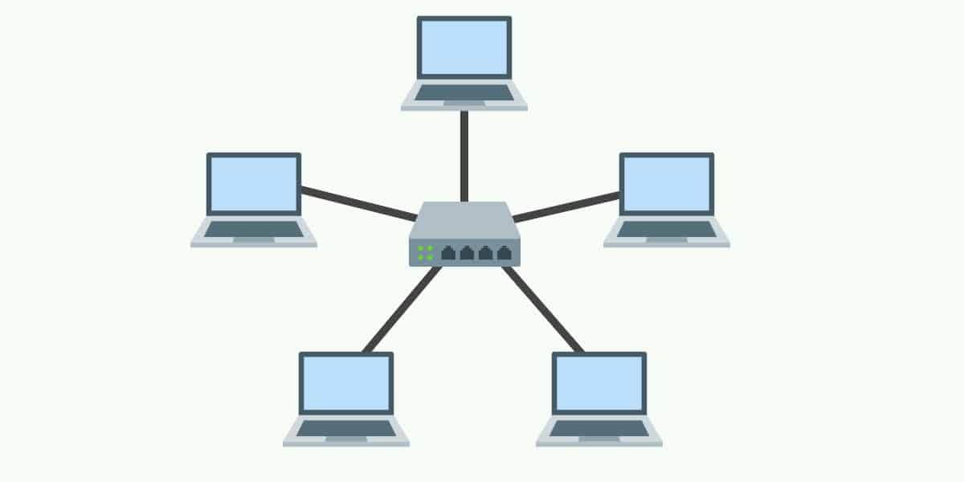
Fig 1.12. Star topology
Advantages of Star Topology
- Due to its centralized nature, the topology offers simplicity of operation.
- It also achieves isolation of each device in the network.
- Adding or removing network nodes is easy, and can be done without affecting the entire network.
- Due to the centralized nature, it is easy to detect faults in the network devices.
- As the analysis of traffic is easy, the topology poses lesser security risk.
- Data packets do not have to pass through many nodes, like in the case of a ring network. Thus, with the use of a high-capacity central hub, traffic load can be handled at fairly decent speeds.
Disadvantages of Star Topology
- Network operation depends on the functioning of the central hub. Hence, central hub failure leads to failure of the entire network.
- Also, the number of nodes that can be added, depends on the capacity of the central hub.
- The setup cost is quite high.

5.3 Ring topology
In ring topology, the computers in the network are connected in a circular fashion, and the data travels in one direction. Each computer is directly connected to the next computer, forming a single pathway for signals through the network. This type of network is easy to install and manage. If there is a problem in the network, it is easy to pinpoint which connection is defective. It is also good for handling high-volume traffic over long distances since every computer can act as a booster of the signal. On the downside, adding computers to this type of network is more cumbersome, and if one single computer fails, the entire network goes down.
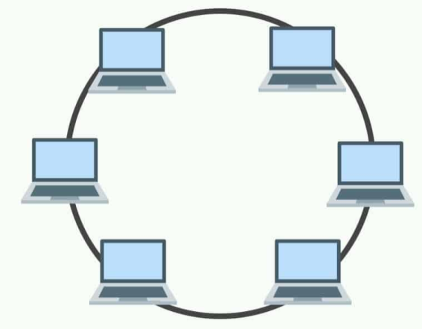
Fig 1.13. Ring topology:
Advantages of Ring Topology
- The data being transmitted between two nodes passes through all the intermediate nodes. A central server is not required for the management of this topology.
- The traffic is unidirectional and the data transmission is high-speed.
- In comparison to a bus, a ring is better at handling load.
- The adding or removing of network nodes is easy, as the process requires changing only two connections.
- The configuration makes it easy to identify faults in network nodes.
- In this topology, each node has the opportunity to transmit data. Thus, it is a very organized network topology.
- It is less costly than a star topology.
Disadvantages of Ring Topology
- The failure of a single node in the network can cause the entire network to fail.
- The movement or changes made to network nodes affect the entire network’s performance.
- Data sent from one node to another has to pass through all the intermediate nodes. This makes the transmission slower in comparison to that in a star topology. The transmission speed drops with an increase in the number of nodes.
- There is heavy dependency on the wire connecting the network nodes in the ring.

5.4 Mesh topology
In mesh topology, every node has a direct point-to-point connection to every other node. Because all connections are direct, the network can handle very high-volume traffic. It is also robust because if one connection fails, the others remain intact. Security is also high since data travels along a dedicated connection.
Mesh topology can be formed by using the formula:
Number of cables = (n*(n-1))/2; Where n is the number of nodes that represents the network

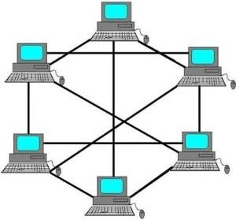
Fig 1.14. Mesh topology
Advantages of Mesh Topology
- The arrangement of the network nodes is such that it is possible to transmit data from one node to many other nodes at the same time.
- The failure of a single node does not cause the entire network to fail as there are alternate paths for data transmission.
- It can handle heavy traffic, as there are dedicated paths between any two network nodes.
- Point-to-point contact between every pair of nodes, makes it easy to identify faults.
Disadvantages of Mesh Topology
- The arrangement wherein every network node is connected to every other node of the network, many connections serve no major purpose. This leads to redundancy of many network connections.
- A lot of cabling is required. Thus, the costs incurred in setup and maintenance are high.
- Owing to its complexity, the administration of a mesh network is difficult.

5.5 Tree topology
A tree topology is a special type of structure where many connected elements are arranged like the branches of a tree. For example, tree topologies are frequently used to organize the computers in a corporate network, or the information in a database.
In a tree topology, there can be only one connection between any two connected nodes. Because any two nodes can have only one mutual connection, tree topologies create a natural parent and child hierarchy.
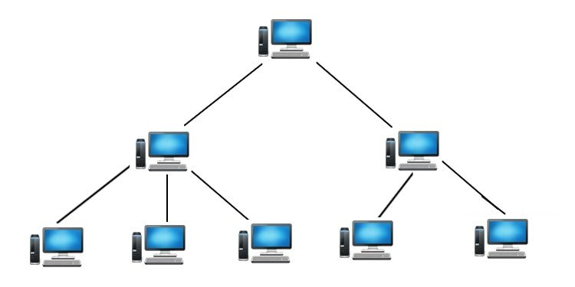
Fig 1.15. Tree Topology

Advantages of Tree Topology
- The tree topology is useful in cases where a star or bus cannot be implemented individually. It is most-suited in networking multiple departments of a university or corporation, where each unit (star segment) functions separately, and is also connected with the main node (root node).
- The advantages of centralization that are achieved in a star topology are inherited by the individual star segments in a tree network.
- Each star segment gets a dedicated link from the central bus. Thus, failing of one segment does not affect the rest of the network.
- Fault identification is easy.
- The network can be expanded by the addition of secondary nodes. Thus, scalability is achieved.
Disadvantages of Tree Topology
- As multiple segments are connected to a central bus, the network depends heavily on the bus. Its failure affects the entire network.
- Owing to its size and complexity, maintenance is not easy and costs are high. Also, configuration is difficult in comparison to that in other topologies.
- Though it is scalable, the number of nodes that can be added depends on the capacity of the central bus and on the cable type.

5.6 Hybrid Topology
The combination of various different topologies is known as Hybrid topology. A Hybrid topology is a connection between different links and nodes to transfer the data. When two or more different topologies are combined together is termed as Hybrid topology and if similar topologies are connected with each other will not result in Hybrid topology. For example, if there exist a ring topology in one branch of ICICI bank and bus topology in another branch of ICICI bank, connecting these two topologies will result in Hybrid topology.
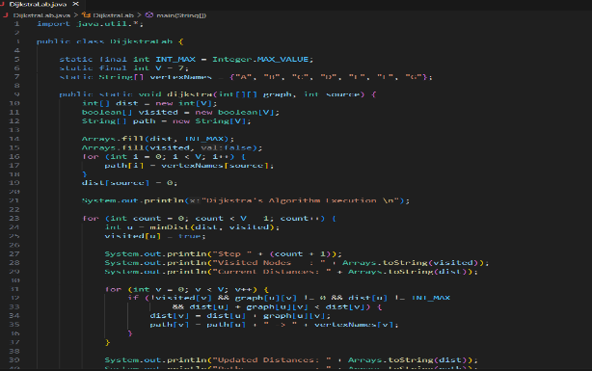
Fig 1.16. Hybrid Topology

Conclusion: Hence, we have successfully setup small network to share resources.

SCREENSHOT:
Implemented in lab 3205 (group activity)

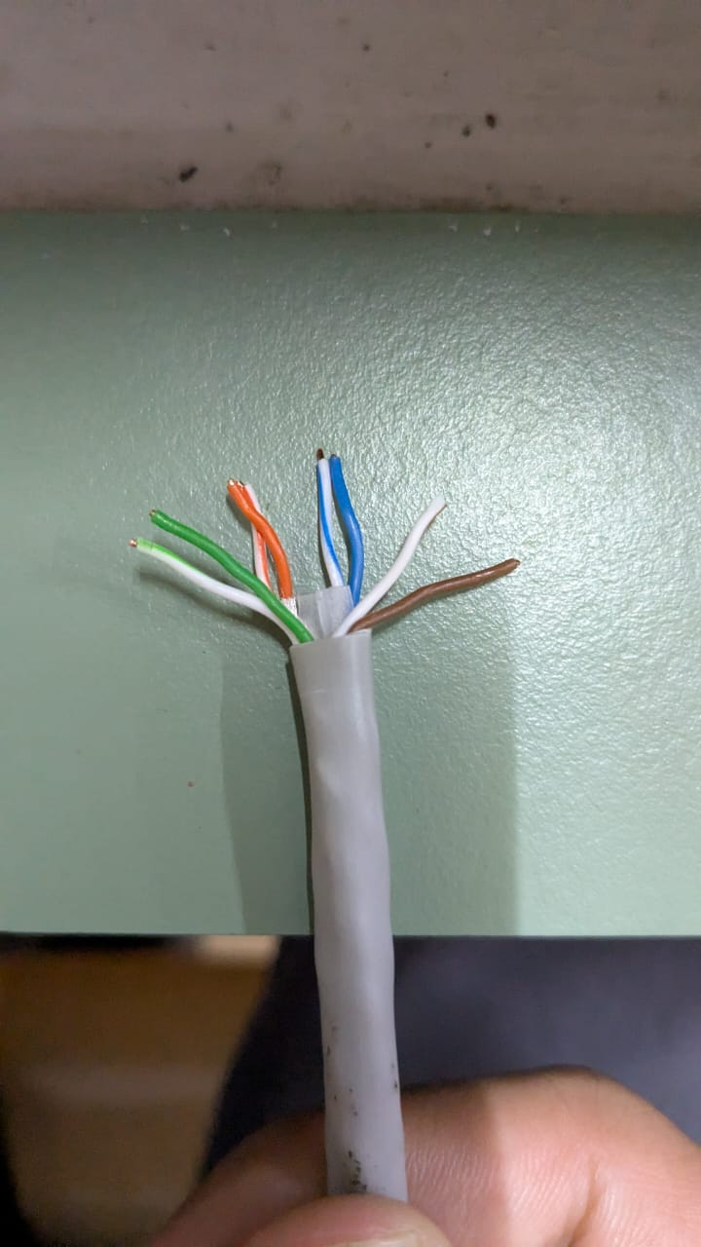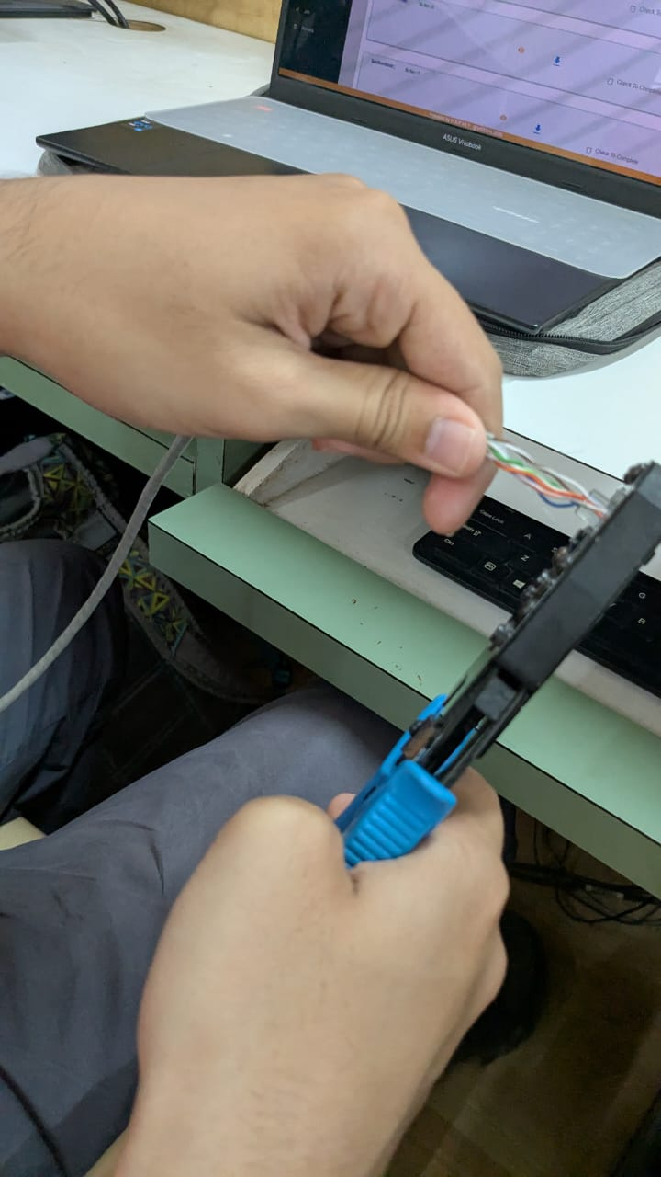
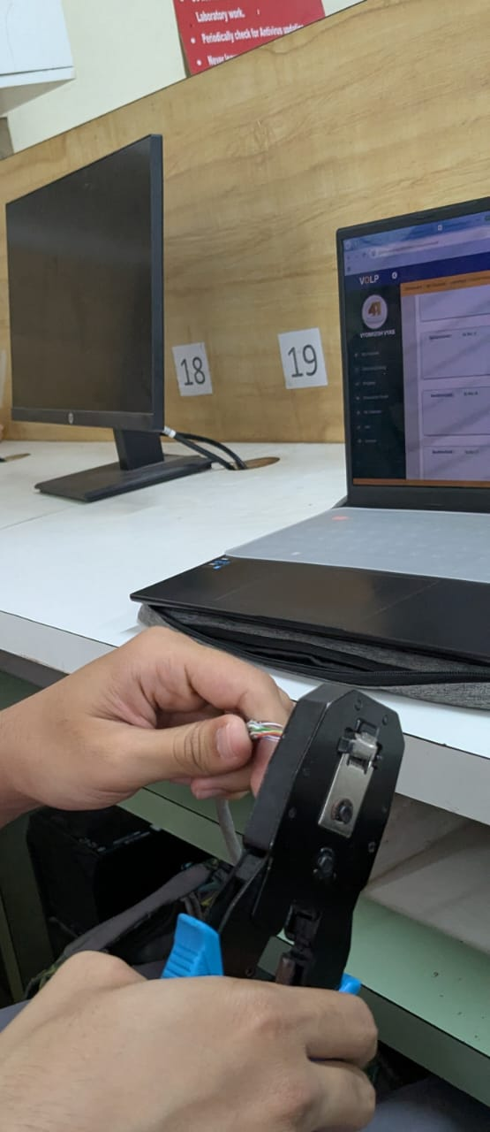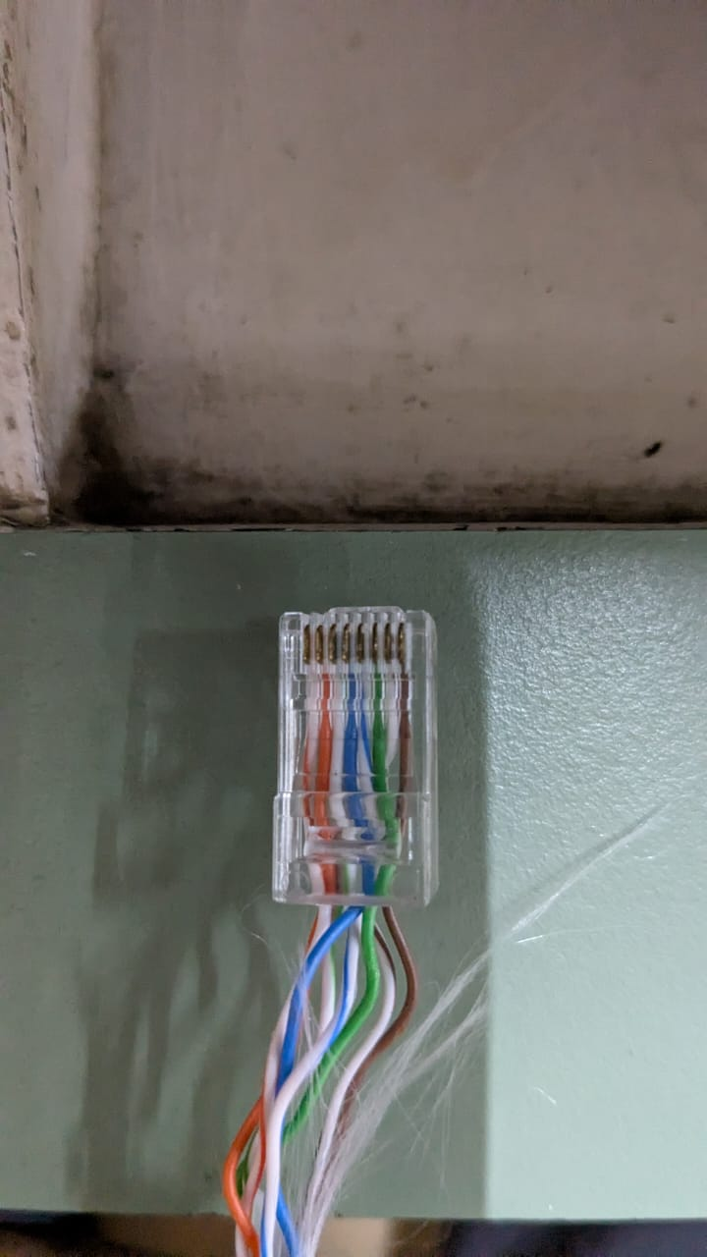

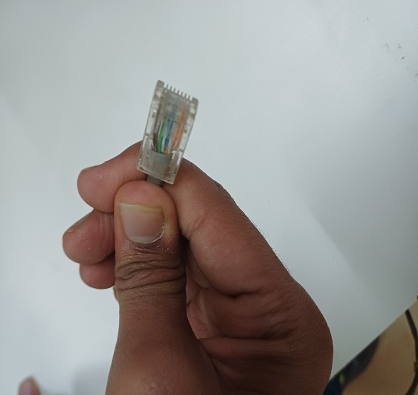
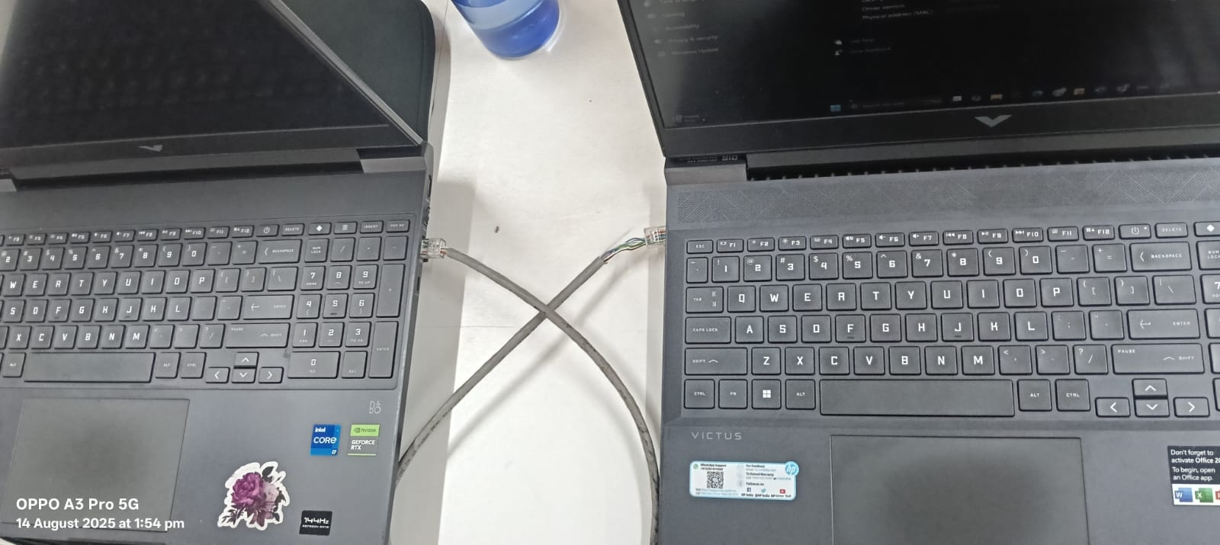

Name : Atharva Salitri
Division : TY CSAI-B
Batch : B2
Roll No. : 029
PRN : 12310120
Subject : Computer Network Technology

Assignment No:2

Title: Setting up small wireless computer network and hands-on networking command
Problem Statement: Set up a small wired network of 2 to 4 computers using access point and ask students to access it on their wireless gadgets. Hands on for network commands - ping, pathping, ipconfig/ifconfig, arp, netstat, nbtstat, nslookup, route, traceroute/tracert, nmap.
Course Objective: To learn transmission mediums, networking devices and topologies used in the Internet.
Course Outcome: Select topology, essential components of physical layer and networking devices to design computer networks.
Tools Required: Access point, Personal Computer/Laptop with wireless connectivity.
Theory:
1. Access Point (AP)
An Access Point (AP) is a networking hardware device that allows wireless devices to connect to a wired network using Wi-Fi or related standards. It acts as a bridge between wireless clients (like laptops, smartphones, tablets) and the wired LAN (Local Area Network).

1.1 Key Functions of Access Point:
- Wireless Connectivity: Enables wireless communication within a local area by transmitting and receiving wireless signals.
- Data Bridging: Connects wireless clients to a wired Ethernet network.
- Network Extension: Extends the range of a wired network to accommodate mobile devices.
- Authentication and Security: Supports security protocols like WPA2/WPA3 to protect the wireless network from unauthorized access.
- Traffic Management: Manages wireless traffic by distributing bandwidth among multiple clients.

1.2 Working of an Access Point:
- The AP connects to a router or switch via an Ethernet cable.
- It broadcasts a wireless signal (SSID – Service Set Identifier).
- Wireless devices detect this signal and connect using proper credentials.
- The AP forwards the wireless traffic to the router/switch, which then routes it to the Internet or local resources.

1.3 Advantages:
- Provides mobility to users within the network coverage area.
- Reduces cabling costs.
- Easily scalable for more devices and larger areas.

1.4 Common Standards:
- IEEE 802.11 a/b/g/n/ac/ax (Wi-Fi standards)

2. Wireless Gadgets – Theory (for CN Subject)
Wireless gadgets are electronic devices that connect to a network or other devices without using physical cables, typically through Wi-Fi, Bluetooth, or cellular networks. These devices rely on wireless communication standards to exchange data, enabling mobility and ease of use.

2.1 Common Wireless Gadgets in Networking:
Gadget | Description
Smartphone | Mobile device with Wi-Fi and cellular connectivity for internet access and communication.
Laptop | Portable computer that connects wirelessly to a network via Wi-Fi.
Tablet | Touchscreen device, similar to a smartphone, used for internet access, reading, and multimedia.
Smart TV | Television that connects to the internet via Wi-Fi to stream online content.
Wi-Fi Printer | Printer that connects to devices over a wireless network, allowing remote printing.
Smartwatch | Wearable device that connects via Bluetooth or Wi-Fi for syncing with phones and receiving notifications.
IoT Devices | Gadgets like smart bulbs, thermostats, or security cameras that operate wirelessly over a home or office network.
Wireless Headphones | Use Bluetooth to connect to computers or phones for audio communication.

2.2 Wireless Technologies Used:
- Wi-Fi (IEEE 802.11) – For connecting to wireless LANs.
- Bluetooth – For short-range device-to-device communication.
- Cellular (3G/4G/5G) – For wide-area network access using SIM-enabled devices.
- Zigbee/Z-Wave – For smart home and IoT connectivity.

2.3 Advantages of Wireless Gadgets:
- Mobility – Use anywhere within signal range.
- Ease of Use – No cables required.
- Flexibility – Easily connect and disconnect.
- Portability – Lightweight and travel-friendly.

3. Networking Commands:
3.1 tracert: The traceroute command (or tracert on Windows) is used to track the path that a packet takes from your computer to a destination (like google.com). It helps in understanding network hops and identifying latency or failure points in a network.
Linux/macOS
traceroute google.com
Windows
tracert google.com
Tracing route to google.com [2404:6800:4009:812::200e]
over a maximum of 30 hops:
1 2 ms 2 ms 2 ms 2401:4900:52fb:51a0::16
…….

What It Shows
Each line in the output tells:
- The hop number (router in the path)
- The IP address (and domain if resolved)
- Response times for three packets (in milliseconds)

3.2 pathping: The pathping command is a Windows network diagnostic tool that combines the features of ping and tracert. It provides detailed information about the route and packet loss between your computer and a destination (like a website or IP address).
pathping www.google.com
Tracing route to google.com [2404:6800:4009:830::200e]
over a maximum of 30 hops:
0 LAPTOP-1HQO4D8I [2409:4042:4e15:34a8:b9ca:4b52:7ba6:1d63]
1 jiofi.local.html [2409:4042:4e15:34a8:cc3:4945:643d:9c0d]
2 * * *
Computing statistics for 25 seconds...
Source to Here This Node/Link
Hop RTT Lost/Sent = Pct Lost/Sent = Pct Address
0 LAPTOP-1HQO4D8I [2409:4042:4e15:34a8:b9ca:4b52:7ba6:1d63]
1/ 100 = 1% |
1 6ms 1/ 100 = 1% 0/ 100 = 0% jiofi.local.html [2409:4042:4e15:34a8:cc3:4945:643d:9c0d]

Trace complete.
What pathping Does
- Traces the route your packets take to the destination (like tracert).
- Pings each hop (router) multiple times to measure:
  - Latency (delay)
  - Packet loss at each hop
3.3 ipconfig: The ipconfig command is used in Windows to view and manage your network configuration details. "ipconfig helps users find out their current IP configuration.
ipconfig
Ethernet adapter Ethernet:

Connection-specific DNS Suffix . :
Link-local IPv6 Address . . . . . : fe80::5e7f:98ff:fe20:7c3a%5
IPv4 Address. . . . . . . . . . . : 192.168.1.5
Subnet Mask . . . . . . . . . . . : 255.255.255.0
Default Gateway . . . . . . . . . : 192.168.1.1

- ipconfig /all → Shows detailed info, including DNS, MAC address, DHCP server.
- ipconfig /release → Releases current IP address.
- ipconfig /renew → Requests a new IP from the DHCP server.

3.4 arp: The arp command in Windows is used to view and manage the Address Resolution Protocol (ARP) cache, which maps IP addresses to MAC (hardware) addresses on your local network.
arp -a
Interface: 192.168.225.138 --- 0xe
Internet Address Physical Address Type
169.254.169.254 fa-69-9c-67-91-2d dynamic
192.168.225.1 fa-69-9c-67-91-2d dynamic
192.168.225.255 ff-ff-ff-ff-ff-ff static
224.0.0.2 01-00-5e-00-00-02 static
224.0.0.22 01-00-5e-00-00-16 static
224.0.0.251 01-00-5e-00-00-fb static
224.0.0.252 01-00-5e-00-00-fc static
239.255.255.250 01-00-5e-7f-ff-fa static
255.255.255.255 ff-ff-ff-ff-ff-ff static

Useful Commands:
Command | Description
arp -a | View ARP table
arp -d <ip> | Delete an ARP entry (e.g., arp -d 192.168.1.1)
arp -s <ip> <mac> | Manually add a static ARP entry

3.5 netstat: The netstat (Network Statistics) command is used to display network connections, routing tables, interface statistics, and port usage on your computer.
Netstat -a
Active Connections

Proto Local Address Foreign Address State

TCP 127.0.0.1:2030 LAPTOP-1HQO4D8I:0 LISTENING
TCP 127.0.0.1:5500 LAPTOP-1HQO4D8I:0 LISTENING
TCP 127.0.0.1:27017 LAPTOP-1HQO4D8I:0 LISTENING
TCP 127.0.0.1:49682 LAPTOP-1HQO4D8I:49683 ESTABLISHED
TCP 192.168.225.138:61634 23.100.109.78:https ESTABLISHED
TCP 192.168.225.138:63985 www:https CLOSE_WAIT
TCP 192.168.225.138:64202 download:http CLOSE_WAIT
TCP [2409:4042:4e15:34a8:b9ca:4b52:7ba6:1d63]:49921 whatsapp-chatd-edge6-shv-02-pnq1:5222 ESTABLISHED

Useful Options (Windows):
Command | Description
netstat -a | Show all active connections and listening ports
netstat -n | Show addresses and ports in numeric format (IP instead of hostname)
netstat -o | Show connections with Process ID (PID)
netstat -b | Show which executable (program) is using each connection
netstat -an | Combine -a and -n for detailed info
netstat -r | Show the routing table (like route print)
netstat -e | Show Ethernet statistics

3.6 nbtstat: The nbtstat command is used to troubleshoot NetBIOS name resolution issues in Windows systems. It displays NetBIOS over TCP/IP (NetBT) protocol statistics, name tables, and name caches.
nbtstat -n
Bluetooth Network Connection:
Node IpAddress: [0.0.0.0] Scope Id: []

No names in cache

Wi-Fi:
Node IpAddress: [192.168.203.185] Scope Id: []

NetBIOS Local Name Table

Name Type Status
---------------------------------------------
LAPTOP-1HQO4D8I<20> UNIQUE Registered
LAPTOP-1HQO4D8I<00> UNIQUE Registered
WORKGROUP <00> GROUP Registered

Local Area Connection* 1:
Node IpAddress: [0.0.0.0] Scope Id: []

No names in cache

Local Area Connection* 2:
Node IpAddress: [0.0.0.0] Scope Id: []

No names in cache

Useful Options:
Command | Description
nbtstat -n | Shows local NetBIOS names and their status
nbtstat -c | Displays the NetBIOS name cache (recently resolved names)
nbtstat -R | Clears the NetBIOS name cache
nbtstat -r | Lists names resolved by broadcast and WINS
nbtstat -S | Shows NetBIOS sessions with IP addresses
nbtstat -a <hostname> | Displays NetBIOS table of a remote computer by hostname
nbtstat -A <IP> | Displays NetBIOS table of a remote computer by IP address

3.7 nslookup: The nslookup command is used to query DNS (Domain Name System) servers and obtain domain name or IP address mapping information.
nslookup google.com
Server: UnKnown
Address: 192.168.203.48

Non-authoritative answer:
Name: google.com
Addresses: 2404:6800:4009:812::200e
142.250.67.174

3.8 route: The route command is used to view, add, delete, or modify entries in the IP routing table on your system. It shows how packets are forwarded when sent across networks.
route print
===================================================================
Interface List
16...a0 e7 0b 36 79 79 ......Microsoft Wi-Fi Direct Virtual Adapter #3
18...a2 e7 0b 36 79 78 ......Microsoft Wi-Fi Direct Virtual Adapter #4
14...a0 e7 0b 36 79 78 ......Intel(R) Wireless-AC 9560
5...a0 e7 0b 36 79 7c ......Bluetooth Device (Personal Area Network)
1...........................Software Loopback Interface 1
===================================================================
IPv4 Route Table
===================================================================
Active Routes:
Network Destination Netmask Gateway Interface Metric
0.0.0.0 0.0.0.0 192.168.203.48 192.168.203.185 50
127.0.0.0 255.0.0.0 On-link 127.0.0.1 331
127.0.0.1 255.255.255.255 On-link 127.0.0.1 331
…….

3.9 nmap: nmap is a powerful open-source tool used for network discovery, security auditing, and port scanning. It’s widely used by system administrators and cybersecurity professionals.

- Scan a single IP:
nmap 192.168.0.1
- Scan a range of IPs:
nmap 192.168.0.1-10
- Scan a subnet:
nmap 192.168.0.0/24
- Scan for open ports and services:
nmap -sV 192.168.0.1
- Detect operating system:
nmap -O 192.168.0.1
- Aggressive scan (OS, services, traceroute, scripts):
nmap -A 192.168.0.1
- Scan top 100 ports:
nmap --top-ports 100 192.168.0.1

Conclusion: Hence, a small network we have successfully established using an access point, and relevant networking commands were executed effectively..
SCREENSHOTS:
Done in group on 18/7/25

PING
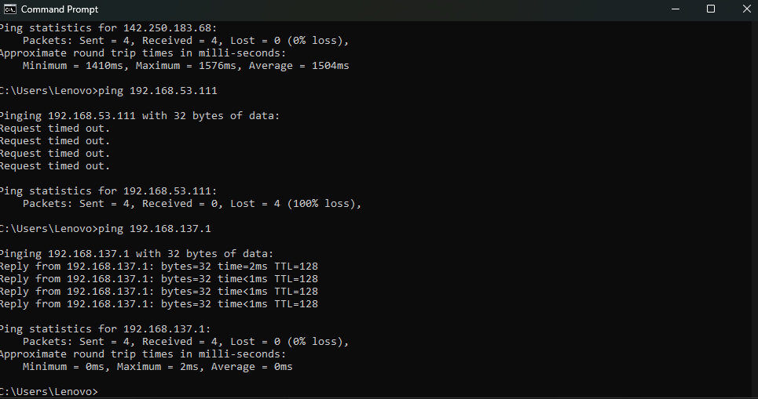

PATHPING
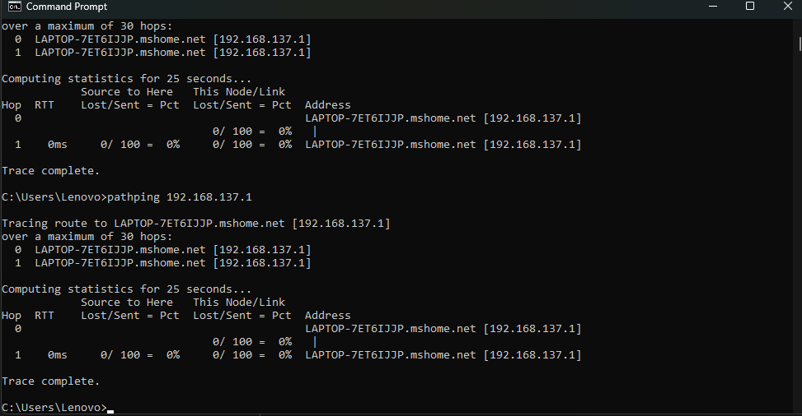

TRACE ROUTE
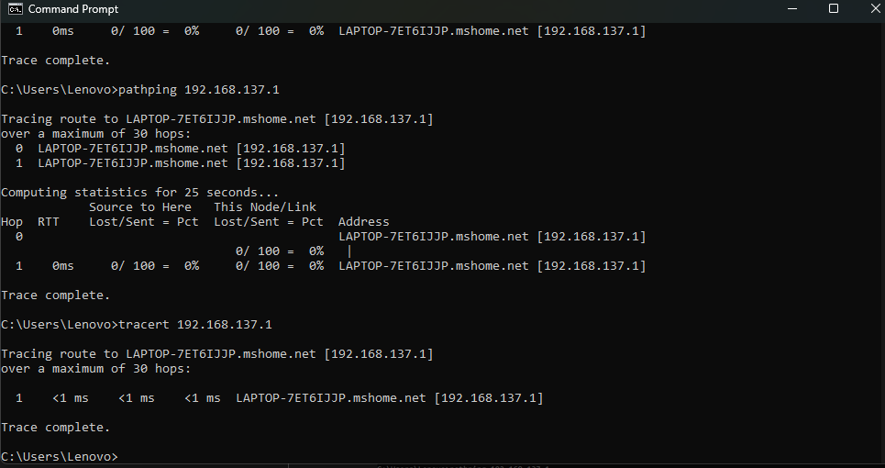

IPCONFIG

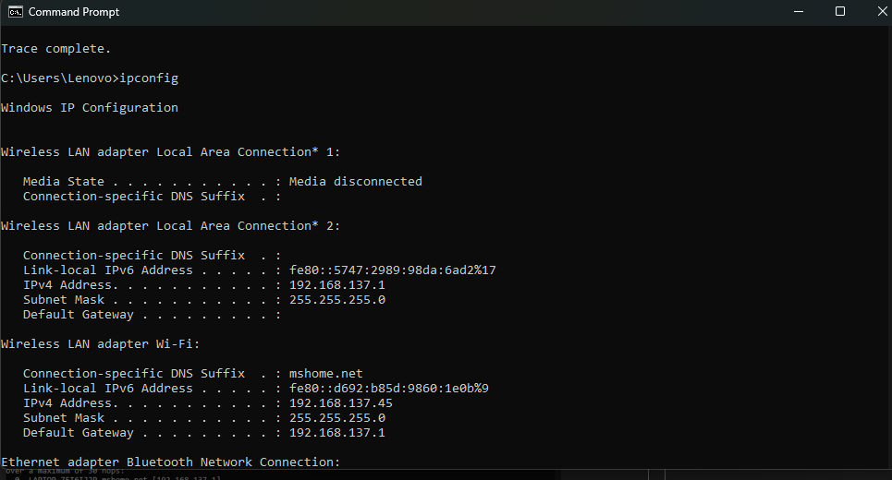

ARP
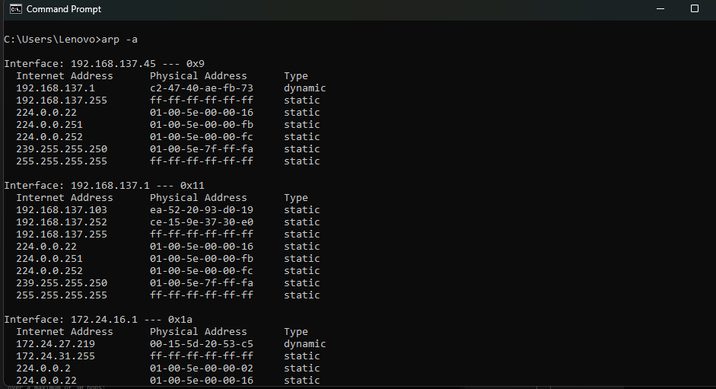

NETSTAT
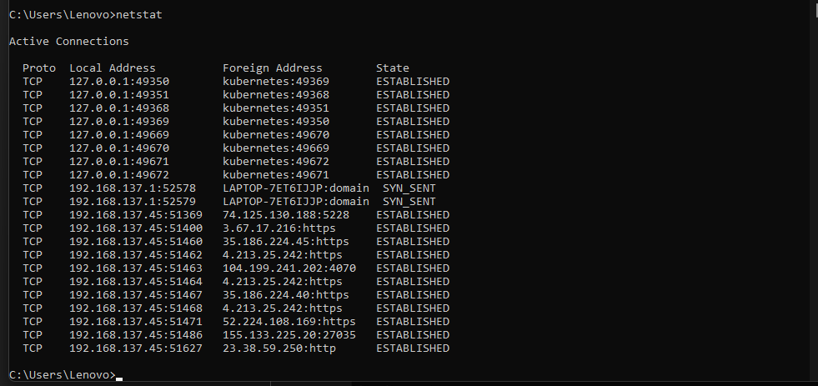

NBSTAT

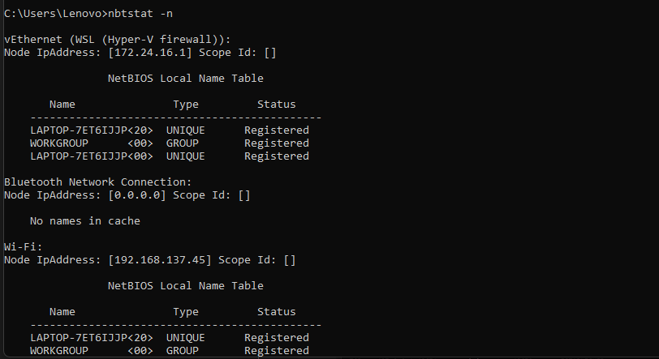

NSLOOKUP

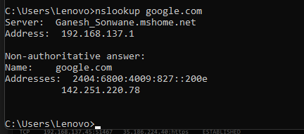

ROUTE

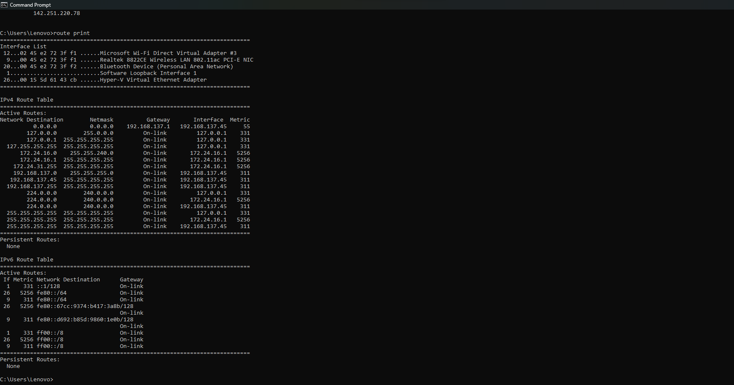

Name : Atharva Salitri
Division : TY CSAI-B
Batch : B2
Roll No. : 029
PRN : 12310120
Subject : Computer Network Technology

Assignment No:3

Title: Dijkstra Algorithm.
Problem Statement: Write a program to find the shortest path using Dijkstra Equation for Link State Routing Protocol which is used by Open Shortest Path First Protocol (OSPF) in the Internet for the network flow provided by instructor.
Course Objective: To learn networking standards, IP packet switching and routing used in the Internet.
Course Outcome: Build wired and wireless intranet with correct communication and service frameworks.
Tools Required: Eclipse, Java.
Theory:
1. Link State Routing Protocol:
Link State Routing Protocols are dynamic routing protocols used in packet-switched networks to determine the best path for data packets. The most widely used link-state protocol is OSPF (Open Shortest Path First), which operates within an Autonomous System (AS). OSPF maintains a link-state database of the entire network topology and computes the shortest path using Dijkstra’s Algorithm.
Link state routing is a technique in which each router shares the knowledge of its neighborhood with every other router in the internetwork.
- It is a dynamic routing algorithm in which each router shares knowledge of its neighbors with every other router in the network.
- A router sends its information about its neighbors only to all the routers through flooding.
- Information sharing takes place only whenever there is a change.
- It makes use of Dijkastra’s Algorithm for making routing tables.
- Problems – Heavy traffic due to flooding of packets.
– Flooding can result in infinite looping which can be solved by using Time to live (TTL) field.

2. Dijkstra’s Algorithm:
Dijkstra’s algorithm is a graph search algorithm that finds the shortest path between a source node and all other nodes in a weighted graph. It is optimal and guarantees the least-cost path in a network.

2.1 Working of Dijkstra’s Algorithm in OSPF:
- Each router in the network identifies its neighbors and calculates the cost (typically delay, bandwidth, or hop count) to reach them.
- Routers exchange Link State Advertisements (LSAs) to share their topology information.
- Each router independently constructs a Link State Database (LSDB) representing the entire network graph.
- Dijkstra’s algorithm is then applied on the LSDB to calculate the Shortest Path Tree (SPT).
- The result is stored in the routing table, where each destination has the next-hop and associated cost.

2.2 Steps in Dijkstra’s Algorithm:
- Initialize distances from source to all nodes as infinity, except the source (distance 0).
- Maintain a priority queue (or visited/unvisited set).
- Select the unvisited node with the smallest known distance.
- Update distances to adjacent nodes if a shorter path is found.
- Mark the current node as visited and repeat until all nodes are visited.

3. Example:

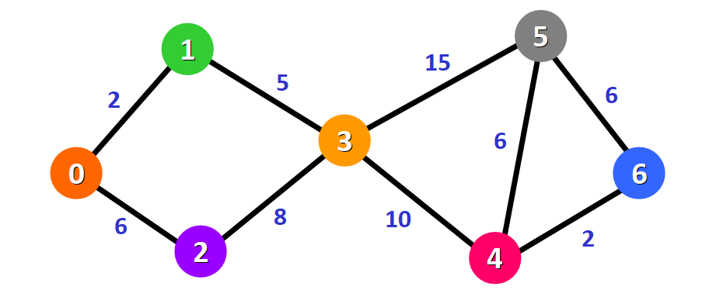
Initially, we have this list of distances (please see the list below):
- The distance from the source node to itself is 0. For this example, the source node will be node 0 but it can be any node that you choose.
- The distance from the source node to all other nodes has not been determined yet, so we use the infinity symbol to represent this initially.
Unvisited Node: {0,1,2,3,4,5,6}
0 | 1 | 2 | 3 | 4 | 5 | 6
0 | ∞ | ∞ | ∞ | ∞ | ∞ | ∞

Since we are choosing to start at node 0, we can mark this node as visited. Equivalently, we cross it off from the list of unvisited nodes and add a red border to the corresponding node in diagram:
Now we need to start checking the distance from node 0 to its adjacent nodes. As you can see, these are nodes 1 and 2 (see the red edges):
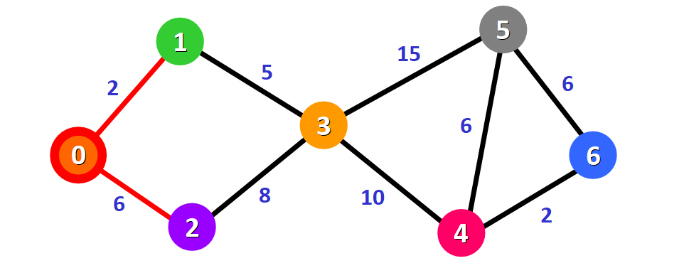
Unvisited Node:{1,2,3,4,5,6}
0 | 1 | 2 | 3 | 4 | 5 | 6
0 | 2 | 6 | ∞ | ∞ | ∞ | ∞

Unvisited Node:{2,3,4,5,6}
0 | 1 | 2 | 3 | 4 | 5 | 6
0 | 2 | 6 | 7 | ∞ | ∞ | ∞

For node 3: the total distance is 7 because we add the weights of the edges that form the path 0 -> 1 -> 3 (2 for the edge 0 -> 1 and 5 for the edge 1 -> 3).
From the list of distances, we can immediately detect that this is node 2 with distance 6:

Unvisited Node:{3,4,5,6}
0 | 1 | 2 | 3 | 4 | 5 | 6
0 | 2 | 6 | 7 | ∞ | ∞ | ∞

Node 3 already has a distance in the list that was recorded previously (7, see the list below). This distance was the result of a previous step, where we added the weights 5 and 2 of the two edges that we needed to cross to follow the path 0 -> 1 -> 3.
But now we have another alternative. If we choose to follow the path 0 -> 2 -> 3, we would need to follow two edges 0 -> 2 and 2 -> 3 with weights 6 and 8, respectively, which represents a total distance of 14.
Clearly, the first (existing) distance is shorter (7 vs. 14), so we will choose to keep the original path 0 -> 1 -> 3. We only update the distance if the new path is shorter.
Therefore, we add this node to the path using the first alternative: 0 -> 1 -> 3.
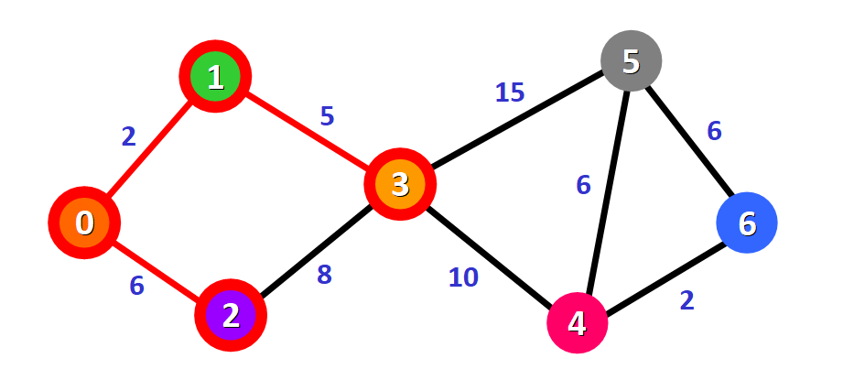
We update the distances of these nodes to the source node, always trying to find a shorter path, if possible:
For node 4: the distance is 17 from the path 0 -> 1 -> 3 -> 4.
For node 5: the distance is 22 from the path 0 -> 1 -> 3 -> 5.
Notice that we can only consider extending the shortest path (marked in red). We cannot consider paths that will take us through edges that have not been added to the shortest path (for example, we cannot form a path that goes through the edge 2 -> 3).
Unvisited Node:{4,5,6}
0 | 1 | 2 | 3 | 4 | 5 | 6
0 | 2 | 6 | 7 | 17 | 22 | ∞

We need to choose which unvisited node will be marked as visited now. In this case, it's node 4 because it has the shortest distance in the list of distances. We add it graphically in the diagram:
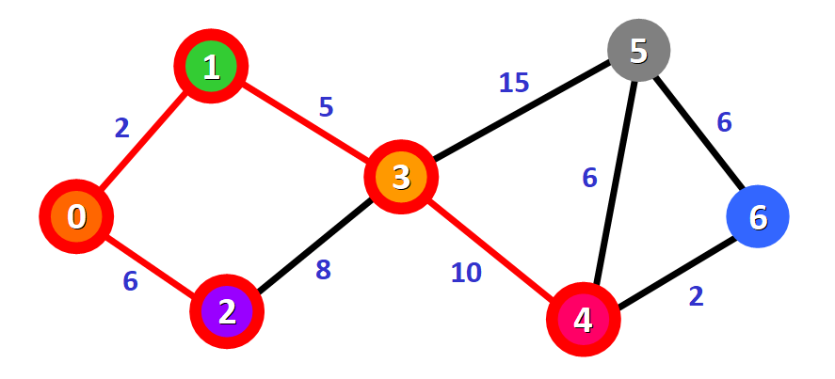
For node 5:
- The first option is to follow the path 0 -> 1 -> 3 -> 5, which has a distance of 22 from the source node (2 + 5 + 15). This distance was already recorded in the list of distances in a previous step.
- The second option would be to follow the path 0 -> 1 -> 3 -> 4 -> 5, which has a distance of 23 from the source node (2 + 5 + 10 + 6).
Clearly, the first path is shorter, so we choose it for node 5.

For node 6:
- The path available is 0 -> 1 -> 3 -> 4 -> 6, which has a distance of 19 from the source node (2 + 5 + 10 + 2).

Unvisited Node:{5,6}
0 | 1 | 2 | 3 | 4 | 5 | 6
0 | 2 | 6 | 7 | 17 | 22 | 19

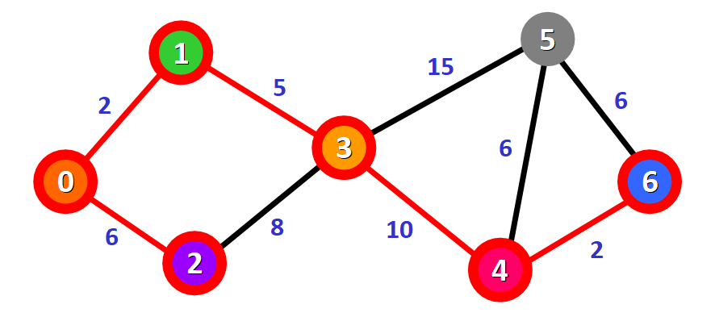
Only one node has not been visited yet, node 5. Let's see how we can include it in the path.
There are three different paths that we can take to reach node 5 from the nodes that have been added to the path:
- Option 1: 0 -> 1 -> 3 -> 5 with a distance of 22 (2 + 5 + 15).
- Option 2: 0 -> 1 -> 3 -> 4 -> 5 with a distance of 23 (2 + 5 + 10 + 6).
- Option 3: 0 -> 1 -> 3 -> 4 -> 6 -> 5 with a distance of 25 (2 + 5 + 10 + 2 + 6).
Unvisited Node:{6}
0 | 1 | 2 | 3 | 4 | 5 | 6
0 | 2 | 6 | 7 | 17 | 22 | 19

We have the final result with the shortest path from node 0 to each node in the graph.
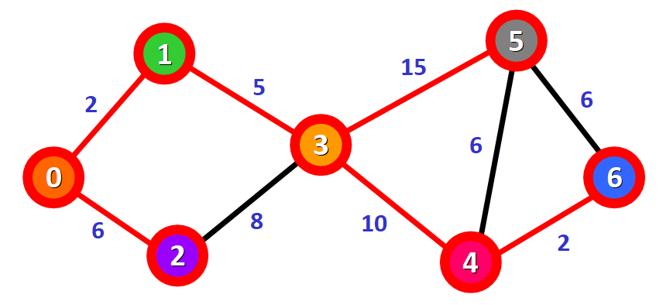

Conclusion: Hence, find the shortest path using Dijkstra Equation for Link State Routing Protocol.
Program:
import java.util.*;
import java.util.*;

public class DijkstraRouting
{
static final int INF = Integer.MAX_VALUE; // A constant to represent infinity
static final int V = 7; // Number of vertices (nodes) in the graph
static String[] vertexNames = {"A", "B", "C", "D", "E", "F", "G"}; // Names for display

// Function to implement Dijkstra's algorithm
public static void dijkstra(int[][] graph, int source)
{
int[] dist = new int[V]; // Array to hold the shortest distance from source
boolean[] visited = new boolean[V]; // Track visited nodes
String[] path = new String[V]; // Track path taken to reach each node

// Initialize distances to infinity and paths with source node
Arrays.fill(dist, INF);
Arrays.fill(visited, false);
for (int i = 0; i < V; i++)
{
path[i] = vertexNames[source]; // Start path from source
}
System.out.println("Initial Values");
System.out.println("Visited: " + Arrays.toString(visited));
System.out.println("Distances: " + Arrays.toString(dist));
System.out.println("Path: " + Arrays.toString(path) + "\n");

dist[source] = 0; // Distance to itself is zero

// Loop through all vertices to find shortest path
for (int count = 0; count < V - 1; count++)
{
// Pick the unvisited node with the smallest distance
int u = minDistance(dist, visited);
visited[u] = true;

// Print current state (iteration-wise trace)
System.out.println("Step " + (count + 1) + ":");
System.out.println("Visited: " + Arrays.toString(visited));
System.out.println("Distances: " + Arrays.toString(dist));

// Update distance and path for neighboring vertices
for (int v = 0; v < V; v++)
{
if (!visited[v] && graph[u][v] != 0 && dist[u] != INF &&
dist[u] + graph[u][v] < dist[v]) {
dist[v] = dist[u] + graph[u][v]; // Update distance
path[v] = path[u] + " -> " + vertexNames[v]; // Update path
}
}
System.out.println("Update distance and path for neighboring vertices");
System.out.println("Distances: " + Arrays.toString(dist));
System.out.println("Path: " + Arrays.toString(path) + "\n");
}

// Final output of shortest paths from source
System.out.println("\nVertex\tDistance\tPath");
for (int i = 0; i < V; i++)
{
if (i != source)
{
System.out.println(vertexNames[source] + " -> " + vertexNames[i] + "\t" +
dist[i] + "\t\t" + path[i]);
}
}
}

// Helper function to find the unvisited node with the smallest distance
public static int minDistance(int[] dist, boolean[] visited)
{
int min = INF, minIndex = -1;
for (int v = 0; v < V; v++)
{
if (!visited[v] && dist[v] <= min)
{
min = dist[v];
minIndex = v;
}
}
return minIndex;
}

// Main method to execute the program
public static void main(String[] args)
{
// Graph represented as adjacency matrix (7x7)
int[][] graph =
{
// A B C D E F G
{ 0, 2, 5, 0, 0, 0, 0 }, // A
{ 2, 0, 1, 2, 0, 0, 0 }, // B
{ 5, 1, 0, 3, 1, 4, 0 }, // C
{ 0, 2, 3, 0, 2, 0, 3 }, // D
{ 0, 0, 1, 2, 0, 0, 5 }, // E
{ 0, 0, 4, 0, 0, 0, 2 }, // F
{ 0, 0, 0, 3, 5, 2, 0 } // G
};

dijkstra(graph, 0); // Call Dijkstra from source node A (index 0)
}
}

Output:
Initial Values
Visited: [false, false, false, false, false, false, false]
Distances: [2147483647, 2147483647, 2147483647, 2147483647, 2147483647, 2147483647, 2147483647]
Path: [A, A, A, A, A, A, A]

Step 1:
Visited: [true, false, false, false, false, false, false]
Distances: [0, 2147483647, 2147483647, 2147483647, 2147483647, 2147483647, 2147483647]
Update distance and path for neighboring vertices

Distances: [0, 2, 5, 2147483647, 2147483647, 2147483647, 2147483647]
Path: [A, A -> B, A -> C, A, A, A, A]

Step 2:
Visited: [true, true, false, false, false, false, false]
Distances: [0, 2, 5, 2147483647, 2147483647, 2147483647, 2147483647]
Update distance and path for neighboring vertices

Distances: [0, 2, 3, 4, 2147483647, 2147483647, 2147483647]
Path: [A, A -> B, A -> B -> C, A -> B -> D, A, A, A]

Step 3:
Visited: [true, true, true, false, false, false, false]
Distances: [0, 2, 3, 4, 2147483647, 2147483647, 2147483647]
Update distance and path for neighboring vertices

Distances: [0, 2, 3, 4, 4, 7, 2147483647]
Path: [A, A -> B, A -> B -> C, A -> B -> D, A -> B -> C -> E, A -> B -> C -> F, A]

Step 4:
Visited: [true, true, true, false, true, false, false]
Distances: [0, 2, 3, 4, 4, 7, 2147483647]
Update distance and path for neighboring vertices

Distances: [0, 2, 3, 4, 4, 7, 9]
Path: [A, A -> B, A -> B -> C, A -> B -> D, A -> B -> C -> E, A -> B -> C -> F, A -> B -> C -> E -> G]

Step 5:
Visited: [true, true, true, true, true, false, false]
Distances: [0, 2, 3, 4, 4, 7, 9]
Update distance and path for neighboring vertices

Distances: [0, 2, 3, 4, 4, 7, 7]
Path: [A, A -> B, A -> B -> C, A -> B -> D, A -> B -> C -> E, A -> B -> C -> F, A -> B -> D -> G]

Step 6:
Visited: [true, true, true, true, true, false, true]
Distances: [0, 2, 3, 4, 4, 7, 7]
Update distance and path for neighboring vertices

Distances: [0, 2, 3, 4, 4, 7, 7]
Path: [A, A -> B, A -> B -> C, A -> B -> D, A -> B -> C -> E, A -> B -> C -> F, A -> B -> D -> G]

Vertex Distance Path
A -> B 2 A -> B
A -> C 3 A -> B -> C
A -> D 4 A -> B -> D
A -> E 4 A -> B -> C -> E
A -> F 7 A -> B -> C -> F
A -> G 7 A -> B -> D -> G

SCREENSHOTS:
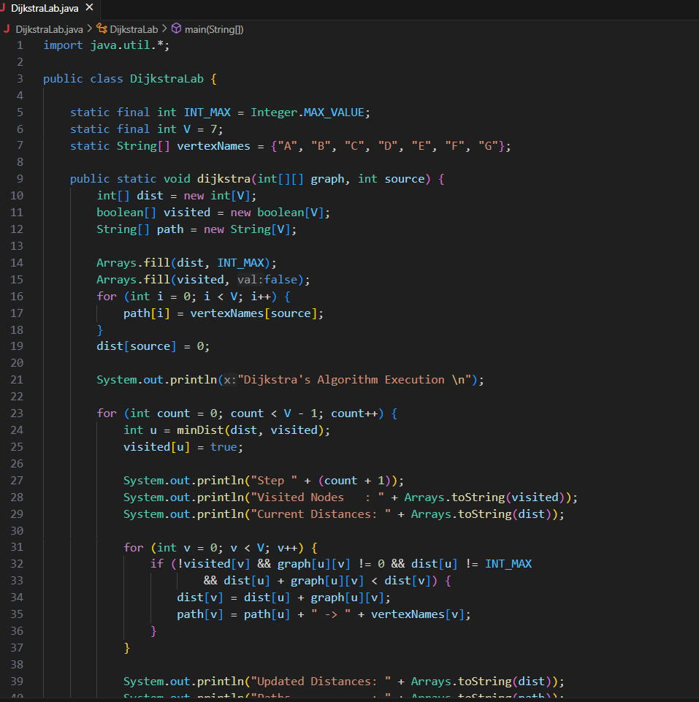

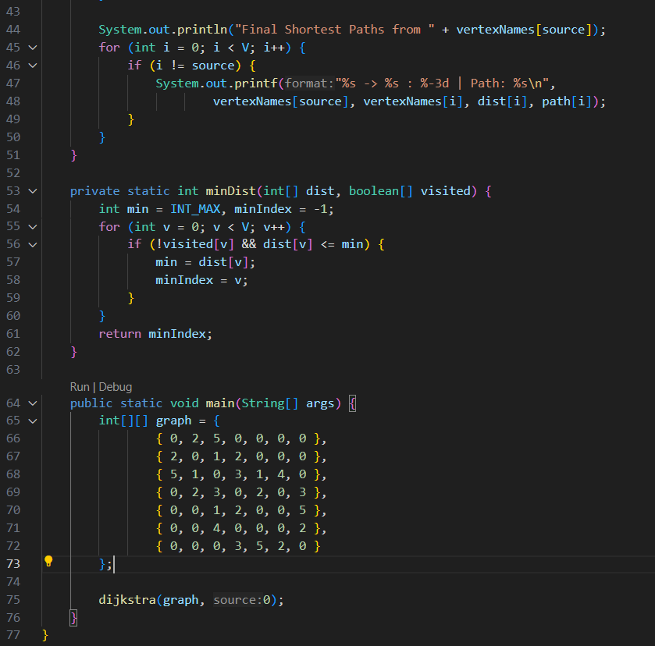

OUTPUT:
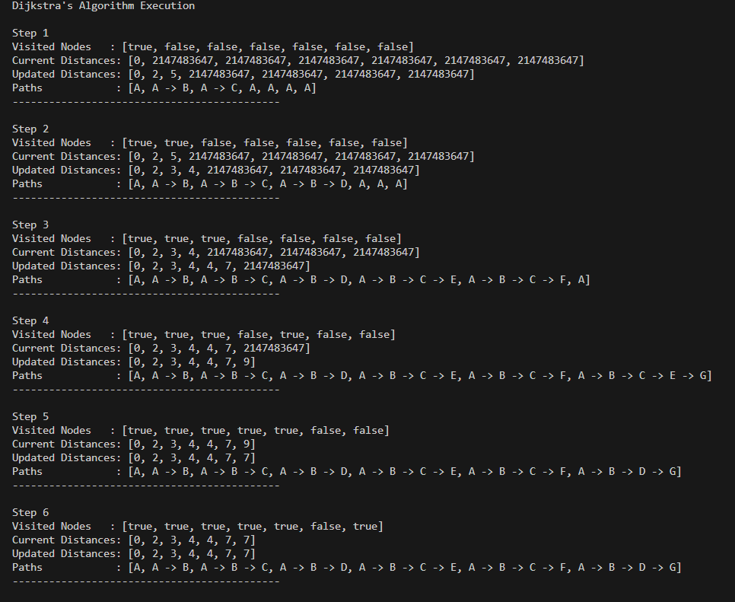
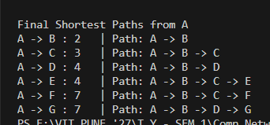

2nd Example
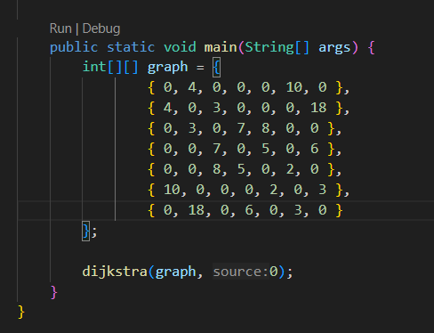
OUTPUT:
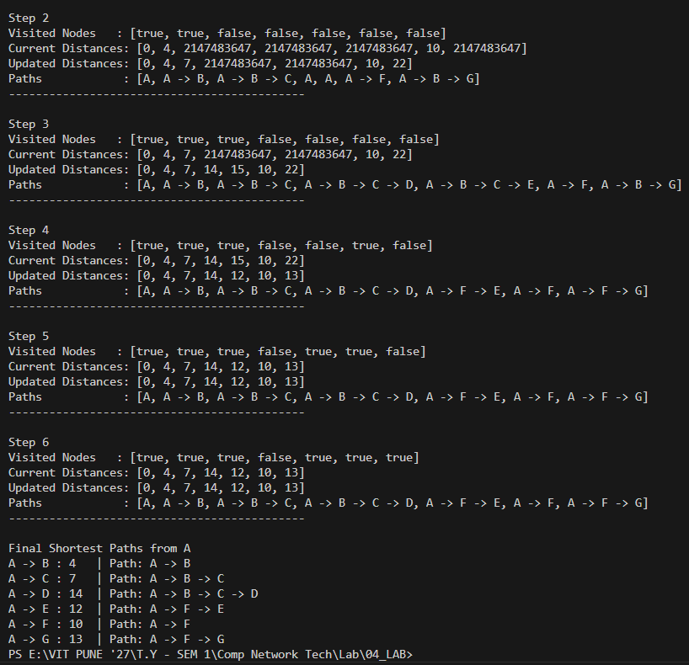

Name : Atharva Salitri
Division : TY CSAI-B
Batch : B2
Roll No. : 029
PRN : 12310120
Subject : Computer Network Technology

Assignment No:4

Title: Client server programs using TCP Berkeley socket.
Problem Statement: Write the client server programs using TCP Berkeley socket primitives for wired /wireless network for following a. to say Hello to Each other b. File transfer.
Course Objective: To learn transport layer and application layer protocols used in the Internet.
Course Outcome: Develop Client-Servers by the means of correct standards, protocols and technologies.
Tools Required: Eclipse, Java.
Theory:
- Introduction
The term network programming refers to writing programs that execute across multiple devices (computers), in which the devices are all connected to each other using a network.
The java.net package of the J2SE APIs contains a collection of classes and interfaces that provide the low-level communication details, allowing you to write programs that focus on solving the problem at hand.
The java.net package provides support for the two common network protocols:
- TCP: TCP stands for Transmission Control Protocol, which allows for reliable communication between two applications. TCP is typically used over the Internet Protocol, which is referred to as TCP/IP.
- UDP: UDP stands for User Datagram Protocol, a connection-less protocol that allows for packets of data to be transmitted between applications.

- Berkeley Socket Primitives (TCP/IP Socket Programming):
The Berkeley Sockets API was developed at the University of California, Berkeley, and forms the foundation for network communication in many operating systems including UNIX, Linux, and Windows.
Socket Primitives for TCP (Connection-Oriented):
Primitive | Description
socket() | Creates a new socket descriptor (endpoint for communication).
bind() | Binds the socket to a local IP address and port.
listen() | Marks the socket as a passive socket to accept incoming connection requests.
accept() | Accepts a connection request from a client and returns a new socket descriptor for communication.
connect() | Used by the client to initiate a connection with the server.
send() / write() | Sends data over the connection.
recv() / read() | Receives data from the connection.
close() | Closes the socket and terminates the connection.

- Socket Programming Flow (TCP):
Server Side:
- Create socket using socket()
- Bind the socket to an IP and port using bind()
- Listen for connections using listen()
- Accept incoming client connections using accept()
- Communicate using read() and write()
- Close the connection with close()
lient Side:
- Create socket using socket()
- Connect to server using connect()
- Communicate using read() and write()
- Close the connection with close()

- Socket Programming Using Java:
Sockets provide the communication mechanism between two computers using TCP. A client program creates a socket on its end of the communication and attempts to connect that socket to a server. When the connection is made, the server creates a socket object on its end of the communication. The client and server can now communicate by writing to and reading from the socket.
The java.net.Socket class represents a socket, and the java.net.ServerSocket class provides a mechanism for the server program to listen for clients and establish connections with them.
The following steps occur when establishing a TCP connection between two computers using sockets:
- The server instantiates a ServerSocket object, denoting which port number communication is to occur on.
- The server invokes the accept() method of the ServerSocket class. This method waits until a client connects to the server on the given port.
- After the server is waiting, a client instantiates a Socket object, specifying the server name and port number to connect to.
- The constructor of the Socket class attempts to connect the client to the specified server and port number. If communication is established, the client now has a Socket object capable of communicating with the server.
- On the server side, the accept() method returns a reference to a new socket on the server that is connected to the client's socket.
After the connections are established, communication can occur using I/O streams. Each socket has both an OutputStream and an InputStream. The client's OutputStream is connected to the server's InputStream, and the client's InputStream is connected to the server's OutputStream.
TCP is a two way communication protocol, so data can be sent across both streams at the same time. There are following use full classes providing complete set of methods to implement sockets.

- ServerSocket Class Methods:
public ServerSocket(int port) throws IOException
Attempts to create a server socket bound to the specified port. An exception occurs if the port is already bound by another application.
public ServerSocket(int port, int backlog) throws IOException
Similar to the previous constructor, the backlog parameter specifies how many incoming clients to store in a wait queue.
public ServerSocket(int port, int backlog, InetAddress address) throws IOException
Similar to the previous constructor, the InetAddress parameter specifies the local IP address to bind to. The InetAddress is used for servers that may have multiple IP addresses, allowing the server to specify which of its IP addresses to accept client requests on
public ServerSocket() throws IOException
Creates an unbound server socket. When using this constructor, use the bind() method when you are ready to bind the server socket
public Socket accept() throws IOException
Waits for an incoming client. This method blocks until either a client connects to the server on the specified port or the socket times out, assuming that the time-out value has been set using the setSoTimeout() method. Otherwise, this method blocks indefinitely

- Socket Class Methods:
The java.net.Socket class represents the socket that both the client and server use to communicate with each other. The client obtains a Socket object by instantiating one, whereas the server obtains a Socket object from the return value of the accept() method.
public Socket(String host, int port) throws UnknownHostException, IOException.
This method attempts to connect to the specified server at the specified port. If this constructor does not throw an exception, the connection is successful and the client is connected to the server.
public Socket(InetAddress host, int port) throws IOException
This method is identical to the previous constructor, except that the host is denoted by an InetAddress object.
public void connect(SocketAddress host, int timeout) throws IOException
This method connects the socket to the specified host. This method is needed only when you instantiated the Socket using the no-argument constructor.
public InetAddress getInetAddress()
This method returns the address of the other computer that this socket is connected to.
public int getPort()
Returns the port the socket is bound to on the remote machine.
public void close() throws IOException
Closes the socket, which makes this Socket object no longer capable of connecting again to any server

Conclusion: Hence, we have Successfully Wrote a client server programs using TCP Berkeley socket primitives for following a) Say Hello to Each other b)File transfer

Program:
//**************************Client.Java************************************
import java.io.*;
import java.net.*;
public class Client
{
public static void main(String[] args) throws IOException
{
Socket socket = new Socket("127.0.0.1", 12345);

BufferedReader in = new BufferedReader(new InputStreamReader(socket.getInputStream()));
PrintWriter out = new PrintWriter(socket.getOutputStream(), true);
BufferedReader userInput = new BufferedReader(new InputStreamReader(System.in));

String messageFromServer, messageFromClient;

while (true)
{
System.out.print("You (Client): ");
messageFromClient = userInput.readLine();
out.println(messageFromClient);

if (messageFromClient.equalsIgnoreCase("bye"))
{
System.out.println("You ended the chat.");
break;
}

messageFromServer = in.readLine();
if (messageFromServer == null || messageFromServer.equalsIgnoreCase("bye"))
{
System.out.println("Server ended the chat.");
break;
}

System.out.println("Server: " + messageFromServer);
}

socket.close();
System.out.println("Connection closed.");
}
}
//**************************Server.Java************************************
import java.io.*;
import java.net.*;

public class Server
{
public static void main(String[] args) throws IOException
{
ServerSocket serverSocket = new ServerSocket(12345);
System.out.println("Server is waiting for connection...");

Socket socket = serverSocket.accept();
System.out.println("Client connected: " + socket.getInetAddress());

BufferedReader in = new BufferedReader(new InputStreamReader(socket.getInputStream()));
PrintWriter out = new PrintWriter(socket.getOutputStream(), true);
BufferedReader userInput = new BufferedReader(new InputStreamReader(System.in));

String messageFromClient, messageFromServer;

while (true)
{
messageFromClient = in.readLine();
if (messageFromClient == null || messageFromClient.equalsIgnoreCase("bye"))
{
System.out.println("Client ended the chat.");
break;
}
System.out.println("Client: " + messageFromClient);

System.out.print("You (Server): ");
messageFromServer = userInput.readLine();
out.println(messageFromServer);

if (messageFromServer.equalsIgnoreCase("bye")) {
System.out.println("You ended the chat.");
break;
}
}

socket.close();
serverSocket.close();
System.out.println("Connection closed.");
}
}

Output:
Server is waiting for connection...  Client connected: /127.0.0.1  Client: Hello  You (Server): hi how are you  Client ended the chat.  Connection closed. | You (Client): Hello  Server: hi how are you  You (Client): bye  You ended the chat.  Connection closed.

//**************************Client.Java************************************
import java.io.*;
import java.net.*;

public class FTClient {
public static void main(String[] args) {
String serverIP = "127.0.0.1"; // localhost
int port = 5000;
String filePath = "C:/VIT/AY 2025-26/DBMS/LabProgram/CNAssignment/src/FileTrans/clientfile/sample.txt"; // File to send

try (Socket socket = new Socket(serverIP, port)) {
File file = new File(filePath);
FileInputStream fis = new FileInputStream(file);
DataOutputStream dos = new DataOutputStream(socket.getOutputStream());

// Send file name first
dos.writeUTF(file.getName());

// Send file data
byte[] buffer = new byte[4096];
int bytesRead;
while ((bytesRead = fis.read(buffer)) > 0) {
dos.write(buffer, 0, bytesRead);
}

fis.close();
dos.close();
socket.close();

System.out.println("File sent successfully from ClientFiles/" + file.getName());
} catch (IOException e) {
e.printStackTrace();
}
}
}
//**************************Server.Java************************************
import java.io.*;
import java.net.*;

public class FTServer {
public static void main(String[] args) {
int port = 5000;
String saveDir = "C:/VIT/AY 2025-26/DBMS/LabProgram/CNAssignment/src/FileTrans/serverfile/"; // Save incoming file here

try (ServerSocket serverSocket = new ServerSocket(port)) {
System.out.println("Server started. Waiting for file...");

Socket socket = serverSocket.accept();
System.out.println("Client connected: " + socket.getInetAddress());

DataInputStream dis = new DataInputStream(socket.getInputStream());

// Receive file name
String fileName = dis.readUTF();
System.out.println("Receiving file: " + fileName);

FileOutputStream fos = new FileOutputStream(saveDir + fileName);

// Receive file data
byte[] buffer = new byte[4096];
int bytesRead;
while ((bytesRead = dis.read(buffer)) > 0) {
fos.write(buffer, 0, bytesRead);
}

fos.close();
dis.close();
socket.close();

System.out.println("File received and saved to ServerFiles/" + fileName);
} catch (IOException e) {
e.printStackTrace();
}
}
}

Output:
Client Side:
File sent successfully from ClientFiles/sample.txt

Server Side:
Server started. Waiting for file...
Client connected: /127.0.0.1
Receiving file: sample.txt
File received and saved to ServerFiles/sample.txt

Screenshots:
Client.java
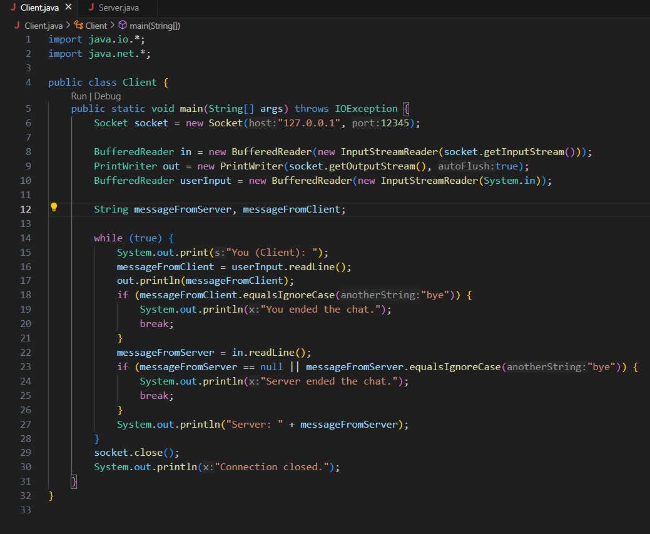

Server.java
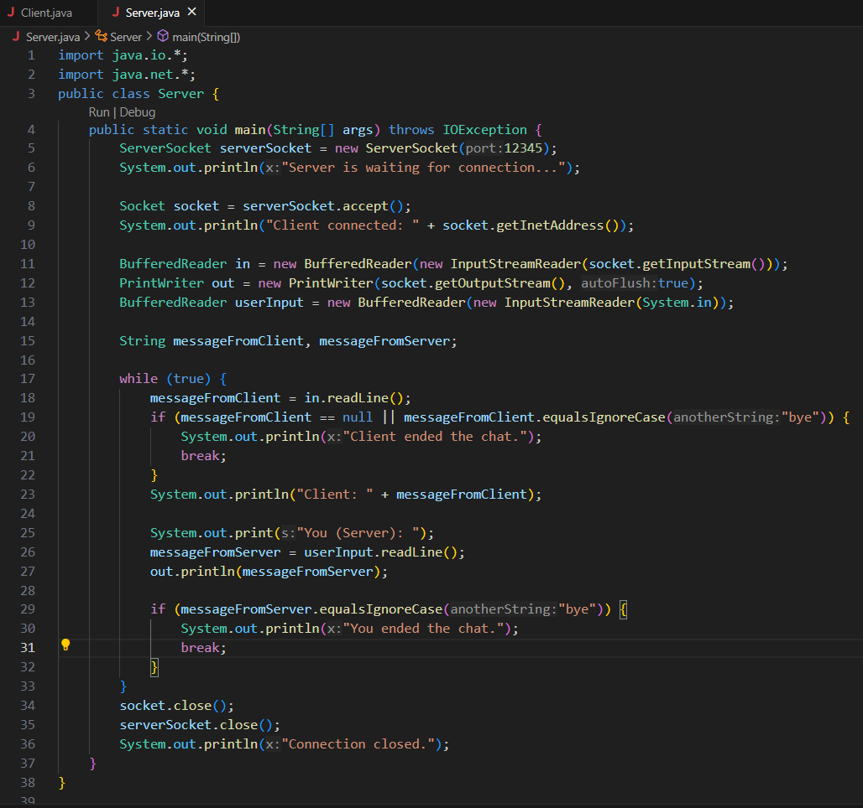
OUTPUT:
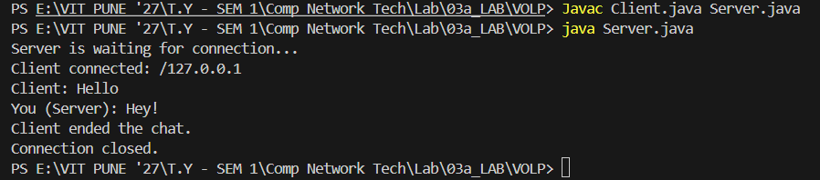
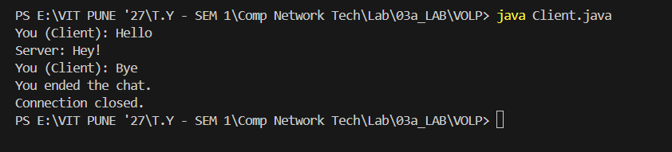
File Transfer
Client.java
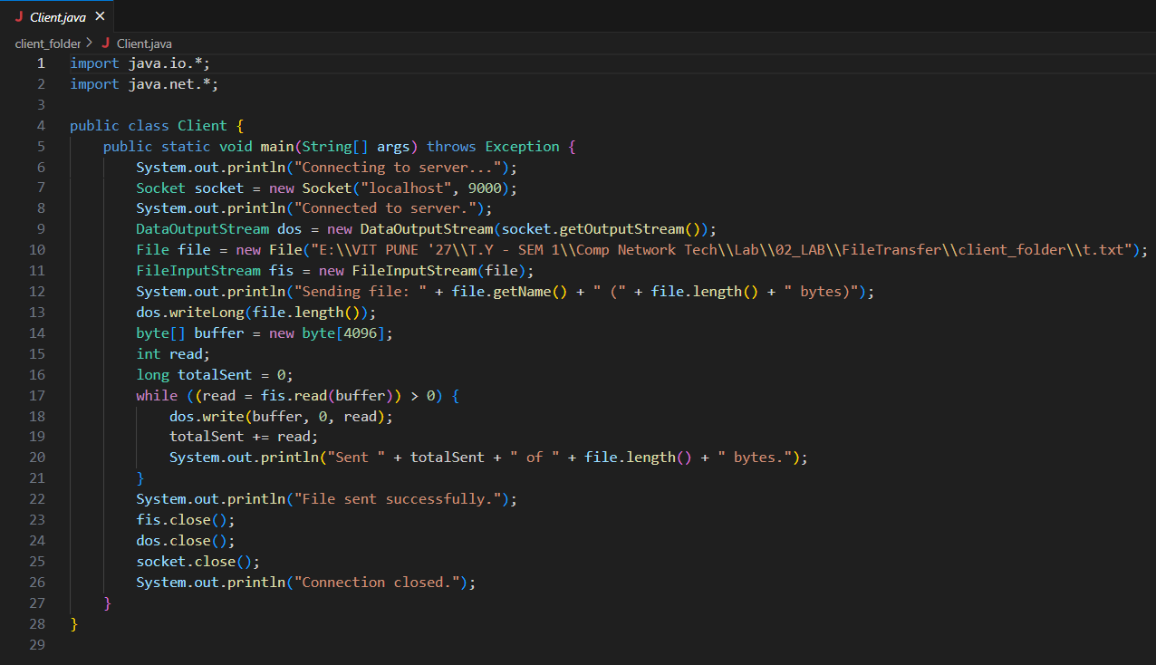
Server.java
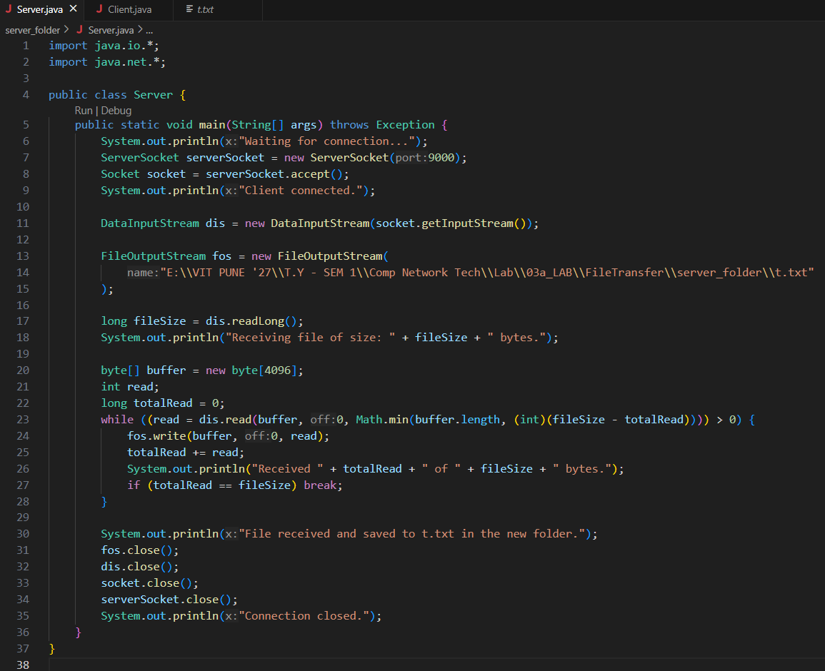
OUTPUT:
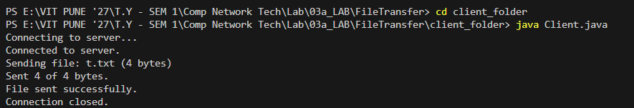

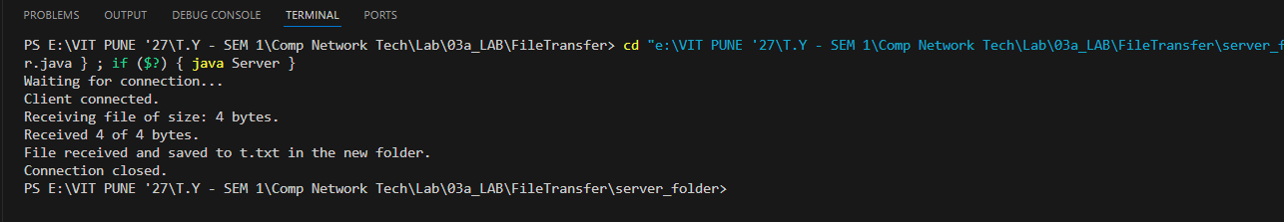

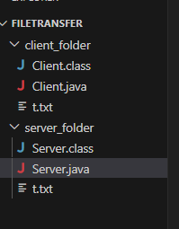

Name : Atharva Salitri
Division : TY CSAI-B
Batch : B2
Roll No. : 029
PRN : 12310120
Subject : Computer Network Technology

Assignment No:5

Title: Client server programs using UDP Berkeley socket primitives.
Problem Statement: Write the client server programs using UDP Berkeley socket primitives for wired /wireless network for following a. to say Hello to Each other b. Calculator (Trigonometry).
Course Objective: To learn transport layer and application layer protocols used in the Internet.
Course Outcome: Develop Client-Servers by the means of correct standards, protocols and technologies.
Tools Required: Eclipse, Java.
Theory:
- Introduction
The term network programming refers to writing programs that execute across multiple devices (computers), in which the devices are all connected to each other using a network.
The java.net package of the J2SE APIs contains a collection of classes and interfaces that provide the low-level communication details, allowing you to write programs that focus on solving the problem at hand.
The java.net package provides support for the two common network protocols:
- TCP: TCP stands for Transmission Control Protocol, which allows for reliable communication between two applications. TCP is typically used over the Internet Protocol, which is referred to as TCP/IP.
- UDP: UDP stands for User Datagram Protocol, a connection-less protocol that allows for packets of data to be transmitted between applications.

- What is UDP?
UDP (User Datagram Protocol) is a connectionless, lightweight transport protocol that allows applications to send and receive datagrams without establishing a connection. It is faster but less reliable than TCP, as it does not guarantee delivery, ordering, or error checking.

2.1 Berkeley Sockets Model
The Berkeley Sockets API is a low-level network communication interface originally developed for UNIX systems. Java’s java.net package provides a high-level abstraction of Berkeley Sockets.
In UDP communication, Berkeley Sockets provide:
- No connection establishment: Send and receive packets independently.
- Datagram-based communication: Each message is sent as an individual packet.
- Best-effort delivery: No guarantee of packet arrival or order.

2.3 UDP Communication Flow in Java
Server Side:
- Create DatagramSocket on a fixed port.
- Wait for incoming packets using receive().
- Read data from DatagramPacket.
- Optionally send a response using send().
Client Side:
- Create DatagramSocket.
- Create DatagramPacket with message and server details.
- Send message using send().
- Wait for reply using receive().

- Java Classes Used in UDP (Berkeley Sockets Model)
Class Name | Package | Description
DatagramSocket | java.net | Used to send and receive UDP packets. It acts as the communication endpoint.
DatagramPacket | java.net | Represents a UDP datagram packet. Carries data to be sent or received.
InetAddress | java.net | Represents an IP address (IPv4 or IPv6). Used to specify sender/receiver host.
IOException | java.io | Handles input/output errors that may occur during socket communication.
UnknownHostException | java.net | Thrown when IP address of a host cannot be determined (usually on client side).
SocketException | java.net | Thrown when there is an error creating or accessing a DatagramSocket.

Conclusion: Hence, we have Successfully wrote a client server programs using UDP Berkeley socket primitives for wired /wireless network to say Hello to Each other and Calculator (Trigonometry).

Program:
//**************************Client.Java************************************
package ChatApplication;

import java.net.*;
import java.util.Scanner;

public class Client {
public static void main(String[] args) {
try {
DatagramSocket clientSocket = new DatagramSocket(); // Create client socket
InetAddress serverAddress = InetAddress.getByName("localhost"); // Server IP
Scanner scanner = new Scanner(System.in);
byte[] sendData;
byte[] receiveData = new byte[1024];

while (true) {
// Ask client user to enter a message
System.out.print("You (Client): ");
String message = scanner.nextLine();
sendData = message.getBytes();

// Send message to server
DatagramPacket sendPacket = new DatagramPacket(sendData, sendData.length, serverAddress, 9876);
clientSocket.send(sendPacket);

if (message.equalsIgnoreCase("bye")) {
System.out.println("You exited the chat.");
break;
}

// Receive server reply
DatagramPacket receivePacket = new DatagramPacket(receiveData, receiveData.length);
clientSocket.receive(receivePacket);
String serverReply = new String(receivePacket.getData(), 0, receivePacket.getLength());

System.out.println("Server: " + serverReply);

if (serverReply.equalsIgnoreCase("bye")) {
System.out.println("Server exited the chat.");
break;
}
}

clientSocket.close();
} catch (Exception e) {
e.printStackTrace();
}
}
}

//**************************Server.Java************************************
package ChatApplication;

import java.net.*;
import java.util.Scanner;

public class Server {
public static void main(String[] args) {
try {
DatagramSocket serverSocket = new DatagramSocket(9876); // Server socket on port 9876
Scanner scanner = new Scanner(System.in);
byte[] receiveData = new byte[1024];
byte[] sendData;

System.out.println("Server is running...");

while (true) {
// Receive message from client
DatagramPacket receivePacket = new DatagramPacket(receiveData, receiveData.length);
serverSocket.receive(receivePacket);
String clientMessage = new String(receivePacket.getData(), 0, receivePacket.getLength());

System.out.println("Client: " + clientMessage);

if (clientMessage.equalsIgnoreCase("bye")) {
System.out.println("Client exited the chat.");
break;
}

// Ask server user to type a reply
System.out.print("You (Server): ");
String reply = scanner.nextLine();
sendData = reply.getBytes();

// Send response to client
InetAddress clientAddress = receivePacket.getAddress();
int clientPort = receivePacket.getPort();
DatagramPacket sendPacket = new DatagramPacket(sendData, sendData.length, clientAddress, clientPort);
serverSocket.send(sendPacket);

if (reply.equalsIgnoreCase("bye")) {
System.out.println("Server exited the chat.");
break;
}
}

serverSocket.close();
} catch (Exception e) {
e.printStackTrace();
}
}
}
Output:
Server is running...  Client: Hello  You (Server): hi how are you  Client ended the chat.  Connection closed. | You (Client): Hello  Server: hi how are you  You (Client): bye  You ended the chat.  Connection closed.

//**************************Client.Java************************************
package Calculator;

import java.net.DatagramPacket;
import java.net.DatagramSocket;
import java.net.InetAddress;
import java.util.Scanner;

public class Client {
public static void main(String[] args) throws Exception {
DatagramSocket clientSocket = new DatagramSocket();
InetAddress IPAddress = InetAddress.getByName("localhost");
Scanner sc = new Scanner(System.in);

while (true) {
// Get user input
System.out.print("Enter operator (sin/cos/tan): ");
String op = sc.next();
System.out.print("Enter number: ");
double num = sc.nextDouble();

// Prepare data to send
String message = op + " " + num;
byte[] sendData = message.getBytes();
DatagramPacket sendPacket = new DatagramPacket(sendData, sendData.length, IPAddress, 9877);
clientSocket.send(sendPacket);

// Receive response
byte[] receiveData = new byte[1024];
DatagramPacket receivePacket = new DatagramPacket(receiveData, receiveData.length);
clientSocket.receive(receivePacket);
String reply = new String(receivePacket.getData(), 0, receivePacket.getLength());
System.out.println(reply);

// Ask user if they want to continue
System.out.print("Do you want to continue? (yes/no): ");
String choice = sc.next();
if (!choice.equalsIgnoreCase("yes")) break;
}

clientSocket.close();
sc.close();
}
}

//**************************Server.Java************************************
package Calculator;

import java.net.DatagramPacket;
import java.net.DatagramSocket;
import java.util.StringTokenizer;

public class Server {
public static void main(String[] args) throws Exception {
DatagramSocket serverSocket = new DatagramSocket(9877);
byte[] receiveData = new byte[1024];
byte[] sendData;

while (true) {
// Receive request from client
DatagramPacket receivePacket = new DatagramPacket(receiveData, receiveData.length);
serverSocket.receive(receivePacket);
String input = new String(receivePacket.getData(), 0, receivePacket.getLength());

// Parse operation and number
StringTokenizer st = new StringTokenizer(input, " ");
String op = st.nextToken();
double num = Double.parseDouble(st.nextToken());

// Perform trigonometric operation
double result;
switch (op.toLowerCase()) {
case "sin": result = Math.sin(Math.toRadians(num)); break;
case "cos": result = Math.cos(Math.toRadians(num)); break;
case "tan": result = Math.tan(Math.toRadians(num)); break;
default: result = Double.NaN;
}

// Send result back to client
String output = "Result: " + result;
sendData = output.getBytes();
DatagramPacket sendPacket = new DatagramPacket(sendData, sendData.length,
receivePacket.getAddress(), receivePacket.getPort());
serverSocket.send(sendPacket);
}
}
}

Output:
Execute Server followed by client
Client Side:
Enter operator (sin/cos/tan): sin
Enter number: 90
Result: 1.0
Do you want to continue? (yes/no): yes
Enter operator (sin/cos/tan): tan
Enter number: 90
Result: 1.633123935319537E16
Do you want to continue? (yes/no): no

Screenshots:
HelloClient.java
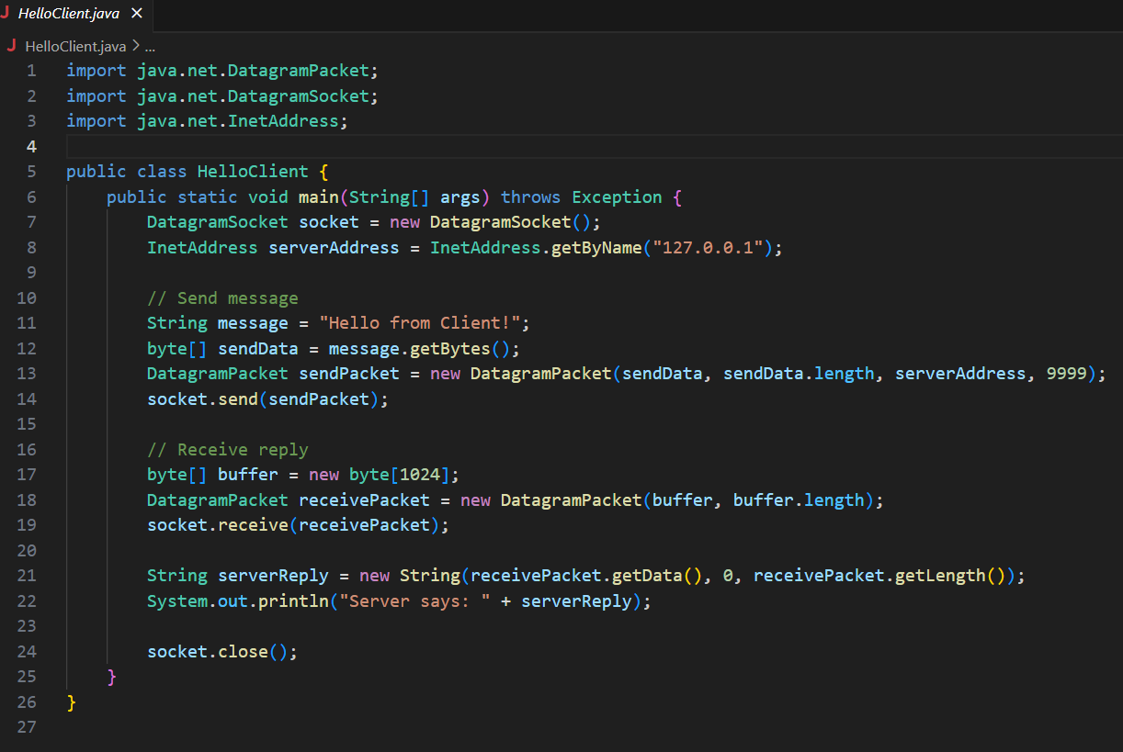

HelloServer.java
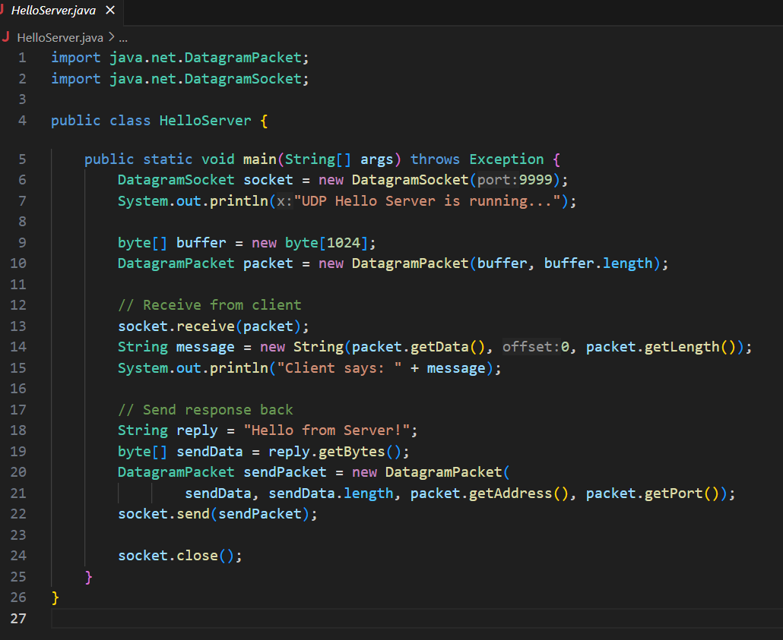
OUTPUT:
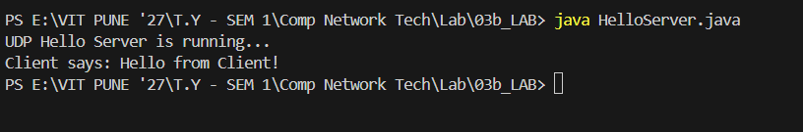
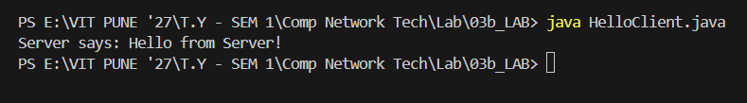

TrigClient.java
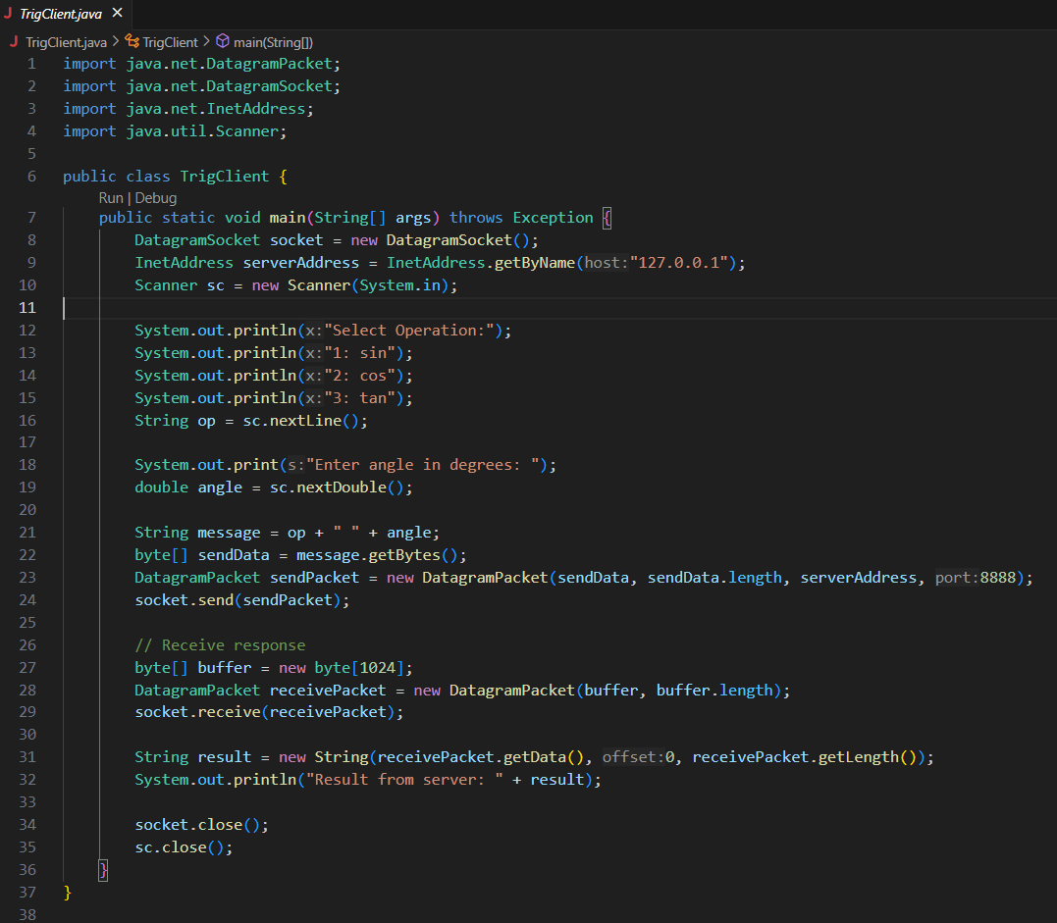

TrigServer.java
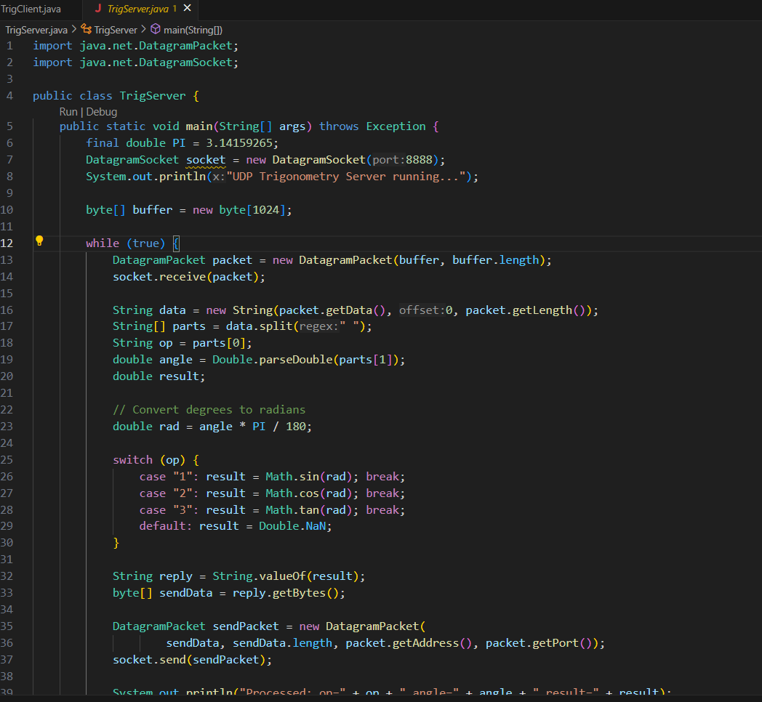
OUTPUT:
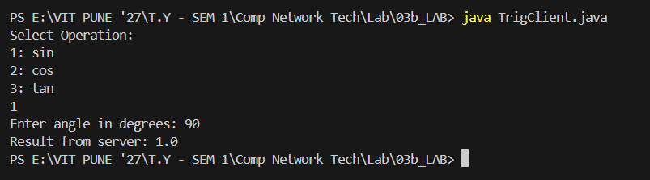

Name : Atharva Salitri
Division : TY CSAI-B
Batch : B2
Roll No. : 029
PRN : 12310120
Subject : Computer Network Technology

Assignment No:6

Title: Understanding protocol stack of Intranet.
Problem Statement: Analyze packet formats of Ethernet, IP, TCP and UDP captured through Wireshark for wired networks.
Course Objective: To learn transport layer and application layer protocols used in the Internet.
Course Outcome: Develop Client-Servers by the means of correct standards, protocols and technologies.
Tools Required: Wireshark.
Theory:
1. Introduction
Wireshark is a network packet analyzer. A network packet analyzer presents captured packet data in as much detail as possible. You could think of a network packet analyzer as a measuring device for examining what’s happening inside a network cable, just like an electrician uses a voltmeter for examining what’s happening inside an electric cable (but at a higher level, of course). In the past, such tools were either very expensive, proprietary, or both. However, with the advent of Wireshark, that has changed. Wireshark is available for free, is open source, and is one of the best packet analyzers available today.
1.1 Features
The following are some of the many features Wireshark provides:
- Available for UNIX and Windows.
- Capture live packet data from a network interface.
- Open files containing packet data captured with tcpdump/WinDump, Wireshark, and many other packet capture programs.
- Import packets from text files containing hex dumps of packet data.
- Display packets with very detailed protocol information.
- Save packet data captured.
- Export some or all packets in a number of capture file formats.
- Filter packets on many criteria.
- Search for packets on many criteria.
- Colorize packet display based on filters.
- Create various statistics.

2. Wireshark Filter
2.1 Display Filter
Wireshark provides a display filter language that enables you to precisely control which packets are displayed. They can be used to check for the presence of a protocol or field, the value of a field, or even compare two fields to each other. These comparisons can be combined with logical operators, like "and" and "or", and parentheses into complex expressions.
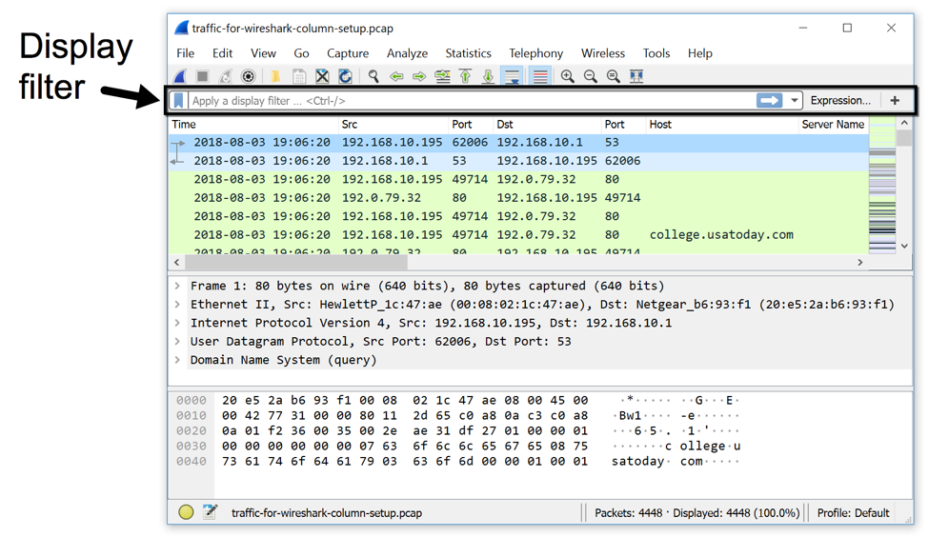
Wireshark's display filter uses Boolean expressions, so you can specify values and chain them together. The following expressions are commonly used:
- Equals: == or eq
- And: && or and
- Or: || (double pipe) or or
2.1.1 Example
- eth.src == 00:11:22:33:44:55: Source MAC address is 00:11:22:33:44:55
- ip.addr == 10.0.0.1: Find all traffic that has IP of 10.0.0.1
- tcp.dstport != 80: Destination tcp port is NOT 80
- ip.addr==10.10.10.1
- ip.addr==192.168.1.10 && ip.addr==192.168.1.20
- !(ip.addr==192.168.1.10 && ip.addr==192.168.1.20)
- (ip.addr==192.168.1.10 && ip.addr==192.168.1.20) && (tcp.port==445 || tcp.port==139)
- ip.src==10.10.10.0/24
- eth.addr==00:1b:17:00:01:31
- ip.addr==10.10.10.1 && tcp.port==80
- tcp.port==80
- tcp.port==80 || tcp.port==3389
- tcp.dstport==80
- eth.dst=ff:ff:ff:ff:ff:ff
- ip.addr==255.255.255.255
ip.host contains "imap"

2.2 Capture Filters
Capture filters are used to decrease the size of captures by filtering out packets before they are added. Capture filters enable you to capture only traffic that you want to be captured, eliminating an unwanted stream of packets. Capturing packets is a processor-intensive task, and packet analyzers use a good amount of primary memory while they are running. Packets are only sent to the capture engine if they meet a certain criterion (capture filter expressions). Capture filters do not facilitate advanced filtering options, as in display filters.
2.2.1 Examples
Capture only traffic to or from IP address 172.18.5.4:
- host 172.18.5.4
Capture traffic to or from a range of IP addresses:
- net 192.168.0.0/24
or
- net 192.168.0.0 mask 255.255.255.0
Capture traffic from a range of IP addresses:
- src net 192.168.0.0/24
or
- src net 192.168.0.0 mask 255.255.255.0
Capture traffic to a range of IP addresses:
- dst net 192.168.0.0/24
or
- dst net 192.168.0.0 mask 255.255.255.0
Capture only DNS (port 53) traffic:
- port 53
Capture non-HTTP and non-SMTP traffic on your server (both are equivalent):
- host www.example.com and not (port 80 or port 25)
host www.example.com and not port 80 and not port 25
Capture except all ARP and DNS traffic:
- port not 53 and not arp
Capture traffic within a range of ports
- (tcp[0:2] > 1500 and tcp[0:2] < 1550) or (tcp[2:2] > 1500 and tcp[2:2] < 1550)
or, with newer versions of libpcap (0.9.1 and later):
- tcp portrange 1501-1549
Capture only Ethernet type EAPOL:
- ether proto 0x888e
Reject ethernet frames towards the Link Layer Discovery Protocol Multicast group:
- not ether dst 01:80:c2:00:00:0e
Capture only IPv4 traffic - the shortest filter, but sometimes very useful to get rid of lower layer protocols like ARP and STP:
- ip
Capture only unicast traffic - useful to get rid of noise on the network if you only want to see traffic to and from your machine, not, for example, broadcast and multicast announcements:
- not broadcast and not multicast
Capture IPv6 "all nodes" (router and neighbor advertisement) traffic. Can be used to find rogue RAs:
- dst host ff02::1

Conclusion:
Hence, we have Successfully Capture packets using Wireshark and wrote the exact packet capture filter expressions.

Example:
1. Identify Facebook.com IP Address
sudo apt-get install traceroute
traceroute facebook.com
traceroute to facebook.com (31.13.86.8), 30 hops max, 60 byte packets

2. Capture all TCP traffic to/from Facebook, during the time when you log in to your Facebook account.
Capture filter: tcp and host 31.13.86.8
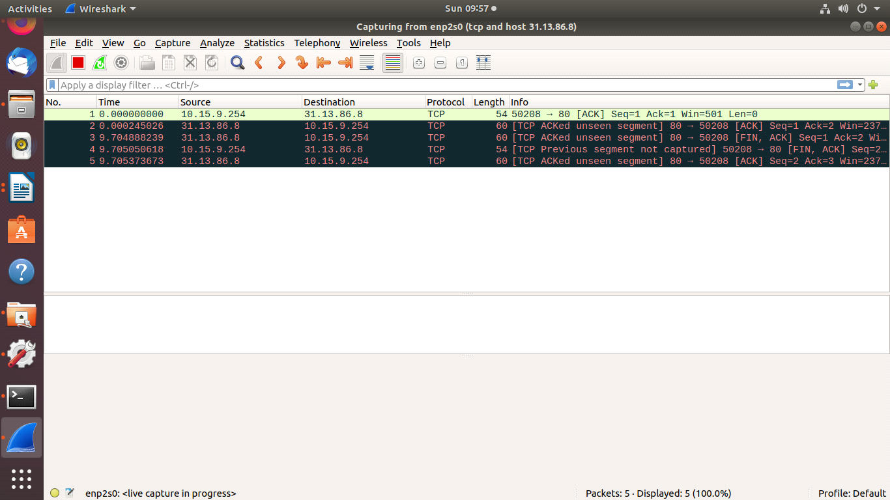

3. Capture all HTTP traffic to/from Facebook, when you log in to your Facebook account
Capture filter: tcp port 80 and host 31.13.86.8
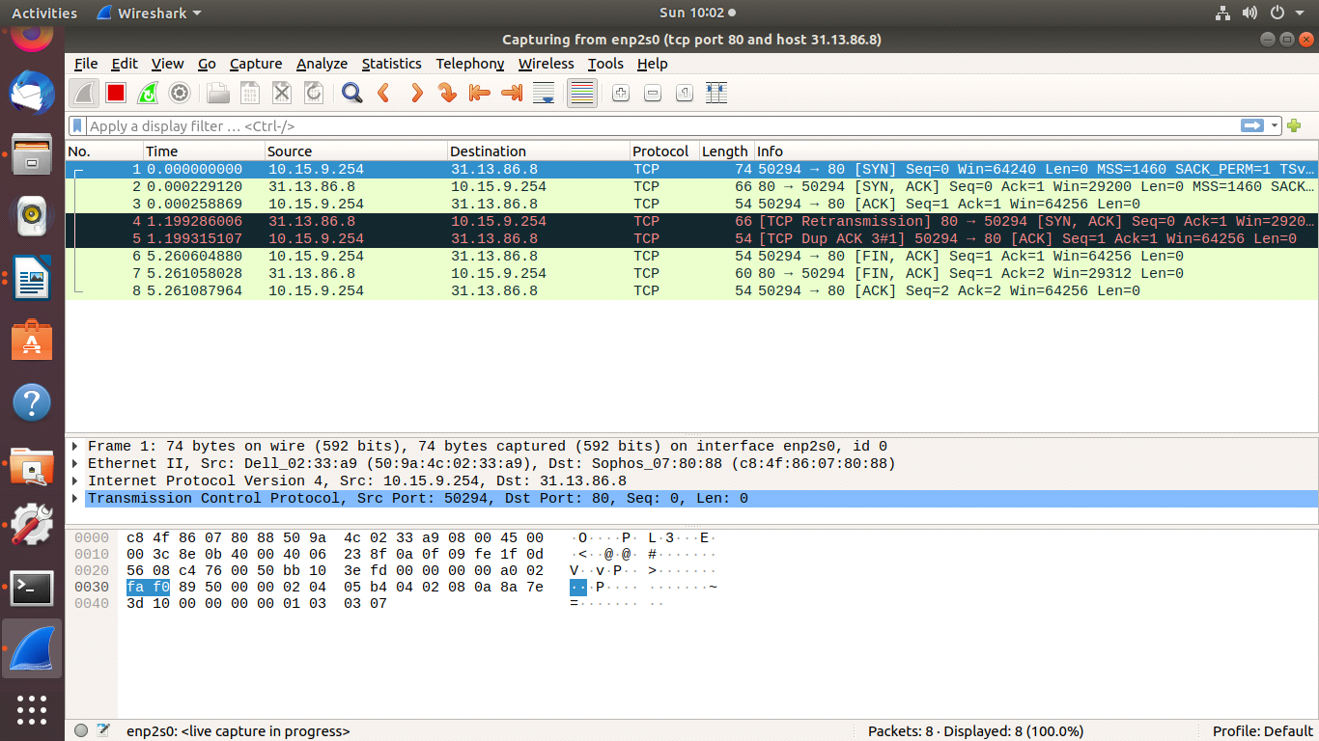
4. Write a DISPLAY filter expression to count all TCP packets (captured under item #1) that have the flags SYN, PSH, and RST set. Show the fraction of packets that had each flag set.
DISPLAY filter:
tcp.flags.syn==1 && ip.dst==31.13.86.8
tcp.flags.push==1 && ip.dst==31.13.86.8
tcp.flags.reset==1 && ip.dst==31.13.86.8

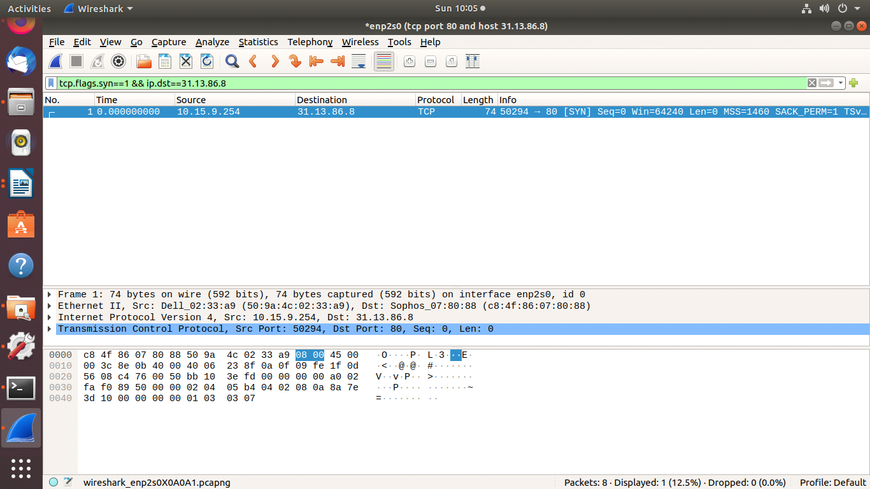
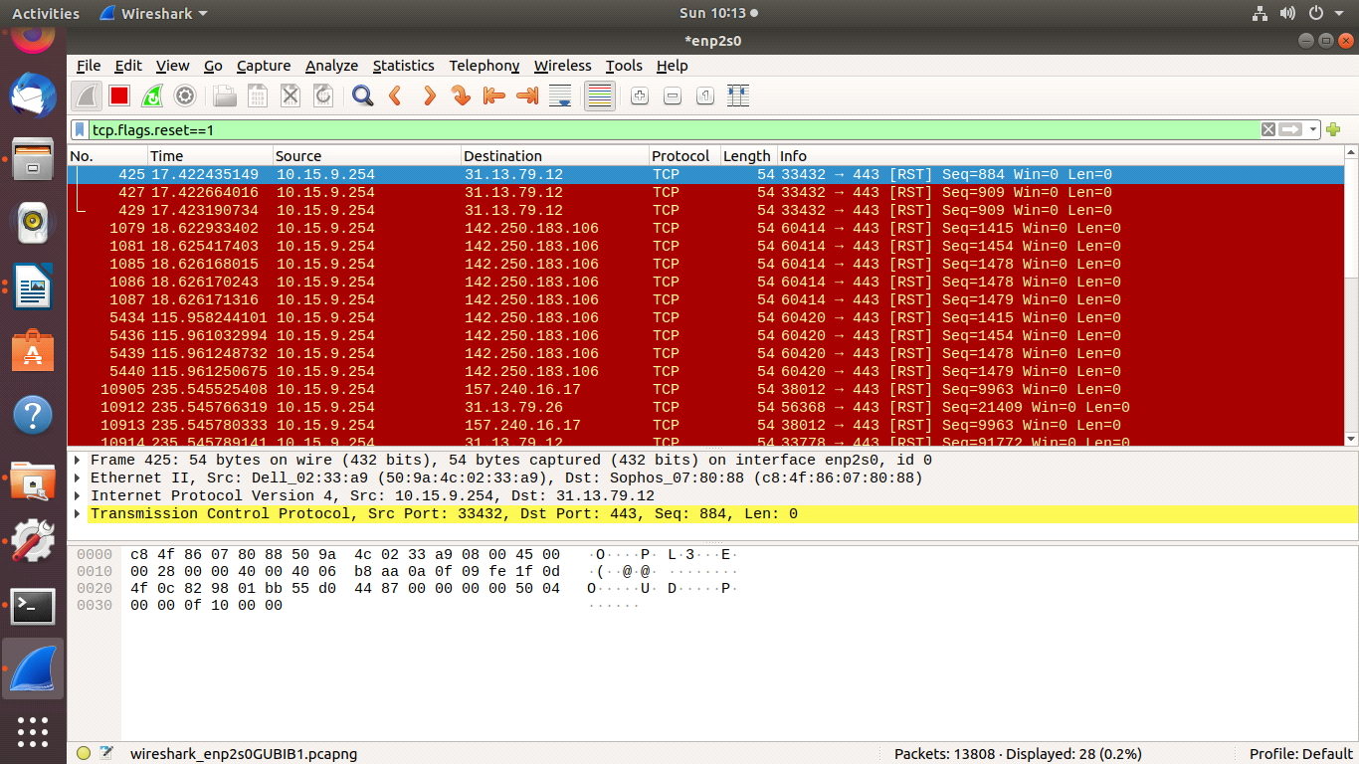
5. Count how many TCP packets you received from / sent to Face book, and how many of each were also HTTP packets.
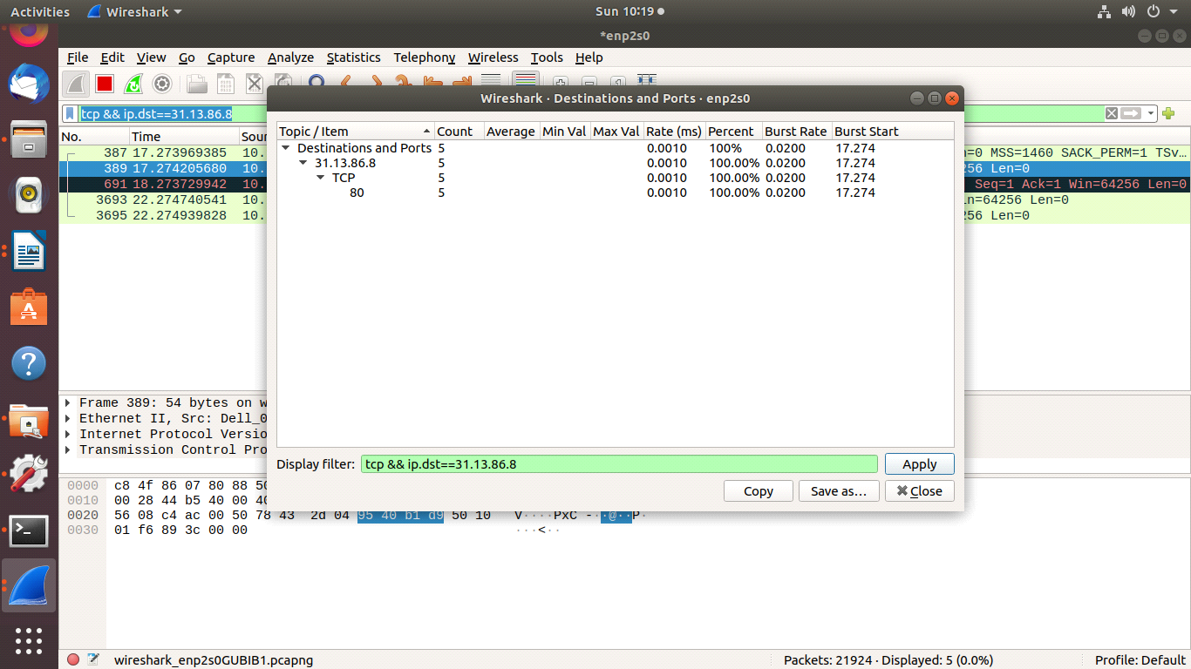

OUTPUT:
  - SETUP
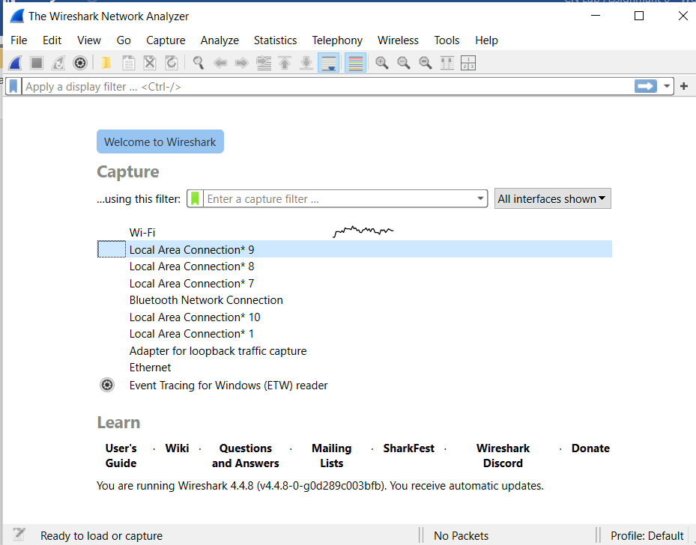
  - VIEW
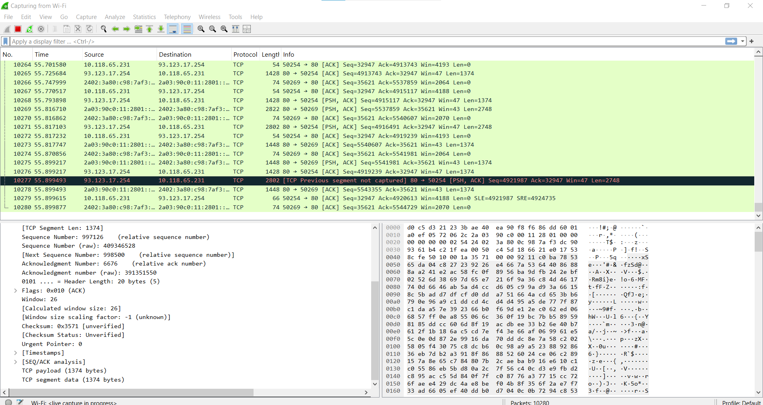

  - Display with Filter (tcp.dstport != 80)
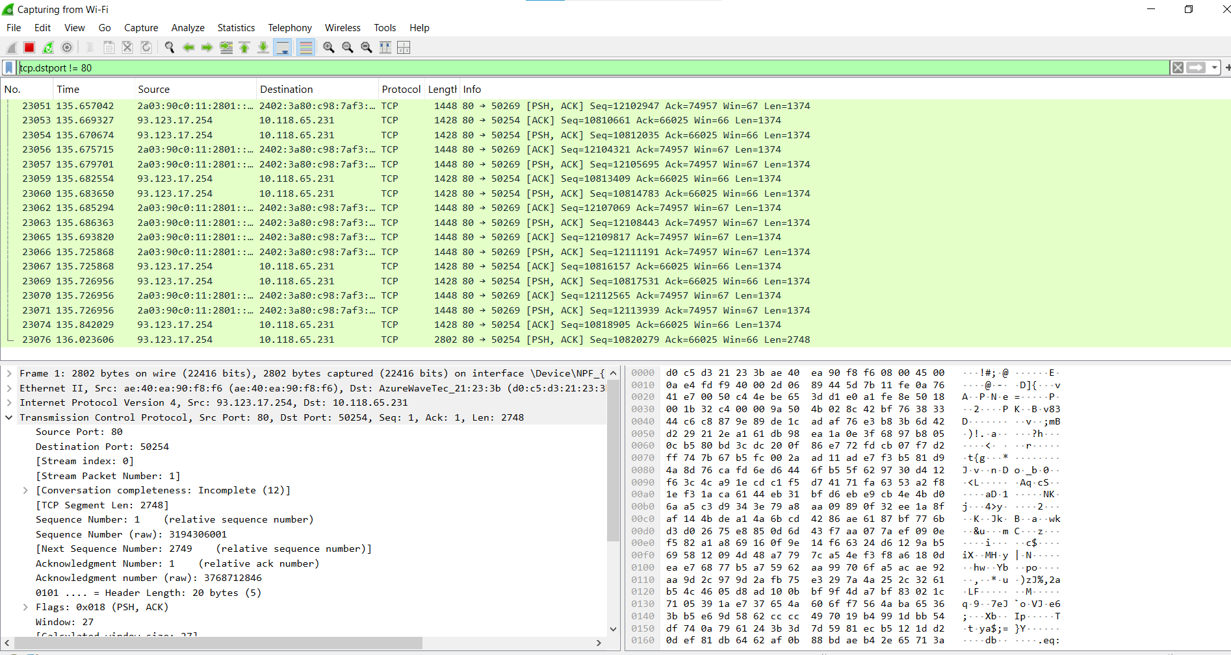
  - Traceroute Facebook.com
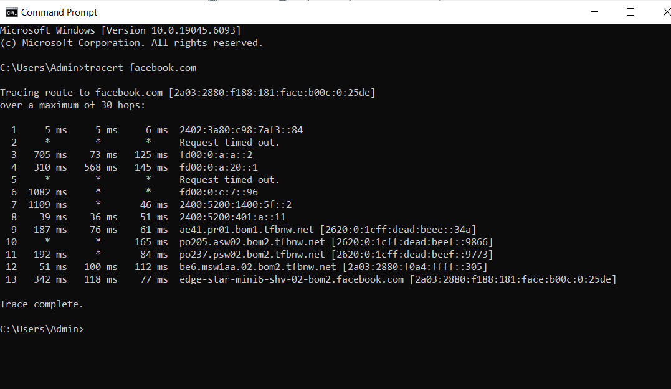

  - Nslookup facebook.com
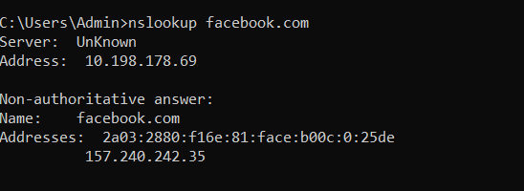

  - Facebook.com open
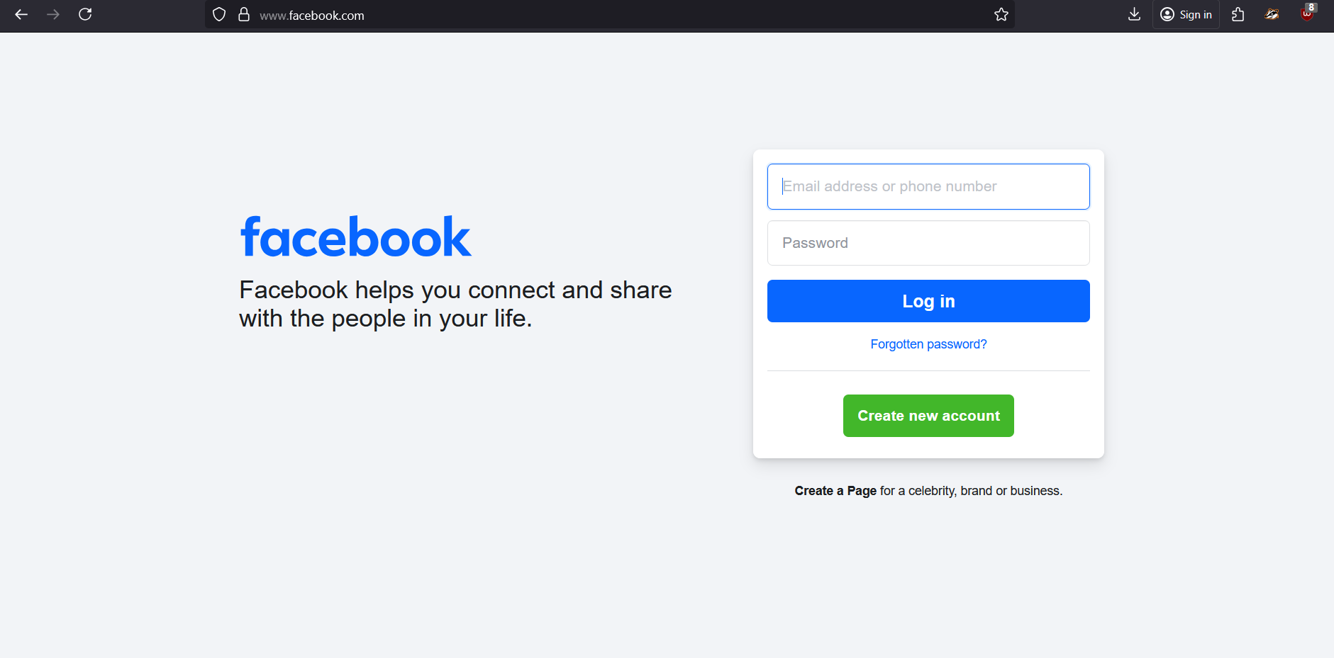

  - Ip.addr== 10.198.178.69
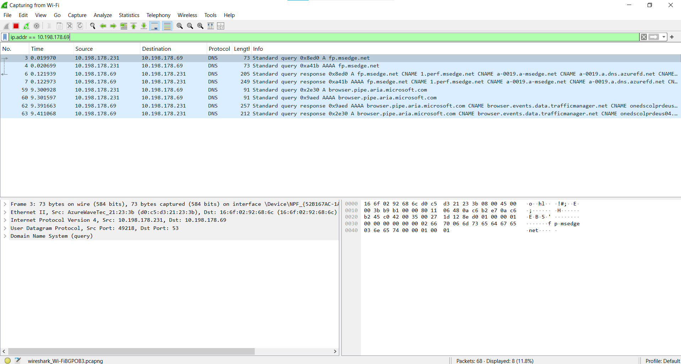

Second Example VIT.EDU
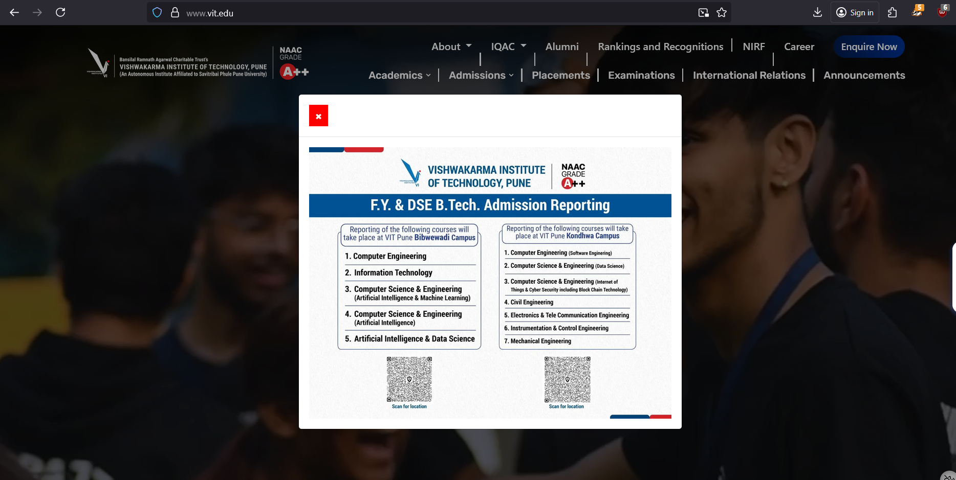

  - Tracert vit.edu

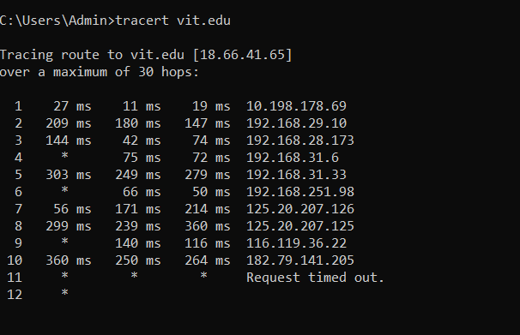

  - Ip.addr== 18.66.41.65
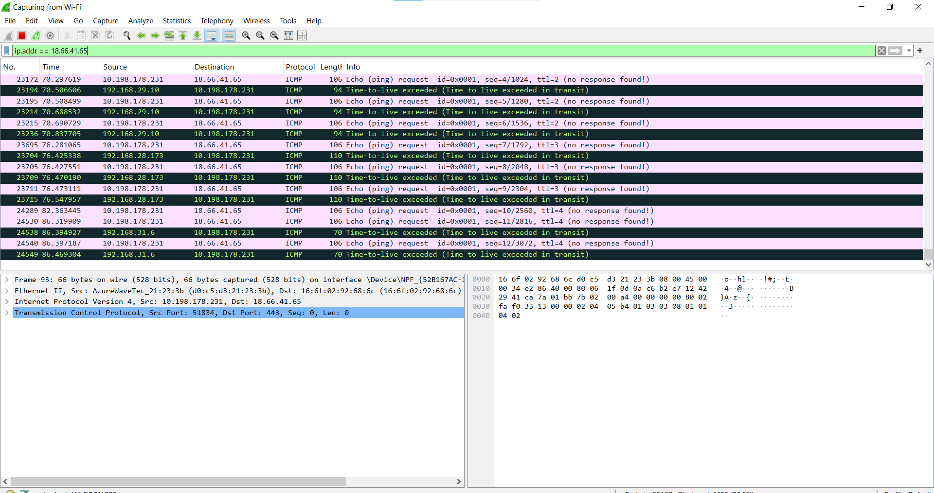

  - tcp.flags.syn==1 && ip.dst==18.66.41.65
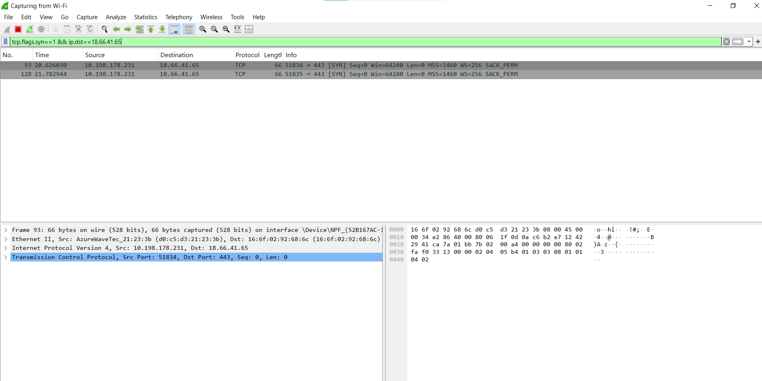

  - tcp and ip.addr-==18.66.41.65
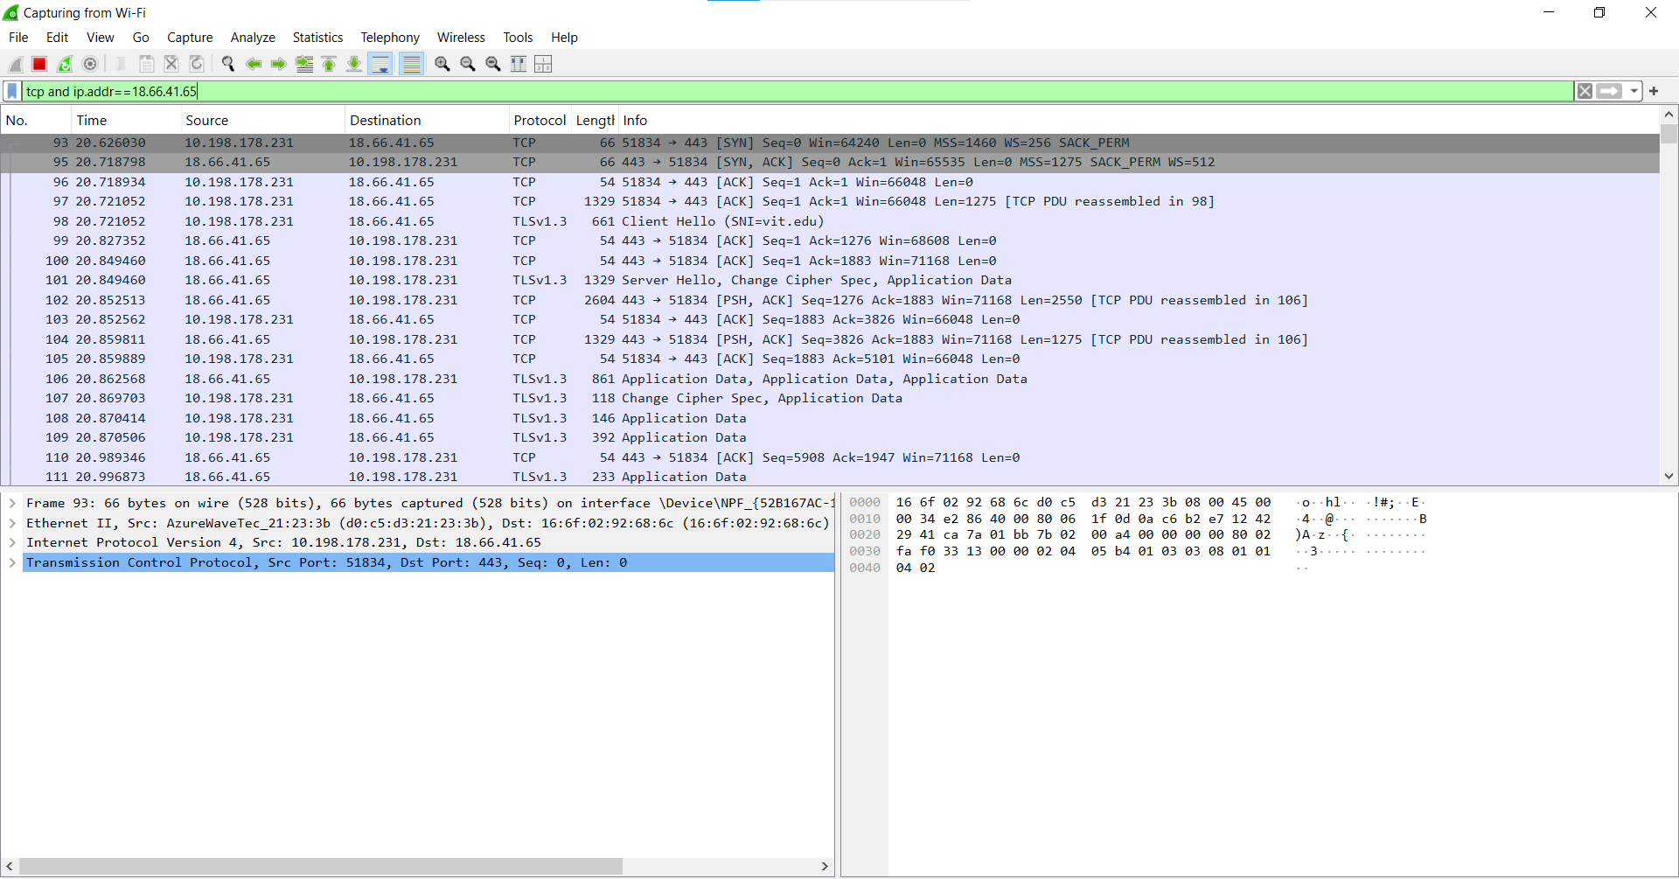

Name : Atharva Salitri
Division : TY CSAI-B
Batch : B2
Roll No. : 029
PRN : 12310120
Subject : Computer Network Technology

Assignment No:7

Title: Design and develop a website.
Problem Statement: Design and develop a website using toggleable or dynamic tabs or pills with bootstrap and JQuery to show the relevance of SDP, EDI, DT and Course projects in VIT.
Course Objective: To learn front end technologies for website development.
Course Outcome: Build single page applications using REACT as a reusable UI component technology
Tools Required: Notepad++ Editor, Google Crome, HTML, Bootstrap, JQuery.
Theory:
1. Bootstrap
- Bootstrap is a free front-end framework for faster and easier web development
- Bootstrap includes HTML and CSS based design templates for typography, forms, buttons, tables, navigation, modals, image carousels and many other, as well as optional JavaScript plugins
- Bootstrap also gives you the ability to easily create responsive designs
- Bootstrap 5 (released 2021) is the newest version of Bootstrap (released 2013); with new components, faster stylesheet and more responsiveness.
- Bootstrap 5 supports the latest, stable releases of all major browsers and platforms. However, Internet Explorer 11 and down is not supported.
- The main differences between Bootstrap 5 and Bootstrap 3 & 4, is that Bootstrap 5 has switched to vanilla JavaScript instead of jQuery.
1.1 Why Use Bootstrap?
- Easy to use: Anybody with just basic knowledge of HTML and CSS can start using Bootstrap
- Responsive features: Bootstrap's responsive CSS adjusts to phones, tablets, and desktops
- Mobile-first approach: In Bootstrap, mobile-first styles are part of the core framework
- Browser compatibility: Bootstrap 5 is compatible with all modern browsers (Chrome, Firefox, Edge, Safari, and Opera).
1.2 Bootstrap 5 CDN
<!-- Latest compiled and minified CSS -->
<link href="https://cdn.jsdelivr.net/npm/bootstrap@5.3.3/dist/css/bootstrap.min.css" rel="stylesheet">

<!-- Latest compiled JavaScript -->
<script src="https://cdn.jsdelivr.net/npm/bootstrap@5.3.3/dist/js/bootstrap.bundle.min.js"></script>

2. Bootstrap Component
2.1 Bootstrap 5 Containers
Containers are used to pad the content inside of them, and there are two container classes available:
- The .container class provides a responsive fixed width container
- The .container-fluid class provides a full width container, spanning the entire width of the viewport

<!DOCTYPE html>
<html lang="en">
<head>
<title>Bootstrap Example</title>
<meta charset="utf-8">
<meta name="viewport" content="width=device-width, initial-scale=1">
<link href="https://cdn.jsdelivr.net/npm/bootstrap@5.3.3/dist/css/bootstrap.min.css" rel="stylesheet">
<script src="https://cdn.jsdelivr.net/npm/bootstrap@5.3.3/dist/js/bootstrap.bundle.min.js"></script>
</head>
<body>

<div class="container">
<h1>My First Bootstrap Page</h1>
<p>This part is inside a .container class.</p>
<p>The .container class provides a responsive fixed width container.</p>
<p>Resize the browser window to see that the container width will change at different breakpoints.</p>
</div>

</body>
</html>

2.2 Bootstrap 5 Grid System
Bootstrap's grid system is built with flexbox and allows up to 12 columns across the page.
If you do not want to use all 12 columns individually, you can group the columns together to create wider columns:
The grid system is responsive, and the columns will re-arrange automatically depending on the screen size.
Make sure that the sum adds up to 12 or fewer (it is not required that you use all 12 available columns).
The Bootstrap 5 grid system has six classes:
- .col- (extra small devices - screen width less than 576px)
- .col-sm- (small devices - screen width equal to or greater than 576px)
- .col-md- (medium devices - screen width equal to or greater than 768px)
- .col-lg- (large devices - screen width equal to or greater than 992px)
- .col-xl- (xlarge devices - screen width equal to or greater than 1200px)
- .col-xxl- (xxlarge devices - screen width equal to or greater than 1400px)
The classes above can be combined to create more dynamic and flexible layouts.
The following example shows how to create three equal-width columns, on all devices and screen widths:
<div class="container-fluid mt-3">
<h1>Three equal width columns</h1>
<p>Note: Try to add a new div with class="col" inside the row class - this will create four equal-width columns.</p>
<div class="row">
<div class="col p-3 bg-primary text-white">.col</div>
<div class="col p-3 bg-dark text-white">.col</div>
<div class="col p-3 bg-primary text-white">.col</div>
</div>
</div>

2.3 Text Colors
Bootstrap 5 has some contextual classes that can be used to provide "meaning through colors".
The classes for text colors are: .text-muted, .text-primary, .text-success, .text-info, .text-warning, .text-danger, .text-secondary, .text-white, .text-dark, .text-body (default body color/often black) and .text-light.
<div class="container mt-3">
<h2>Contextual Colors</h2>
<p>Use the contextual classes to provide "meaning through colors":</p>
<p class="text-muted">This text is muted.</p>
<p class="text-primary">This text is important.</p>
<p class="text-success">This text indicates success.</p>
<p class="text-info">This text represents some information.</p>
<p class="text-warning">This text represents a warning.</p>
<p class="text-danger">This text represents danger.</p>
<p class="text-secondary">Secondary text.</p>
<p class="text-dark">This text is dark grey.</p>
<p class="text-body">Default body color (often black).</p>
<p class="text-light">This text is light grey (on white background).</p>
<p class="text-white">This text is white (on white background).</p>
</div>

2.4 Background Colors
The classes for background colors are: .bg-primary, .bg-success, .bg-info, .bg-warning, .bg-danger, .bg-secondary, .bg-dark and .bg-light.

<div class="container mt-3">
<h2>Background Color with Contrasting Text Color</h2>
<p class="text-bg-primary">This text is important.</p>
<p class="text-bg-success">This text indicates success.</p>
<p class="text-bg-info">This text represents some information.</p>
<p class="text-bg-warning">This text represents a warning.</p>
<p class="text-bg-danger">This text represents danger.</p>
<p class="text-bg-secondary">Secondary background color.</p>
<p class="text-bg-dark">Dark grey background color.</p>
<p class="text-bg-light">Light grey background color.</p>
</div>

2.5 Bootstrap 5 Tables
A basic Bootstrap 5 table has a light padding and horizontal dividers.
The .table class adds basic styling to a table.
<div class="container mt-3">
<h2>Basic Table</h2>
<p>The .table class adds basic styling (light padding and horizontal dividers) to a table:</p>
<table class="table">
<thead>
<tr>
<th>Firstname</th>
<th>Lastname</th>
<th>Email</th>
</tr>
</thead>
<tbody>
<tr>
<td>John</td>
<td>Doe</td>
<td>john@example.com</td>
</tr>
<tr>
<td>Mary</td>
<td>Moe</td>
<td>mary@example.com</td>
</tr>
<tr>
<td>July</td>
<td>Dooley</td>
<td>july@example.com</td>
</tr>
</tbody>
</table>
</div>
3.1 How to use jQuery?
There are two ways to use jQuery.
Local Installation − You can download jQuery library on your local machine and include it in your HTML code.
Go to the https://jquery.com/download/ to download the latest version available.
Now put downloaded jquery-3.7.1.min.js file in a directory of your website, e.g. /jquery.

CDN Based Version − You can include jQuery library into your HTML code directly from Content Delivery Network (CDN).

3.2 jQuery Syntax
The jQuery syntax is tailor-made for selecting HTML elements and performing some action on the element(s).

Basic syntax is: $(selector).action()

- A $ sign to define/access jQuery
- A (selector) to "query (or find)" HTML elements
- A jQuery action() to be performed on the element(s)

Examples:
$(this).hide() - hides the current element.
$("p").hide() - hides all <p> elements.
$(".test").hide() - hides all elements with class="test".
$("#test").hide() - hides the element with id="test".

3.3 jQuery Selectors
jQuery selectors allow you to select and manipulate HTML element(s).
jQuery selectors are used to "find" (or select) HTML elements based on their name, id, classes, types, attributes, values of attributes and much more. It's based on the existing CSS Selectors, and in addition, it has some own custom selectors.
All selectors in jQuery start with the dollar sign and parentheses: $().
3.3.1 The element Selector
The jQuery element selector selects elements based on the element name.
You can select all <p> elements on a page like this: $("p")
3.3.2 The #id Selector
The jQuery #id selector uses the id attribute of an HTML tag to find the specific element.
An id should be unique within a page, so you should use the #id selector when you want to find a single, unique element.
To find an element with a specific id, write a hash character, followed by the id of the HTML element: $("#test")
3.3.3 The .class Selector
The jQuery class selector finds elements with a specific class.
To find elements with a specific class, write a period character, followed by the name of the class: $(".test")
<!DOCTYPE html>
<html>
<head>
<script src="https://ajax.googleapis.com/ajax/libs/jquery/3.2.1/jquery.min.js"></script>
<script>
$(document).ready(function(){
$("button").click(function(){
$(".test").hide();
});
});
</script>
</head>
<body>
<h2 class="test">This is a heading</h2>
<p class="test">This is a paragraph.</p>
<p>This is another paragraph.</p>
<button>Click me</button>
</body>
</html>
3.4 jQuery Event
All the different visitor's actions that a web page can respond to are called events.
An event represents the precise moment when something happens.
Examples:
- moving a mouse over an element
- selecting a radio button
- clicking on an element
Mouse Events | Keyboard Events | Form Events | Document/Window Events
click | keypress | submit | load
dblclick | keydown | change | resize
mouseenter | keyup | focus | scroll
mouseleave |  | blur | unload
3.4.1 Commonly Used jQuery Event Methods
$(document).ready()
The $(document).ready() method allows us to execute a function when the document is fully loaded.
click()
The click() method attaches an event handler function to an HTML element. The function is executed when the user clicks on the HTML element.
dblclick()
The dblclick() method attaches an event handler function to an HTML element. The function is executed when the user double-clicks on the HTML element.
mouseenter()
The mouseenter() method attaches an event handler function to an HTML element. The function is executed when the mouse pointer enters the HTML element.
mouseleave()
The mouseleave() method attaches an event handler function to an HTML element. The function is executed when the mouse pointer leaves the HTML element.
mousedown()
The mousedown() method attaches an event handler function to an HTML element. The function is executed, when the left, middle or right mouse button is pressed down, while the mouse is over the HTML element.
mouseup()
The mouseup() method attaches an event handler function to an HTML element. The function is executed, when the left, middle or right mouse button is released, while the mouse is over the HTML element.
hover()
The hover() method takes two functions and is a combination of the mouseenter() and mouseleave() methods. The first function is executed when the mouse enters the HTML element, and the second function is executed when the mouse leaves the HTML element.

<!DOCTYPE html>
<html>
<head>
<script src="https://ajax.googleapis.com/ajax/libs/jquery/3.2.1/jquery.min.js"></script>
<script>
$(document).ready(function(){
$("#p1").hover(function(){
alert("You entered p1!");
},
function(){
alert("Bye! You now leave p1!");
});
});
</script>
</head>
<body>
<p id="p1">This is a paragraph.</p>
</body>
</html>

Conclusion: Hence, we have successfully designed and developed a website using toggleable or dynamic tabs (pills) with Bootstrap and jQuery to showcase the relevance of SDP, EDI, DT, and Course Projects in VIT.

Program:
<!DOCTYPE html>
<html lang="en">
<head>
<meta charset="UTF-8">
<meta name="viewport" content="width=device-width, initial-scale=1.0">
<title>VIT Projects Relevance</title>
<!-- Bootstrap CSS -->
<link href="https://cdn.jsdelivr.net/npm/bootstrap@5.3.3/dist/css/bootstrap.min.css" rel="stylesheet">
<!-- jQuery -->
<script src="https://code.jquery.com/jquery-3.7.1.min.js"></script>
<!-- Bootstrap JS -->
<script src="https://cdn.jsdelivr.net/npm/bootstrap@5.3.3/dist/js/bootstrap.bundle.min.js"></script>
</head>
<body class="bg-light">

<div class="container py-5">
<h2 class="text-center mb-4">Relevance of Projects in VIT</h2>

<!-- Nav Pills -->
<ul class="nav nav-pills mb-3 justify-content-center" id="projectTabs" role="tablist">
<li class="nav-item" role="presentation">
<button class="nav-link active" id="sdp-tab" data-bs-toggle="pill" data-bs-target="#sdp" type="button" role="tab">SDP</button>
</li>
<li class="nav-item" role="presentation">
<button class="nav-link" id="edi-tab" data-bs-toggle="pill" data-bs-target="#edi" type="button" role="tab">EDI</button>
</li>
<li class="nav-item" role="presentation">
<button class="nav-link" id="dt-tab" data-bs-toggle="pill" data-bs-target="#dt" type="button" role="tab">DT</button>
</li>
<li class="nav-item" role="presentation">
<button class="nav-link" id="course-tab" data-bs-toggle="pill" data-bs-target="#course" type="button" role="tab">Course Projects</button>
</li>
</ul>

<!-- Tab Content -->
<div class="tab-content p-4 border bg-white shadow rounded" id="projectTabsContent">
<div class="tab-pane fade show active" id="sdp" role="tabpanel">
<h4>SDP (Software Development Project)</h4>
<p>The SDP focuses on building complete software solutions where students learn end-to-end development, teamwork, and project management practices. It enhances coding skills, testing, and documentation aligned with industry standards.</p>
</div>
<div class="tab-pane fade" id="edi" role="tabpanel">
<h4>EDI (Engineering Design and Innovation)</h4>
<p>EDI emphasizes innovation, problem-solving, and engineering design skills. Students apply design thinking approaches to create prototypes, implement solutions, and develop critical thinking abilities relevant to real-world challenges.</p>
</div>
<div class="tab-pane fade" id="dt" role="tabpanel">
<h4>DT (Design Thinking)</h4>
<p>Design Thinking projects encourage creativity, empathy, and innovative problem analysis. Students learn to explore user needs, brainstorm ideas, and develop impactful solutions that can be implemented in academic and industrial contexts.</p>
</div>
<div class="tab-pane fade" id="course" role="tabpanel">
<h4>Course Projects</h4>
<p>Course-based projects are integrated into regular curriculum subjects. They provide hands-on learning, practical applications of theoretical concepts, and prepare students for higher-level research and industry internships.</p>
</div>
</div>
</div>

<!-- jQuery Script Example -->
<script>
$(document).ready(function(){
// Highlight active tab in console (demo of jQuery usage)
$('#projectTabs button').on('shown.bs.tab', function (event) {
console.log("Active Tab: " + $(event.target).text());
});
});
</script>
</body>
</html>
Output:
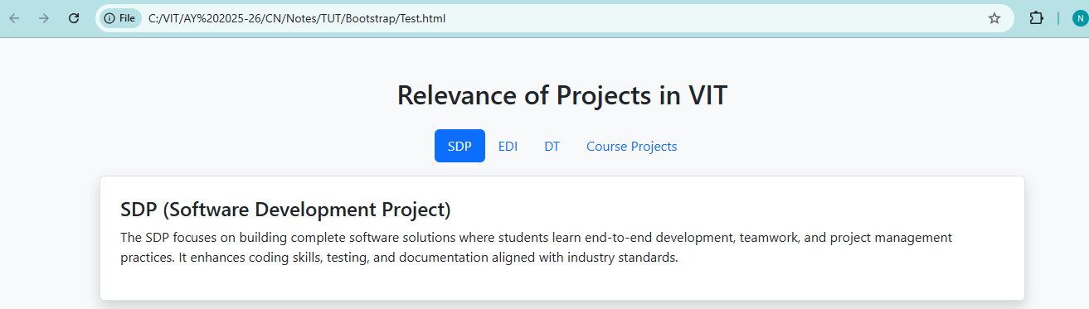
OUTPUT:
