Evaluation Noise, Fitness Landscape, and Encoding Bias in Metaheuristic Hyperparameter Optimization of XGBoost on Small Imbalanced Cancer Data
Figures and tables (English version). Numbering follows the manuscript; citation numbers [n] follow its reference list.
Table 1. Position of this study relative to related work.
Study and focus | HPO landscape | Evaluation noise | Class composition manipulated | Optimizer behaviour | Position / encoding bias test | Small imbalanced clinical data
[29] AutoML search-space landscape | ✓ | – | – | – | – | –
[30] Algorithm configuration landscape | ✓ | – | – | – | – | –
[31] HPO landscape (ELA) | ✓ | – | – | – | – | –
[16, 17] Model-selection bias | – | ✓ | – | – | – | –
[19, 20] Noisy evolutionary optimization | – | ✓ | – | ✓ | – | –
[22] Structural bias of metaheuristics | – | – | – | ✓ | ✓ | –
[11–13] Metaheuristic HPO on medical data | – | – | – | – | – | ±
This study | ✓ | ✓ | ✓ | ✓ | ✓ | ✓
✓ = main analysis of the study; – = not a focus of the analysis; ± = partly (medical data, but not necessarily small and imbalanced).
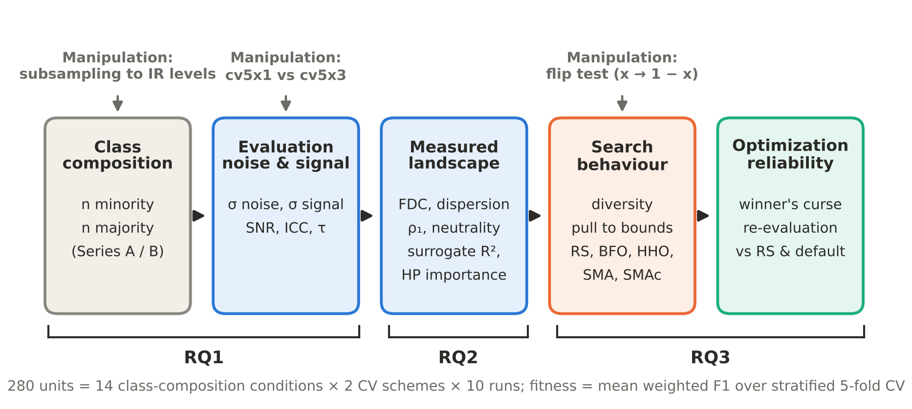
Figure 1. Study framework. Class composition and CV scheme are manipulated to test their effect on evaluation noise and on the landscape (RQ1–RQ2); BFO, HHO, and SMA are used as behavioural probes with Random Search as reference, and the flip test separates search ability from position bias (RQ3).
Table 2. Design of the 14 class-composition conditions (development and test sets per run).
Dataset | IR level | Series | Actual IR | Positives | Negatives | n dev | n test | Test positives
Lung | 3:1 | A | 3.03 | 32 | 97 | 129 | 23 | 6
Lung | original | A | 6.31 | 32 | 202 | 234 | 42 | 6
Thyroid | original | B | 2.36 | 92 | 217 | 309 | 55 | 16
Thyroid | 3:1 | B | 3.01 | 72 | 217 | 289 | 52 | 13
Thyroid | 6:1 | B | 5.86 | 37 | 217 | 254 | 45 | 6
Breast | original | B | 1.68 | 180 | 303 | 483 | 86 | 32
Breast | 3:1 | B | 3.00 | 101 | 303 | 404 | 72 | 18
Breast | 6:1 | B | 5.94 | 51 | 303 | 354 | 63 | 9
Breast | 12:1 | B | 12.12 | 25 | 303 | 328 | 59 | 5
Cervical | 3:1 | A | 2.98 | 46 | 137 | 183 | 33 | 8
Cervical | 6:1 | A | 5.98 | 46 | 275 | 321 | 57 | 8
Cervical | 12:1 | A | 11.96 | 46 | 550 | 596 | 106 | 8
Cervical | original | A/B | 14.41 | 46 | 663 | 709 | 126 | 8
Cervical | 20:1 | B | 20.12 | 33 | 664 | 697 | 123 | 6
Series A: minority count fixed, majority varied; Series B: majority count fixed, minority reduced. Cervical original belongs to both series. Each condition is run with 2 CV schemes × 10 runs = 20 units; 280 units in total.
Table 3. XGBoost hyperparameter search space (optimized in the normalized space [0,1]⁹).
Hyperparameter | Range | Type
learning_rate | 0.01–0.30 | continuous
max_depth | 3–10 | integer
min_child_weight | 1–10 | integer
gamma | 0–5 | continuous
subsample | 0.5–1.0 | continuous
colsample_bytree | 0.5–1.0 | continuous
reg_alpha | 0–10 | continuous
reg_lambda | 0–10 | continuous
n_estimators | 50–500 | integer

Table 4. Evaluation noise, between-configuration signal, and SNR per condition (mean of 10 runs; SNR = median of 10 runs).
Dataset | Level | σnoise cv5x1 | σnoise cv5x3 | σsignal cv5x1 | σsignal cv5x3 | SNR cv5x1 | SNR cv5x3 | ICC cv5x1 | ICC cv5x3 | τ cv5x1 | τ cv5x3
Lung | 3:1 | 0.0218 | 0.0128 | 0.0357 | 0.0373 | 3.09 | 9.13 | 0.67 | 0.84 | 0.58 | 0.74
Lung | original | 0.0114 | 0.0072 | 0.0098 | 0.0103 | 0.77 | 2.21 | 0.42 | 0.65 | 0.39 | 0.61
Thyroid | original | 0.0096 | 0.0055 | 0.0148 | 0.0150 | 1.17 | 4.06 | 0.54 | 0.77 | 0.41 | 0.58
Thyroid | 3:1 | 0.0147 | 0.0081 | 0.0367 | 0.0377 | 6.79 | 21.79 | 0.83 | 0.94 | 0.39 | 0.52
Thyroid | 6:1 | 0.0075 | 0.0040 | 0.0040 | 0.0044 | 0.15 | 0.88 | 0.24 | 0.49 | 0.22 | 0.40
Breast | original | 0.0059 | 0.0032 | 0.0079 | 0.0079 | 1.81 | 6.63 | 0.62 | 0.84 | 0.58 | 0.75
Breast | 3:1 | 0.0066 | 0.0038 | 0.0067 | 0.0070 | 1.03 | 2.88 | 0.48 | 0.74 | 0.51 | 0.68
Breast | 6:1 | 0.0054 | 0.0034 | 0.0053 | 0.0055 | 0.78 | 2.76 | 0.45 | 0.67 | 0.41 | 0.62
Breast | 12:1 | 0.0054 | 0.0029 | 0.0031 | 0.0036 | 0.32 | 1.21 | 0.26 | 0.55 | 0.29 | 0.53
Cervical | 3:1 | 0.0197 | 0.0114 | 0.0068 | 0.0083 | 0.11 | 0.57 | 0.11 | 0.33 | 0.11 | 0.30
Cervical | 6:1 | 0.0154 | 0.0090 | 0.0170 | 0.0170 | 1.32 | 3.98 | 0.53 | 0.75 | 0.45 | 0.63
Cervical | 12:1 | 0.0080 | 0.0046 | 0.0135 | 0.0136 | 2.92 | 10.12 | 0.73 | 0.89 | 0.63 | 0.78
Cervical | original | 0.0075 | 0.0040 | 0.0140 | 0.0140 | 4.12 | 13.60 | 0.77 | 0.92 | 0.70 | 0.82
Cervical | 20:1 | 0.0059 | 0.0033 | 0.0132 | 0.0132 | 5.59 | 16.77 | 0.82 | 0.94 | 0.73 | 0.84
σ = standard deviation of wF1; SNR = σ²signal/σ²noise; ICC = σ²signal/(σ²signal + σ²noise); τ = mean Kendall τ of rankings across partitions.
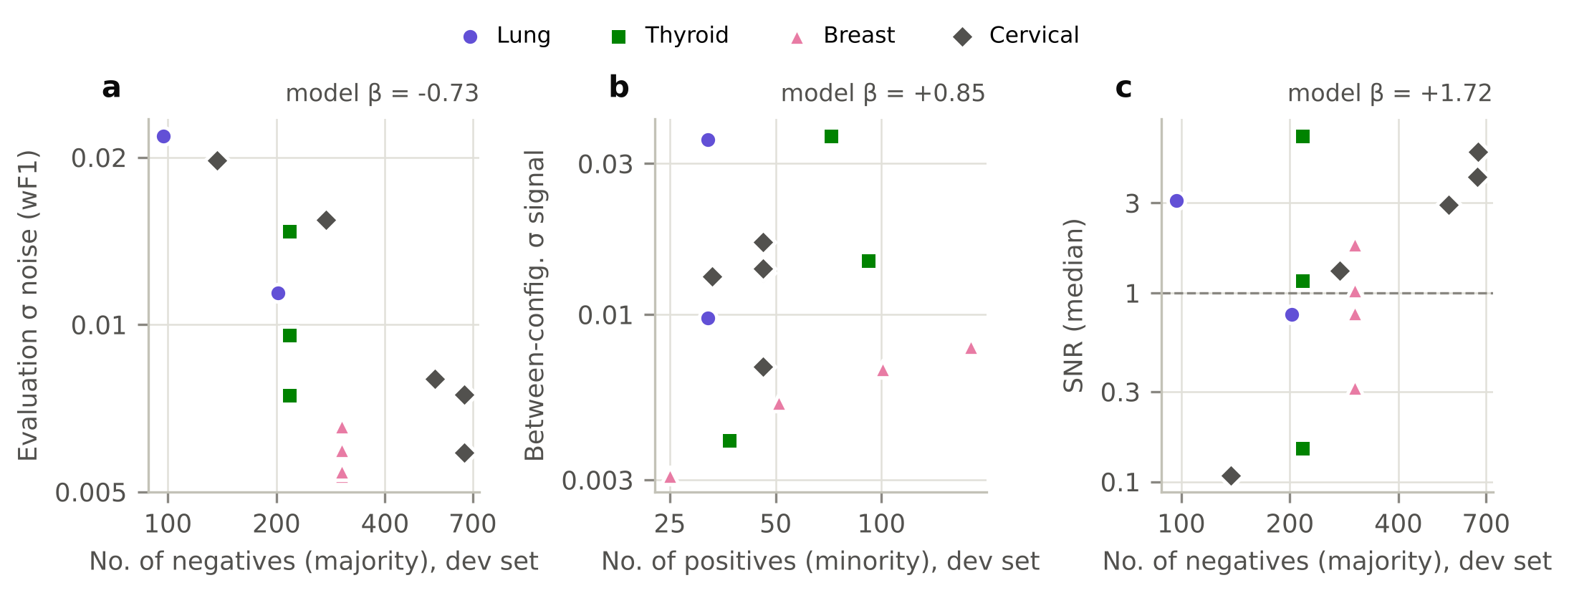
Figure 2. Mechanism of evaluation noise in weighted F1. (a) Evaluation σ noise against the number of majority samples; (b) between-configuration σ signal against the number of minority samples; (c) SNR against class size. Points are condition means (cv5x1, 10 runs); β is the log–log coefficient of the mixed model (Table 5), which controls for the other class count, CV scheme, and dataset, so the raw pattern in each panel need not look linear.
Table 5. Log–log models of noise, signal, and SNR on class sample counts and CV scheme (280 units).
Response | Predictor | β mixed | 95% CI | p | β FE | 95% CI | p
log σ noise | log(no. of positives) | 0.146 | [0.08, 0.21] | < 0.001 | 0.148 | [−0.01, 0.31] | 0.065
log σ noise | log(no. of negatives) | −0.734 | [−0.80, −0.67] | < 0.001 | −0.734 | [−0.88, −0.59] | < 0.001
log σ noise | cv5x3 (vs cv5x1) | −0.562 | [−0.62, −0.51] | < 0.001 | −0.562 | [−0.59, −0.54] | < 0.001
log σ signal | log(no. of positives) | 0.846 | [0.59, 1.10] | < 0.001 | 0.867 | [0.40, 1.33] | < 0.001
log σ signal | log(no. of negatives) | 0.139 | [−0.14, 0.42] | 0.338 | 0.158 | [−0.41, 0.73] | 0.589
log σ signal | cv5x3 (vs cv5x1) | 0.173 | [−0.05, 0.40] | 0.129 | 0.173 | [0.01, 0.33] | 0.032
log SNR | log(no. of positives) | 1.173 | [0.81, 1.53] | < 0.001 | 1.202 | [0.63, 1.77] | < 0.001
log SNR | log(no. of negatives) | 1.721 | [1.32, 2.12] | < 0.001 | 1.765 | [0.80, 2.73] | < 0.001
log SNR | cv5x3 (vs cv5x1) | 1.354 | [1.04, 1.67] | < 0.001 | 1.354 | [1.17, 1.53] | < 0.001
Mixed: linear mixed model with a random intercept per dataset; FE: dataset fixed effects with cluster-robust standard errors.
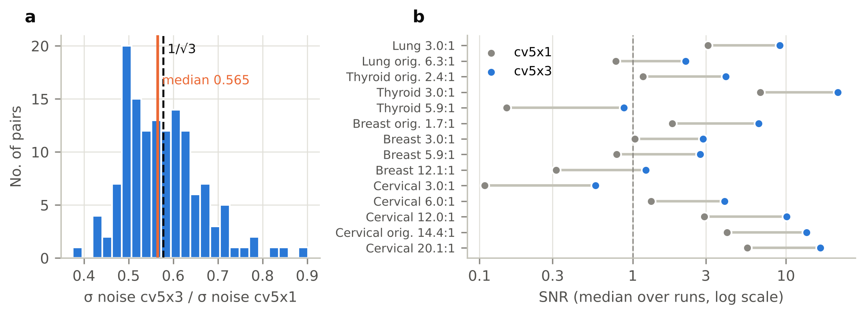
Figure 3. Validation of the noise manipulation. (a) Ratio of σ noise cv5x3/cv5x1 over 140 pairs, centred near the theoretical value 1/√3. (b) Median SNR per condition under cv5x1 and cv5x3.
Table 6. Effect of noise on landscape metrics: paired differences cv5x3 − cv5x1 (140 pairs) and correlation with log SNR (280 units).
Metric | Median Δ [95% CI] | Δ > 0 | r | p Holm | Spearman ρ (log SNR)
ρ₁ random walk | 0.098 [0.078, 0.109] | 124/140 | 0.82 | < 0.001 | 0.44
Surrogate R² (learnability) | 0.080 [0.066, 0.101] | 126/140 | 0.93 | < 0.001 | 0.59
FDC | 0.028 [0.016, 0.048] | 101/140 | 0.50 | < 0.001 | 0.37
Neutrality ratio | −0.051 [−0.071, −0.030] | 37/140 | −0.58 | < 0.001 | −0.53
Top-10% clusters | 0.000 [0.000, 0.000] | 41/140 | −0.21 | 0.078 | –
Dispersion | −0.011 [−0.019, −0.005] | 50/140 | −0.34 | < 0.001 | –
wF1 range | −0.006 [−0.008, −0.003] | 37/140 | −0.60 | < 0.001 | 0.34
r = rank-biserial correlation; all Spearman correlations have Holm-adjusted p < 0.001.
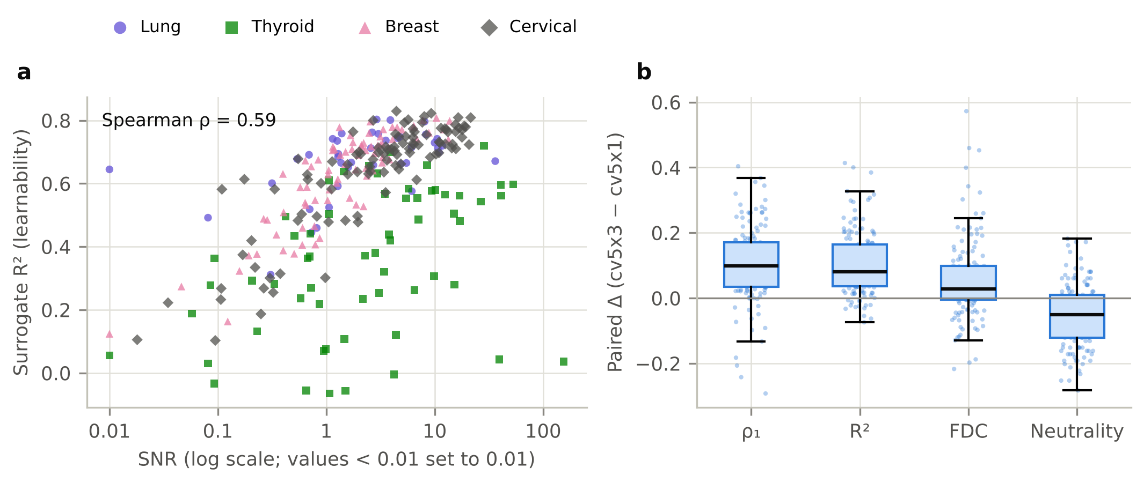
Figure 4. Noise changes the measured landscape. (a) Landscape learnability (out-of-bag R² of a random-forest surrogate) against SNR, per unit. (b) Paired differences (cv5x3 − cv5x1) for random-walk ρ₁, surrogate R², FDC, and neutrality ratio.
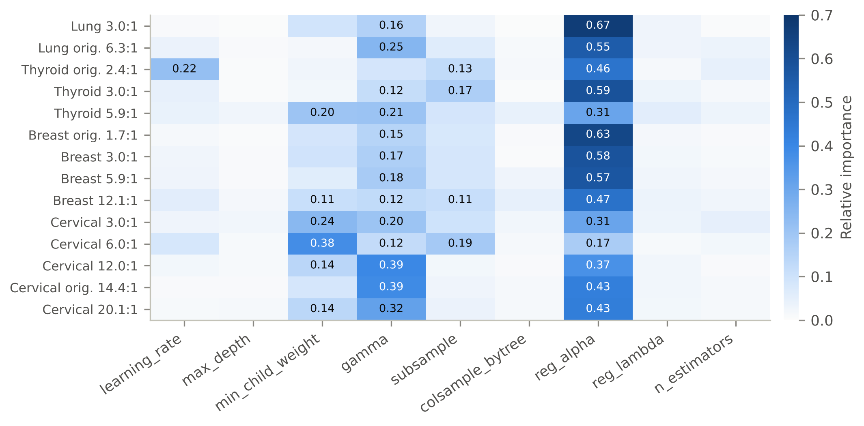
Figure 5. Relative hyperparameter importance (normalized permutation importance of the random-forest surrogate; mean of 20 units per condition). Values ≥ 0.10 are shown.
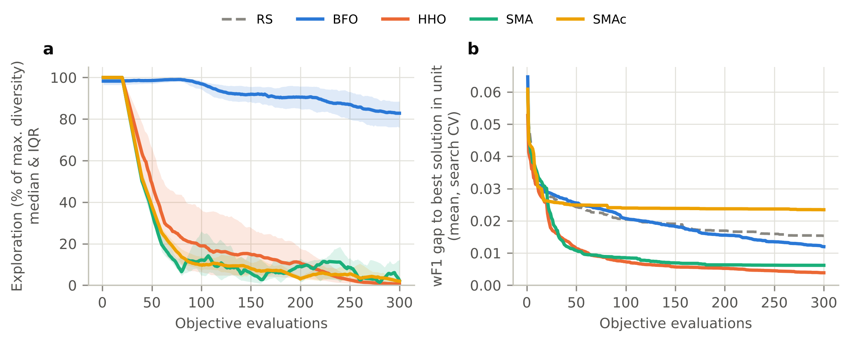
Figure 6. Search behaviour (cv5x1, original orientation, n = 140 units). (a) Exploration as a percentage of the maximum population diversity (median and IQR). (b) Mean gap between the best CV score found so far and the best CV score reached by any method on the same unit.
Table 7. Flip test: re-evaluation difference, original − mirrored space (cv5x1, 140 pairs), and fraction of dimensions at the bounds.
Optimizer | Δ wF1 [95% CI] | Δ > 0 | r | p Holm | Δ minority F1 [95% CI] | p Holm | Lower/upper bound (original) | Lower/upper bound (mirrored)
BFO | −0.0022 [−0.0032, −0.0011] | 54/140 | −0.14 | 0.143 | −0.0037 [−0.0081, −0.0006] | 0.096 | 0% / 0% | 0% / 0%
HHO | 0.0019 [0.0008, 0.0034] | 88/140 | 0.31 | 0.003 | 0.0038 [0.0005, 0.0082] | 0.004 | 50% / 1% | 31% / 3%
SMA | 0.0122 [0.0082, 0.0160] | 123/140 | 0.89 | < 0.001 | 0.0113 [0.0066, 0.0173] | < 0.001 | 66% / 0% | 0% / 38%
TPE | 0.0007 [−0.0006, 0.0020] | 79/140 | 0.20 | 0.038 | 0.0010 [−0.0016, 0.0041] | 0.328 | 0% / 0% | 0% / 0%
Bounds: fraction of dimensions whose final population centroid lies within 0.02 of the lower/upper bound, expressed in the original space; for TPE, centroid of the 20 best configurations. SMAc: 0% / 0%. TPE p-values form a separate test family (control).
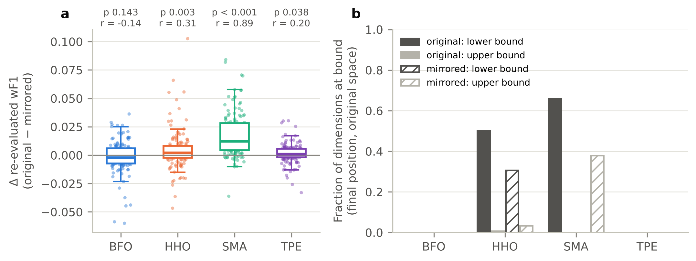
Figure 7. Encoding-invariance test with TPE as control. (a) Difference in re-evaluated wF1 between the original orientation and the mirrored space (same seed; 140 pairs), with Holm-adjusted p and rank-biserial r (TPE as a separate test family). (b) Fraction of hyperparameter dimensions whose final population centroid lies at a bound, expressed in the original space; for TPE, centroid of the 20 best configurations.
Table 8. Implementation robustness check: SMA and HHO from the mealpy 3.0.1 library on the same 12 cv5x1 units (re-evaluated wF1).
Comparison | Median difference | Difference > 0 | Wilcoxon p
mealpy SMA: original − mirrored | 0.0138 | 12/12 | < 0.001
own SMA (v5.2): original − mirrored (same units) | 0.0239 | 12/12 | < 0.001
mealpy HHO: original − mirrored | 0.0075 | 8/12 | 0.301
own HHO (v5.2): original − mirrored (same units) | 0.0020 | 8/12 | 0.233
mealpy SMA − RS | 0.0132 | 11/12 | 0.002
mealpy SMA (mirrored) − RS | −0.0096 | 3/12 | 0.021
mealpy SMA (domain [−1,1]) − RS | −0.0166 | 0/12 | < 0.001
mealpy SMA − own SMA (v5.2) | −0.0016 | 4/12 | 0.067
Units: Cervical original, Cervical 6:1, and Breast original (runs 0–3). With n = 12, the direction and consistency of the differences are more informative than p-values.
Table 9. Winner's curse (best CV − mean of five re-evaluations) per optimizer and CV scheme (TPE run on cv5x1 only).
Optimizer | cv5x1, mean [95% CI] | cv5x3, mean [95% CI] | Ratio cv5x3/cv5x1 | Paired median Δ [95% CI] | p Holm
RS | 0.0103 [0.0083, 0.0124] | 0.0049 [0.0036, 0.0062] | 0.48 | 0.0035 [0.0022, 0.0052] | < 0.001
BFO | 0.0130 [0.0111, 0.0149] | 0.0069 [0.0057, 0.0082] | 0.54 | 0.0054 [0.0038, 0.0071] | < 0.001
HHO | 0.0148 [0.0124, 0.0172] | 0.0090 [0.0076, 0.0103] | 0.60 | 0.0035 [0.0022, 0.0059] | < 0.001
SMA | 0.0104 [0.0084, 0.0128] | 0.0054 [0.0041, 0.0067] | 0.52 | 0.0029 [0.0019, 0.0045] | < 0.001
SMAc | 0.0084 [0.0066, 0.0104] | 0.0044 [0.0031, 0.0057] | 0.53 | 0.0030 [0.0019, 0.0041] | < 0.001
TPE | 0.0153 [0.0132, 0.0175] | – | – | – | –

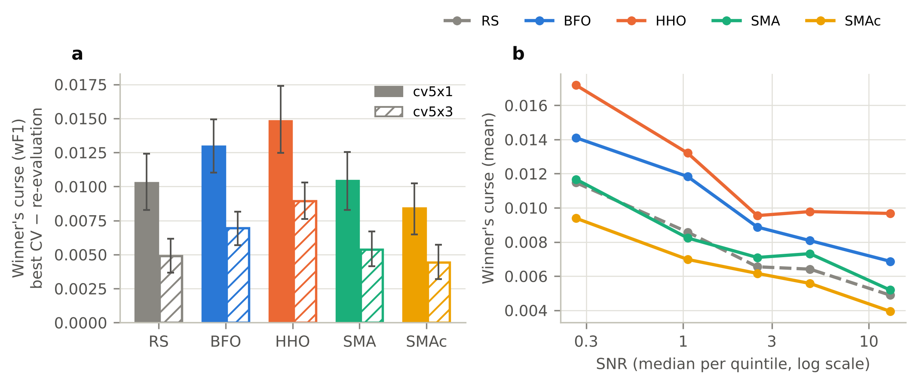
Figure 8. Winner's curse (best CV − mean of five re-evaluations on new CV partitions). (a) Per optimizer and CV scheme (mean and bootstrap 95% CI). (b) As a function of SNR (quintiles).
Table 10. Re-evaluated wF1 compared with Random Search and default XGBoost (cv5x1, 140 paired units).
Reference | Method | Median Δ [95% CI] | Δ > 0 | r | p Holm
Random Search | BFO | 0.0000 [−0.0015, 0.0020] | 70/140 | 0.07 | 0.459
Random Search | BFO (mirrored) | 0.0012 [0.0003, 0.0025] | 85/140 | 0.22 | 0.052
Random Search | HHO | 0.0055 [0.0036, 0.0071] | 103/140 | 0.64 | < 0.001
Random Search | HHO (mirrored) | 0.0020 [0.0005, 0.0037] | 83/140 | 0.24 | 0.038
Random Search | SMA | 0.0068 [0.0049, 0.0099] | 109/140 | 0.71 | < 0.001
Random Search | SMA (mirrored) | −0.0035 [−0.0051, −0.0026] | 34/140 | −0.64 | < 0.001
Random Search | SMAc | −0.0042 [−0.0057, −0.0026] | 37/140 | −0.63 | < 0.001
Random Search | TPE | 0.0043 [0.0034, 0.0065] | 107/140 | 0.66 | < 0.001
Random Search | TPE (mirrored) | 0.0038 [0.0020, 0.0054] | 94/140 | 0.52 | < 0.001
XGBoost default | RS | −0.0016 [−0.0037, −0.0000] | 58/140 | −0.14 | 0.445
XGBoost default | BFO | −0.0009 [−0.0028, 0.0013] | 64/140 | −0.04 | 0.679
XGBoost default | BFO (mirrored) | 0.0014 [−0.0007, 0.0030] | 77/140 | 0.13 | 0.445
XGBoost default | HHO | 0.0044 [0.0026, 0.0064] | 96/140 | 0.50 | < 0.001
XGBoost default | HHO (mirrored) | 0.0010 [−0.0008, 0.0028] | 76/140 | 0.18 | 0.267
XGBoost default | SMA | 0.0066 [0.0049, 0.0087] | 116/140 | 0.80 | < 0.001
XGBoost default | SMA (mirrored) | −0.0075 [−0.0114, −0.0044] | 44/140 | −0.54 | < 0.001
XGBoost default | SMAc | −0.0065 [−0.0097, −0.0028] | 44/140 | −0.50 | < 0.001
XGBoost default | TPE | 0.0044 [0.0027, 0.0056] | 99/140 | 0.55 | < 0.001
XGBoost default | TPE (mirrored) | 0.0028 [0.0015, 0.0037] | 92/140 | 0.41 | < 0.001
Holm correction per reference; TPE rows (Bayesian optimization baseline) form a separate test family, so p-values of the other methods are unchanged.
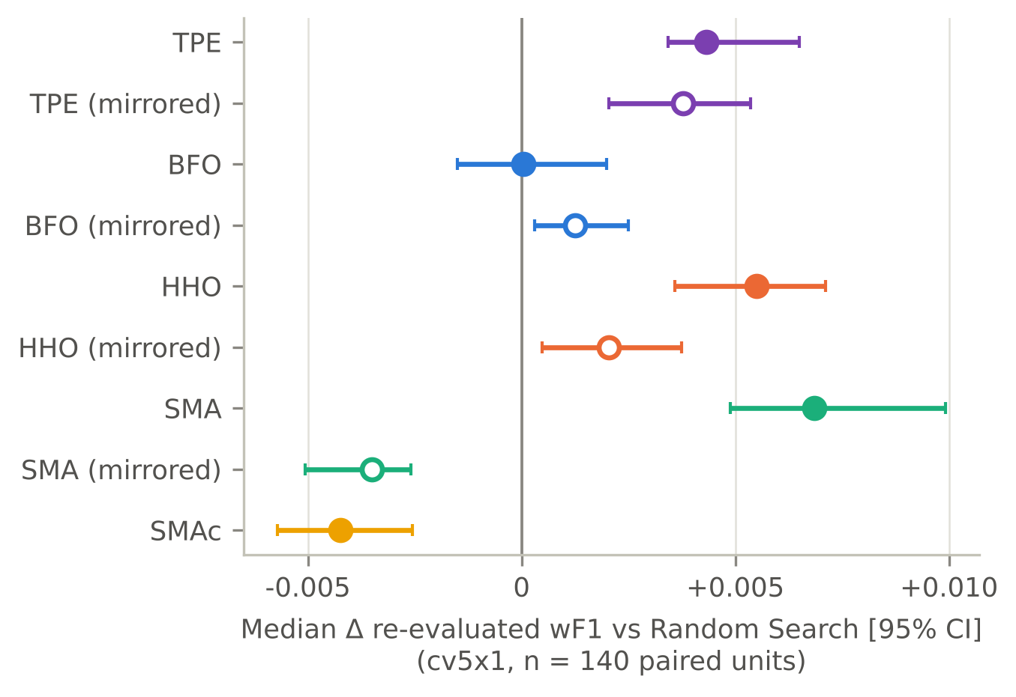
Figure 9. Median difference in re-evaluated wF1 relative to Random Search (bootstrap 95% CI) in the original orientation (filled markers) and the mirrored space (open markers), including TPE as the Bayesian optimization baseline.
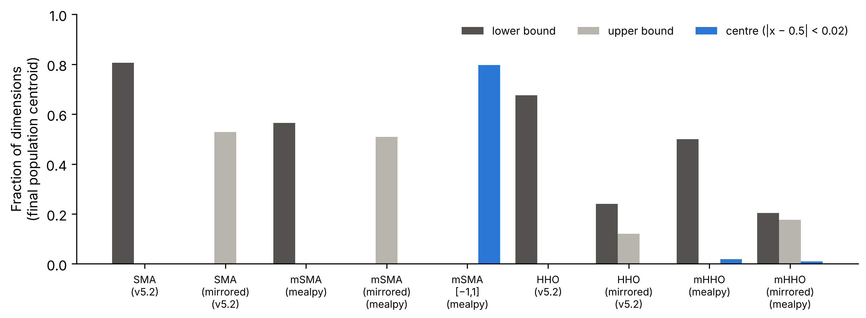
Figure S1. Fraction of dimensions whose final population centroid lies at the lower bound, upper bound, or centre of the space, for SMA and HHO from this study (v5.2) and from mealpy, in the original, mirrored, and [−1,1] domains (12 cv5x1 units).

