Project Document

Fid’Lin

Final Version

4/16/19

CPSC 4910 SP19

Prepared by:
Team 2
Jakob Beckleheimer, Dylan Brownell, Tanner Groll, Derek Pendleton, and Phil Snider

<Fiddle Player Practice App>
SECTION 1 - INTRODUCTION #3
1.1 PURPOSE # 3
1.2 SCOPE # 3
1.3 TERMINOLOGY # 3
1.4 REFERENCES # 4
SECTION 2 – MANAGEMENT #4
2.1 GENERAL DESCRIPTION # 4
2.2 SOFTWARE VALIDATION # 4
2.3 CONFIGURATION MANAGEMENT PLAN # 4
2.4 PROJECT SCHEDULE # 5
SECTION 3 - REQUIREMENTS #5
3.1 BUSINESS REQUIREMENTS #5
3.2 FUNCTIONAL REQUIREMENTS # 5
3.2.1 Functional Capabilities
3.2.1 System Inputs
3.2.2 System Outputs
3.3 NONFUNCTIONAL REQUIREMENTS # 6
3.3.1 Performance Considerations
3.3.2 User Interface
3.3.3 Language
3.3.4 Operating Environment
SECTION 4 – DESIGN # 6
4.1 Context # 7
SECTION 5 - IMPLEMENTATION STRATEGY # 11
SECTION 6 - USER DOCUMENTATION # 11
6.1 INSTALLATION GUIDE #11
6.2 USER'S GUIDE #11
SECTION 7 - TEST AND VALIDATION # 11
7.1 TEST PLAN #11

SECTION 1 - INTRODUCTION
Fid’Lin, the fiddle / violin player practice app, is an application intended to aid fiddle or violin players in learning how to play and practice their instrument. In order to aid musicians in both tuning their open strings and keeping specific tempos, our application provides tuning support as well as a metronome feature. Additionally, this application will provide user feedback while he/she plays so that the user can discover what area to focus on when it comes to practice. The Fid’Lin features are designed in a manner to aid the user in as many areas as possible while remaining compact and easy to navigate so that our users can utilize their practice time to the fullest. (Stakeholders: Russ Hare)
  - PURPOSE
Application’s purpose is to aid the user in all areas related to practicing the fiddle or violin. Some of areas of aid include helping the player tune their instrument by recording the pitch of the instrument and notifying the user to tune the instrument to a higher or lower pitch. This app also helps the user learn basic scales and keep up with tempo using a metronome. The app has built in support for all major and minor scales (diatonic and pentatonic), as well as chromatic scales in first position. It covers two octaves. Future plans for the application include: a profiling system to allow users to keep track of their progression on learning the instrument, a video feature to provide the user access to an assortment of practice videos and tutorials, and an intonation feature to help the user determine exactly how certain notes should sound and why they may be experiencing problems with their own performance. The video feature will also include recording functionality so that a user can record his/herself playing their instrument in order to perform a self-review.
1.2 SCOPE
Our aim for this project was to create an all-inclusive Fiddle practice application by the end of the semester. It was to be beneficial for both beginners and veterans of the instrument. Our development phase included standard software engineering practices such as: proper planning of system design, developing documentation and system diagrams, assigning roles among the group, establishing design and testing phases, and providing status reports/presentations with our share holder(s). The scope of our project changed through development, we no longer quite meet the All-Inclusive practice application we had hoped as we fell short of the Intonation and Video features, although we did complete our plans for the Tuning/Practice/Metronome features of the application. We have created plans for future implementation of these features that would be finished in a secondary phase of design. All documents and system diagrams reflect plans for these features being implemented. Our finalized product is available locally and supports Android 8.1 and 9.0.
1.3 TERMINOLOGY
Fiddle / Violin – wooden instrument, generally with a hollow body, that is the smallest and highest-pitched instrument within its family (of ones that see regular use anyways)
Metronome - a device that marks time at a selected rate with a designated tik sounding output
Pitch – how “high” or “low” a note is (associated with musical melodies); also a major auditory attribute along with duration, loudness, and timbre
Key – a specific part of an instrument
Scale – any set of musical notes ordered by fundamental frequency or pitch.
Tempo - the speed at which a passage of music is or should be played.
Tuning – adjusting musical pitch of an instrument to reflect standard harmony
Intonation – pitch accuracy of an instrument (flat, sharp, or both: either successively or simultaneously)
Flat – lower in pitch by one semitone (half step)
Sharp – higher in pitch by one semitone (half step)
Open strings – when a string is bowed (or plucked) without being stopped by any fingers. Provides different sound compared to a stopped string
Pitch Range (violin) – tuned in fifths, in the notes G₃,D₄,A₄,E₅ with G₃ being the lowest and two octaves above E₅ , or E₇, being the highest when tuned normally. Possible to go higher depending on specifics of instrument and skill of user as well as other factors.
1.4 REFERENCES
Multimedia Timer for Metronome implementation:
https://www.codeproject.com/Articles/5501/The-Multimedia-Timer-for-the-NET-Framework

SECTION 2 – MANAGEMENT
- Jakob Beckleheimer – Application Architect
- Dylan Brownell – QA Manager
- Tanner Groll – SA Manager
- Derek Pendleton – Development Manager
- Phil Snider – Project Manager
2.1 GENERAL DESCRIPTION
A functioning mobile application, written in C#, that is Android 8.1 and 9.0 compatible. Application is designed to be an all-inclusive practice app for the violin/fiddle. Aim was to be as efficient as possible in application navigation and support the user to the fullest while keeping the application simplistic in nature. Allow user to practice playing notes, tune his/her instrument, or access a metronome. Future features will include a practice video section, ability to record self-practice videos to analyze one’s own play, as well as an intonation feature.
2.2 SOFTWARE VALIDATION
Implemented almost all of the desired features by the Stake Holder including: tuning assistance, assistance with playing scales (with access to all scales), adjustable metronome that provides a visible display as well as audio. The feature we failed to implement, intonation, was discussed with the Share Holder to be an acceptable removal from the current product requirements. It is still a desired feature that is scheduled to be a future implementation and we have generated the appropriate plans for its implementation at the Stake Holder’s request in order to satisfy their demands.
2.3 CONFIGURATION MANAGEMENT PLAN
Our project milestones document was developed in a manner to include any major changes to our overall design strategy. These include documenting our: limit from multiplatform support to strictly modern Android support, limiting our Video feature to strictly a GUI implementation as we lack time to finish the full feature, removing the Intonation feature from the current scope of our project as it would not fit into the time frame due to delays in design stage for other features. Important to note that we also dropped plans to implement account functionality when we realized we were strict on time and could not finish major components like intonation. Although the only real Business Requirement that was changed here is the Intonation feature, the other features we were discussing in the middle of development and not something we necessarily knew were possible, although we discussed the idea of dropping them with our Stake Holder as we initially suggest features so we needed to confirm we were allowed to drop them as well in favor of more important tasks.
2.4 PROJECT SCHEDULE
Our project schedule was kept on track through use of our documentation such as the product backlog, project milestones, as well as the Test Plan. The product backlog helped us keep track of any completed features and easily notice any features we have not yet completed. The milestones served as a method for establishing a rough schedule of what features/documentation/system diagrams we need done in the designated time frame. Test Plan was involved exclusively with planning our testing schedule. These documents were a formal method for documenting progress and scheduling and were what we displayed to our Stake Holder(s) as well as in presentations. We also utilized some more informal planning and scheduling strategies using Trello and Discord. These applications allowed us to stay in constant communication to discuss current updates or plans individually. Once we had all updated each other on new changes we would go and update our documents to reflect the new schedule and plans at about a weekly or bi-weekly pace.

SECTION 3 - REQUIREMENTS
3.1 BUSINESS REQUIREMENT SPECIFICATION (BRS)
This document was created back in iteration 1 to demonstrate a simple outline of features that were required of us. We have updated it to reflect our final product, link below (works only if file downloaded locally too).
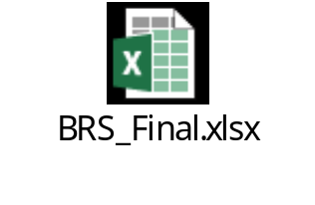
3.2 FUNCTIONAL REQUIREMENT SPECIFICATION (FRS)
(System Requirements)
3.2.1 Functional Capabilities (also included in the BRS)
-Assist tuning violin to at least open strings in standard tuning, preferably alternate tunings as well
-Assist playing scales by playing tone for correct note and displaying finger position and name of correct note
-Include all major, minor, chromatic, and pentatonic scales
-Adjustable metronome that counts at user entered tempo
-Metronome should have visible display in addition to audio
-(To Be Implemented in Future Iteration) Checks intonation by listening to played notes and determines if fingers are in correct position, assuming standard tuning
-(To Be Implemented in Future Iteration) Provide user access to a catalog of practice videos and allow user to record his/her own videos for self-review
3.2.2 System Inputs
-Desired BPM input from user for metronome feature
-Preferred Scales and Key for tuning feature
-Specific Note for tuning an instrument
3.2.3 System Outputs
-Visual and Auditory output for a metronome application
-Provide specific note output based on user selection in the tuning feature
-Visual display of a fretboard and the different notes to choose from in the tuning feature
3.3 NONFUNCTIONAL REQUIREMENTS
3.3.1 Performance Considerations
-Current final product deliverable is not very demanding, however future plans related to intonation and video support may prove to be difficult. Testing on a Visual Studio android emulator may not be an accurate test in comparison to testing on a real Android OS utilized in modern phones.
3.3.2 User Interface
-Application menu shall remain simple and responsive
-Utilize a main menu screen where you select which feature to access
3.3.3 Language
-Utilized C# (supports cross-platform development)
3.3.4 Operating Environment
-Android 8.1 or 9.0

SECTION 4 – DESIGN
Starting with Iteration 1 of our design, we started developing UML diagrams to help us in planning the design of our product. The activity and use cases diagrams came first and the state/class/sequence diagrams were developed later in development once we had a better understanding of what type of product we were developing. Our Use Case diagram has been updated to reflect the final product and it’s limited scope but to also demonstrate the future planned features and their relation to the rest of the scope (however this was the only diagram with the future plans). We wanted to rest of our documents to represent the current finalized product so that it is not too confusing for our Stake Holders as to what we are providing in this final iteration. We documented these plans for the future features into the Test Plan, Product Backlog, as well as our Project Milestones to serve as a strategy for another design phase and when we were to begin that next design phase, we would update the other diagrams to reflect these new features. For now, we believe the Use Case to be acceptable as the only demonstration of the future plans.

4.1 SYSTEM CONTEXT
A context diagram shows how the app will be structured and accessed by a user. Use Case diagrams are one design diagram that people occasionally substitute in place of a context diagram as they both represent the scope of the project/product at a similar level of abstraction.
Use Case Diagram:
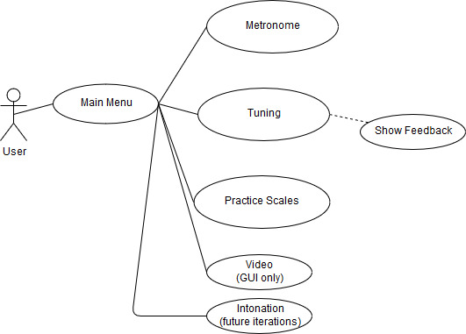

Activity Diagrams:
Diagram 1 for tuning
Diagram 2 for practice
Diagram 3 for metronome
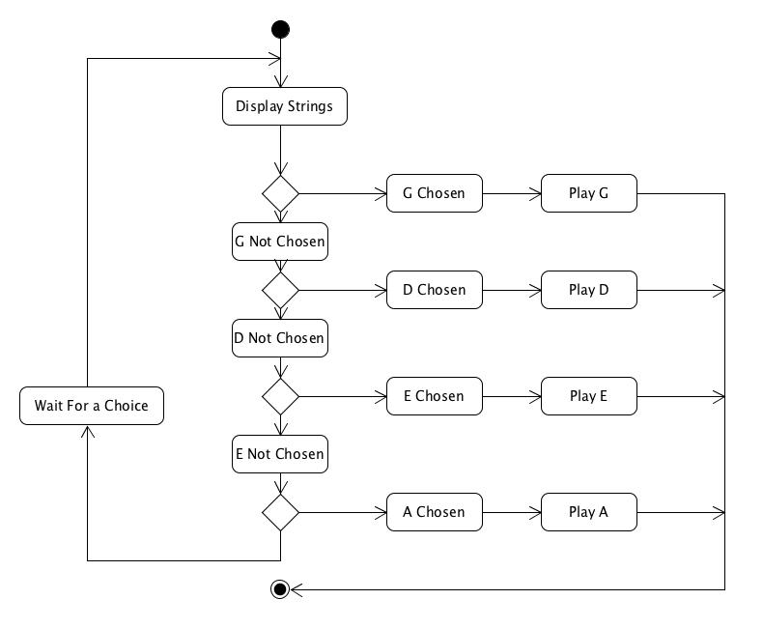
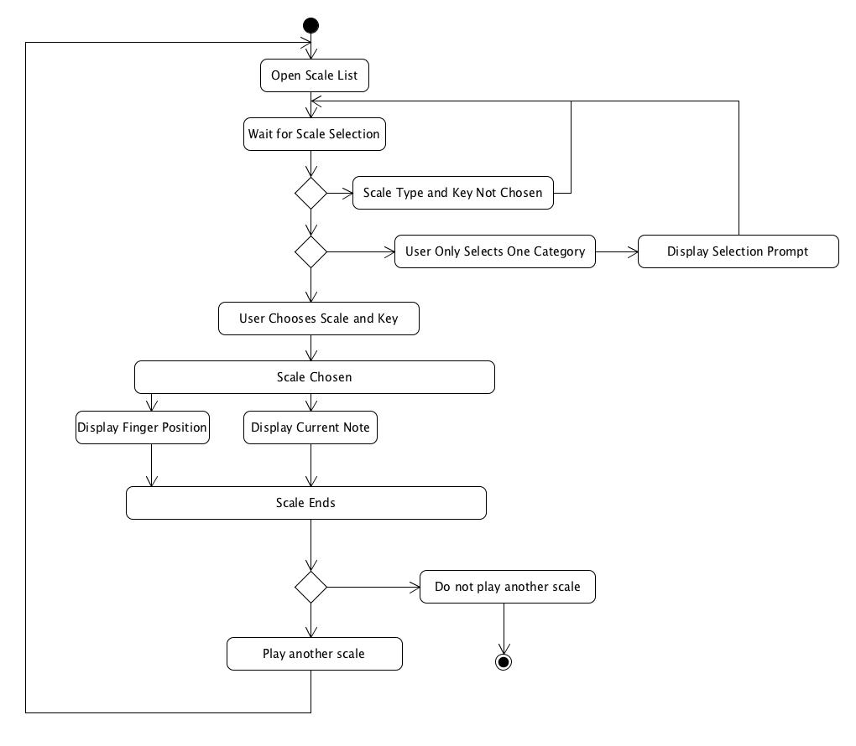
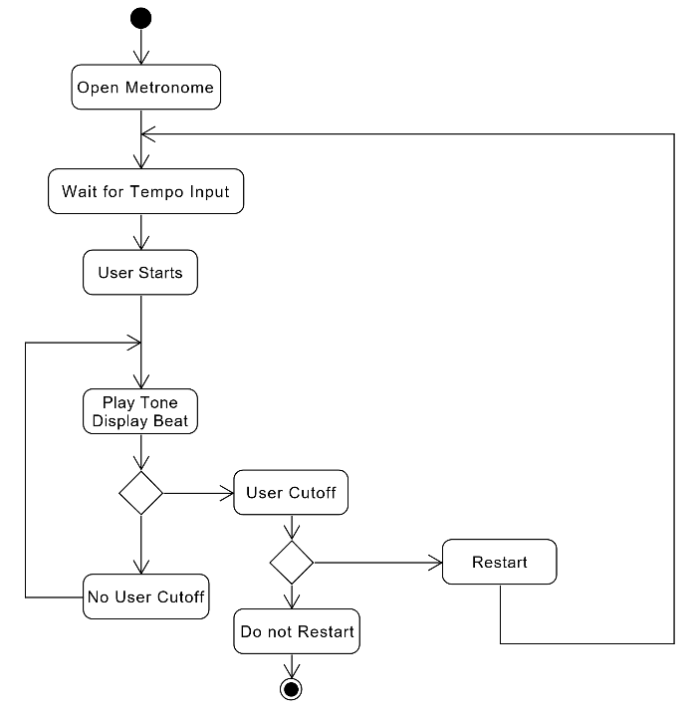
State Diagram:
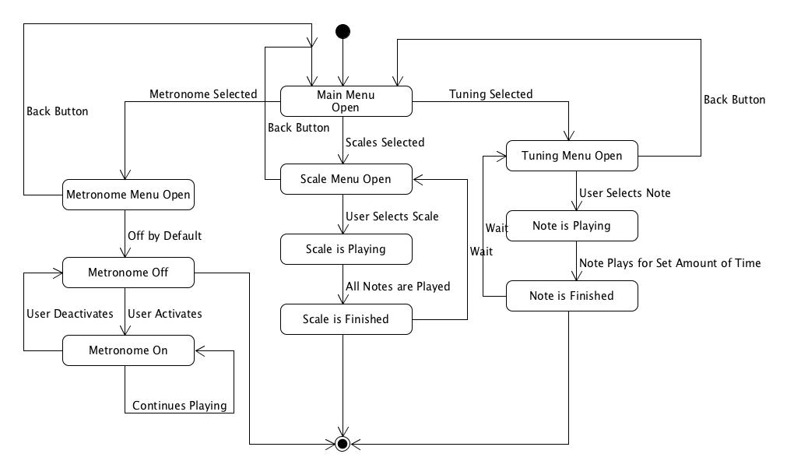

Sequence Diagram:
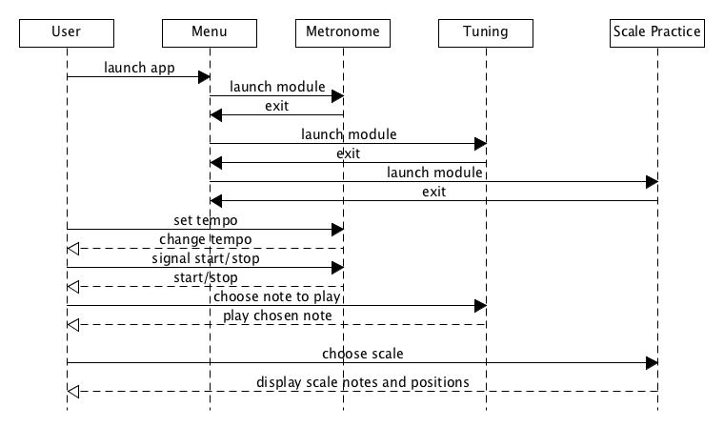
Class Diagram:
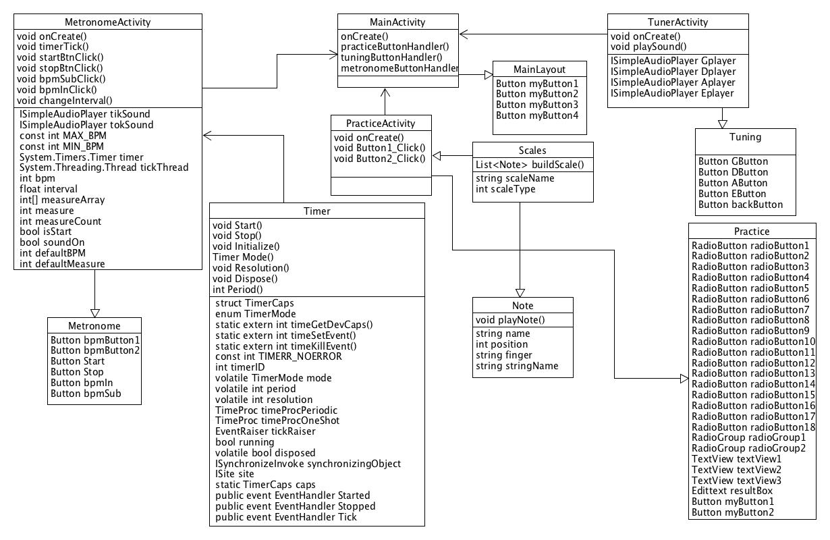

SECTION 5 - IMPLEMENTATION STRATEGY
The various features we implemented for our product were tracked with the help of both Trello (informal) and our Product Backlog (formal). The product backlog was continually updated throughout the semester and served as a simple way to distinguish individual tasks and distribute the work load amongst the group. Meeting with our Stake Holder to discuss delays in production or design allowed us to alter the scope of our project to allow us to meet deadlines with feasible results. Both the Project Milestones and Product Backlog for our project are linked below as they will best explain our features we implemented and the time frame we worked with related to the entirety of the design process. (files need to be downloaded locally to open).
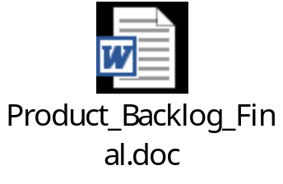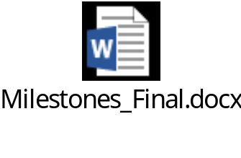
SECTION 6 - USER DOCUMENTATION
Product finalized to be compatible with android 8.1 or 9.0 but we currently are running it locally with the help of Visual Studio and an android emulator. Future plans will be to get it available on the google play store but that would be post-implementation of the intonation and video features.
6.1 INSTALLATION GUIDE
Download our Fid’Lin Zip folder and extract the entirety of the contents into your Visual Studio repository. Project can be launched with the solution file, then the appropriate NuGet packages must be installed: xam.plugin.sampleaudioplayer and xamarin.android.support.v7. The appropriate android emulator must be installed as well: either android 8.1 or 9.0. Launch the project through one of the emulators to experience the final product.
6.2 USER'S GUIDE
Application itself is very simple and straightforward to navigate. Launching the emulator should open the application by default. The main menu should be displayed first and from here you can navigate to any of the 3 (4 but Video feature not finished in this finalized product) features: Tuning/Metronome/Practice. These different features each have buttons to perform the different tasks associated with them and need no explanation.

SECTION 7 - TEST AND VALIDATION
7.1 TEST PLAN
This plan was created by the first sprint and has been updated throughout the entirety of the project. A finalized document has been completed and a link to it is below (assuming you have the test plan downloaded locally in addition to this document).
